Detailed System Architecture & Operational Framework
The heart of our technology strategy is a solid-state Electrothermal Swing Adsorption (ESA) framework utilizing highly structured carbon monoliths. Traditional carbon capture systems rely on massive vertical towers where liquid chemical solvents trickle down through rising flue gases via gravity, requiring immense amounts of energy to boil water just to release the captured gas. Our system replaces this entire chemical mass-transfer setup with a compact, static metal housing containing a 3D-printed, cellular honeycomb block.
During the passive capture phase, the high-volume industrial exhaust stream is channeled straight through the parallel micro-channels of our monolithic block. This structure features a vast internal surface area optimized at the molecular scale with sub-two-nanometer micropores. As the gas flows through, carbon dioxide molecules are cleanly trapped on the inner surface of the carbon matrix via physisorption, while the stripped, environmentally safe exhaust vents directly out of the system.
When the porous monolith reaches maximum capacity, the exhaust valve closes and the regeneration phase begins instantly. Rather than using external steam loops or slow-heating thermal jackets, we apply a low-voltage electrical potential directly across integrated electrodes wrapped around the monolith. Because the carbon matrix is highly conductive but precisely engineered with physical resistance, the passage of current triggers instantaneous, uniform volumetric heating throughout the block via the Joule effect. This targeted energy transfer warms only the exact solid structure holding the carbon molecules, avoiding the massive thermal penalties of heating dead fluids. Within thirty seconds, the localized temperature spike breaks the weak molecular bonds, causing the monolith to cleanly release a concentrated stream of purified carbon gas under a light vacuum, resetting the system for the next cycle.
Advanced Manufacturing & Scalability
Our solid-state device dramatically undercuts the capital and operational expenses of legacy technologies because it relies entirely on a modular design with zero high-speed moving parts, eliminating specialized bearings, dynamically balanced shafts, and heavy industrial drive motors. We manufacture these advanced monolithic blocks by transitioning a highly stable, settled material science mechanism into an automated, high-throughput manufacturing workflow.
The core honeycomb structures are produced using industrial 3D-extrusion printing technology. We blend a highly consistent, raw activated carbon or zeolite powder feedstock with an organic binder and a conductive matrix compound to form a custom, high-viscosity printable paste. This paste is loaded into automated direct-ink-writing gantries that continuously extrude the precise, parallel micro-channel geometry down to strict millimeter tolerances. Once printed, the green monoliths undergo a controlled thermal drying process followed by high-temperature carbonization in an inert atmosphere, which bakes away the volatile binders, locks in structural rigidity, and opens up the necessary internal microporosity.
Because the resulting blocks are mechanically robust, structurally inert, and entirely solid-state, they eliminate the mechanical friction, attrition, and dust generation common in traditional granular or bead-based fluid beds. We package these standardized, mass-produced carbon blocks into scalable, modular stainless-steel container shells. This allows our manufacturing footprint to scale via parallel replication rather than custom infrastructure engineering, enabling us to assemble entire systems inside a standard fabrication garage using off-the-shelf electrical controls and basic metal assembly.

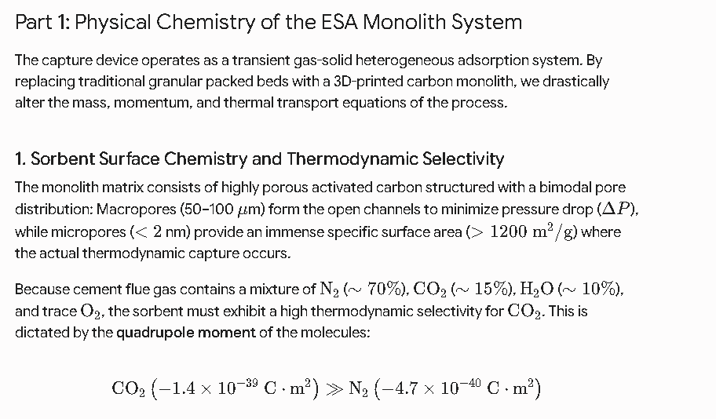
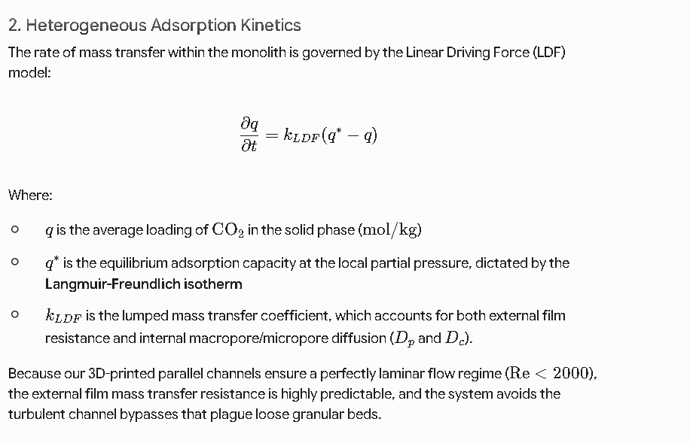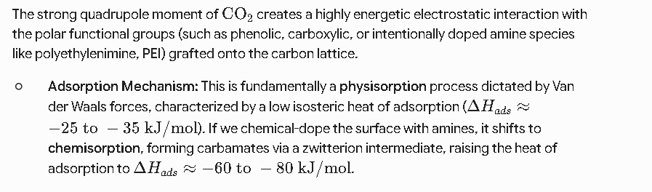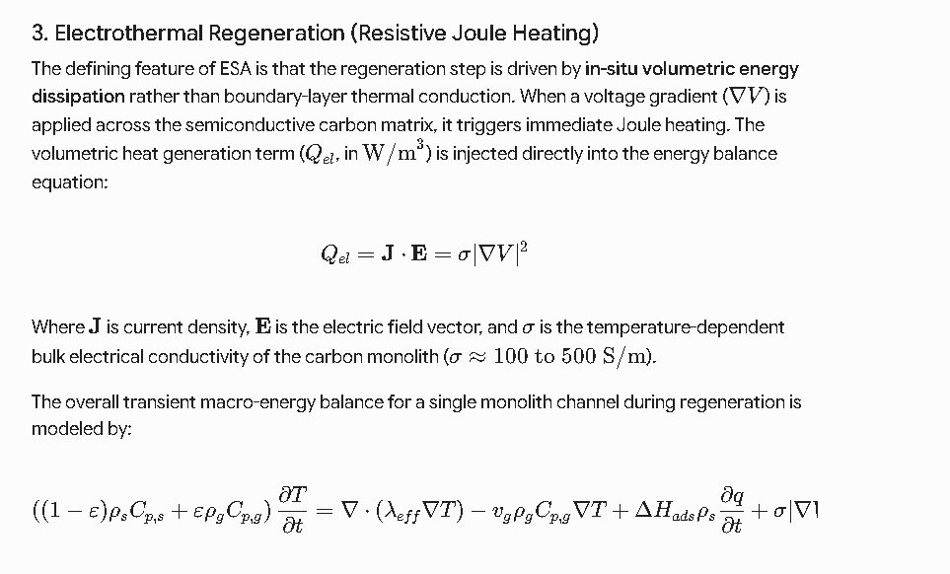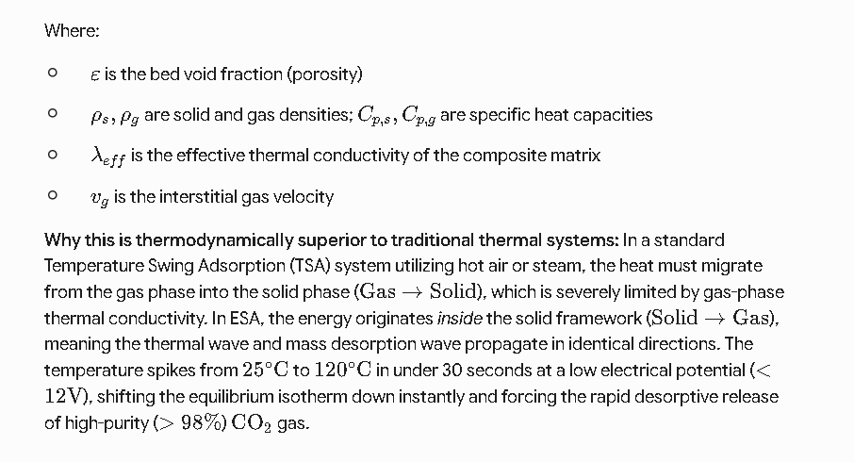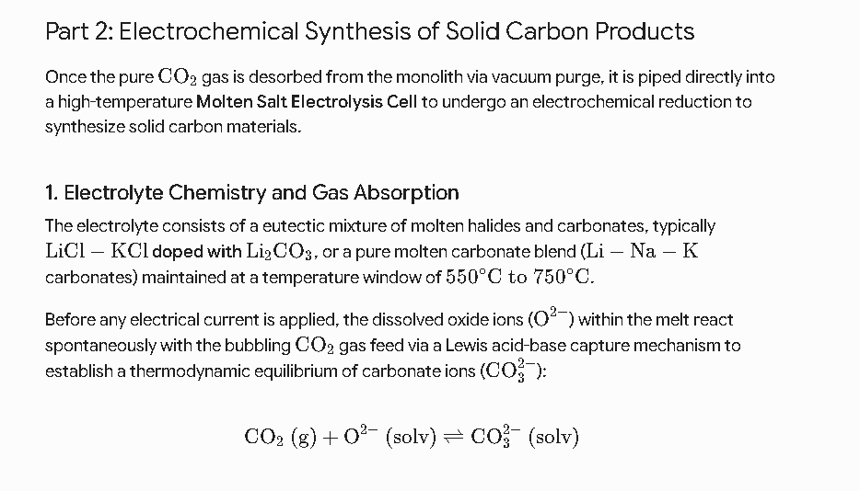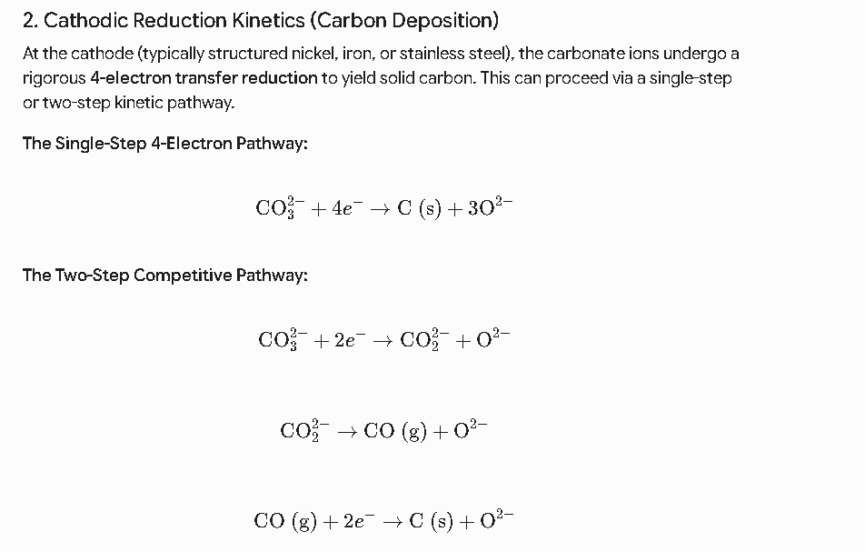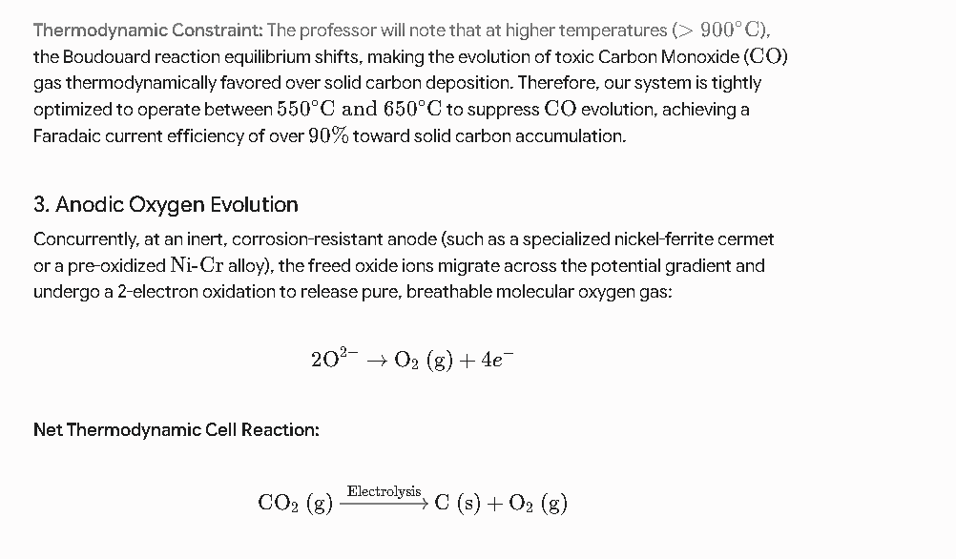
Research paper: https://researchportal.vub.be/en/publications/electrical-swing-adsorption-on-3d-printed-activated-carbon-monoli/#:~:text=capture%20from%20biogas.-,Electrical%20swing%20adsorption%20on%203D%2Dprinted%20activated%20carbon%20monoliths%20for,%3B%20Sutens%2C%20Ben%20et%20al.

