**WoodProjectReserve**

Woodworking Project Reservation Application Design Document

Christopher Culver

MSSE674

Regis University

|  |  |  |  |  |
| --- | --- | --- | --- | --- |
| Revision History | | | | |
| **Date** | **Revision** | **Author** | **Description** | **Document Tracking** |
| 8-28-2021 | 1.0 | Chris Culver | Creation |  |
| 9-10-2021 | 1.0 | Chris Culver | Reviewed |  |

Contents

1 Introduction 4

1.1 Intent 4

1.2 High Level Requirements 4

1.2.1 Registration 4

1.2.2 Authentication 4

1.2.3 Reservation 5

1.2.4 Project Status Update 5

1.2.5 Administration 5

1.2.6 Future Enhancements 5

2 WoodProjectReserve 6

2.1 Intent 6

2.2 Customer Interacting Use Cases 6

2.2.1 Use Case Diagram 6

3 Fully Dressed Use Case 7

3.1 Intent 7

3.2 Reservation Use Case 7

3.3 Project Status Update Use Case 9

# 1 Introduction

## 1.1 Intent

This document details the requirements of the WoodProjectReserve application along with two customer interaction use cases. The document also includes the design details of the WoodProjectReserve Application.

## 1.2 High Level Requirements

WoodProjectReserve is an application that will give customers of a woodworking business the ability to request projects. The application will also give woodworking business owners a way to manage and track incoming projects.

During the initial build of this application, it will be built as windows-based localized client used by the woodworking business owners. At this time, all customer data and project information will be inputted by the business owner.

### 1.2.1 Registration

Customers are required to register to submit a project request. The registration process will capture the customer's first name, last name, email address, user id, and password.

Customer is required to answer three security questions, which they can use when user id’s and/or passwords are forgotten.

### 1.2.2 Authentication

Customers are required to have a valid user id and password. The login process will provide the ability to reset a forgotten password.

### 1.2.3 Reservation

During the initial build, the business owner will guide the customer through the project reservation process. Customers will have the choice of construction material, wood types (main and secondary), finish type, project name, desired completion date, and details for the builder.

When a customer wants to place a reservation they must pass their user id and password to the owner to complete the reservation and have their project entered into the project list.

### 1.2.4 Project Status Update

The customer will be able to check the status of their requested project by logging in and seeing updates inputted by the business owner. At this time, the customer will contact the business owner and they well send project data to the customer’s email, giving similar data to viewing the project within the application.

### 1.2.5 Administration

An administrator will be able to manage the project list, updating timelines, cost, and project details as needed. The administrator will also be allowed to add or remove projects as needed from the project list.

### 1.2.6 Future Enhancements

Future iterations will extend this application to include web support, secure storage and processing of customer payment, raw material inventory, and storefront for already built goods.

# 2 WoodProjectReserve

## 2.1 Intent

This section lists the use cases for customer interaction with the application.

## 2.2 Customer Interacting Use Cases

The following are customer uses cases listed in priority order:

|  |
| --- |
| Reservation |
| Project Status Update |
| Registration |
| Authentication |

### 2.2.1 Use Case Diagram

The following figure shows the use case diagram and use cases associated with the Customer actor:

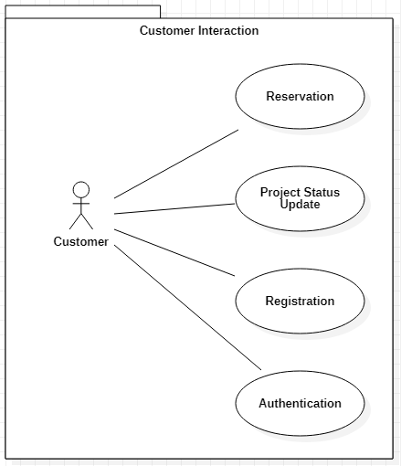

Figure 2-1 WoodProjectReserve Customer Interaction Use Cases

# 3 Fully Dressed Use Case

## 3.1 Intent

This section will document the Reservation and Project Status Update use cases in detail.

## 3.2 Reservation Use Case

|  |  |
| --- | --- |
| **Use case name:** | Reservation |
| **Use case ID:** | Res – 001 |
| **Primary actor(s):** | Customer |
| **Secondary actor(s):** |  |
| **Brief description:** | Customer creates a new reservation for a woodworking project detailing specifications of the project which will be loaded into the WoodProjectReserve application. |
| **Preconditions:** | Customer has a valid account in the WoodProjectReserve application. |
| **Flow of events:** | 1. Log into WoodProjectReserve    1. Login authenticated 2. Display Reservation form 3. Enter Project Name 4. Enter Desired Completion Date    1. If date less than or equal to current date display message that time needs to be in the future 5. Enter Construction Material 6. Enter Wood Type Main and Wood Type Secondary (optional) 7. Enter Finish Type 8. Enter additional project details |
| **Post-conditions:** | Customer reservation is in the WoodProjectReserve application, tied to the customer id and reservation id. |
| **Priority:** |  |
| **Alternative flows and exceptions:** | Failed login authentication   1. If account does not exist, register customer for account 2. If bad user id/password, display failed login attempt message |
| **Non-behavioral requirements:** |  |
| **Assumptions:** |  |
| **Issues:** |  |
| **Source:** | WoodProjectReserve Application |

## 3.3 Project Status Update Use Case

|  |  |
| --- | --- |
| **Use case name:** | Project Status Update |
| **Use case ID:** | Stat – 001 |
| **Primary actor(s):** | Customer |
| **Secondary actor(s):** |  |
| **Brief description:** | Customer requests the status of a previously submitted project reservation, which is displayed in the application Reservation form. |
| **Preconditions:** | Customer has a valid account in the WoodProjectReserve application.  Customer has submitted a project reservation |
| **Flow of events:** | 1. Log into WoodProjectReserve    1. Login authenticated 2. Display Reservation form 3. Click print button to output reservation details to text file |
| **Post-conditions:** | Customer views reservation details in output text file |
| **Priority:** |  |
| **Alternative flows and exceptions:** | Failed login authentication   1. If account does not exist, register customer for account 2. If bad user id/password, display failed login attempt message |
| **Non-behavioral requirements:** |  |
| **Assumptions:** |  |
| **Issues:** |  |
| **Source:** | WoodProjectReserve Application |