Statistical report for ACASA-TAVI
  - AntiCoagulation versus AcetylSalicylic Acid after Transcatheter Aortic Valve Implantation
C. Cunen
01 juli 2026
Table of Contents

Introduction
The ACASA-TAVI study is a two-arm, randomised, controlled, parallel-group, multicentre, single-country, open-label blinded-endpoint, Phase III trial. Patients are randomised to either ASA (usual care) or DOAC (active treatment) in a 1:1 ratio. The goal of the study is to evaluate the efficacy and safety of DOAC versus ASA after TAVI. Treatment duration is 12 months and the primary endpoints are evaluated at 12 months. See Protocol (current version is dated November 10th 2022).
This report summarises the results from the analysis of primary and secondary endpoints, as well as baseline and safety data.
All 360 randomised patients are included in all analyses (except in some sensitivity analyses, where this is made explicit). The analyses have been implemented according to the SAP version 1.0, dated xx.xx.xxxx.
The present results are built on sham randomisation generated from the most recent export from Viedoc. No true treatment assignments have been unlocked. All findings in this document should therefore be interpreted as preliminary and descriptive only. Final efficacy comparisons will not be conducted until the database is locked and genuine randomisation codes are used.

Patient enrolment and disposition
There are 360 randomised participants: 27 from Haukeland, 333 from OUS. The FAS includes all participants.

Patient disposition (reasons for non-completion)
Overview of study completion and reasons for non-completion
 | DOAC | ASA | Total
Number of randomised participants | 180 | 180 | 360
Study completed
No | 14 | 10 | 24
Yes | 166 | 170 | 336
Reason for discontinuation
Voluntary discontinuation by patient | 4 | 5 | 9
Incorrect randomisation | 1 | 0 | 1
Non-compliance | 1 | 0 | 1
Death | 7 | 5 | 12
Other | 1 | 0 | 1

Protocol deviations
Number of major and minor protocol deviations, summarized by treatment group with details of type of deviation provided.
Number of minor protocol deviations
Treatment | Category of PD | n
DOAC | Incorrect treatment and/or dose | 2
DOAC | Prohibited concomitant medication | 3
DOAC | Failure to collect important data | 6
DOAC | Serious breach - Other | 1
DOAC | Other | 10
ASA | Prohibited concomitant medication | 3
ASA | Failure to collect important data | 4
ASA | Serious breach - SAE notification / safety procedure | 2
ASA | Other | 8
There are currently no protocol deviations that are categorised as “major”.

Demographics and baseline characteristics

Table 1
Baseline characteristics for all 360 participants. Continuous variables are summarised by mean (SD), or by median (IQR) as appopriate.
Age (years) | 74.5 (3.7)
Sex, female | 37%
NYHA functional class III or IV | 29%
Body mass index (kg/m^2) | 28.1 (4.7)
Coronary artery disease | 24%
Hypertension | 71%
Diabetes mellitus | 28%
Previous stroke | 11%
Permanent pacemaker | 2%
Chronic obstructive pulmonary disease | 14%
EuroSCORE II (%) | 2.3 (2)
Troponin T (ng/L) | 16 (11 - 28)
NT-proBNP (ng/L) | 413 (197 - 812)
Glomerular filtration rate (mL/min/1 1.73 m^2) | 75 (18.4)
Pre-TAVI aortic valve parameters
Left ventricular ejection fraction (%) | 53.9 (8)
Aortic valve mean gradient (mmHg) | 49.6 (12.5)
Aortic valvular area (cm^2) | 0.8 (0.2)
Aortic annular area (mm^2) | 478.4 (93.6)
Aortic annular perimeter (mm) | 78.8 (7.7)
Bicuspid aortic valve | 14%
Valce-in-valve | 2%
Procedural characteristics
Balloon-expanded valve | 71%
Self-expandable valve | 29%
Pre-dilatation | 37%
Post-dilatation | 9%

Demographics and medical history
Demographics and medical history.
Characteristic | DOAC(n=180) | ASA(n=180) | Overall (n=360)
Age (years) | 74.4 (3.7) | 74.5 (3.7) | 74.5 (3.7)
Sex, n (%)
Male | 115 (63.9%) | 111 (61.7%) | 226 (62.8%)
Female | 65 (36.1%) | 69 (38.3%) | 134 (37.2%)
Hypertension, n (%)
Yes | 124 (70.9%) | 126 (72%) | 250 (71.4%)
Missing | 5 (2.8%) | 5 (2.8%) | 10 (2.8%)
Coronary artery disease, n (%)
Yes | 36 (20.6%) | 47 (26.9%) | 83 (23.7%)
Missing | 5 (2.8%) | 5 (2.8%) | 10 (2.8%)
Diabetes mellitus, n (%)
Yes | 54 (30.9%) | 45 (25.7%) | 99 (28.3%)
Missing | 5 (2.8%) | 5 (2.8%) | 10 (2.8%)
Chronic obstructive pulmonary disease, n (%)
Yes | 26 (14.9%) | 22 (12.6%) | 48 (13.7%)
Missing | 5 (2.8%) | 5 (2.8%) | 10 (2.8%)
Previous stroke, n (%)
Yes | 19 (10.9%) | 21 (12%) | 40 (11.4%)
Missing | 5 (2.8%) | 5 (2.8%) | 10 (2.8%)
Permanent pacemaker
Yes | 5 (2.9%) | 3 (1.7%) | 8 (2.3%)
Missing | 5 (2.8%) | 5 (2.8%) | 10 (2.8%)
Smoking status, n (%)
Never smoked | 59 (32.8%) | 66 (36.7%) | 125 (34.7%)
Has stopped | 94 (52.2%) | 91 (50.6%) | 185 (51.4%)
Sometimes | 1 (0.6%) | 1 (0.6%) | 2 (0.6%)
Daily | 26 (14.4%) | 22 (12.2%) | 48 (13.3%)

Vital signs and physical characteristics at baseline
Vital signs and physical characteristics at baseline.
Characteristic | DOAC(n=180) | ASA(n=180) | Overall (n=360)
Weight (kg) | 84.3 (16.2) | 84.9 (15.9) | 84.6 (16)
Height (cm) | 173.8 (9.3) | 173 (9) | 173.4 (9.1)
Body mass index (kg/m2) | 27.9 (4.9) | 28.3 (4.5) | 28.1 (4.7)
Systolic blood pressure (mmHg) | 137 (19.1) | 143.6 (22) | 140.3 (20.8)
Diastolic blood pressure (mmHg) | 71.9 (9.8) | 71.9 (10.4) | 71.9 (10.1)
Body temperature (C) | 36.7 (0.4) | 36.7 (0.4) | 36.7 (0.4)
Pulse rate (beats/min) | 74.7 (14.6) | 73 (11.6) | 73.8 (13.2)
Respiratory rate (breaths/min) | 16.9 (2.9) | 16.8 (2.2) | 16.8 (2.5)
Mini-Cog
Signs of cognitive impairment (0-2) | 15 (9.3%) | 11 (6.9%) | 26 (8.1%)
No cognitive impairment (3-5) | 147 (90.7%) | 148 (93.1%) | 295 (91.9%)
Missing | 18 (10%) | 21 (11.7%) | 39 (10.8%)
Five times sit-to-stand
< 15 sec | 115 (83.3%) | 109 (79.6%) | 224 (81.5%)
>= 15 sec | 23 (16.7%) | 28 (20.4%) | 51 (18.5%)
Missing | 42 (23.3%) | 43 (23.9%) | 85 (23.6%)
Frailty, n (%)
Robust | 75 (41.7%) | 90 (50%) | 165 (45.8%)
Pre-frail | 59 (32.8%) | 43 (23.9%) | 102 (28.3%)
Frail | 0 (0%) | 0 (0%) | 0 (0%)
Missing | 46 (25.6%) | 47 (26.1%) | 93 (25.8%)

Clinical chemistry and hematology at baseline
Some results related to clinical chemistry and hematology at baseline.
Characteristic | DOAC(n=180) | ASA(n=180) | Overall (n=360)
Hemoglobin | 13.4 (1.6) | 13.7 (1.6) | 13.6 (1.6)
Platelets | 220.1 (61.7) | 232.9 (67) | 226.5 (64.7)
Leukocytes | 7.2 (6.1 - 8.6) | 7.4 (6.5 - 8.7) | 7.3 (6.3 - 8.7)
International Normalized Ratio (INR) | 1.1 (0.1) | 1 (0.1) | 1.1 (0.1)
Sodium | 139.5 (2.7) | 139.6 (2.8) | 139.6 (2.7)
Potassium | 4.1 (0.4) | 4 (0.4) | 4.1 (0.4)
ALT | 25.3 (13.3) | 27.6 (13.9) | 26.4 (13.6)
Cardiac troponin T | 17 (11.8 - 27.8) | 15 (11 - 28) | 16 (11 - 28)
NT-proBNP | 431 (216 - 815) | 372 (177 - 779) | 413 (197 - 812)
GFR | 73.6 (19.6) | 76.3 (17.1) | 75 (18.4)
Glucose | 6.8 (2) | 6.8 (2.2) | 6.8 (2.1)
Glycated haemoglobin (HbA1c) | 42.2 (9.3) | 42 (9.9) | 42.1 (9.6)
Triglycerides | 1.6 (0.9) | 1.5 (0.7) | 1.5 (0.8)
Missing | 6 (3.3%) | 4 (2.2%) | 10 (2.8%)
Total cholesterol | 4.2 (1.1) | 4.3 (1.1) | 4.2 (1.1)
HDL cholesterol | 1.4 (0.4) | 1.5 (0.5) | 1.4 (0.5)
LDL cholesterol | 2.2 (0.9) | 2.3 (0.9) | 2.3 (0.9)
Creatinine | 92.2 (46.8) | 84.8 (29.4) | 88.5 (39.2)
Albumin | 42.7 (3.8) | 43 (2.8) | 42.9 (3.3)
Missing | 6 (3.3%) | 4 (2.2%) | 10 (2.8%)
Bilirubin | 8.9 (4.5) | 9.9 (5.6) | 9.4 (5.1)
Missing | 6 (3.3%) | 4 (2.2%) | 10 (2.8%)
CRP | 1.6 (0.8 - 4) | 1.4 (0.7 - 3.3) | 1.5 (0.8 - 3.8)

Echocardiography pre-TAVI and at baseline
Some echocardiography parameters pre-TAVI.
Characteristic | DOAC(n=180) | ASA(n=180) | Overall (n=360)
Aortic valve mean gradient (mmHg) | 49.4 (13) | 49.8 (12.1) | 49.6 (12.5)
LVOT (mm) | 22.7 (1.8) | 22.3 (1.9) | 22.5 (1.9)
Presence of low-flow low-gradient | 9 (5%) | 10 (5.6%) | 19 (5.3%)
Left ventricular ejection fraction (%) | 53.1 (7.9) | 54.7 (8) | 53.9 (8)
Left ventricular global longitudinal strain (%) | -15.2 (3.4) | -16.4 (8.8) | -15.8 (6.7)
Stroke volume (mL) | 83.8 (19.7) | 87 (23.1) | 85.4 (21.5)
Stroke volume index (mL per m^2) | 42.1 (10) | 43.5 (11.3) | 42.8 (10.7)
Aortic valvular area (cm^2) | 0.8 (0.2) | 0.8 (0.2) | 0.8 (0.2)
Aortic valve regurgitation | 116 (64.8%) | 113 (62.8%) | 229 (63.8%)
Missing echocardiography | 0 (0%) | 0 (0%) | 0 (0%)
Some echocardiography parameters at baseline (post-TAVI).
Characteristic | DOAC(n=180) | ASA(n=180) | Overall (n=360)
Aortic valve mean gradient (mmHg) | 12.8 (4.7) | 13 (4.5) | 12.9 (4.6)
LVOT (mm) | 21.2 (2) | 21 (2) | 21.1 (2)
Presence of low-flow low-gradient | 44 (24.9%) | 30 (16.9%) | 74 (20.8%)
Left ventricular ejection fraction (%) | 57.5 (9) | 56.8 (9.7) | 57.1 (9.4)
Left ventricular global longitudinal strain (%) | -15.6 (3.4) | -15.6 (3.4) | -15.6 (3.4)
Stroke volume (mL) | 79.5 (14.7) | 82.7 (15.9) | 81.1 (15.4)
Stroke volume index (mL per m^2) | 39.7 (6.7) | 41.2 (7.2) | 40.4 (7)
Doppler velocity index | 0.5 (0.1) | 0.5 (0.1) | 0.5 (0.1)
Aortic valvular area (cm^2) | 1.9 (0.4) | 1.9 (0.4) | 1.9 (0.4)
Aortic valve regurgitation | 63 (35.2%) | 62 (34.4%) | 125 (34.8%)
Missing echocardiography | 60 (33.3%) | 56 (31.1%) | 116 (32.2%)

Primary analyses of primary endpoints

Co-primary efficacy endpoint (HALT)

Descriptive statistics
Descriptive statistics for HALT (primary efficacy endpoint). Counts and proportions.
 | DOAC | ASA | Overall
Missing HALT | 15 | 10 | 25
No thickening | 127 | 133 | 260
HALT | 38 (23%) | 37 (21.8%) | 75 (22.4%)
HALT & Death | 45 (26.2%) | 42 (24%) | 87 (25.1%)
<=25% of leaflet | 20 | 17 | 37
>25-50 % of leaflet | 13 | 9 | 22
>50-75 % of lealet | 2 | 5 | 7
>75 % of leaflet | 3 | 6 | 9
Death | 7 | 5 | 12

Unadjusted analysis with multiple imputation
The analysis model only uses the treatment variable and no other covariates.
Multiple imputation with imputation model containing BMI, sodium, potassium, ALT, triglycerides, albumin, and bilirubin.
Estimated average unadjusted risk ratio, along with corresponding p-value and confidence interval.
contrast | estimate | p.value | 95CI_low | 95CI_high
DOAC / ASA | 1.079 | 0.684 | 0.748 | 1.556
We see from the table above that the null hypothesis of equality is not rejected.
Estimated average unadjusted risk difference, along with corresponding confidence interval.
contrast | estimate | 95CI_low | 95CI_high
DOAC - ASA | 0.019 | -0.073 | 0.112

Co-primary safety endpoint

Descriptive statistics
Descriptive statistics for primary safety endpoint. Counts and proportions. The counts are the number of participants experiencing an event of a particular type as their *first* safety event. Some participants may experience more than one safety event.
 | DOAC | ASA | Overall
Missing | 4 | 2 | 6
No safety events | 159 | 163 | 322
Safety events | 17 (9.7%) | 15 (8.4%) | 32 (9%)
bleeding | 5 | 4 | 9
death | 6 | 5 | 11
mi | 2 | 2 | 4
stroke | 4 | 4 | 8
Occurrence and timing of intercurrent events
Out of 360 participants, 55 participants experience some form of treatment deviation, mostly switching between the two study drugs. All participants have the possibility to switch between study drugs. A few participants switch multiple times.
Number of participants with treatment deviations.
 | No change in study drug | Switching or stopping | Early discontinuation
DOAC | 152 | 24 | 4
ASA | 153 | 23 | 4
Overall | 305 | 47 | 8
Out of the 32 safety events, 10 happen in participants that also switch between the treatments at some point. Among these 10 participants: 6 experience the safety event before switching, while 4 experience the safety event after their first switch.
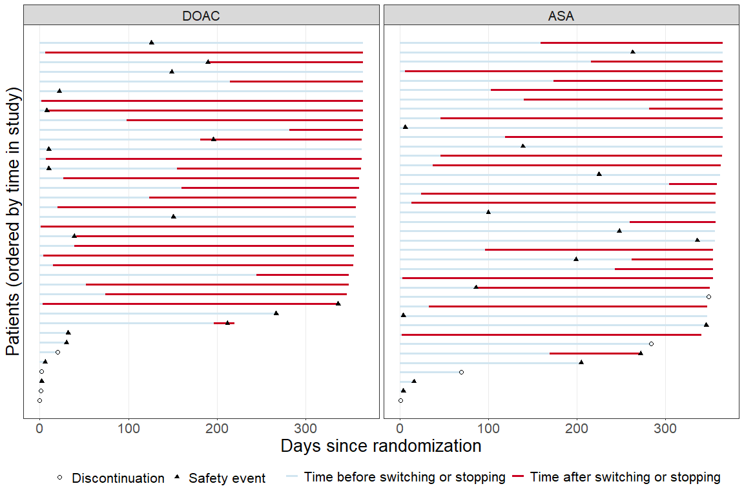
Timing of safety events and/or treatment deviations. Some participants switch between drugs multiple times and in those cases the figure gives the timing of the first switch.
In this figure there are 77 participants, including 32 participants experiencing the safety event, and 55 participants with treatment deviations (10 participants are part of both groups).

Adjusted analysis with multiple imputation, treatment policy strategy
Should I show diagnostics of the imputation?
Covariates in the analysis model: treatment, age, sex, cad, prev_stroke, diabetes, hypertension, GFR
Multiple imputation with imputation model containing the same covariates.
Estimated average adjusted risk difference, along with corresponding confidence interval.
contrast | estimate | 95CI_low | 95CI_high
DOAC - ASA | 0.012 | -0.048 | 0.072
We see from the table above that the null hypothesis of inferiority is rejected.
Estimated average adjusted risk ratio, along with corresponding confidence interval.
contrast | estimate | 95CI_low | 95CI_high
DOAC / ASA | 1.141 | 0.588 | 2.214

Overall conclusions
Study is inconclusive.

Sensitivity analyses of primary endpoints

HALT
Co-primary efficacy: results of primary analysis and 3 sensitivity analyses. Estimated average risk ratios, along with corresponding confidence intervals. MI stands for Mulitple Imputation.
 | estimate | 95CI_low | 95CI_high
primary analysis | 1.079 | 0.748 | 1.556
1: adjusted, with MI | 0.956 | 0.673 | 1.358
2: unadjusted, complete-case | 1.090 | 0.757 | 1.569
3: unadjusted, worst-case | 1.128 | 0.807 | 1.575
Co-primary efficacy: results of primary analysis and 3 sensitivity analyses. Estimated average risk differences, along with corresponding confidence intervals. MI stands for Mulitple Imputation.
 | estimate | 95CI_low | 95CI_high
primary analysis | 0.019 | -0.073 | 0.112
1: adjusted, with MI | -0.011 | -0.100 | 0.077
2: unadjusted, complete-case | 0.022 | -0.070 | 0.113
3: unadjusted, worst-case | 0.033 | -0.059 | 0.126

Safety composite
Co-primary safety: results of primary analysis and 3 sensitivity analyses. Estimated average risk differences, along with corresponding confidence intervals. MI stands for Mulitple Imputation.
 | estimate | 95CI_low | 95CI_high
primary analysis | 0.012 | -0.048 | 0.072
1: unadjusted, with MI | 0.012 | -0.048 | 0.072
2: adjusted, complete-case | 0.012 | -0.048 | 0.072
3: adjusted, worst-case | 0.019 | -0.044 | 0.083
Co-primary safety: results of primary analysis and 3 sensitivity analyses. Estimated average risk ratios, along with corresponding confidence intervals. MI stands for Mulitple Imputation.
 | estimate | 95CI_low | 95CI_high
primary analysis | 1.141 | 0.588 | 2.214
1: unadjusted, with MI | 1.141 | 0.587 | 2.217
2: adjusted, complete-case | 1.144 | 0.590 | 2.215
3: adjusted, worst-case | 1.202 | 0.658 | 2.197
For the fourth sensitivity analysis we re-do the non-inferiority hypothesis test, but using the risk ratio and a non-inferiority margin of 1.35. We see from the table above that this null hypothesis of inferiority is not rejected.

Supplementary analyses of primary endpoints

HALT: hypothetical strategy for death
The analysis model only uses the treatment variable and no other covariates.
Multiple imputation with imputation model containing BMI, sodium, potassium, ALT, triglycerides, albumin, and bilirubin.
Estimated average unadjusted risk ratio, along with corresponding p-value and confidence interval.
contrast | estimate | p.value | 95CI_low | 95CI_high
DOAC / ASA | 1.061 | 0.770 | 0.712 | 1.582
Estimated average unadjusted risk difference, along with corresponding confidence interval.
contrast | estimate | 95CI_low | 95CI_high
DOAC - ASA | 0.014 | -0.077 | 0.105

Safety composite: hypothetical strategy for treatment deviations
to do

Safety compositet: composite strategy for treatment deviations
With this strategy we still have 360 observations, but now we have 77 safety events.
Estimated average adjusted risk difference, along with corresponding confidence interval.
contrast | estimate | 95CI_low | 95CI_high
DOAC - ASA | -0.017 | -0.101 | 0.067
Estimated average adjusted risk ratio, along with corresponding p-value and confidence interval.
contrast | estimate | p.value | 95CI_low | 95CI_high
DOAC / ASA | 0.923 | 0.689 | 0.623 | 1.367

Safety composite: primary strata strategy for treatment deviations
With this strategy we now have 305 observations and 22 safety events.
Estimated average adjusted risk difference, along with corresponding confidence interval.
contrast | estimate | 95CI_low | 95CI_high
DOAC - ASA | -0.015 | -0.073 | 0.044
Estimated average adjusted risk ratio, along with corresponding p-value and confidence interval.
contrast | estimate | p.value | 95CI_low | 95CI_high
DOAC / ASA | 0.817 | 0.625 | 0.364 | 1.834

Key secondary endpoints

Clinical efficacy
Descriptive statistics for clinical efficacy composite by treatment arms and overall. Counts and proportions.
 | DOAC | ASA | Overall
Missing | 6 | 7 | 13
composite=0 | 45 | 44 | 89
death | 7 | 5 | 12
hospitalisation | 34 | 33 | 67
KCCQ < 45 | 8 | 8 | 16
decline in KCCQ > 10 | 5 | 9 | 14
composite=1 | 129 | 129 | 258
composite=1, % | 74.1% | 74.6% | 74.4%
Estimated average risk difference, along with corresponding confidence interval.
contrast | estimate | 95CI_low | 95CI_high
DOAC - ASA | -0.008 | -0.100 | 0.083
Estimated average risk ratio, along with corresponding confidence interval.
contrast | estimate | 95CI_low | 95CI_high
DOAC / ASA | 0.989 | 0.874 | 1.118

Thromboembolic events
Descriptive statistics for thromboembolic events by treatment arms and overall. Counts and proportions.
 | DOAC | ASA | Overall
Missing | 8 | 4 | 12
No thromboembolic event | 166 | 170 | 336
With thromboembolic event | 6 | 6 | 12
events, % | 3.5% | 3.4% | 3.4%
Estimated risk difference, along with corresponding confidence interval.
contrast | estimate | 95CI_low | 95CI_high
DOAC - ASA | 0.000 | -0.042 | 0.042

Bleeding events
Descriptive statistics for VARC-3 bleeding events by treatment arms and overall. Counts and proportions.
 | DOAC | ASA | Overall
Missing | 5 | 3 | 8
No bleeding events | 168 | 173 | 341
VARC-3 bleeding events | 7 | 4 | 11
Type 1 | 5 | 2 | 7
Type 2 | 0 | 0 | 0
Type 3 | 1 | 2 | 3
Type 4 | 1 | 0 | 1
VARC-3 bleeding events, % | 4% | 2.3% | 3.1%
Estimated risk difference, along with corresponding confidence interval.
contrast | estimate | 95CI_low | 95CI_high
DOAC - ASA | 0.017 | -0.022 | 0.058

All-cause mortality
Descriptive statistics for deaths by treatment arms and overall. Counts and proportions.
 | DOAC | ASA | Overall
Missing | 0 | 0 | 0
Alive at end-of-study | 173 | 175 | 348
Deaths | 7 | 5 | 12
Deaths from cardiovascular causes | 3 | 4 | 7
Deaths, % | 3.9% | 2.8% | 3.3%
Estimated risk difference, along with corresponding confidence interval.
contrast | estimate | 95CI_low | 95CI_high
DOAC - ASA | 0.011 | -0.030 | 0.053

Hemodynamic valve deterioration
Descriptive statistics for HVD by treatment arms and overall. Counts and proportions.
 | DOAC | ASA | Overall
Missing | 14 | 11 | 25
No HVD (stage 0 or 1) | 142 | 147 | 289
Stage 1 | 32 | 32 | 64
HVD (stage 2 or 3) | 24 | 22 | 46
Stage 3 | 0 | 0 | 0
HVD (stage 2 or 3), % | 14.5% | 13% | 13.7%
HVD and death, % | 17.9% | 15.5% | 16.7%
As, we see in the table above, no participant has HVD of stage 3.
Estimated average risk difference, along with corresponding confidence interval.
contrast | estimate | 95CI_low | 95CI_high
DOAC - ASA | 0.023 | -0.056 | 0.102
Estimated average risk ratio, along with corresponding confidence interval.
contrast | estimate | 95CI_low | 95CI_high
DOAC / ASA | 1.149 | 0.714 | 1.850

Safety composite with TIA
Descriptive statistics for safety composite including TIA by treatment arms and overall. Counts and proportions.
 | DOAC | ASA | Overall
Missing | 4 | 2 | 6
No safety events | 155 | 159 | 314
Safety events | 21 | 19 | 40
bleeding | 7 | 4 | 11
death | 7 | 5 | 12
mi | 2 | 2 | 4
stroke | 4 | 4 | 8
tia | 6 | 4 | 10
Safety events, % | 11.9% | 10.7% | 11.3%
Estimated average adjusted risk difference, along with corresponding confidence interval.
contrast | estimate | 95CI_low | 95CI_high
DOAC - ASA | 0.011 | -0.055 | 0.077
Estimated average adjusted risk ratio, along with corresponding confidence interval.
contrast | estimate | 95CI_low | 95CI_high
DOAC / ASA | 1.104 | 0.615 | 1.983

Secondary safety endpoints

Sub-group analyses

HALT
These analyses use the treatment variable, the subgroup factor, their interaction, and no other covariates.
Multiple imputation with imputation model containing BMI, sodium, potassium, ALT, triglycerides, albumin, and bilirubin.
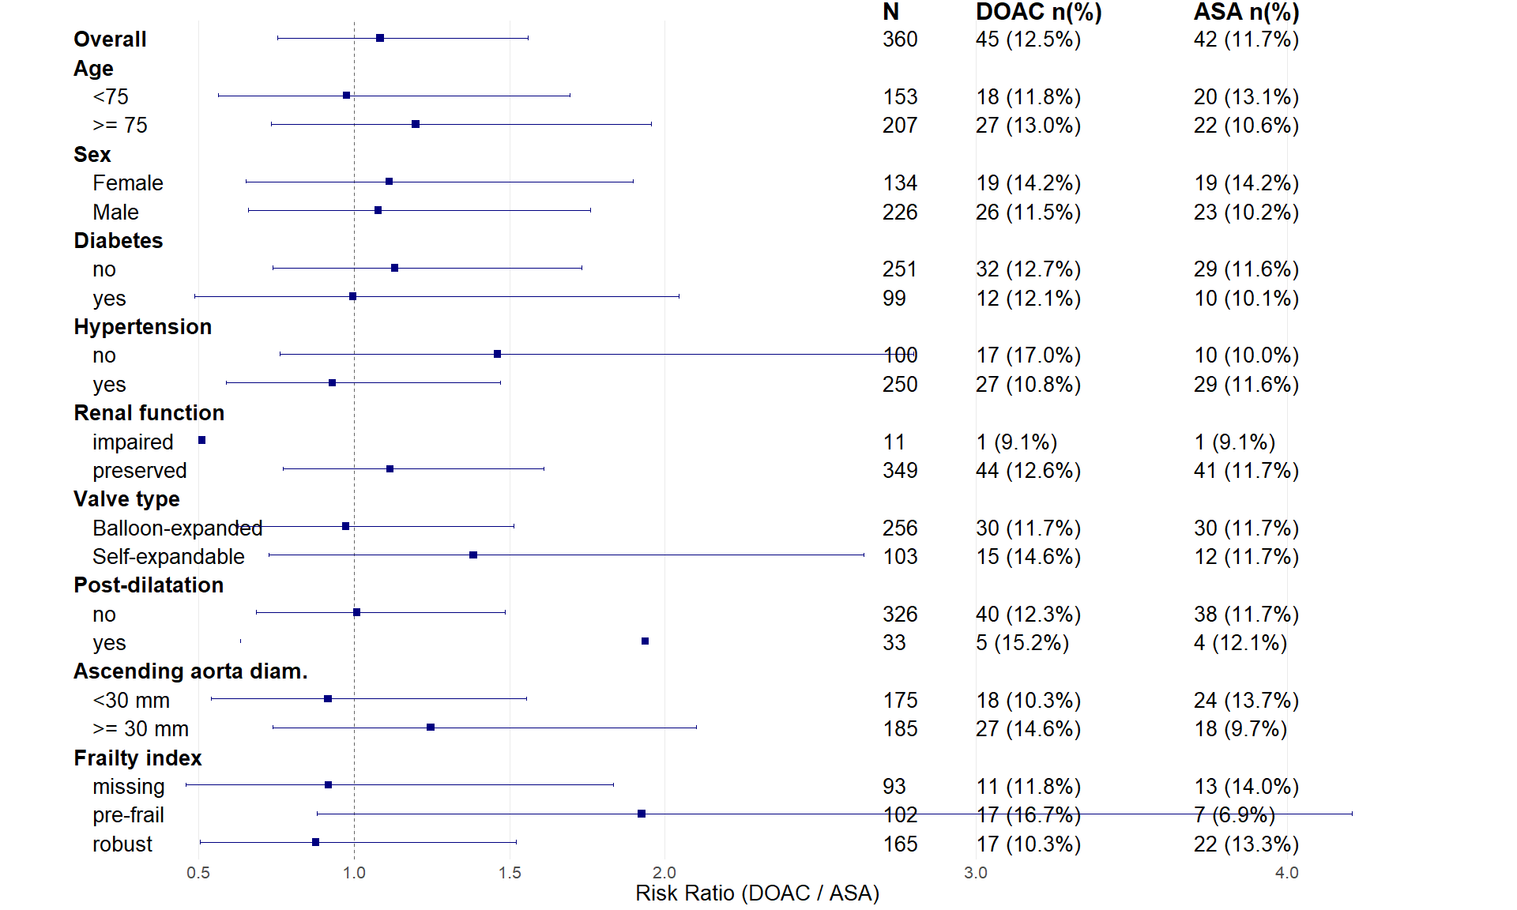
Forest plot of subgroup analyses for HALT.
Subgroups with few participants may get confidence intervals which are too wide to show in the figure above. In those case, check the tables below.
Age subgroups and HALT. Estimated average unadjusted risk ratio, along with corresponding confidence interval.
contrast | age | estimate | 95CI_low | 95CI_high
DOAC / ASA | <75 | 0.977 | 0.563 | 1.694
DOAC / ASA | >= 75 | 1.199 | 0.735 | 1.956
Sex and HALT. Estimated average unadjusted risk ratio, along with corresponding confidence interval.
contrast | sex | estimate | 95CI_low | 95CI_high
DOAC / ASA | Male | 1.079 | 0.661 | 1.760
DOAC / ASA | Female | 1.113 | 0.653 | 1.897
Diabetes and HALT. Estimated average unadjusted risk ratio, along with corresponding confidence interval.
contrast | diabetes | estimate | 95CI_low | 95CI_high
DOAC / ASA | no | 1.132 | 0.740 | 1.732
DOAC / ASA | yes | 0.997 | 0.486 | 2.044
Hypertension and HALT. Estimated average unadjusted risk ratio, along with corresponding confidence interval.
contrast | hypertension | estimate | 95CI_low | 95CI_high
DOAC / ASA | no | 1.462 | 0.763 | 2.800
DOAC / ASA | yes | 0.931 | 0.589 | 1.470
Renal function and HALT. Estimated average unadjusted risk ratio, along with corresponding confidence interval.
contrast | renal function | estimate | 95CI_low | 95CI_high
DOAC / ASA | impaired | 0.512 | 0.048 | 5.473
DOAC / ASA | preserved | 1.116 | 0.773 | 1.611
Valve type and HALT. Estimated average unadjusted risk ratio, along with corresponding confidence interval.
contrast | valve type | estimate | 95CI_low | 95CI_high
DOAC / ASA | Balloon-expanded | 0.974 | 0.626 | 1.514
DOAC / ASA | Self-expandable | 1.384 | 0.727 | 2.638
Post-dilatation and HALT. Estimated average unadjusted risk ratio, along with corresponding confidence interval.
contrast | post-dilatation | estimate | 95CI_low | 95CI_high
DOAC / ASA | no | 1.010 | 0.686 | 1.486
DOAC / ASA | yes | 1.937 | 0.634 | 5.914
Ascending aorta diameter and HALT. Estimated average unadjusted risk ratio, along with corresponding confidence interval.
contrast | ascending aorta diam. | estimate | 95CI_low | 95CI_high
DOAC / ASA | <30 mm | 0.917 | 0.542 | 1.554
DOAC / ASA | >= 30 mm | 1.247 | 0.740 | 2.101
Frailty and HALT. Estimated average unadjusted risk ratio, along with corresponding confidence interval.
contrast | frailty index | estimate | 95CI_low | 95CI_high
DOAC / ASA | robust | 0.877 | 0.506 | 1.521
DOAC / ASA | pre-frail | 1.925 | 0.880 | 4.209
DOAC / ASA | missing | 0.918 | 0.460 | 1.834

Safety composite
These analyses use the treatment variable, the subgroup factor, their interaction, and covariates age, sex, cad, prev_stroke, diabetes, hypertension, GFR.
Multiple imputation with imputation model containing treatment, age, sex, cad, prev_stroke, diabetes, hypertension, GFR.
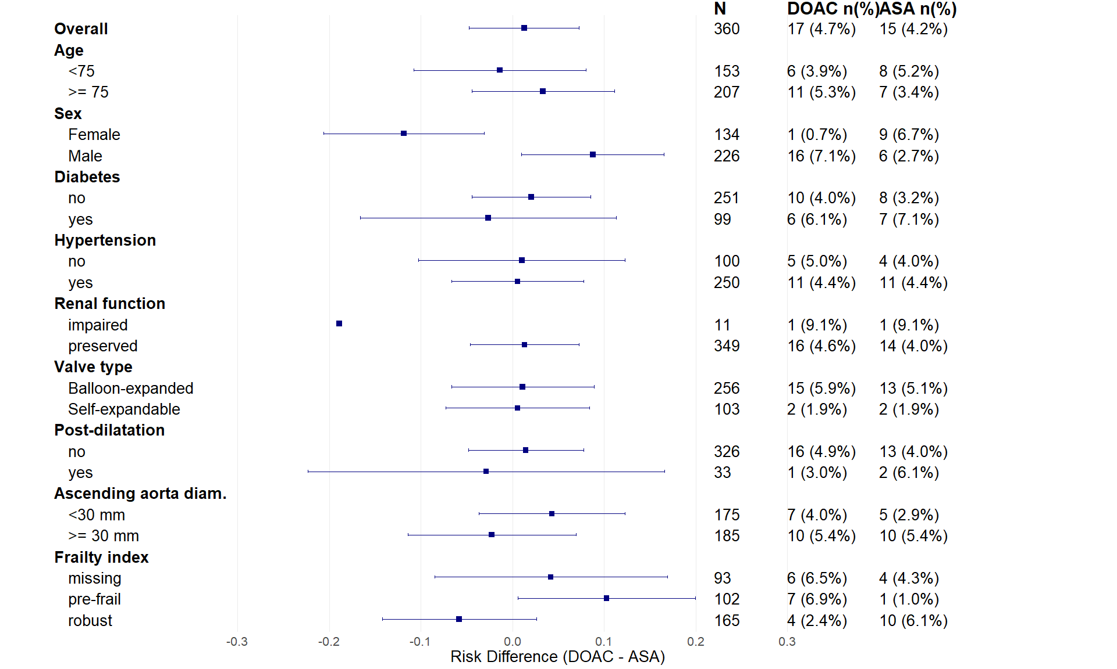
Forest plot of subgroup analyses for safety composite.
Subgroups with few participants may get confidence intervals which are too wide to show in the figure above. In those case, check the tables below.
Age subgroups and safety risk. Estimated average adjusted risk difference, along with corresponding confidence interval.
contrast | age | estimate | 95CI_low | 95CI_high
DOAC - ASA | <75 | -0.014 | -0.108 | 0.080
DOAC - ASA | >= 75 | 0.033 | -0.044 | 0.111
Sex and safety risk. Estimated average adjusted risk difference, along with corresponding confidence interval.
contrast | sex | estimate | 95CI_low | 95CI_high
DOAC - ASA | Male | 0.088 | 0.010 | 0.165
DOAC - ASA | Female | -0.119 | -0.206 | -0.031
Diabetes and safety risk. Estimated average adjusted risk difference, along with correspondin confidence interval.
contrast | diabetes | estimate | 95CI_low | 95CI_high
DOAC - ASA | no | 0.020 | -0.045 | 0.085
DOAC - ASA | yes | -0.027 | -0.166 | 0.113
Hypertension and safety risk. Estimated average adjusted risk difference, along with corresponding confidence interval.
contrast | hypertension | estimate | 95CI_low | 95CI_high
DOAC - ASA | no | 0.010 | -0.102 | 0.123
DOAC - ASA | yes | 0.006 | -0.066 | 0.078
Renal function and safety risk. Estimated average adjusted risk difference, along with corresponding confidence interval.
contrast | renal function | estimate | 95CI_low | 95CI_high
DOAC - ASA | impaired | -0.189 | -0.796 | 0.417
DOAC - ASA | preserved | 0.013 | -0.047 | 0.073
Valve type and safety risk. Estimated average adjusted risk difference, along with corresponding confidence interval.
contrast | valve type | estimate | 95CI_low | 95CI_high
DOAC - ASA | Balloon-expanded | 0.011 | -0.067 | 0.089
DOAC - ASA | Self-expandable | 0.006 | -0.073 | 0.084
Post-dilatation and safety risk. Estimated average adjusted risk difference, along with corresponding confidence interval.
contrast | post-dilatation | estimate | 95CI_low | 95CI_high
DOAC - ASA | no | 0.014 | -0.048 | 0.077
DOAC - ASA | yes | -0.029 | -0.223 | 0.166
Ascending aorta diameter and safety risk. Estimated average adjusted risk difference, along with corresponding confidence interval.
contrast | ascending aorta diam. | estimate | 95CI_low | 95CI_high
DOAC - ASA | <30 mm | 0.043 | -0.036 | 0.122
DOAC - ASA | >= 30 mm | -0.023 | -0.114 | 0.069
Frailty and safety risk. Estimated average adjusted risk difference, along with corresponding confidence interval.
contrast | frailty index | estimate | 95CI_low | 95CI_high
DOAC - ASA | robust | -0.058 | -0.142 | 0.026
DOAC - ASA | pre-frail | 0.103 | 0.006 | 0.199
DOAC - ASA | missing | 0.042 | -0.085 | 0.169

Additional safety analysis
Which numbers and tables do you want to see here? The two first tables are kind of redundant, but the question is whether one should require that the AE is possibly related to study medication or not.

Overview of adverse events, serious adverse events and suspected unexpected serious adverse reaction
Summary of adverse events.
 | DOAC (n=180) | ASA (n=180) | Overall (n=360)
Number of AEs | 260 | 255 | 515
Number of patients with any AEs | 119 (66.1%) | 114 (63.3%) | 233 (64.7%)
Number of patients with one AE | 56 (31.1%) | 43 (23.9%) | 99 (27.5%)
Number of patients with two AE | 27 (15%) | 41 (22.8%) | 68 (18.9%)
Number of patients with three or more AEs | 36 (20%) | 30 (16.7%) | 66 (18.3%)
Number of SAEs | 124 | 113 | 237
Number of patients with any SAEs | 72 (40%) | 67 (37.2%) | 139 (38.6%)
There are no SUSARs in the dataset. No SAE which is unexpected and possibly, probably or definitely related to study medication.

Suspected adverse reactions: AEs and SAEs with a possible, probable or definite relation to study treatments
Summary of adverse events with a possible, probable or definite relation to study treatments.
 | DOAC (n=180) | ASA (n=180) | Overall (n=360)
Number of AEs | 91 | 93 | 184
Number of patients with any AEs | 63 (29.3%) | 65 (30.2%) | 128 (29.8%)
Number of patients with one AE | 44 (24.4%) | 43 (23.9%) | 87 (24.2%)
Number of patients with two AE | 13 (7.2%) | 18 (10%) | 31 (8.6%)
Number of patients with three or more AEs | 6 (3.3%) | 4 (2.2%) | 10 (2.8%)
Number of SAEs | 34 | 33 | 67
Number of patients with any SAEs | 27 (15%) | 26 (14.4%) | 53 (14.7%)
There are no SUSARs in the dataset.

Adverse Events by System Organ Class and Preferred term
Number of AEs and SAEs by system organ class and preferred term.
 |  | AE |  | SAE
System organ class | Preferred term | DOAC | ASA | DOAC | ASA
blood and lymphatic system disorders | anaemia | 1 | 3 | 0 | 2
 | haemolytic anaemia | 0 | 0 | 0 | 1
 | iron deficiency anaemia | 0 | 0 | 1 | 0
cardiac disorders | acute coronary syndrome | 0 | 0 | 0 | 1
 | acute myocardial infarction | 0 | 0 | 2 | 1
 | angina pectoris | 1 | 0 | 0 | 0
 | atrial fibrillation | 11 | 16 | 2 | 2
 | atrial flutter | 3 | 0 | 0 | 0
 | atrioventricular block | 1 | 1 | 2 | 2
 | atrioventricular block complete | 1 | 0 | 4 | 2
 | atrioventricular block first degree | 0 | 0 | 1 | 0
 | atrioventricular block second degree | 0 | 0 | 2 | 1
 | cardiac arrest | 0 | 0 | 1 | 3
 | cardiac failure | 3 | 1 | 7 | 5
 | myocardial infarction | 0 | 0 | 0 | 1
 | nodal rhythm | 1 | 0 | 1 | 0
 | pericardial effusion | 0 | 1 | 1 | 0
 | pericarditis | 0 | 0 | 0 | 1
 | ventricular arrhythmia | 0 | 0 | 1 | 0
 | ventricular tachycardia | 1 | 0 | 2 | 0
ear and labyrinth disorders | sudden hearing loss | 0 | 1 | 0 | 0
 | vertigo positional | 1 | 0 | 1 | 0
endocrine disorders | hypothyroidism | 0 | 1 | 0 | 0
eye disorders | amaurosis fugax | 4 | 0 | 1 | 3
 | blindness | 0 | 1 | 0 | 0
 | conjunctival haemorrhage | 0 | 1 | 0 | 0
 | diplopia | 1 | 1 | 0 | 0
 | vision blurred | 1 | 1 | 0 | 0
 | visual impairment | 2 | 3 | 0 | 0
 | vitreous haemorrhage | 0 | 0 | 0 | 2
gastrointestinal disorders | abdominal pain | 0 | 0 | 2 | 0
 | abdominal pain upper | 0 | 0 | 3 | 1
 | diverticulum intestinal haemorrhagic | 0 | 0 | 0 | 1
 | dry mouth | 0 | 1 | 0 | 0
 | flatulence | 2 | 1 | 0 | 0
 | gastrointestinal haemorrhage | 0 | 0 | 1 | 1
 | gastrooesophageal reflux disease | 0 | 0 | 0 | 1
 | haematochezia | 1 | 0 | 0 | 0
 | ileus | 0 | 0 | 1 | 0
 | intestinal obstruction | 0 | 0 | 1 | 0
 | intestinal pseudo-obstruction | 0 | 0 | 0 | 1
 | melaena | 1 | 0 | 0 | 0
 | mouth haemorrhage | 0 | 2 | 0 | 0
 | nausea | 1 | 2 | 0 | 0
 | oesophagitis | 1 | 1 | 0 | 0
 | pancreatitis acute | 0 | 0 | 1 | 0
 | rectal haemorrhage | 2 | 0 | 1 | 0
general disorders and administration site conditions | chest pain | 2 | 1 | 2 | 10
 | death | 0 | 0 | 2 | 2
 | fatigue | 0 | 1 | 1 | 0
 | fibrosis | 1 | 0 | 0 | 0
 | gait disturbance | 1 | 0 | 0 | 0
 | hernia | 0 | 0 | 1 | 0
 | injection site discomfort | 0 | 0 | 0 | 1
 | paravalvular regurgitation | 0 | 1 | 1 | 2
 | prolapse | 0 | 1 | 0 | 0
 | prosthetic cardiac valve thrombosis | 0 | 0 | 2 | 0
hepatobiliary disorders | cholecystitis | 0 | 0 | 0 | 1
 | cholelithiasis | 0 | 1 | 0 | 0
 | hepatic cirrhosis | 0 | 0 | 0 | 1
 | hepatic fibrosis | 0 | 1 | 0 | 0
immune system disorders | hypersensitivity | 0 | 0 | 0 | 1
infections and infestations | arthritis bacterial | 1 | 0 | 0 | 1
 | cellulitis | 0 | 0 | 2 | 0
 | covid-19 | 0 | 0 | 0 | 2
 | device related infection | 0 | 0 | 0 | 2
 | endocarditis | 0 | 0 | 4 | 7
 | enterococcal infection | 0 | 1 | 0 | 0
 | erysipelas | 1 | 0 | 1 | 1
 | infection | 0 | 0 | 2 | 0
 | localised infection | 0 | 1 | 0 | 0
 | lower respiratory tract infection | 0 | 0 | 2 | 0
 | pharyngitis | 1 | 0 | 0 | 0
 | pneumonia | 2 | 1 | 1 | 3
 | postoperative wound infection | 0 | 1 | 0 | 0
 | pyelonephritis | 0 | 0 | 1 | 1
 | respiratory tract infection | 1 | 0 | 0 | 0
 | septic embolus | 0 | 0 | 1 | 0
 | septic pulmonary embolism | 0 | 0 | 0 | 1
 | septic shock | 0 | 0 | 1 | 0
 | tooth infection | 0 | 2 | 0 | 0
 | urinary tract infection | 2 | 2 | 1 | 1
injury, poisoning and procedural complications | alcohol poisoning | 0 | 0 | 1 | 0
 | ankle fracture | 2 | 0 | 0 | 0
 | cervical vertebral fracture | 0 | 0 | 1 | 0
 | facial bones fracture | 0 | 0 | 1 | 0
 | fall | 2 | 1 | 1 | 1
 | femoral neck fracture | 0 | 0 | 1 | 1
 | forearm fracture | 1 | 0 | 0 | 0
 | ligament rupture | 0 | 1 | 0 | 0
 | limb injury | 1 | 0 | 0 | 0
 | periorbital haematoma | 0 | 0 | 0 | 1
 | post procedural haematoma | 0 | 0 | 1 | 0
 | prescribed overdose | 0 | 0 | 0 | 1
 | skin laceration | 0 | 0 | 1 | 0
 | upper limb fracture | 1 | 0 | 0 | 0
 | vascular pseudoaneurysm | 0 | 0 | 0 | 1
 | wrist fracture | 0 | 0 | 1 | 0
investigations | enterococcus test positive | 0 | 0 | 0 | 1
 | occult blood | 0 | 1 | 0 | 0
metabolism and nutrition disorders | dehydration | 0 | 1 | 0 | 0
 | diabetic ketoacidosis | 0 | 0 | 0 | 1
 | gout | 1 | 1 | 1 | 0
 | hyperglycaemia | 1 | 0 | 2 | 0
 | hypoglycaemia | 0 | 1 | 0 | 0
 | hypomagnesaemia | 0 | 0 | 0 | 1
 | iron deficiency | 1 | 0 | 0 | 0
 | type 2 diabetes mellitus | 0 | 1 | 0 | 1
musculoskeletal and connective tissue disorders | arthralgia | 0 | 1 | 0 | 0
 | arthritis | 0 | 1 | 0 | 1
 | musculoskeletal chest pain | 0 | 0 | 1 | 0
 | osteoarthritis | 0 | 1 | 0 | 0
 | pain in extremity | 1 | 1 | 0 | 0
 | polymyalgia rheumatica | 0 | 0 | 1 | 0
neoplasms benign, malignant and unspecified (incl cysts and polyps) | basal cell carcinoma | 1 | 0 | 0 | 0
 | bladder cancer | 1 | 0 | 0 | 0
 | brain neoplasm | 1 | 0 | 0 | 0
 | breast cancer | 0 | 0 | 0 | 1
 | colorectal adenocarcinoma | 0 | 0 | 0 | 1
 | laryngeal papilloma | 0 | 1 | 0 | 0
 | malignant melanoma | 0 | 0 | 1 | 0
 | metastases to lymph nodes | 0 | 0 | 0 | 1
 | prostate cancer | 0 | 1 | 0 | 0
 | rectosigmoid cancer | 0 | 0 | 0 | 1
 | renal neoplasm | 0 | 1 | 0 | 0
nervous system disorders | amnesia | 0 | 0 | 0 | 1
 | balance disorder | 0 | 2 | 0 | 0
 | cerebral artery embolism | 0 | 0 | 0 | 1
 | cerebral haemorrhage | 0 | 0 | 2 | 0
 | cerebral infarction | 1 | 0 | 0 | 2
 | cerebrovascular accident | 0 | 0 | 2 | 1
 | dizziness | 20 | 25 | 1 | 1
 | embolic cerebral infarction | 0 | 0 | 0 | 1
 | epilepsy | 0 | 0 | 2 | 0
 | hyposmia | 0 | 1 | 0 | 0
 | lethargy | 0 | 1 | 0 | 0
 | migraine | 0 | 1 | 0 | 0
 | presyncope | 0 | 1 | 2 | 0
 | seizure | 0 | 0 | 1 | 0
 | syncope | 3 | 2 | 4 | 2
 | transient ischaemic attack | 0 | 0 | 5 | 1
 | tremor | 1 | 1 | 0 | 0
 | vascular dementia | 1 | 0 | 0 | 1
psychiatric disorders | autoscopy | 1 | 0 | 0 | 0
 | confusional state | 0 | 0 | 1 | 0
 | delirium | 0 | 0 | 1 | 0
renal and urinary disorders | acute kidney injury | 1 | 0 | 0 | 0
 | haematuria | 6 | 4 | 1 | 0
 | nephrolithiasis | 1 | 0 | 0 | 0
 | nephrotic syndrome | 0 | 0 | 1 | 0
 | renal failure | 0 | 1 | 0 | 0
 | urinary retention | 1 | 0 | 1 | 0
reproductive system and breast disorders | gynaecomastia | 1 | 0 | 0 | 0
 | uterine prolapse | 1 | 0 | 0 | 0
respiratory, thoracic and mediastinal disorders | acute pulmonary oedema | 0 | 1 | 0 | 0
 | chronic obstructive pulmonary disease | 0 | 0 | 3 | 0
 | dyspnoea | 1 | 1 | 1 | 0
 | emphysema | 1 | 0 | 0 | 0
 | epistaxis | 19 | 16 | 0 | 0
 | haemoptysis | 1 | 0 | 0 | 0
 | hypersensitivity pneumonitis | 0 | 1 | 0 | 0
 | pleural effusion | 2 | 1 | 0 | 0
 | productive cough | 1 | 0 | 0 | 0
 | pulmonary embolism | 0 | 1 | 0 | 0
 | pulmonary oedema | 1 | 0 | 0 | 0
 | sleep apnoea syndrome | 0 | 1 | 0 | 0
skin and subcutaneous tissue disorders | decubitus ulcer | 0 | 0 | 1 | 0
 | petechiae | 0 | 0 | 1 | 0
 | pruritus | 0 | 1 | 0 | 0
 | rash | 0 | 1 | 0 | 0
 | skin haemorrhage | 1 | 1 | 0 | 0
surgical and medical procedures | appendicectomy | 0 | 0 | 1 | 0
 | cardiac pacemaker insertion | 0 | 0 | 7 | 13
 | cardiac resynchronisation therapy | 0 | 0 | 1 | 0
 | cataract operation | 0 | 1 | 0 | 0
 | cholecystectomy | 0 | 0 | 0 | 1
 | colectomy | 0 | 0 | 1 | 0
 | hip arthroplasty | 0 | 0 | 0 | 1
 | large intestinal polypectomy | 0 | 1 | 0 | 0
 | mole excision | 0 | 1 | 0 | 0
 | orchidectomy | 0 | 1 | 0 | 0
 | percutaneous coronary intervention | 0 | 0 | 1 | 1
 | skin neoplasm excision | 0 | 1 | 0 | 0
 | spinal laminectomy | 0 | 0 | 1 | 0
 | transurethral bladder resection | 1 | 0 | 0 | 0
vascular disorders | aortic aneurysm | 0 | 0 | 1 | 0
 | deep vein thrombosis | 1 | 1 | 0 | 0
 | embolism | 0 | 0 | 0 | 1
 | haematoma | 1 | 1 | 1 | 0
 | haemorrhage | 0 | 0 | 0 | 1
 | hypertension | 1 | 1 | 0 | 0
 | hypotension | 0 | 3 | 0 | 1
 | peripheral arterial occlusive disease | 0 | 0 | 1 | 0
 | thrombophlebitis superficial | 1 | 0 | 0 | 0
 | thrombosis | 0 | 1 | 0 | 0
 | vasculitis | 0 | 0 | 1 | 0

