Statistical report for ACASA-TAVI
  - AntiCoagulation versus AcetylSalicylic Acid after Transcatheter Aortic Valve Implantation
C. Cunen
08 juni 2026
Table of Contents

Introduction
The ACASA-TAVI study is a prospective investigation of losartan as an adjunctive therapy for patients with glioblastoma. According to Protocol Version 7.0 (17-Dec-2024), the trial collects comprehensive demographic, clinical, imaging, and quality-of-life information prior to treatment initiation.
This report summarises the currently available baseline data with emphasis on clinical status, imaging assessments, and prior treatments that may influence subsequent outcomes.
The safety analysis is based on the Safety Analysis Set including all subjects with any safety information after baseline (N=53). Patients randomised to hydroxychloroquine without receiving any amount of the treatment will be excluded from the safety population (nobody was excluded based on that condition). The primary efficacy analysis is based on the Full Analysis Set (FAS) including all randomised subjects who have had at least one baseline and one post-randomisation evaluation of efficacy (N=51). The secondary efficacy analysis is based on the Per Protocol Set including all participants of the FAS who took at least 7 of the 8 first hydroxychloroquine doses (N=49) Analysis according to final SAP version 2.1, dated 28.05.2020 Data extraction Viedoc electronic data capture system, time stamped: 26.05.2020 12:06 UTC
The aim of this document is to produce tables and figures to be included into the article as requested by email from Merete Hetland 10 December 2019. The analyses are prespecified in the Statistical Analysis Plan (SAP) dated 2nd of September 2019, and the locked database with an update received on the 10th of December dated 26th of October 2019.

Randomisation Status
The present dataset is built on sham randomisation generated from the most recent export from Viedoc. No true treatment assignments have been unlocked. All findings in this document should therefore be interpreted as preliminary and descriptive only. Final efficacy comparisons will not be conducted until the database is locked and genuine randomisation codes are used.

Data preparations
The data have been further prepared in accordance with the SAP, except for the imputation of missing baseline Body Mass Index (BMI) for two trial subjects. They have been imputed with the median BMI value among all other ITT subjects. This imputation is not described in the SAP.

Specifications to the analyses
For the continuous CRP and ESR parameters, I have fitted a generalized linear mixed gamma model due to skewness. This model gave the best fit according to Akaike’s Information Criterion over a standard linear mixed model and a generalized linear mixed lognormal model. For the joint count variables I fitted a generalised linear mixed negative binomial model over a corresponding poisson model due to overdispersion. All these specification are according to the analysis plan.

Patient enrolment and disposition

Trial population
The following table summarizes the number of patients that were screened (?), that were eligible and randomized, that received the treatment and that were lost to follow-up, as well as the number of patients included in the analyses. This table should be used to fill in the CONSORT diagram (??).
Counts
description | n
Assessed at screening
Eligible at screening
Ineligible at screening
Eligible and randomised | 359
Eligible not randomised
Randomized but ineligible | 1
Non-completers | 24
Randomised and FAS | 360
Randomised and FAS with primary efficacy endpoint | 334
Randomised and FAS with primary safety endpoint | 257

Patient disposition (reasons for non-completion)
Overview of study completion and reasons for non-completion. The counts of “Study completed” which are neither “Yes” nor “No” are participants who have not had their final visit yet.
Overview of study completion and reasons for non-completion
 | DOAC | ASA | Total
Number of randomised participants | 180 | 180 | 360
Study completed
No | 14 | 10 | 24
Yes | 166 | 170 | 336
Reason for discontinuation
Voluntary discontinuation by patient | 4 | 5 | 9
Incorrect randomisation | 1 | 0 | 1
Non-compliance | 1 | 0 | 1
Death | 7 | 5 | 12
Other | 1 | 0 | 1

Timing of end of study, withdrawals and follow ups
Time from randomisation to end of study and time from randomisation to withdrawal/lost to follow-up is summarized by median and min-max, overall and by treatment group.
Length of study by treatment groups
 | DOAC | ASA | Overall
All participants | 361 (0-510) | 357 (1-440) | 358.5 (0-510)
Non-completers | 31 (0-363) | 183.5 (1-271) | 121 (0-363)

Protocol deviations
Number of major and minor protocol deviations, summarized by treatment group with details of type of deviation provided.
Number of minor protocol deviations
Treatment | Category of PD | n
DOAC | Incorrect treatment and/or dose | 2
DOAC | Prohibited concomitant medication | 3
DOAC | Failure to collect important data | 6
DOAC | Serious breach - Other | 1
DOAC | Other | 10
ASA | Prohibited concomitant medication | 3
ASA | Failure to collect important data | 4
ASA | Serious breach - SAE notification / safety procedure | 2
ASA | Other | 8
There are currently no PD that are categorised as “major”.
Number of major protocol deviations
Treatment | Category of PD | n

Adherence to allocated treatment
Number of patients participants switching between ASA and DOAC or stopping the treatment altogether (so far - final data could reveal more switches), by treatment group and in total.
Number of participants switching or stopping.
 | No change in study drug | Switching | Stopping
DOAC | 156 | 17 | 7
ASA | 157 | 19 | 4
Total | 313 | 36 | 11

Analysis sets
The FAS includes all participants. The SAS is the same as the FAS. The PP includes all participants except – non-completers that did not die (voluntary discontinuation mostly) – participants with important protocol deviations – participants switching between ASA and DOAC or stopping the treatment altogether.
Number of participants in the different analysis sets.
 | Full analysis set | Safety analysis set | Per protocol set
DOAC | 180 | 178 | 152
ASA | 180 | 179 | 153
Total | 360 | 357 | 305

Demographics and baseline characteristics

Table for abstract (May 2026)
Baseline characteristics for all 360 participants. Continuous variables are summarised by mean (SD), or by median (IQR) as indicated.
Age (years) | 74.5 (3.7)
Sex, female | 37%
Body mass index (kg/m^2) | 28.1 (4.7)
Coronary artery disease | 24%
Hypertension | 71%
Diabetes mellitus | 28%
Previous stroke | 11%
Permanent pacemaker | 2%
Chronic obstructive pulmonary disease | 14%
Troponin T (ng/L) | 16 (11 - 28)
NT-proBNP (ng/L) | 413 (197 - 812)
Glomerular filtration rate (mL/min/1 1.73 m^2) | 75 (18.4)
Pre-TAVI echocardiography parameters
Left ventricular ejection fraction (%) | 53.6 (7.7)
Aortic valve mean gradient (mmHg) | 49.6 (12.6)
Aortic valvular area (cm^2) | 0.8 (0.2)
Procedural characteristics
Balloon-expanded valve | 71%
Self-expandable valve | 29%

Demographics and medical history
Demographics and medical history.
Characteristic | DOAC(n=180) | ASA(n=180) | Overall (n=360)
Age (years) | 74.4 (3.7) | 74.5 (3.7) | 74.5 (3.7)
Sex, n (%)
Male | 115 (63.9%) | 111 (61.7%) | 226 (62.8%)
Female | 65 (36.1%) | 69 (38.3%) | 134 (37.2%)
Hypertension, n (%)
Yes | 124 (70.9%) | 126 (72%) | 250 (71.4%)
Missing | 5 (2.8%) | 5 (2.8%) | 10 (2.8%)
Coronary artery disease, n (%)
Yes | 36 (20.6%) | 47 (26.9%) | 83 (23.7%)
Missing | 5 (2.8%) | 5 (2.8%) | 10 (2.8%)
Diabetes mellitus, n (%)
Yes | 54 (30.9%) | 45 (25.7%) | 99 (28.3%)
Missing | 5 (2.8%) | 5 (2.8%) | 10 (2.8%)
Chronic obstructive pulmonary disease, n (%)
Yes | 26 (14.9%) | 22 (12.6%) | 48 (13.7%)
Missing | 5 (2.8%) | 5 (2.8%) | 10 (2.8%)
Previous stroke, n (%)
Yes | 19 (10.9%) | 21 (12%) | 40 (11.4%)
Missing | 5 (2.8%) | 5 (2.8%) | 10 (2.8%)
Permanent pacemaker
Yes | 5 (2.9%) | 3 (1.7%) | 8 (2.3%)
Missing | 5 (2.8%) | 5 (2.8%) | 10 (2.8%)
Smoking status, n (%)
Never smoked | 59 (32.8%) | 66 (36.7%) | 125 (34.7%)
Has stopped | 94 (52.2%) | 91 (50.6%) | 185 (51.4%)
Sometimes | 1 (0.6%) | 1 (0.6%) | 2 (0.6%)
Daily | 26 (14.4%) | 22 (12.2%) | 48 (13.3%)

Vital signs and physical characteristics at baseline
Vital signs and physical characteristics at baseline.
Characteristic | DOAC(n=180) | ASA(n=180) | Overall (n=360)
Weight (kg) | 84.3 (16.2) | 84.9 (15.9) | 84.6 (16)
Height (cm) | 173.8 (9.3) | 173 (9) | 173.4 (9.1)
Body mass index (kg/m2) | 27.9 (4.9) | 28.3 (4.5) | 28.1 (4.7)
Systolic blood pressure (mmHg) | 137 (19.1) | 143.6 (22) | 140.3 (20.8)
Diastolic blood pressure (mmHg) | 71.9 (9.8) | 71.9 (10.4) | 71.9 (10.1)
Body temperature (C) | 36.7 (0.4) | 36.7 (0.4) | 36.7 (0.4)
Pulse rate (beats/min) | 74.7 (14.6) | 73 (11.6) | 73.8 (13.2)
Respiratory rate (breaths/min) | 16.9 (2.9) | 16.8 (2.2) | 16.8 (2.5)
Mini-Cog
Signs of cognitive impairment (0-2) | 15 (9.3%) | 11 (6.9%) | 26 (8.1%)
No cognitive impairment (3-5) | 147 (90.7%) | 148 (93.1%) | 295 (91.9%)
Missing | 18 (10%) | 21 (11.7%) | 39 (10.8%)
Five times sit-to-stand
< 15 sec | 115 (83.3%) | 109 (79.6%) | 224 (81.5%)
>= 15 sec | 23 (16.7%) | 28 (20.4%) | 51 (18.5%)
Missing | 42 (23.3%) | 43 (23.9%) | 85 (23.6%)
Frailty, n (%)
Robust | 75 (41.7%) | 90 (50%) | 165 (45.8%)
Pre-frail | 59 (32.8%) | 43 (23.9%) | 102 (28.3%)
Frail | 0 (0%) | 0 (0%) | 0 (0%)
Missing | 46 (25.6%) | 47 (26.1%) | 93 (25.8%)

Clinical chemistry and hematology at baseline
Some results related to clinical chemistry and hematology at baseline.
Characteristic | DOAC(n=180) | ASA(n=180) | Overall (n=360)
Hemoglobin | 13.4 (1.6) | 13.7 (1.6) | 13.6 (1.6)
Platelets | 220.1 (61.7) | 232.9 (67) | 226.5 (64.7)
Leukocytes | 7.2 (6.1 - 8.6) | 7.4 (6.5 - 8.7) | 7.3 (6.3 - 8.7)
International Normalized Ratio (INR) | 1.1 (0.1) | 1 (0.1) | 1.1 (0.1)
Sodium | 139.5 (2.7) | 139.6 (2.8) | 139.6 (2.7)
Potassium | 4.1 (0.4) | 4 (0.4) | 4.1 (0.4)
ALT | 25.3 (13.3) | 27.6 (13.9) | 26.4 (13.6)
Cardiac troponin T | 17 (11.8 - 27.8) | 15 (11 - 28) | 16 (11 - 28)
NT-proBNP | 431 (216 - 815) | 372 (177 - 779) | 413 (197 - 812)
GFR | 73.6 (19.6) | 76.3 (17.1) | 75 (18.4)
Glucose | 6.8 (2) | 6.8 (2.2) | 6.8 (2.1)
Glycated haemoglobin (HbA1c) | 42.2 (9.3) | 42 (9.9) | 42.1 (9.6)
Triglycerides | 1.6 (0.9) | 1.5 (0.7) | 1.5 (0.8)
Missing | 6 (3.3%) | 4 (2.2%) | 10 (2.8%)
Total cholesterol | 4.2 (1.1) | 4.3 (1.1) | 4.2 (1.1)
HDL cholesterol | 1.4 (0.4) | 1.5 (0.5) | 1.4 (0.5)
LDL cholesterol | 2.2 (0.9) | 2.3 (0.9) | 2.3 (0.9)
Creatinine | 92.2 (46.8) | 84.8 (29.4) | 88.5 (39.2)
Albumin | 42.7 (3.8) | 43 (2.8) | 42.9 (3.3)
Missing | 6 (3.3%) | 4 (2.2%) | 10 (2.8%)
Bilirubin | 8.9 (4.5) | 9.9 (5.6) | 9.4 (5.1)
Missing | 6 (3.3%) | 4 (2.2%) | 10 (2.8%)
CRP | 1.6 (0.8 - 4) | 1.4 (0.7 - 3.3) | 1.5 (0.8 - 3.8)

Echocardiography pre-TAVI and at baseline
Some echocardiography parameters pre-TAVI.
Characteristic | DOAC(n=180) | ASA(n=180) | Overall (n=360)
Aortic valve mean gradient (mmHg) | 49.4 (13.2) | 49.9 (12) | 49.6 (12.6)
LVOT (mm) | 22.7 (1.8) | 22.3 (1.9) | 22.5 (1.9)
Presence of low-flow low-gradient | 9 (5.3%) | 9 (5.3%) | 18 (5.3%)
Left ventricular ejection fraction (%) | 52.9 (7.6) | 54.4 (7.8) | 53.6 (7.7)
Left ventricular global longitudinal strain (%) | -15.2 (3.4) | -16.4 (8.9) | -15.8 (6.7)
Stroke volume (mL) | 83.7 (19.8) | 86 (22.5) | 84.9 (21.2)
Stroke volume index (mL per m^2) | 40.5 (12.6) | 41.1 (14.1) | 40.8 (13.3)
Aortic valvular area (cm^2) | 0.8 (0.2) | 0.8 (0.2) | 0.8 (0.2)
Aortic valve regurgitation | 108 (63.5%) | 105 (61.4%) | 213 (62.5%)
Missing echocardiography | 9 (5%) | 9 (5%) | 18 (5%)
Some echocardiography parameters at baseline (post-TAVI).
Characteristic | DOAC(n=180) | ASA(n=180) | Overall (n=360)
Aortic valve mean gradient (mmHg) | 13 (4.9) | 13.1 (4.7) | 13.1 (4.8)
LVOT (mm) | 21.4 (2) | 21.2 (2) | 21.3 (2)
Presence of low-flow low-gradient | 24 (19%) | 22 (17.2%) | 46 (18.1%)
Left ventricular ejection fraction (%) | 57.7 (9) | 55.9 (12) | 56.8 (10.7)
Left ventricular global longitudinal strain (%) | -15.7 (3.4) | -15.6 (3.4) | -15.6 (3.4)
Stroke volume (mL) | 83 (14.7) | 82.8 (20.4) | 82.9 (17.7)
Stroke volume index (mL per m^2) | 41.3 (7) | 41.3 (9.2) | 41.3 (8.2)
Aortic valvular area (cm^2) | 1.9 (0.4) | 1.9 (0.5) | 1.9 (0.4)
Aortic valve regurgitation | 41 (32.5%) | 40 (31.2%) | 81 (31.9%)
Missing echocardiography | 58 (32.2%) | 55 (30.6%) | 113 (31.4%)

Characteristics of the TAVI procedure
Characteristics of the TAVI procedure.
Characteristic | DOAC(n=180) | ASA(n=180) | Overall (n=360)
TAVI valve type, n (%)
Balloon-expanded | 130 (72.6%) | 126 (70%) | 256 (71.3%)
Self-expandable | 49 (27.4%) | 54 (30%) | 103 (28.7%)
TAVI post-dilatation, n (%)
Yes | 13 (7.3%) | 20 (11.1%) | 33 (9.2%)
No | 166 (92.7%) | 160 (88.9%) | 326 (90.8%)
TAVI supra-valvular prothesis position, n (%)
Yes | 46 (25.7%) | 54 (30%) | 100 (27.9%)
No | 133 (74.3%) | 126 (70%) | 259 (72.1%)
Ascending aorta diameter (mm) | 30.5 (4) | 29.6 (3.8) | 30.1 (3.9)
Missing | 0 (0%) | 0 (0%) | 0 (0%)

Change in baseline characteristics
Some baseline variables are measured again at 12 months. Do you want a table looking at the change in these values? Not here maybe

Primary endpoints

Primary efficacy endpoint

Descriptive statistics
Also by site?
Descriptive statistics for HALT (primary efficacy endpoint). Counts and proportions.
 | DOAC | ASA | Overall
No thickening | 127 | 133 | 260
<=25% of leaflet | 20 | 16 | 36
>25-50 % of leaflet | 13 | 9 | 22
>50-75 % of lealet | 2 | 5 | 7
>75 % of leaflet | 3 | 6 | 9
Missing HALT | 15 | 11 | 26
Death | 7 | 5 | 12
Total HALT | 38 (23%) | 36 (21.3%) | 74 (22.2%)
Total HALT & Death | 45 (26.2%) | 41 (23.8%) | 86 (25%)

Unadjusted analysis with multiple imputation
Multiple imputation with imputation model containing sex, hemoglobin, potassium, bmi, sodium and LDL cholesterol. So the model does not use the treatment variable (to stay more or less in-line with the protocol). But the analysis model only uses the treatment variable and no other covariates.
Estimated average unadjusted risk difference, along with corresponding p-value and confidence interval.
contrast | estimate | SE | p.value | 95CI_low | 95CI_high
ASA - DOAC | -0.027 | 0.047 | 0.570 | -0.119 | 0.066

Unadjusted analysis, complete-cases
Dropping participants with missing HALT value (ie. dropping 16 observations - remember that some participants with missing HALT are dead and so are counted as ‘events’ in this analysis).
Estimated average unadjusted risk difference, along with corresponding p-value and confidence interval.
contrast | estimate | SE | p.value | 95CI_low | 95CI_high
ASA - DOAC | -0.023 | 0.047 | 0.618 | -0.115 | 0.068

Adjusted analysis with multilple imputation
Multiple imputation with imputation model containing sex, hemoglobin, potassium, bmi, sodium and LDL cholesterol. So the model does not use the treatment variable (to stay more or less in-line with the protocol). The analysis model uses the covariates listed above and the treatment variable in addition.
Estimated average adjusted risk difference, along with corresponding p-value and confidence interval.
contrast | estimate | SE | p.value | 95CI_low | 95CI_high
ASA - DOAC | -0.011 | 0.046 | 0.814 | -0.101 | 0.080

Adjusted analysis, complete-cases
Dropping participants with missing HALT value (ie. dropping 16 observations - remember that some participants with missing HALT are dead and so are counted as ‘events’ in this analysis).
Fitted model.
 | estimate | SE | p.value
(Intercept) | -15.69 | 7.55 | 0.04
ran_trtASA | -0.07 | 0.26 | 0.80
sexFemale | 0.67 | 0.29 | 0.02
hemoglobin | 0.16 | 0.09 | 0.08
potassium | 0.87 | 0.37 | 0.02
bmi | -0.10 | 0.03 | 0.00
sodium | 0.08 | 0.05 | 0.10
LDLchol | -0.15 | 0.15 | 0.31
Distribution of risk differences for all study participants.
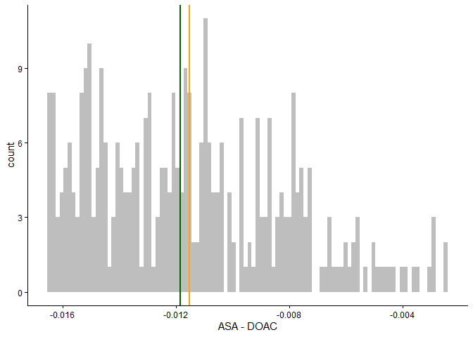
Distribution of risk difference for all study participants. Mean risk difference in orange. Median in green.
Estimated average adjusted risk difference, along with corresponding p-value and confidence interval.
contrast | estimate | SE | p.value | 95CI_low | 95CI_high
ASA - DOAC | -0.012 | 0.046 | 0.801 | -0.101 | 0.078
Estimated average adjusted risk ratio, along with corresponding p-value and confidence interval.
contrast | estimate | p.value | 95CI_low | 95CI_high
ASA/DOAC | 0.955 | 0.801 | 0.667 | 1.367

Primary safety endpoint

Descriptive statistics
Also by site?
Descriptive statistics for primary safety endpoint. Counts and proportions.
 | DOAC | ASA | Overall
No safety events | 112 | 117 | 229
bleeding | 2 | 3 | 5
death | 6 | 5 | 11
mi | 2 | 2 | 4
stroke | 4 | 4 | 8
Missing | 54 | 49 | 103
Total safety event | 14 (11.1%) | 14 (10.7%) | 28 (10.9%)
Out of the 28 safety events, 9 happen in patients that also switch between the treatments at some point. Among these 9 patients: 6 experience the safety event before switching, while 3 experience the safety event after switching.
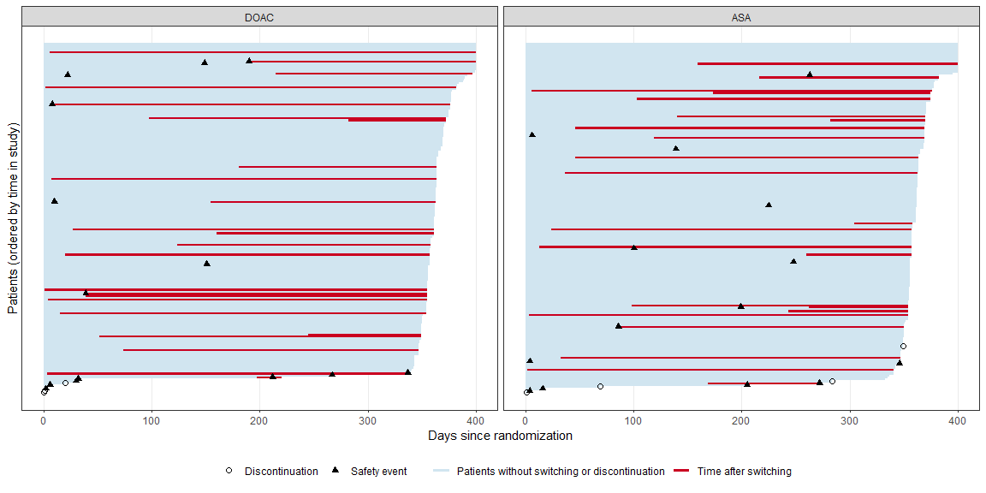
All patients
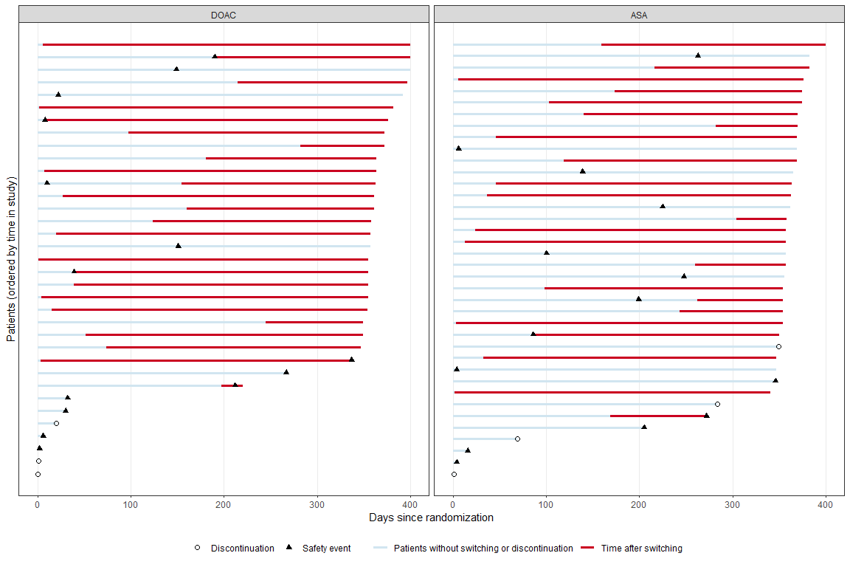
Patients with safety events and/or switching and discontinuation
In this figure there are 46 switches and 7 discontinuations, and these number may seem to bit slightly at odds with the numbers presented in Table 2.6. But that’s actually just because what is called “switches” here in fact includes both “switches and stops” in Table 2.6.

Unadjusted analysis with multiple imputation, treatment policy strategy
Multiple imputation with imputation model containing no covariates (so using only the overall event rate, to stay more or less in-line with the protocol). The analysis model uses the treatment variable and no other covariates.
Estimated average unadjusted risk difference, along with corresponding p-value and confidence interval.
contrast | estimate | SE | p.value.nonsup | 95CI_low | 95CI_high
DOAC - ASA | 0.001 | 0.040 | 0.000 | -0.077 | 0.080

Unadjusted analysis, complete-cases, treatment policy strategy
Discuss margin (in protocol it says 11.9%, but that seems a bit wide maybe)
Estimated average unadjusted risk difference, along with corresponding p-value (for non-inferiority test) and confidence interval.
contrast | estimate | SE | p.value.nonsup | 95CI_low | 95CI_high
DOAC - ASA | 0.004 | 0.039 | 0.002 | -0.072 | 0.080

Key secondary endpoints

Clinical efficacy

Thromboembolic events

Bleeding events

All-cause mortality

Secondary safety endpoints

Additional safety analysis
Which numbers and tables do you want to see here?

Overview of adverse events, serious adverse events and suspected unexpected serious adverse reaction
Summary of adverse events.
 | DOAC (n=180) | ASA (n=180) | Overall (n=360)
Number of AEs | 260 | 254 | 514
Number of patients with any AEs | 119 (66.1%) | 113 (62.8%) | 232 (64.4%)
Number of patients with one AE | 56 (31.1%) | 42 (23.3%) | 98 (27.2%)
Number of patients with two AE | 27 (15%) | 41 (22.8%) | 68 (18.9%)
Number of patients with three or more AEs | 36 (20%) | 30 (16.7%) | 66 (18.3%)
Number of SAEs | 124 | 113 | 237
Number of patients with any SAEs | 72 (40%) | 67 (37.2%) | 139 (38.6%)
Number of SUSARs | 8 | 1 | 9
Number of patients with any SUSARs | 8 (4.4%) | 1 (0.6%) | 9 (2.5%)

Adverse events of special interest
Number of adverse events of special interest by system organ class and preferred term.
System organ class | Preferred term | DOAC | ASA
general disorders and administration site conditions | paravalvular regurgitation | 0 | 1
skin and subcutaneous tissue disorders | petechiae | 1 | 0

Maximal intensity and causal relationships of AEs and SAEs to acetylsalicylic acid
Number of adverse events by categories of intensity and causal relationship to acetylsalicylic acid.
intensity | Unrelated | Unlikely | Possible | Probable | Definite
Mild | 15 | 43 | 20 | 5 | 0
Moderate | 40 | 24 | 14 | 6 | 0
Severe | 33 | 13 | 13 | 5 | 0

Maximal intensity and causal relationships of AEs and SAEs to apixaban
Number of adverse events by categories of intensity and causal relationship to apixaban.
intensity | Unrelated | Unlikely | Possible | Probable | Definite
Mild | 14 | 33 | 19 | 4 | 0
Moderate | 12 | 15 | 7 | 3 | 0
Severe | 15 | 7 | 8 | 1 | 0

Maximal intensity and causal relationships of AEs and SAEs to edoxaban
Number of adverse events by categories of intensity and causal relationship to edoxaban.
intensity | Unrelated | Unlikely | Possible | Probable | Definite
Mild | 2 | 13 | 27 | 7 | 0
Moderate | 12 | 21 | 6 | 4 | 0
Severe | 12 | 8 | 3 | 0 | 0

Maximal intensity and causal relationships of AEs and SAEs to rivaroxaban
Number of adverse events by categories of intensity and causal relationship to rivaroxaban.
intensity | Unrelated | Unlikely | Possible | Probable | Definite
Mild | 0 | 3 | 5 | 2 | 0
Moderate | 3 | 3 | 3 | 3 | 0
Severe | 1 | 1 | 0 | 0 | 0

Adverse Events by System Organ Class and Preferred term
Number of AEs and SAEs by system organ class and preferred term.
 |  | AE |  | SAE
System organ class | Preferred term | DOAC | ASA | DOAC | ASA
blood and lymphatic system disorders | anaemia | 1 | 3 | 0 | 2
 | haemolytic anaemia | 0 | 0 | 0 | 1
 | iron deficiency anaemia | 0 | 0 | 1 | 0
cardiac disorders | acute coronary syndrome | 0 | 0 | 0 | 1
 | acute myocardial infarction | 0 | 0 | 2 | 1
 | angina pectoris | 1 | 0 | 0 | 0
 | atrial fibrillation | 11 | 16 | 2 | 2
 | atrial flutter | 3 | 0 | 0 | 0
 | atrioventricular block | 1 | 1 | 2 | 2
 | atrioventricular block complete | 1 | 0 | 4 | 2
 | atrioventricular block first degree | 0 | 0 | 1 | 0
 | atrioventricular block second degree | 0 | 0 | 2 | 1
 | cardiac arrest | 0 | 0 | 1 | 3
 | cardiac failure | 3 | 1 | 7 | 5
 | myocardial infarction | 0 | 0 | 0 | 1
 | nodal rhythm | 1 | 0 | 1 | 0
 | pericardial effusion | 0 | 1 | 1 | 0
 | pericarditis | 0 | 0 | 0 | 1
 | ventricular arrhythmia | 0 | 0 | 1 | 0
 | ventricular tachycardia | 1 | 0 | 2 | 0
ear and labyrinth disorders | sudden hearing loss | 0 | 1 | 0 | 0
 | vertigo positional | 1 | 0 | 1 | 0
endocrine disorders | hypothyroidism | 0 | 1 | 0 | 0
eye disorders | amaurosis fugax | 4 | 0 | 1 | 3
 | blindness | 0 | 1 | 0 | 0
 | conjunctival haemorrhage | 0 | 1 | 0 | 0
 | diplopia | 1 | 1 | 0 | 0
 | vision blurred | 1 | 1 | 0 | 0
 | visual impairment | 2 | 3 | 0 | 0
 | vitreous haemorrhage | 0 | 0 | 0 | 2
gastrointestinal disorders | abdominal pain | 0 | 0 | 2 | 0
 | abdominal pain upper | 0 | 0 | 3 | 1
 | diverticulum intestinal haemorrhagic | 0 | 0 | 0 | 1
 | dry mouth | 0 | 1 | 0 | 0
 | flatulence | 2 | 1 | 0 | 0
 | gastrointestinal haemorrhage | 0 | 0 | 1 | 1
 | gastrooesophageal reflux disease | 0 | 0 | 0 | 1
 | haematochezia | 1 | 0 | 0 | 0
 | ileus | 0 | 0 | 1 | 0
 | intestinal obstruction | 0 | 0 | 1 | 0
 | intestinal pseudo-obstruction | 0 | 0 | 0 | 1
 | melaena | 1 | 0 | 0 | 0
 | mouth haemorrhage | 0 | 2 | 0 | 0
 | nausea | 1 | 2 | 0 | 0
 | oesophagitis | 1 | 1 | 0 | 0
 | pancreatitis acute | 0 | 0 | 1 | 0
 | rectal haemorrhage | 2 | 0 | 1 | 0
general disorders and administration site conditions | chest pain | 2 | 1 | 2 | 10
 | death | 0 | 0 | 2 | 2
 | fatigue | 0 | 1 | 1 | 0
 | fibrosis | 1 | 0 | 0 | 0
 | gait disturbance | 1 | 0 | 0 | 0
 | hernia | 0 | 0 | 1 | 0
 | injection site discomfort | 0 | 0 | 0 | 1
 | paravalvular regurgitation | 0 | 1 | 1 | 2
 | prolapse | 0 | 1 | 0 | 0
 | prosthetic cardiac valve thrombosis | 0 | 0 | 2 | 0
hepatobiliary disorders | cholecystitis | 0 | 0 | 0 | 1
 | cholelithiasis | 0 | 1 | 0 | 0
 | hepatic cirrhosis | 0 | 0 | 0 | 1
 | hepatic fibrosis | 0 | 1 | 0 | 0
immune system disorders | hypersensitivity | 0 | 0 | 0 | 1
infections and infestations | arthritis bacterial | 1 | 0 | 0 | 1
 | cellulitis | 0 | 0 | 2 | 0
 | covid-19 | 0 | 0 | 0 | 2
 | device related infection | 0 | 0 | 0 | 2
 | endocarditis | 0 | 0 | 4 | 7
 | enterococcal infection | 0 | 1 | 0 | 0
 | erysipelas | 1 | 0 | 1 | 1
 | infection | 0 | 0 | 2 | 0
 | localised infection | 0 | 1 | 0 | 0
 | lower respiratory tract infection | 0 | 0 | 2 | 0
 | pharyngitis | 1 | 0 | 0 | 0
 | pneumonia | 2 | 1 | 1 | 3
 | postoperative wound infection | 0 | 1 | 0 | 0
 | pyelonephritis | 0 | 0 | 1 | 1
 | respiratory tract infection | 1 | 0 | 0 | 0
 | septic embolus | 0 | 0 | 1 | 0
 | septic pulmonary embolism | 0 | 0 | 0 | 1
 | septic shock | 0 | 0 | 1 | 0
 | tooth infection | 0 | 2 | 0 | 0
 | urinary tract infection | 2 | 2 | 1 | 1
injury, poisoning and procedural complications | alcohol poisoning | 0 | 0 | 1 | 0
 | ankle fracture | 2 | 0 | 0 | 0
 | cervical vertebral fracture | 0 | 0 | 1 | 0
 | facial bones fracture | 0 | 0 | 1 | 0
 | fall | 2 | 1 | 1 | 1
 | femoral neck fracture | 0 | 0 | 1 | 1
 | forearm fracture | 1 | 0 | 0 | 0
 | ligament rupture | 0 | 1 | 0 | 0
 | limb injury | 1 | 0 | 0 | 0
 | periorbital haematoma | 0 | 0 | 0 | 1
 | post procedural haematoma | 0 | 0 | 1 | 0
 | prescribed overdose | 0 | 0 | 0 | 1
 | skin laceration | 0 | 0 | 1 | 0
 | upper limb fracture | 1 | 0 | 0 | 0
 | vascular pseudoaneurysm | 0 | 0 | 0 | 1
 | wrist fracture | 0 | 0 | 1 | 0
investigations | enterococcus test positive | 0 | 0 | 0 | 1
 | occult blood | 0 | 1 | 0 | 0
metabolism and nutrition disorders | dehydration | 0 | 1 | 0 | 0
 | diabetic ketoacidosis | 0 | 0 | 0 | 1
 | gout | 1 | 1 | 1 | 0
 | hyperglycaemia | 1 | 0 | 2 | 0
 | hypoglycaemia | 0 | 1 | 0 | 0
 | hypomagnesaemia | 0 | 0 | 0 | 1
 | iron deficiency | 1 | 0 | 0 | 0
 | type 2 diabetes mellitus | 0 | 1 | 0 | 1
musculoskeletal and connective tissue disorders | arthralgia | 0 | 1 | 0 | 0
 | arthritis | 0 | 1 | 0 | 1
 | musculoskeletal chest pain | 0 | 0 | 1 | 0
 | osteoarthritis | 0 | 1 | 0 | 0
 | pain in extremity | 1 | 1 | 0 | 0
 | polymyalgia rheumatica | 0 | 0 | 1 | 0
neoplasms benign, malignant and unspecified (incl cysts and polyps) | basal cell carcinoma | 1 | 0 | 0 | 0
 | bladder cancer | 1 | 0 | 0 | 0
 | brain neoplasm | 1 | 0 | 0 | 0
 | breast cancer | 0 | 0 | 0 | 1
 | colorectal adenocarcinoma | 0 | 0 | 0 | 1
 | laryngeal papilloma | 0 | 1 | 0 | 0
 | malignant melanoma | 0 | 0 | 1 | 0
 | metastases to lymph nodes | 0 | 0 | 0 | 1
 | prostate cancer | 0 | 1 | 0 | 0
 | rectosigmoid cancer | 0 | 0 | 0 | 1
 | renal neoplasm | 0 | 1 | 0 | 0
nervous system disorders | amnesia | 0 | 0 | 0 | 1
 | balance disorder | 0 | 2 | 0 | 0
 | cerebral artery embolism | 0 | 0 | 0 | 1
 | cerebral haemorrhage | 0 | 0 | 2 | 0
 | cerebral infarction | 1 | 0 | 0 | 2
 | cerebrovascular accident | 0 | 0 | 2 | 1
 | dizziness | 20 | 25 | 1 | 1
 | embolic cerebral infarction | 0 | 0 | 0 | 1
 | epilepsy | 0 | 0 | 2 | 0
 | hyposmia | 0 | 1 | 0 | 0
 | lethargy | 0 | 1 | 0 | 0
 | migraine | 0 | 1 | 0 | 0
 | presyncope | 0 | 1 | 2 | 0
 | seizure | 0 | 0 | 1 | 0
 | syncope | 3 | 2 | 4 | 2
 | transient ischaemic attack | 0 | 0 | 5 | 1
 | tremor | 1 | 1 | 0 | 0
 | vascular dementia | 1 | 0 | 0 | 1
psychiatric disorders | autoscopy | 1 | 0 | 0 | 0
 | confusional state | 0 | 0 | 1 | 0
 | delirium | 0 | 0 | 1 | 0
renal and urinary disorders | acute kidney injury | 1 | 0 | 0 | 0
 | haematuria | 6 | 4 | 1 | 0
 | nephrolithiasis | 1 | 0 | 0 | 0
 | nephrotic syndrome | 0 | 0 | 1 | 0
 | renal failure | 0 | 1 | 0 | 0
 | urinary retention | 1 | 0 | 1 | 0
reproductive system and breast disorders | gynaecomastia | 1 | 0 | 0 | 0
 | uterine prolapse | 1 | 0 | 0 | 0
respiratory, thoracic and mediastinal disorders | acute pulmonary oedema | 0 | 1 | 0 | 0
 | chronic obstructive pulmonary disease | 0 | 0 | 3 | 0
 | dyspnoea | 1 | 1 | 1 | 0
 | emphysema | 1 | 0 | 0 | 0
 | epistaxis | 19 | 16 | 0 | 0
 | haemoptysis | 1 | 0 | 0 | 0
 | hypersensitivity pneumonitis | 0 | 1 | 0 | 0
 | pleural effusion | 2 | 1 | 0 | 0
 | productive cough | 1 | 0 | 0 | 0
 | pulmonary embolism | 0 | 1 | 0 | 0
 | pulmonary oedema | 1 | 0 | 0 | 0
 | sleep apnoea syndrome | 0 | 1 | 0 | 0
skin and subcutaneous tissue disorders | decubitus ulcer | 0 | 0 | 1 | 0
 | petechiae | 0 | 0 | 1 | 0
 | pruritus | 0 | 1 | 0 | 0
 | rash | 0 | 1 | 0 | 0
 | skin haemorrhage | 1 | 0 | 0 | 0
surgical and medical procedures | appendicectomy | 0 | 0 | 1 | 0
 | cardiac pacemaker insertion | 0 | 0 | 7 | 13
 | cardiac resynchronisation therapy | 0 | 0 | 1 | 0
 | cataract operation | 0 | 1 | 0 | 0
 | cholecystectomy | 0 | 0 | 0 | 1
 | colectomy | 0 | 0 | 1 | 0
 | hip arthroplasty | 0 | 0 | 0 | 1
 | large intestinal polypectomy | 0 | 1 | 0 | 0
 | mole excision | 0 | 1 | 0 | 0
 | orchidectomy | 0 | 1 | 0 | 0
 | percutaneous coronary intervention | 0 | 0 | 1 | 1
 | skin neoplasm excision | 0 | 1 | 0 | 0
 | spinal laminectomy | 0 | 0 | 1 | 0
 | transurethral bladder resection | 1 | 0 | 0 | 0
vascular disorders | aortic aneurysm | 0 | 0 | 1 | 0
 | deep vein thrombosis | 1 | 1 | 0 | 0
 | embolism | 0 | 0 | 0 | 1
 | haematoma | 1 | 1 | 1 | 0
 | haemorrhage | 0 | 0 | 0 | 1
 | hypertension | 1 | 1 | 0 | 0
 | hypotension | 0 | 3 | 0 | 1
 | peripheral arterial occlusive disease | 0 | 0 | 1 | 0
 | thrombophlebitis superficial | 1 | 0 | 0 | 0
 | thrombosis | 0 | 1 | 0 | 0
 | vasculitis | 0 | 0 | 1 | 0

