Statistical report for ACASA-TAVI
  - AntiCoagulation versus AcetylSalicylic Acid after Transcatheter Aortic Valve Implantation
C. Cunen
19 juni 2026
Table of Contents

Introduction

Randomisation Status
The present dataset is built on sham randomisation generated from the most recent export from Viedoc. No true treatment assignments have been unlocked. All findings in this document should therefore be interpreted as preliminary and descriptive only. Final efficacy comparisons will not be conducted until the database is locked and genuine randomisation codes are used.

Data preparations
The data have been prepared in accordance with the SAP, except for …

Patient enrolment and disposition
27 patients from haukeland, 333 from OUS

Trial population
The following table summarizes the number of patients that were screened (?), that were eligible and randomized, that received the treatment and that were lost to follow-up, as well as the number of patients included in the analyses. This table should be used to fill in the CONSORT diagram (??).
Counts
description | n
Assessed at screening
Eligible at screening
Ineligible at screening
Eligible and randomised | 359
Eligible not randomised
Randomized but ineligible | 1
Non-completers | 24
Randomised and FAS | 360
Randomised and FAS with co-primary efficacy endpoint | 334
Randomised and FAS with co-primary safety endpoint | 354

Patient disposition (reasons for non-completion)
Overview of study completion and reasons for non-completion. The counts of “Study completed” which are neither “Yes” nor “No” are participants who have not had their final visit yet.
Overview of study completion and reasons for non-completion
 | DOAC | ASA | Total
Number of randomised participants | 180 | 180 | 360
Study completed
No | 14 | 10 | 24
Yes | 166 | 170 | 336
Reason for discontinuation
Voluntary discontinuation by patient | 4 | 5 | 9
Incorrect randomisation | 1 | 0 | 1
Non-compliance | 1 | 0 | 1
Death | 7 | 5 | 12
Other | 1 | 0 | 1

Timing of end of study, withdrawals and follow ups
Time from randomisation to end of study and time from randomisation to withdrawal/lost to follow-up is summarized by median and min-max, overall and by treatment group.
Length of study by treatment groups
 | DOAC | ASA | Overall
All participants | 361 (0-510) | 357 (1-440) | 358.5 (0-510)
Non-completers | 31 (0-363) | 183.5 (1-271) | 121 (0-363)

Protocol deviations
Number of major and minor protocol deviations, summarized by treatment group with details of type of deviation provided.
Number of minor protocol deviations
Treatment | Category of PD | n
DOAC | Incorrect treatment and/or dose | 2
DOAC | Prohibited concomitant medication | 3
DOAC | Failure to collect important data | 6
DOAC | Serious breach - Other | 1
DOAC | Other | 10
ASA | Prohibited concomitant medication | 3
ASA | Failure to collect important data | 4
ASA | Serious breach - SAE notification / safety procedure | 2
ASA | Other | 8
There are currently no PD that are categorised as “major”.
Number of major protocol deviations
Treatment | Category of PD | n

Adherence to allocated treatment
Number of patients participants switching between ASA and DOAC or stopping the treatment altogether (so far - final data could reveal more switches), by treatment group and in total.
Number of participants switching or stopping.
 | No change in study drug | Switching or stopping
DOAC | 156 | 24
ASA | 157 | 23
Total | 313 | 47

Analysis sets
The FAS includes all participants. The SAS is the same as the FAS. The PP includes all participants except – non-completers that did not die (voluntary discontinuation mostly) – participants with important protocol deviations – participants switching between ASA and DOAC or stopping the treatment altogether.
Number of participants in the different analysis sets.
 | Full analysis set | Per protocol set
DOAC | 180 | 152
ASA | 180 | 153
Total | 360 | 305

Demographics and baseline characteristics

Table 1
Baseline characteristics for all 360 participants. Continuous variables are summarised by mean (SD), or by median (IQR) as appopriate.
Age (years) | 74.5 (3.7)
Sex, female | 37%
NYHA functional class III or IV | 29%
Body mass index (kg/m^2) | 28.1 (4.7)
Coronary artery disease | 24%
Hypertension | 71%
Diabetes mellitus | 28%
Previous stroke | 11%
Permanent pacemaker | 2%
Chronic obstructive pulmonary disease | 14%
EuroSCORE II (%) | 2.4 (2.1)
Troponin T (ng/L) | 16 (11 - 28)
NT-proBNP (ng/L) | 413 (197 - 812)
Glomerular filtration rate (mL/min/1 1.73 m^2) | 75 (18.4)
Pre-TAVI aortic valve parameters
Left ventricular ejection fraction (%) | 53.7 (7.7)
Aortic valve mean gradient (mmHg) | 49.6 (12.6)
Aortic valvular area (cm^2) | 0.8 (0.2)
Aortic annular area (mm^2) | 478.4 (93.6)
Aortic annular perimeter (mm) | 78.8 (7.7)
Bicuspid aortic valve | 14%
Valce-in-valve | 2%
Procedural characteristics
Balloon-expanded valve | 71%
Self-expandable valve | 29%
Pre-dilation | 37%
Post-dilation | 9%

Demographics and medical history
Demographics and medical history.
Characteristic | DOAC(n=180) | ASA(n=180) | Overall (n=360)
Age (years) | 74.4 (3.7) | 74.5 (3.7) | 74.5 (3.7)
Sex, n (%)
Male | 115 (63.9%) | 111 (61.7%) | 226 (62.8%)
Female | 65 (36.1%) | 69 (38.3%) | 134 (37.2%)
Hypertension, n (%)
Yes | 124 (70.9%) | 126 (72%) | 250 (71.4%)
Missing | 5 (2.8%) | 5 (2.8%) | 10 (2.8%)
Coronary artery disease, n (%)
Yes | 36 (20.6%) | 47 (26.9%) | 83 (23.7%)
Missing | 5 (2.8%) | 5 (2.8%) | 10 (2.8%)
Diabetes mellitus, n (%)
Yes | 54 (30.9%) | 45 (25.7%) | 99 (28.3%)
Missing | 5 (2.8%) | 5 (2.8%) | 10 (2.8%)
Chronic obstructive pulmonary disease, n (%)
Yes | 26 (14.9%) | 22 (12.6%) | 48 (13.7%)
Missing | 5 (2.8%) | 5 (2.8%) | 10 (2.8%)
Previous stroke, n (%)
Yes | 19 (10.9%) | 21 (12%) | 40 (11.4%)
Missing | 5 (2.8%) | 5 (2.8%) | 10 (2.8%)
Permanent pacemaker
Yes | 5 (2.9%) | 3 (1.7%) | 8 (2.3%)
Missing | 5 (2.8%) | 5 (2.8%) | 10 (2.8%)
Smoking status, n (%)
Never smoked | 59 (32.8%) | 66 (36.7%) | 125 (34.7%)
Has stopped | 94 (52.2%) | 91 (50.6%) | 185 (51.4%)
Sometimes | 1 (0.6%) | 1 (0.6%) | 2 (0.6%)
Daily | 26 (14.4%) | 22 (12.2%) | 48 (13.3%)

Vital signs and physical characteristics at baseline
Vital signs and physical characteristics at baseline.
Characteristic | DOAC(n=180) | ASA(n=180) | Overall (n=360)
Weight (kg) | 84.3 (16.2) | 84.9 (15.9) | 84.6 (16)
Height (cm) | 173.8 (9.3) | 173 (9) | 173.4 (9.1)
Body mass index (kg/m2) | 27.9 (4.9) | 28.3 (4.5) | 28.1 (4.7)
Systolic blood pressure (mmHg) | 137 (19.1) | 143.6 (22) | 140.3 (20.8)
Diastolic blood pressure (mmHg) | 71.9 (9.8) | 71.9 (10.4) | 71.9 (10.1)
Body temperature (C) | 36.7 (0.4) | 36.7 (0.4) | 36.7 (0.4)
Pulse rate (beats/min) | 74.7 (14.6) | 73 (11.6) | 73.8 (13.2)
Respiratory rate (breaths/min) | 16.9 (2.9) | 16.8 (2.2) | 16.8 (2.5)
Mini-Cog
Signs of cognitive impairment (0-2) | 15 (9.3%) | 11 (6.9%) | 26 (8.1%)
No cognitive impairment (3-5) | 147 (90.7%) | 148 (93.1%) | 295 (91.9%)
Missing | 18 (10%) | 21 (11.7%) | 39 (10.8%)
Five times sit-to-stand
< 15 sec | 115 (83.3%) | 109 (79.6%) | 224 (81.5%)
>= 15 sec | 23 (16.7%) | 28 (20.4%) | 51 (18.5%)
Missing | 42 (23.3%) | 43 (23.9%) | 85 (23.6%)
Frailty, n (%)
Robust | 75 (41.7%) | 90 (50%) | 165 (45.8%)
Pre-frail | 59 (32.8%) | 43 (23.9%) | 102 (28.3%)
Frail | 0 (0%) | 0 (0%) | 0 (0%)
Missing | 46 (25.6%) | 47 (26.1%) | 93 (25.8%)

Clinical chemistry and hematology at baseline
Some results related to clinical chemistry and hematology at baseline.
Characteristic | DOAC(n=180) | ASA(n=180) | Overall (n=360)
Hemoglobin | 13.4 (1.6) | 13.7 (1.6) | 13.6 (1.6)
Platelets | 220.1 (61.7) | 232.9 (67) | 226.5 (64.7)
Leukocytes | 7.2 (6.1 - 8.6) | 7.4 (6.5 - 8.7) | 7.3 (6.3 - 8.7)
International Normalized Ratio (INR) | 1.1 (0.1) | 1 (0.1) | 1.1 (0.1)
Sodium | 139.5 (2.7) | 139.6 (2.8) | 139.6 (2.7)
Potassium | 4.1 (0.4) | 4 (0.4) | 4.1 (0.4)
ALT | 25.3 (13.3) | 27.6 (13.9) | 26.4 (13.6)
Cardiac troponin T | 17 (11.8 - 27.8) | 15 (11 - 28) | 16 (11 - 28)
NT-proBNP | 431 (216 - 815) | 372 (177 - 779) | 413 (197 - 812)
GFR | 73.6 (19.6) | 76.3 (17.1) | 75 (18.4)
Glucose | 6.8 (2) | 6.8 (2.2) | 6.8 (2.1)
Glycated haemoglobin (HbA1c) | 42.2 (9.3) | 42 (9.9) | 42.1 (9.6)
Triglycerides | 1.6 (0.9) | 1.5 (0.7) | 1.5 (0.8)
Missing | 6 (3.3%) | 4 (2.2%) | 10 (2.8%)
Total cholesterol | 4.2 (1.1) | 4.3 (1.1) | 4.2 (1.1)
HDL cholesterol | 1.4 (0.4) | 1.5 (0.5) | 1.4 (0.5)
LDL cholesterol | 2.2 (0.9) | 2.3 (0.9) | 2.3 (0.9)
Creatinine | 92.2 (46.8) | 84.8 (29.4) | 88.5 (39.2)
Albumin | 42.7 (3.8) | 43 (2.8) | 42.9 (3.3)
Missing | 6 (3.3%) | 4 (2.2%) | 10 (2.8%)
Bilirubin | 8.9 (4.5) | 9.9 (5.6) | 9.4 (5.1)
Missing | 6 (3.3%) | 4 (2.2%) | 10 (2.8%)
CRP | 1.6 (0.8 - 4) | 1.4 (0.7 - 3.3) | 1.5 (0.8 - 3.8)

Echocardiography pre-TAVI and at baseline
Some echocardiography parameters pre-TAVI.
Characteristic | DOAC(n=180) | ASA(n=180) | Overall (n=360)
Aortic valve mean gradient (mmHg) | 49.4 (13.2) | 49.9 (12) | 49.6 (12.6)
LVOT (mm) | 22.7 (1.8) | 22.3 (1.9) | 22.5 (1.9)
Presence of low-flow low-gradient | 9 (5.3%) | 9 (5.2%) | 18 (5.2%)
Left ventricular ejection fraction (%) | 52.9 (7.6) | 54.5 (7.8) | 53.7 (7.7)
Left ventricular global longitudinal strain (%) | -15.2 (3.4) | -16.4 (8.9) | -15.8 (6.7)
Stroke volume (mL) | 83.7 (19.8) | 86 (22.4) | 84.9 (21.2)
Stroke volume index (mL per m^2) | 40.5 (12.6) | 41.1 (14.1) | 40.8 (13.3)
Aortic valvular area (cm^2) | 0.8 (0.2) | 0.8 (0.2) | 0.8 (0.2)
Aortic valve regurgitation | 108 (63.5%) | 106 (61.6%) | 214 (62.6%)
Missing echocardiography | 9 (5%) | 8 (4.4%) | 17 (4.7%)
Some echocardiography parameters at baseline (post-TAVI).
Characteristic | DOAC(n=180) | ASA(n=180) | Overall (n=360)
Aortic valve mean gradient (mmHg) | 12.7 (4.6) | 13 (4.6) | 12.8 (4.6)
LVOT (mm) | 21.2 (2) | 21.1 (2) | 21.1 (2)
Presence of low-flow low-gradient | 38 (24.4%) | 30 (18.6%) | 68 (21.5%)
Left ventricular ejection fraction (%) | 57.7 (9) | 55.9 (12) | 56.8 (10.7)
Left ventricular global longitudinal strain (%) | -15.6 (3.4) | -15.6 (3.4) | -15.6 (3.4)
Stroke volume (mL) | 80.1 (15.1) | 82.2 (18.9) | 81.2 (17.2)
Stroke volume index (mL per m^2) | 39.5 (8.2) | 40.6 (9.2) | 40.1 (8.7)
Aortic valvular area (cm^2) | 1.9 (0.4) | 1.9 (0.5) | 1.9 (0.4)
Aortic valve regurgitation | 53 (33.5%) | 53 (32.7%) | 106 (33.1%)
Missing echocardiography | 59 (32.8%) | 55 (30.6%) | 114 (31.7%)

Characteristics of the TAVI procedure
Characteristics of the TAVI procedure.
Characteristic | DOAC(n=180) | ASA(n=180) | Overall (n=360)
TAVI valve type, n (%)
Balloon-expanded | 130 (72.6%) | 126 (70%) | 256 (71.3%)
Self-expandable | 49 (27.4%) | 54 (30%) | 103 (28.7%)
TAVI post-dilatation, n (%)
Yes | 13 (7.3%) | 20 (11.1%) | 33 (9.2%)
No | 166 (92.7%) | 160 (88.9%) | 326 (90.8%)
TAVI supra-valvular prothesis position, n (%)
Yes | 46 (25.7%) | 54 (30%) | 100 (27.9%)
No | 133 (74.3%) | 126 (70%) | 259 (72.1%)
Ascending aorta diameter (mm) | 30.5 (4) | 29.6 (3.8) | 30.1 (3.9)
Missing | 0 (0%) | 0 (0%) | 0 (0%)

Primary analysis of primary endpoints

Occurrence and timing of intercurrent events
Maybe here… Death and switches

Co-primary efficacy endpoint

Descriptive statistics
Descriptive statistics for HALT (primary efficacy endpoint). Counts and proportions.
 | DOAC | ASA | Overall
No thickening | 127 | 133 | 260
<=25% of leaflet | 20 | 16 | 36
>25-50 % of leaflet | 13 | 9 | 22
>50-75 % of lealet | 2 | 5 | 7
>75 % of leaflet | 3 | 6 | 9
Missing HALT | 15 | 11 | 26
Death | 7 | 5 | 12
Total HALT | 38 (23%) | 36 (21.3%) | 74 (22.2%)
Total HALT & Death | 45 (26.2%) | 41 (23.6%) | 86 (24.9%)

Main analysis: Unadjusted analysis with multiple imputation
Multiple imputation with imputation model containing sex, hemoglobin, potassium, bmi, sodium and LDL cholesterol. So the model does not use the treatment variable (to stay more or less in-line with the protocol). But the analysis model only uses the treatment variable and no other covariates.
Estimated average unadjusted risk ratio, along with corresponding p-value and confidence interval.
contrast | estimate | p.value | 95CI_low | 95CI_high
DOAC / ASA | 1.124 | 0.531 | 0.779 | 1.621

Co-primary safety endpoint

Descriptive statistics
Descriptive statistics for primary safety endpoint. Counts and proportions. The counts are the number of participants experiencing an event of a particular type as their *first* safety event. Some patients may experience more than one safety event.
 | DOAC | ASA | Overall
No safety events | 159 | 163 | 322
bleeding | 5 | 4 | 9
death | 6 | 5 | 11
mi | 2 | 2 | 4
stroke | 4 | 4 | 8
Missing | 4 | 2 | 6
Total safety event | 17 (9.7%) | 15 (8.4%) | 32 (9%)
Out of the 32 safety events, 10 happen in patients that also switch between the treatments at some point. Among these 10 patients: 6 experience the safety event before switching, while 4 experience the safety event after switching.
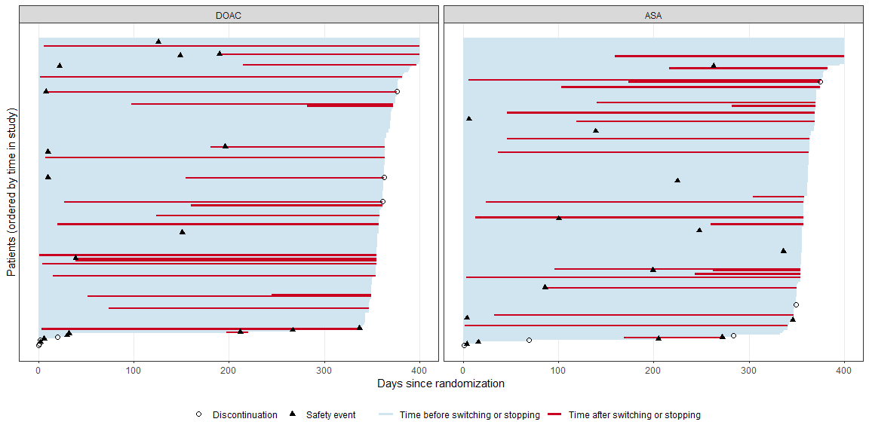
All patients
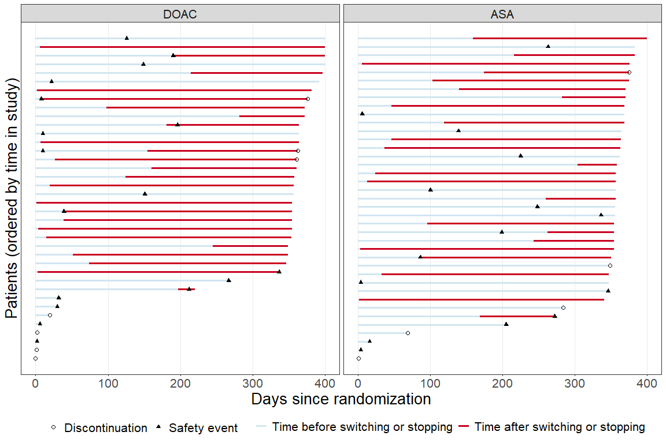
Patients with safety events and/or switching and discontinuation
In this figure there are 77 patients, including 32 patients experiencing the safety event, 47 patients with switching/stopping and 12 patients that discontinue* (actually 9 voluntary discontinuation, one incorrect randomisation [very early], and two which are followed for a full year, but have “other” or “non-compliance” listed as end-of-study reason). Some patients are then part of more than one group.

Unadjusted analysis with multiple imputation, treatment policy strategy
Multiple imputation with imputation model containing no covariates (so using only the overall event rate, to stay more or less in-line with the protocol). The analysis model uses the treatment variable and no other covariates.
Estimated average unadjusted risk difference, along with corresponding p-value and confidence interval.
contrast | estimate | SE | p.value.nonsup | 95CI_low | 95CI_high
DOAC - ASA | 0.012 | 0.030 | 0.000 | -0.047 | 0.072

Sensitivity analyses of primary endpoints

Key secondary endpoints

Clinical efficacy
Descriptive statistics for clinical efficacy composite by treatment arms and overall. Counts and proportions.
 | DOAC | ASA | Overall
Missing | 6 | 7 | 13
composite=0 | 129 | 129 | 258
composite=1 | 45 | 44 | 89
composite=1, % | 25.9% | 25.4% | 25.6%

Thromboembolic events
Descriptive statistics for thromboembolic events by treatment arms and overall. Counts and proportions.
 | DOAC | ASA | Overall
Missing | 8 | 4 | 12
No thromboembolic event | 166 | 170 | 336
With thromboembolic event | 6 | 6 | 12
events, % | 3.5% | 3.4% | 3.4%

Bleeding events
Descriptive statistics for VARC-3 bleeding events by treatment arms and overall. Counts and proportions.
 | DOAC | ASA | Overall
Missing | 5 | 3 | 8
No bleeding events | 168 | 173 | 341
Type 1 | 5 | 2 | 7
Type 2 | 0 | 0 | 0
Type 3 | 1 | 2 | 3
Type 4 | 1 | 0 | 1
VARC-3 bleeding events | 7 | 4 | 11
events, % | 4% | 2.3% | 3.1%

All-cause mortality
Descriptive statistics for deaths by treatment arms and overall. Counts and proportions.
 | DOAC | ASA | Overall
Missing | 0 | 0 | 0
Alive at EOS | 173 | 175 | 348
Death from cardiovascular causes | 3 | 4 | 7
Deaths | 7 | 5 | 12
Deaths, % | 3.9% | 2.8% | 3.3%

Hemodynamic valve deterioration
Descriptive statistics for HVD by treatment arms and overall. Counts and proportions.
 | DOAC | ASA | Overall
Missing | 110 | 114 | 224
No HVD (stage 2 or 3) | 60 | 61 | 121
HVD (stage 2 or 3) | 10 | 5 | 15
HVD (2 or 3), % | 14.3% | 7.6% | 11%

Secondary safety endpoints

Sub-group analyses

HALT
Unadjusted logistic regression (with multiple imputation using same imputation model as in the primary analysis).

Age
Descriptive statistics for HALT (primary efficacy endpoint) in age subgroups. Counts and proportions.
 | <75 |  | >= 75
 | DOAC | ASA | DOAC | ASA
no HALT | 53 | 57 | 74 | 76
HALT | 15 | 18 | 23 | 18
Deaths | 3 | 1 | 4 | 4
HALT & Deaths | 25.4% | 25% | 26.7% | 22.4%
Estimated average unadjusted risk ratio, along with corresponding p-value and confidence interval.
contrast | age | estimate | p.value | 95CI_low | 95CI_high
DOAC / ASA | <75 | 1.037 | 0.899 | 0.596 | 1.804
DOAC / ASA | >= 75 | 1.204 | 0.456 | 0.738 | 1.964
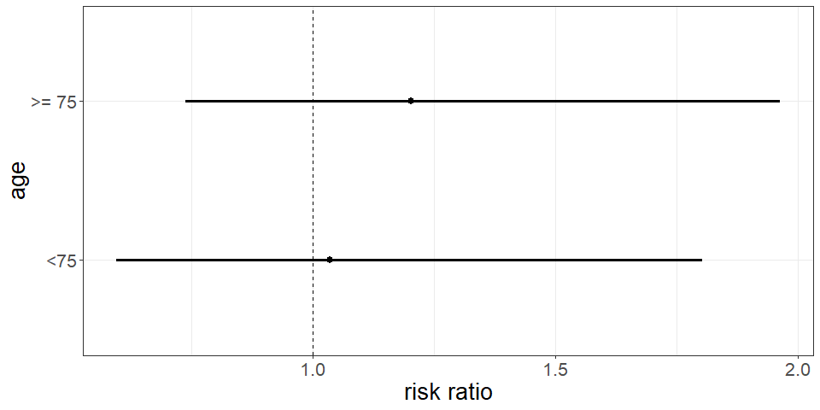
Estimated risk ratio between DOAc and ASA in two age groups, with 95% confidence interval.

Sex
Descriptive statistics for HALT (primary efficacy endpoint) by sex. Counts and proportions.
 | Male |  | Female
 | DOAC | ASA | DOAC | ASA
no HALT | 85 | 84 | 42 | 49
HALT | 20 | 21 | 18 | 15
Deaths | 6 | 2 | 1 | 3
HALT & Deaths | 23.4% | 21.5% | 31.1% | 26.9%
Estimated average unadjusted risk ratio, along with corresponding p-value and confidence interval.
contrast | sex | estimate | p.value | 95CI_low | 95CI_high
DOAC / ASA | Male | 1.103 | 0.699 | 0.671 | 1.811
DOAC / ASA | Female | 1.154 | 0.608 | 0.667 | 1.995
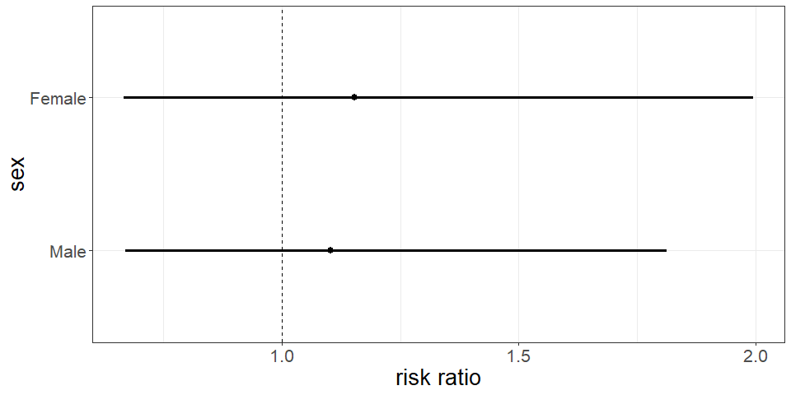
Estimated risk ratio between DOAc and ASA in two age groups, with 95% confidence interval.

Diabetes
Descriptive statistics for HALT (primary efficacy endpoint) by diabetes. Counts and proportions.
 | No diabetes |  | Diabetes
 | DOAC | ASA | DOAC | ASA
no HALT | 87 | 97 | 36 | 34
HALT | 27 | 24 | 10 | 9
Deaths | 5 | 4 | 2 | 1
HALT & Deaths | 26.9% | 22.4% | 25% | 22.7%

Hypertension
Descriptive statistics for HALT (primary efficacy endpoint) by hypertension. Counts and proportions.
 | No hypertension |  | Hypertension
 | DOAC | ASA | DOAC | ASA
no HALT | 31 | 36 | 92 | 95
HALT | 14 | 7 | 23 | 26
Deaths | 3 | 2 | 4 | 3
HALT & Deaths | 35.4% | 20% | 22.7% | 23.4%

Impaired renal function
Descriptive statistics for HALT (primary efficacy endpoint) by renal function. Counts and proportions.
 | Impaired |  | Preserved
 | DOAC | ASA | DOAC | ASA
no HALT | 6 | 2 | 121 | 131
HALT | 0 | 0 | 38 | 36
Deaths | 1 | 1 | 6 | 4
HALT & Deaths | 14.3% | 33.3% | 26.7% | 23.4%
Here there are so few in the impaired group that I don’t think inference is necessary.

TAVI valve type
Descriptive statistics for HALT (primary efficacy endpoint) by valve type. Counts and proportions.
 | Balloon-expanded |  | Self-expandable
 | DOAC | ASA | DOAC | ASA
no HALT | 95 | 92 | 32 | 41
HALT | 23 | 27 | 15 | 9
Deaths | 7 | 3 | 0 | 2
HALT & Deaths | 24% | 24.6% | 31.9% | 21.2%

TAVI post-dilation
Descriptive statistics for HALT (primary efficacy endpoint) by post-dilation. Counts and proportions.
 | No | Yes
 | DOAC | ASA | DOAC | ASA
no HALT | 119 | 117 | 8 | 16
HALT | 33 | 33 | 5 | 3
Deaths | 7 | 4 | 0 | 1
HALT & Deaths | 25.2% | 24% |  | 38.5% | 20%

TAVI supra-valcular prosthesis position
Descriptive statistics for HALT (primary efficacy endpoint) by supra-valcular prosthesis position. Counts and proportions.
 | No |  | Yes
 | DOAC | ASA | DOAC | ASA
no HALT | 97 | 92 | 30 | 41
HALT | 24 | 27 | 14 | 9
Deaths | 7 | 3 | 0 | 2
HALT & Deaths | 24.2% | 24.6% | 31.8% | 21.2%

Ascending aorta diameter
Descriptive statistics for HALT (primary efficacy endpoint) by ascending aorta diameter (mm). Counts and proportions.
 | < 30 |  | >= 30
 | DOAC | ASA | DOAC | ASA
no HALT | 56 | 70 | 71 | 63
HALT | 15 | 22 | 23 | 14
Deaths | 3 | 2 | 4 | 3
HALT & Deaths | 24.3% | 25.5% | 27.6% | 21.2%

Frailty index
Descriptive statistics for HALT (primary efficacy endpoint) by frailty category. Counts and proportions.
 | robust |  | pre-frail |  | missing
 | DOAC | ASA | DOAC | ASA | DOAC | ASA
no HALT | 57 | 64 | 38 | 36 | 32 | 33
HALT | 16 | 21 | 13 | 6 | 9 | 9
Deaths | 1 | 1 | 4 | 1 | 2 | 3
HALT & Deaths | 23% | 25.6% | 30.9% | 16.3% | 25.6% | 26.7%

Additional safety analysis
Which numbers and tables do you want to see here? The two first tables are kind of redundant, but the question is whether one should require that the AE is possibly related to study medication or not.

Overview of adverse events, serious adverse events and suspected unexpected serious adverse reaction
Summary of adverse events.
 | DOAC (n=180) | ASA (n=180) | Overall (n=360)
Number of AEs | 260 | 255 | 515
Number of patients with any AEs | 119 (66.1%) | 114 (63.3%) | 233 (64.7%)
Number of patients with one AE | 56 (31.1%) | 43 (23.9%) | 99 (27.5%)
Number of patients with two AE | 27 (15%) | 41 (22.8%) | 68 (18.9%)
Number of patients with three or more AEs | 36 (20%) | 30 (16.7%) | 66 (18.3%)
Number of SAEs | 124 | 113 | 237
Number of patients with any SAEs | 72 (40%) | 67 (37.2%) | 139 (38.6%)
There are no SUSARs in the dataset. No SAE which is unexpected and possibly, probably or definitely related to study medication.

Suspected adverse reactions: AEs and SAEs with a possible, probable or definite relation to study treatments
Summary of adverse events with a possible, probable or definite relation to study treatments.
 | DOAC (n=180) | ASA (n=180) | Overall (n=360)
Number of AEs | 91 | 93 | 184
Number of patients with any AEs | 63 (29.3%) | 65 (30.2%) | 128 (29.8%)
Number of patients with one AE | 44 (24.4%) | 43 (23.9%) | 87 (24.2%)
Number of patients with two AE | 13 (7.2%) | 18 (10%) | 31 (8.6%)
Number of patients with three or more AEs | 6 (3.3%) | 4 (2.2%) | 10 (2.8%)
Number of SAEs | 34 | 33 | 67
Number of patients with any SAEs | 27 (15%) | 26 (14.4%) | 53 (14.7%)
There are no SUSARs in the dataset.

Adverse Events by System Organ Class and Preferred term
Number of AEs and SAEs by system organ class and preferred term.
 |  | AE |  | SAE
System organ class | Preferred term | DOAC | ASA | DOAC | ASA
blood and lymphatic system disorders | anaemia | 1 | 3 | 0 | 2
 | haemolytic anaemia | 0 | 0 | 0 | 1
 | iron deficiency anaemia | 0 | 0 | 1 | 0
cardiac disorders | acute coronary syndrome | 0 | 0 | 0 | 1
 | acute myocardial infarction | 0 | 0 | 2 | 1
 | angina pectoris | 1 | 0 | 0 | 0
 | atrial fibrillation | 11 | 16 | 2 | 2
 | atrial flutter | 3 | 0 | 0 | 0
 | atrioventricular block | 1 | 1 | 2 | 2
 | atrioventricular block complete | 1 | 0 | 4 | 2
 | atrioventricular block first degree | 0 | 0 | 1 | 0
 | atrioventricular block second degree | 0 | 0 | 2 | 1
 | cardiac arrest | 0 | 0 | 1 | 3
 | cardiac failure | 3 | 1 | 7 | 5
 | myocardial infarction | 0 | 0 | 0 | 1
 | nodal rhythm | 1 | 0 | 1 | 0
 | pericardial effusion | 0 | 1 | 1 | 0
 | pericarditis | 0 | 0 | 0 | 1
 | ventricular arrhythmia | 0 | 0 | 1 | 0
 | ventricular tachycardia | 1 | 0 | 2 | 0
ear and labyrinth disorders | sudden hearing loss | 0 | 1 | 0 | 0
 | vertigo positional | 1 | 0 | 1 | 0
endocrine disorders | hypothyroidism | 0 | 1 | 0 | 0
eye disorders | amaurosis fugax | 4 | 0 | 1 | 3
 | blindness | 0 | 1 | 0 | 0
 | conjunctival haemorrhage | 0 | 1 | 0 | 0
 | diplopia | 1 | 1 | 0 | 0
 | vision blurred | 1 | 1 | 0 | 0
 | visual impairment | 2 | 3 | 0 | 0
 | vitreous haemorrhage | 0 | 0 | 0 | 2
gastrointestinal disorders | abdominal pain | 0 | 0 | 2 | 0
 | abdominal pain upper | 0 | 0 | 3 | 1
 | diverticulum intestinal haemorrhagic | 0 | 0 | 0 | 1
 | dry mouth | 0 | 1 | 0 | 0
 | flatulence | 2 | 1 | 0 | 0
 | gastrointestinal haemorrhage | 0 | 0 | 1 | 1
 | gastrooesophageal reflux disease | 0 | 0 | 0 | 1
 | haematochezia | 1 | 0 | 0 | 0
 | ileus | 0 | 0 | 1 | 0
 | intestinal obstruction | 0 | 0 | 1 | 0
 | intestinal pseudo-obstruction | 0 | 0 | 0 | 1
 | melaena | 1 | 0 | 0 | 0
 | mouth haemorrhage | 0 | 2 | 0 | 0
 | nausea | 1 | 2 | 0 | 0
 | oesophagitis | 1 | 1 | 0 | 0
 | pancreatitis acute | 0 | 0 | 1 | 0
 | rectal haemorrhage | 2 | 0 | 1 | 0
general disorders and administration site conditions | chest pain | 2 | 1 | 2 | 10
 | death | 0 | 0 | 2 | 2
 | fatigue | 0 | 1 | 1 | 0
 | fibrosis | 1 | 0 | 0 | 0
 | gait disturbance | 1 | 0 | 0 | 0
 | hernia | 0 | 0 | 1 | 0
 | injection site discomfort | 0 | 0 | 0 | 1
 | paravalvular regurgitation | 0 | 1 | 1 | 2
 | prolapse | 0 | 1 | 0 | 0
 | prosthetic cardiac valve thrombosis | 0 | 0 | 2 | 0
hepatobiliary disorders | cholecystitis | 0 | 0 | 0 | 1
 | cholelithiasis | 0 | 1 | 0 | 0
 | hepatic cirrhosis | 0 | 0 | 0 | 1
 | hepatic fibrosis | 0 | 1 | 0 | 0
immune system disorders | hypersensitivity | 0 | 0 | 0 | 1
infections and infestations | arthritis bacterial | 1 | 0 | 0 | 1
 | cellulitis | 0 | 0 | 2 | 0
 | covid-19 | 0 | 0 | 0 | 2
 | device related infection | 0 | 0 | 0 | 2
 | endocarditis | 0 | 0 | 4 | 7
 | enterococcal infection | 0 | 1 | 0 | 0
 | erysipelas | 1 | 0 | 1 | 1
 | infection | 0 | 0 | 2 | 0
 | localised infection | 0 | 1 | 0 | 0
 | lower respiratory tract infection | 0 | 0 | 2 | 0
 | pharyngitis | 1 | 0 | 0 | 0
 | pneumonia | 2 | 1 | 1 | 3
 | postoperative wound infection | 0 | 1 | 0 | 0
 | pyelonephritis | 0 | 0 | 1 | 1
 | respiratory tract infection | 1 | 0 | 0 | 0
 | septic embolus | 0 | 0 | 1 | 0
 | septic pulmonary embolism | 0 | 0 | 0 | 1
 | septic shock | 0 | 0 | 1 | 0
 | tooth infection | 0 | 2 | 0 | 0
 | urinary tract infection | 2 | 2 | 1 | 1
injury, poisoning and procedural complications | alcohol poisoning | 0 | 0 | 1 | 0
 | ankle fracture | 2 | 0 | 0 | 0
 | cervical vertebral fracture | 0 | 0 | 1 | 0
 | facial bones fracture | 0 | 0 | 1 | 0
 | fall | 2 | 1 | 1 | 1
 | femoral neck fracture | 0 | 0 | 1 | 1
 | forearm fracture | 1 | 0 | 0 | 0
 | ligament rupture | 0 | 1 | 0 | 0
 | limb injury | 1 | 0 | 0 | 0
 | periorbital haematoma | 0 | 0 | 0 | 1
 | post procedural haematoma | 0 | 0 | 1 | 0
 | prescribed overdose | 0 | 0 | 0 | 1
 | skin laceration | 0 | 0 | 1 | 0
 | upper limb fracture | 1 | 0 | 0 | 0
 | vascular pseudoaneurysm | 0 | 0 | 0 | 1
 | wrist fracture | 0 | 0 | 1 | 0
investigations | enterococcus test positive | 0 | 0 | 0 | 1
 | occult blood | 0 | 1 | 0 | 0
metabolism and nutrition disorders | dehydration | 0 | 1 | 0 | 0
 | diabetic ketoacidosis | 0 | 0 | 0 | 1
 | gout | 1 | 1 | 1 | 0
 | hyperglycaemia | 1 | 0 | 2 | 0
 | hypoglycaemia | 0 | 1 | 0 | 0
 | hypomagnesaemia | 0 | 0 | 0 | 1
 | iron deficiency | 1 | 0 | 0 | 0
 | type 2 diabetes mellitus | 0 | 1 | 0 | 1
musculoskeletal and connective tissue disorders | arthralgia | 0 | 1 | 0 | 0
 | arthritis | 0 | 1 | 0 | 1
 | musculoskeletal chest pain | 0 | 0 | 1 | 0
 | osteoarthritis | 0 | 1 | 0 | 0
 | pain in extremity | 1 | 1 | 0 | 0
 | polymyalgia rheumatica | 0 | 0 | 1 | 0
neoplasms benign, malignant and unspecified (incl cysts and polyps) | basal cell carcinoma | 1 | 0 | 0 | 0
 | bladder cancer | 1 | 0 | 0 | 0
 | brain neoplasm | 1 | 0 | 0 | 0
 | breast cancer | 0 | 0 | 0 | 1
 | colorectal adenocarcinoma | 0 | 0 | 0 | 1
 | laryngeal papilloma | 0 | 1 | 0 | 0
 | malignant melanoma | 0 | 0 | 1 | 0
 | metastases to lymph nodes | 0 | 0 | 0 | 1
 | prostate cancer | 0 | 1 | 0 | 0
 | rectosigmoid cancer | 0 | 0 | 0 | 1
 | renal neoplasm | 0 | 1 | 0 | 0
nervous system disorders | amnesia | 0 | 0 | 0 | 1
 | balance disorder | 0 | 2 | 0 | 0
 | cerebral artery embolism | 0 | 0 | 0 | 1
 | cerebral haemorrhage | 0 | 0 | 2 | 0
 | cerebral infarction | 1 | 0 | 0 | 2
 | cerebrovascular accident | 0 | 0 | 2 | 1
 | dizziness | 20 | 25 | 1 | 1
 | embolic cerebral infarction | 0 | 0 | 0 | 1
 | epilepsy | 0 | 0 | 2 | 0
 | hyposmia | 0 | 1 | 0 | 0
 | lethargy | 0 | 1 | 0 | 0
 | migraine | 0 | 1 | 0 | 0
 | presyncope | 0 | 1 | 2 | 0
 | seizure | 0 | 0 | 1 | 0
 | syncope | 3 | 2 | 4 | 2
 | transient ischaemic attack | 0 | 0 | 5 | 1
 | tremor | 1 | 1 | 0 | 0
 | vascular dementia | 1 | 0 | 0 | 1
psychiatric disorders | autoscopy | 1 | 0 | 0 | 0
 | confusional state | 0 | 0 | 1 | 0
 | delirium | 0 | 0 | 1 | 0
renal and urinary disorders | acute kidney injury | 1 | 0 | 0 | 0
 | haematuria | 6 | 4 | 1 | 0
 | nephrolithiasis | 1 | 0 | 0 | 0
 | nephrotic syndrome | 0 | 0 | 1 | 0
 | renal failure | 0 | 1 | 0 | 0
 | urinary retention | 1 | 0 | 1 | 0
reproductive system and breast disorders | gynaecomastia | 1 | 0 | 0 | 0
 | uterine prolapse | 1 | 0 | 0 | 0
respiratory, thoracic and mediastinal disorders | acute pulmonary oedema | 0 | 1 | 0 | 0
 | chronic obstructive pulmonary disease | 0 | 0 | 3 | 0
 | dyspnoea | 1 | 1 | 1 | 0
 | emphysema | 1 | 0 | 0 | 0
 | epistaxis | 19 | 16 | 0 | 0
 | haemoptysis | 1 | 0 | 0 | 0
 | hypersensitivity pneumonitis | 0 | 1 | 0 | 0
 | pleural effusion | 2 | 1 | 0 | 0
 | productive cough | 1 | 0 | 0 | 0
 | pulmonary embolism | 0 | 1 | 0 | 0
 | pulmonary oedema | 1 | 0 | 0 | 0
 | sleep apnoea syndrome | 0 | 1 | 0 | 0
skin and subcutaneous tissue disorders | decubitus ulcer | 0 | 0 | 1 | 0
 | petechiae | 0 | 0 | 1 | 0
 | pruritus | 0 | 1 | 0 | 0
 | rash | 0 | 1 | 0 | 0
 | skin haemorrhage | 1 | 1 | 0 | 0
surgical and medical procedures | appendicectomy | 0 | 0 | 1 | 0
 | cardiac pacemaker insertion | 0 | 0 | 7 | 13
 | cardiac resynchronisation therapy | 0 | 0 | 1 | 0
 | cataract operation | 0 | 1 | 0 | 0
 | cholecystectomy | 0 | 0 | 0 | 1
 | colectomy | 0 | 0 | 1 | 0
 | hip arthroplasty | 0 | 0 | 0 | 1
 | large intestinal polypectomy | 0 | 1 | 0 | 0
 | mole excision | 0 | 1 | 0 | 0
 | orchidectomy | 0 | 1 | 0 | 0
 | percutaneous coronary intervention | 0 | 0 | 1 | 1
 | skin neoplasm excision | 0 | 1 | 0 | 0
 | spinal laminectomy | 0 | 0 | 1 | 0
 | transurethral bladder resection | 1 | 0 | 0 | 0
vascular disorders | aortic aneurysm | 0 | 0 | 1 | 0
 | deep vein thrombosis | 1 | 1 | 0 | 0
 | embolism | 0 | 0 | 0 | 1
 | haematoma | 1 | 1 | 1 | 0
 | haemorrhage | 0 | 0 | 0 | 1
 | hypertension | 1 | 1 | 0 | 0
 | hypotension | 0 | 3 | 0 | 1
 | peripheral arterial occlusive disease | 0 | 0 | 1 | 0
 | thrombophlebitis superficial | 1 | 0 | 0 | 0
 | thrombosis | 0 | 1 | 0 | 0
 | vasculitis | 0 | 0 | 1 | 0

