Statistical report for ACASA-TAVI
  - AntiCoagulation versus AcetylSalicylic Acid after Transcatheter Aortic Valve Implantation
C. Cunen
28 mai 2026
Table of Contents

Introduction
The ACASA-TAVI study is a prospective investigation of losartan as an adjunctive therapy for patients with glioblastoma. According to Protocol Version 7.0 (17-Dec-2024), the trial collects comprehensive demographic, clinical, imaging, and quality-of-life information prior to treatment initiation.
This report summarises the currently available baseline data with emphasis on clinical status, imaging assessments, and prior treatments that may influence subsequent outcomes.
The safety analysis is based on the Safety Analysis Set including all subjects with any safety information after baseline (N=53). Patients randomised to hydroxychloroquine without receiving any amount of the treatment will be excluded from the safety population (nobody was excluded based on that condition). The primary efficacy analysis is based on the Full Analysis Set (FAS) including all randomised subjects who have had at least one baseline and one post-randomisation evaluation of efficacy (N=51). The secondary efficacy analysis is based on the Per Protocol Set including all participants of the FAS who took at least 7 of the 8 first hydroxychloroquine doses (N=49) Analysis according to final SAP version 2.1, dated 28.05.2020 Data extraction Viedoc electronic data capture system, time stamped: 26.05.2020 12:06 UTC
The aim of this document is to produce tables and figures to be included into the article as requested by email from Merete Hetland 10 December 2019. The analyses are prespecified in the Statistical Analysis Plan (SAP) dated 2nd of September 2019, and the locked database with an update received on the 10th of December dated 26th of October 2019.

Randomisation Status
The present dataset is built on sham randomisation generated from the most recent export from Viedoc. No true treatment assignments have been unlocked. All findings in this document should therefore be interpreted as preliminary and descriptive only. Final efficacy comparisons will not be conducted until the database is locked and genuine randomisation codes are used.

Data preparations
The data have been further prepared in accordance with the SAP, except for the imputation of missing baseline Body Mass Index (BMI) for two trial subjects. They have been imputed with the median BMI value among all other ITT subjects. This imputation is not described in the SAP.

Specifications to the analyses
For the continuous CRP and ESR parameters, I have fitted a generalized linear mixed gamma model due to skewness. This model gave the best fit according to Akaike’s Information Criterion over a standard linear mixed model and a generalized linear mixed lognormal model. For the joint count variables I fitted a generalised linear mixed negative binomial model over a corresponding poisson model due to overdispersion. All these specification are according to the analysis plan.

Patient enrolment and disposition

Trial population
The following table summarizes the number of patients that were screened (?), that were eligible and randomized, that received the treatment and that were lost to follow-up, as well as the number of patients included in the analyses. This table should be used to fill in the CONSORT diagram (??).
Counts
description | n
Assessed at screening
Eligible at screening
Ineligible at screening
Eligible and randomised | 359
Eligible not randomised
Randomized but ineligible | 1
Non-completers | 23
Randomised and FAS | 360
Randomised and FAS with primary efficacy endpoint | 270
Randomised and FAS with primary safety endpoint | 211

Patient disposition (reasons for non-completion)
Overview of study completion and reasons for non-completion. The counts of “Study completed” which are neither “Yes” nor “No” are participants who have not had their final visit yet.
Overview of study completion and reasons for non-completion
 | DOAC | ASA | Total
Number of randomised participants | 180 | 180 | 360
Study completed
No | 14 | 9 | 23
Yes | 164 | 164 | 328
 | 2 | 7 | 9
Reason for discontinuation
Voluntary discontinuation by patient | 4 | 4 | 8
Incorrect randomisation | 1 | 0 | 1
Non-compliance | 1 | 0 | 1
Death | 7 | 5 | 12
Other | 1 | 0 | 1

Timing of end of study, withdrawals and follow ups
Time from randomisation to end of study and time from randomisation to withdrawal/lost to follow-up is summarized by median and min-max, overall and by treatment group.
Length of study by treatment groups
 | DOAC | ASA | Overall
All participants | 357 (0-510) | 357 (1-440) | 357 (0-510)
Non-completers | 31 (0-363) | 183 (1-265) | 69 (0-363)

Protocol deviations
Number of major and minor protocol deviations, summarized by treatment group with details of type of deviation provided.
Number of minor protocol deviations
Treatment | Category of PD | n
DOAC | Incorrect treatment and/or dose | 2
DOAC | Prohibited concomitant medication | 3
DOAC | Failure to collect important data | 6
DOAC | Serious breach - Other | 1
DOAC | Other | 3
ASA | Prohibited concomitant medication | 2
ASA | Failure to collect important data | 4
ASA | Serious breach - SAE notification / safety procedure | 2
ASA | Other | 1
There are currently no PD that are categorised as “major”.
Number of major protocol deviations
Treatment | Category of PD | n

Adherence to allocated treatment
Number of patients participants switching between ASA and DOAC or stopping the treatment altogether (so far - final data could reveal more switches), by treatment group and in total.
Number of participants switching or stopping.
 | No change in study drug | Switching | Stopping
DOAC | 156 | 17 | 7
ASA | 158 | 19 | 3
Total | 314 | 36 | 10

Analysis sets
The FAS includes all participants. The SAS includes all participants except those that leave the study within one day (assuming they did not take any dose of study medication). The PP includes all participants except – non-completers that did not die (voluntary discontinuation mostly) – participants with important protocol deviations – participants thatswitching between ASA and DOAC or stopping the treatment altogether.
Number of participants in the different analysis sets.
 | Full analysis set | Safety analysis set | Per protocol set
DOAC | 180 | 176 | 150
ASA | 180 | 172 | 150
Total | 360 | 348 | 300

Demographics and baseline characteristics
Are these terms clearly defined? We have many more variables from the form “Vital Signs and Physical Examination (PE)” than the ones that are shown here.

Table for abstract (May 2026)
Baseline characteristics of all 360 participants. Continuous variables are summarised by mean (SD).
Age (years) | 74.5 (3.7)
Sex, female | 37%
Body mass index (kg/m^2) | 28.1 (4.7)
Coronary artery disease | 24%
Hypertension | 71%
Diabetes mellitus | 28%
Previous stroke | 11%
Chronic obstructive pulmonary disease | 14%
Troponin T (ng/L) | 31 (76)
NT-proBNP (ng/L) | 1045 (2681)
Glomerular filtration rate (mL/min/1 1.73 m^2) | 74.8 (18.4)
Pre-TAVI echocardiography parameters
Left ventricular ejection fraction (%) | 53.6 (7.8)
Aortic valve mean gradient (mmHg) | 49.6 (12.6)
Aortic valvular area (cm^2) | 0.8 (0.2)
Procedural characteristics
Balloon-expanded valve | 72%
Self-expandable valve | 28%

Demographics
Demographics, some variables measured at baseline, some characteristics related to TAVI procedure, and counts of preexisting conditions.
Characteristic | DOAC(n=180) | ASA(n=180) | Overall (n=360)
Age (years) | 74.4 (3.7) | 74.5 (3.7) | 74.5 (3.7)
Sex, n (%)
Male | 115 (63.9%) | 111 (61.7%) | 226 (62.8%)
Female | 65 (36.1%) | 69 (38.3%) | 134 (37.2%)
Weight (kg) | 84.3 (16.2) | 84.9 (15.9) | 84.6 (16)
Height (cm) | 173.8 (9.3) | 173 (9) | 173.4 (9.1)
Body mass index (kg/m2) | 27.9 (4.9) | 28.3 (4.5) | 28.1 (4.7)
Frailty, n (%)
Robust | 75 (41.7%) | 90 (50%) | 165 (45.8%)
Pre-frail | 59 (32.8%) | 43 (23.9%) | 102 (28.3%)
Frail | 0 (0%) | 0 (0%) | 0 (0%)
Missing | 46 (25.6%) | 47 (26.1%) | 93 (25.8%)
Smoking status, n (%)
Never smoked | 59 (32.8%) | 66 (36.7%) | 125 (34.7%)
Has stopped | 94 (52.2%) | 91 (50.6%) | 185 (51.4%)
Sometimes | 1 (0.6%) | 1 (0.6%) | 2 (0.6%)
Daily | 26 (14.4%) | 22 (12.2%) | 48 (13.3%)
TAVI valve type, n (%)
Balloon-expanded | 130 (72.6%) | 127 (70.6%) | 257 (71.6%)
Self-expandable | 49 (27.4%) | 53 (29.4%) | 102 (28.4%)
TAVI post-dilatation, n (%)
Yes | 13 (7.3%) | 20 (11.1%) | 33 (9.2%)
No | 166 (92.7%) | 160 (88.9%) | 326 (90.8%)
TAVI supra-valvular prothesis position, n (%)
Yes | 46 (25.7%) | 53 (29.4%) | 99 (27.6%)
No | 133 (74.3%) | 127 (70.6%) | 260 (72.4%)
Ascending aorta diameter (mm) | 30.5 (4.1) | 29.7 (3.9) | 30.1 (4)
Hypertension, n (%)
Yes | 124 (70.9%) | 126 (72%) | 250 (71.4%)
No | 51 (29.1%) | 49 (28%) | 100 (28.6%)
Coronary artery disease, n (%)
Yes | 36 (20.6%) | 47 (26.9%) | 83 (23.7%)
No | 139 (79.4%) | 128 (73.1%) | 267 (76.3%)
Diabetes mellitus, n (%)
Yes | 54 (30.9%) | 45 (25.7%) | 99 (28.3%)
No | 121 (69.1%) | 130 (74.3%) | 251 (71.7%)
Chronic obstructive pulmonary disease, n (%)
Yes | 26 (14.9%) | 22 (12.6%) | 48 (13.7%)
No | 149 (85.1%) | 153 (87.4%) | 302 (86.3%)
Previous stroke, n (%)
Yes | 19 (10.9%) | 21 (12%) | 40 (11.4%)
No | 156 (89.1%) | 154 (88%) | 310 (88.6%)

Some baseline characteristics
Vital signs, and some results related to clinical chemistry and hematology at baseline.
Characteristic | DOAC(n=180) | ASA(n=180) | Overall (n=360)
Systolic blood pressure (mmHg) | 136.96 (19.1) | 144.22 (22.74) | 140.59 (21.28)
Diastolic blood pressure (mmHg) | 71.91 (9.8) | 71.94 (10.39) | 71.92 (10.09)
Hemoglobin | 13.44 (1.6) | 13.74 (1.57) | 13.59 (1.59)
Platelets | 220.09 (61.73) | 232.93 (67.01) | 226.51 (64.65)
Leukocytes | 8.9 (17.95) | 7.84 (2.2) | 8.37 (12.78)
International Normalized Ratio (INR) | 1.06 (0.14) | 1.04 (0.09) | 1.05 (0.12)
Sodium | 139.52 (2.69) | 139.61 (2.77) | 139.56 (2.73)
Potassium | 4.14 (0.38) | 4.05 (0.36) | 4.1 (0.37)
ALT | 25.32 (13.29) | 27.55 (13.87) | 26.44 (13.61)
Cardiac troponin T | 35.33 (102.61) | 26.69 (32.38) | 31.01 (76.1)
NT-proBNP | 1176.37 (3319.3) | 913.88 (1841.26) | 1044.76 (2681.48)
Creatinine | 92.52 (46.66) | 84.83 (29.38) | 88.67 (39.13)
GFR | 73.26 (19.6) | 76.35 (17.13) | 74.8 (18.45)
Glucose | 6.76 (2.04) | 7 (3.24) | 6.88 (2.71)
Glycated haemoglobin (HbA1c) | 42.23 (9.29) | 41.98 (9.9) | 42.1 (9.59)
Triglycerides | 1.58 (0.93) | 1.49 (0.67) | 1.53 (0.81)
Total cholesterol | 4.15 (1.08) | 4.27 (1.1) | 4.21 (1.09)
HDL cholesterol | 1.41 (0.43) | 1.47 (0.47) | 1.44 (0.45)
LDL cholesterol | 2.22 (0.89) | 2.32 (0.93) | 2.27 (0.91)
Albumin | 42.69 (3.83) | 43.05 (2.79) | 42.87 (3.35)
CRP | 5.13 (12.37) | 4.8 (10.4) | 4.97 (11.41)
Bilirubin | 8.9 (4.51) | 9.9 (5.57) | 9.4 (5.09)

Change in baseline characteristics
Change from baseline to 12 months in Vital signs, and some results related to clinical chemistry and hematology.
Characteristic | Overall (n=360) | Overall 12 months (n=331)
Systolic blood pressure (mmHg) | 140.59 (21.28) | 145.35 (20.25)
Diastolic blood pressure (mmHg) | 71.92 (10.09) | 74.3 (10.65)
Hemoglobin | 13.59 (1.59) | 13.63 (1.65)
Platelets | 226.51 (64.65) | 210.75 (59)
Leukocytes | 8.37 (12.78) | 7.59 (2.18)
International Normalized Ratio (INR) | 1.05 (0.12) | 1.1 (0.15)
Sodium | 139.56 (2.73) | 139.66 (2.5)
Potassium | 4.1 (0.37) | 4.18 (0.35)
ALT | 26.44 (13.61) | 26.29 (13.73)
Cardiac troponin T | 31.01 (76.1) | 18.54 (12.53)
NT-proBNP | 1044.76 (2681.48) | 403.34 (1198.1)
Creatinine | 88.67 (39.13) | 89.02 (40.67)
GFR | 74.8 (18.45) | 73.81 (18.35)
Glucose | 6.88 (2.71) | 6.73 (2.16)
Glycated haemoglobin (HbA1c) | 42.1 (9.59) | 42.7 (10.72)
Triglycerides | 1.53 (0.81) | 1.55 (0.8)
Total cholesterol | 4.21 (1.09) | 4.21 (1.17)
HDL cholesterol | 1.44 (0.45) | 1.45 (0.45)
LDL cholesterol | 2.27 (0.91) | 2.27 (0.99)
Albumin | 42.87 (3.35) | 41.83 (4.07)
CRP | 4.97 (11.41) | 4.54 (11.31)
Bilirubin | 9.4 (5.09) | 9.75 (5.19)

Primary endpoints

Primary efficacy endpoint

Descriptive statistics
Also by site?
Descriptive statistics for HALT (primary efficacy endpoint). Counts and proportions.
 | DOAC | ASA | Overall
No thickening | 101 | 105 | 206
<=25% of leaflet | 19 | 14 | 33
>25-50 % of leaflet | 8 | 8 | 16
>50-75 % of lealet | 2 | 4 | 6
>75 % of leaflet | 3 | 6 | 9
Missing HALT | 47 | 43 | 90
Death | 7 | 5 | 12
Total HALT | 32 (24.1%) | 32 (23.4%) | 64 (23.7%)
Total HALT & Death | 39 (27.9%) | 37 (26.1%) | 76 (27%)

Unadjusted analysis with multiple imputation
Multiple imputation with imputation model containing sex, hemoglobin, potassium, bmi, sodium and LDL cholesterol. So the model does not use the treatment variable (to stay more or less in-line with the protocol). But the analysis model only uses the treatment variable and no other covariates.
Estimated average unadjusted risk difference, along with corresponding p-value and confidence interval.
contrast | estimate | SE | p.value | 95CI_low | 95CI_high
ASA - DOAC | -0.016 | 0.051 | 0.757 | -0.117 | 0.085

Unadjusted analysis, complete-cases
Dropping participants with missing HALT value (ie. dropping 78 observations - remember that some participants with missing HALT are dead and so are counted as ‘events’ in this analysis).
Estimated average unadjusted risk difference, along with corresponding p-value and confidence interval.
contrast | estimate | SE | p.value | 95CI_low | 95CI_high
ASA - DOAC | -0.018 | 0.053 | 0.733 | -0.122 | 0.086

Adjusted analysis with multilple imputation
Multiple imputation with imputation model containing sex, hemoglobin, potassium, bmi, sodium and LDL cholesterol. So the model does not use the treatment variable (to stay more or less in-line with the protocol). The analysis model uses the covariates listed above and the treatment variable in addition.
Estimated average adjusted risk difference, along with corresponding p-value and confidence interval.
contrast | estimate | SE | p.value | 95CI_low | 95CI_high
ASA - DOAC | 0.005 | 0.050 | 0.913 | -0.093 | 0.104

Adjusted analysis, complete-cases
Dropping participants with missing HALT value (ie. dropping 78 observations - remember that some participants with missing HALT are dead and so are counted as ‘events’ in this analysis).
Fitted model.
 | estimate | SE | p.value
(Intercept) | -16.30 | 8.00 | 0.04
ran_trtASA | -0.03 | 0.28 | 0.91
sexFemale | 0.77 | 0.32 | 0.02
hemoglobin | 0.17 | 0.10 | 0.10
potassium | 1.10 | 0.40 | 0.01
bmi | -0.11 | 0.03 | 0.00
sodium | 0.08 | 0.05 | 0.13
LDLchol | -0.21 | 0.17 | 0.20
Distribution of risk differences for all study participants.
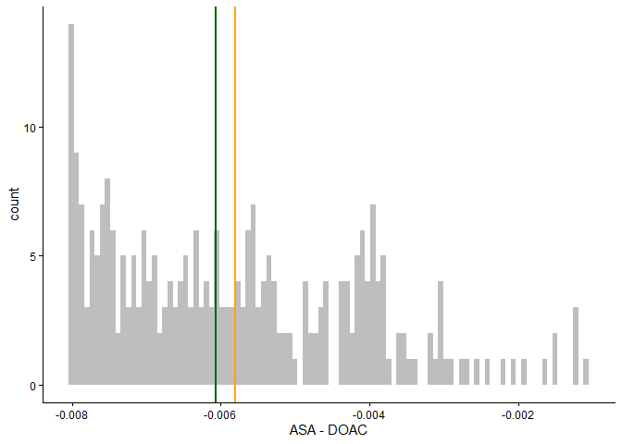
Distribution of risk difference for all study participants. Mean risk difference in orange. Median in green.
Estimated average adjusted risk difference, along with corresponding p-value and confidence interval.
contrast | estimate | SE | p.value | 95CI_low | 95CI_high
ASA - DOAC | -0.006 | 0.051 | 0.910 | -0.106 | 0.095
Estimated average adjusted risk ratio, along with corresponding p-value and confidence interval.
contrast | estimate | p.value | 95CI_low | 95CI_high
ASA/DOAC | 0.979 | 0.910 | 0.674 | 1.421

Primary safety endpoint

Descriptive statistics
Also by site?
Descriptive statistics for primary safety endpoint. Counts and proportions.
 | DOAC | ASA | Overall
No safety events | 93 | 91 | 184
bleeding | 2 | 2 | 4
death | 6 | 5 | 11
mi | 2 | 2 | 4
stroke | 4 | 4 | 8
Missing | 73 | 76 | 149
Total safety event | 14 (13.1%) | 13 (12.5%) | 27 (12.8%)
Out of the 27 safety events, 9 happen in patients that also switch between the treatments at some point. Among these 9 patients: 6 experience the safety event before switching, while 3 experience the safety event after switching.
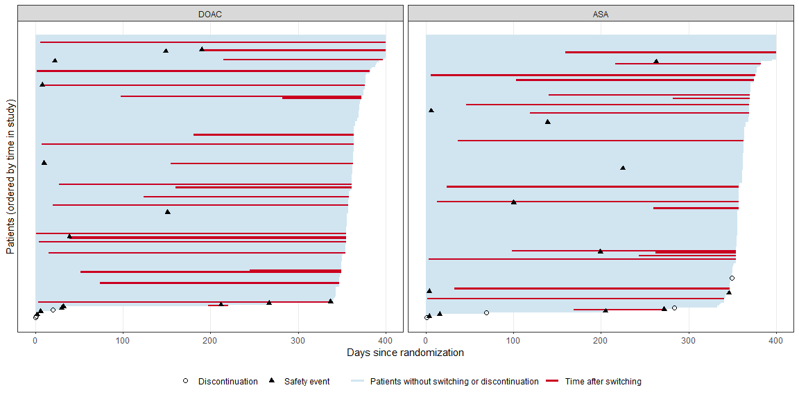
All patients
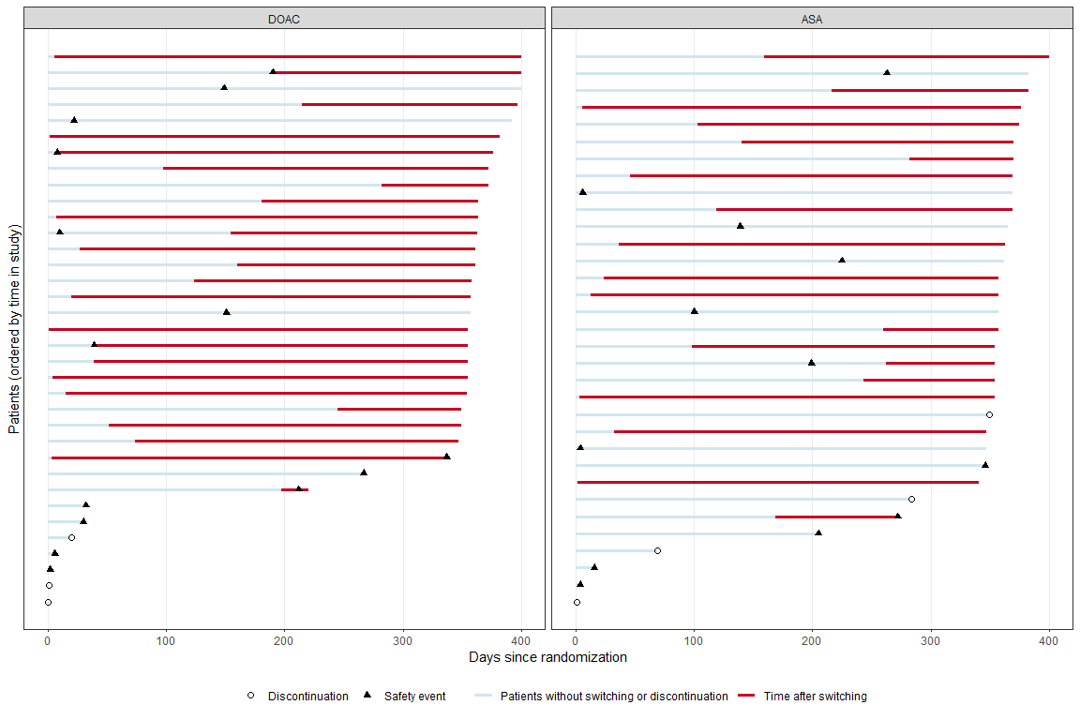
Patients with safety events and/or switching and discontinuation
In this figure there are 46 switches and 7 discontinuations, and these number may seem to bit slightly at odds with the numbers presented in Table 2.6. But that’s actually just because what is called “switches” here in fact includes both “switches and stops” in Table 2.6.

Unadjusted analysis with multiple imputation, treatment policy strategy
Multiple imputation with imputation model containing no covariates (so using only the overall event rate, to stay more or less in-line with the protocol). The analysis model uses the treatment variable and no other covariates.
Estimated average unadjusted risk difference, along with corresponding p-value and confidence interval.
contrast | estimate | SE | p.value.nonsup | 95CI_low | 95CI_high
DOAC - ASA | 0.009 | 0.042 | 0.000 | -0.073 | 0.092

Unadjusted analysis, complete-cases, treatment policy strategy
Discuss margin (in protocol it says 11.9%, but that seems a bit wide maybe)
Estimated average unadjusted risk difference, along with corresponding p-value (for non-inferiority test) and confidence interval.
contrast | estimate | SE | p.value.nonsup | 95CI_low | 95CI_high
DOAC - ASA | 0.006 | 0.046 | 0.007 | -0.084 | 0.096

