/**

* Rock ChMS

* Developer

* Handbook

*/

DRAFT Version: 0.1.32

Last updated: 5/10/2012http://www.sparkdevelopmentnetwork.com/assets/images/spark-logo.png

# **Table of Contents**

Table of Contents 2

Keeping Developers Happy 3

Setting Up Your Development Environment 4

Getting Git 4

Getting RockChMS 4

Getting Started 5

Database 5

Web Config 5

First Time – Creating and Seeding the Database 6

Coding Standards 7

Task Tracking & Communication 9

Required Reading 10

This Handbook 10

Developer Reference 10

The Framework API 10

The REST API 10

Highly Recommended 10

Recommended 10

Developer Communication 11

# **Keeping Developers Happy**

Developers are fickle and that’s OK. They have good and bad habits, and have opinions on how things should be done. Unfortunately if left untamed, this can lead to a state of unhappiness for everyone. For example, attempting to perform diffs against code whose tab-spacing changes from version to version makes developers unhappy.

This handbook will contain the **rules and regulations** which are intended to keep everyone happy and it will also explain some of the environment setup needed to get started with developing.

# Setting Up Your Development Environment

## Getting Git

[SmartGit](http://www.syntevo.com/smartgit/index.html) is a Git client for Windows, Mac OS X and Linux. It provides a GUI to the Git command-line interface. We recommend SmartGit because it’s free for non-commercial use.

1. Download and install “**Git for Windows**” from here <http://code.google.com/p/msysgit/> with all the default settings.
2. [Download](http://www.syntevo.com/smartgit/download.html) and install SmartGit.
   1. Follow this to install Git <http://help.github.com/win-set-up-git/>
3. Run SmartGit to complete SmartGit setup using the defaults except where noted below:
   1. For the **Type of Usage** step you will probably want to select the third option, “Non-Commercial Use Only” as long as you’re only working on the non-commercial Rock-ChMS project.
   2. For the **Git & HG Executables step,** verify that the Git Executable path is filled in with the path to where you installed Git from step 1.
   3. For the **User Information** step, use your GitHub account name and email.
   4. For the **Hosting Providers** step, select GitHub as your main hosting provider.
   5. For the Master Passwords… step, we **do not** recommend choosing the “Don’t use a master password” option.
   6. In the Welcome to SmartGit window, if asked “What do you want to do?” just cancel/close that window and proceed to the next section.

## Getting RockChMS

1. Locate the project’s Git repository by visiting <https://github.com/SparkDevNetwork/Rock-ChMS>.
2. Find the project’s repository read-only URL address (it will be something like <https://github.com/SparkDevNetwork/Rock-ChMS.git>) if you’re on the Rock developer core team you can use your read-write Url or if you’ve forked the Rock-ChMS repo, you can use the read-write Url to your forked repo.
3. In SmartGit, go to “Project” » “Clone” (or choose “clone existing repository”) and use the default settings except where noted here:
   1. In the **Repository Url** field, enter “[https:// github.com/SparkDevNetwork/Rock-ChMS.git](https://User@github.com/SparkDevNetwork/Rock-ChMS.git)”
   2. In the **Local Directory** step, locate or create a folder on your computer where you’ll store your Git Working Tree, e.g., C:\projects\Rock-ChMS.

**NOTE**: Most of us find it’s best to unselect the “show unchanged files” option (Crtl+1) in SmartGit.

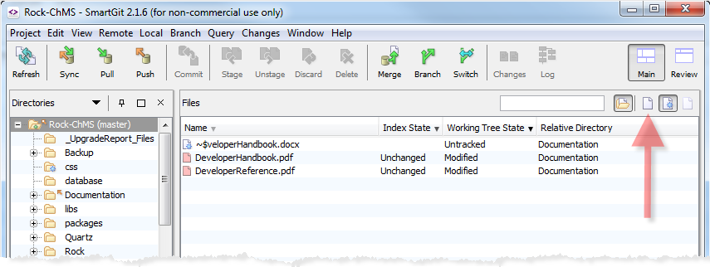

## Getting Started

### Database

You’ll need to create an empty “RockChMS” database on your local system with a default user (owner) of “RockUser”. When you run “Update-Database” (described below), the EF framework will create all the needed tables and data.

Note: Make sure your SQL Server properties Security’s Server Authentication is set to “SQL Server and Windows Authentication mode”. You’ll also need to enable TCP/IP and Named Pipes in your SQL Server Client Protocols (if you have not already done this before).

### Web Config

If it does not exist, create an empty web.connectionString.config file under your RockWeb project. Add with something like:



Replace <Password> with the one you created in the Database step above.

### First Time – Creating and Seeding the Database

Start Visual Studio and open the Package Manager Console window and run “Update-Database” (you can pass the –Verbose flag if you wish) as shown below. *Make sure you’re Default project is set to Rock as shown here in this screenshot.*

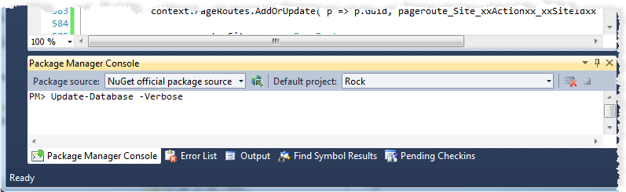

Once you do this, your RockChMS database should have all the required tables and initial seed data required to be able to run Rock as the Administrator user.

Press F5 to launch Rock in Debug mode and then login to rock using the default administrator login (Admin) and password (Admin).

# **Coding Standards**

The following are the adopted coding standards:

* First and foremost, follow the established patterns you see in the existing code base. Don’t invent your own patterns.
* See <http://www.dotnetspider.com/tutorials/CodingStandards.doc>
* Follow the Naming Conventions and Standards outlined by items 1 through 11 in section 7.
* Follow the Indentation and Spacing outlined in section 8. Use Spacing Settings for Visual Studio. Under Options, Text Editor, C#, Spacing checkbox the following (you may need to check the “Show all settings” checkbox in the lower left corner if you don’t see these settings):

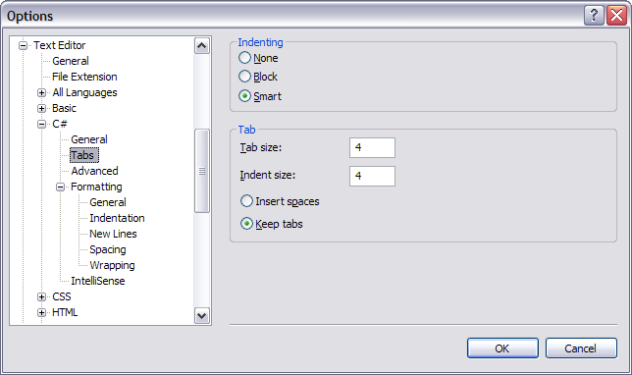

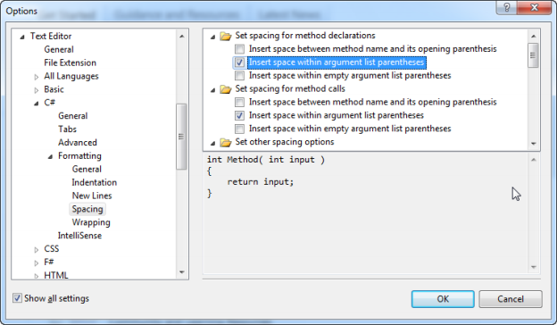

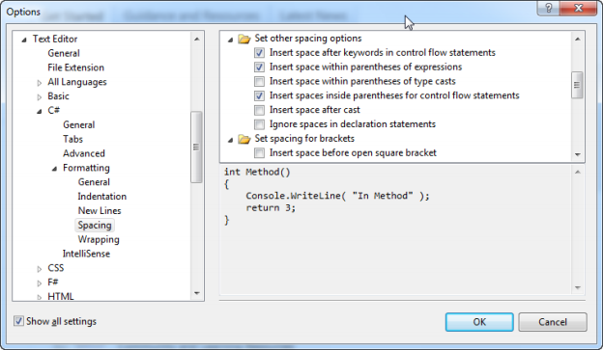

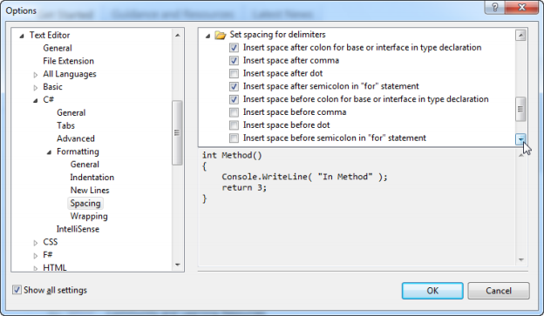

# **Task Tracking & Communication**

We use [GitHub for tracking public issues](https://github.com/SparkDevNetwork/Rock-ChMS/issues), Trello for tracking project team tasks, and are currently using Campfire for immediate team member Q & A communications and [Basecamp](https://sparkdev.basecamphq.com/) general purpose, large team communications as well as technology/feature discussions and witeboarding.

Team communications

http://campfirenow.com/images/logo_campfire-full.png

Instant Q & A communications

Public issue reporting

Task tracking

# Required Reading

## This Handbook

Ok, you’re almost done so don’t get too flustered about it.

## Developer Reference

|  |  |
| --- | --- |
|  | Found in the **Documentation** folder, the Developer Reference is not only good for you, it is required reading. Seriously though – it is the best way to get ramped up developing proper in Rock ChMS. |

## The Framework API

This is found in your Documentation folder’s SandCastle\index.html

## The REST API

This is found on your Rock environment under ~/REST/help

## Highly Recommended

## Recommended

# **Developer Communication**

Here are the best ways to communicate with the team and the Rock ChMS developer community.

|  |  |
| --- | --- |
| http://www.37signals.com/svn/images/campfire-logo-for-fluid.png | Developer Lounge in Campfire  <https://sparkdevnetwork.campfirenow.com/40198> |
|  | IRC Channel #RockChMS irc://chat.freenode.net/#RockChMS |
|  | Twitter - Follow us:  [[@Rock](http://twitter.com/airdo)ChMS](http://twitter.com/rockChMS)  [@SparkDevNetwork](http://twitter.com/#!/SparkDevNetwork)  [@RefreshCache](http://twitter.com/refreshcache) |
| Spark Dev Network | TBD - Developer forums on our community site |
|  | Github Wiki (use when you need to document something you create)  <https://github.com/SparkDevNetwork/Rock-ChMS/wiki/Reference> |