|  |  |
| --- | --- |
| Image result for csueb logo | **Data Warehousing and BI** |
| **Chenwei** |

**Test the Database**

Perform the following updates to the source files *after* loading the data in each table.

**Response 1:** Add following row in the Customer source file (row 2 below the header) with your name.

1000000,YourFirstName,YourLastName,California,25,5

Execute the Customer data flow to insert the above row in the Customer dimension. Update the CustomerLocation to Texas and CustomerAge to 26 for CustomerID 1000000 in the Customer source file. Execute the data flow to update the record in the dimension. Submit the screenshot of the Customer dimension after sorting by CustomerID.

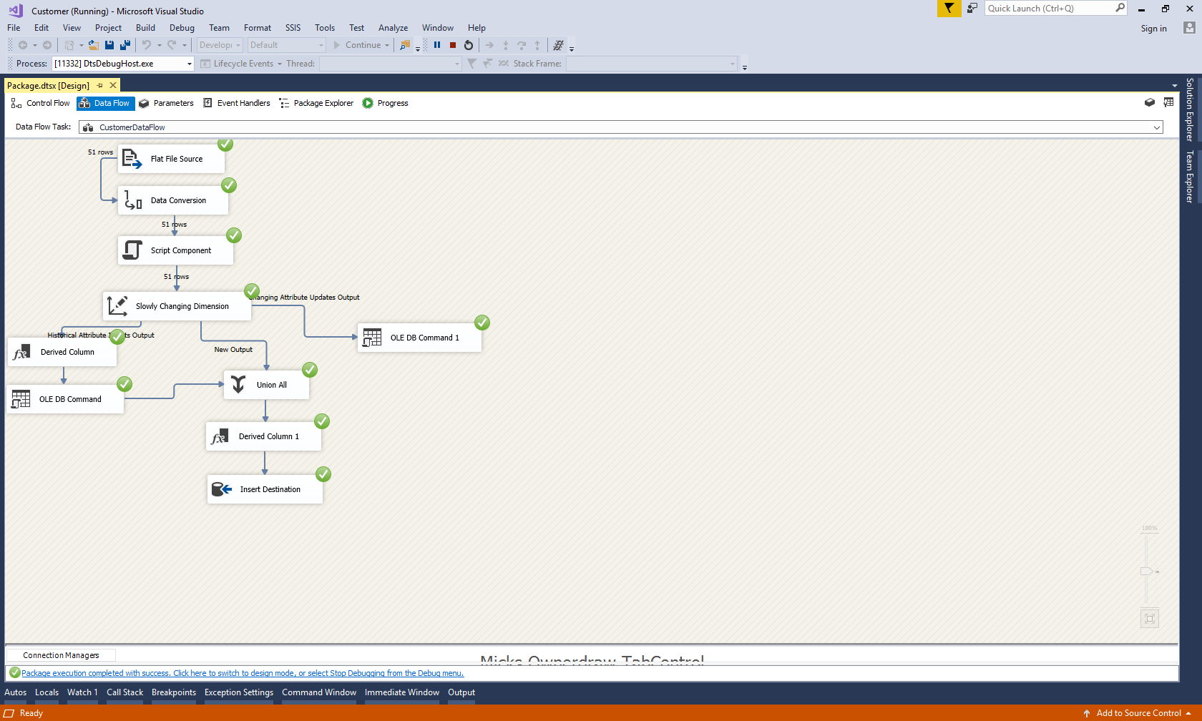

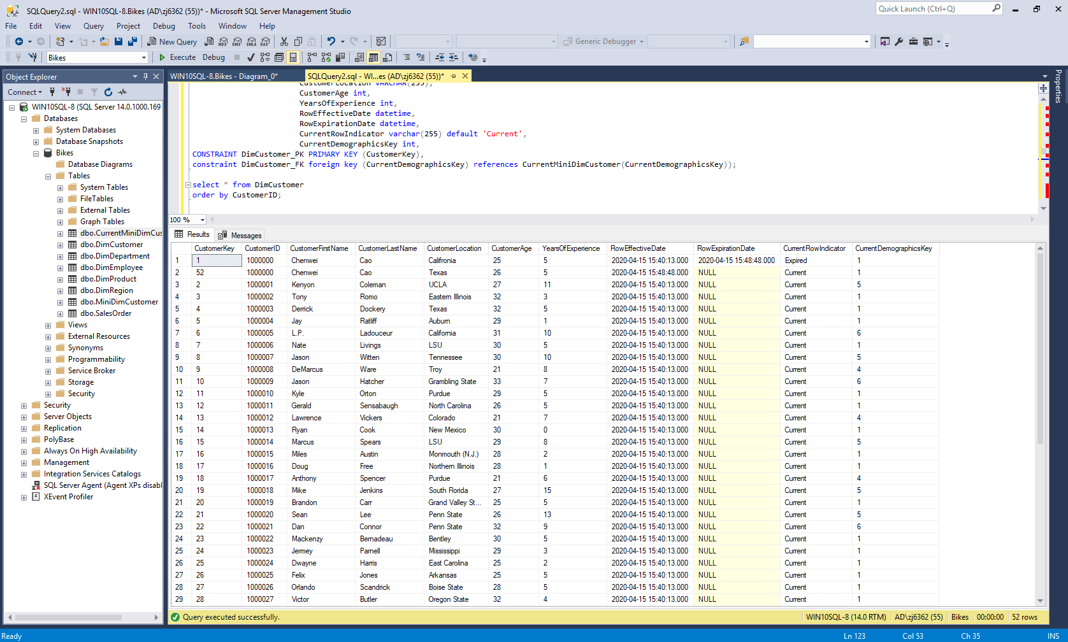

**Response 2:** Again update the CustomerLastName to Doe, CustomerLocation to California, and YearsOfExperience to 6 for CustomerID 1000000 in the Customer source file and save it. Submit the screenshot of the Customer dimension after running your model.

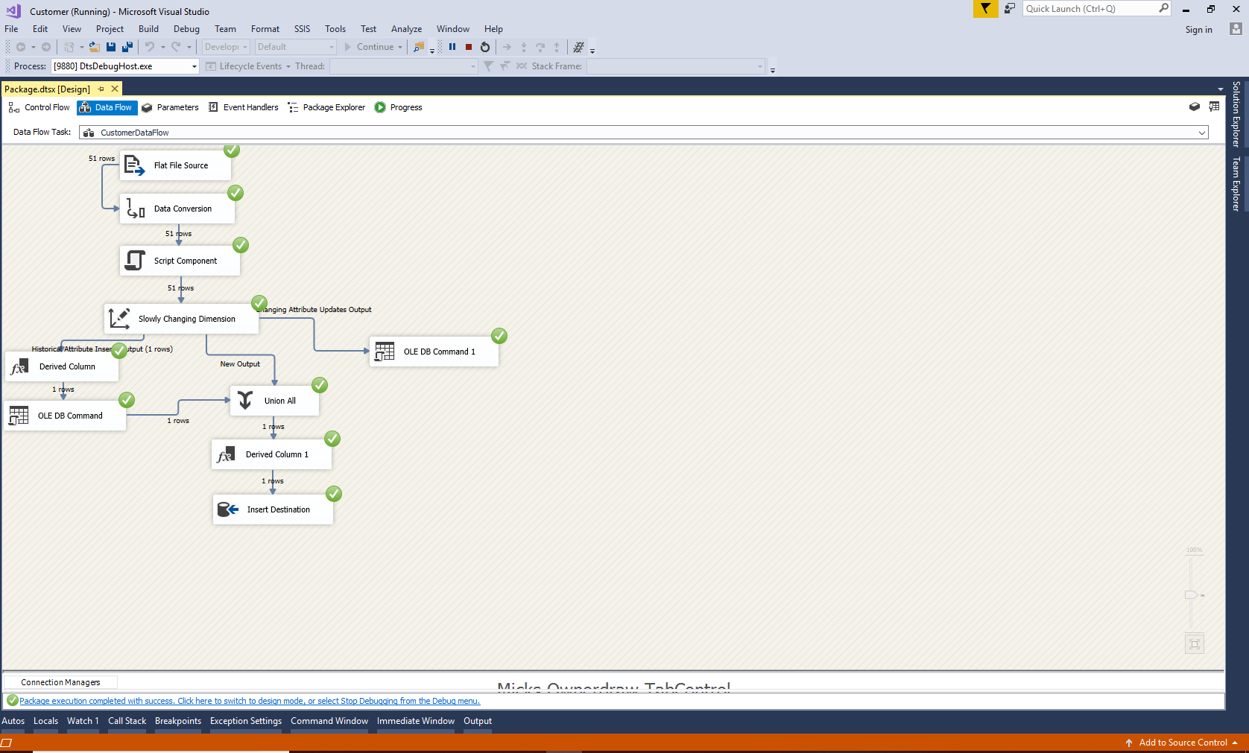

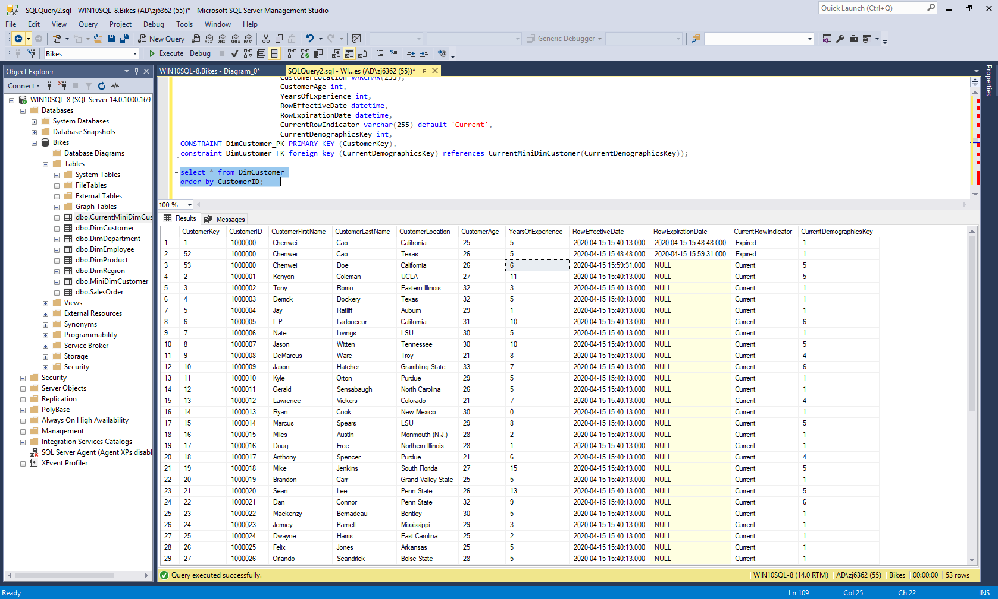

**Response 3:** Add following transactions in the SalesOrder source file. Submit the screenshot of the fact table after running your model.

40000197030,12-29-2014,30000100,1000000,99001006784,90000489,2,300.00

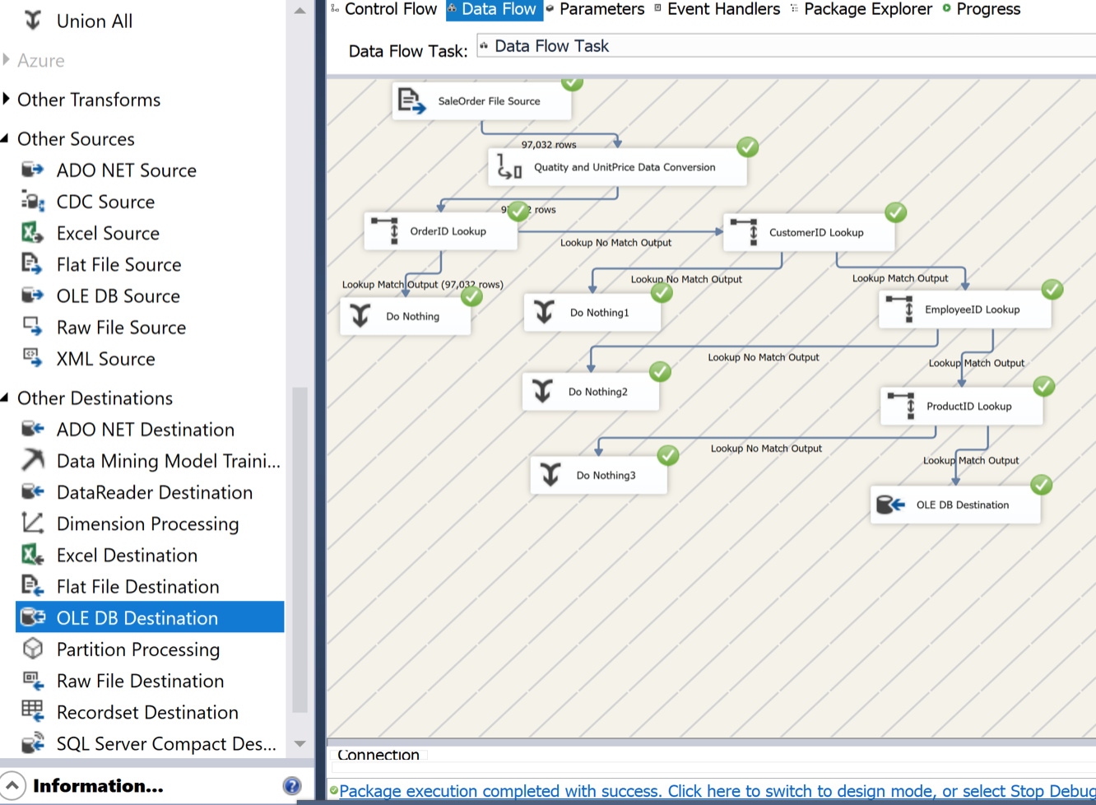

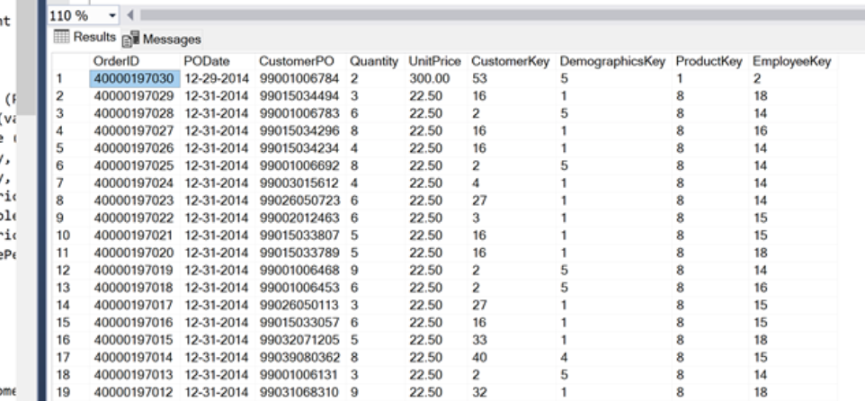

**Response 4:** Add following row in the Employee source file (row 2 below the header) with your project partner’s name and gender.

90000488,PartnerFirstName,PartnerLastName,4,1246 Main Street,Gender,1-1-1995,72000.00,4

Execute the Employee data flow to insert the above row in the Employee dimension. Update the DepartmentID to 2 for EmployeeID 90000488 in the Employee source file and save it. Submit the screenshot of the Employee dimension after running your model.

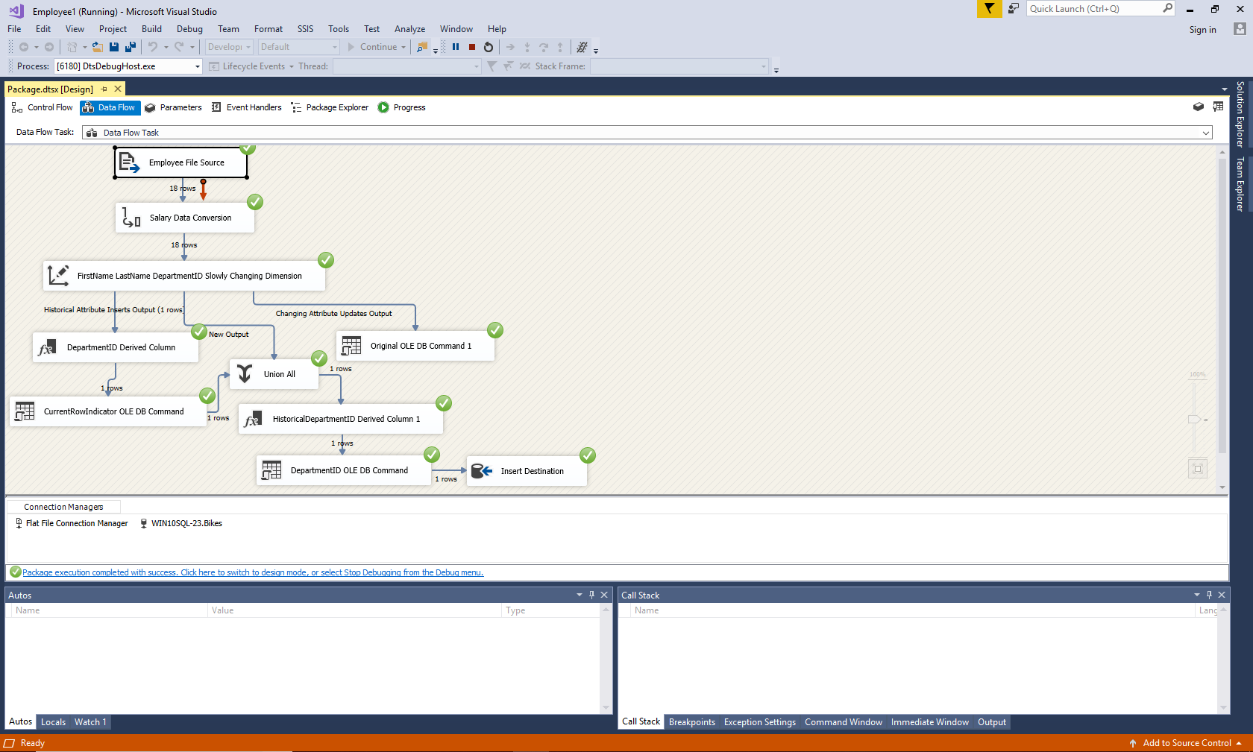

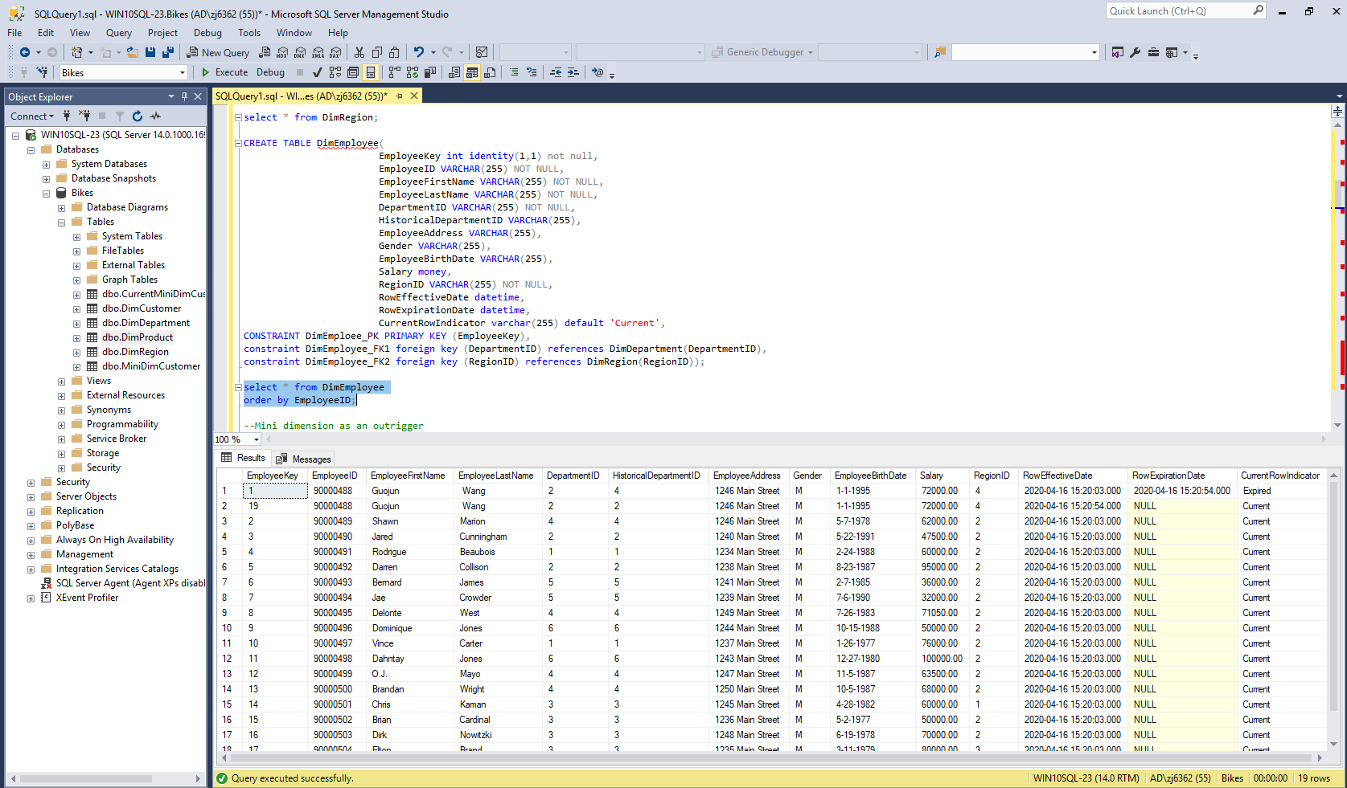

**Response 5:** Again update the DepartmentID to 5 and EmployeeLastName to Doe for EmployeeID 90000488 in the Employee source file and save it. Submit the screenshot of the Employee dimension after running your model.

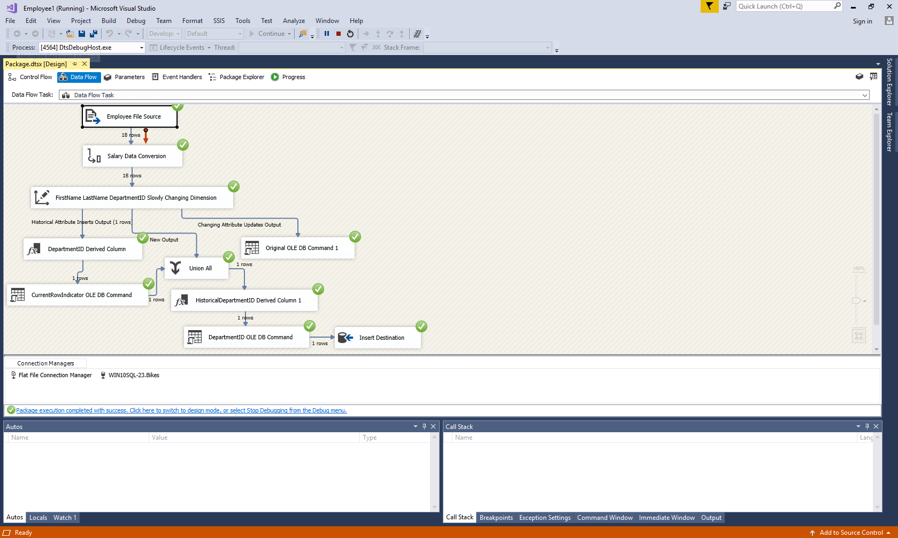

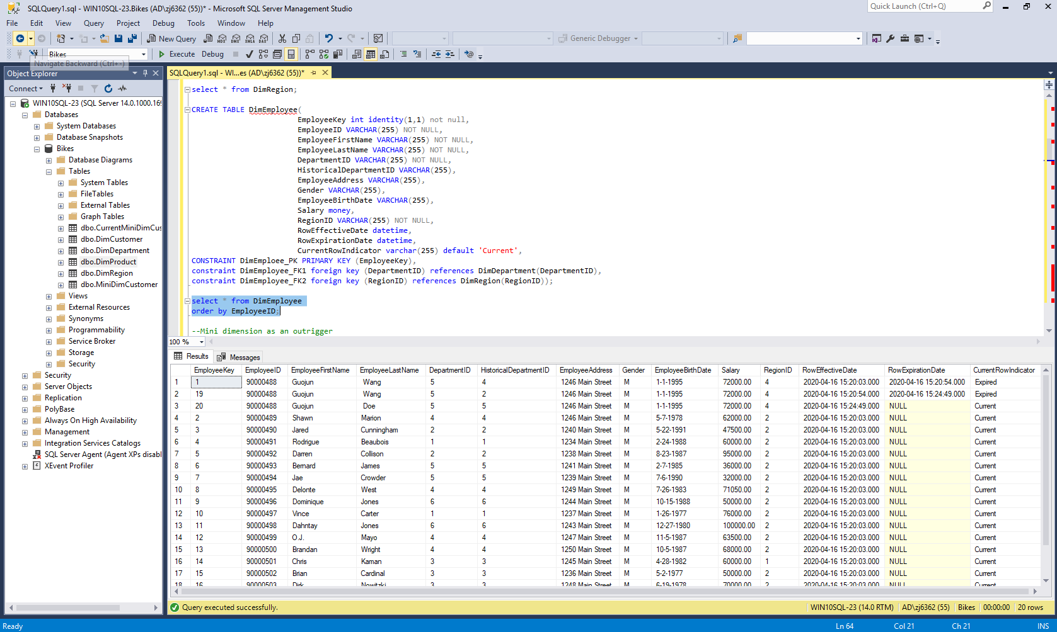

**Response 6:** Add following transactions in the SalesOrder source file. Submit the screenshot of the fact table after running your model.

40000197031,12-30-2014,30000100,1000000,99001006790,90000488,4,300.00

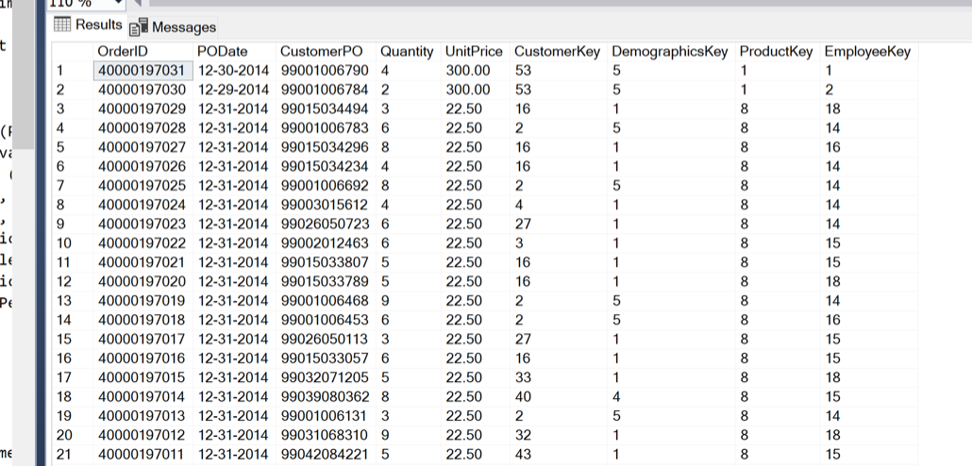

**Response 7:** Update the WholeSalePrice to 250.00 for ProductID 30000100 in the Product source file and save it. Submit the screenshot of the Product dimension after running your model.

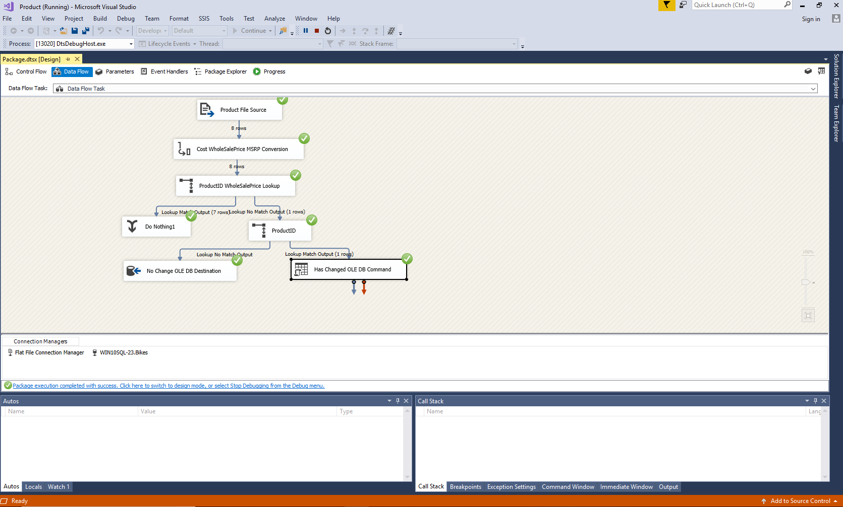

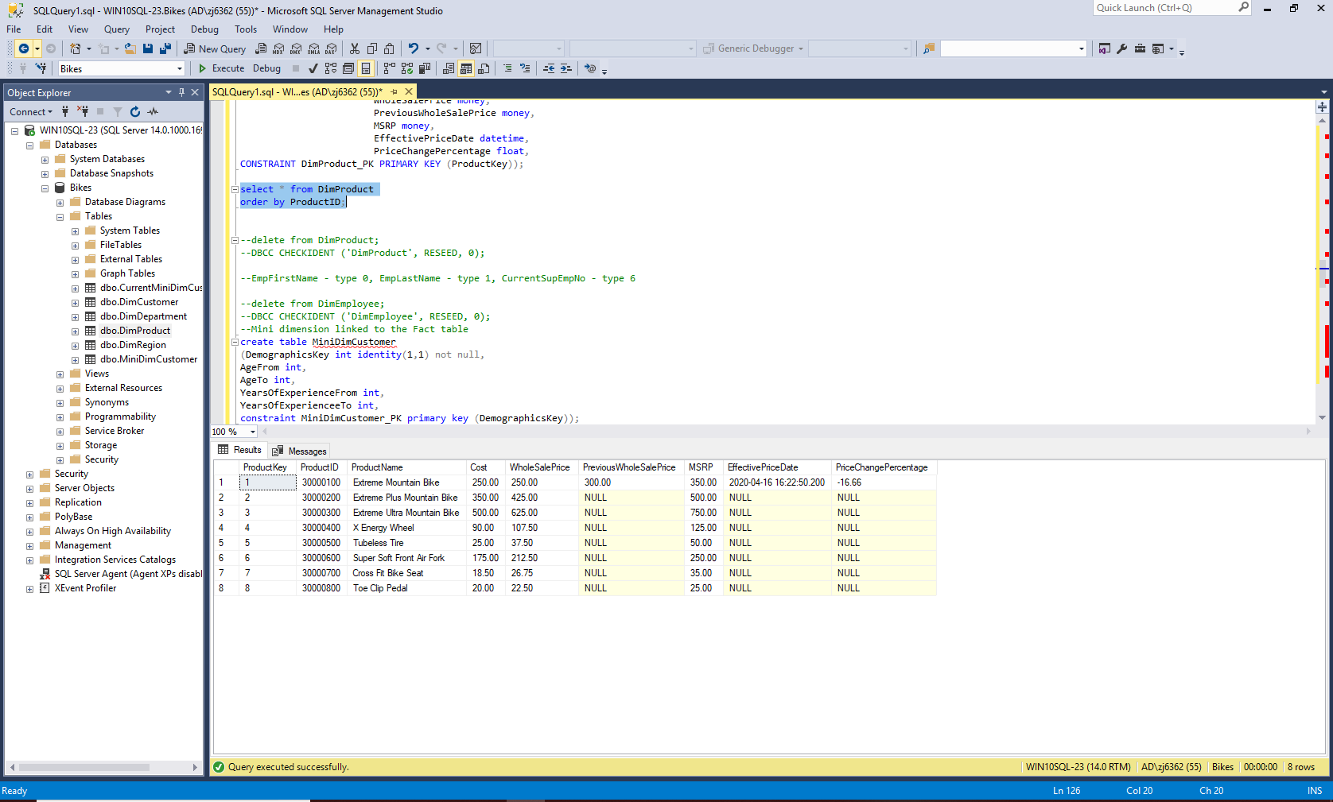

**Response 8:** Again update the WholeSalePrice to 350.00 for ProductID 30000100 in the Product source file and save it. Submit the screenshot of the Product dimension after running your model.

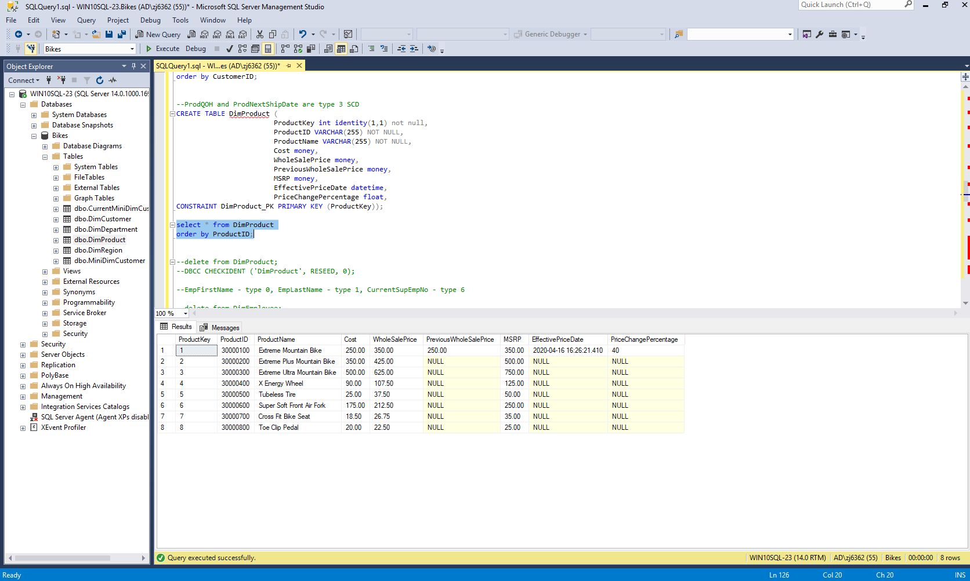

**Response 9:** Add following transactions in the SalesOrder source file. Submit the screenshot of the fact table after running your model.

40000197032,12-31-2014,30000100,1000000,99001006799,90000488,2,300.00

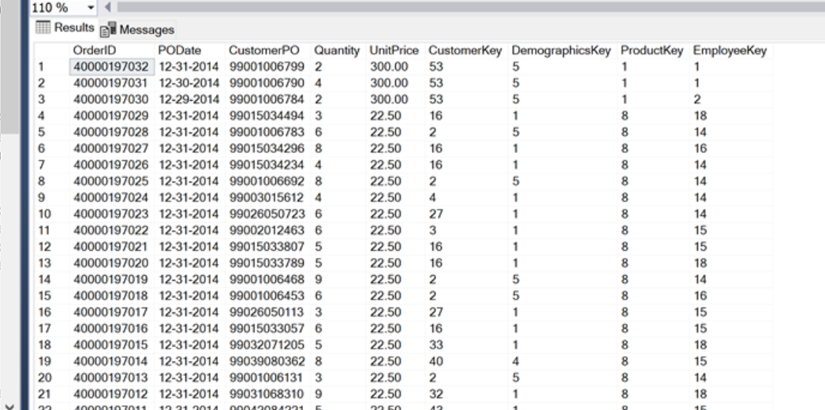

**Deliverables:**

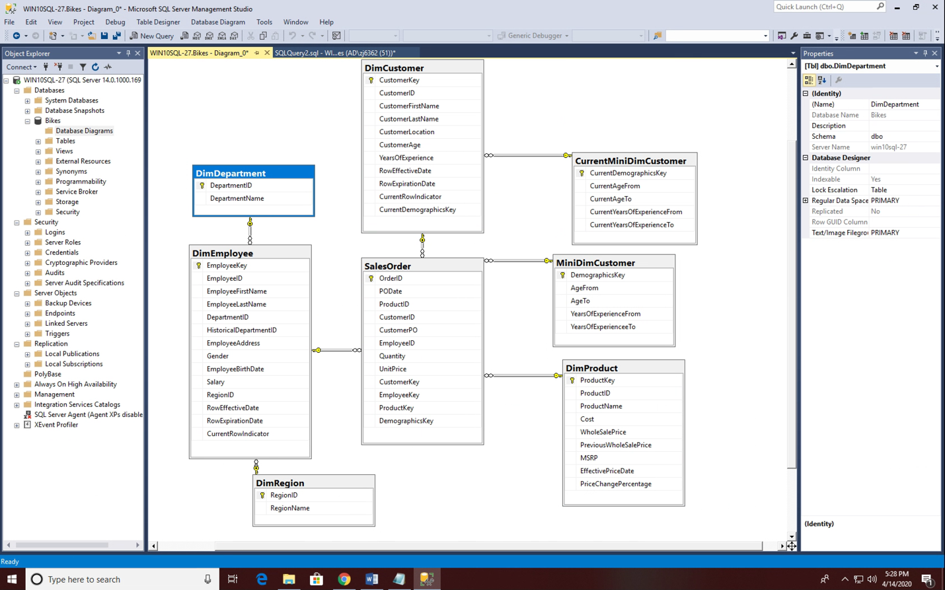

The data flow of Customer, Product, and Employee dimensions and also the SalesOrder fact table.