Mobile Application

**Internal Supervisor: Courtney Walker**

**Course: Special Project**

**Date: April 3, 2019**

|  |  |
| --- | --- |
| Name | ID Number |
| Timoy Wallace | 1600154344 |
| Jamone Moore | 1600200469 |
| Jevauhn Robinson | 1600196158 |

**Problem Definition**

Develop two sets of apps that will allow people to query artisans and small business within an area:

* One app based on PWA, will perform the admin functions.
* The other app will be used by the general public for both searching and submitting.

Details for Ads will be based on native-script.

* The application will use Geolocation push notifications.
* A simple Cloud Backend service will be created the Lecturer.

**Requirements**

Students are required to provide;

1. A specification document with Use Cases, Class Diagrams, Sequence Diagrams

and Storyboards.

2. Application Documentation; User Guide. Explain how the app works. Describe each

function.

3. PWA App for the Admin side of the application

4. Native-Script App for the customer side of the app

**Small Business Application**

Business Owner Admin

Customers

**Manage Business Registration –** The Trader/ Small Time Business owner has to register their place of operations. The registration will require a location, business name, contact information, listing of the services they are offering to customers. Administration speaks with the SME/ Trader to gather details about their business to ensure its legitimacy.

**Manage Stock/Services –** The Trader / Small time business owner will visit this page when they are adding, updating, delete or reading the stock, items, and services they offer which is available to customers.

**Manage Feedback /Reviews –** The customers are able to leave a review on any business; leaving a star rating, as well as a written review expressing valuable information for other on-looking customers. The SME/ Trader is able to Leave a comment on the customer’s review and view the customer’s review. The administration is able to keep the feedback/ review moderate, removing all explicit and another foul language.

**Search Product & Services -** The Customer is able to search and traverse through the listing of their “searched item/services” adding filters to rating, geolocation, pricing, etc…

**Listing Store Locate –** The customer is able to search for stores available in their geolocation, filtering the options and see the businesses within their area. The administration adds all SME/ Traders to the store listing allowing for every business to show on the store locations.

**Manage Store Listing -** The administration verifies the businesses legitimacy then enabling it to be available on the listing for customers.

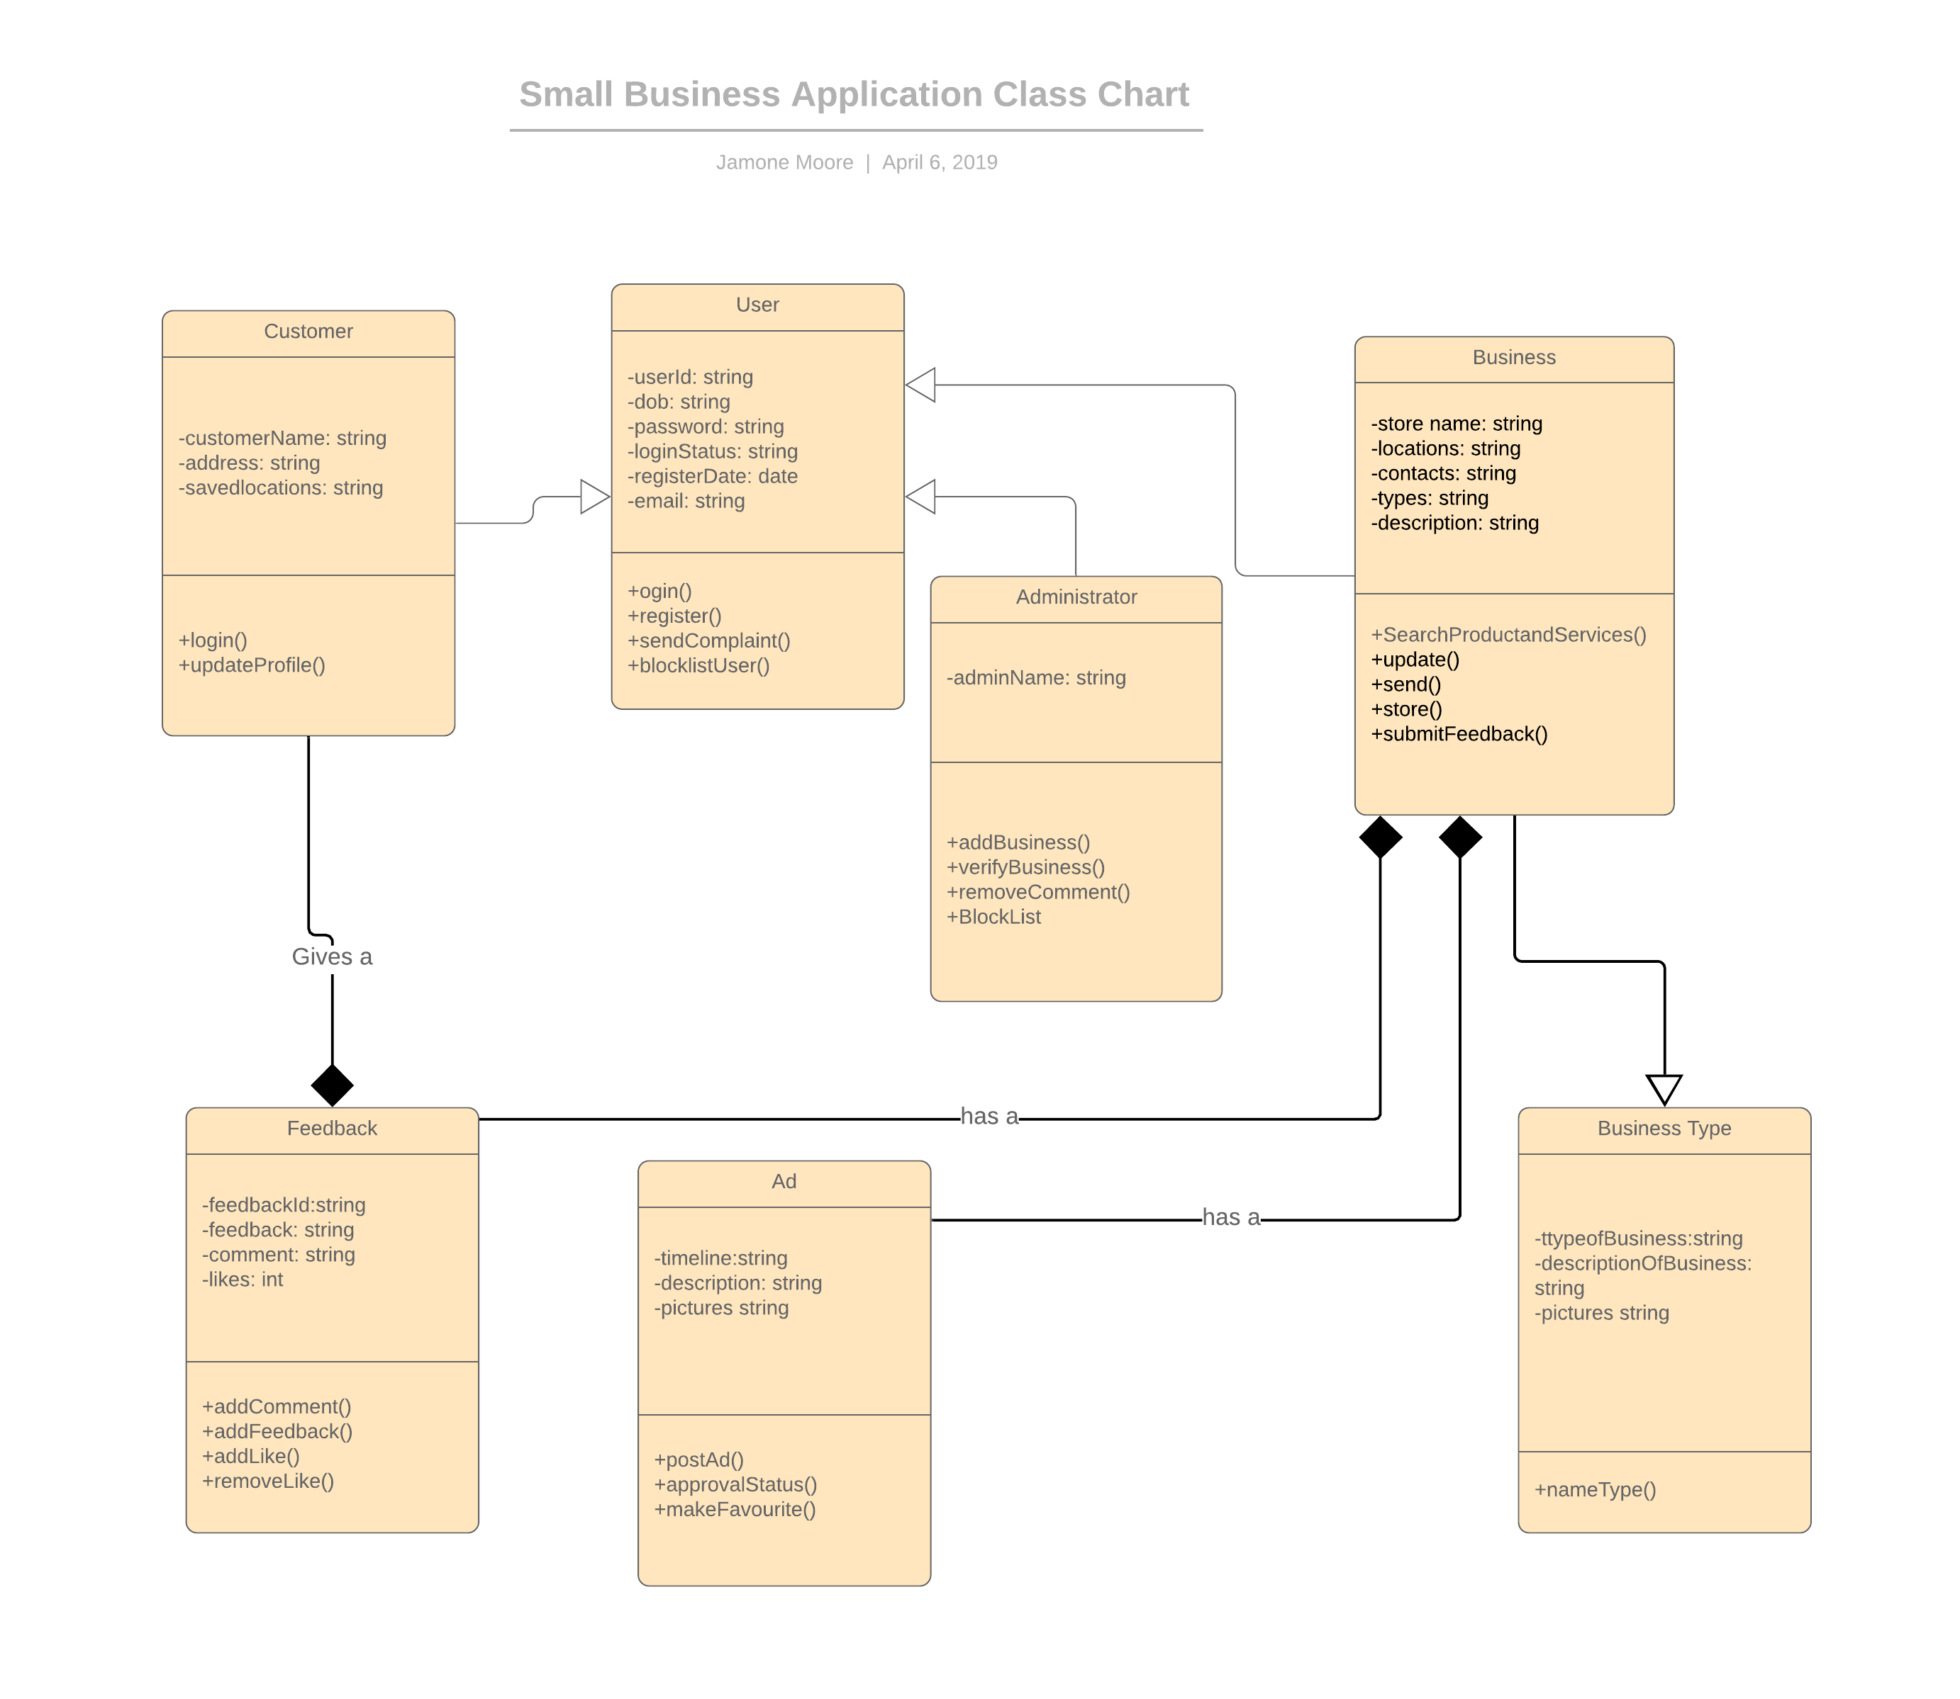

Sequence Chart

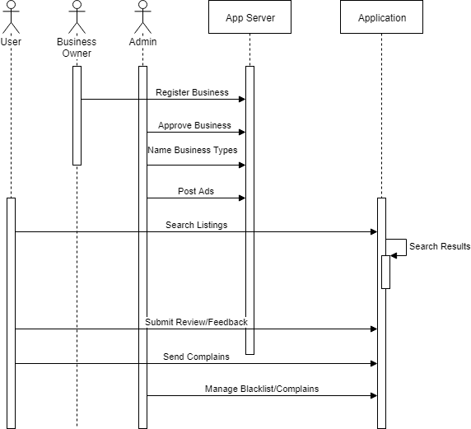

Story Board

|  |  |  |
| --- | --- | --- |
| Categories | | |
| Types of business | Types of Services | |
| * Hotel |  | |
| * Automobile Sale |  | |
| * Banking and Loan |  | |
| * Bars |  | |
| * Beauty Salons |  | |
| * Building Contractor |  | |
| * Auto Parts |  | |
| * Car Repair and Servicing |  | |
| * Cellphone Accessories, Equipment, and Repair |  | |
| * Coffee and Tea |  | |
| * Dentist |  | |
| * Dermatologist |  | |
| * Doctors |  | |
| * Electrical |  | |
| * Employment Agency | |  |
| * Florist | |  |
| * Funeral Homes and Directors | |  |
| * Gas Station | |  |
| * General Contractor | |  |
| * Guest House | |  |
| * Hospital | |  |
| * Insurance | |  |
| * Lawyer | |  |
| * Locksmith | |  |
| * Masseuse | |  |
| * Medical Equipment & Supplies | |  |
| * Nursery Child Care | |  |
| * Nursing Home | |  |
| * Party Supplies and Rental | |  |
| * Pet Shop | |  |
| * Pharmacies | |  |
| * Physiotherapist | |  |
| * Pizza | |  |
| * Plumbing | |  |
| * Real Estate | |  |
| * Reception | |  |

Appendix