Curriculum Design for Object-Oriented Programming
Date: June 2022
Instructor: Yanbing Chen, Rong Jin
Class: Computer Science and Technology English-Taught Class 22(1)
Student ID: 2022337621292
Name: 金坤东

Curriculum Design Requirement for Object-Oriented Programming
Table of Contents
1 Title
Distribution and Inventory Management System
2 Business flow diagram
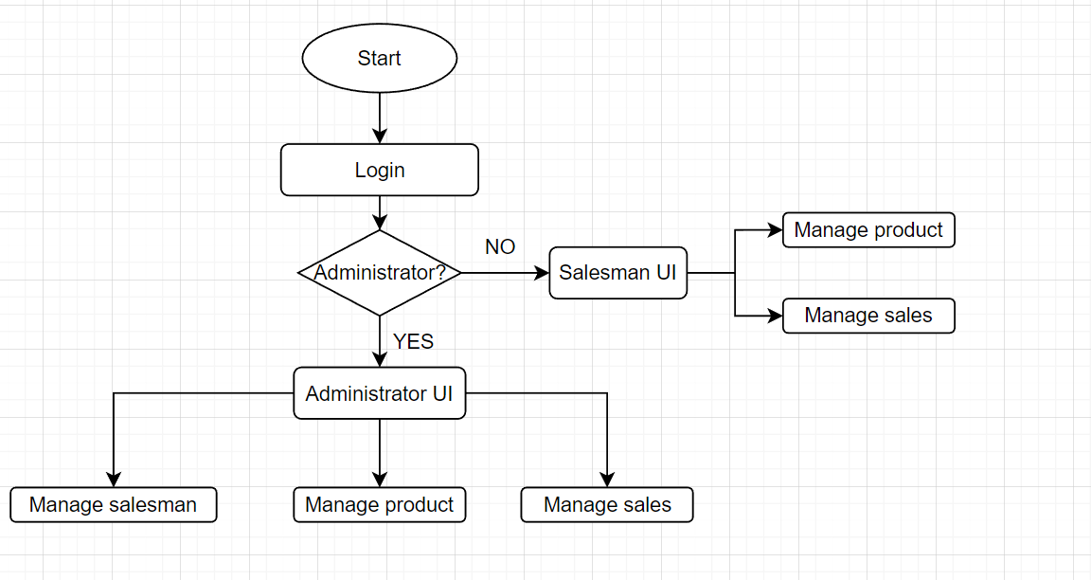
3 Design of Class
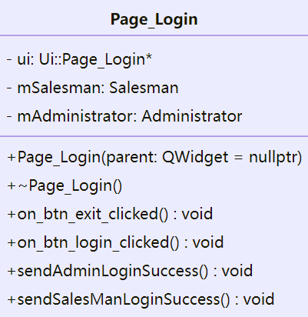

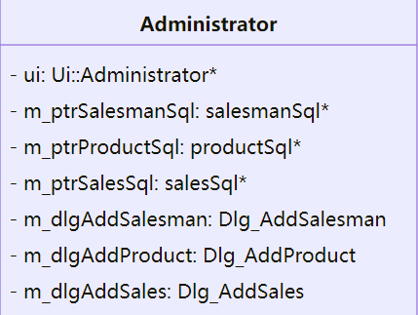
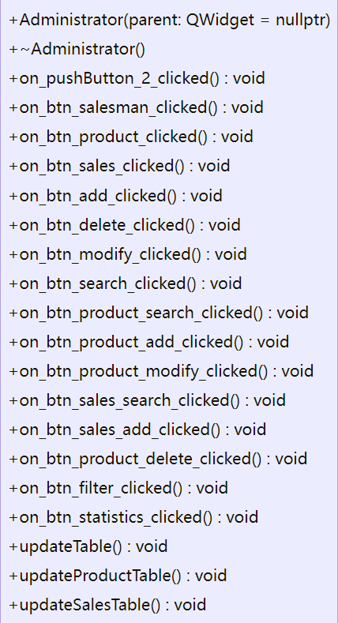
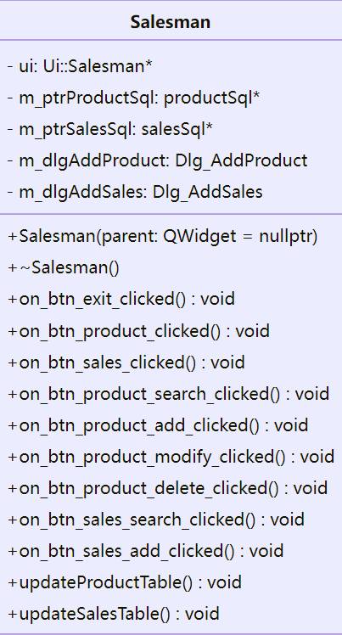
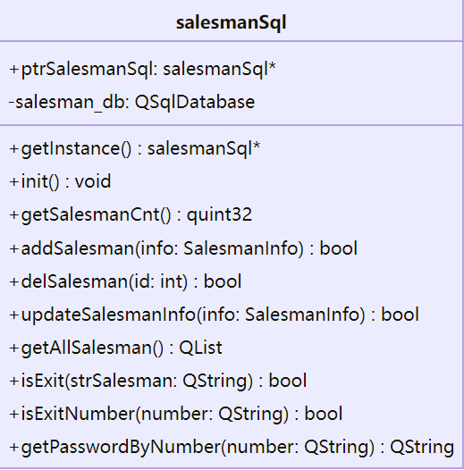
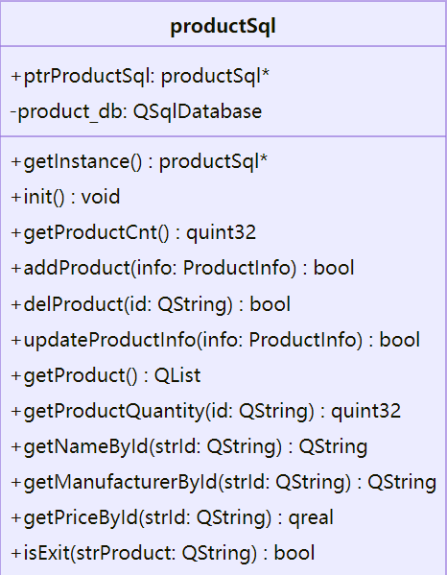
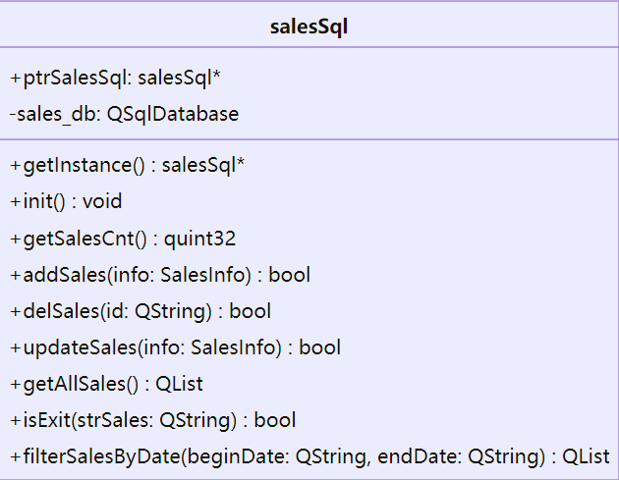
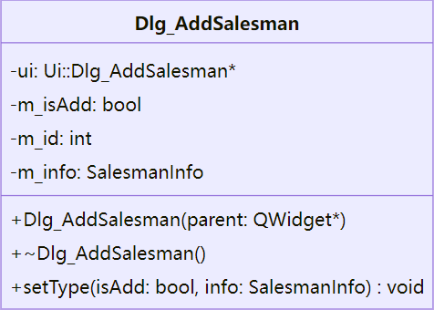
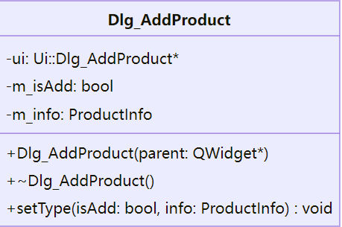
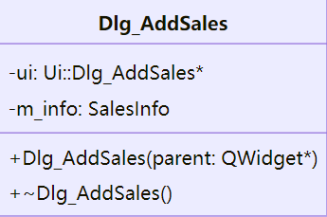
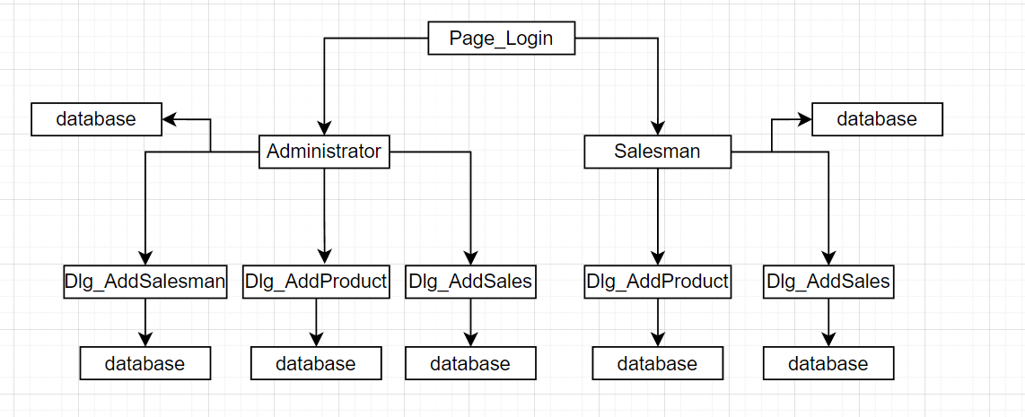
4 Source Code and Specification
Source code has been attached.
5 Output and Analysis
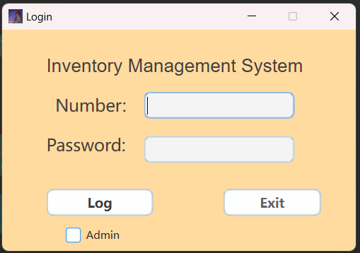
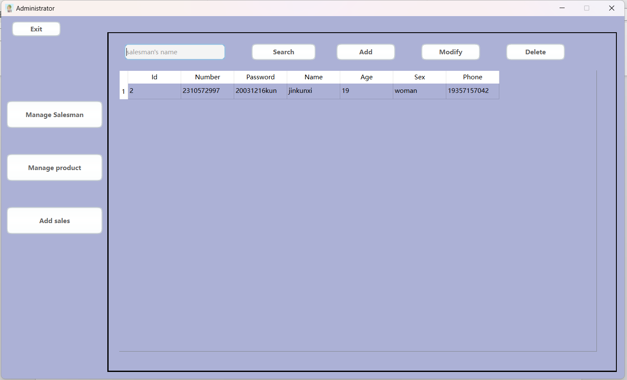
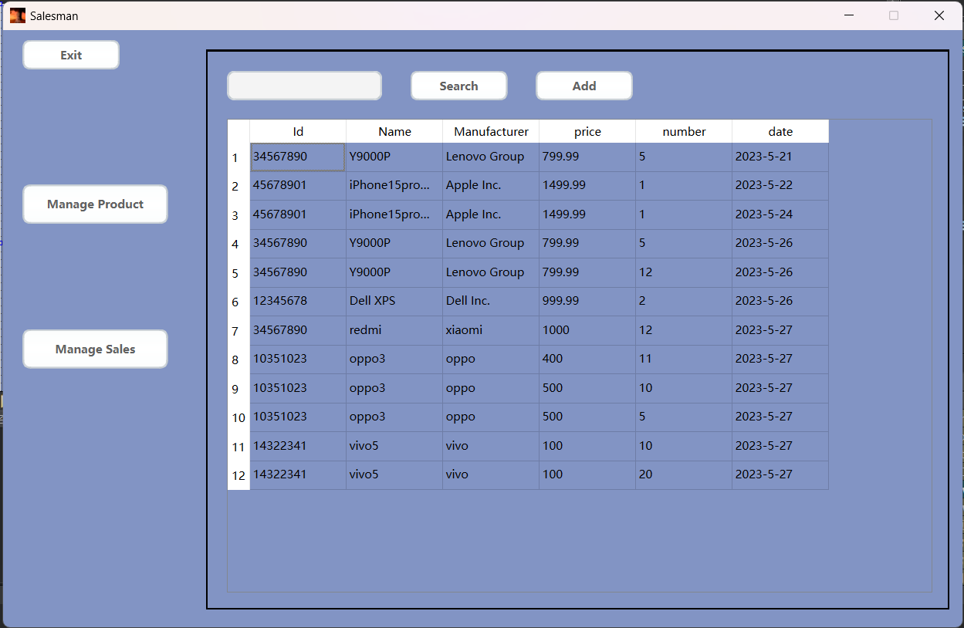
6 Conclusion
Qt is an environment based on C++ development that allows designers to easily create UI interactive interfaces. It has powerful built-in database plugin functionality, which enables me to seamlessly store user information, product data, and sales records in this management system.
In Qt, the switching between different interfaces is achieved through the association between classes, where one class contains objects of another class.

