Assignment 9

1. Task 1: Create a webpage using Bootstrap 5 (without using a template), build a front-end webpage and a back-end webpage, and pass parameters from the front-end to the back-end (PHP):

(1) Homepage, **index.html**

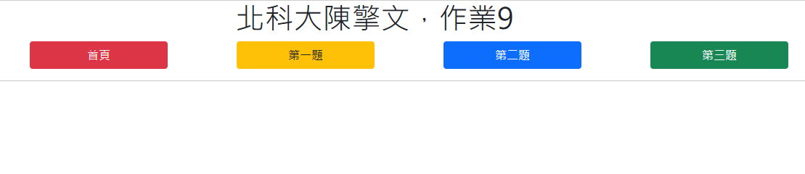

(2) Task 1: **a1.html**

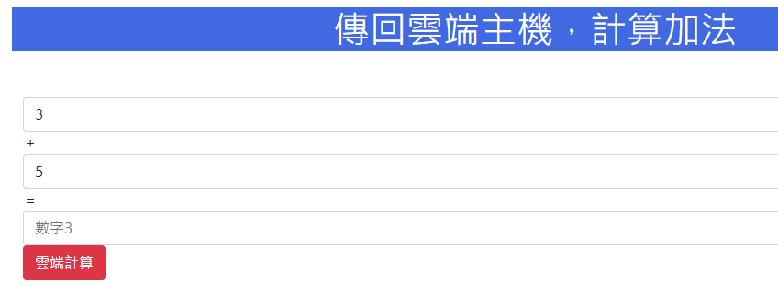

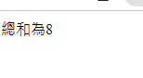

(3) Task 2: **a2.html**

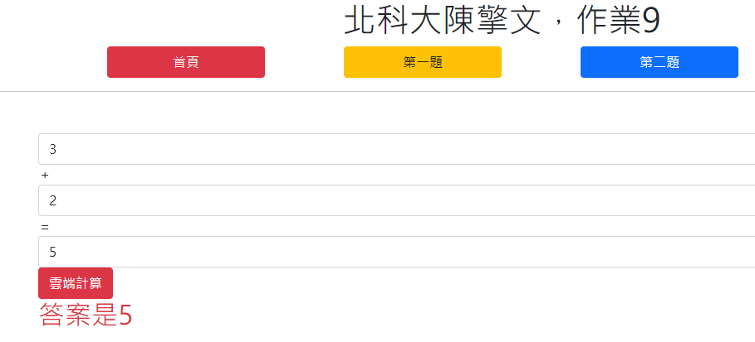

(4) Task 3: **a3.html**

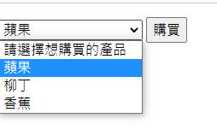

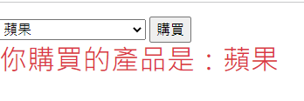

(5) Upload to the Byethost website (which can handle back-end pages, PHP).

(6) Upload the URL to the assignment section on Zuvio to complete the task.

