**Chapter 7 Using JavaScript and JavaApplet to create various special effects**

directory

1. Concept: Use JavaScript or JavaApplet to directly modify the code of the web page to create special effects 2

2. Concept: It's too difficult to write JavaScript/JavaApplet on your own, how to get started quickly: 4

3. Exercise 1: Where to copy JavaScript (js)/JavaApplet (java) web page syntax: 5

(1). **Method 1**: Go to Google and enter a keyword to search for a website:**JavaScript teaching** 5

(2). **Method 2**: Several well-known websites in China: The website is built with a treasure chest, Web Effects Gallery 5

4. Exercise 2: Create a snowstorm effect 6

5. Exercise 3: Move the marquee horizontally 10

6. Exercise 4: Preventing Stealing Images (Creating an Effect of Not Being Able to Right-Click to Download Images) 15

7. Exercise 5:Hidden menus 18

8. Exercise 6:Wavy text 23

9. Exercise 7:Mouse indicator stars around 26

10. Advice for beginners: 29

11. Exercise 2: Make a mouse clock 30

12. Exercise 3: Set the color of the reels 38

13. Exercise 5: Make the effect that the mouse over the image will fade away 43

14. Exercise 8:Java applet effect: Reflection in water 48

15. Exercise 9:Java applet effects: Put on the web online game: Russia Cubes 53

16. Exercise 10:Java applet effect: Ripples in the water 58

17. Exercise 11:Java applet effect: Snow scene 59

18. Exercise 12:Java Applet Effect: Projecting an image 60

# Concept: Use JavaScript or JavaApplet to directly modify the code of the web page to create special effects

There are several ways to create effects in Dreamweaver

|  |
| --- |
| (1). **Use behavioral effects, Dreamweaver provides more than 10 kinds of special effects**  **(2). Use the Extension plug-in component to import the mxp file**  **(3). Use Spry function (Spry Menu Column, Spry Tab Panel, Spry Foldable, Collapsible Panel)**  **(4).Use JavaScript or JavaApplet to directly modify the code of the web page to create special effects** |

**(1). Use behavioral effects, Dreamweaver provides more than 10 kinds of special effects**

There are only 10 kinds of behavioral effects provided in Dreamweaver, which sometimes cannot meet the needs of various web designers to design various web dynamic effects

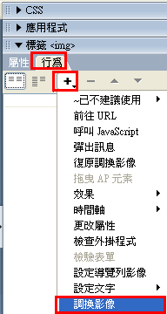

**(2). Use the Extension plug-in to import the mxp file**

Dreamweaver provides an extension, which is an add-on component that allows the user to download the components he wants to make various web effects like 'behavioral effects'.

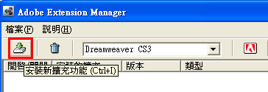

**(3). Use Spry function (Spry Menu Column, Spry Tab Panel, Spry Foldable, Collapsible Panel)**

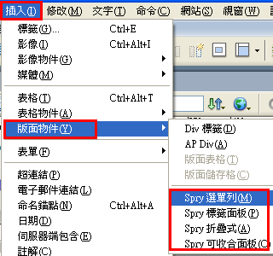

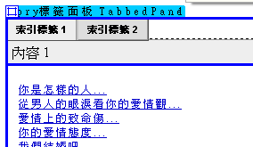

**(4). Use JavaScript or JavaApplet to directly modify the web code to make special effects**

JavaApplet and JavaScript are also interactive web design tools, which provide two ways to build them in Dreamweaver

* Insert an external 'JavaApplet with JavaScript' component method
* Dreamweaver has a built-in way to use the 'JavaApplet and JavaScript' component

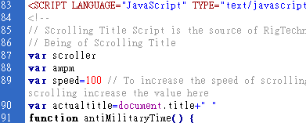

# Concept: It's too difficult to write JavaScript/JavaApplet on your own, how to get started quickly:

It is difficult for a beginner to write JavaScript/JavaApplet on his own

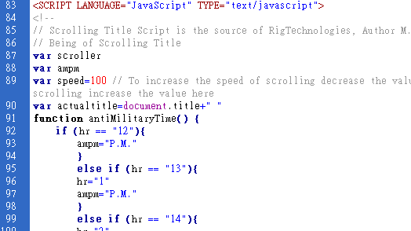

However, many people have written the grammar of various special effects functions, put them on the Internet, and provided them to netizens for free to copy and paste

So, basically, as long as you read the instructions for using the special effect, copy and paste, and then modify the parameters

How to get started quickly

# Exercise 1: Where to copy JavaScript (js)/JavaApplet (java) web page syntax:

## **Method 1**: Go to Google and enter a keyword to search for a website: **JavaScript Tutorial**

Downloadable (almost always free)

Search keyword 1: **JavaScript teaching**

Search keyword 2: **js teaching**

Search keyword 3: **JavaApplet teaching**

## **Method 2**: Several well-known websites in China: The website builds a treasure chest, a [web special effects museum](http://sn007395h.xxking.com/java_script.htm)

The website is built with a treasure chest

<http://ip194097.ntcu.edu.tw/course/x/2010/bang-iah/pah-po-siuN/>

[**Web Effects Pavilion**](http://sn007395h.xxking.com/java_script.htm) website:<http://sn007395h.xxking.com/java_script.htm>

# Exercise 2: Create a snowstorm effect

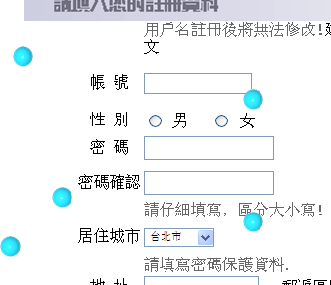

Turn on the Work1.html

Go to the website to build a treasure chest

<http://dob.tnc.edu.tw/>

Module: Select "Java Script"



<http://dob.tnc.edu.tw/themes/old/showPage.php?s=3519&t=6&at=9>

Let's take a look at the examples



How to use:

**Step 1:**

Copy the code

|  |
| --- |
| onload="snow(); " |

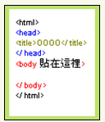

Stick it on the inside of the < body >

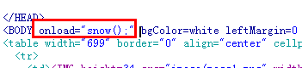

**Step 2:**

Copy the code

|  |
| --- |
| <script type="text/javascript">  // 程式作者：風痕影（hit1205@m70.url.com.tw）  // 作者網站：風痕水影（http://hit1205.blogdns.org/）  // 製作日期：2004年11月15-17日  // 更新日期：v1.1 2004年12月25日  n=6; // 雪花數目  wind=0; // 風力  re=60; // 更新  vy=4; // 雪花速度  vx=4; // 搖晃程度  img="http://dob.tnc.edu.tw/authorHD/1/snow.gif"; // 圖檔  img_h=30; // 雪花高  h=250; // 效果範圍高  w=300; // 效果範圍寬  for(i=0;i<n;i++){document.write("<div id=\"snow"+i+"\" style=\"position:absolute;top:-"+(Math.random()*h+img_h)+"px;left:"+Math.random()*(w-img_h)+"px;\"><img src=\""+img+"\" border=\"0\"></div>");}  function snow(){  for(i=0;i<n;i++){  dgs=document.getElementById("snow"+i).style;  if((parseInt(dgs.top)<h)&&(parseInt(dgs.left)<w)&&(parseInt(dgs.left)>-img_h)){  if(Math.round(Math.random())==1){o=1;}else{o=-1;}  dgs.top=parseInt(dgs.top)+vy+"px";  dgs.left=parseInt(dgs.left)+Math.random()*vx*o+wind+"px";  }  else{  dgs.top=-(Math.random()*h+img_h)+"px";  dgs.left=Math.random()*(w-img_h)+"px";  }  }  setTimeout("snow();",re);  }  </script> |

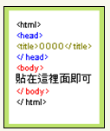

Paste it on <body>.....</body>

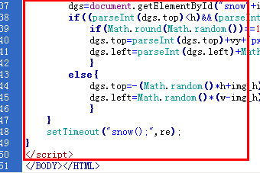

outcome



# Exercise 3: Move the marquee horizontally

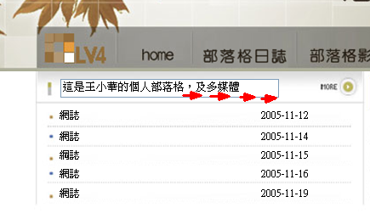

Start Work2 .html

Go to the website to build a treasure chest

<http://dob.tnc.edu.tw/>

Module: Select "Java Script"



<http://dob.tnc.edu.tw/themes/old/showPage.php?s=69&t=6&at=4>

Let's take a look at the examples



How to use:

**Step 1:**

Copy the code

|  |
| --- |
| <SCRIPT Language="JavaScript">  var msg="這是用JAVA Script 所做出來的跑馬燈，打字效果的喔！";  var interval = 100;  seq = 0;  function Scroll() {  document.tmForm.tmText.value = msg.substring(0, seq+1);  seq++;  if ( seq >= msg.length ) { seq = 0 };  window.setTimeout("Scroll();", interval );  }  </SCRIPT> |

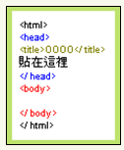

Stick it in front of the </head>

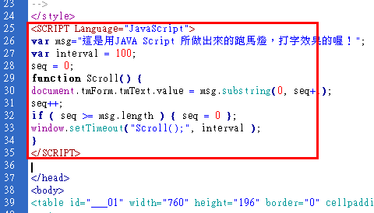

**Step 2:**

Copy the code

|  |
| --- |
| OnLoad="Scroll(); " |

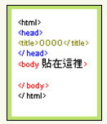

Stick it in front of the </head>

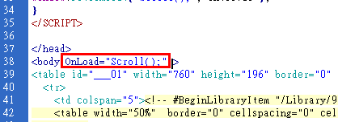

**Step 3:**

Copy the code

|  |
| --- |
| <FORM Name=tmForm><INPUT Type=Text Name=tmText Size=35></FORM> |

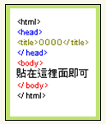

First, click on the location where you want to place the marquee

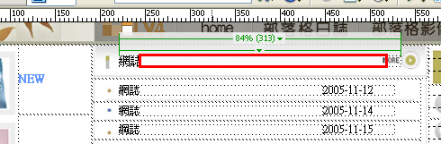

Then switch to the code area and paste the syntax

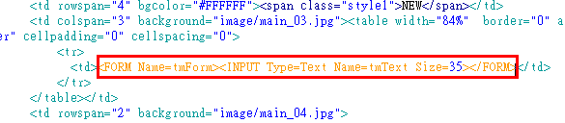

Result, preview

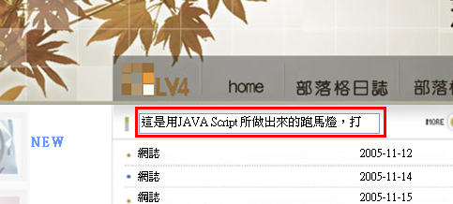

Modify the text

|  |
| --- |
| 這是王小華的個人部落格，及多媒體工作室網站！ |

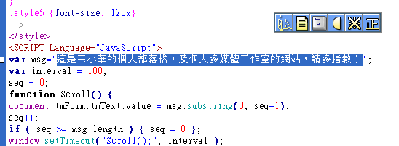

Preview the results



# Exercise 4: Preventing Stealing Images (Creating an Effect of Not Being Able to Right-Click to Download Images)

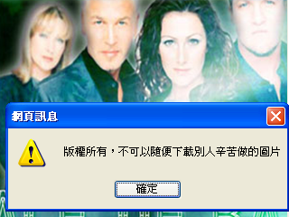

Images placed on a web page can easily be right-clicked "Save Image"

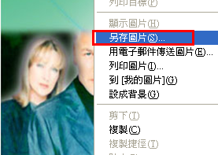

Turn on work3.html

How can I prevent stealing images?

Method 1: Lock the right mouse button

Go to the website to build a treasure chest

<http://dob.tnc.edu.tw/>

Module: Select "Java Script"

Select Column: Mouse Cursor

Article: New Mouse Clock



<http://dob.tnc.edu.tw/themes/old/showPage.php?s=367&t=6&at=2>

Let's take a look at the examples



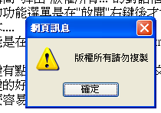

How to use:

|  |
| --- |
| oncontextmenu="window.event.returnValue=false;alert('版權所有請勿複製')" |

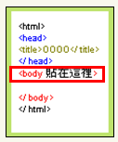

Copy the code



Attach it to < body ............> the inside

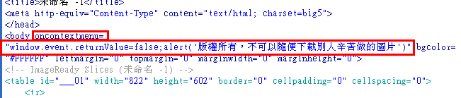

Modify the warning text: All rights reserved, you can't just download the pictures that others have worked hard to make

As a result, browse



# Exercise 5: Hidden menus

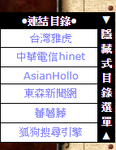

Go to [**the Web Effects Pavilion**](http://sn007395h.xxking.com/java_script.htm) website:<http://sn007395h.xxking.com/javaback/link/01.htm>

Enable the index .html

Step 1: Copy the code

|  |
| --- |
| <!--隱藏式連結選單_開始-->  <STYLE>  <!--  A.ssmItems:link {color:8080ff;text-decoration:none;/*超連結文字*/}  A.ssmItems:hover {color:8080ff;text-decoration:none;/*瀏覽過的連結文字*/ }  A.ssmItems:active {color:8080ff;text-decoration:none;/*按下連結的格式*/}  A.ssmItems:visited {color:8080ff;text-decoration:none;/*滑鼠移至連結*/}  //-->  </STYLE>  <!--主程式_開始--切勿刪除!!!-->  <script language="JavaScript">  <!--  NS6 = (document.getElementById&&!document.all)  IE = (document.all)  NS = (navigator.appName=="Netscape" && navigator.appVersion.charAt(0)=="4")  tempBar='';barBuilt=0;ssmItems=new Array();  moving=setTimeout('null',1)  function moveOut() {  if ((NS6||NS)&&parseInt(ssm.left)<0 || IE && ssm.pixelLeft<0) {  clearTimeout(moving);moving = setTimeout('moveOut()', slideSpeed);slideMenu(10)}  else {clearTimeout(moving);moving=setTimeout('null',1)}};  function moveBack() {clearTimeout(moving);moving = setTimeout('moveBack1()', waitTime)}  function moveBack1() {  if ((NS6||NS) && parseInt(ssm.left)>(-menuWidth) || IE && ssm.pixelLeft>(-menuWidth)) {  clearTimeout(moving);moving = setTimeout('moveBack1()', slideSpeed);slideMenu(-10)}  else {clearTimeout(moving);moving=setTimeout('null',1)}}  function slideMenu(num){  if (IE) {ssm.pixelLeft += num;}  if (NS||NS6) {ssm.left = parseInt(ssm.left)+num;}  if (NS) {bssm.clip.right+=num;bssm2.clip.right+=num;}}  function makeStatic() {  if (NS||NS6) {winY = window.pageYOffset;}  if (IE) {winY = document.body.scrollTop;}  if (NS6||IE||NS) {  if (winY!=lastY&&winY>YOffset-staticYOffset) {  smooth = .2 * (winY - lastY - YOffset + staticYOffset);}  else if (YOffset-staticYOffset+lastY>YOffset-staticYOffset) {  smooth = .2 * (winY - lastY - (YOffset-(YOffset-winY)));}  else {smooth=0}  if(smooth > 0) smooth = Math.ceil(smooth);  else smooth = Math.floor(smooth);  if (IE) bssm.pixelTop+=smooth;  if (NS6||NS) bssm.top=parseInt(bssm.top)+smooth  lastY = lastY+smooth;  setTimeout('makeStatic()', 1)}}  function buildBar() {  if(barText.indexOf('<IMG')>-1) {tempBar=barText}  else{for (b=0;b<barText.length;b++) {tempBar+=barText.charAt(b)+"<BR>"}}  document.write('<td align="center" rowspan="100" width="'+barWidth+'" bgcolor="'+barBGColor+'" valign="'+barVAlign+'"><p align="center"><font face="'+barFontFamily+'" Size="'+barFontSize+'" COLOR="'+barFontColor+'"><B>'+tempBar+'</B></font></p></TD>')}  function initSlide() {  if (NS6){ssm=document.getElementById("thessm").style;bssm=document.getElementById("basessm").style;  bssm.clip="rect(0 "+document.getElementById("thessm").offsetWidth+" "+document.getElementById("thessm").offsetHeight+" 0)";ssm.visibility="visible";}  else if (IE) {ssm=document.all("thessm").style;bssm=document.all("basessm").style  bssm.clip="rect(0 "+thessm.offsetWidth+" "+thessm.offsetHeight+" 0)";bssm.visibility = "visible";}  else if (NS) {bssm=document.layers["basessm1"];  bssm2=bssm.document.layers["basessm2"];ssm=bssm2.document.layers["thessm"];  bssm2.clip.left=0;ssm.visibility = "show";}  if (menuIsStatic=="yes") makeStatic();}  function buildMenu() {  if (IE||NS6) {document.write('<DIV ID="basessm" style="visibility:hidden;Position : Absolute ;Left : '+XOffset+' ;Top : '+YOffset+' ;Z-Index : 20;width:'+(menuWidth+barWidth+10)+'"><DIV ID="thessm" style="Position : Absolute ;Left : '+(-menuWidth)+' ;Top : 0 ;Z-Index : 20;" onmouseover="moveOut()" onmouseout="moveBack()">')}  if (NS) {document.write('<LAYER name="basessm1" top="'+YOffset+'" LEFT='+XOffset+' visibility="show"><ILAYER name="basessm2"><LAYER visibility="hide" name="thessm" bgcolor="'+menuBGColor+'" left="'+(-menuWidth)+'" onmouseover="moveOut()" onmouseout="moveBack()">')}  if (NS6){document.write('<table border="0" cellpadding="0" cellspacing="0" width="'+(menuWidth+barWidth+2)+'" bgcolor="'+menuBGColor+'"><TR><TD>')}  document.write('<table border="0" cellpadding="0" cellspacing="1" width="'+(menuWidth+barWidth+2)+'" bgcolor="'+menuBGColor+'">');  for(i=0;i<ssmItems.length;i++) {  if(!ssmItems[i][3]){ssmItems[i][3]=menuCols;ssmItems[i][5]=menuWidth-1}  else if(ssmItems[i][3]!=menuCols)ssmItems[i][5]=Math.round(menuWidth*(ssmItems[i][3]/menuCols)-1);  if(ssmItems[i-1]&&ssmItems[i-1][4]!="no"){document.write('<TR>')}  if(!ssmItems[i][1]){  document.write('<td bgcolor="'+hdrBGColor+'" HEIGHT="'+hdrHeight+'" ALIGN="'+hdrAlign+'" VALIGN="'+hdrVAlign+'" WIDTH="'+ssmItems[i][5]+'" COLSPAN="'+ssmItems[i][3]+'"> <font face="'+hdrFontFamily+'" Size="'+hdrFontSize+'" COLOR="'+hdrFontColor+'"><b>'+ssmItems[i][0]+'</b></font></td>')}  else {if(!ssmItems[i][2])ssmItems[i][2]=linkTarget;  document.write('<TD BGCOLOR="'+linkBGColor+'" onmouseover="bgColor=\''+linkOverBGColor+'\'" onmouseout="bgColor=\''+linkBGColor+'\'" WIDTH="'+ssmItems[i][5]+'" COLSPAN="'+ssmItems[i][3]+'"><ILAYER><LAYER onmouseover="bgColor=\''+linkOverBGColor+'\'" onmouseout="bgColor=\''+linkBGColor+'\'" WIDTH="100%" ALIGN="'+linkAlign+'"><DIV ALIGN="'+linkAlign+'"><FONT face="'+linkFontFamily+'" Size="'+linkFontSize+'"> <A HREF="'+ssmItems[i][1]+'" target="'+ssmItems[i][2]+'" CLASS="ssmItems">'+ssmItems[i][0]+'</DIV></LAYER></ILAYER></TD>')}  if(ssmItems[i][4]!="no"&&barBuilt==0){buildBar();barBuilt=1}  if(ssmItems[i][4]!="no"){document.write('</TR>')}}  document.write('</table>')  if (NS6){document.write('</TD></TR></TABLE>')}  if (IE||NS6) {document.write('</DIV></DIV>')}  if (NS) {document.write('</LAYER></ILAYER></LAYER>')}  theleft=-menuWidth;lastY=0;setTimeout('initSlide();', 1)}  -->  </script>  <!--主程式_結束--切勿刪除!!!-->  <script>  <!--  <!--YOffset=95;設定選單距離從上面算下來的位置-->  YOffset=95;  <!--XOffset=0;設定選單距離從左邊算過來的位置-->  XOffset=0;  staticYOffset=30;  slideSpeed=20  waitTime=100;  <!--menuBGColor="#000000";設定選單外框顏色-->  menuBGColor="#000000";  menuIsStatic="yes";  <!--menuWidth=100;設定選單的寬度-->  menuWidth=100;  menuCols=2;  <!--hdrFontFamily="verdana";設定連結目錄區域的字型-->  hdrFontFamily="verdana";  <!--hdrFontSize="2";設定連結目錄區域的字體大小-->  hdrFontSize="2";  <!--hdrFontColor="#FFFFFF";設定選單目錄標題文字顏色-->  hdrFontColor="#FFFFFF";  <!--hdrBGColor="#000000";設定選單目錄標題背景顏色-->  hdrBGColor="#000000";  hdrAlign="center";  hdrVAlign="center";  <!--hdrHeight="10";設定選單目錄區域的高度-->  hdrHeight="10";  <!--linkFontFamily="Verdana";設定連結文字區域的字型-->  linkFontFamily="Verdana";  <!--linkFontSize="2";設定連結文字區域的字體大小-->  linkFontSize="2";  <!--linkBGColor="#FFFFFF";;設定選單連結項目區域背景顏色-->  linkBGColor="#FFFFFF";  <!--linkOverBGColor="#cccccc";設定滑鼠指標移至連結區域的背景顏色-->  linkOverBGColor="#cccccc";  <!--linkTarget="_blank";設定視窗開啟的方式，blank表示為開新視窗連結，top表示為在同一視窗開啟-->  linkTarget="_blank";  <!--linkAlign="center";設定連結的文字顯示的區域，center為置中-->  linkAlign="center";  <!--barBGColor="#000000";設定目錄選單的背景顏色-->  barBGColor="#000000";  <!--barFontFamily="Verdana";設定文字的字型-->  barFontFamily="Verdana";  <!--barFontSize="2";設定文字的大小-->  barFontSize="2";  <!--barFontColor="#FFFFFF";設定目錄選單的文字顏色-->  barFontColor="#FFFFFF";  barVAlign="center";  <!--barWidth=20;設定★隱藏式目錄選單★區域的寬度-->  barWidth=20;  <!--在barText="★隱藏式目錄選單★";中修改目錄選單須顯示的文字-->  barText="★隱藏式目錄選單★";  <!--在ssmItems[0]=["+連結目錄+"]中修改顯示連結目錄的文字-->  ssmItems[0]=["+連結目錄+"]  <!--設定連結網址文字_開始-->  ssmItems[1]=["連結名稱", "連結網址"]  ssmItems[2]=["連結名稱", "連結網址"]  ssmItems[3]=["連結名稱", "連結網址"]  ssmItems[4]=["連結名稱", "連結網址"]  ssmItems[5]=["連結名稱", "連結網址"]  ssmItems[6]=["連結名稱", "連結網址"]  <!--設定連結網址文字_結束-->  buildMenu();  -->  </script>  <!--隱藏式連結選單_結束--> |



Paste it on <head>...... </head>

Modify the hyperlink text and the hyperlink URL

<!-- set the link URL text_start-->

ssmItems[1]=["link name", "link URL"]

ssmItems[2]=["link name", "link URL"]

ssmItems[3]=["link name", "link URL"]

ssmItems[4]=["link name", "link URL"]

ssmItems[5]=["link name", "link URL"]

ssmItems[6]=["link name", "link URL"]

<!-- set the link URL text_end-->

For example:

Yahoo website

*[https://tw.yahoo.com](https://tw.yahoo.com/)*

As a result, browse



# Exercise 6: Wavy text



Go to [**the Web Effects Gallery**](http://sn007395h.xxking.com/java_script.htm) website:<http://sn007395h.xxking.com/javaback/word/13.htm>

Enable the index .html

Step 1: Copy the code

|  |
| --- |
| <!--波浪文字_開始-->  <script language="JavaScript">  <!--  <!--在此修改文字的內容-->  message="網頁特效語法 http://asianhollo.com"  ns6switch=1  var ns6=document.getElementById&&!document.all  mes=new Array();  mes[0]=-2;  mes[1]=-5;  mes[2]=-8;  mes[3]=-11;  mes[4]=-14;  mes[5]=-11;  mes[6]=-8;  mes[7]=-5;  mes[8]=-2;  num=0;  num2=0;  txt="";  function jump0(){  if (ns6&&!ns6switch){  jump.innerHTML=message  return  }  if(message.length > 6){  for(i=0; i != message.length;i++){  txt=txt+"<span style='position:relative;' id='n"+i+"'>"+message.charAt(i)+"</span>"};  jump.innerHTML=txt;  txt="";  jump1a()  }  else{  alert("您輸入的文字太少 !")  }  }  function jump1a(){  nfinal=(document.getElementById)? document.getElementById("n0") : document.all.n0  nfinal.style.left=-num2;  if(num2 != 9){  num2=num2+3;  setTimeout("jump1a()",50)  }  else{  jump1b()  }  }  function jump1b(){  nfinal.style.left=-num2;  if(num2 != 0){num2=num2-3;  setTimeout("jump1b()",50)  }  else{  jump2()  }  }  function jump2(){  txt="";  for(i=0;i != message.length;i++){  if(i+num > -1 && i+num < 70){  txt=txt+"<span style='position:relative;top:"+mes[i+num]+"'>"+message.charAt(i)+"</span>"  }  else{txt=txt+"<span>"+message.charAt(i)+"</span>"}  }  jump.innerHTML=txt;  txt="";  if(num != (-message.length)){  num--;  setTimeout("jump2()",50)}  else{num=0;  setTimeout("jump0()",50)}}  -->  </script>  <div id="jumpx" align="center" style="font-family:細明體;color:#000000;font-size:15pt"></div>  <script language="JavaScript">  <!--  if (document.all||document.getElementById){  jump=(document.getElementById)? document.getElementById("jumpx") : document.all.jumpx  jump0()  }  else  document.write(message)  -->  </script>  <!--波浪文字_結束--> |



Paste it on <body>...... Copyright caption between </body>

The full Copyright© Statement

If you write more formally and completely, the correct way to write it is this, we provide the Chinese and English versions:

© Copyright [year] [owner]

| **Company name** | **Copyright Notice** |
| --- | --- |
| [Apple](https://www.apple.com/tw/) | Copyright © 2022 Apple Inc. All Rights Reserved. |
| [Facebook](https://www.facebook.com/) | Privacy Policy · Terms of Service · Advertising · Ad Choices · Cookie · · Meta © 2022 |
| [Samsung](https://www.samsung.com/tw/) | © 1995-2022 Taiwan Samsung Electronics Co., Ltd. All rights reserved |
| [McDonald's](https://www.mcdonalds.com/) | © 2017 – 2022 McDonald’s. All Rights Reserved. |
| [LINE](https://line.me/) | © LINE Corporation |

As a result, browse



# Exercise 7: Mouse indicator stars around

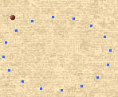

Go to [**the Web Effects Pavilion**](http://sn007395h.xxking.com/java_script.htm) website:<http://sn007395h.xxking.com/javaback/mouse/20.htm>

Enable the index .html

Step 1: Copy the code

|  |
| --- |
| <!--星點圍繞_開始-->  <script language="JavaScript">  <!--  CoLoUrS=new Array('00ff00','ff00ff','fff000','3366ff');  var step=0.3,a_StEp=0.05,RunTime=0,currStep=0,Xpos=0,Ypos=0,cntr=70,count_a=0;  var count=0,move=1,Ay=0,Ax=0,dots=16;var x;brwsr=(document.layers)?1:0;  if (brwsr){  for (i=0; i < dots; i++){  document.write('<LAYER NAME="a'+i+'" LEFT=0 TOP=0 BGCOLOR=#3366ff CLIP="0,0,3,3"></LAYER>');  }  window.captureEvents(Event.MOUSEMOVE);  function nsMouse(evnt){  Xpos = evnt.pageX;  Ypos = evnt.pageY;  }  window.onMouseMove = nsMouse  }  else{  document.write('<div id="ys" style="position:absolute;top:0px;left:0px"><div style="position:relative">');  for (i=0; i < dots; i++){  document.write('<div id="ieDivs" style="position:absolute;top:0px;left:0px;width:3px;height:3px;background:#3366ff;font-size:3px"></div>');  }  document.write('</div></div>');  function ieMouse(){  Ypos=event.y;  Xpos=event.x;  }  window.document.onmousemove = ieMouse  }  function MouseFollow(){  ay = Math.round(Ay+=(Ypos- Ay)* 4/40);  ax = Math.round(Ax+=(Xpos- Ax)* 4/40);  setTimeout('MouseFollow()',10);  }  function colourStep(){  count+=move;  if (count >= dots) {count=0;count_a+=move}  if (count_a == CoLoUrS.length) count_a=0;  if (brwsr) document.layers["a"+count].bgColor=CoLoUrS[count_a];  else ieDivs[count].style.background=CoLoUrS[count_a];  setTimeout('colourStep()',100)  }  function TwistnSpin(){  if (!brwsr) ys.style.top=document.body.scrollTop;  for (i=0; i < dots; i++)  {  var allLayers=(document.layers)?document.layers["a"+i]:ieDivs[i].style;  allLayers.top=ay+cntr*Math.cos((currStep+i*4)/10.2)*Math.sin(currStep/20);  allLayers.left=ax+cntr*Math.sin((currStep+i*4)/10.2)*Math.cos(1+currStep/20);  }  currStep-=step;  setTimeout("TwistnSpin()",10);  }  function CombineNstart(){  MouseFollow();TwistnSpin();colourStep();  }  window.onload=CombineNstart;  -->  </script>  <!--星點圍繞_結束--> |



Paste it on <head>...... </head>

As a result, browse



# Advice for beginners:

Beginners to the web and new to special effects such as JavaScript or Java applets

It's going to feel very exquisite

And then

Since then, each web page has many JavaScript or Java applet effects

to later

The whole page is "moving around, jumping around, going around, it's very lively"

**But**

**In fact**

**When more than 2 effects are placed on a single page**

**tends to become ......"The visual confusion makes the texture of the web page worse, and the execution speed of the web page slows down".**

So, you can refer to these experiences

|  |
| --- |
| **(1) Whether the web page is good or not, always in the overall design of the web page (template)**  **(2) Sometimes, the fewer things there are, the better it looks (this is similar to interior design)**  **(3) Special effects such as JavaScript can only increase 'functionality', but not 'aesthetics'**  **Don't think that by adding more JavaScript effects, you can improve the texture of your web page**  **(4) The use of JavaScript and other special effects should be used in moderation**  **Just right, just right, to make the best looking web page** |

|  |
| --- |
| **But**  **If the web page needs to be 'functional' (e.g. drop-down menu, right-click, branch-like menu)**  **so**  **You have to think of JavaScript and other special effects** |

# Exercise 2: Make a mouse clock

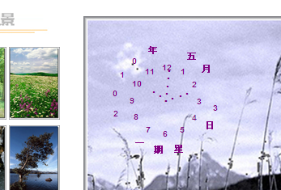

Go to the website to build a treasure chest

<http://dob.tnc.edu.tw/>

Module: Select "Java Script"

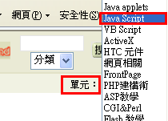

Select Column: Mouse Cursor

Article: New Mouse Clock



<http://dob.tnc.edu.tw/themes/old/showPage.php?s=2220&t=6&at=1>

Let's take a look at the examples

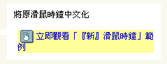

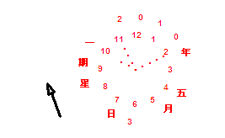

How to use:

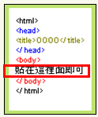

Copy the code



The code pasted to the index.html

Attach it to < body> ......</body> inside

|  |
| --- |
| <!-- BEGIN Eric's Mouse-Clock CODE -->  <SCRIPT language=JavaScript>  dCol='000000';//date colour.  fCol='000000';//face colour.  sCol='000000';//seconds colour.  mCol='000000';//minutes colour.  hCol='000000';//hours colour.  ClockHeight=40;  ClockWidth=40;  ClockFromMouseY=0;  ClockFromMouseX=100;    //Alter nothing below! Alignments will be lost!    d=new Array("星期日","星期一","星期二","星期三","星期四","星期五","星期六");  m=new Array("一月","二月","三月","四月","五月","六月","七月","八月","九月","十月","十一月","十二月");  date=new Date();  day=date.getDate();  year=date.getYear();  if (year < 2000) year=year+1900;  TodaysDate=year+"年 "+m[date.getMonth()]+" "+day+"日 "+d[date.getDay()]+" ";  D=TodaysDate.split('');  H='...';  H=H.split('');  M='....';  M=M.split('');  S='.....';  S=S.split('');  Face='1 2 3 4 5 6 7 8 9 10 11 12';  font='Arial';  size=1;  speed=0.5;  ns=(document.layers);  ie=(document.all);  Face=Face.split(' ');  n=Face.length;  a=size*10;  ymouse=0;  xmouse=0;  scrll=0;  props="<font face="+font+" size="+size+" color="+fCol+"><B>";  props2="<font face="+font+" size="+size+" color="+dCol+"><B>";  Split=360/n;  Dsplit=360/D.length;  HandHeight=ClockHeight/4.5  HandWidth=ClockWidth/4.5  HandY=-7;  HandX=-2.5;  scrll=0;  step=0.02;  currStep=0;  y=new Array();x=new Array();Y=new Array();X=new Array();  for (i=0; i < n; i++){y[i]=0;x[i]=0;Y[i]=0;X[i]=0}  Dy=new Array();Dx=new Array();DY=new Array();DX=new Array();  for (i=0; i < D.length; i++){Dy[i]=0;Dx[i]=0;DY[i]=0;DX[i]=0}  if (ns){  for (i=0; i < D.length; i++)  document.write('<layer name="nsDate'+i+'" top=0 left=0 height='+a+' width='+a+'><center>'+props2+D[i]+'</font></center></layer>');  for (i=0; i < n; i++)  document.write('<layer name="nsFace'+i+'" top=0 left=0 height='+a+' width='+a+'><center>'+props+Face[i]+'</font></center></layer>');  for (i=0; i < S.length; i++)  document.write('<layer name=nsSeconds'+i+' top=0 left=0 width=15 height=15><font face=Arial size=3 color='+sCol+'><center><b>'+S[i]+'</b></center></font></layer>');  for (i=0; i < M.length; i++)  document.write('<layer name=nsMinutes'+i+' top=0 left=0 width=15 height=15><font face=Arial size=3 color='+mCol+'><center><b>'+M[i]+'</b></center></font></layer>');  for (i=0; i < H.length; i++)  document.write('<layer name=nsHours'+i+' top=0 left=0 width=15 height=15><font face=Arial size=3 color='+hCol+'><center><b>'+H[i]+'</b></center></font></layer>');  }  if (ie){  document.write('<div id="Od" style="position:absolute;top:0px;left:0px"><div style="position:relative">');  for (i=0; i < D.length; i++)  document.write('<div id="ieDate" style="position:absolute;top:0px;left:0;height:'+a+';width:'+a+';text-align:center">'+props2+D[i]+'</B></font></div>');  document.write('</div></div>');  document.write('<div id="Of" style="position:absolute;top:0px;left:0px"><div style="position:relative">');  for (i=0; i < n; i++)  document.write('<div id="ieFace" style="position:absolute;top:0px;left:0;height:'+a+';width:'+a+';text-align:center">'+props+Face[i]+'</B></font></div>');  document.write('</div></div>');  document.write('<div id="Oh" style="position:absolute;top:0px;left:0px"><div style="position:relative">');  for (i=0; i < H.length; i++)  document.write('<div id="ieHours" style="position:absolute;width:16px;height:16px;font-family:Arial;font-size:16px;color:'+hCol+';text-align:center;font-weight:bold">'+H[i]+'</div>');  document.write('</div></div>');  document.write('<div id="Om" style="position:absolute;top:0px;left:0px"><div style="position:relative">');  for (i=0; i < M.length; i++)  document.write('<div id="ieMinutes" style="position:absolute;width:16px;height:16px;font-family:Arial;font-size:16px;color:'+mCol+';text-align:center;font-weight:bold">'+M[i]+'</div>');  document.write('</div></div>')  document.write('<div id="Os" style="position:absolute;top:0px;left:0px"><div style="position:relative">');  for (i=0; i < S.length; i++)  document.write('<div id="ieSeconds" style="position:absolute;width:16px;height:16px;font-family:Arial;font-size:16px;color:'+sCol+';text-align:center;font-weight:bold">'+S[i]+'</div>');  document.write('</div></div>')  }  (ns)?window.captureEvents(Event.MOUSEMOVE):0;  function Mouse(evnt){  ymouse = (ns)?evnt.pageY+ClockFromMouseY-(window.pageYOffset):event.y+ClockFromMouseY;  xmouse = (ns)?evnt.pageX+ClockFromMouseX:event.x+ClockFromMouseX;  }  (ns)?window.onMouseMove=Mouse:document.onmousemove=Mouse;  function ClockAndAssign(){  time = new Date ();  secs = time.getSeconds();  sec = -1.57 + Math.PI * secs/30;  mins = time.getMinutes();  min = -1.57 + Math.PI * mins/30;  hr = time.getHours();  hrs = -1.575 + Math.PI * hr/6+Math.PI*parseInt(time.getMinutes())/360;  if (ie){  Od.style.top=window.document.body.scrollTop;  Of.style.top=window.document.body.scrollTop;  Oh.style.top=window.document.body.scrollTop;  Om.style.top=window.document.body.scrollTop;  Os.style.top=window.document.body.scrollTop;  }  for (i=0; i < n; i++){  var F=(ns)?document.layers['nsFace'+i]:ieFace[i].style;  F.top=y[i] + ClockHeight*Math.sin(-1.0471 + i*Split*Math.PI/180)+scrll;  F.left=x[i] + ClockWidth*Math.cos(-1.0471 + i*Split*Math.PI/180);  }  for (i=0; i < H.length; i++){  var HL=(ns)?document.layers['nsHours'+i]:ieHours[i].style;  HL.top=y[i]+HandY+(i*HandHeight)*Math.sin(hrs)+scrll;  HL.left=x[i]+HandX+(i*HandWidth)*Math.cos(hrs);  }  for (i=0; i < M.length; i++){  var ML=(ns)?document.layers['nsMinutes'+i]:ieMinutes[i].style;  ML.top=y[i]+HandY+(i*HandHeight)*Math.sin(min)+scrll;  ML.left=x[i]+HandX+(i*HandWidth)*Math.cos(min);  }  for (i=0; i < S.length; i++){  var SL=(ns)?document.layers['nsSeconds'+i]:ieSeconds[i].style;  SL.top=y[i]+HandY+(i*HandHeight)*Math.sin(sec)+scrll;  SL.left=x[i]+HandX+(i*HandWidth)*Math.cos(sec);  }  for (i=0; i < D.length; i++){  var DL=(ns)?document.layers['nsDate'+i]:ieDate[i].style;  DL.top=Dy[i] + ClockHeight*1.5*Math.sin(currStep+i*Dsplit*Math.PI/180)+scrll;  DL.left=Dx[i] + ClockWidth*1.5*Math.cos(currStep+i*Dsplit*Math.PI/180);  }  currStep-=step;  }  function Delay(){  scrll=(ns)?window.pageYOffset:0;  Dy[0]=Math.round(DY[0]+=((ymouse)-DY[0])*speed);  Dx[0]=Math.round(DX[0]+=((xmouse)-DX[0])*speed);  for (i=1; i < D.length; i++){  Dy[i]=Math.round(DY[i]+=(Dy[i-1]-DY[i])*speed);  Dx[i]=Math.round(DX[i]+=(Dx[i-1]-DX[i])*speed);  }  y[0]=Math.round(Y[0]+=((ymouse)-Y[0])*speed);  x[0]=Math.round(X[0]+=((xmouse)-X[0])*speed);  for (i=1; i < n; i++){  y[i]=Math.round(Y[i]+=(y[i-1]-Y[i])*speed);  x[i]=Math.round(X[i]+=(x[i-1]-X[i])*speed);  }  ClockAndAssign();  setTimeout('Delay()',20);  }  if (ns||ie)window.onload=Delay;  </SCRIPT> |

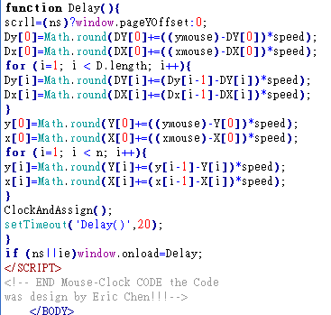

As a result, browse

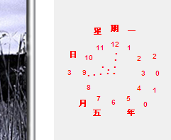

Modify the color

|  |
| --- |
| 1. To modify the color, please use the following items: 2. dCol='000000'; //date colour. 3. fCol='000000'; //face colour. 4. sCol='000000'; //seconds colour. 5. mCol='000000'; //minutes colour. 6. hCol='000000'; //hours colour. 7. From top to bottom: Beijing time, numerals, second hand, minute hand, hour hand |

Start by looking up the color code for a color

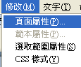

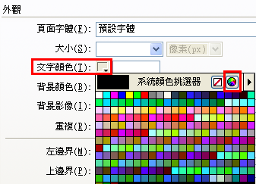

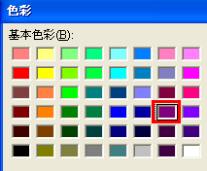

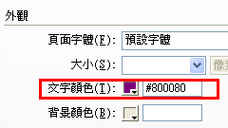

Copy the color code

Click 'Cancel' on this page (so that it will not really be set)

Paste the color code '800080' into the code area

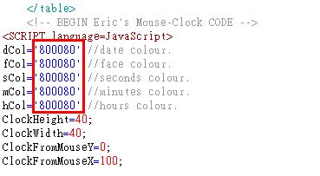

Result, preview



# Exercise 3: Set the color of the reels

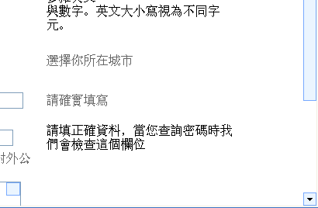

Start work1.html

Go to the website to build a treasure chest

<http://dob.tnc.edu.tw/>

Module: Select "Java Script"



<http://dob.tnc.edu.tw/themes/old/showPage.php?s=706&t=6&at=29>

Let's take a look at the examples



How to use:

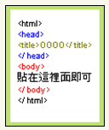

Copy the code



Attach it to < body> ............</body> inside

|  |
| --- |
| <script language="JavaScript1.2">  <!--  //onMouseover Scrollbar effect- by Svetlin Staev (thewebmonster@altavista.com)  //Submitted to Dynamic Drive  //Visit http://www.dynamicdrive.com for this script  /*---------------[IE 5.5 Scrollbars colorer]--------------------*/  function scrollBar(line,face,theme)  {  if (!line||!face)  {  line=null;  face=null;  switch(theme)  {  case "blue": //設定色系名稱  var line="#78AAFF"; //設定捲軸色系框線  var face="#EBF5FF"; //設定捲軸色系底色  break;  case "orange":  var line="#FBBB37";  var face="#FFF9DF";  break;  case "red":  var line="#FF7979";  var face="#FFE3DD";  break;  case "green":  var line="#00C600";  var face="#D1EED0";  break;  case "neo":  var line="#FFFFFF";  var face="#64D0FE";  break;  }  }    with(document.body.style)  {  scrollbarDarkShadowColor=line;  scrollbar3dLightColor=line;  scrollbarArrowColor="black";  scrollbarBaseColor=face;  scrollbarFaceColor=face;  scrollbarHighlightColor=face;  scrollbarShadowColor=face;  scrollbarTrackColor="#FFFFFF";  }  }    /*------------------[Pointer coordinates catcher]---------------*/  function colorBar(){  var w = document.body.clientWidth;  var h = document.body.clientHeight;  var x = event.clientX;  var y = event.clientY;  if(x>w) scrollBar('#FFFFFF','#CCEEFF'); // 滑鼠移上後欲顯示的顏色（格式為：框線，底色）  else scrollBar(null,null,"blue"); //選擇載入時捲軸色系（由上方設定）  }    if (document.all){  scrollBar(null,null,"blue");  document.onmousemove=colorBar;  }  //-->  </script> |

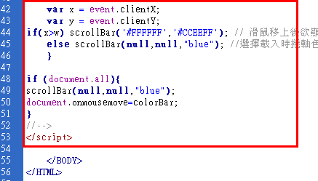

outcome



Modify the reel color

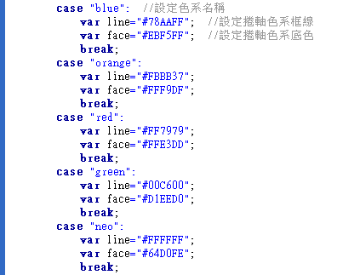

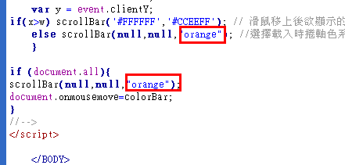

As a result, browse

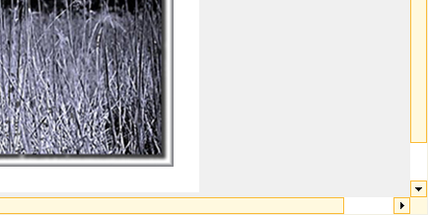

# Exercise 5: Make the effect that the mouse over the image will fade away

If you click the mouse, the image will be clear, and if you leave the mouse, the image will fade

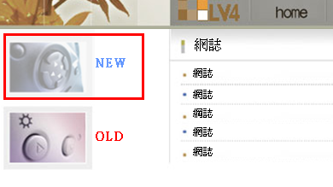

Start Work2 .html

Go to the website to build a treasure chest

<http://dob.tnc.edu.tw/>

Module: Select "Java Script"



<http://dob.tnc.edu.tw/themes/old/showPage.php?s=2549&t=6&at=27>

Let's take a look at the examples



How to use:

**Step 1:**

Copy the code

|  |
| --- |
| <script language="JavaScript1.2">  function high(which2){  theobject=which2  if (window.downlighting) clearInterval(downlighting)  highlighting=setInterval("highlightit(theobject)",50)  }  function low(which2){  clearInterval(highlighting)  theobject=which2  downlighting=setInterval("downlightit(theobject)",50)  }  function highlightit(cur2){  if (cur2.filters.alpha.opacity<100)  cur2.filters.alpha.opacity+=5  else if (window.highlighting)  clearInterval(highlighting)  }  function downlightit(cur2){  if (cur2.filters.alpha.opacity>40)  cur2.filters.alpha.opacity-=20 //修改滑鼠移開圖示後的亮度，數字越小就越亮  else if (window.downlightit)  clearInterval(downlighting)  }  </script>  <center>  <img src="http://www.lineage.com.hk/lineage/image/community/fansite/princess-icon.gif" style="filter:alpha(opacity=40)" onmouseover="high(this)" onmouseout="low(this)" width="100" height="100"> |

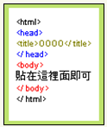

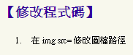

Paste it on <body>.....</body>

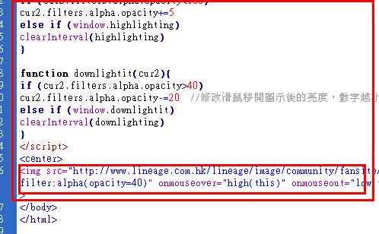

**Specify the image you want to fade**

Put the last paragraph < img src ......> cut it out

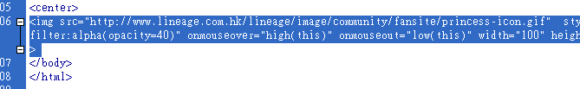

**Start by clicking on the image you want to fade**

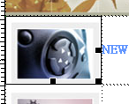

Then look at the code

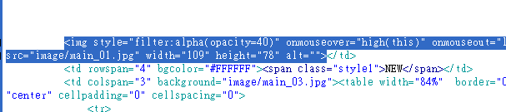

Attach the part you just cut

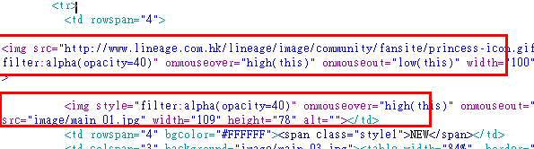

Cut out the command to set the fade and paste it on the image with the specified fade

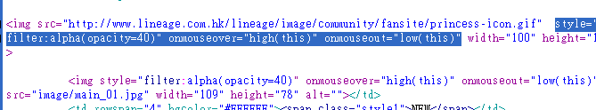

Delete the remaining directives

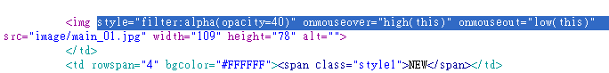

Result, preview

If you click the mouse, the image will be clear, and if you leave the mouse, the image will fade



Also set the fade effect for the next image

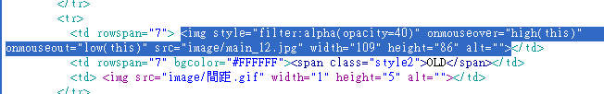

# Exercise 8: Java Applet Effects: Reflections in Water

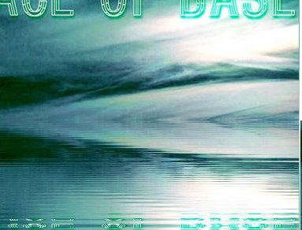

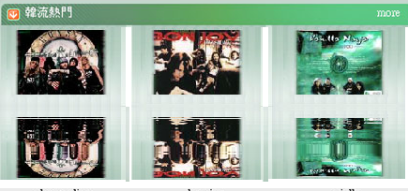

Turn on work3.html

Go to the website to build a treasure chest

<http://dob.tnc.edu.tw/>

Unit: Select 'java applet'

Select 'Reflection in Water' (uncategorized).

<http://dob.tnc.edu.tw/themes/old/showPage.php?s=139&t=5&at>=



The download must be applied



Found that it is no longer available for download

So go to another website

|  |  |
| --- | --- |
| Power Information Network | <http://www.powerpc.idv.tw/> |

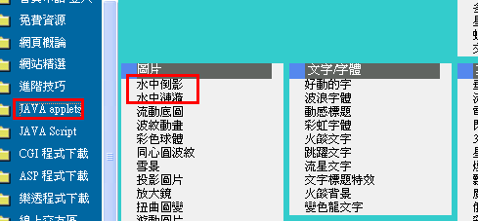

<http://www.powerpc.idv.tw/43a.htm>

Download 'Reflection in Water' and unzip it

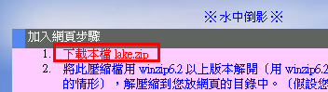

Copy the file below the web10 directory (the same directory as work3.html)



Paste on

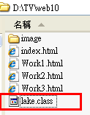

Preview

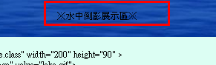

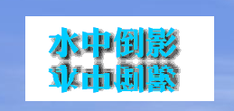

Copy the code

|  |
| --- |
| <applet code="Lake.class" width="200" height="90" ><param name="image" value="lake.gif"></applet> |

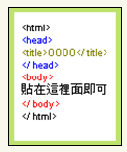

Copy the code



Start by clicking on the image you want to display the reflection

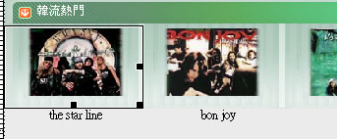

Paste it into the code area

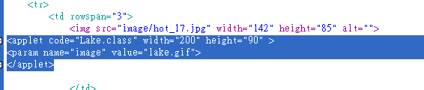

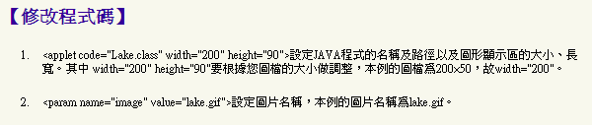

Modify the pattern file name: image/hot_17.jpg

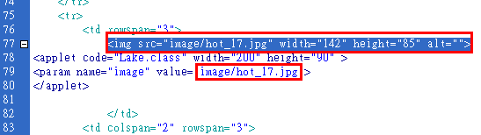

Modify the image to be displayed (keep the width as it is, and the height * 1.5 times)



And delete the grammar of the original picture file

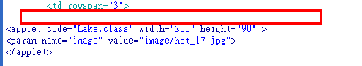

As a result, browse

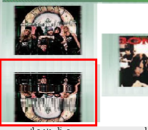

Modify a few more other images



# Exercise 9: Java Applet Effects: Put on the web online game: Russia Cubes

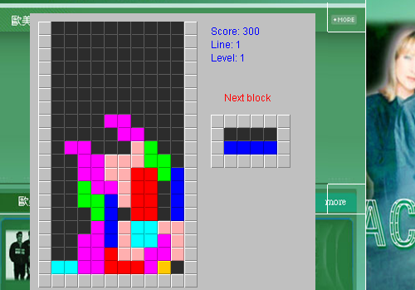

Turn on work3.html

to the power information network

<http://www.powerpc.idv.tw/>

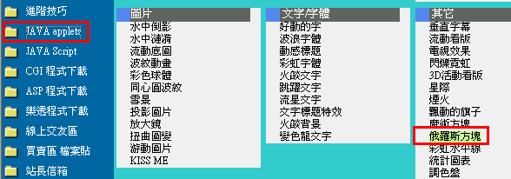

<http://www.powerpc.idv.tw/93a.htm>

Download 'Russia Cubes and unzip it

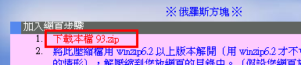

Copy the file below the web10 directory (the same directory as work3.html)

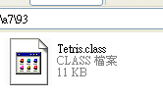

Paste on

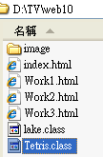

Preview

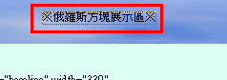

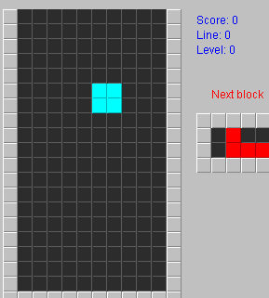

Copy the code

|  |
| --- |
| <applet code="Tetris.class" align="baseline" width="330" height="360">  </applet> |



Copy the code

Add a layer

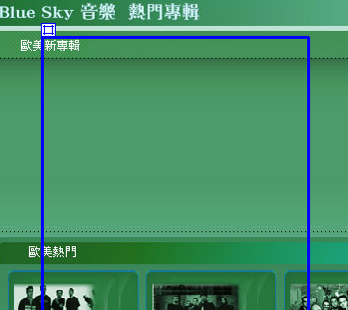

and tap inside the layer

Switch to the code area



Paste it into the code area

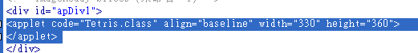

As a result, browse



Instructions for this game

|  |
| --- |
| 旋轉：enter  向左：←  向左：→  直接向下放：↓ |

# Exercise 10: Java Applet Effects: Ripples in Water

Download the anwater.zip

code

|  |
| --- |
| <applet code="AnWater.class" width=150 height=100>  <param name=image value="d4-16.jpg">  <param name=res value="1">  <param name=light value="YES">  <param name=autodesign value="YES">  <param name=density value="4">  <param name=fishnum value="0">  <param name=cross value="NO">  <param name=crossfactor value="30">  <param name=rainsize value="0">  <param name=rainfactor value="10">  <param name=srainsize value="0">  <param name=srainfactor value="10">  <param name=textscroll value="waterscr.txt">  <param name=textoffset value="132">  <param name=textspeed value="2">  <param name=textfont value="Arial">  <param name=textbold value="NO">  <param name=textsize value="14">  <param name=textshadow value="YES">  <param name=TextColR value="255">  <param name=TextColG value="255">  <param name=TextColB value="200">  <param name=TextSColR value="20">  <param name=TextSColG value="20">  <param name=TextSColB value="50">  <param name=TextJumpAmp value="10">  <param name=TextJumpSpd value="4">  <param name=memdelay value="1000">  <param name=priority value="3">  </applet> |

# Exercise 11: Java Applet Effects: Snow Scenes

Download 96.zip

|  |
| --- |
| <applet code="alcsnow.class"align="baseline" width="200" height="150"><paramname="grph" value="05.jpg"><param name="snows"value="1000"><param name=" threadsleep" value="60"></applet> |

# Exercise 12: Java Applet Effects: Projecting Pictures

Download 103.zip

|  |
| --- |
| <applet code="stn_bump.class" align="baseline" width="200" height="150" name="stn_bump"><!-- Set size and program control file--><param name="color" value="05.jpg"><param name=" bump" value="05.jpg"><!-- Set the program projection map*.jpg file, both of which should be the same size--><param name="link" value="http://powerpc.24h.cc"><!-- set the program link path--><param name="hred" value="60"> <param name="hgreen" value="130"><param name="hblue" value="190"><!-- Set the red, green, and blue RGB values of the projected rays from 0 to 255--><param name="hexp" value="200"><!-- Set the size of the cast rays, The smaller the value, the greater the light -- ></applet> |