**Chapter 1 Web Templates, How to Use Website Templates**

**Make a web page with the texture of a master's design**

directory

1. Web Templates, Website Templates Introduction: 2

2. How to download or buy 'Web Templates, Website Templates': 6

3. "Web Template, Website Template". 5 Type : 7

4. Example Exercise 1: Using thehtml web template for website' to make a website quickly 8

5. Sample Exercise 1-2: Other Exercise Templates 20

6. Example Exercise 2: Using the Web Page Template Builder,HTML web templates for custom production of websites' to quickly create a website 23

7. Example Exercise 3: Using thePSD web template website' to make a website quickly 32

8. Example Exercise 4: Using 'Footage, Background, Buttons,icon free download' to quickly make a website 37

# Web Templates, Website Templates Introduction:

## **Difficulties and bottlenecks that students often encounter in designing websites:**

Generally, after learning web page production, students will encounter a bottleneck, that is, the website designed is too monotonous, without texture and creative beauty

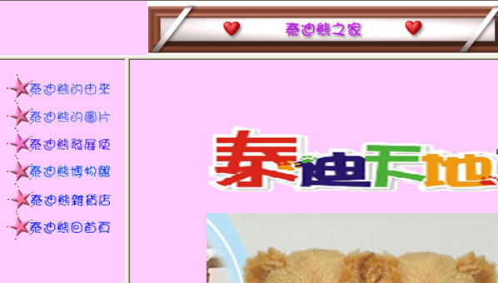

If you use too much javascript or java applet dynamic effects, not only will you have no design taste, but it will also cause the web page to be very confusing

Many people learn a lot of web skills, but in the end, they find that these skills are not very helpful for web pages

**Because the web page you make is .........It's not good-looking**

**Therefore, in fact, the key to the success of the whole web design is actually in the "aesthetic arrangement and texture design"**

**But how can students create a creative, design-oriented website?**

==> This requires a long learning process of art training

**Is there a quick way to do it right away?**

==> Yes, you can use "web template, website template" to solve this problem

This is shown in the figure below

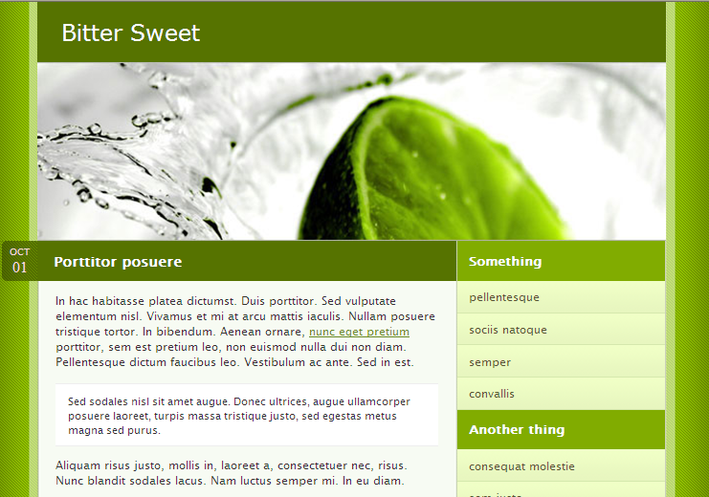

## **What is a 'web template, website template':**

These templates are created by many masters who love design, and all of these creations have one characteristic, that is, they are beautiful. So even people who don't know how to design web can easily apply templates and make a beautiful web page. Some of these websites are html websites, and some are flash website boilerplates

The more professional the website design, the more you need to spend money on it, such as:

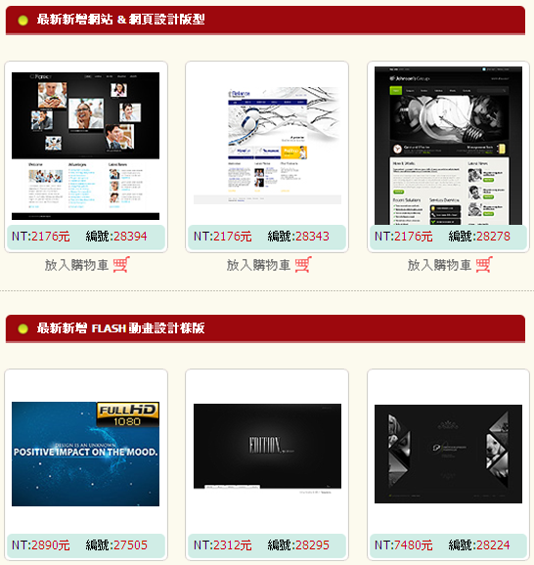

However, there are also many websites that are free to download

In particular, there are many well-known websites abroad that provide these open source Web Design downloads

Many of them are also very beautiful and professionally designed websites

For example:

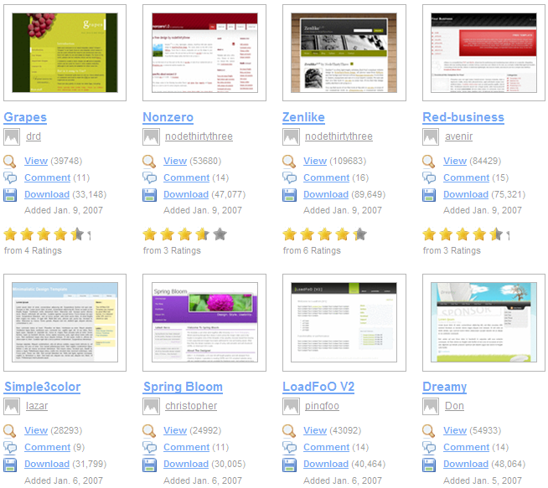

# How to download or buy 'Web Templates, Website Templates':

to Google

Enter a keyword

|  |
| --- |
| Web page templates  Website templates  Web templates  Website template  Free web templates  web design  web templates |

These websites that people can download for free are all located in 'Chinese mainland, Korea, Europe and the United States', and there are very few such websites in Taiwan

But Korea, China's web template websites, many are graphic templates in psd format

It is not convenient to use, and there is a lot of subsequent processing

On the contrary, most of the web template websites in Europe and the United States provide processed htm websites, which can be directly applied to Dreamweaver, and many of the designs are fresh and beautiful

You don't need to worry about English, in fact, there are many treasures in these European and American web template websites

Don't be afraid to visit the English websites of these templates

As long as it can download

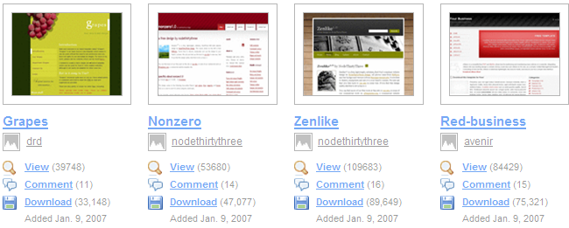

# There are 5 types of web templates and website templates:

* **HTML web template website** (which has been processed into a website containing index.html and images).
* **Web Template Generator, or HTML Web Template Custom Production Website** (you can set what functions you need for the web page, and you can automatically generate the web page template you need).
* **PSD web template website** (just a photoshop design image).
* **Flash web template website** (the main content is flash design website).
* **Materials, backgrounds, buttons, icons are free to download**
* **Paid web template website**

# Example Exercise 1: Use the 'HTML Web Template Website' to quickly create a website

## **Objectives :**

### HTML web template website: It has been processed into a website containing index.html and images

### Search for Google, download a template, and import it into Dreamweaver



## **List several "html web template websites" at home and abroad**

Please do your own Google search:

Or the following websites

|  |  |
| --- | --- |
| <http://www.oswd.org/> | Open Source Web Design (OSWD) is different in that it provides so many templates that you might not be able to read them all in a day if you had to look closely. Currently, OSWD has a total of 2,080 templates, and the number is still growing. And because there are so many designs to choose from, they have selected some of their favorite templates, Our Favorite Designs, so that visitors can directly find the essence of the website |
| <http://www.freecsstemplates.org/> | The site is currently designed and offers more than 100 free CSS templates, licensed under CC Name Markup 2.5.  Each template is unique in that it doesn't use tables at all (CSS and XHTML only) and is W3C compliant with the XHTML standard. Even if you don't download it directly, it's very useful to refer to how someone else's CSS is written. |
| <http://www.openwebdesign.org/browse.php> | is a theme website that focuses on free web design templates, providing designers or website owners to share their own free web page styles. At present, there are more than 1,000 kinds of template works on the website, which users can preview and download online |
| <http://www.freewebsitetemplates.com/> | [ree Website Templates](http://www.freewebsitetemplates.com/) More than 50 kinds are available[Free website design](http://www.freegroup.org/category/free-templates/)Most of the templates provided by the site are quite pictures, which appear lively and colorful. Users can download the website set for free and add the content they want to present, making it easy to create a personal website |
| <http://www.freelayouts.com/> | Free Layouts has been working on free website scenery since January 2000, with the goal of providing free web scenery for people with no web design experience, or giving designers some creative inspiration.  In addition, Free Layouts adheres to the W3 Web Standard specification, and in order to continue this mission, the website also accepts only themes that meet the web design standards, which means that users can download a series of web design that meet the web standards here. |
| <http://www.opendesigns.org/> | OpenDesigns offers a wide range of open-source website templates for web design sets based on XHTML and CSS, as well as live previews online and free downloads. Don't know where to start before creating a web page? At this time, you might as well spend a minute or two browsing the OpenDesigns website, which may give you a lot of inspiration. |
| <http://www.openwebdesign.org/browse.php> | [Open Web Design](http://www.openwebdesign.org/) is a themed website that focuses on free web design templates, offering designers or website owners to share their own[Free web page styles](http://www.freegroup.org/category/free-templates/)。 At present, there are more than 1,000 kinds of template works on the website, which users can preview and download online. |
| <http://www.templatesland.com/free-templates.htm> | emplatesLand is a small free web template website, including some free, but good quality Web Templates, suitable for web designers to use, these styles can be downloaded directly and applied to the website, only a few modifications, a beautiful website can be easily completed. |
| [http://www.freetemplatesonline.com/index.php](http://www.freetemplatesonline.com/) | FreeTemplatesOnline.com is a website that provides a variety of different styles of web templates, in addition to a variety of different web styles, there are also CSS Templates, osCommerce Templates, WordPress Themes... and other various styles can be downloaded. There are two types of scenery on the website: Free and Premium. |
| <http://www.freecsstemplates.org/> | Free CSS Templates is a foreign website that provides free CSS sets, and there are currently more than hundreds of CSS template designs. Each scene has a preview image and an actual display in the browser. The ZIP file can be downloaded and used directly. |
| <http://www.web2feel.com/> | A good [Web2.0](http://zh.wikipedia.org/wiki/Web_2.0) style set site - web2feel.com  Different from other set websites, you don't need to find a dark place here, because the webmaster has carefully selected for you, and most of the sets that appear on the web2feel website are related to [Web2.0](http://zh.wikipedia.org/wiki/Web_2.0), such as the very common gradient logo or rounded corner design, etc., if you want to add some [Web2.0 style to your blog](http://zh.wikipedia.org/wiki/Web_2.0)  , Then look for the set here! |
| <http://bestmoban.com/> | There is a saying that "everything is hard to get started", and the most headache when making a website is the beginning part. If you often encounter such a situation and don't know how to start, you can actually go through some of them[Free web templates](http://www.freegroup.org/category/free-templates/)website to give you inspiration. Bestmoban.com The best template is a template website built by mainland netizens, providing business templates, personal templates, entertainment templates, cartoon templates, and even web materials for free |
| <http://www.zeroweb.org/> | Foreign free resource websites, provide website templates for free download, and can be previewed and downloaded online, web image materials include buttons, backgrounds, icons, etc., and there are some related illustrations available for use, the content is quite rich.  In addition, ZeroWeb.org has services that are convenient for webmasters, such as a free message board, website forwarding, and an online contact form. |
| <http://www.oswd.org/> | Open Source Web Design, or OSWD for short, provides free downloadable web design templates and the ability to share your designs with others. With over 2,000 web design templates out there, it's one of the must-see websites for web designers. |
| <http://designmagus.com/free_icons> | The DesignMagus website offers free icons, free website colors, and free website templates, which are not many, but they are all very textured. In fact, DesignMagus is a company that helps design icon icons, and you can see the price on the Home, but if you don't want to pay to make unique icons, then you can check out their free icon area. |
| <http://www.freegroup.org/category/free-templates/> | Domestic introduction website: Collect and introduce some foreign web template design websites |
| <http://www.simplethemes.net/> | Simple Themes - Minimalist WordPress Themes!  Simple - Minimalistic WordPress Themes includes a wide range of free WordPress themes, but this one is mainly minimalist. Although this simple, monotonous set theme may not have many pictures or colors, it is still deeply loved by some users. The minimalist theme is not only more comfortable to read, but also the fast loading speed of the page |
| <http://www.skinpress.com/category/wordpress/> | SkinPress has quite a few carefully selected ones[WordPress](http://wordpress.org/)Themes to make your WordPress more eye-catching. There are currently about hundreds of exquisite sets, all with large previews from start to finish, as well as demo links for users to test. In the future, Joomla and PHP Link Directory theme will be added one after another, which is recommended for friends who use WordPress to set up a website. |

## **URL of the template downloaded for the exercise example:**

arrive

<http://www.oswd.org/>

to a selection of the most loved templates inside

<http://www.oswd.org/designs/favorites/>

Download this template

<http://www.oswd.org/design/preview/id/3569>

After downloading, unzip it and save it in the 'web2' directory

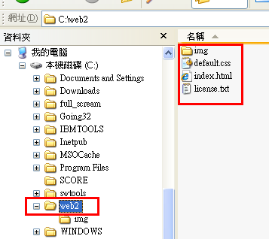

## **Open Dreamweaver, create a new website, and open this web2 folder:**

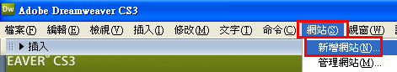

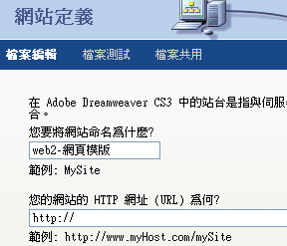



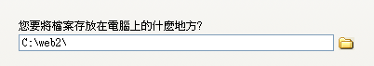

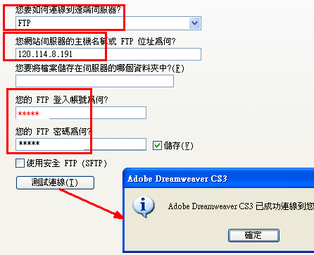

## **Dump the information of the website: (If you don't dump it, next time, you have to add a new website, it's too troublesome)**

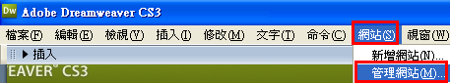

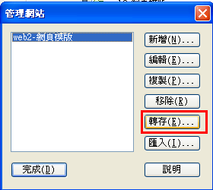

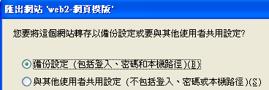

Result: An additional 'Site Definition' file was created

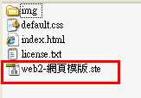

The next time you turn it on, you can open it and you can reopen the website that has already been defined

## **Test: Close the site and then reopen it**

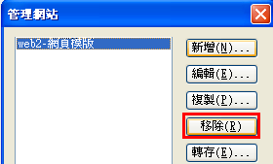

Then import it in

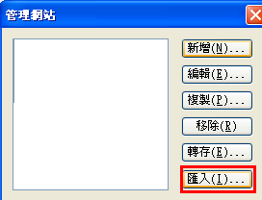

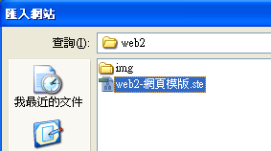

Outcome:

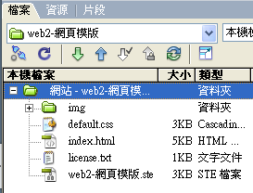

## **Turn on Home index.html**

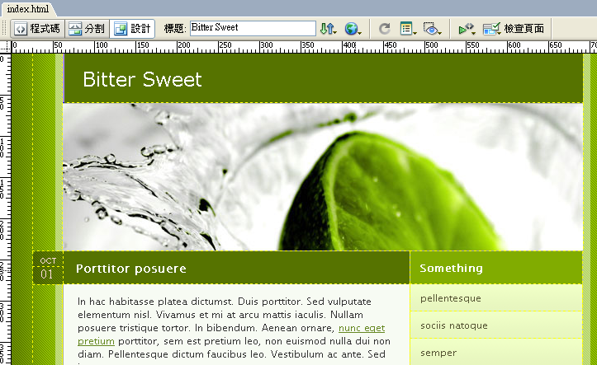

## **Modify the content of the Home to be used as a template for each future page:**

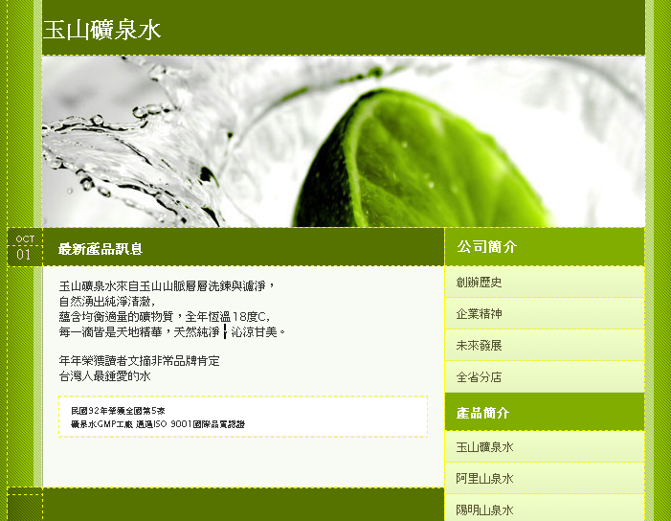

**Modify the top title and encoding of IE web pages**

Note: Websites downloaded from abroad are all Western European languages, or Chinese Simplified Chinese, or Korean

This will cause garbled Chinese characters

For example:

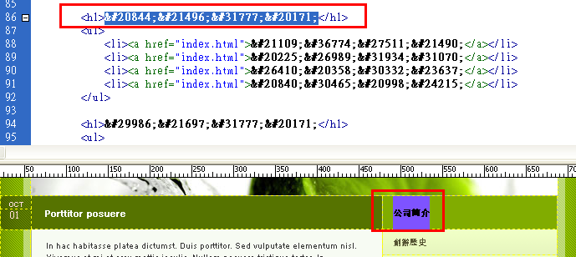

Modify the top title and encoding of IE web pages

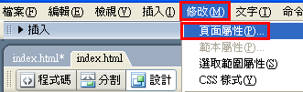

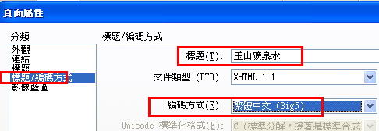

**Add text items from the web page**

|  |
| --- |
| 公司簡介  創辦歷史  企業精神  未來發展  全省分店  產品簡介  玉山礦泉水  阿里山泉水  陽明山泉水  合歡山泉水  網路購物  匯款方法  線上購物  常見Q&A  email聯絡 |

**Banner title**

|  |
| --- |
| 玉山礦泉水公司 |

**Imprint Notice:**

|  |
| --- |
|  |
| 玉山礦泉水    版權所有 © 2010 Yushan Mountain Mineral Water! Taiwan All Rights Reserved. |

**Latest product information**

|  |
| --- |
| 玉山礦泉水來自玉山山脈層層洗鍊與濾淨，  自然湧出純淨清澈，  蘊含均衡適量的礦物質，全年恆溫18度C，  每一滴皆是天地精華，天然純淨、沁涼甘美。  年年榮獲讀者文摘非常品牌肯定  台灣人最鍾愛的水  民國92年榮獲全國第5家  礦泉水GMP工廠 通過ISO 9001國際品質認證 |

**archive**

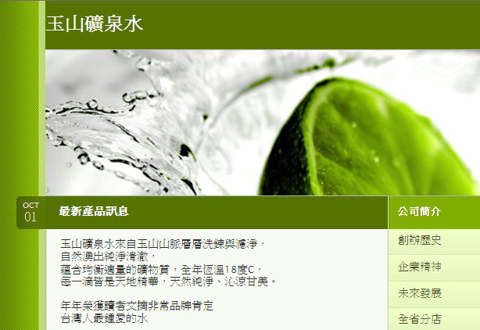

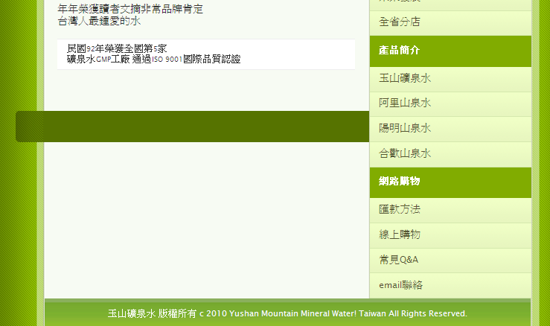

## **Delete an item**

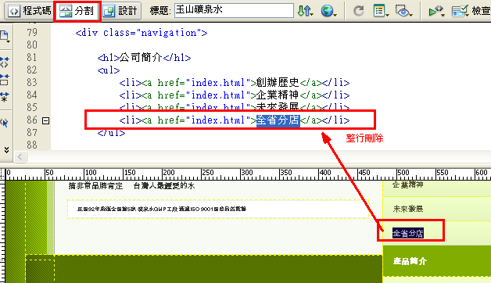

## **Add a new item**

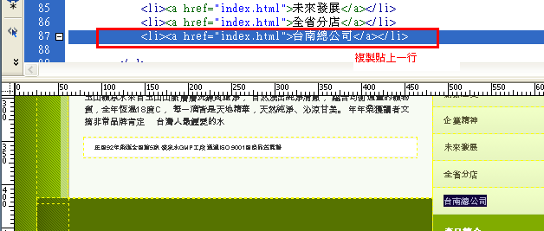

## **Save as another web template:**

Then save as a result

history.htm (Company History)

spirit.htm (Enterprise Spirit)

future.htm (Future Development)

store.htm (Provincial Branch)

….

Edit each page yourself and hyperlink to each other

# Sample Exercise 1-2: Other Exercise Templates

<http://www.freewebsitetemplates.com/template10.php>

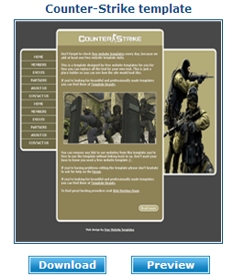

**Add text items from the web page**

|  |
| --- |
| Home  Web Albums  Gradually transparency  360-degree ring field  Auxiliary line animation |

**Banner title**

|  |
| --- |
| CS Talent Website |

**Imprint Notice:**

|  |
| --- |
| CS Talent ©Copyright 2010 CS Taiwan All Rights Reserved |

**Latest product information**

|  |
| --- |
| Counter-Strike evolves again with an Online version First debuted in 1999, Counter-Strike is a first-person shooter featuring terrorists versus counter-terrorism teams. The exhilarating shooting sensation, the thrill of-for-tat, and the fluidity and balance of the game make this game the best-selling FPS in the world. Inheriting the absolute force developed by CS Online (Counter-Striker Online), it not only maintains the original CS game characteristics, but also emphasizes the addition of weapons, maps, characters, etc. without destroying these game characteristics... and other items to provide players with new fun without losing the original flavor.  The new friend system and clan system not only make it easier for you to play with your friends, but also allow you to develop your own clan, and the war between clans provides players with new fun.  Individual and clan rankings are updated directly in the game every day, so you can not only directly check your position among all players to better understand your strength, but also check the positions of other players to effectively grasp the current status of your competitors. |

Set up hyperlinks

|  |
| --- |
| index.htm  a1.htm  a2.htm  a3.htm  a4.htm |

**archive**

<http://www.oswd.org/designs/favorites/page/3>

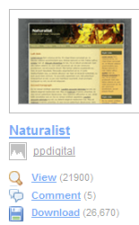

<http://www.freewebsitetemplates.com/template5.php>

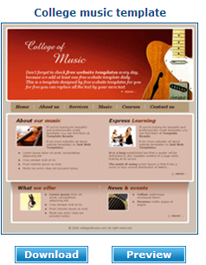

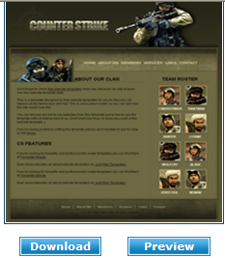

# Example Exercise 2: Use 'Web Template Generator, HTML Web Template Custom Production Website' to quickly make a website

## **Objectives :**

### **Web Template Builder:** web Theme Generator, web Template Builder

### **Free website template site**: In addition to downloading the layout of the website, you can also redesign the font, background, color, border, image, etc. online, which is a good design for users who are not good at CSS or web page source code. After the customization is completed, you can download the theme compressed file, which contains the website template, CSS file and the images you need

### **Free website template site**: You can set what functions you need for your web page, and you can automatically generate the web page template you need

### **Exercise**: Search Google, download a template, and import it into Dreamweaver

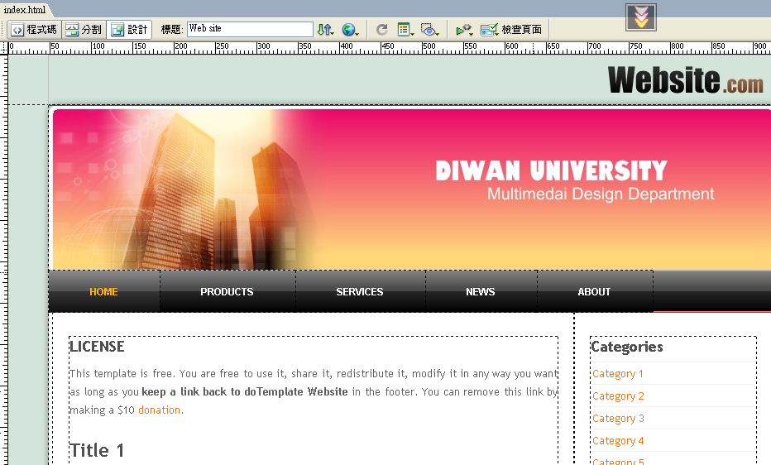

## **List several "html web template websites" at home and abroad**

Please do your own Google search:

Or the following websites

|  |  |
| --- | --- |
| doTemplate Free Website Templates Offer Sites:<http://www.dotemplate.com/> | It is a free website template site, in addition to downloading the layout of the website, you can also redesign the font, background, color, border, picture, etc. online, which is a good design for users who are not good at CSS or web page source code. After the customization is completed, you can download the theme compressed file, which contains the website template, CSS file and the images you need |
| Wordpress Theme Generator ：<http://www.yvoschaap.com/wpthemegen/> | Users who use WordPress as a blog can use this set template |

## **URL of the template downloaded for the exercise example:**

to the doTemplate website

doTemplate is a free website template provider for the station,

In addition to downloading the layout of the website, you can also redesign the font, background, color, border, image, and more online, which is a good design for users who are not good at CSS or web source code. After the customization is completed, you can download the theme compressed file, which contains the website template, CSS file and the images you need

arrive

Website URL: <http://www.dotemplate.com/>

Step 1: On the doTemplate website: Click on '**Free Templates**' to see about dozens of website scenes.

* PREVIEW - PREVIEW THE THEME.
* CUSTOMIZE - Customize the theme of the scene.

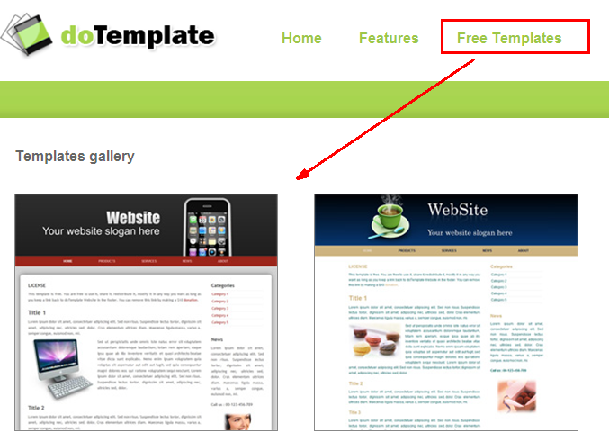

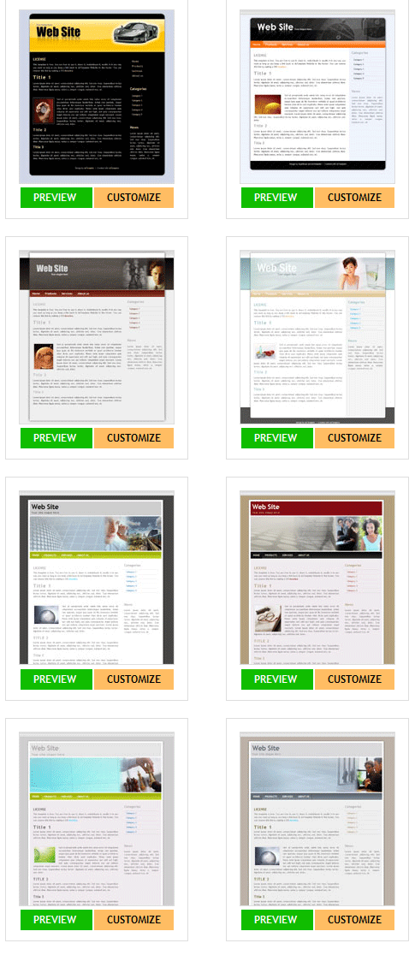

Select a template

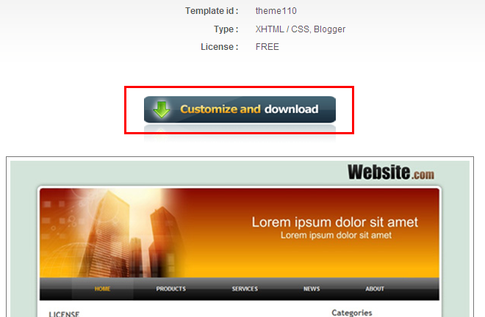

Step 2 Customize your website style online, including background color, borders, images, titles, menus, and more.

Click on the banner title

Change text content, font, color

Found: Entering Chinese will have garbled characters, or no text will be displayed (you can wait until later in dreamweaver to modify)

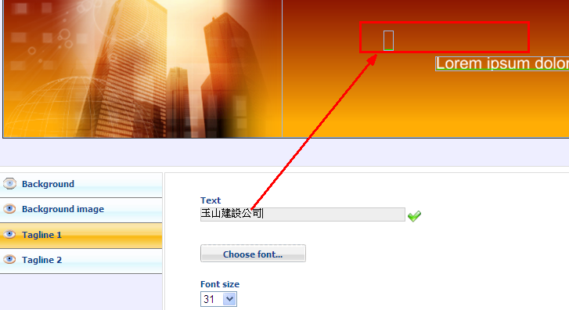

outcome

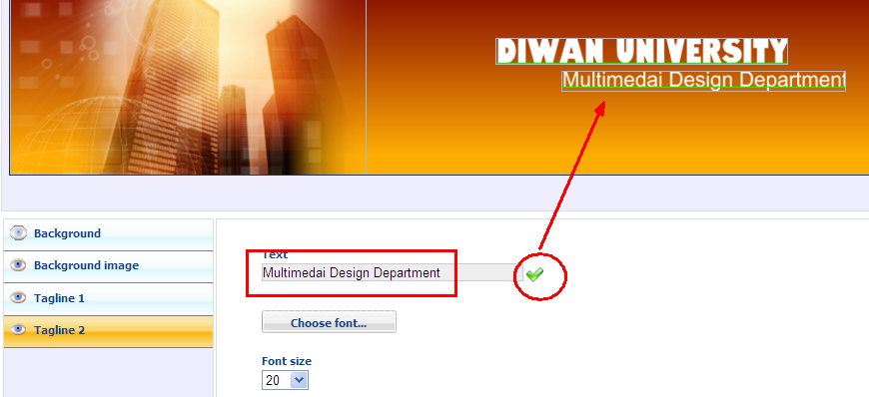

Are you sure

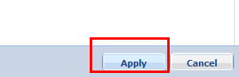

Change the background

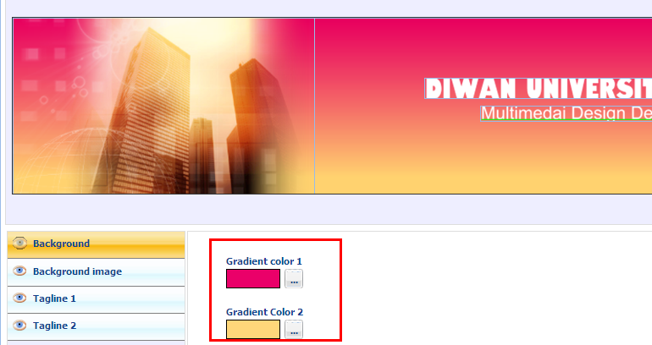

Step 3. When the customization is completed, remember to click Apply to apply the new style, if you like, you can click Download to download, the downloaded compressed file contains 1 HTML file, CSS file and web image.

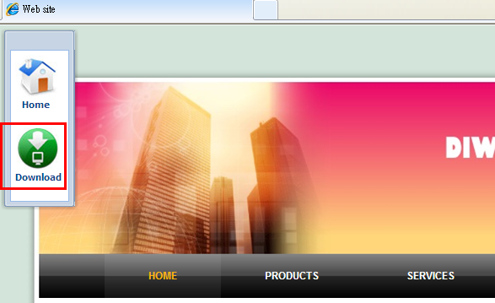

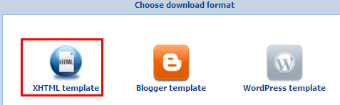

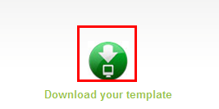

After downloading, unzip it and save it in the 'web3' directory

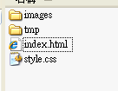

## **Open Dreamweaver, create a new website, and open this web3 folder:**



Open the index.html Home



## **Modify the content of the Home to be used as a template for each future page:**

….

archive

Then save as a result

history.htm (Company History)

spirit.htm (Enterprise Spirit)

future.htm (Future Development)

store.htm (Provincial Branch)

….

Edit each page yourself and hyperlink to each other

# Example Exercise 3: Use 'PSD Web Template Website' to quickly create a website

## **Objectives :**

### PSD web template website: It's just a photoshop design image, not a index.html website

### So download it, read it into Photoshop software, slice it yourself, and then save it into a index.html file

### Exercise: Go to Google and download a template, then import it into Photoshop, slice and archive it, and then import it into Dreamweaver

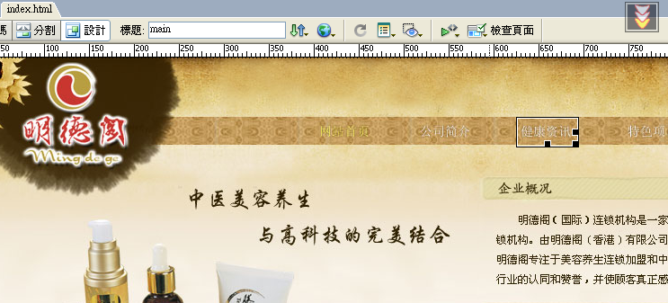

## **List several 'PSD** web template websites' **at home and abroad**

Please do your own Google search:

Or the following websites

|  |  |
| --- | --- |
| <http://www.design3edge.com/> | Generally, most of the websites that provide web template downloads are limited to providing "site-wide" template styles, without taking into account users who only need "partial" styles, but design3edge is not the case, in addition to providing "site-wide" templates, there are also templates that provide various special pages such as 404 error pages, login pages, registration pages, and article reply styles. However, most of the files downloaded from design3edge are .psd files (Photoshop) instead of HTML+CSS, which can be a big problem for the average user |
| Mainland website: model world  <http://www.mbsky.com/> | Web Templates, Website Templates, Taobao Templates, Online Store Templates, Forum CMS Templates, Free Templates, Web Materials, Web page creation tutorial free download, template world (mbsky_com).  Collect thousands of templates of all kinds  Most of them are .psd files (Photoshop) rather than HTML+CSS, which can be a big problem for the average user  It is available as a free download |
| Mainland website: the best template  <http://bestmoban.com/> | Page Templates - Best Templates Bestmoban_com  Collect thousands of templates of all kinds  Most of them are .psd files (Photoshop) rather than HTML+CSS, which can be a big problem for the average user  You need to be a member to download |

## **URL of the template downloaded for the exercise example:**

To the mainland website: the model world

<http://www.mbsky.com/>

I choose it inside:

You are here: >> Templates, World →, Web Templates, → Themes, → Chinese Medicine Beauty & Wellness Web Page PSD Templates

Download this template

<http://mbsky.com/SoftView/SoftView_73013.html>

Once downloaded, unzip it and open Photoshop

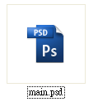

Open Photoshop

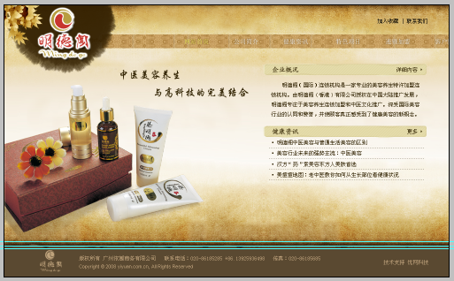

Changed simplified Chinese characters to traditional Chinese characters

In the layer, find 'T' and quickly press twice to edit and modify the text content

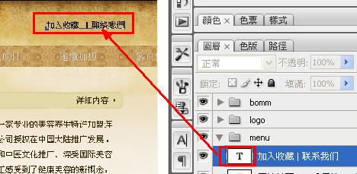

## **How to cut an image into many small areas for easy hyperlinking:**

After the modification is completed, the part to be hyperlinked is cut into small areas

Select the Slice tool on the palette,

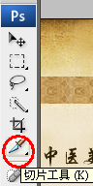

**Tip: Cut large areas of color into separate pieces and keep them as neat as possible on the horizontal line**

The cut diagram looks like this:

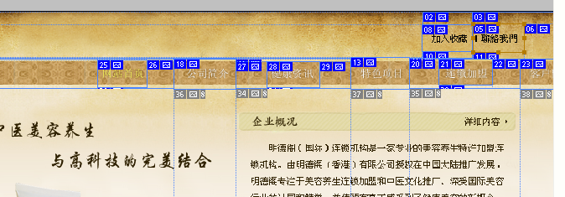

Output as a web page

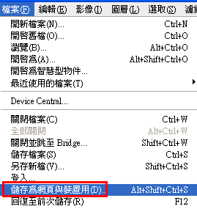

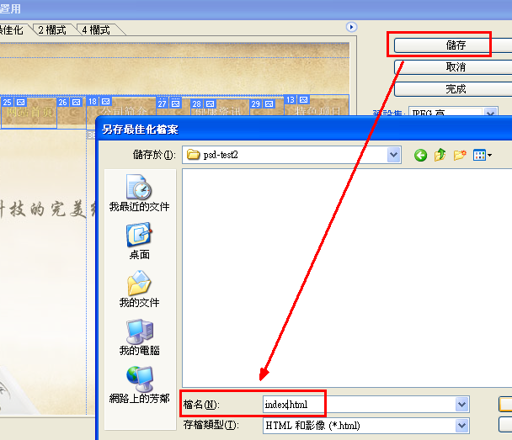

Save to the web4 folder

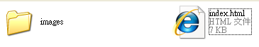

## **Open Dreamweaver, create a new website, and open this web4 folder:**



Open the index.html Home

Check if you can hyperlink the button



## **Modify the content of the Home to be used as a template for each future page:**

….

archive

Then save as a result

history.htm (Company History)

spirit.htm (Enterprise Spirit)

future.htm (Future Development)

store.htm (Provincial Branch)

….

Edit each page yourself and hyperlink to each other

# Example Exercise 4: Use 'Assets, Backgrounds, Buttons, Icons Free Download' to quickly make a website

## **Objectives :**

### Materials, backgrounds, buttons, icons are free to download

## **List several 'Footage, Backgrounds, Buttons, Icons Free Download' websites**

Please do your own Google search:

Or the following websites

|  |  |
| --- | --- |
| <http://bestmoban.com/> | There is a saying that "everything is hard to get started", and the most headache when making a website is the beginning part. If you often encounter such a situation and don't know how to start, you can actually use some [free web template](http://www.freegroup.org/category/free-templates/) websites to give you inspiration. Bestmoban.com The best template is a template website built by mainland netizens, providing business templates, personal templates, entertainment templates, cartoon templates, and even web materials for free |
| <http://www.zeroweb.org/> | Foreign free resource websites, provide website templates for free download, and can be previewed and downloaded online, web image materials include buttons, backgrounds, icons, etc., and there are some related illustrations available for use, the content is quite rich.  In addition, ZeroWeb.org has services that are convenient for webmasters, such as a free message board, website forwarding, and an online contact form. |