**Assignment 4**

**1. Task: Create a simple website and upload it to web hosting space. The completed steps are as follows:**

**(1)** **Download the web template website**

**Or go to the website and download it yourself:** [**http://www.openwebdesign.org/browse.php?page=2**](http://www.openwebdesign.org/browse.php?page=2)

**(2) Modify the website's title, encoding, heading, and copyright statement.**

**(3) Create five hyperlinks on the website:**

**(3-1) Homepage: **index.htm\*\***

**(3-2) Task 1: **a1.htm** (Copy the design from the index template)**

**HTML: List**

**Create a list using the commands: `ul...li`.**

CSS有3種：

* style
* class
* link外部css

**(3-3) Task 2: **a2.htm** (Copy the design from the index template)**

**Third type of CSS: External link**

**Link to an external CSS file:** [**https://acupun.site/lecture/html5_CSS_javascript/3-css1.css**](https://acupun.site/lecture/html5_CSS_javascript/3-css1.css)

**Command:** <link href=" " rel="stylesheet"/>

**(a).文字方塊的html指令：**<input type="text" value="顯示值" size="幾個字寬度" />

**按鈕的html指令：**<input type="button" value="顯示值" size="幾個字寬度" />

(b) Convert text to an integer: `parseInt("text");`

(c) Set the value of a text box: `textBoxName.value = ...;`

**(3-5) Task 4: **a4.htm** (Copy the design from the index template)**

**JavaScript: If statement for comparing values**

**Command structure:**

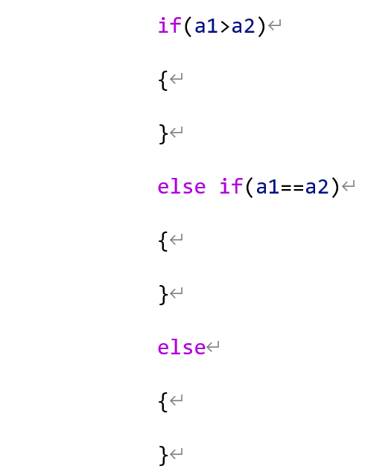

**(4) Upload the website to Github hosting.**

**(5) Paste the URL into Zuvio**

**Submit the URL in the assignment section for Assignment 3 on Zuvio to complete the task.**