**Assignment 6**

**1. Task: Create a simple website and upload it to web hosting space. The completed steps are as follows:**

**(1)** **Download responsive web templates for websites(Bootstrap 3)**

**Source:** [**Template King**](http://www.mobanwang.com/mb/202211/20391.html#yulan)

**(2) Modify the website's title, encoding, heading, and copyright statement.**

**(3) Create six hyperlinks on the website:**

**(3-1) Homepage: **index.htm\*\***

**(3-2) Task 1: Bootstrap Button**

**Refer to the button implementation on the Bootstrap 5 official website.**

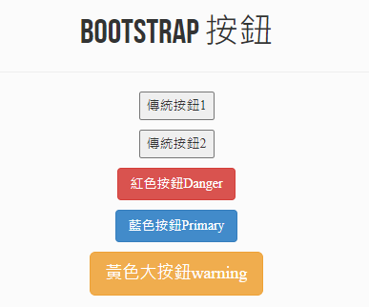

**(3-3) Task 2: Text Alignment, Italics, and Bold**

**Note: Since the template is based on Bootstrap 3, you must refer to the Bootstrap 3 website for instructions.**

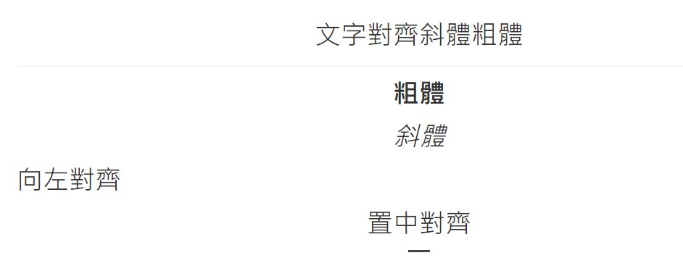

**(3-4) Task 3: Responsive Images**

**Note: Since the template is based on Bootstrap 3, you must refer to the Bootstrap 3 website for instructions.**



**(3-5) Task 4: Table**

**Note: Since the template is based on Bootstrap 3, you must refer to the Bootstrap 3 website for instructions.**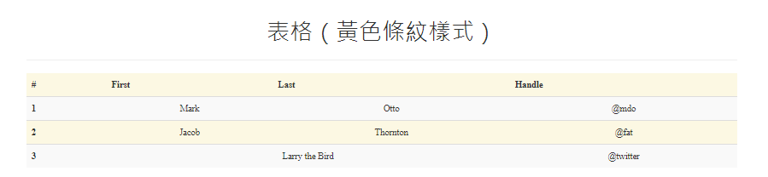

|  |  |  |
| --- | --- | --- |
| **產品** | **數量** | **價格** |
| 筆電 | 105 | **30000** |
| 手機 | 20 | **15000** |
| 平板 | 15 | **7000** |
| 電腦 | 30 | **25000** |
| 鍵盤 | 90 | **200** |
| 滑鼠 | 60 | **500** |

**(3-5) Task 5: Single Button Dropdown Menu**

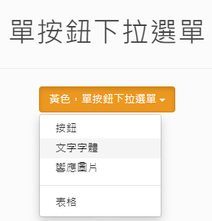

**(5) Paste the URL into Zuvio**

**Submit the URL in the assignment section on Zuvio to complete the task.**