**Assignment 7**

**1. Task: Create a simple website and upload it to a web hosting space. The completed steps are as follows:**

**(1) Download a responsive website template (Bootstrap 4)**

**下載響應式網頁模板網站(Bootstrap 4)**

**Source: Template King**

[**模板王**](http://www.mobanwang.com/mb/202302/20538.html)

**(2) Modify the website's title, encoding, heading, and copyright statement.**

**(3) Create six hyperlinks on the website:**

**(3-1) Homepage: **index.htm\*\***

**(3-2) Task 1: Random Numbers**

**Note: Since the template is based on Bootstrap 4, you must refer to the Bootstrap 4 website for instructions.**

**Generate a random number between 0 and 1: Math.random()  
Generate a random number between 1 and 10 (Method 1): Math.ceil(Math.random() * 10)  
Generate a random number between 1 and 10 (Method 2): Math.floor(Math.random() * 10) + 1**

**Bootstrap layout parameters: container — row — col-n (1 to 12)**

<div class="container">

<div class="row">

< div class=" col-5">產

<div col-6 offset-1">

</div>

Note: A row can have a maximum of 12 columns (col-12).  
Each element's width can be defined, e.g., col-3 (occupies 3 spaces).  
The space between elements can be controlled using offset, e.g., offset-3 (3 spaces between elements).

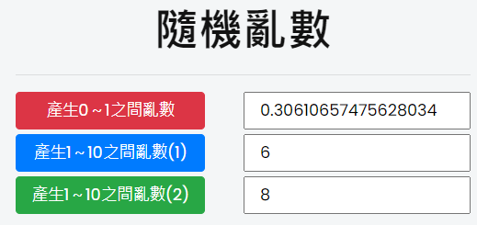

[**How to set up space layout in Bootstrap4**](https://v4.bootcss.com/docs/layout/grid/)

[**Bootstrap4如何設定空間排版**](https://v4.bootcss.com/docs/layout/grid/)

**(3-3) Task 2: Draw Poker Cards**

**Download poker card images.**

**下載撲克牌圖片**

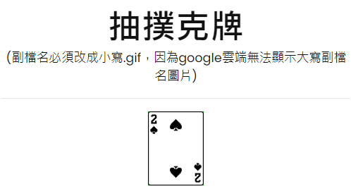

**(3-4) Task 3: Player vs Banker Poker Comparison**

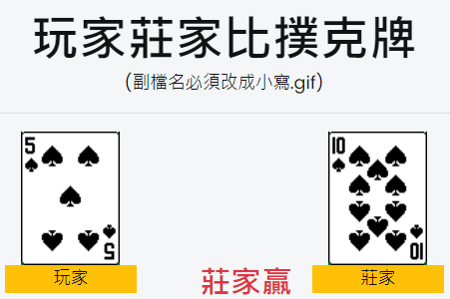

**排版設定**

**1.兩個row:**

**<div class=”row”>**

**<div class=”row”>**

**Layout Settings:**

**1.Two rows:**

**<div class=”row”>**

**<div class=”row”>**

**2.Control the position of the picture**

**<img class=”col-3 offset-1“**

**<img class=”col-3 offset-4“**

**col-3: Indicates the element occupies 3 column spaces.  
offset-1: Indicates the element is offset by 1 space from the previous one.**

**3. There are two types of JavaScript variables:**

**Local variable: n1**

**Global variable: var n1**

**(3-5) Task 4: Create multiple collapsible messages.**

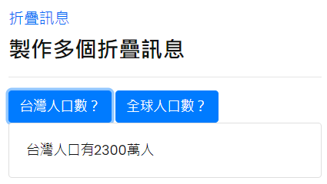

**Reference: Bootstrap Collapsible Components**

**Refer to the method for creating one collapsible component, and then turn it into two collapsible message components.**

**<a class="btn btn-primary" data-toggle="collapse" href="#collapseExample1" role="button" aria-expanded="false" aria-controls="collapseExample1">**

**台灣人口數？**

**</a>**

**</p>**

**<div class="collapse" id="collapseExample1">**

**<div class="card card-body">**

**台灣人口有2300萬人**

**</div>**

**(5) Paste the URL into Zuvio**

**Submit the URL in the assignment section on Zuvio to complete the task.**