


The Smartest Restaurant Management Platform
Accounting. Inventory. Scheduling. AP Automation. All-in-One.
The Smartest Restaurant Management Platform
Accounting. Inventory. Scheduling. AP Automation. All-in-One.

Software and Service
Proposal for

[Company Name]
[Contact Name]
[City, State]



Prepared By:
[Your Name]
[Your Title]
[Your Phone]


7 Bendix, Unit B
Irvine, CA 92618
949-652-7800
www.restaurant365.com

We Help Restaurants Grow

About Restaurant365
Restaurant365 consolidates multiple technology solutions into a single cloud-based software which eliminates all of the work associated with exporting and importing data from one system to another -- along with the headaches that come with it. Not only is R365 a “best in class” restaurant accounting platform, but the operational module is natively built within the accounting system to fully remove any integration issues. The software is easy to use, works on any device and can be seamlessly automated with hundreds of apps or other systems. Connectors and open APIs truly enable the platform to “talk” with other systems including POS providers, payroll processors, food and beverage vendors, and banks.

"If you want a successful restaurant and at any given moment understand how your business is doing while having complete control of it, the only way to go is Restaurant365."

Glorian Leach, CFO/Owner
F&D Cantina and Woodfired Italian Kitchen
R365 Benefits
Restaurant accounting is the cornerstone of Restaurant365® Software, a cloud-based, all-inclusive management solution—built specifically for restaurants—that scales and positions restaurant concepts for growth.
Key Features Include:
- Restaurant accounting, operations, and reporting in a single cloud-based platform
- Connects to your POS, Payroll, Vendors and Banking
- Real-time financial and operational reporting
- Fully mobile solution that runs on your Mac, PC, tablet and mobile devices
- End-to-end AP Automation

Real-Time Reports Based

On Real Data
Restaurant365 brings your accounting and back- office together. Stop waiting for systems to update or speak to each other; the information is already there with Restaurant365.
View custom analytics for all, some, or one of your restaurant locations with the click of a button.

Review high-level reports of your sales, menu items, labor, inventory, food and recipe costing, accounting, and more. Yes, it’s really all here. Don’t want everyone to see everything? Keep reports on a need-to-know basis with user roles and permissions.

More than 10,000 Restaurants Trust Restaurant365
Page 2 of
5
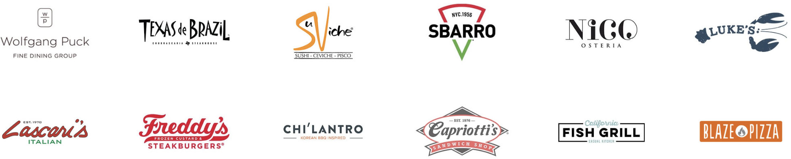



Restaurant Specific Accounting
Bring your sales, inventory and staff into one view with the only accounting system built specifically for the unique needs of restaurants.
Completely Connected
Connect all of your systems - POS, banks, vendors and more - and consolidate your reporting and operations in a mobile- friendly platform.



Prime Cost Control
Control your food costs and optimize your labor. See actuals vs. planned costs with variance reporting. Avoid overpayments with automated alerts.
Smart Predictive Forecasting
Forecast sales based on history, timing, and even the weather. Order the right amount of food at the right time. Create the perfect staff schedule.

Proposed Solution
As the world’s only, all-in-one, mobile accounting and operations management platform, Restaurant365 offers a powerful and easy to use restaurant management solution for controlling prime costs, improving profitability, managing staff, saving time and improving your team’s visibility into your business.
Thank you for the opportunity to submit our proposal for restaurant management software for your growing restaurant company. Our all in one solution for Accounting, Operations, Labor and Reporting will enable you to manage your prime costs while saving 2-5% on your Food, Beverage and Labor costs, and also speed up your business processes and period end close.

Software Subscription
Your Restaurant365 subscription grants you the right to access and use your software on an unlimited basis for unlimited users. Your subscription is a monthly fee per POS integrated restaurant and includes unlimited usage of all accounting functions for your non-restaurant locations and businesses.
Software Support: Restaurant365 Software Support covers unlimited support for your above-store software management team, as well as built in help and learning management systems within your software platform. Software Support is offered 6 days a week from 8am – 8pm CT.

Software Enhancements: Your Restaurant365 subscription grants you access all future enhancements and improvements to the tools and features that you have elected to enable within your proposed package below. We’ll never stop innovating for our customers.

Pricing

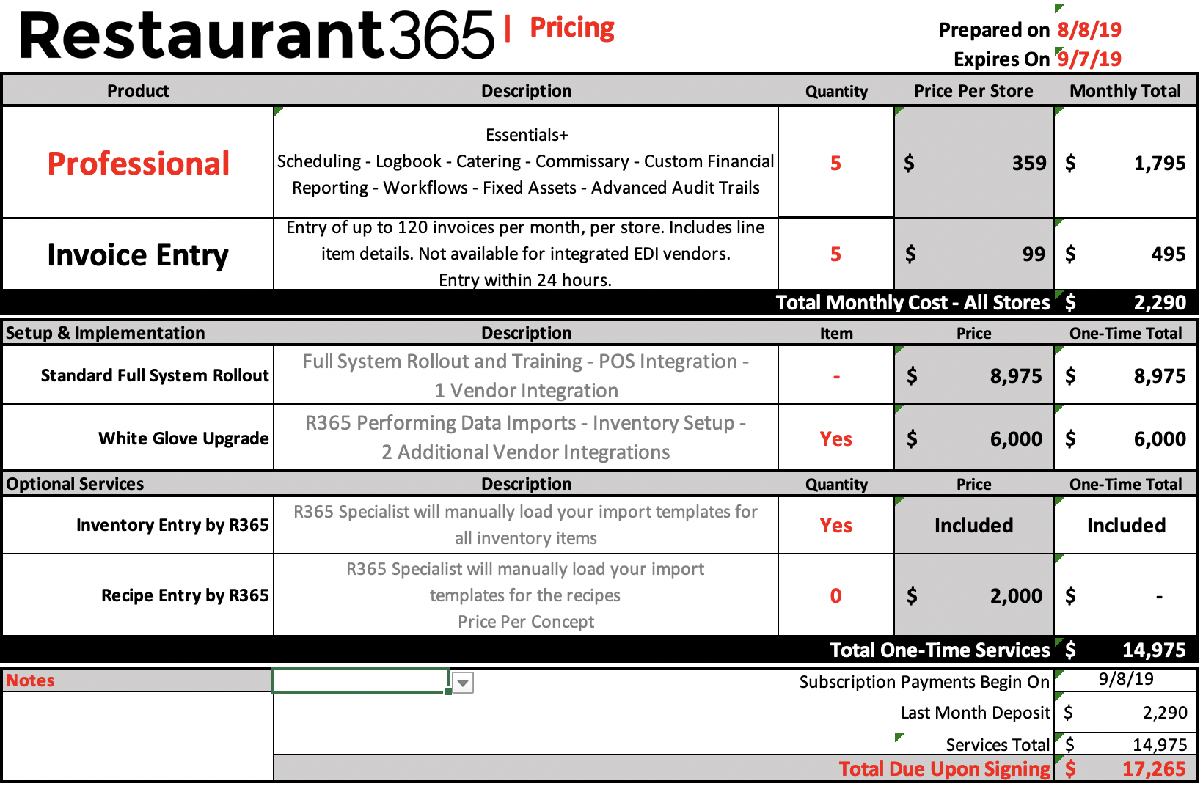

Terms and Conditions:
[Any terms, conditions, or expirations noted here]

Return on Investment

Typically, Restaurant365 customers reach improvement benchmarks within the first year beyond the staffing overhead and efficiency savings. Conservative estimates, based on customer feedback, are COG improvement (2%) and labor improvement (1%) usually resulting in nearly [$DOLLAR ESTIMATE] within 5 years.

Beyond meeting the stated goals on which the customer has placed primary importance, the cultural shift represented by access to a daily P&L, flash report, and labor analysis at the store level has the potential to yield significant savings - managers are empowered by access to advanced reporting.

Our conservative COG and labor improvement goals put [COMPANY NAME] in a position to save nearly [$DOLLARS]/MONTH/STORE]. If paperwork is executed, and the project moves on pace with the timeline suggested, we estimate those savings will total to [$DOLLARS ANNUALLY] within a year.

Return on Investment Calculation

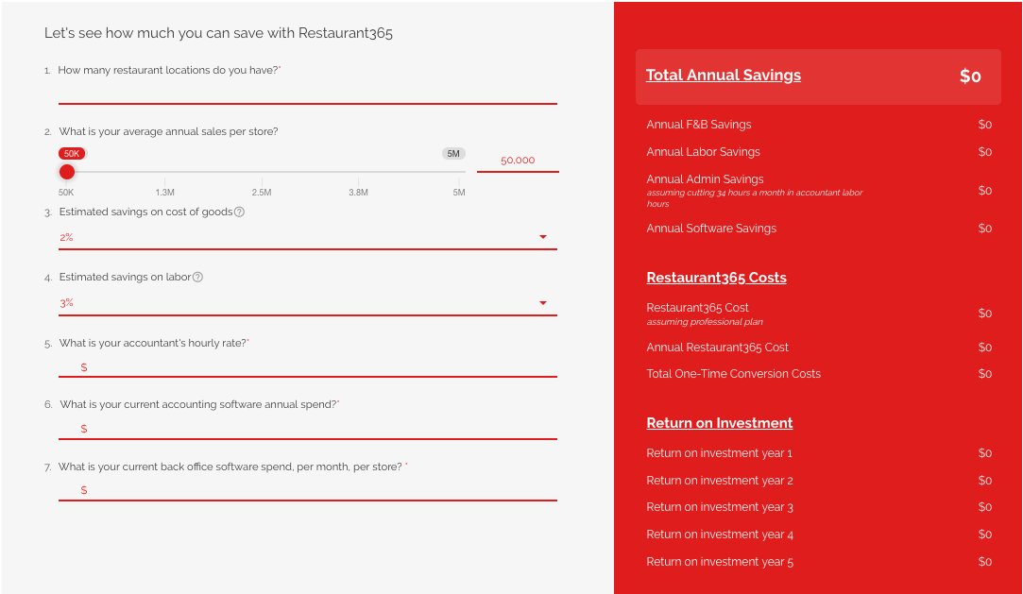

Next Steps
Closing

Review Proposal
[Relevant text here as it relates to the specific client close]
- Schedule Call with [YOUR NAME]
on [DATE] to Accept Pricing
Considerations
- Execute Order Form
- Receive Access to R365 Database
- Take up to 15 days to get organized before project start
- Schedule Orientation Call
- Meet the Setup Team and Begin Uploading Data

We Help Restaurants Grow!

