Predicting Student Course Completion
A Machine Learning Analysis Report

Clifton Chen Yi
Admin Number: 231220B

February 2026

i. Introduction

Problem Statement
Online learning platforms face significant student dropout rates, with Massive Open Online Courses (MOOCs) often experiencing attrition exceeding 90% (Onah et al., 2014). This high dropout represents a critical challenge for educational providers, resulting in lost revenue, wasted resources, and unfulfilled student potential. The ability to predict whether a student will complete a course early in their enrolment would enable platforms to implement targeted interventions — such as personalised reminders, mentor outreach, or adaptive content — to improve retention.

Objective
This analysis aims to build a supervised binary classification model that predicts whether a student will complete an online course ("Completed" vs "Not Completed") using a dataset of 100,000 student-course enrolment records with 40 features spanning demographics, course metadata, engagement behaviour, and payment details (Patel, 2024). The expected outcomes are: (1) identify the most predictive features of course completion, (2) achieve an F1-Score of at least 0.70 and ROC-AUC of at least 0.75, and (3) provide actionable insights for early intervention strategies.

ii. Dataset Overview
This dataset is well-suited for binary classification because it contains a large sample size (100,000 records), a nearly balanced target variable (~49% Completed vs ~51% Not Completed), and 40 features spanning four distinct categories — demographics, course metadata, engagement behaviour, and payment — providing diverse predictive signals without requiring class imbalance handling techniques such as SMOTE or class weighting.

Dataset Source
The dataset is the Student Course Completion Prediction Dataset, sourced from Kaggle (Patel, 2024): https://www.kaggle.com/datasets/nisargpatel344/student-course-completion-prediction-dataset. It contains 100,000 student-course enrolment records with 40 features.

Key Features
The 40 features are organised into four categories:
- Demographics: Gender, Age, Education_Level, Employment_Status, City — capturing student background. EDA later confirmed these have limited predictive power for this dataset.
- Course Metadata: Course_ID, Course_Name, Category, Course_Level, Course_Duration_Days, Instructor_Rating — describing course characteristics and structure.
- Engagement Behaviour: Login_Frequency, Video_Completion_Rate, Quiz_Score_Avg, Progress_Percentage, Assignments_Submitted, Assignments_Missed, Discussion_Participation, Time_Spent_Hours — measuring student activity, which proved to be the strongest predictive category.
- Payment: Payment_Mode, Fee_Paid, Payment_Amount, Discount_Used — financial context.
The target variable is "Completed" (Completed / Not Completed).

Challenges
The raw dataset is pre-cleaned with zero missing values and no duplicates — an unrealistic characteristic for real-world educational data. To practise proper data cleaning, missing values (~2% per column) and duplicates (~500 rows) were introduced artificially. Additional dataset-specific challenges included: high-cardinality identifier columns (Student_ID, Name, City with 15+ unique values) that risk overfitting if retained; right-skewed distributions in Time_Spent_Hours and Days_Since_Last_Login requiring robust imputation choices; and outliers detected via the IQR method in Time_Spent_Hours (5.1%) and Days_Since_Last_Login (3.7%), which could distort linear models like Logistic Regression.

iii. Data Preprocessing and Cleaning

Summary of Steps
- Handling Missing Values: Missing values in Age, Video_Completion_Rate, Quiz_Score_Avg, and Satisfaction_Rating were filled using median imputation, chosen specifically because these features exhibit right-skewness in this dataset.
- Duplicate Removal: 500 duplicate rows were identified and removed, restoring the dataset to 100,000 unique records.
- Dropping Non-Predictive Columns: Six columns (Student_ID, Name, City, Course_ID, Course_Name, Enrollment_Date) were dropped — identifiers carry no predictive signal, while City's 15+ unique values would inflate dimensionality without adding discriminative power, as confirmed by EDA showing uniform completion rates across demographics.
- Feature Encoding: A hybrid strategy was used — ordinal encoding for naturally ordered features (Education_Level: HighSchool→0 to PhD→4; Course_Level: Beginner→0 to Advanced→2; Internet_Connection_Quality: Low→0 to High→2) and one-hot encoding for low-cardinality nominal features (Gender, Employment_Status, Device_Type, Category, Payment_Mode).
- Feature Engineering: Two new features were created: Assignment_Completion_Rate (submitted / total assignments) and Quiz_Performance (Quiz_Score_Avg × Quiz_Attempts), designed to capture engagement quality rather than raw counts.
- Feature Scaling: StandardScaler (mean=0, std=1) was applied only for Logistic Regression, which is sensitive to feature scales; tree-based models used unscaled data as they are scale-invariant.

Alternative Method Considered
Mean imputation was considered as an alternative to median imputation. However, median imputation was selected because features such as Time_Spent_Hours (mean=3.87, median=2.10) and Days_Since_Last_Login (mean=6.19, median=3.00) are right-skewed in this dataset, making the median more robust to outliers and more representative of the typical student. KNN imputation was also considered but rejected due to its O(n²) computational cost on 100,000 rows. For feature encoding, one-hot encoding all categorical features was considered but rejected because City alone (15+ unique values) would substantially inflate the feature matrix, increasing the risk of the curse of dimensionality while adding negligible predictive value — as confirmed by EDA showing near-identical completion rates across demographic categories.

Key Outcomes
After preprocessing, the dataset was reduced from 40 to 34 features (plus 2 engineered features), with all categorical variables encoded numerically. The data was split 80/20 into training (80,000 records) and test (20,000 records) sets with stratified sampling to preserve the ~49/51% class balance. These preprocessing steps ensured the dataset was ready for modelling: no missing values, appropriate encodings preserving ordinal relationships, and standardised scaling where required.

iv. Exploratory Data Analysis (EDA)

Findings
EDA revealed several key insights specific to this dataset that directly influenced modelling decisions:
- Balanced Target: The target variable is nearly balanced (~49% Completed vs ~51% Not Completed), as shown in Figure 1. This confirmed that accuracy is a valid metric and class imbalance techniques (e.g., SMOTE) are unnecessary — unlike many real-world educational datasets with heavily skewed dropout rates.
- Engagement Features Dominate: Boxplots (Figure 2) showed that Progress_Percentage, Video_Completion_Rate, and Quiz_Score_Avg have the clearest separation between completers and non-completers, while demographic features (Gender, Employment_Status, Device_Type) showed near-identical distributions across both classes. This guided the decision to prioritise engagement features and confirmed that demographics contribute little discriminative information in this dataset.
- Low Inter-Feature Correlation: The correlation heatmap (Figure 3) revealed that no feature pairs exceed a correlation of 0.8, indicating minimal multicollinearity. This is a favourable condition for Logistic Regression — justifying its selection as a baseline — since high multicollinearity would destabilise coefficient estimates.
- Outliers in Behavioural Features: The IQR method detected outliers in Time_Spent_Hours (5.1%) and Days_Since_Last_Login (3.7%). These were retained rather than removed, as they represent genuine student behaviour patterns (e.g., students who cram or disengage for extended periods) rather than data errors.

Visualisations
Figure 1: Distribution of Course Completion Status
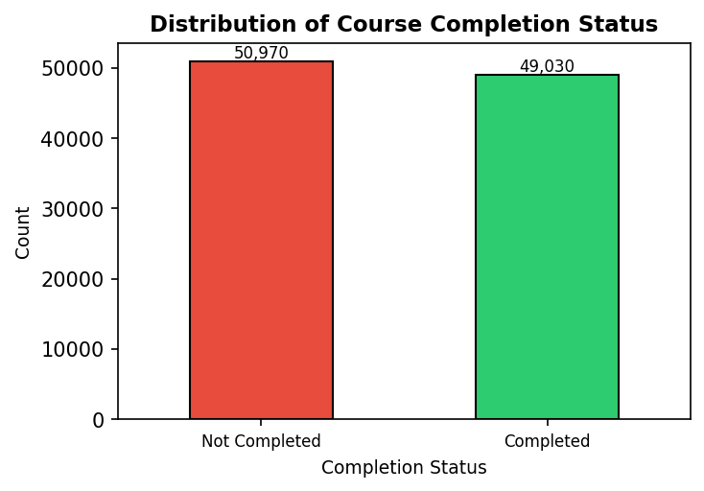
The near-equal class split (49%/51%) confirms that accuracy is valid and class imbalance handling is unnecessary.
Figure 2: Key Features by Completion Status
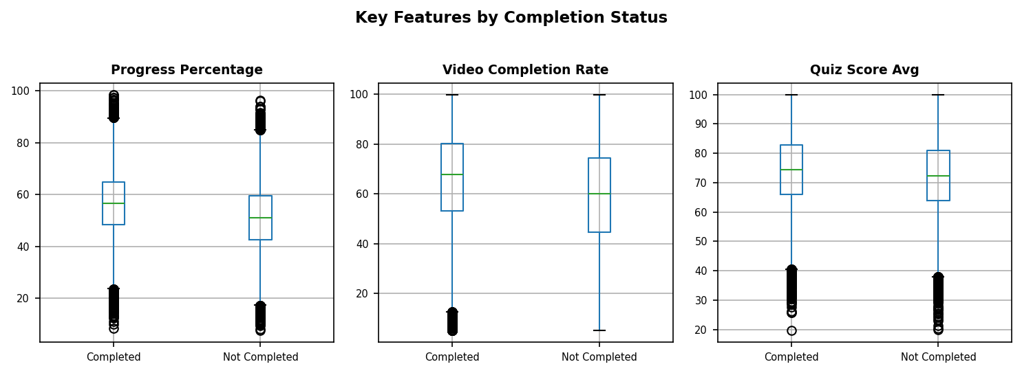
Progress_Percentage shows the strongest separation; engagement metrics are more discriminative than demographics for this dataset.
Figure 3: Correlation Heatmap of Selected Features
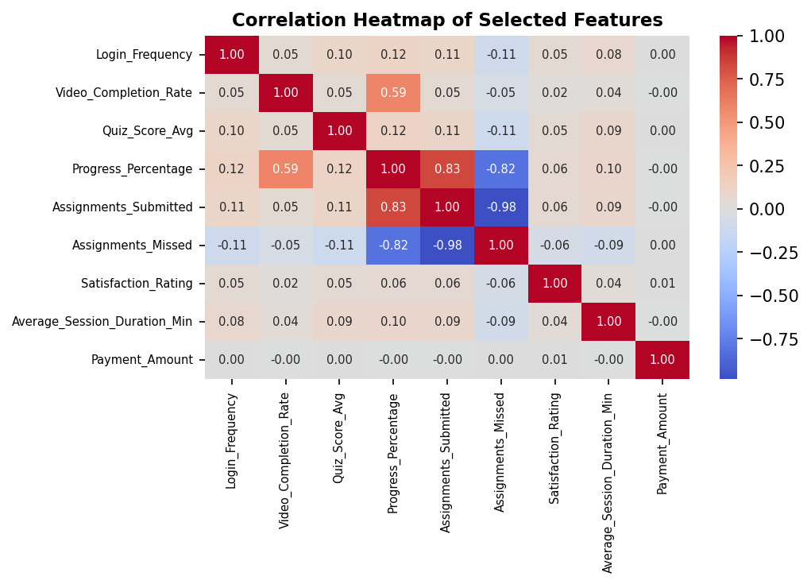
Low inter-feature correlations (all below 0.8) confirm minimal multicollinearity, supporting the use of Logistic Regression.

v. Machine Learning Model

Model Used
Three supervised classification algorithms were trained, each selected based on specific characteristics observed in this dataset:
- Logistic Regression (baseline): Selected because EDA revealed low inter-feature correlation (Figure 3), satisfying the assumption of minimal multicollinearity. The near-balanced target distribution (Figure 1) further supports this choice, as Logistic Regression performs well when classes are balanced. It models the log-odds of completion as a linear combination of features, providing interpretable coefficients.
- Random Forest: Selected to test whether non-linear feature interactions — such as combinations of engagement metrics (Video_Completion_Rate, Quiz_Score_Avg) that EDA identified as individually predictive — could improve upon the linear baseline. This bagging ensemble reduces variance through averaging across 100 decision trees.
- Gradient Boosting: Selected for its sequential error-correction approach and extensive tuning options (learning_rate, max_depth, n_estimators), offering the most potential for optimisation on this dataset. Its bounded tree depth (max_depth=5) helps control the overfitting observed in unconstrained Random Forest.
An alternative considered was Support Vector Machine (SVM). However, SVM was not used because its O(n²) computational complexity is prohibitive for the 100,000-row dataset, and tree-based ensembles scale linearly while naturally handling the mixed feature types (ordinal, one-hot, continuous) present in this dataset after encoding.

Evaluation
Model | Accuracy | Precision | Recall | F1-Score | ROC-AUC
Logistic Regression | 0.6047 | 0.5953 | 0.5896 | 0.5924 | 0.6484
Random Forest | 0.5933 | 0.5810 | 0.5917 | 0.5863 | 0.6339
Gradient Boosting | 0.6040 | 0.5954 | 0.5910 | 0.5932 | 0.6476

Table 1: Performance comparison of the three classification models.
All three models achieve modest performance (F1 ≈ 0.59, AUC ≈ 0.64), falling short of the initial targets (F1 ≥ 0.70, AUC ≥ 0.75). This result is itself informative: it indicates that the 40 features in this dataset provide limited discriminative power for predicting course completion — the engagement features that EDA identified as most separable (Figure 2) are necessary but insufficient for strong predictions. Logistic Regression achieved the best overall performance (F1=0.5924, AUC=0.6484), slightly outperforming both tree-based models. This confirms that the decision boundary in this dataset has a significant linear component, and that capturing non-linear interactions yields negligible additional benefit. Hyperparameter tuning on Gradient Boosting via GridSearchCV selected shallower trees (max_depth=3) but did not improve test performance. Cross-validation (5-fold stratified) confirmed stable generalisation with all standard deviations below 0.011.

Improvements
- Incorporate richer data sources: Real-time behavioural logs (e.g., clickstream data, forum participation, video watch patterns) and prior academic history could provide stronger predictive signals beyond the static features available in this dataset.
- Address potential data leakage: Progress_Percentage may partially encode completion status. In production, this feature should be measured at a fixed point (e.g., course midpoint) rather than at the end, to ensure the model predicts future completion rather than reflecting already-completed progress.

vi. Conclusion

Business Objectives
The primary objective of building a binary classification pipeline to predict course completion was achieved. A complete machine learning workflow — from data preprocessing and EDA through model training, comparison, tuning, and cross-validation — was successfully implemented. However, the initial performance targets (F1 ≥ 0.70, AUC ≥ 0.75) were not met; the best model (Logistic Regression) achieved F1 = 0.5924 and AUC = 0.6484. This shortfall is itself a valuable dataset-specific finding: it reveals that the available features — while spanning demographics, course metadata, engagement, and payment — provide limited discriminative power for course completion in this dataset. The analysis successfully identified that engagement metrics (Progress_Percentage, Video_Completion_Rate, Quiz_Score_Avg) are the strongest predictors, which platforms can use for early-warning systems and targeted student interventions.

Challenges
- Pre-cleaned dataset: The dataset contained no missing values or duplicates, which is unrealistic for real-world educational data. This was overcome by intentionally introducing dirty data (~2% missing values, 500 duplicates) to practise and demonstrate proper preprocessing techniques.
- Limited predictive signal: Despite 40 features and 100,000 records, all models achieved only ~60% accuracy. This was addressed by thorough feature engineering (Assignment_Completion_Rate, Quiz_Performance) and hyperparameter tuning, though improvements were marginal — highlighting that this dataset's features reach a predictive ceiling that requires richer data sources to overcome.
- Overfitting in Random Forest: The default Random Forest model showed 100% training accuracy but only 59.3% test accuracy — a clear overfitting gap. This was identified through systematic train-test performance comparison and could be mitigated by constraining tree depth or increasing minimum samples per leaf.

vii. References
McKinney, W. (2010). Data structures for statistical computing in Python. Proceedings of the 9th Python in Science Conference, 51–56. https://doi.org/10.25080/Majora-92bf1922-00a
Onah, D. F. O., Sinclair, J., & Boyatt, R. (2014). Dropout rates of massive open online courses: Behavioural patterns. In L. Gómez Chova, A. López Martínez, & I. Candel Torres (Eds.), EDULEARN14 Proceedings (pp. 5825–5834). IATED Academy. https://doi.org/10.13140/RG.2.1.2402.0009
Patel, N. (2024). Student course completion prediction dataset [Data set]. Kaggle. https://www.kaggle.com/datasets/nisargpatel344/student-course-completion-prediction-dataset
Pedregosa, F., Varoquaux, G., Gramfort, A., Michel, V., Thirion, B., Grisel, O., Blondel, M., Prettenhofer, P., Weiss, R., Dubourg, V., Vanderplas, J., Passos, A., Cournapeau, D., Brucher, M., Perrot, M., & Duchesnay, É. (2011). Scikit-learn: Machine learning in Python. Journal of Machine Learning Research, 12, 2825–2830. https://jmlr.org/papers/v12/pedregosa11a.html

