# in Section 2 , under zomato capstone project  
  
# Q1: How do you load the Zomato dataset into a Pandas Data Frame, and which Pandas   
# method provides basic information about the dataset?  
  
  
import pandas as pd  
import numpy as np  
import matplotlib.pyplot as plt  
import seaborn as sns  
  
zomato = pd.read_csv("zomato.csv")  
  
# checking the head  
zomato.head()  
  
# checking the shape, how many rows and columns  
zomato.shape

(9551, 21)

zomato.info()

<class 'pandas.core.frame.DataFrame'>  
RangeIndex: 9551 entries, 0 to 9550  
Data columns (total 21 columns):  
 # Column Non-Null Count Dtype   
--- ------ -------------- -----   
 0 Restaurant ID 9551 non-null int64   
 1 Restaurant Name 9551 non-null object   
 2 Country Code 9551 non-null int64   
 3 City 9551 non-null object   
 4 Address 9551 non-null object   
 5 Locality 9551 non-null object   
 6 Locality Verbose 9551 non-null object   
 7 Longitude 9551 non-null float64  
 8 Latitude 9551 non-null float64  
 9 Cuisines 9542 non-null object   
 10 Average Cost for two 9551 non-null int64   
 11 Currency 9551 non-null object   
 12 Has Table booking 9551 non-null object   
 13 Has Online delivery 9551 non-null object   
 14 Is delivering now 9551 non-null object   
 15 Switch to order menu 9551 non-null object   
 16 Price range 9551 non-null int64   
 17 Aggregate rating 9551 non-null float64  
 18 Rating color 9551 non-null object   
 19 Rating text 9551 non-null object   
 20 Votes 9551 non-null int64   
dtypes: float64(3), int64(5), object(13)  
memory usage: 1.5+ MB

# Q2: Identify missing values in the Zomato dataset using a Pandas method. How can you   
# count the number of missing values for each column?  
  
  
# checking the nulls if any and their count  
zomato.isna().sum()

Restaurant ID 0  
Restaurant Name 0  
Country Code 0  
City 0  
Address 0  
Locality 0  
Locality Verbose 0  
Longitude 0  
Latitude 0  
Cuisines 9  
Average Cost for two 0  
Currency 0  
Has Table booking 0  
Has Online delivery 0  
Is delivering now 0  
Switch to order menu 0  
Price range 0  
Aggregate rating 0  
Rating color 0  
Rating text 0  
Votes 0  
dtype: int64

# Q3: What Pandas method provides summary statistics for numerical columns in the Zomato   
# dataset, and what insights can you derive from these statistics  
  
# checking the summary  
zomato.describe()

Restaurant ID Country Code Longitude Latitude \  
count 9.551000e+03 9551.000000 9551.000000 9551.000000   
mean 9.051128e+06 18.365616 64.126574 25.854381   
std 8.791521e+06 56.750546 41.467058 11.007935   
min 5.300000e+01 1.000000 -157.948486 -41.330428   
25% 3.019625e+05 1.000000 77.081343 28.478713   
50% 6.004089e+06 1.000000 77.191964 28.570469   
75% 1.835229e+07 1.000000 77.282006 28.642758   
max 1.850065e+07 216.000000 174.832089 55.976980   
  
 Average Cost for two Price range Aggregate rating Votes   
count 9551.000000 9551.000000 9551.000000 9551.000000   
mean 1199.210763 1.804837 2.666370 156.909748   
std 16121.183073 0.905609 1.516378 430.169145   
min 0.000000 1.000000 0.000000 0.000000   
25% 250.000000 1.000000 2.500000 5.000000   
50% 400.000000 2.000000 3.200000 31.000000   
75% 700.000000 2.000000 3.700000 131.000000   
max 800000.000000 4.000000 4.900000 10934.000000

zomato.dtypes

Restaurant ID int64  
Restaurant Name object  
Country Code int64  
City object  
Address object  
Locality object  
Locality Verbose object  
Longitude float64  
Latitude float64  
Cuisines object  
Average Cost for two int64  
Currency object  
Has Table booking object  
Has Online delivery object  
Is delivering now object  
Switch to order menu object  
Price range int64  
Aggregate rating float64  
Rating color object  
Rating text object  
Votes int64  
dtype: object

# Q4: How do you identify categorical columns in the Zomato dataset, and why is it useful to   
# iterate through these columns?  
  
categorical_columns = zomato.select_dtypes(include=['object', 'category']).columns.tolist()  
# Additionally, if some integer columns represent categories  
int_columns = zomato.select_dtypes(include=['int64']).columns.tolist()  
for col in int_columns:  
 if zomato[col].nunique() < 10: # Assuming a small number of unique values implies categorical nature  
 categorical_columns.append(col)

for col in categorical_columns:  
 zomato[col].fillna(zomato[col].mode()[0], inplace=True) # Fill missing values with mode  
 #zomato[col] = zomato[col].str.lower().str.strip() # Standardize text

from sklearn.preprocessing import LabelEncoder  
  
label_encoders = {}  
for col in categorical_columns:  
 le = LabelEncoder()  
 zomato[col] = le.fit_transform(zomato[col])  
 label_encoders[col] = le

for col in categorical_columns:  
 print(zomato[col].value_counts())

Restaurant Name  
1099 83  
2099 79  
6106 63  
2717 51  
4077 48  
 ..  
4653 1  
3264 1  
3025 1  
3001 1  
7240 1  
Name: count, Length: 7446, dtype: int64  
City  
88 5473  
50 1118  
89 1080  
43 251  
48 25  
 ...   
93 1  
78 1  
77 1  
71 1  
133 1  
Name: count, Length: 141, dtype: int64  
Address  
4527 11  
7486 11  
5312 10  
8649 9  
4333 8  
 ..  
1301 1  
1552 1  
4505 1  
5368 1  
4258 1  
Name: count, Length: 8918, dtype: int64  
Locality  
216 122  
835 99  
971 87  
274 86  
639 85  
 ...   
587 1  
736 1  
764 1  
796 1  
670 1  
Name: count, Length: 1208, dtype: int64  
Locality Verbose  
222 122  
848 99  
1024 87  
280 86  
805 85  
 ...   
851 1  
981 1  
988 1  
1109 1  
681 1  
Name: count, Length: 1265, dtype: int64  
Cuisines  
1306 945  
1329 511  
497 354  
828 354  
1514 334  
 ...   
225 1  
1548 1  
599 1  
200 1  
1110 1  
Name: count, Length: 1825, dtype: int64  
Currency  
4 8652  
2 482  
7 80  
1 60  
3 60  
9 60  
6 40  
11 34  
0 22  
5 21  
8 20  
10 20  
Name: count, dtype: int64  
Has Table booking  
0 8393  
1 1158  
Name: count, dtype: int64  
Has Online delivery  
0 7100  
1 2451  
Name: count, dtype: int64  
Is delivering now  
0 9517  
1 34  
Name: count, dtype: int64  
Switch to order menu  
0 9551  
Name: count, dtype: int64  
Rating color  
2 3737  
4 2148  
5 2100  
1 1079  
0 301  
3 186  
Name: count, dtype: int64  
Rating text  
0 3737  
3 2148  
2 2100  
5 1079  
1 301  
4 186  
Name: count, dtype: int64  
Price range  
0 4444  
1 3113  
2 1408  
3 586  
Name: count, dtype: int64

# Q5: Create a Seaborn plot to visualize the distribution of cuisine types. Which Seaborn   
# function is suitable, and what insights can be gained?  
  
  
import seaborn as sns  
import matplotlib.pyplot as plt  
  
# Assuming df is your DataFrame with a column 'cuisine_type'  
sns.countplot(x='Rating text', data=zomato)  
plt.xticks(rotation=45) # Rotates the x-axis labels for better readability  
plt.title('Distribution of Cuisine Types')  
plt.xlabel('Rating')  
plt.ylabel('Count')  
plt.show()

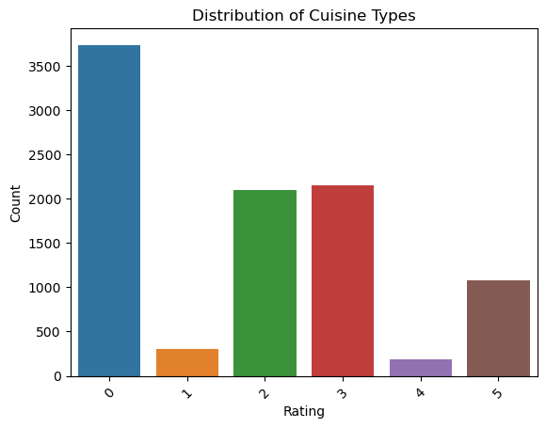

# Q6: Visualize the distribution of restaurant ratings using a Seaborn plot. What insights can   
# you gather from this visualization?  
  
import seaborn as sns  
import matplotlib.pyplot as plt  
  
# Assuming df is your DataFrame with a column 'ratings'  
sns.histplot(data=zomato, x='Rating text', bins=20, kde=True)  
plt.title('Distribution of Ratings')  
plt.xlabel('Ratings')  
plt.ylabel('Frequency')  
plt.show()

C:\Users\DELL\anaconda3\Lib\site-packages\seaborn\_oldcore.py:1119: FutureWarning: use_inf_as_na option is deprecated and will be removed in a future version. Convert inf values to NaN before operating instead.  
 with pd.option_context('mode.use_inf_as_na', True):

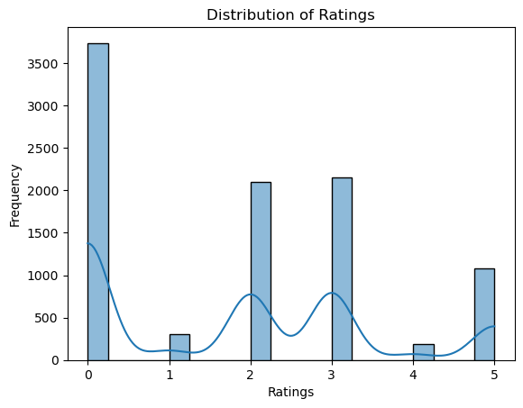

# Q7: Create any plot of choice to explore the relationship between two numerical columns.   
# Which Seaborn function is appropriate, and what does the scatter plot reveal?  
  
import matplotlib.pyplot as plt  
  
df = pd.read_csv('zomato.csv')  
  
x = df['Average Cost for two']  
y = df['Votes']  
  
# creating scatter plot  
plt.scatter(x,y, label = 'Data Points')  
  
# customizing the scatter plot  
plt.xlabel("Average Cost for two")  
plt.ylabel("Votes")  
plt.title("Scatter Plot")  
  
# adding legend, inorder to show the text "Data Points"  
plt.legend()  
  
# Display the plot  
plt.show()

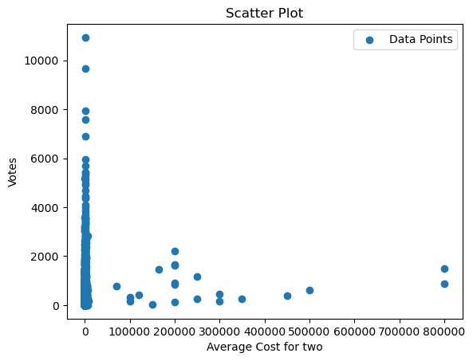

import matplotlib.pyplot as plt  
  
df = pd.read_csv('zomato.csv')  
  
x = df['Price range']  
y = df['Votes']  
  
# creating scatter plot  
plt.scatter(x,y, label = 'Data Points')  
  
# customizing the scatter plot  
plt.xlabel("X-axis")  
plt.ylabel("Y-axis")  
plt.title("Scatter Plot")  
  
# adding legend, inorder to show the text "Data Points"  
plt.legend()  
  
# Display the plot  
plt.show()

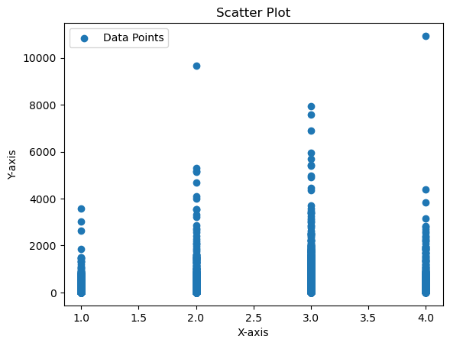

# Q8: Introduce a different type of visualization. What Seaborn or Matplotlib function can be   
# used  
  
import seaborn as sns  
import matplotlib.pyplot as plt  
  
df = pd.read_csv('zomato.csv')  
  
# Assuming df is your DataFrame with columns 'cuisine_type' and 'average_rating'  
sns.barplot(x='Average Cost for two', y='Votes', data=df)  
plt.title('Relationship between Total Price range and Votes')  
plt.xlabel('Two Average Cost')  
plt.ylabel('Customer Votes')  
plt.show()

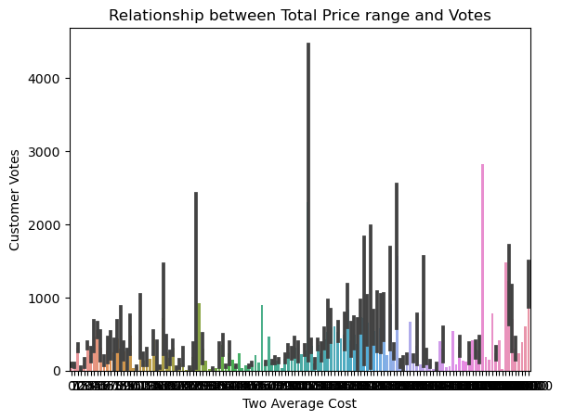

import seaborn as sns  
import matplotlib.pyplot as plt  
  
df = pd.read_csv('zomato.csv')  
  
# Assuming df is your DataFrame with columns 'cuisine_type' and 'average_rating'  
sns.barplot(x='Price range', y='Votes', data=df)  
plt.title('Relationship between Total Price range and Votes')  
plt.xlabel('Two Average Cost')  
plt.ylabel('Customer Votes')  
plt.show()

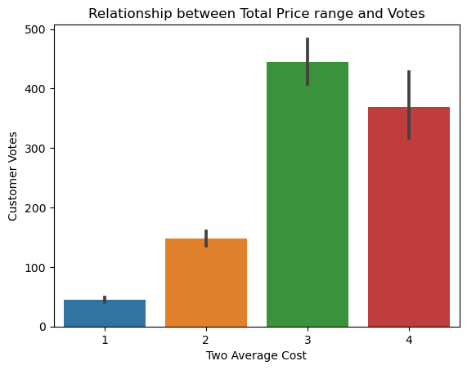

# Q9: How can you display the generated plots for the Zomato dataset, and which Matplotlib   
# function should be used  
  
  
import pandas as pd  
import seaborn as sns  
import matplotlib.pyplot as plt  
  
df = pd.read_csv('zomato.csv')  
  
#if you want to create a histogram of numerical ratings this is best  
sns.histplot(data=df, x='Rating text', bins=20, kde=True)  
plt.title('Distribution of Ratings on Zomato')  
plt.xlabel('Rating text')  
plt.ylabel('Aggregate rating')  
plt.show()  
  
#if you prefer a bar plot to show average ratings by cuisine type:  
sns.barplot(x='Rating text', y='Aggregate rating', data=df)  
plt.xticks(rotation=45)  
plt.title('Average Rating by Cuisine Type on Zomato')  
plt.xlabel('Rating text')  
plt.ylabel('Aggregate rating')  
plt.show()

C:\Users\DELL\anaconda3\Lib\site-packages\seaborn\_oldcore.py:1119: FutureWarning: use_inf_as_na option is deprecated and will be removed in a future version. Convert inf values to NaN before operating instead.  
 with pd.option_context('mode.use_inf_as_na', True):

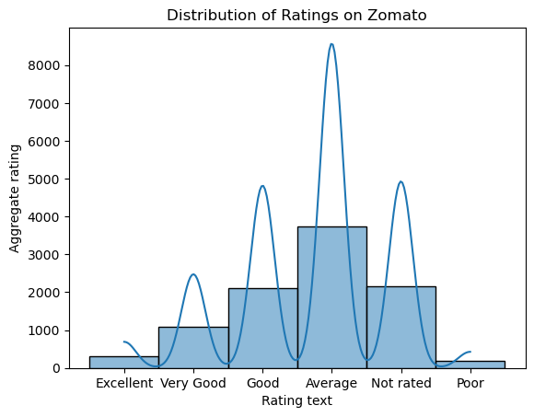

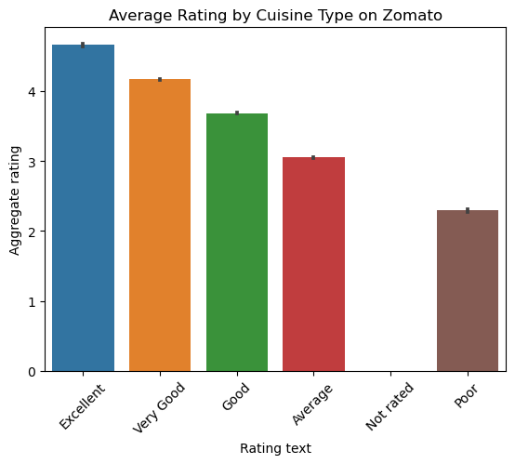

# Q10: Based on the visualizations of the Zomato dataset, what conclusions or   
# recommendations can be made? Look for patterns, trends, or interesting observations  
  
  
# Conclusions and Recommendations  
# New Menu i.e. Popular Cuisines and Dishes: more efforts on promoting popular cuisines and dishes.  
# Pricing = pricing should be based on the restaurant and its location, so that it can generate good and regular flow of   
# customers  
# offers and promotions   
# Optimizing all knids of Operations During Peak Times: allocating human resources and other necessary resources, according   
# to the peak time i.e. demand and supply.