Table of Contents

Findings: 2

Wrong data on the 2 most expensive bottles? 2

Counties 2

Per capita spending – counties with 100k+ population 2

Per store sales over the period – counties with 100k+ population 3

Stores 4

Products 5

10 products make 25% of all sales in $ 5

Total sales: $392,293,023 5

Margins 7

Timeframe 9

Daily trend 9

No data on Sundays: 9

Analysis 12

Counties: 12

Stores: 12

Products: 12

Yearly changes: 12

# Findings:

### Wrong data on the 2 most expensive bottles?

*Absolut w/ Zing Zang Bloody Mary Mix:* is $1599 state cost / $2398 per bottle

*Absolut Zing Zang Bloody Mary Mix:* $11.49/ $17.24 per bottle

*Cedar Ridge Barrel Proof Bourbon:* only 2 sales of 1 bottle each at convenience stores.

Real cost should be around $40/bottle

Sources: <http://whiskeyreviewer.com/2017/09/cedar-ridge-bourbon-review-092217/> [https://www.wine-searcher.com/find/cedar%20ridge%20distil%20bourbon%20whisky%20iowa%20usa#t](https://www.wine-searcher.com/find/cedar ridge distil bourbon whisky iowa usa" \l "t1)1

## Counties

### Per capita spending – counties with 100k+ population

|  |  |  |  |  |
| --- | --- | --- | --- | --- |
| County | Population | nr_of_stores | total_sales | sales_per_capita |
| Polk | 430640 | 197 | $86,397,461.79 | $200.63 |
| Linn | 211226 | 102 | $34,460,047.49 | $163.14 |
| Scott | 165224 | 64 | $27,902,848.67 | $168.88 |
| Black Hawk | 131090 | 78 | $22,967,283.29 | $175.20 |
| Johnson | 130882 | 49 | $24,200,402.25 | $184.90 |
| Woodbury | 102172 | 40 | $13,242,016.16 | $129.61 |

**Linn, while being the second most populated county, has similar sales results as smaller counties will fewer stores.**

### Per store sales over the period – counties with 100k+ population

|  |  |  |  |  |
| --- | --- | --- | --- | --- |
| County | Population | nr_of_stores | total_sales | sales_per_store |
| Polk | 430640 | 197 | $86,397,461.79 | $438,565.80 |
| Linn | 211226 | 102 | $34,460,047.49 | $337,843.60 |
| Scott | 165224 | 64 | $27,902,848.67 | $435,982.01 |
| Black Hawk | 131090 | 78 | $22,967,283.29 | $294,452.35 |
| Johnson | 130882 | 49 | $24,200,402.25 | $493,885.76 |
| Woodbury | 102172 | 40 | $13,242,016.16 | $331,050.40 |

**Linn, Black Haw and Woodbury have smaller sales per store compared to the other counties.**

## Stores

|  |  |  |  |  |  |
| --- | --- | --- | --- | --- | --- |
| **Name** | **County** | **Nr of sales** | **Total sales** | **Avg sales** | **% of sales 100+ btl** |
| Hy-vee #3 / Bdi / Des Moines | Polk | 2046 | $13,920,087.22 | $472.43 | 9% |
| Central City 2 | Polk | 2143 | $11,942,399.97 | $462.40 | 10% |
| Sam's Club 6344 / Windsor Heights | Polk | 1310 | $6,159,480.06 | $1,106.23 | 35% |
| Sam's Club 8162 / Cedar Rapids | Linn | 1477 | $5,734,721.57 | $803.75 | 30% |
| Hy-vee Wine and Spirits / Iowa City | Johnson | 2401 | $5,665,143.70 | $235.67 | 6% |
| Costco Wholesale #788 | Dallas | 877 | $4,907,465.88 | $1,825.69 | 32% |
| Lot-a-spirits | Scott | 1302 | $4,289,169.59 | $319.73 | 3% |
| Sam's Club 8238 / Davenport | Scott | 1021 | $3,308,625.56 | $623.56 | 24% |
| **Average** | | **1572** | **$6,990,886** | **$731.18** | **18.45%** |

**The top 10 stores in total sales on average have 18.45% transaction involving 100+ bottles. This indicates that sales are more consumer oriented than wholesale.**

## Products

### 10 products make 25% of all sales in $

#### Total sales: $392,293,023

|  |  |  |  |
| --- | --- | --- | --- |
| Description | Category | Sales | % of total sales |
| Black Velvet | CANADIAN WHISKIES | $18,315,550.64 | 4.67% |
| Captain Morgan Spiced Rum | SPICED RUM | $13,772,752.25 | 3.51% |
| Jack Daniels Old #7 Black Lbl | TENNESSEE WHISKIES | $13,701,656.82 | 3.49% |
| Fireball Cinnamon Whiskey | WHISKEY LIQUEUR | $10,622,967.34 | 2.71% |
| Crown Royal Canadian Whisky | CANADIAN WHISKIES | $9,714,022.78 | 2.48% |
| Hawkeye Vodka | 80 PROOF VODKA | $8,730,823.84 | 2.23% |
| Absolut Swedish Vodka 80 Prf | IMPORTED VODKA | $7,431,864.05 | 1.89% |
| Grey Goose Vodka | IMPORTED VODKA | $6,444,939.38 | 1.64% |
| Jagermeister Liqueur | MISC. IMPORTED CORDIALS & LIQUEURS | $6,298,430.40 | 1.61% |
| Jim Beam | STRAIGHT BOURBON WHISKIES | $5,163,920.19 | 1.32% |
| Total | | $100,196,927.69 | 25.54% |

|  |  |  |  |  |
| --- | --- | --- | --- | --- |
| **Item** | **avg btl price** | **avg sale** | **avg btl qty** | **count** |
| Black Velvet | $10.17 | $225.85 | 20.62 | 81,095 |
| Hawkeye Vodka | $7.31 | $117.56 | 16.06 | 74,264 |
| Seagrams 7 Crown Bl Whiskey | $12.40 | $109.43 | 8.95 | 39,577 |
| Captain Morgan Spiced Rum | $17.65 | $367.78 | 20.48 | 37,448 |
| Smirnoff Vodka 80 Prf | $11.82 | $134.95 | 11.77 | 36,136 |
| Fireball Cinnamon Whiskey | $15.58 | $294.55 | 18.47 | 36,065 |
| Jack Daniels Old #7 Black Lbl | $25.33 | $385.22 | 15.36 | 35,568 |
| Absolut Swedish Vodka 80 Prf | $19.28 | $224.27 | 11.02 | 33,138 |
| Bacardi Superior Rum | $13.40 | $150.40 | 10.8 | 32,552 |
| Jim Beam | $16.16 | $161.85 | 9.88 | 31,906 |
| *Top 10 average* | *$14.77* | *$223.33* | *14.84* | *45,094* |
| *All sales average* | *$14.37* | *$128.62* | *9.86* |  |

The top 10 products by unit sold all have at least 8 bottles sold per transaction with an average of 14.84 bottles sold per transaction, which is higher than the average of all sales. Also, of note is that the average transaction of these products is higher by almost $100 than all the sales.

## Margins

|  |  |  |  |  |  |
| --- | --- | --- | --- | --- | --- |
| Description | Bottle price avg. | Bottle state cost avg | Total profit | Margin % | nr_sales |
| Black Velvet | $10.17 | $6.75 | $6,144,705.67 | 50.69 | 81095 |
| Captain Morgan Spiced Rum | $17.65 | $11.77 | $4,590,286.75 | 49.99 | 37448 |
| Jack Daniels Old #7 Black Lbl | $25.33 | $16.88 | $4,567,750.22 | 50.01 | 35568 |
| Fireball Cinnamon Whiskey | $15.58 | $10.39 | $3,541,448.72 | 50.01 | 36065 |
| Crown Royal Canadian Whisky | $24.99 | $16.66 | $3,237,724.15 | 50 | 28453 |
| Hawkeye Vodka | $7.31 | $4.87 | $2,913,004.84 | 50.07 | 74264 |
| Absolut Swedish Vodka 80 Prf | $19.28 | $12.84 | $2,482,433.43 | 50.21 | 33138 |
| Grey Goose Vodka | $24.23 | $16.14 | $2,149,997.33 | 50.1 | 27845 |
| Jagermeister Liqueur | $17.81 | $11.87 | $2,099,928.40 | 50.02 | 28714 |
| Jim Beam | $16.16 | $10.74 | $1,730,013.78 | 50.44 | 31906 |

Almost all products have a margin around 50%

|  |  |  |  |
| --- | --- | --- | --- |
| Description | Total profit | Margin % | nr_sales |
| Jim Beam Operation Homefront | $83,589.16 | 124.43 | 238 |
| Jose Cuervo Silver w/1L Classic Light Margarita Mix | $19,451.58 | 106.41 | 120 |
| Maestro Dobel | $5,356.08 | 86.74 | 60 |
| Ole Smoky Apple Pie w/Flask | $1,897.92 | 78.36 | 50 |
| Passion XO Pink | $324.22 | 72.83 | 24 |
| Passion XO Blue | $391.30 | 70.37 | 26 |
| Jose Cuervo Gold w/1L Classic Margarita Mix | $25,767.13 | 70.08 | 214 |
| Passion XO Sun | $301.86 | 69.33 | 18 |
| Absolut Tune | $3,234.32 | 58.73 | 60 |
| Skyy Infusions Texas Grapefruit | $836.67 | 58.52 | 19 |

**The only products with a margin higher than 50% are niche products.**

## Timeframe

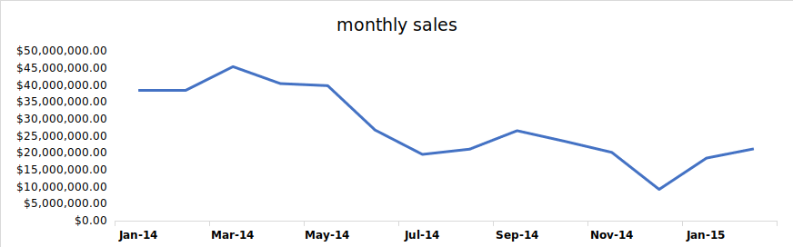

**Significant drop in sales from May 2014 onward.**

##### Daily trend

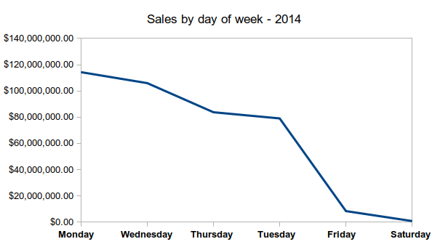

Most sales are made at the start of the week.

##### No data on Sundays:

*Only Class E liquor licensees (carryout liquor) and Class B wine permittees (carryout wine) have a Sunday sales privilege as part of their basic license.*

***Source:*** [***https://abd.iowa.gov/alcohol/alcohol-laws/hours-sale***](https://abd.iowa.gov/alcohol/alcohol-laws/hours-sale)

Yearly change / growth

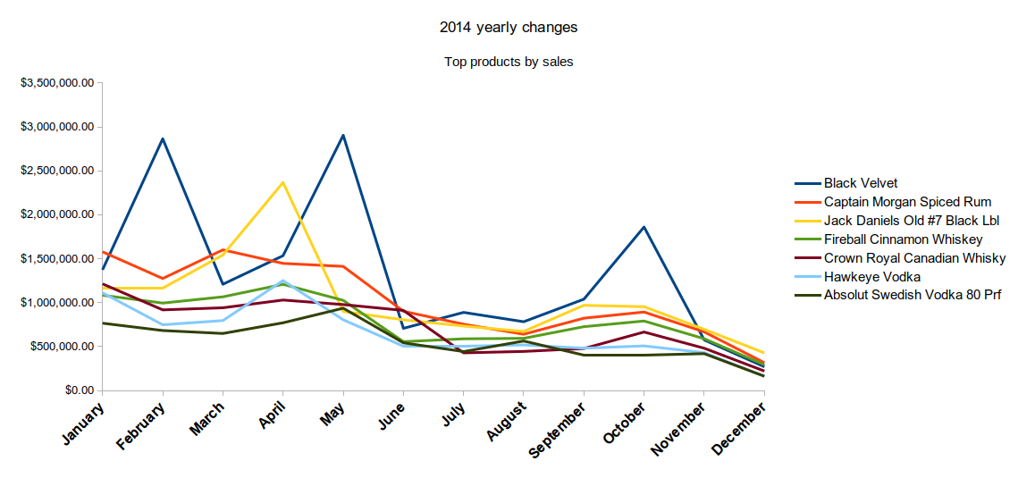

The top products by sales amount reflect the monthly sales trend seen above. The best-selling products by amount of sales is Black velvet, a Canadian whisky. This product, unlike the other, fluctuated wildly over the year, with spikes in February, May and October.

Another product, the American whisky Jack Daniels Old #7, shows some milder variations but still with a notable peak in April.

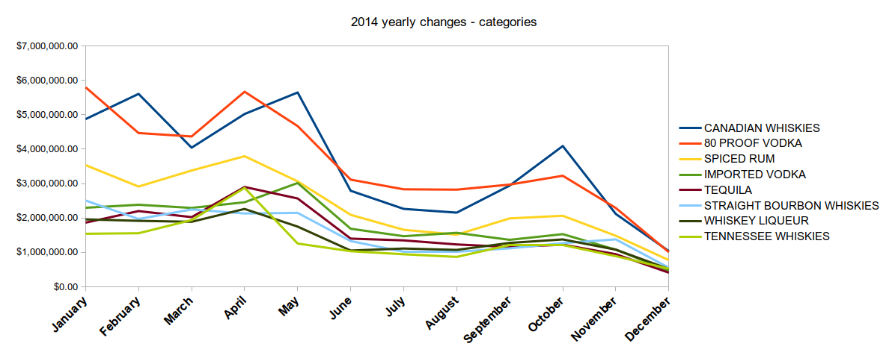

Looking at categories, the shape is similar with a downward trend towards the end of the year. However, the two most prominent categories do not reflect the products above. Canadian Whiskies and 80 proof vodka are the products selling the most.

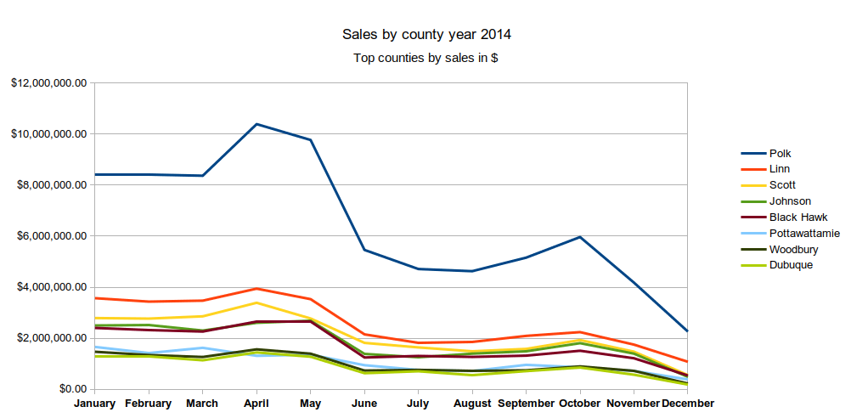

Looking at the top counties by sales, Polk, the most populated one, is far ahead of the rest. With a peak from March to June. The October rebound seen in the charts preceding this one is also present.