Day 1 - Advanced AI

What is LLM?
In simple terms LLM is prediction of text that what comes next.
- A computer program trained on a massive amount of text that learns to understand and generate human language.
- Under the hood LLMs are based on transformer neural networks.Transformer LLMs are capable of unsupervised training, although a more precise explanation is that transformers perform self-learning. It is through this process that transformers learn to understand basic grammar, languages, and knowledge.
Large means - billions of parameters
Language means - oriented to text
Model means - It’s a mathematical system , not a database stored system.
The Core Difference: Size
 | LLM | SLM
Full Name | Large Language Model | Small Language Model
Parameters | Billions–Trillions | Millions–Few Billions
Examples | Claude, GPT-4, Gemini | Phi-3, Mistral 7B, Gemma
Runs on | Powerful cloud servers | Laptops, phones, edge devices
Speed | Slower | Faster
Cost | Expensive | Cheap
Knowledge | Very broad | More focused/narrow
Accuracy | Generally higher | Slightly lower

LLMs are the brains in the cloud. SLMs are the brains in your pocket.
Think of it like vehicles:
- 🚀 LLM = A jumbo jet — carries enormous capacity, handles anything, but needs a huge runway (expensive infrastructure) to operate.
- 🚗 SLM = A car — smaller, cheaper, runs on your driveway, great for everyday tasks, but can't carry 300 passengers.

What is RAG?
Retrieval Augmentation Generation model combines the strengths of retrieval-based and generation-based approaches, leading to more accurate and contextually rich AI responses.
Flow of the RAG model:
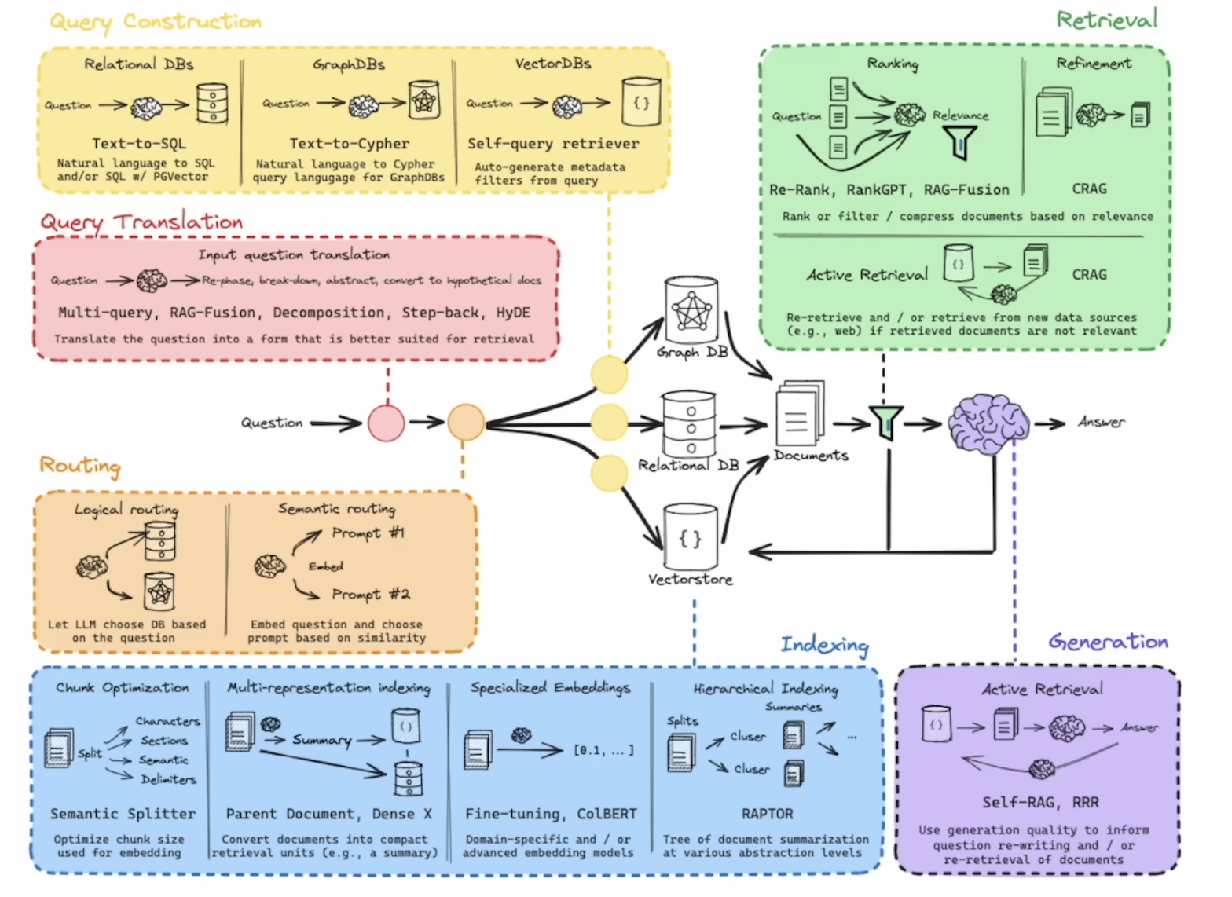
Advantages of the RAG Architecture Model
- Enhanced Accuracy: By combining retrieval-based and generation-based approaches, the RAG model significantly improves the accuracy of responses.
- Contextual Relevance: The use of contextual data ensures that the generated responses are highly relevant to the client’s query.
- Efficiency: The vector database allows for efficient retrieval of information, speeding up the overall process.
- Scalability: The architecture is scalable, making it suitable for a wide range of applications, from customer support to complex research queries.
https://www.pinecone.io/learn/retrieval-augmented-generation/
Difference between Chains and Agents?
- Agents are like characters or personas with specific capabilities. They use chains and tools to perform their functions.
- Chains are sequences of processing steps for prompts. They are used within agents to define how the agent processes information.
- Tools are specialized functionalities that can be used by agents or within chains for specific tasks.
How would you build a chatGpt for your college notes?

