We at Big Mountain Resort are looking to increase revenue. We looked at increasing ticket prices to do this. We created a model to determine (a) whether this would be feasible and (b) which aspects of our resort we could advertise in order to support a price increase. Our model suggests this is feasible, and we could increase our ticket prices by as much as $15.

As seen in this graph, we have room to increase ticket prices compared to the market:

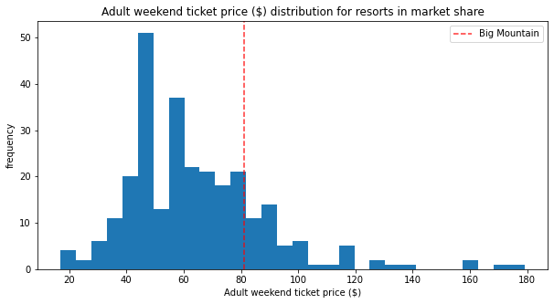

although we currently have the highest ticket price in Montana.

Nevertheless, our model suggests that we are underpriced for the features we offer. The features that we do very well in compared to the market include total number of runs:

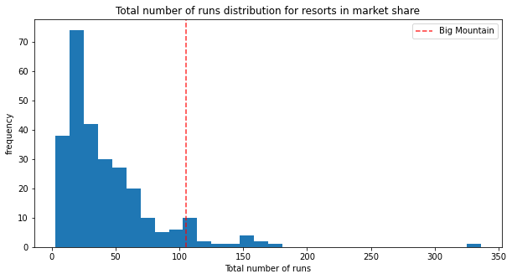

longest run:

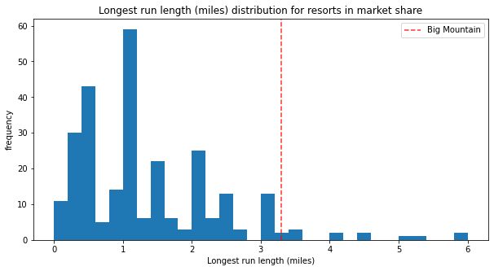

total number of chairs:

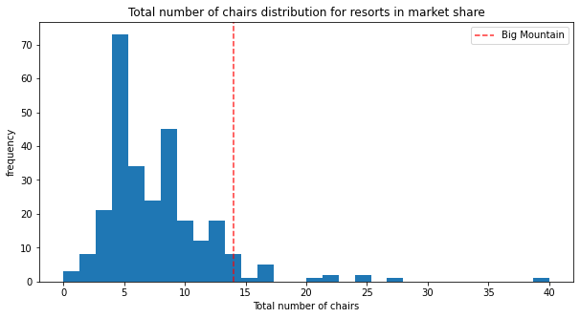

and snow-making:

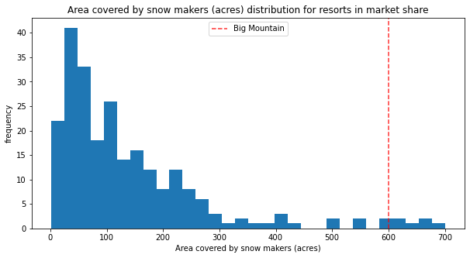

We also compare well to the market in vertical drop and fast quads.

We used our model to look at how four potential changes to the resort would affect ticket prices:

1. Permanently closing down up to 10 of the least used runs. This doesn't impact any other resort statistics.
2. Increase the vertical drop by adding a run to a point 150 feet lower down but requiring the installation of an additional chair lift to bring skiers back up, without additional snow making coverage
3. Same as number 2, but adding 2 acres of snow making cover
4. Increase the longest run by 0.2 mile to boast 3.5 miles length, requiring an additional snow making coverage of 4 acres

Our model showed that option 2 increases support for ticket price by $1.99. Given an expected 350,000 visitors coming five times over the season, this could amount to $3,474,638 in additional revenue. The other three options did not support an increase in ticket price.

In summary, we are underpriced compared to the market. We have several features we can highlight in marketing, supporting an increase in ticket prices. Our model suggests that increasing our vertical drop may improve our resort even more despite the attendant costs. Overall, we have room to grow the business at Big Mountain Resort.