CDAC Mumbai DAC Forum & Mentor

Assessment

**SOFTWARE REQUIREMENT SPECIFICATION FOR**

**E-PHARMA**

**[16-06-2019]**

**CDAC, MUMBAI**

## Revision History:

|  |  |  |  |  |
| --- | --- | --- | --- | --- |
| **Version.** | **DATE** | **Authored By** | **Reviewed By** | **REASON FOR CHANGE** |
| 00 | 16/06/2019 | Team-09 |  | 1st release |

CDAC Mumbai DAC Forum & Mentor

Assessment

# Table of Contents

1. Introduction 1
   1. Purpose 1
   2. Document Conventions 1
   3. Intended Audience and Reading Suggestions 1
   4. Product Scope 2
   5. References 3
2. Overall Description 3
   1. Product Perspective 3
   2. Product Functions 3
   3. User Classes and Characteristics 3
   4. Operating Environment 3
   5. Design and Implementation Constraints 3
   6. User Documentation 4
   7. Assumptions and Dependencies 4
3. External Interface Requirements 4
   1. User Interfaces 4
   2. Hardware Interfaces 5
   3. Software Interfaces 5
   4. Communications Interfaces 5
4. System Features 5
   1. System Feature 1 5
   2. System Feature 2 (and so on) 5
5. Other Non-functional Requirements 6
   1. Performance Requirements 6
   2. Safety Requirements 7
   3. Security Requirements 7
   4. Software Quality Attributes 7
   5. Business Rules 7
6. Other Requirements 8

CDAC Mumbai DAC Forum & Mentor

Assessment

# Introduction

## Purpose

**E-PHARMA** is a web application through which the customer will be able to search and buy the medicine from anywhere and as per the requirements and also the medicines will be delivered to user.

This project aims at solving the above issues such as urgent need of medicine, unavailability of medicines etc. by providing an option to order medicine online and get it delivered at your location in feasible time.

One can order medicines compared with different stores in best prices. The purpose of this project is to ease buying medicines at better prices and save time.

## Document Convention Headings: -

Text: -Bold Font-Size: - 14

Highlighting: - Times New Roman

## Sub Headings: -

Text: -Bold Font-Size: - 12

Highlighting: - Times New Roman

## Header: -

Text: - Simple Font-Size: -10

Highlighting: - Times New Roman

## Footer: -

Text: - Simple Font-Size: -10

Highlighting: - Times New Roman

## Intended Audience and Reading Suggestions

This document is intended for developers, users, testers and project managers for the purpose of understanding the design of system in terms of different perspectives. Further, this document contains functionalities and characteristics of system along with the working Environment. It also includes other information related to system such as external interface requirements, features and other non - functional requirements.

# Product Scope

Our project is targeted on easy accessibility of authorized medicines by order. The user can surf the medicine items according to categories.

It provides 24 hours service. One can check the reviews and ratings of a pharmacy. It also provides exclusive medicines at lower prices after comparing it with different stores. Payment can be done through online payment gateway or cash on delivery.

# References

<https://stackoverflow.com/>

<https://docs.microsoft.com/en-us/dotnet/>

<https://www.asp.net/>

<https://html.com/>

<https://git-scm.com/>

# Overall Description

## Product Perspective

## 

## Some of the Existing E-Pharmacy sites in market are unlicensed. Sites that offer to sell you drugs without a doctor’s prescription are unlicensed. There is also a high probability of buying counterfeit drugs. With so many of these E-pharmacy sites being illegal, counterfeit and fake drugs are bound to make rounds.

## Some of them may ask for personal and financial information which they may end up selling. Some of the sites don’t have proper security measures and thus are prone to hackers. Delivery for some of the drugs can take a few days. This can be unfortunate for you if you need your medication urgently.

## Keeping in mind these types of disadvantages we developed “E-PHARMA” an online medicine web-application as a replacement for the unlicensed sites and maintain a little safety and security of users.

## Will provide a convenient, Private and Confidential, Time and Money Saving and affordable way.

## 

## Product Functions

## The customer will able to view medicines category wise.

## The customer can compare prices with different stores.

## The customer can also view reviews and ratings of the medicine

CDAC Mumbai DAC Forum & Mentor

Assessment

## User Classes and Characteristics Admin:

Admin can view the user’s details which are given during registration.

Admin can add medicine item details like name, photo, description, formula; price and category will be able to access all the functions of the system.

Admin can view, edit the medicine items details as well as Enable/disable medicine items according to availability of their expiry dates.

Admin will look into supply management and will view analytics.

## Customer:

User has to register with essential details for medicine ordering system.

User has to log in with their credentials to access medicine ordering system.  
Different medicine items with respective categories viewable to the user.

User can view medicine items details and buy the product by doing online payment

## Supplier:

## Supplier has to register with essential details for stock update.

## Supplier has to login with essential details for stock update.

## Supplier will update the stock and create a stock report.

# Operating Environment

## Hardware platform:

* + - * Processor – Above Pentium 4, with clock speed of 2.0 GHz
      * RAM – 1 GB or above
      * Hard Disk – Free disk space of above 1 GB

## Software platform:

* + - * Front-end: HTML, CSS, Bootstrap, JavaScript, Angular.
      * Back-end: Java, J2EE, Spring Boot .

## Supported tools:

* + - * Eclipse J2EE , MySQL Workbench, Git.

# Design and Implementation Constraints

## Constraints:

* User interface is only in English. No other language option is available
* User can log-in only with his assigned user-name and password
* Limited to HTTP/HTTPS

CDAC Mumbai DAC Forum & Mentor

Assessment

# User Documentation

User documentation mainly comprises of Help menu of application. It will give all the minute details about the project, if any user has any query about any module or functionality, one can refer it and see how to operate the application. This report is the complete documentation of our project. It gives complete details about the project, its functionality, users, software used, hardware requirement, and environment and so on.

# Assumptions and Dependencies

* Assumptions
  + There is an active internet connection with the system
  + The system has internet browser installed
  + Users know the English language, as the user interface will be provided in English.
* Dependencies:
  + There is a need of constant updating of stock for medicines after any medicines are added.
  + Active participation of users for review and rating is required.

# External Interface Requirements

## User Interfaces

The main element is web-pages using HTML, JavaScript. Multiple interfaces are there like login pages, home pages of Customer, Admin, Supplier, and also the Forum. Admin will update the stock of the medicines as accordingly data will be persisted. Based on the stock of the medicines the feedback provided by Customers, Supplier performance would be evaluated.

CDAC Mumbai DAC Forum & Mentor

Assessment

## Hardware Interfaces

In the hardware interface, the system interacts with hardware given the processor is above P4 with clock speed of 2.0 GHz with 1 GB RAM and the Hard Disk with 1 GB free space in the memory. In future enhancements, it can be made responsive to be able to work with mobile devices as well.

## Software Interfaces

In software interfaces, .NET is the back-end technology used along with MySQL Database. The front-end technologies include HTML, CSS, Bootstrap, and JavaScript. Data will be communicated between these interfaces accordingly.

## Communications Interfaces

The main communication interface for interacting with the System will be the web Browser.

# System Features

## Description

This system helps to provide online medicines and also provide the 24* 7 services to the Customers. This system provides easy accessibility of authorized medicines on one click. This software also aims at carrying out the analysis of the supplier’s performance which will help to improve this system to work more efficiently. This system help the customers to compare the cost of the particular medicine from the different stores so that it would be easier for customers to get the best option for exclusive medicines as we are providing the online reviews and the ratings .This system provide the online payment facility.

## Functional Requirements

## Customer

* + - * This feature used by the customer to login into system.
      * A customer must login with his/her user name and password to the system after registration

and if they are invalid, the customer not allowed to enter the system.

* + - * Username and password will be provided after customer registration is confirmed.
      * Password should be hidden from others while typing it in the field.

CDAC Mumbai DAC Forum & Mentor

Assessment

## Register New Customers

* + - * A new customer will have to register in the system by providing essential details in order to view the medicines in the system.
      * The admin must accept new customers by unblocking him/her.
      * System must be able to verify and validate information.
      * The system must encrypt the password of the customer to provide security.

## Purchasing the Medicines

* + - * The customer can add the desired medicines into his cart by clicking add to cart option on the product. He can view his cart by clicking on the cart button.
      * Customer can remove an order from the cart by clicking remove. After confirming the order

in the cart the customer can submit the cart by providing a delivery address. On successful submitting the cart will become empty.

* + - * System must ensure that, only a registered customer can purchase medicines.

## Admin

* + - * The system must identify the login of the admin.
      * The administrator can add user, delete user, view user and block user
      * The administrator can add supplier, delete supplier, block supplier and search for a supplier.
      * The administrator can add medicines, delete medicines and view medicines.
      * The administrator can view orders and delete orders.

## Supplier

* + - * The system must identify the login of a supplier.
      * A supplier is considered as a staff who can manage orders for the time being. As a future update supplier may give facility to add and manage his own medicines. Suppliers can reduce the work load of admin.
      * He can manage users and manage products. He can also check the orders.

# Performance Requirements

The system should store all the database records of each customers, supplier and admin staff properly and the application should be available for use 24*7 through the server. Also, the application should be user friendly with a proper user interface which makes it easy for the customer to understand. All the options should be present in properly accessible places for customer convenience.

## Safety Requirements

All login ids and passwords of the customers, suppliers and especially admin staff should be protected for privacy using whatever constraints required in the database or the application.

Customers and Suppliers records are to be backed up securely across database servers. In case database is hacked by someone and data is deleted a backup server should be present for such purpose.

## Security Requirements

All passwords of the administrators should be protected for privacy using whatever constraints required in the database or the application. Transactions regarding student and mentor records should be carried out properly. Only admin staff will have access rights to the student data according to the need for E.g.: -marks and feedback for mentor, passwords etc. The database should be protected from attacks and unauthorized access. The interface should be protected from attacks. All passwords should be stored as a secure hash of the administrator password.

## Software Quality Attributes 5.3.1Availability

The system should run on a variety of operating systems that support the JavaScript language. The system should run on a variety of hardware.

## Accessibility

The software will be accessible to Admin, Customer and Supplier.

## Compatibility

The software will be compatible with multiple platforms.

## Durability

The software will be tested for working with multiple users.

CDAC Mumbai DAC Forum & Mentor

Assessment

## Effectiveness

The software will be made to handle operations effectively.

## Maintainability

The system should be easy to maintain. There should be a clear separation between the interface and the business logic code. There should be a clear separation between the data access objects that map the database and the business logic code.

CDAC Mumbai DAC Forum & Mentor

Assessment

# Other Requirements

* **Appendix A: Glossary**
* **SRS:** Software Requirement Specification
* **GUI:** Graphical User Interface
* **P4:** Pentium 4
* **SQL:** Structured Query Language
* **HTML:** Hyper Text Markup Language
* **CSS:** Cascading Style Sheet

CDAC Mumbai DAC Forum & Mentor

Assessment

# Appendix B: Analysis Models

## Use Case Diagram

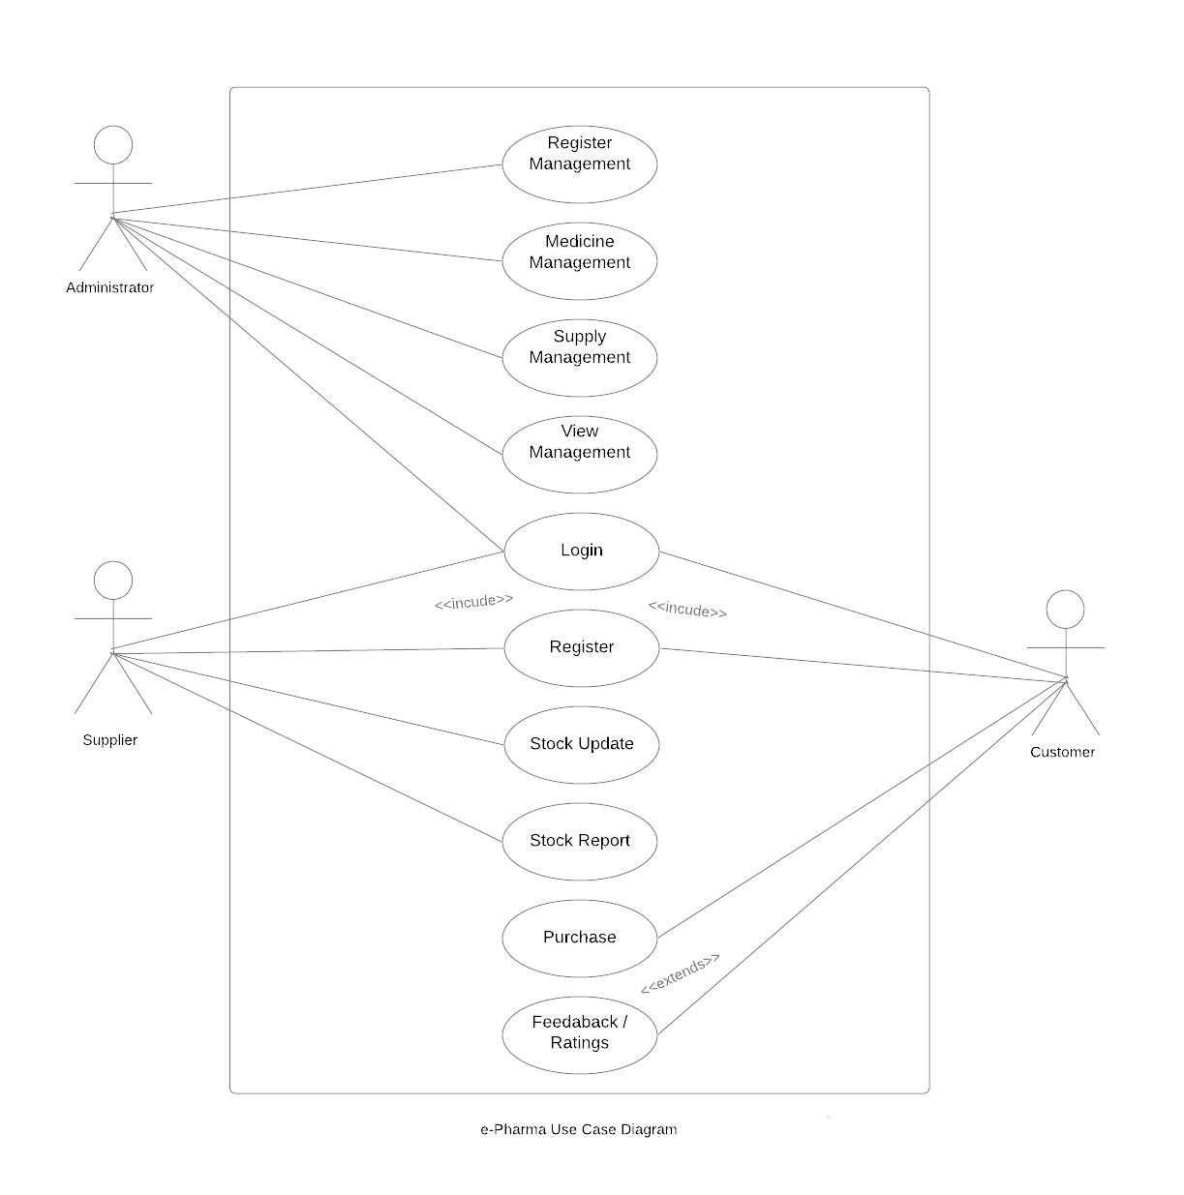

CDAC Mumbai DAC Forum & Mentor

Assessment

## Class Diagram

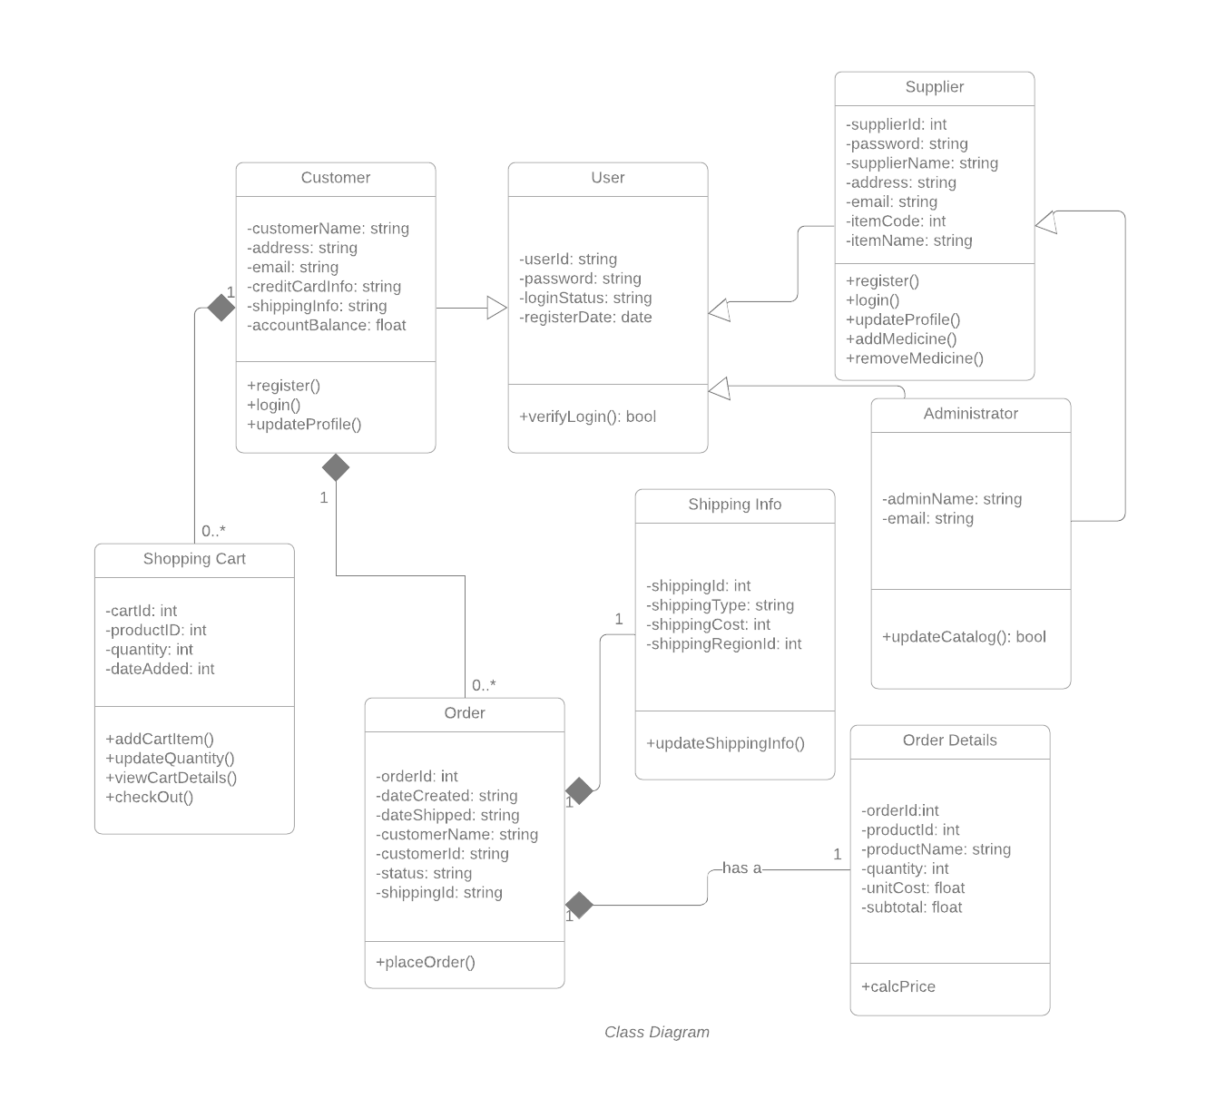

CDAC Mumbai DAC Forum & Mentor

Assessment

## Activity Diagram 1.1:

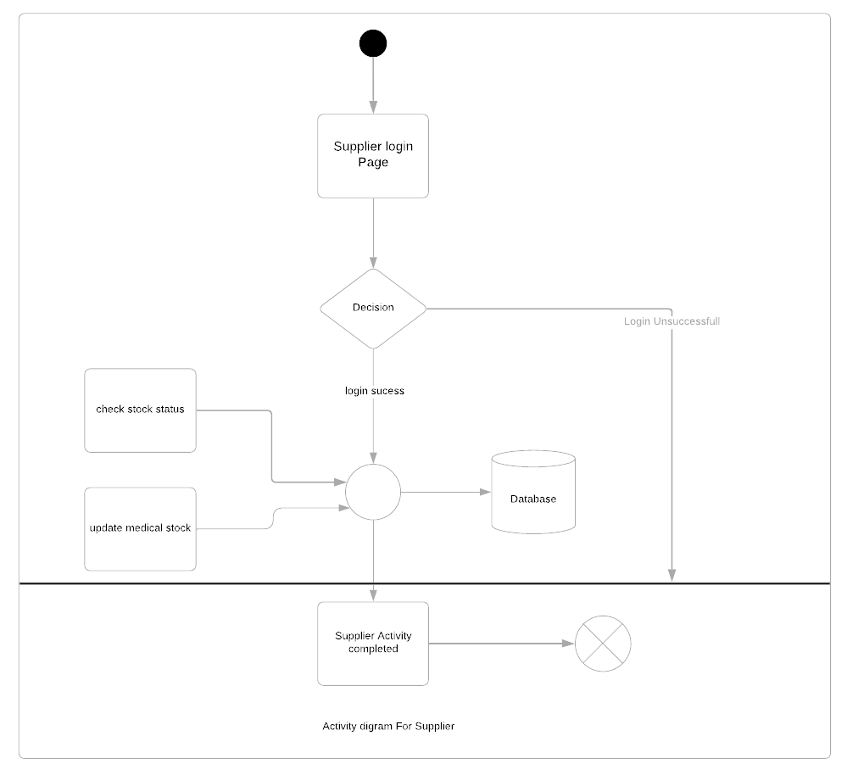

CDAC Mumbai DAC Forum & Mentor

Assessment

## Activity Diagram 1.2:

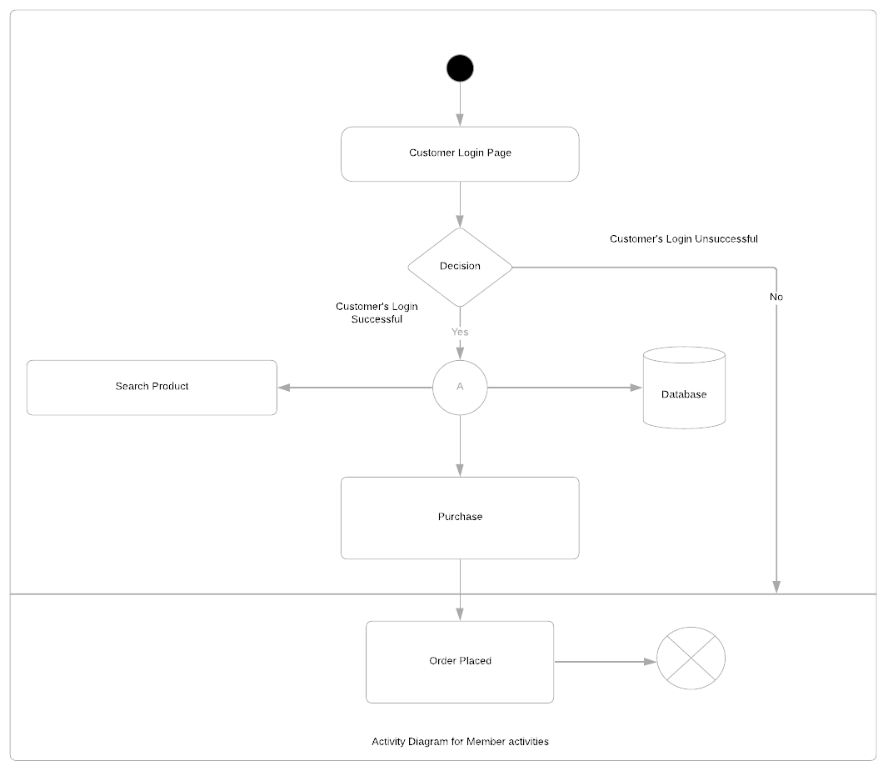

CDAC Mumbai DAC Forum & Mentor

Assessment

## Sequence Diagram 1.1:

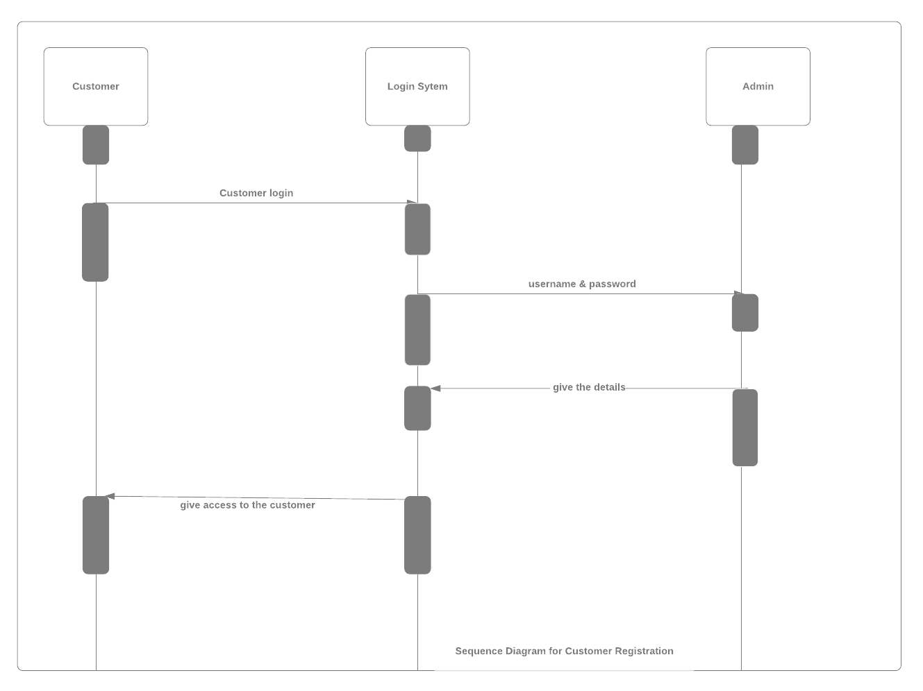

CDAC Mumbai DAC Forum & Mentor

Assessment

## Sequence Diagram 1.2:

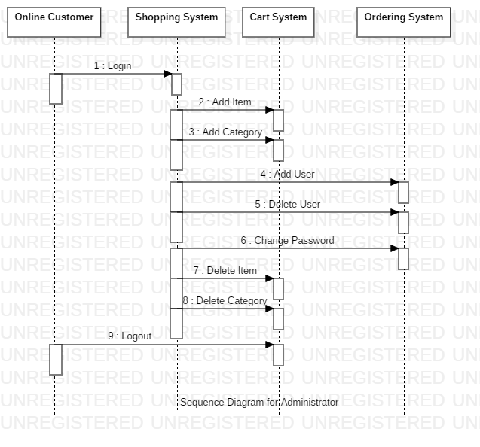

CDAC Mumbai DAC Forum & Mentor

Assessment

## Sequence Diagram 1.3:

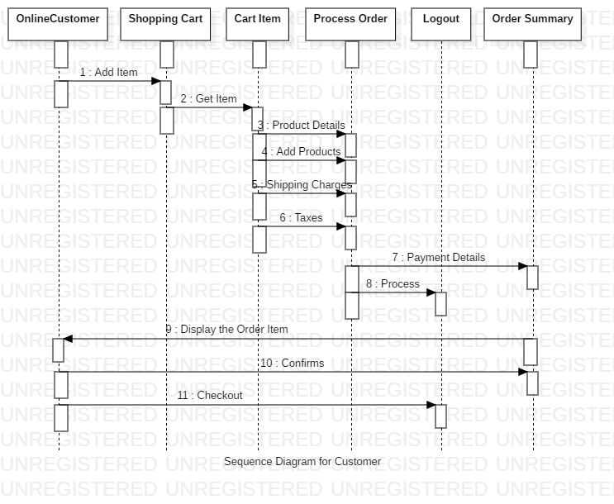

CDAC Mumbai DAC Forum & Mentor

Assessment

## Sequence Diagram 1.4:

