CDAC Mumbai DAC Forum & Mentor

Assessment

**SOFTWARE REQUIREMENT SPECIFICATION FOR**

**DAC FORUM AND MENTOR ASSESSMENT [16-06-2017]**

**CDAC, MUMBAI**

## Revision History:

|  |  |  |  |  |
| --- | --- | --- | --- | --- |
| **Version.** | **DATE** | **Authored By** | **Reviewed By** | **REASON FOR CHANGE** |
| 00 | 16/06/2017 | Team-11 (Ocean’s Eleven) |  | 1st release |

CDAC Mumbai DAC Forum & Mentor

Assessment

# Table of Contents

1. Introduction 1
   1. Purpose 1
   2. Document Conventions 1
   3. Intended Audience and Reading Suggestions 1
   4. Product Scope 2
   5. References 3
2. Overall Description 3
   1. Product Perspective 3
   2. Product Functions 3
   3. User Classes and Characteristics 3
   4. Operating Environment 3
   5. Design and Implementation Constraints 3
   6. User Documentation 4
   7. Assumptions and Dependencies 4
3. External Interface Requirements 4
   1. User Interfaces 4
   2. Hardware Interfaces 5
   3. Software Interfaces 5
   4. Communications Interfaces 5
4. System Features 5
   1. System Feature 1 5
   2. System Feature 2 (and so on) 5
5. Other Non-functional Requirements 6
   1. Performance Requirements 6
   2. Safety Requirements 7
   3. Security Requirements 7
   4. Software Quality Attributes 7
   5. Business Rules 7
6. Other Requirements 8

CDAC Mumbai DAC Forum & Mentor

Assessment

# Introduction

## Purpose

**DAC Forum and mentor assessment** is a web application which provides an interface through which administrative entities can view the mentors performance. The proposed system eliminates the manual entry of attendance mentors, to and fro talks between administrators about how students are coping and instead automates it. It also provides an interface through which student can ask questions which can be answered by mentors and other students.

## Document Convention Headings: -

Text: -Bold Font-Size: - 14

Highlighting: - Times New Roman

## Sub Headings: -

Text: -Bold Font-Size: - 12

Highlighting: - Times New Roman

## Header: -

Text: - Simple Font-Size: -10

Highlighting: - Times New Roman

## Footer: -

Text: - Simple Font-Size: -10

Highlighting: - Times New Roman

## Intended Audience and Reading Suggestions

This document is intended for developers, users, testers and project managers for the purpose of understanding the design of system in terms of different perspectives. Further, this document contains functionalities and characteristics of system along with the working

CDAC Mumbai DAC Forum & Mentor

Assessment

environment. It also includes other information related to system such as external interface requirements, features and other non - functional requirements.

# Product Scope

Our project is targeted to reduce the cumbersome process of maintaining a physical register for attendance of mentors and help students to get guidance from mentors on the go. The Admin can view Mentors performance in graphical format and also this application will help students to ask questions and get answers even if mentors are not present themselves.

# References

<https://angular.io/> <https://material.angularjs.org/latest/> <https://stackoverflow.com/> <https://expressjs.com/> <https://nodejs.org/en/>

# Overall Description

## Product Perspective

Existing technologies in the market carry out management of office activities in a similar manner like keeping employee records, managing their attendance, salaries and the projects or assignments completed by them and so on

Keeping in mind these types of projects we developed “DAC Forum and Mentor Analysis” system for educational institutions as a replacement of the traditional method of doing work on pen and paper by replacing them with software maintained records along with additional facilities for students like forum for solving module related queries and giving feedback of mentor.

## Product Functions

* + - The student will be able to view his performance
    - The student will be able to ask question in forum
    - Administrators can assess Mentors performance

CDAC Mumbai DAC Forum & Mentor

Assessment

* + - Mentors can view team growth

## User Classes and Characteristics Admin:

This person will be able to access all the functions of the system. This person can validate Mentors attendance, can add and update marks of the student also can view student and mentors record.

## Student:

Student can view his own performance. He can post or answer queries on forum also can edit and view the agenda. Student will be able to give feedback of mentor.

## Mentor:

This person can view team growth. He can answer the questions posted in the forum. He will be able to set an agenda for his team.

# Operating Environment

* + - **Hardware platform:**
      * Processor – Above Pentium 4, with clock speed of 2.0 GHz
      * RAM – 1 GB or above
      * Hard Disk – Free disk space of above 1 GB
    - **Software platform:**
      * Front-end: HTML, CSS, Bootstrap, Angular, Angular Material
      * Back-end: MySQL , Node Js, Express Js
    - **Supported tools:**
      * Visual Code Studio, MySQL Workbench

# Design and Implementation Constraints

## Constraints:

* User interface is only in English. No other language option is available
* User can log-in only with his assigned user-name and password
* Limited to HTTP/HTTPS

CDAC Mumbai DAC Forum & Mentor

Assessment

# User Documentation

User documentation mainly comprises of Help menu of application. It will give all the minute details about the project, if any user has any query about any module or functionality, one can refer it and see how to operate the application. This report is the complete documentation of our project. It gives complete details about the project, its functionality, users, software used, hardware requirement,environment and so on.

# Assumptions and Dependencies

* Assumptions
  + There is an active internet connection with the system
  + The system has internet browser installed
  + Users know the English language, as the user interface will be provided in English.
* Dependencies:
  + There is a need of constant updation of marks after each module exam is over.
  + Active participation from Students during feedback is required.
  + Active participation from Mentors during is required and Mentors end.

# External Interface Requirements

## User Interfaces

The main element is web-pages using HTML, JavaScript. Multiple interfaces are there like log-in pages, home pages of Customer, Admin, Supplier, and also the Forum. Admin will update the stock of the medicines as accordingly data will be persisted. Based on the stock of the medicines the feedback provided by Customers, Supplier performance would be evaluated.

CDAC Mumbai DAC Forum & Mentor

Assessment

## Hardware Interfaces

In the hardware interface, the system interacts with hardware given the processor is above P4 with clock speed of 2.0 GHz with 1 GB RAM and the Hard Disk with 1 GB free space in the memory. In future enhancements, it can be made responsive to be able to work with mobile devices as well.

## Software Interfaces

In software interfaces, .NET is the back-end technology used along with MySQL Database. The front-end technologies include HTML, CSS, Bootstrap, JavaScript. Data will be communicated between these interfaces accordingly.

## Communications Interfaces

The main communication interface for interacting with the System will be the web Browser.

# System Features

## Description

This system helps to provide online medicines and also provide the 24* 7 services to the Customers. This system provides easy accessibility of authorized medicines on one click. This software also aims at carrying out the analysis of the supplier’s performance which will help to improve this system to work more efficiently. This system help the customers to compare the cost of the particular medicine from the different stores so that it would be easier for customers to get the best option for exclusive medicines as we are providing the online reviews and the ratings .This system provide the online payment facility.

## Functional Requirements

## Customer

* + - * This feature used by the customer to login into system.
      * A customer must login with his/her user name and password to the system after registration

and if they are invalid, the customer not allowed to enter the system.

* + - * Username and password will be provided after customer registration is confirmed.
      * Password should be hidden from others while typing it in the field.

CDAC Mumbai DAC Forum & Mentor

Assessment

## Register New Customers

* + - * A new customer will have to register in the system by providing essential details in order to view the medicines in the system.
      * The admin must accept new customers by unblocking him/her.
      * System must be able to verify and validate information.
      * The system must encrypt the password of the customer to provide security.

## Purchasing the Medicines

* + - * The customer can add the desired medicines into his cart by clicking add to cart option on the product. He can view his cart by clicking on the cart button.
      * Customer can remove an order from the cart by clicking remove. After confirming the order in the cart the customer can submit the cart by providing a delivery address. On successful submitting the cart will become empty.
      * System must ensure that, only a registered customer can purchase medicines.

## Admin

* + - * The system must identify the login of the admin.
      * The administrator can add user, delete user, view user and block user
      * The administrator can add supplier, delete supplier, block supplier and search for a supplier.
      * The administrator can add medicines, delete medicines and view medicines.
      * The administrator can view orders and delete orders.

## Supplier

* + - * The system must identify the login of a supplier.
      * A supplier is considered as a staff who can manage orders for the time being. As a future update supplier may give facility to add and manage his own medicines. Suppliers can reduce the work load of admin.
      * He can manage users and manage products. He can also check the orders.

1. **Performance Requirements**

The system should store all the database records of each customers, supplier and admin staff properly and the application should be available for use 24*7 through the server. Also, the application should be user friendly with a proper user interface which makes it easy for the customer to understand. All the options should be present in properly accessible places for customer convenience.

## Safety Requirements

All login ids and passwords of the customers, suppliers and especially admin staff should be protected for privacy using whatever constraints required in the database or the application.

Customers and Suppliers records are to be backed up securely across database servers. In case database is hacked by someone and data is deleted a backup server should be present for such purpose.

CDAC Mumbai DAC Forum & Mentor

Assessment

## Security Requirements

All passwords of the administrators should be protected for privacy using whatever constraints required in the database or the application. Transactions regarding student and mentor records should be carried out properly. Only admin staff will have access rights to the student data according to the need for E.g.: -marks and feedback for mentor, passwords etc. The database should be protected from attacks and unauthorized access. The interface should be protected from attacks. All passwords should be stored as a secure hash of the administrator password.

## Software Quality Attributes 5.3.1Availability

The system should run on a variety of operating systems that support the JavaScript language. The system should run on a variety of hardware.

## Accessibility

The software will be accessible to Admin, Customer and Supplier.

## Compatibility

The software will be compatible with multiple platforms.

## Durability

The software will be tested for working with multiple users.

## Effectiveness

The software will be made to handle operations effectively.

## Maintainability

The system should be easy to maintain. There should be a clear separation between the interface and the business logic code. There should be a clear separation between the data access objects that map the database and the business logic code.

CDAC Mumbai DAC Forum & Mentor

Assessment

# Other Requirements

* **Appendix A: Glossary**
* **SRS:** Software Requirement Specification
* **GUI:** Graphical User Interface
* **P4:** Pentium 4
* **SQL:** Structured Query Language
* **HTML:** Hyper Text Markup Language
* **CSS:** Cascading Style Sheet

CDAC Mumbai DAC Forum & Mentor

Assessment

# Appendix B: Analysis Models

## Use Case Diagram

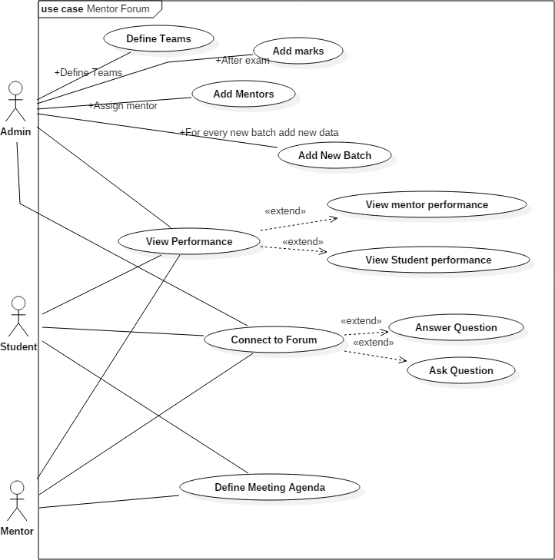

CDAC Mumbai DAC Forum & Mentor

Assessment

## Class Diagram

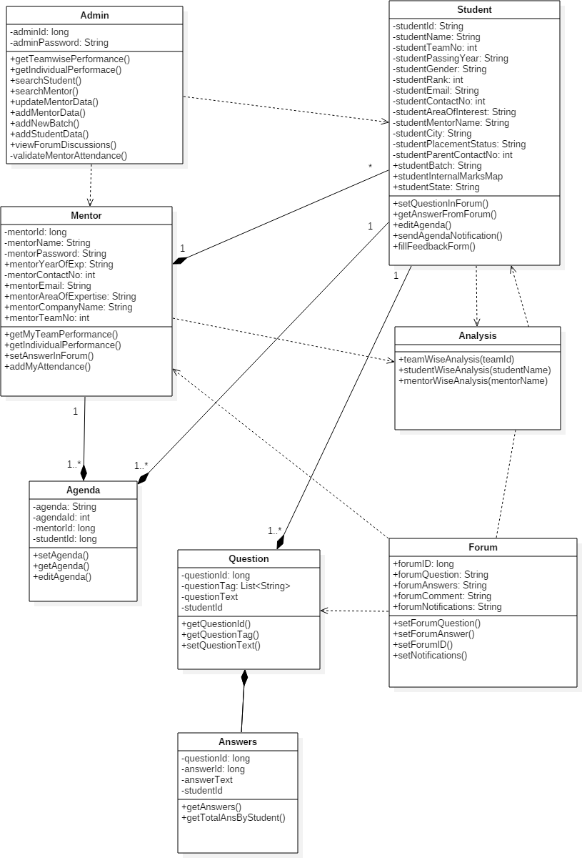

CDAC Mumbai DAC Forum & Mentor

Assessment

## Activity Diagram 1.1:

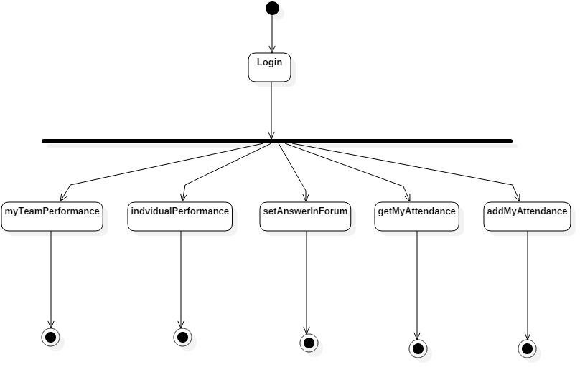

CDAC Mumbai DAC Forum & Mentor

Assessment

## Activity Diagram 1.2:

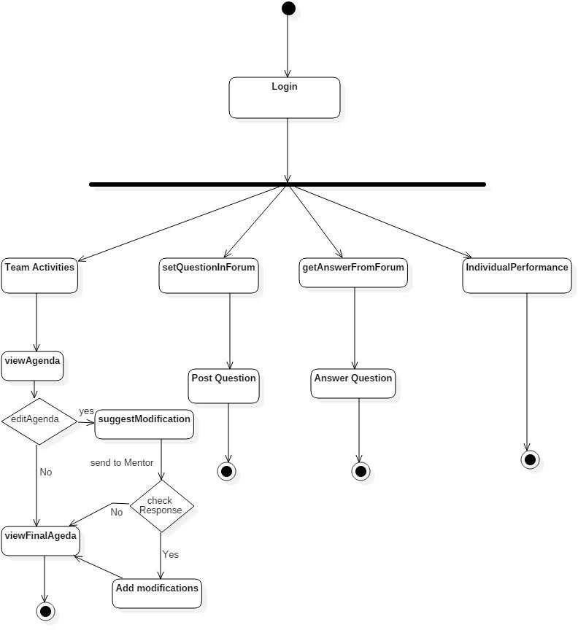

CDAC Mumbai DAC Forum & Mentor

Assessment

## Sequence Diagram 1.1:

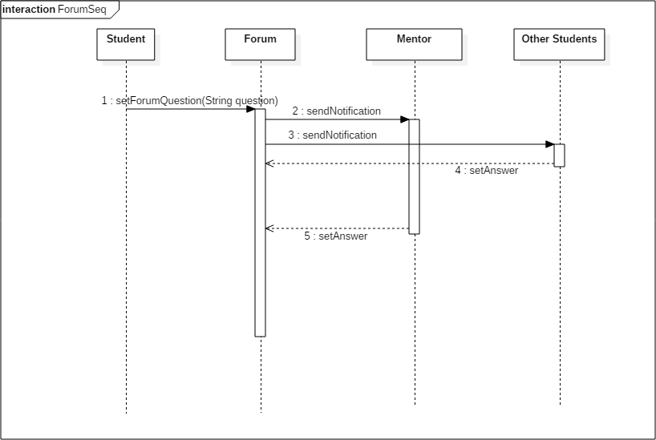

CDAC Mumbai DAC Forum & Mentor

Assessment

## Sequence Diagram 1.2:

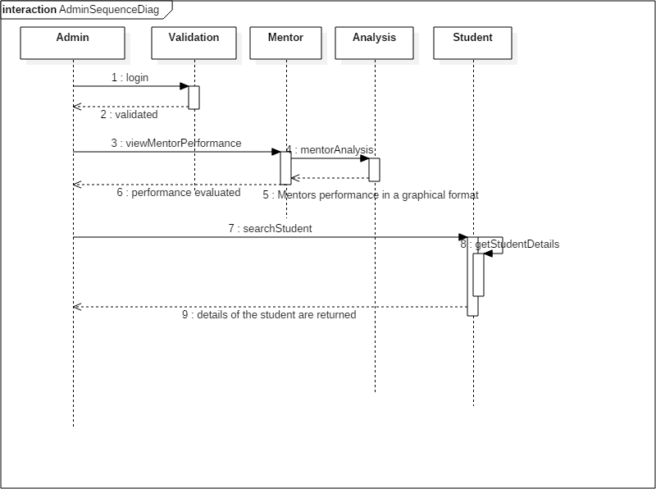

CDAC Mumbai DAC Forum & Mentor

Assessment

## Sequence Diagram 1.3:

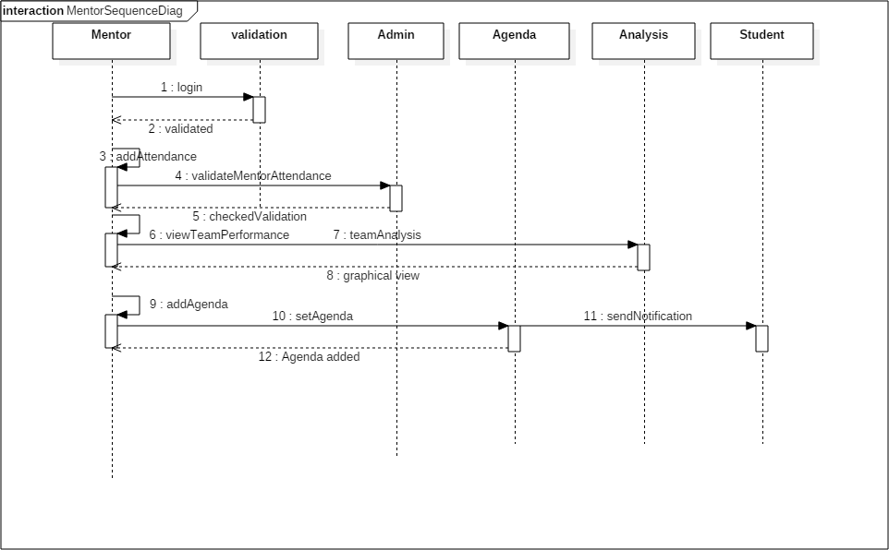

CDAC Mumbai DAC Forum & Mentor

Assessment

## Sequence Diagram 1.4:

