**Project Title: CARBEJDO**

Web application platform for selling and buying used cars.

**Project Overview:**

Customers take their car to one of the showrooms for inspection and sale.   
Cars are evaluated and quotes the base resale price hence car will be purchased and details(customer and car) will be updated in the database

After making the payment to the customer, generation of invoice is done and hence update on the database is made.

Customer and Company then sign various documents and RTO transfer forms. From that point onwards, company is responsible for anything that happens to the car.

Company will then review the car on inspection reports and base price quoted and hence quote a resale price. The car will stay in one of their warehouses till an actual buyer is found.

Once the buyer who visits the showroom gives the approval on the resale price quoted after negotiations, payment will be collected and details of buyer and the car will be updated in the database accordingly.

Hence the updated RTO transfer forms will be handed over to the buyer along with the vehicle.

**ERP Diagram**

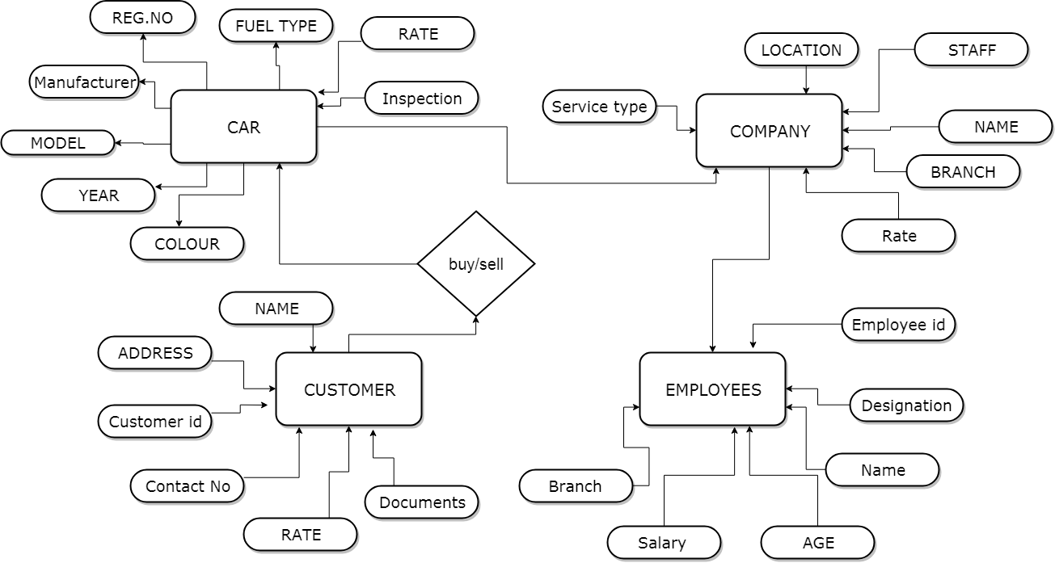

**Class Diagram**

