A

PROJECT REPORT
ON
Online Medicine Donation

Submitted in partial fulfillment for the award of

Post Graduate Diploma in Advance Computing

(PG-DAC) from

INSTITUTE OF EMERGING TECHNOLOGIES

Authorized Training Centre


Under the Guidance of
Ms. Sayali Patil

Mr. Susheel Tiwari (250245920087)
Ms. Ayesha Faiyyaj Sayyad (250245920018)
Mr. Ajinkya Pruthviraj Borse (250245920006)
Mr. Prem Pramod Ragade (250245920068)
Ms. Sharvari Waghumbare (250245920096)



CERTIFICATE

This is to certify that the project report entitled Online Medicine Donation
is a bona fide work carried out by Susheel Tiwari, Ayesha Faiyyaj Sayyad, Ajinkya Pruthviraj Borse, Prem Pramod Ragade and Sharvari Waghumbare submitted in partial fulfillment of the requirement for the C-DAC ACTS, DAC course in Institute of Emerging Technology in the batch of Feb 2025.

Course Coordinator External Examiner

ACKNOWLEDGEMENT

This project Online Medicine Donation was a great learning experience for us and we are submitting this work to Advanced Computing Training School (CDAC).

We are very glad to mention the Ms. Sayali Patil for her valuable guidance to work on this project. Her guidance and support helped us to overcome various obstacles and intricacies during the course of project work.

Our most heart full thanks goes to Mr. Sangram Patil (Director ,IET)who gave all the required support and kind coordination to provide all the necessities like required hardware , internet facility and extra lab hours to complete the project and throughout the course up to the last day here in C-DAC ACTS, Pune.

Sign of student
Mr. Susheel Tiwari (250245920087)
Ms. Ayesha Faiyyaj Sayyad (250245920018)
Mr. Ajinkya Pruthviraj Borse (250245920006)
Mr. Prem Pramod Ragade (250245920068)
Ms. Sharvari Waghumbare (250245920096)

Abstract

Access to basic healthcare, particularly essential medicines, remains a significant challenge in many parts of India, especially for people living below the poverty line. While the government and various NGOs strive to meet public healthcare demands, there is still a considerable shortage of affordable medicines for economically disadvantaged individuals. At the same time, a large volume of unused yet unexpired medicines is discarded daily by individuals after recovery, leading to both wastage and environmental hazards. The absence of a structured, reliable, and transparent system for redistributing surplus medicines results in a lost opportunity to support those in need.

The Online Medicine Donation System addresses this issue by offering a centralized, web-based platform that connects medicine donors with NGOs. Registered users can donate unused medicines by providing essential details such as medicine name, quantity, expiry date, and a photograph. NGOs can log in, view available medicines, request donations, and schedule collections. An admin module oversees the system operations, validates users and NGOs, approves donations, and generates reports for monitoring and transparency.

The platform is developed using ReactJS (frontend), .NET (backend), and MSSQL (database), following a layered architecture to ensure data integrity, authentication, and security. Real-time notifications inform users and NGOs about approval statuses, pickup schedules, and emergency medicine requests. To ensure safety, the system validates expiry dates and adheres to the World Health Organization's Guidelines for Medicine Donations.
Beyond logistics, the system promotes awareness about responsible medicine disposal and encourages public participation in digital healthcare support. By enabling medicine reuse, it bridges public health gaps, reduces pharmaceutical waste, mitigates environmental impact, and supports sustainable healthcare practices.
Future enhancements may include mobile app support, geolocation tracking, and integration with local pharmacies to widen its impact.

Index

Sr. No. | Title | Page No.
1 | Introduction | 6
2 | Problem Definition & Scope | 7
2.1 | Problem Definition | 7
2.2 | Goals & Objectives | 8
2.3 | Major Constraints& Outcomes | 10
3 | Software Requirement Specification | 12
3.1 | Purposed System | 12
3.2 | Scope | 16
4 | System Modules | 17
5 | Performance-Requirements | 18
5.1 | H/W Requirements & S/W Requirements | 20
6 | UML Diagram | 21
6.1 | DFD | 21
6.2 | ERD | 22
6.3 | Use case diagram | 23
6.4 | Class Diagram | 24
6.5 | Sequence diagram | 25
6.6 | Activity Diagram | 26
6.7 | Deployment diagram | 27
6.8 | System Architecture | 28
7 | Test Cases | 29
8 | Screenshots | 31
9 | References | 34

- Introduction

India faces significant challenges in ensuring equitable access to healthcare, particularly essential medicines, for its vast underprivileged and rural populations. Many individuals struggle to afford basic medicines, which adversely affects their health outcomes. Concurrently, there is a recurring problem of unused, unexpired medicines being discarded by households once patients recover. This results in unnecessary wastage of valuable resources and poses environmental risks due to improper disposal.
This mismatch between medicine availability and accessibility highlights the need for an effective system to redistribute surplus medicines to those who need them most. Existing efforts by the government and NGOs are often fragmented and lack a centralized, transparent platform to facilitate medicine donations safely and efficiently.
To address these challenges, the Online Medicine Donation System has been developed. This project focuses on creating a digital platform that bridges medicine donors with NGOs working in healthcare support. By enabling donors to list unused medicines and NGOs to request and collect these medicines, the system aims to optimize resource utilization and reduce wastage.
The platform incorporates features such as user authentication, medicine validation, and real-time updates to ensure safety, reliability, and transparency. Moreover, adherence to international standards like the World Health Organization’s guidelines ensures ethical and safe practices throughout the donation process.
Ultimately, this project not only contributes to improving medicine accessibility for economically disadvantaged populations but also fosters responsible medicine management and environmental sustainability through digital innovation.

2. Problem Definition and Scope
2.1 Problem Definition
A significant portion of the Indian population faces difficulty in accessing basic medicines due to financial limitations. At the same time, a large quantity of unused but still usable medicines is discarded by recovered patients, leading to wastage of important healthcare resources. Currently, there is no centralized and trustworthy platform that links medicine donors with NGOs for collecting and redistributing these medicines. This lack of coordination causes missed opportunities to help those in need, inefficient medicine management, and environmental risks arising from improper disposal. This project aims to fill this gap by developing an online system that enables safe, transparent, and efficient donation, collection, and distribution of medicines to economically disadvantaged individuals.

Scope:

- To develop a web-based platform that allows registered users to donate unused medicines by providing essential information such as medicine name, quantity, expiry date, and images.
- To enable NGOs to register, view available donations, request medicines, and coordinate collection schedules.
- To implement an admin module responsible for validating users and NGOs, approving donations, and ensuring medicines meet safety criteria, especially regarding expiry dates.
- To provide real-time notifications to users and NGOs about donation approvals, collection schedules, and urgent medicine requests.
- To maintain transparency through detailed reports and logs accessible to administrators.
- To follow international guidelines, such as the World Health Organization’s standards for medicine donations, to ensure ethical and safe redistribution.
- To promote awareness of responsible medicine disposal and encourage digital participation in healthcare support.
- The system will be scalable for future enhancements like mobile app integration, geolocation-based pickup coordination, and partnerships with pharmacies.

This project aims to address these needs by implementing a full-stack solution using React.js for the frontend, ASP.NET Core Web API for the backend, and MongoDB with a Database-First approach for data management.
2.2 Goals & Objectives

Goals:

- To Create a Centralized Online Platform
Develop a web-based system that connects medicine donors with NGOs, enabling the safe, verified, and efficient donation of unused medicines.

- To Promote Medicine Reuse and Reduce Waste
Minimize the disposal of unexpired medicines by encouraging individuals to donate them for redistribution to the underprivileged.

- To Improve Access to Medicines for Needy Individuals
Facilitate free medicine access to economically weaker sections of society through NGO partnerships.

- To Ensure Safety and Legality of Donated Medicines
Integrate strict validation mechanisms to filter out expired or unsafe medicines and ensure compliance with health regulations.

- To Digitize and Streamline the Donation Process
Replace manual, unorganized donation efforts with a structured digital process involving user registration, donation tracking, and inventory management.

- To Enhance Transparency and Trust in the Donation System
Provide real-time tracking of medicine status, notifications, and reports to all stakeholders (donors, NGOs, admins).

- To Raise Awareness About Responsible Medicine Disposal
Educate users about safe and ethical ways to handle surplus medicines, reducing environmental pollution risks.

- To Empower NGOs with Digital Tools
Equip NGOs with a web-based dashboard for managing medicine requests, inventory, collection scheduling, and distribution.

- To Align with WHO Guidelines for Medicine Donations
Build the system according to international best practices for pharmaceutical donations, ensuring safety and effectiveness.

- To Encourage Community Participation in Public Health
Foster social responsibility among citizens by involving them in healthcare support through digital engagement.

Objectives:

- To provide an online portal for users to register and donate unused medicines.
- To enable NGOs to collect, manage, and distribute donated medicines effectively.
- To maintain a comprehensive database of medicines with details such as name, quantity, expiry date, and donor information.
- To ensure only valid, unexpired medicines are accepted through verification and approval mechanisms.
- To notify donors and NGOs through alerts about appointments, collections, and urgent medicine requests.
- To generate reports on donations, distributions, and user activity for administrative monitoring.
- To promote awareness about medicine donation and proper handling through guidance content and user forums.

2.3 Major Constraints& Outcomes
Major Constraints:

- Regulatory Compliance and Legal Restrictions

  - Ensuring adherence to pharmaceutical regulations and WHO guidelines for medicine donations is complex and requires constant updates. The prototype does not cover full legal validations or government approvals for redistribution.

- Medicine Safety and Verification

  - Automated verification of medicine authenticity and safety is limited to expiry date checks and photo uploads. There is no in-depth quality control or pharmaceutical testing within the system.

- Limited Geographic Reach

  - Initial deployment focuses on a limited region and network of NGOs. Expanding nationwide requires additional logistical and infrastructural support.

- Internet Dependency

  - The system requires a stable internet connection for real-time updates, notifications, and data synchronization. Offline donation or tracking features are not implemented.

- User Adoption and Awareness

  - Success depends heavily on user participation and awareness. Limited outreach or digital literacy may hinder adoption among target donor and beneficiary populations.

- Inventory Management Complexity

  - The system handles basic inventory tracking but may not support advanced supply chain logistics or emergency medicine prioritization in the prototype phase.

Expected Outcomes:

- Centralized Medicine Donation Platform

  - Enables individuals to register, donate unused medicines, and connect with verified NGOs for efficient redistribution.

- Improved Medicine Access for Underprivileged

  - Facilitates free access to essential medicines for economically disadvantaged populations through NGO partnerships.

- Safety and Compliance Measures

  - Enforces expiry date validation and aligns with WHO donation guidelines to ensure safe medicine redistribution.

- Real-Time Notifications and Tracking

  - Provides timely alerts and status updates to donors, NGOs, and administrators for transparency and efficient coordination.

- User and NGO Management

  - Supports secure role-based login, donation approval workflows, and report generation for administrative oversight.

- Environmental and Social Impact

  - Promotes responsible medicine reuse, reducing pharmaceutical waste and contributing to sustainable healthcare practices.

- Scalable and Extensible Architecture

  - Built using ReactJS, .NET, and MSSQL with layered architecture to allow future enhancements, regional expansion, and integration with external health systems.

3. Software Requirement Specification
3.1 Functional Requirements

- User Registration and Authentication

  - Users (donors, NGOs, admins) must be able to register with valid credentials.
  - Secure login/logout functionality with role-based access control.
  - Password recovery and profile management features.

- Medicine Donation Module

  - Donors can add medicine details including name, quantity, expiry date, and upload a photo.
  - System validates medicine expiry dates to prevent donation of expired medicines.
  - Donors can view donation status and history.

- NGO Management Module

  - NGOs can register and get verified by admins.
  - NGOs can view available donated medicines, request medicines, and schedule collections.
  - NGOs can update inventory status post-distribution.

- Admin Module

  - Admins can verify and approve user registrations and donations.
  - Admins can monitor system activity, generate reports, and manage content.
  - Admins oversee compliance with safety and donation guidelines.

- Notification System

  - Real-time alerts via email or in-app notifications for donation approvals, collection schedules, and urgent medicine requests.

- Reporting and Analytics

  - Generate reports on donations, distributions, user activity, and inventory status.
  - Analytics for system usage and medicine redistribution effectiveness.

3.2 Non-Functional Requirements

- Performance

  - The system should handle concurrent users smoothly without lag.
  - Quick response time for search, submission, and notification delivery.

- Security

  - Use secure authentication methods such as JWT tokens.
  - Encrypt sensitive data stored in the database.
  - Role-based access control to prevent unauthorized actions.

- Usability

  - Intuitive and user-friendly interface accessible on both desktop and mobile browsers.
  - Clear navigation and help features for ease of use.

- Reliability and Availability

  - System uptime should be maintained above 99%.
  - Regular backups and failover mechanisms to prevent data loss.

- Scalability

  - Architecture should support future expansion in terms of user base and additional features.
  - Easily integrable with external health or government systems.

- Maintainability

  - Modular code design for easier updates and troubleshooting.
  - Proper documentation for developers and administrators.

3.3 Technical Requirements

- Frontend: ReactJS for dynamic and responsive UI.
- Backend: .NET Core Web API for robust, secure service layer.
- Database: Microsoft SQL Server (MSSQL) for structured data storage.
- Hosting: Cloud-based or on-premises deployment as per availability.
- Notifications: Email service integration (SMTP) or push notification system.
- Security: HTTPS, SSL certificates, JWT authentication, data encryption

3.1 Purposed System
Key features of the purposed system include:

- User Registration and Role Management:
Different user roles (donors, NGOs, administrators) can register, log in, and access features appropriate to their role with secure authentication and verification.

- Medicine Donation and Validation:
Donors can submit details about unused medicines including name, quantity, expiry date, and images. The system automatically validates expiry dates to ensure only safe medicines are accepted.

- NGO Request and Collection Coordination:
NGOs can browse available medicines, place requests, and schedule pickups. The platform facilitates seamless coordination between donors and NGOs for medicine collection.

- Administrative Oversight:
Admins monitor user registrations, approve medicines, oversee compliance with health regulations, and generate reports for transparency and auditing.

- Real-Time Notifications:
Users receive timely alerts about donation approvals, collection schedules, and urgent medicine requirements, enhancing communication and efficiency.

- Data Management and Reporting:
The system maintains a comprehensive database of medicines, donors, and NGOs, enabling tracking, reporting, and analytics to measure impact and optimize operations.
By implementing this system, the project aims to reduce pharmaceutical waste, improve access to essential medicines for the underprivileged, and promote responsible healthcare practices through digital engagement and community participation.
The proposed system is a full-stack online music streaming platform designed to replicate and customize the core features of Spotify. It enables users to register, log in, browse a music library, create and manage playlists, stream songs in real-time, and access premium features through an integrated payment gateway.

The system adopts a Database-First approach with MSSQL for efficient storage and retrieval of user profiles, playlist data, and music metadata in BSON format. React.js is used for the frontend to provide a responsive and interactive user experience, while the backend is developed in ASP.NET Core Web API to ensure scalability, security, and maintainability.

Key Features of the Proposed System

- User Authentication – Secure registration and login using JWT tokens.

- Music Library – Organized collection of songs with search and filter options.

- Playlist Management – Create, edit, and delete playlists.

- Music Streaming – HTML5 audio player with play, pause, skip, and repeat.

- Payment Gateway Integration – Secure subscription purchase for premium features.

- Responsive UI – Seamless experience across devices (desktop, tablet, mobile).
- Scalable Architecture – Easy integration of future features like recommendations and offline mode.

3.2 Scope

The scope of the Online Medicine Donation System defines the boundaries and extent of the project, focusing on the features, functionalities, and target users that the system will serve.
- Medicine Donation Facilitation:
The system will enable individual users to register and donate unused, unexpired medicines by providing detailed information and images, promoting medicine reuse.
- NGO Participation:
Registered NGOs can access the platform to view available medicine donations, request medicines based on needs, and coordinate collection and distribution to the needy.
- Safety and Compliance:
The system ensures strict validation of medicine expiry dates and adherence to health and safety regulations, aligning with WHO guidelines to prevent the redistribution of unsafe medicines.
- Multi-Role User Access:
Supports various user roles including donors, NGOs, and administrators with tailored access to functionalities such as donation management, request handling, and system oversight.
- Digital Communication and Notifications:
Facilitates real-time notifications for donation approvals, collection scheduling, and urgent medicine requirements to improve coordination and responsiveness.
- Reporting and Analytics:
Provides administrators with tools to generate reports on donation trends, user activity, and system performance for monitoring and improvement.
- Geographical Coverage:
Initially targets local or regional deployment with scope for future expansion to broader areas based on user demand and NGO partnerships.
- Exclusions:
The system will not handle direct financial transactions, medicine manufacturing, or delivery logistics beyond coordination between donors and NGOs.
- System Modules
The system is divided into the following major modules:

6.1 User Registration and Authentication Module
- Allows users (donors, NGOs, and admins) to register by providing necessary personal and organizational details.
- Implements secure login/logout functionality with role-based access control.
- Includes password recovery and profile management features.
6.2 Medicine Donation Module
- Enables donors to submit details of unused medicines including medicine name, quantity, expiry date, and a photograph.
- Performs validation to ensure only unexpired and safe medicines are accepted.
- Allows donors to view the status of their donations and history.
6.3 NGO Management Module
- Allows NGOs to register and get verified by the system administrator.
- Provides NGOs access to view available medicines, place requests, and schedule collections.
- Facilitates inventory updates and tracking after medicines are distributed.
6.4 Admin Module
- Provides administrators with tools to verify and approve user registrations and medicine donations.
- Monitors overall system activities and generates reports for transparency and auditing.
- Ensures compliance with safety and legal regulations and handles user management.
6.5 Notification Module
- Sends real-time notifications and alerts to users and NGOs regarding donation approvals, collection schedules, and urgent medicine needs.
- Supports email and in-app notifications to keep stakeholders informed.
6.6 Reporting and Analytics Module
- Generates detailed reports on medicine donations, distributions, user registrations, and system usage.
- Provides insights to improve system efficiency and support decision-making.

- Performance-Requirements
Response Time
  - The system should respond to user requests (such as login, medicine submission, and search queries) within 2 seconds under normal load conditions.
  - Notifications and alerts should be delivered within 5 seconds of the triggering event.
Scalability
  - The platform must support a minimum of 1,000 concurrent users initially, with the ability to scale up as the user base grows without significant degradation in performance.
  - The system architecture should accommodate adding new features and increased data volume without major redesign.
Availability
  - The system should maintain an uptime of 99.5% or higher, minimizing downtime during peak usage hours.
  - Scheduled maintenance should be communicated in advance and performed during off-peak hours.
Throughput
  - The system should handle at least 500 donation submissions and 200 NGO requests per hour without performance degradation.
Data Integrity and Consistency
  - All transaction data, including medicine donations, user registrations, and requests, must be stored reliably to prevent loss or corruption.
  - The system must ensure consistency across all modules, especially between donor submissions and NGO inventories.
Security and Authentication
  - The authentication process should complete within 1 second to avoid user frustration.
  - The system must prevent unauthorized access and protect sensitive data through encryption and secure session management.
Cross-Platform Performance
  - The system must be fully functional and responsive on major web browsers (Chrome, Firefox, Edge, Safari) and mobile browsers.
  - Page load times on mobile networks (3G/4G) should not exceed 3 seconds.
5.1 H/W Requirements & S/W Requirements
Hardware Requirements
For Development Environment
- Processor: Intel i5 (or higher)
- RAM: Minimum 8 GB
- Storage: Minimum 500 GB HDD or 256 GB SSD
- Graphics: Integrated or dedicated GPU for frontend rendering
- Display: 1080p resolution or higher
For Deployment Server
- Processor: Intel Xeon / AMD EPYC (or equivalent)
- RAM: Minimum 16 GB
- Storage: 500 GB SSD (for fast database and file access)
- Network: Minimum 100 Mbps bandwidth for handling multiple user requests
- Operating System: Windows Server 2019 / Linux Ubuntu Server 20.04

Software Requirements
- Frontend: React.js, HTML5, CSS3, JavaScript (ES6+)
- Backend: .NET Core Web API
- Database: Microsoft SQL Server
- Authentication: JWT (JSON Web Token)
- Notification Service: SMTP / Email API (for alerts and notifications)
- Server OS: Windows Server / Linux Ubuntu
IDE & Tools:
- Visual Studio 2022 (for .NET backend)
- Visual Studio Code (for React frontend)
- SQL Server Management Studio (for database management)
- Postman (for API testing)
Version Control & Package Manager:
- Git & GitHub (for source code management)
- npm (for frontend package management)
6. UML Diagram
6.1 Data Flow Diagram
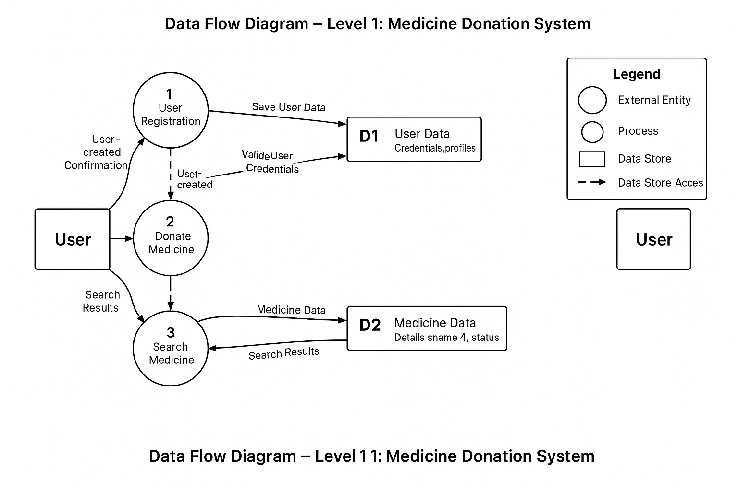
6.2 Entity Relationship Diagram

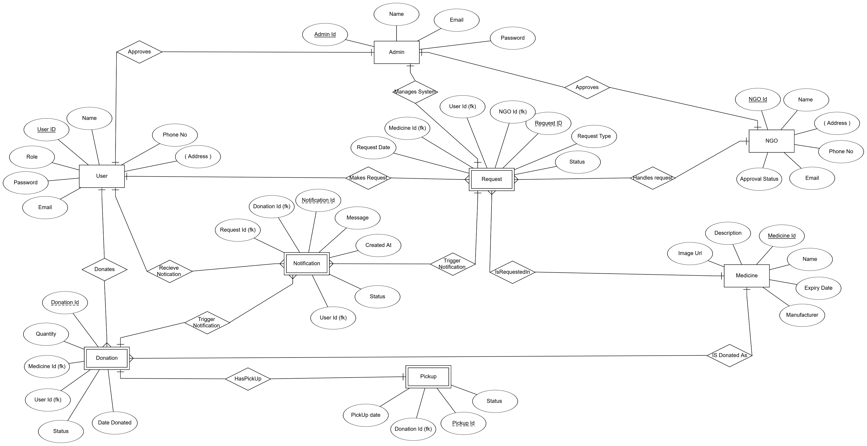

6.3 Use Case Diagram
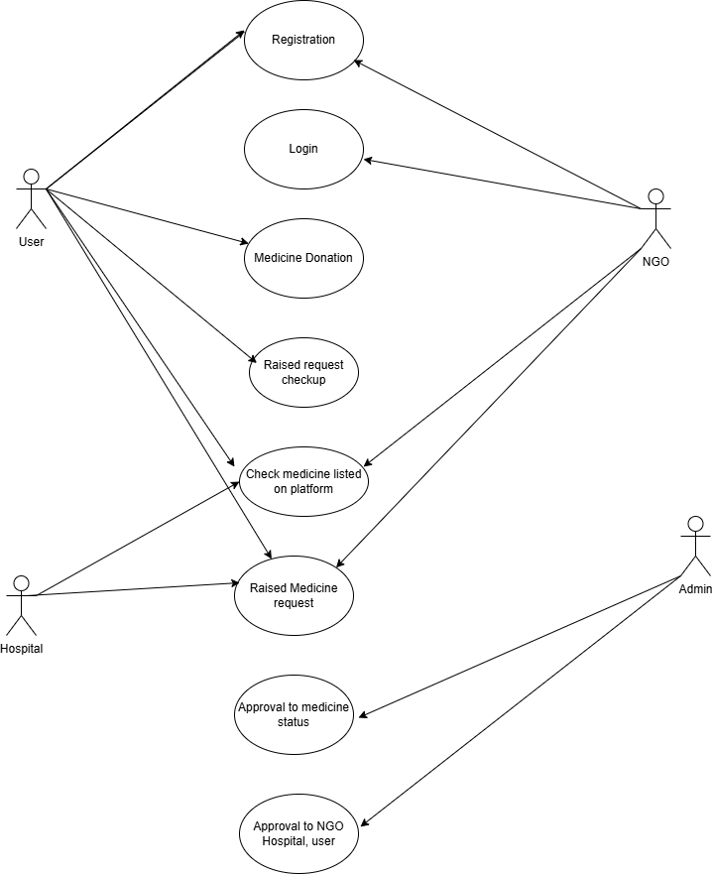
6.4 Class Diagram
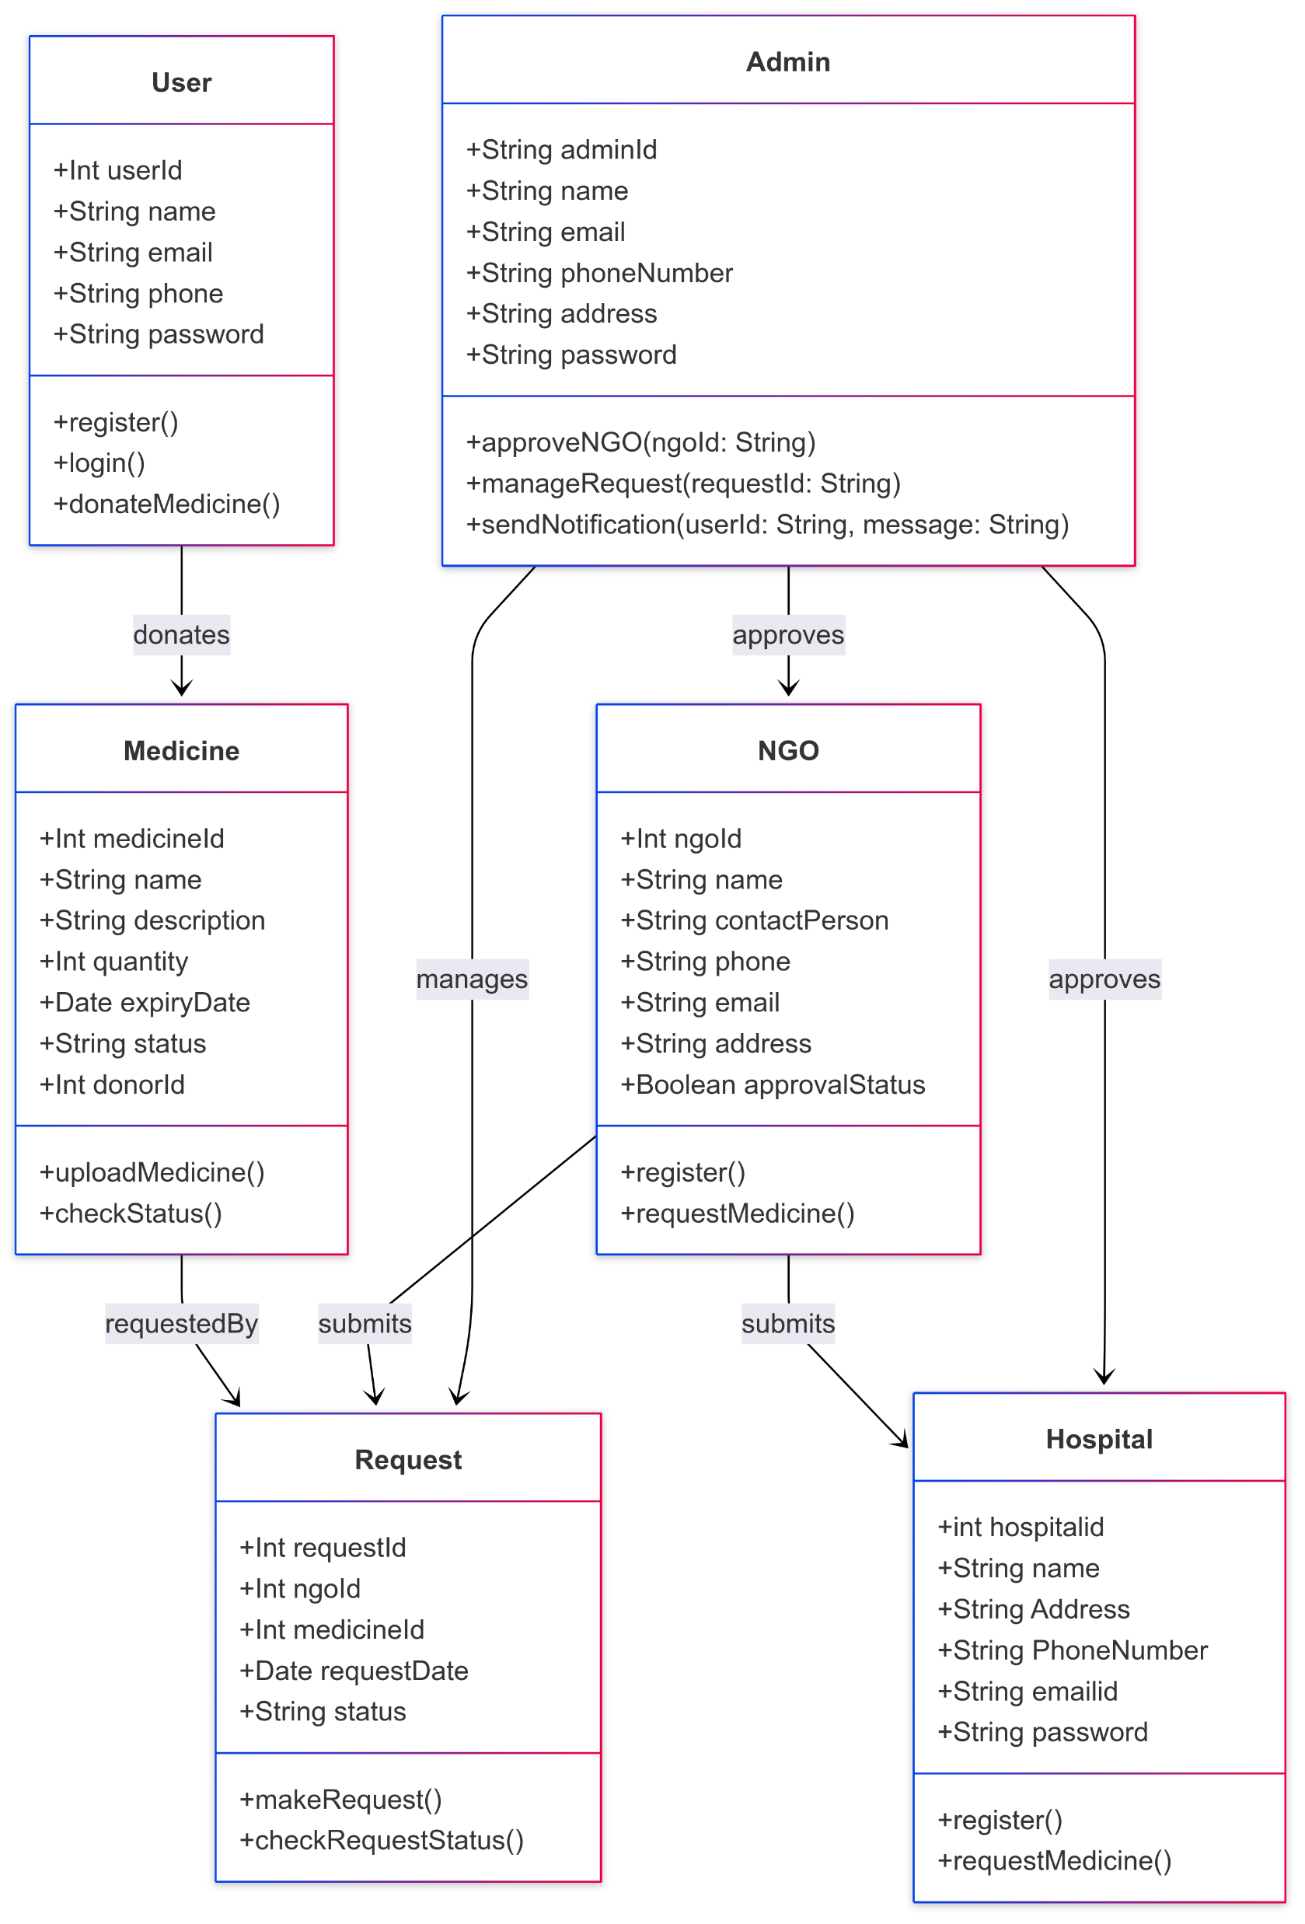
6.5 Sequence Diagram
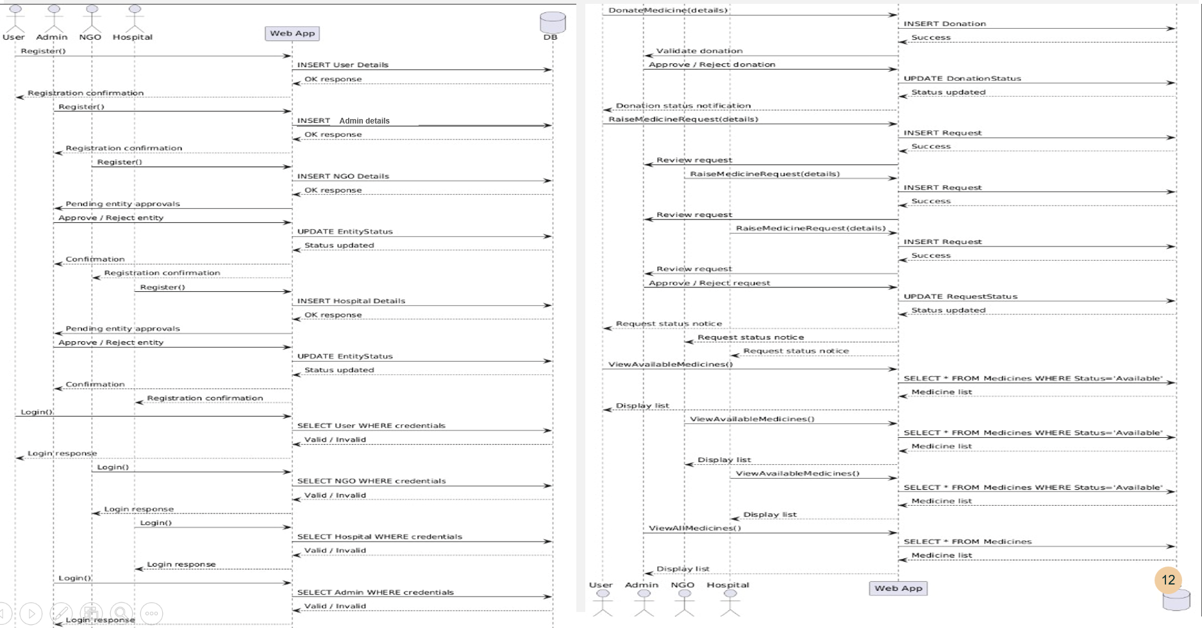
6.6 Activity Diagram
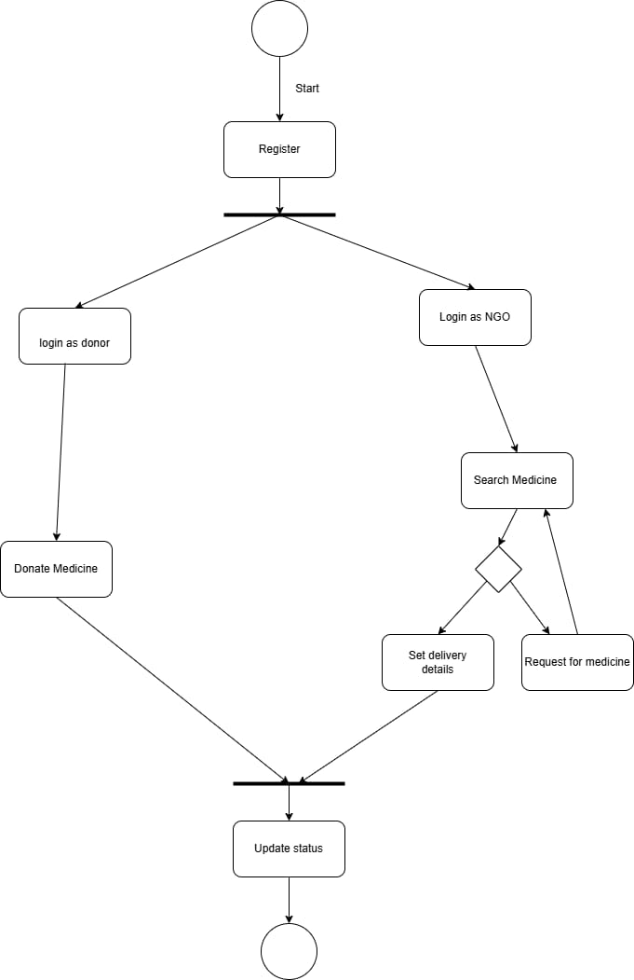
6.7 Deployment diagram
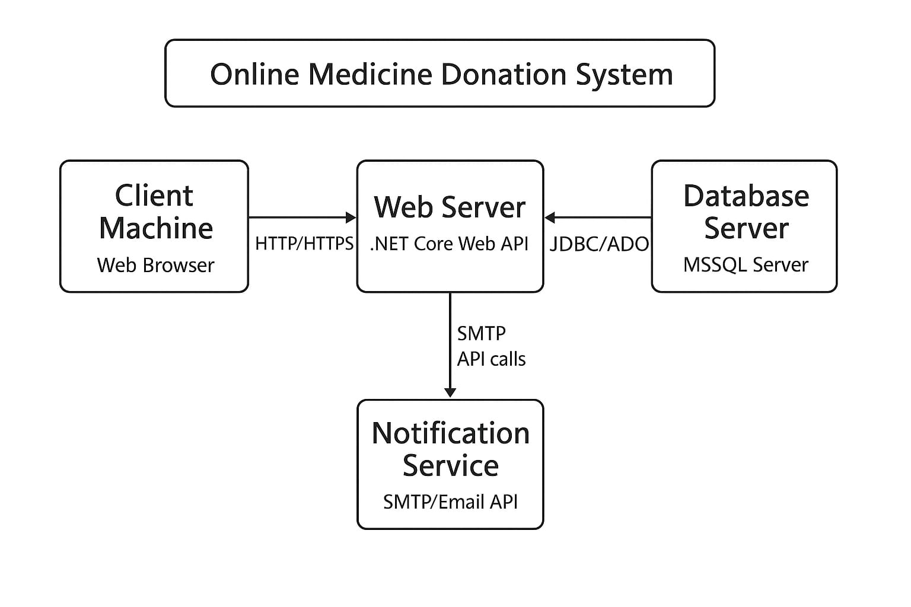
6.8 System Architecture
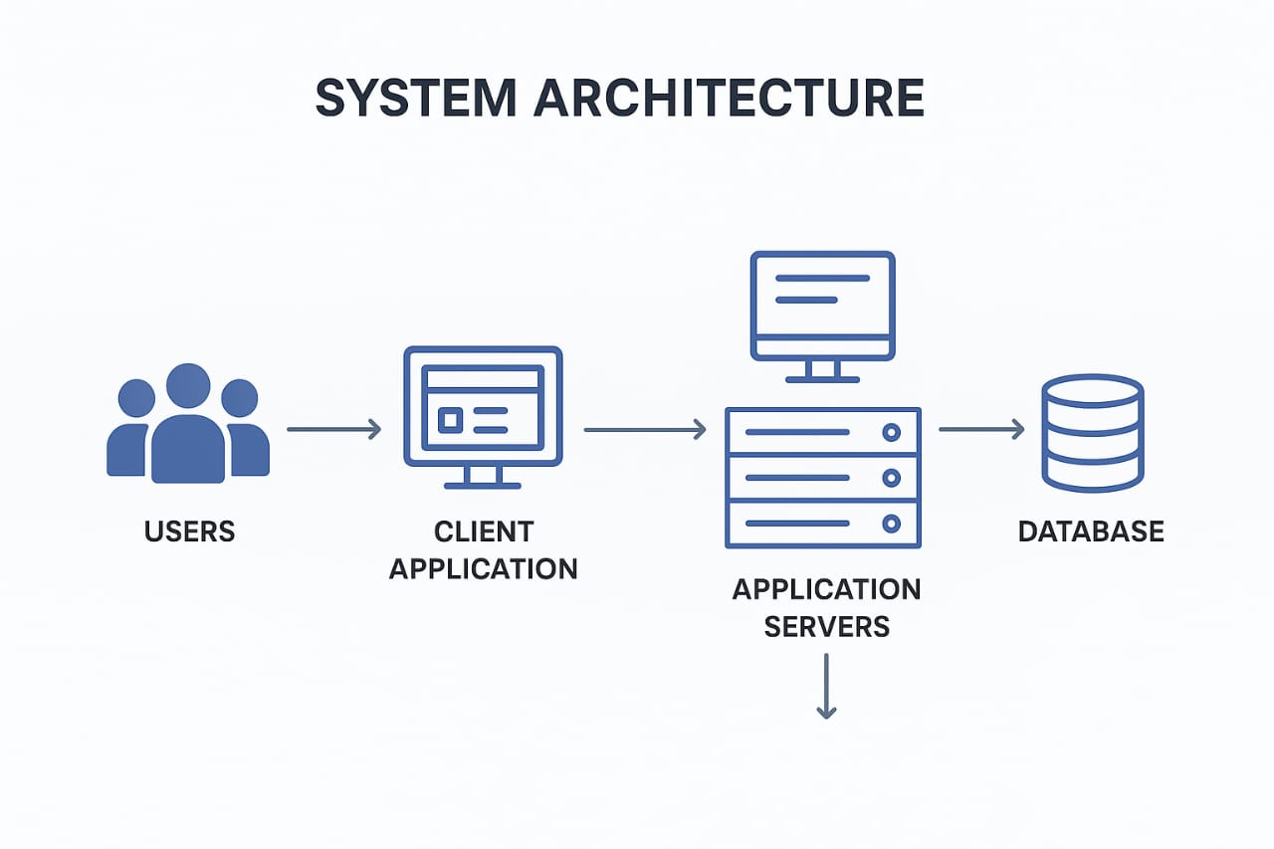

7. Test Cases
Test Case 1 – Donor Registration
Description: Verify that a donor can register with valid details.
Pre-condition: The application must be running.
Steps:

1. Open the registration page.

2. Select the role as "Donor".

3. Enter valid name, email, phone number, and password.

4. Click the "Register" button.
Expected Result: The system displays a success message, creates the account, and redirects to the login page.

Test Case 2 – NGO Registration
Description: Verify that an NGO can register with valid details.
Pre-condition: The application must be running.
Steps:

1. Open the registration page.

2. Select the role as "NGO".

3. Enter valid NGO name, email, contact number, and password.

4. Click the "Register" button.
Expected Result: The system displays a success message and marks the account as “Pending Admin Approval”.

Test Case 3 – Donor Login
Description: Verify donor login with valid credentials.
Pre-condition: Donor account is registered and approved.
Steps:

1. Open the login page.

2. Select the role as "Donor".

3. Enter a valid email and password.

4. Click the "Login" button.
Expected Result: The system redirects the donor to their dashboard.

Test Case 4 – NGO Login with Pending Approval
Description: Verify NGO login when the account is not yet approved.
Pre-condition: NGO account is registered but not approved by admin.
Steps:

1. Open the login page.

2. Select the role as "NGO".

3. Enter a valid email and password.

4. Click the "Login" button.
8. Screenshots
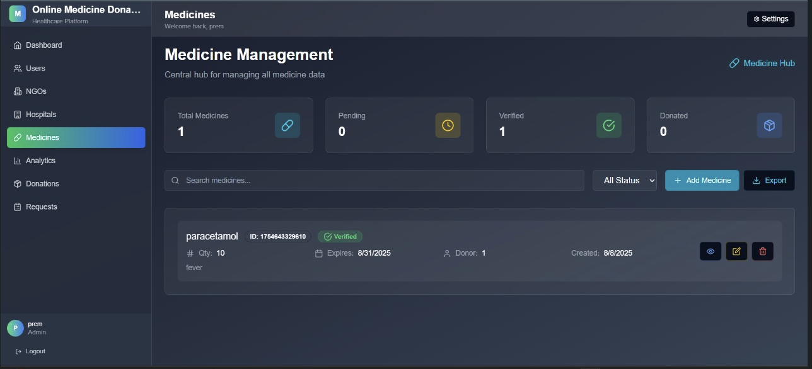
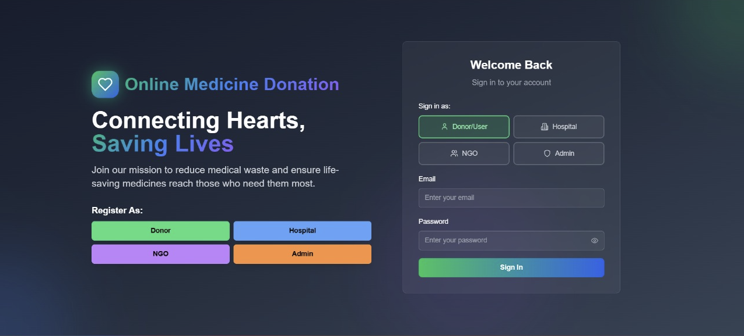
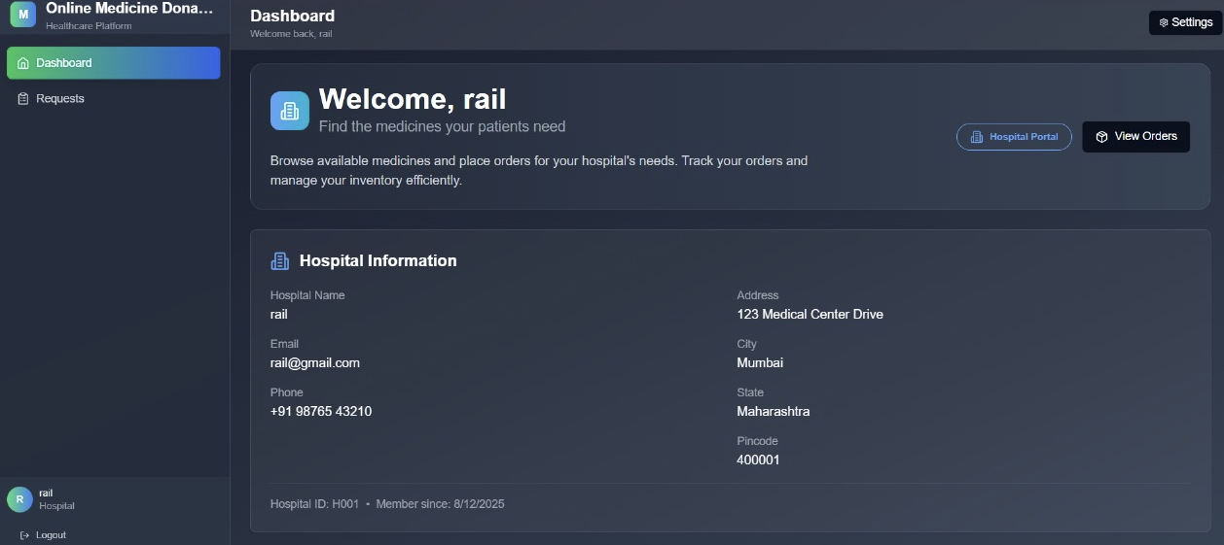
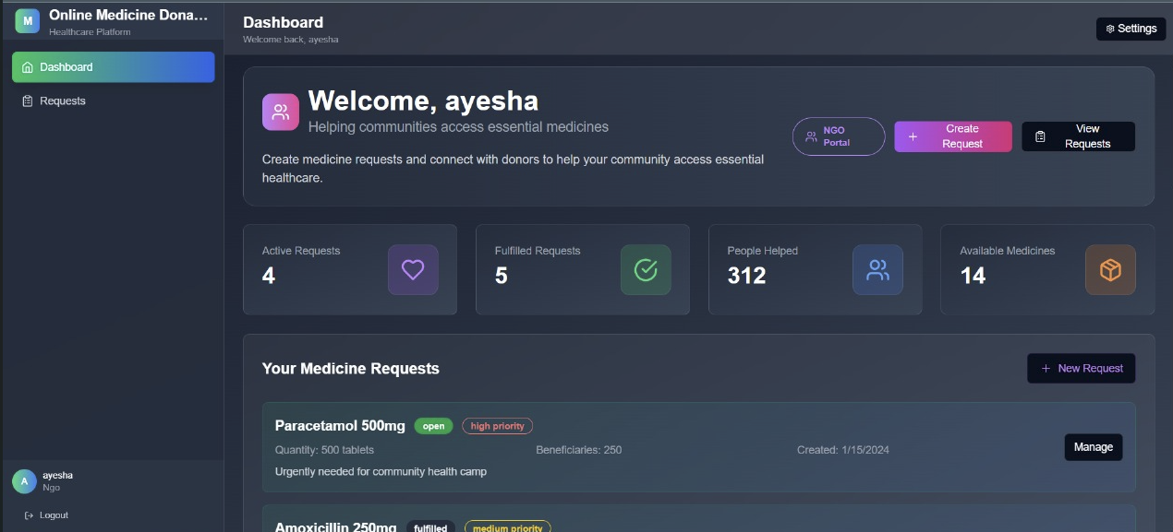
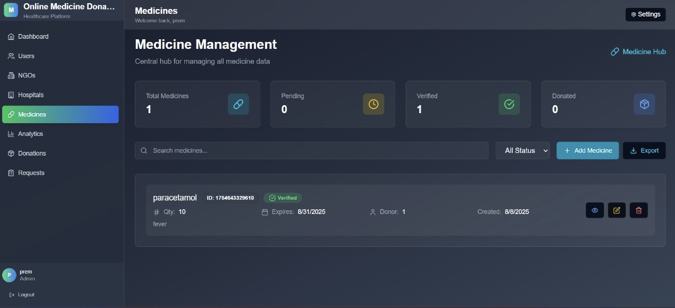
Admin Dashboard
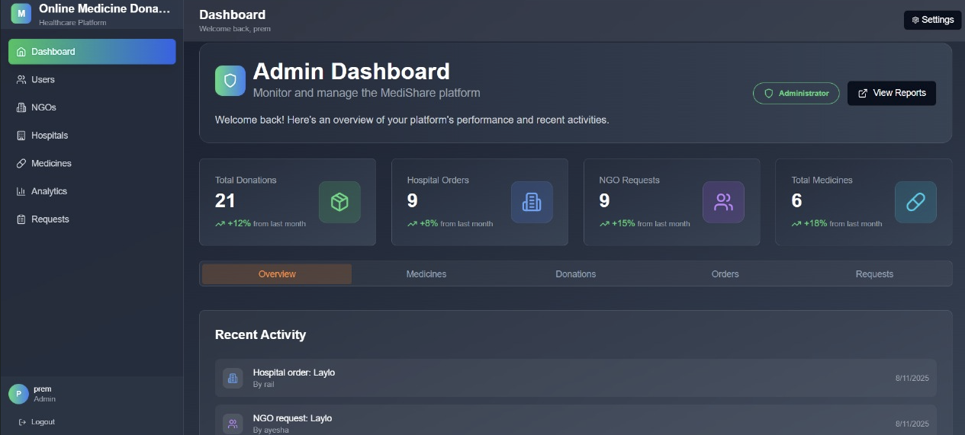
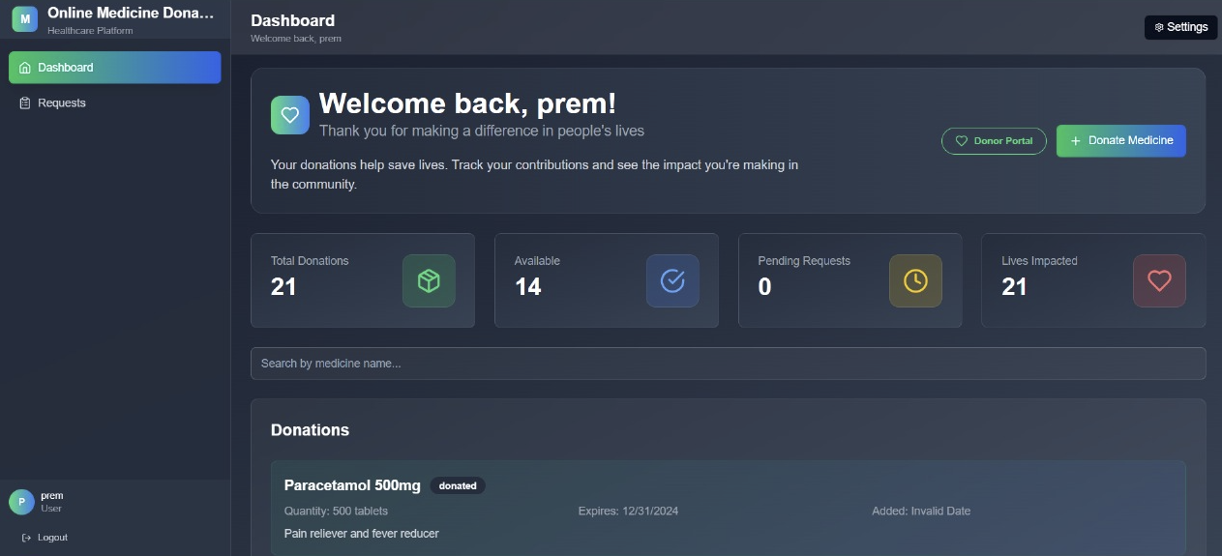
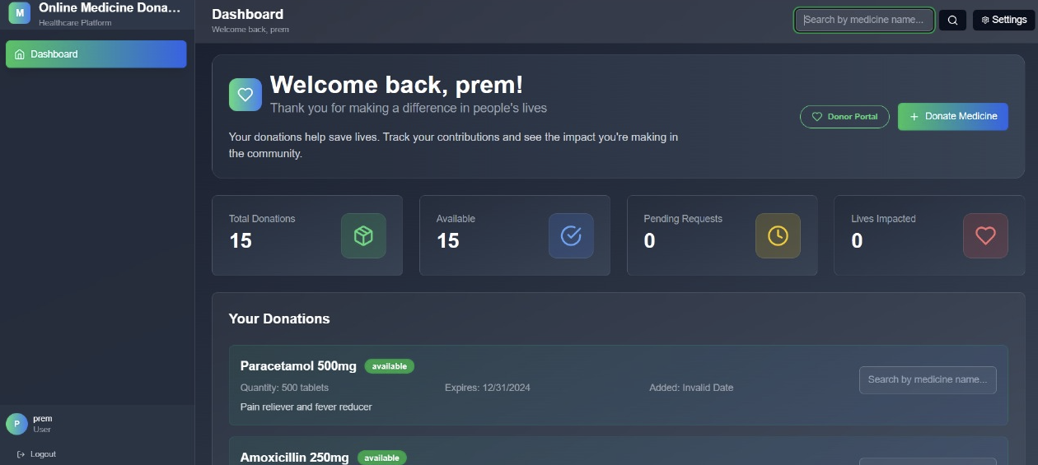
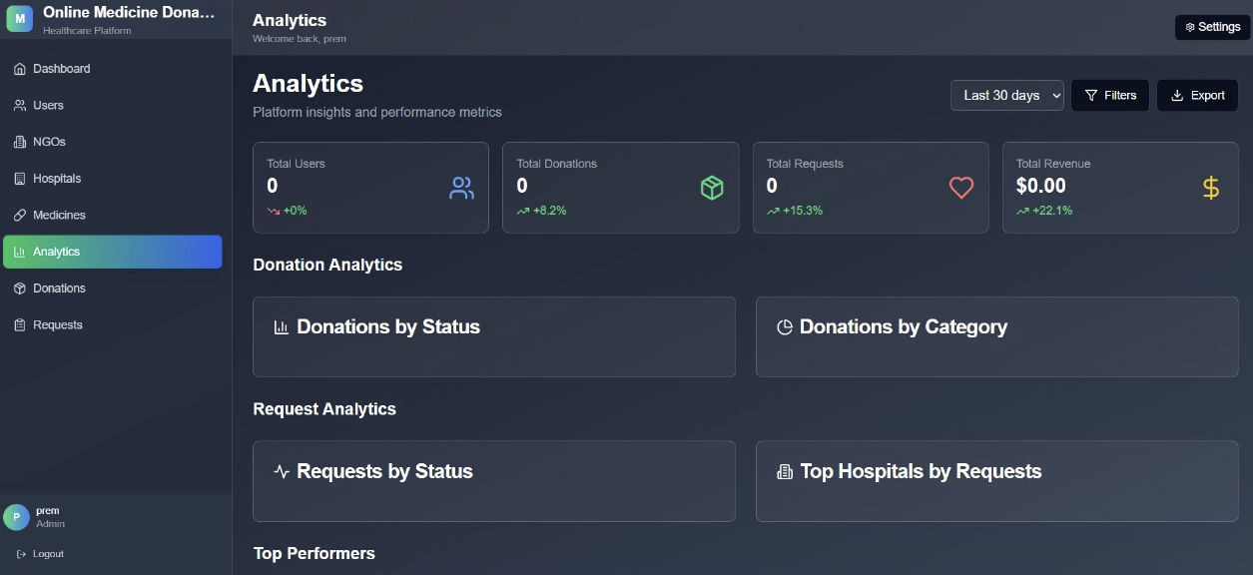

9. References
- World Health Organization. (2017). Guidelines for medicine donations. WHO. https://www.who.int/medicines/publications/med_donationsguide/en/
- Microsoft Docs. (n.d.). Introduction to ASP.NET Core. Retrieved August 2025, from https://docs.microsoft.com/en-us/aspnet/core/?view=aspnetcore-6.0
- React. (n.d.). React – A JavaScript library for building user interfaces. Retrieved August 2025, from https://reactjs.org/
- Microsoft SQL Server Documentation. (n.d.). Overview of SQL Server. Retrieved August 2025, from https://docs.microsoft.com/en-us/sql/sql-server/
- Mozilla Developer Network. (n.d.). JavaScript Guide. Retrieved August 2025, from https://developer.mozilla.org/en-US/docs/Web/JavaScript/Guide
- GitHub. (n.d.). Git Version Control. Retrieved August 2025, from https://git-scm.com/
- Ministry of Health and Family Welfare, Government of India. (2022). National Health Profile. https://main.mohfw.gov.in/

