CDAC Mumbai Competitive Exam Guidance Portal

**SOFTWARE REQUIREMENT SPECIFICATION FOR**

**COMPETITIVE EXAM GUIDENCE PORTAL**

**[28-06-2019]**

**CDAC, MUMBAI**

## Revision History:

|  |  |  |  |  |
| --- | --- | --- | --- | --- |
| **Version.** | **DATE** | **Authored By** | **Reviewed By** | **REASON FOR CHANGE** |
| 00 | 28/06/2019 | Team-8 |  | 1st release |

CDAC Mumbai Competitive Exam Guidance Portal

# Table of Contents

1. Introduction 1
   1. Purpose 1
   2. Document Conventions 1
   3. Intended Audience and Reading Suggestions 1
   4. Product Scope 2
   5. References 3
2. Overall Description 3
   1. Product Perspective 3
   2. Product Functions 3
   3. User Classes and Characteristics 3
   4. Operating Environment 3
   5. Design and Implementation Constraints 3
   6. User Documentation 4
   7. Assumptions and Dependencies 4
3. External Interface Requirements 4
   1. User Interfaces 4
   2. Hardware Interfaces 5
   3. Software Interfaces 5
   4. Communications Interfaces 5
4. System Features 5
   1. System Feature 1 5
   2. System Feature 2 (and so on) 5
5. Other Non-functional Requirements 6
   1. Performance Requirements 6
   2. Safety Requirements 7
   3. Security Requirements 7
   4. Software Quality Attributes 7
6. Other Requirements 8

CDAC Mumbai Competitive Exam Guidance Portal

# Introduction

## Purpose

**Competitive Exam Guidance System** is a web application which provides an interface through which candidate can view the eligible exams according to entered criteria. The proposed system eliminates the need of searching the exams individually instead they can all exams information in this web application only,. It also provides an interface through which candidate can subscribe for exams notification as an alert.

## Document Convention Headings: -

Text: -Bold Font-Size: - 14

Highlighting: - Times New Roman

## Sub Headings: -

Text: -Bold Font-Size: - 12

Highlighting: - Times New Roman

## Header: -

Text: - Simple Font-Size: -10

Highlighting: - Times New Roman

## Footer: -

Text: - Simple Font-Size: -10

Highlighting: - Times New Roman

## Intended Audience and Reading Suggestions

This document is intended for developers, users, testers and project managers for the purpose of understanding the design of system in terms of different perspectives. Further, this document contains functionalities and characteristics of system along with the working

CDAC Mumbai Competitive Exam Guidance Portal

environment. It also includes other information related to system such as external interface requirements, features and other non - functional requirements.

# Product Scope

Our project is focused to reduce the cumbersome process of searching the different competitive exams for the candidates according to their educational qualification by using this web application and providing the appropriate study material for the proper guidance and advice.

# References

<https://spring.io/>

<https://www.java.com/en/>

<https://stackoverflow.com/>

<https://getbootstrap.com/>

<https://hibernate.org/>

# Overall Description

## Product Perspective

This project will propose a system to provide an easy solution for the candidates appearing for the competitive exams by providing appropriate exam references. The other benefits i.e. providing jubilant study material and E- Books, online practice tests, sample question papers and solved question papers which will make a better study pattern for the students by getting proper guidance and advice. This project will hence be helpful for the candidates if they wish to apply for all types of government exams, banking exams. Also this will provide timely schedule for preparation by giving customized alerts and notifications through email.

CDAC Mumbai Competitive Exam Guidance Portal

## Product Functions

* + - The student will be able to select and check eligible exams
    - The candidate can get alerts about particular exam
    - Administrator responsible to manage with exam details

## User Classes and Characteristics Admin:

This person will be able to access all the functions of the system. This person can manage candidate eligible exams, can add and update exam details of the candidate also can view candidate record.

## Candidate:

Candidate can view list of eligible exams by providing educational details and grades. Candidate can get full detail info about that particular exam. Candidate will be able to receive alerts though emails. Candidate can access study references for his exam.

# Operating Environment

## Hardware platform:

* + - * Processor – Above Pentium 4, with clock speed of 2.0 GHz
      * RAM – 1 GB or above
      * Hard Disk – Free disk space of above 1 GB

## Software platform:

* + - * Front-end: HTML, CSS, Bootstrap.
      * Back-end: MySQL ,java,Spring, hibernate.

## Supported tools:

* + - * Visual Code Studio,eclipse jee 2018-09,MySQL Workbench

# Design and Implementation Constraints

## Constraints:

* User interface is only in English. No other language option is available
* User can log-in only with his assigned user-name and password
* Limited to HTTP/HTTPS

CDAC Mumbai Competitive Exam Guidance Portal

# User Documentation

User documentation mainly comprises of Help menu of application. It will give all the minute details about the project, if any user has any query about any module or functionality, one can refer it and see how to operate the application. This report is the complete documentation of our project. It gives complete details about the project, its functionality, users, software used, hardware requirement, environment and so on.

# Assumptions and Dependencies

* Assumptions
  + There is an active internet connection with the system
  + The system has internet browser installed
  + Users know the English language, as the user interface will be provided in English.
* Dependencies:
  + There is a need of constant update of exams .
  + Admin should update exam related details.
  + Candidate should provide Email Id regarding exam alerts.

# External Interface Requirements

## User Interfaces

The main element is web-pages using HTML, Bootstrap Material. Multiple interfaces are there like log-in pages, home pages of Student and Admin. Admin will update exam details for candidates and accordingly data will be persisted. Based on educational qualification details candidate will get information about all eligible exams and also details about that particular exam.

CDAC Mumbai Competitive Exam Guidance Portal

## Hardware Interfaces

In the hardware interface, the system interacts with hardware given the processor is above P4 with clock speed of 2.0 GHz with 1 GB RAM and the Hard Disk with 3 GB free space in the memory. In future enhancements, it can be made responsive to be able to work with mobile devices as well.

## Software Interfaces

In software interfaces java, Spring, hibernate is the back-end technology used along with MySQL Database. The front-end technologies include HTML, CSS, Bootstrap. Data will be communicated between these interfaces accordingly.

## Communications Interfaces

The main communication interface for interacting with the System will be the web Browser.

# System Features

## Description

This system will help candidates to know detailed information about competitive exams. This system will help candidates to know their eligible exams according to his educational qualification. This system will able to provide alerts to candidate regarding his particular exams. This system will provide study material to a candidate. Admin will update upcoming exam details.

## Functional Requirements

## Agenda

* + - * The admin will able to post the exam details to candidate.
      * The system shall allow candidates to provide educational qualification.
      * The system shall also display the upcoming exams details on the dashboard (display).

CDAC Mumbai Competitive Exam Guidance Portal

## Candidate

* + - * The system should maintain a record of candidate.
      * The system will thus help us automate the process of manual alerts.
      * Thus, using this system, we will be able to save a lot of time and energy.

# Performance Requirements

The system should store all the database records of each candidate and admin properly and the application should be available for use 24*7 through the server. Also, the application should be user friendly with a proper user interface which makes it easy for the user to understand. All the options should be present in properly accessible places for user convenience.

## `5.1 Safety Requirements

All login email ID and passwords of the candidates and especially admin should be protected for privacy using whatever constraints required in the database or the application. In case admin can access account of all candidates by email id and passwords. Admin should be changed and new passwords should be issued to all candidates. Candidate and Admin records are to be backed up securely across database servers. In case database is hacked by someone and data is deleted a backup server should be present for such purpose.

## 5.2 Security Requirements

All passwords of the administrators should be protected for privacy using whatever constraints required in the database or the application. Transactions regarding student and mentor records should be carried out properly. Only admin will have access rights to the candidate data according to the need for E.g.: - Candidate Email ID, Highest Education, Grade, passwords etc. The database should be protected from attacks and unauthorized access. The interface should be protected from attacks. All passwords should be stored as a secure hash of the administrator password.

CDAC Mumbai Competitive Exam Guidance Portal

## 5.3 Software Quality 5.3.1Availability

The system should run on a variety of operating systems that support the JavaScript

language. The system should run on a variety of hardware.

## 5.3.2 Accessibility

The software will be accessible to admin, Candidates.

## 5.3.3 Compatibility

The software will be compatible with multiple platforms.

## 5.3.4 Durability

The software will be tested for working with multiple users.

## 5.3.5 Effectiveness

The software will be made to handle operations effectively.

## 5.3.6 Maintainability

The system should be easy to maintain. There should be a clear separation between the

interface and the business logic code. There should be a clear separation between the data access objects that map the database and the business logic code.

CDAC Mumbai Competitive Exam Guidance Portal

# Other Requirements

* **Appendix A: Glossary**
* **SRS:** Software Requirement Specification
* **GUI:** Graphical User Interface
* **P4:** Pentium 4
* **SQL:** Structured Query Language
* **HTML:** Hyper Text Markup Language
* **CSS:** Cascading Style Sheet

CDAC Mumbai Competitive Exam Guidance Portal

# Appendix B: Analysis Models

## Use Case Diagram

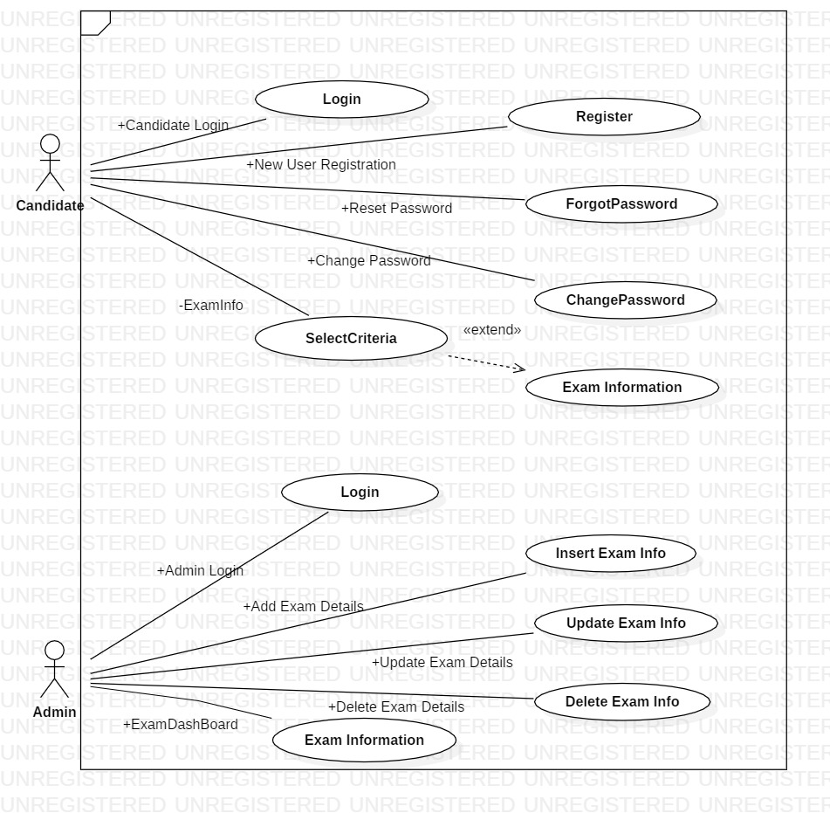

CDAC Mumbai Competitive Exam Guidance Portal

## Class Diagram

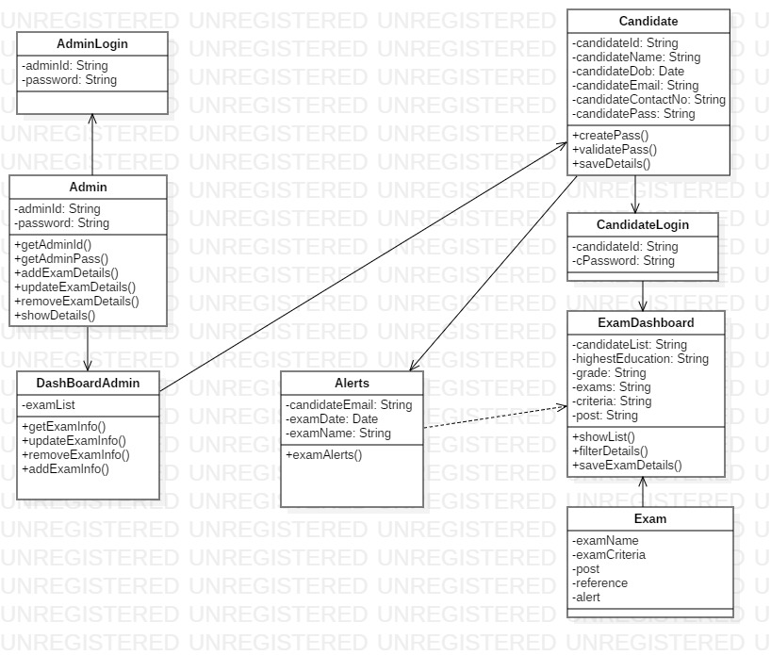

CDAC Mumbai Competitive Exam Guidance Portal

## Activity Diagram 1.1:

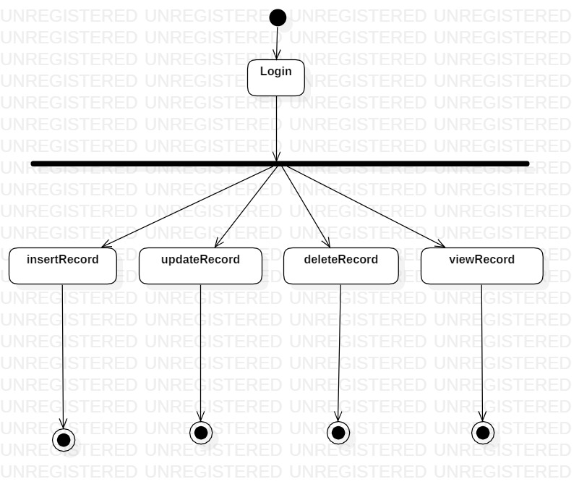

CDAC Mumbai Competitive Exam Guidance Portal

## Activity Diagram 1.2:

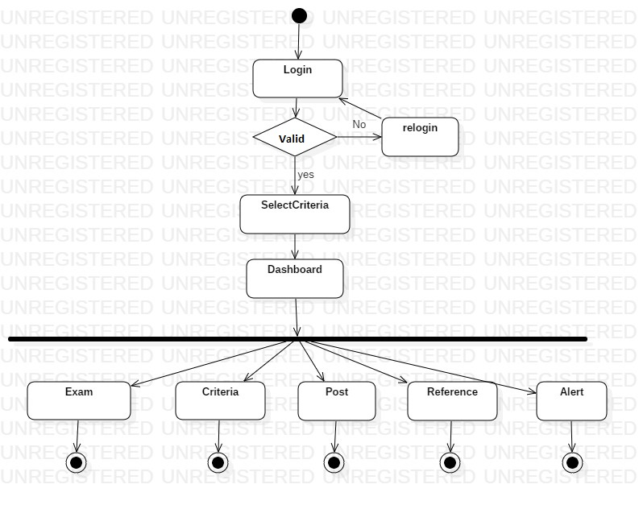

CDAC Mumbai Competitive Exam Guidance Portal

## Sequence Diagram 1.1:

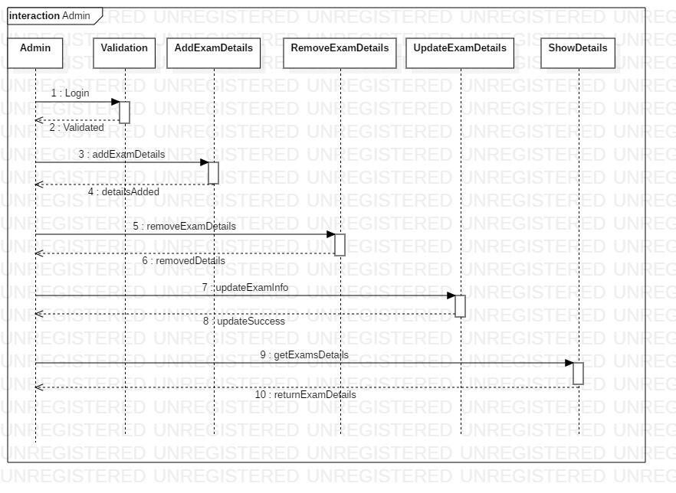

CDAC Mumbai Competitive Exam Guidance Portal

## Sequence Diagram 1.2:

