NIF – Baseband Channel Adaptor (BCA) Interface Design Document

Status: | ISSUED
Version: | 1.2
Team/Department : | Networking / CDMA

Contents
1 Introduction 4
1.1 Purpose and Scope 4
2 Design Overview 4
2.1 Use Cases 4
2.2 Design Requirements & Considerations 6
2.2.1 Runtime Loading 6
2.2.2 Performance 6
2.2.3 Packet Oriented interface support 6
2.2.4 Flow Control 6
2.2.5 Asynchronous IO support 6
2.2.6 Implementation Specific Extended Control Capability 6
2.2.7 BCA Stacking 6
3 Principal Design Decisions: 6
4 Detailed Design 7
4.1 Runtime Loading 10
4.1.1 BCA as a Polymorphic DLL 10
4.1.2 BCA Loading 11
4.1.3 Design Alternative: ECOM Plugin 11
4.2 Required CommDB Support 11
4.3 Capability Query Support 11
4.4 Packet-Oriented Interface Capabilities 11
4.5 Serial Interface Capabilities 11
4.6 Duplex Channel Abstraction 12
4.7 BCA internal buffering 13
4.8 BCA Flow Control 14
4.8.1 Write Path 14
4.8.2 Read Path 15
4.8.3 Note 15
4.9 Management Support 16
4.9.1 General 16
4.9.2 Basic Management 16
4.9.3 Extended Management 16
4.10 Platform Security 16
5 Scenarios 16
5.1 Write Cancellation 16
6 Extended Control Options 17
6.1.1 Serial Port Management 17
6.1.2 HDLC 18
7 Further Information 18
7.1 References 18
7.2 Open Issues 18
7.3 Glossary 18
Appendix A - BCA API Summary by Class / Interface 19
A.1 MBca 19
A.1.1 void Open(TRequestStatus& aStatus) 19
A.1.2 void Shutdown(TRequestStatus& aStatus) 19
A.1.3 void Close() 19
A.1.4 void Read(TRequestStatus& aStatus , TDes& aBuf) 19
A.1.5 void CancelRead() 19
A.1.6 void Write(TRequestStatus& aStatus , const TDesC& aBuf) 19
A.1.7 void CancelWrite() 19
A.1.8 void Ioctl(TRequestSatus& aStatus, TInt aLevel, TInt aName, TDes8& aParam) 19
A.1.9 void Canceloctl() 20
A.1.10 void Release() 20
A.2 MBcaFactory 20
A.2.1 MBca* NewBcaL() 20
A.2.2 void Release() 20
Appendix B - Extended Control Options 20
B.1 BCA with serial capabilities. 20

Introduction

Purpose and Scope
This document discusses the design of NIF – Baseband Channel Adaptor (BCA) interface for the Hardware Adaptation Layer (“HAL”) framework (GT0233 PREQ398) [R2]. The term “BCA” is used to avoid confusion with the existing “E32 HAL” terminology, and because it better reflects the purpose of the framework.

Design Overview
The goal of the BCA framework is to provide an abstract interface for a bearer service, primarily for the data plane of the R-Interface.

Use Cases
The general use case:
[NIF] ← →[BCA: implementation] ← →[Bearer Transport] – [Bearer Realization]
Realization-specific interface
NIF
Bearer Transport
Physical Realisation of a Bearer
BCA interface
Figure 1: General Use Case

The primary use is using BCA to abstract R-Interface data plane transport.
Use Case:
[NIF] ←→ [BCA: implementation] ← →[R-Interface transport] – [R-Interface realization]
BCA hides the R-Interface realization - specific interface from the NIF. Therefore, the same NIF binary can be used with different physical realizations of R-Interface, provided that a suitable implementation of BCA exists.
Realization-specific interface
NIF
R-Interface Transport
Physical Realisation of R-Interface
BCA interface
Figure 2: The Primary Use Case

Likely Use Cases: the goal of the design is to support these use cases
1. Using Raw IP NIF with 27.010 CSY as R-Interface transport [R3]:
[IP NIF] ←→ [BCA: C32] ←→ [27.010 CSY][R-Interface]

2. Using Raw IP NIF with shared memory as R-Interface transport
[IP NIF] ←→ [BCA: Shared Memory] [R-Interface]:
3. Using PPP with C32 and ECUART
[PPP] ←→ [BCA: HDLC] ←→ [BCA: C32] ← → [ECUART][Hardware Serial Port]

Potential Use Cases: supporting these use cases may be required in the future – the design should take them into consideration.

4. Using Raw IP NIF directly with 27.010 as R-Interface transport, without C32.
[IP NIF] ←→[BCA: 27.010] [R-Interface]

5. PPPoE
[PPP] ←→ [BCA: PPPoE] ←→[Ethernet] ←→ [Baseband]

Design Requirements & Considerations

Runtime Loading
Clients (NIFs) identify and load BCAs at runtime, based on CommDB settings in the Bearer tables.

Performance
BCA should be able to support R-Interface protocols implemented using Shared Memory (Use Case 2)
- BCA should impose a minimal overhead.

Packet Oriented interface support
BCA is intended to support packet-based NIFs. Therefore, Read / Write routines must be able to support preservation of packet boundaries.
Some bearers (e.g. C32) deliver data in a stream-oriented format that doesn't necessarily preserve packet boundaries. The BCA must not be precluded from delivering such data, although the notion of a packet boundary in such a case may not be quite accurate.

Flow Control
Flow control is required both on the write and read sides. Both are performed using the asynchronous read/write operations since there can only be one of each outstanding at the same time.

Asynchronous IO support
BCA must support asynchronous IO. That is, BCA must offer an interface that allows the client to queue a read / write, and wait for a completion notification. (Use case 1, 2, 3)

Implementation Specific Extended Control Capability
BCA must be able to support different underlying transports. E.g. byte-oriented streams / serial port (use case 3: HDLC & C32) vs. packet oriented protocols (Use cases 1, 2, RawIP NIF with 27.010). Depending on the capabilities of the underlying protocol used, clients may want to configure themselves (and possibly the BCA) differently.
Use cases:
- HDLC requires access to COMM port settings to support PPP LCP negotiation for ACCM.
When HDLC is not used, most of COMM port settings are likely to be irrelevant to clients.
- Raw IP NIF needs to set COMM port number to be in the 201-300 range, when using 27.010 CSY with C32 [R3]. The assignment must happen at runtime, where port number must correspond to PDP context ID.

BCA Stacking
BCA framework must support BCA stacking: ability to implement a bearer service as a stack of BCAs.
Use Case:
[PPP] ←→ [BCA: HDLC] ←→ [BCA: C32]--[C32: ECUART CSY]

Principal Design Decisions:
- BCA is an abstraction of a duplex channel.
- BCA supports packet boundary preservation. BCA may fragment the packets (e.g. BCA implementing 27.010 Multiplexing protocol). In this case, the packets delivered to the client will be reassembled from fragments as required.
Maximum packet size (MTU / MRU) is advertised as well.
If BCA uses transports that does not support (or can be configured not to support) packet boundary preservation (i.e. serial port), then BCA can read / write arbitrarily large buffers. (E.g. BCA that supports only serial-like capabilities). Appropriate buffer size is advertised.

- BCA is implemented as a polymorphic DLL, loaded at runtime.
- BCA routines (Open / Close / Read / Write / Control) are asynchronous.
To support asynchronous IO, BCA uses Symbian Asynchronous Services API.
- BCA provides support for “capability querying” by clients.
Because of different underlying technologies, BCAs may have different capabilities. (e.g. Serial port capabilities vs. 27.010 capabilities).
- Control options are provided in 2 levels:
a) Basic Control: Functionality common to all BCAs
b) Extended Control: Functionality supported only by a specific implementation BCA.
- It is assumed that BCAs do not buffer: BCA does not take buffer ownership. That is, BCA can process only one buffer at a time. (i.e. one on Read path and one on Write path).
Buffer management is left the clients, i.e. the NIFs.
- At GT0233 Phase 1, BCA implements only a minimal API, providing an essential functionality. That is, no “utility” APIs, that provide non-essential functionality, are defined. These can be added later, without affecting the semantics of existing APIs.

Detailed Design
The following entities are central in BCA design:
- MBcaFactory:
Abstract interface to the object responsible for BCA creation.
Implemented by BCA creation factory, which lives in BCA host Dll.
- MBca:
Abstract Interface to the BCA. Exports method implemented by concrete BCAs.
Implemented by the BCA itself.
The diagrams below illustrate BCA design and use:

BCA
users

BALL Factory
BCA
MBcaFactory
MBca
BCA
Specific
Construction
User (NIF) Process
Client DLL / EXE
BCA host DLL
Figure 3: BCA Objects and Interfaces
.

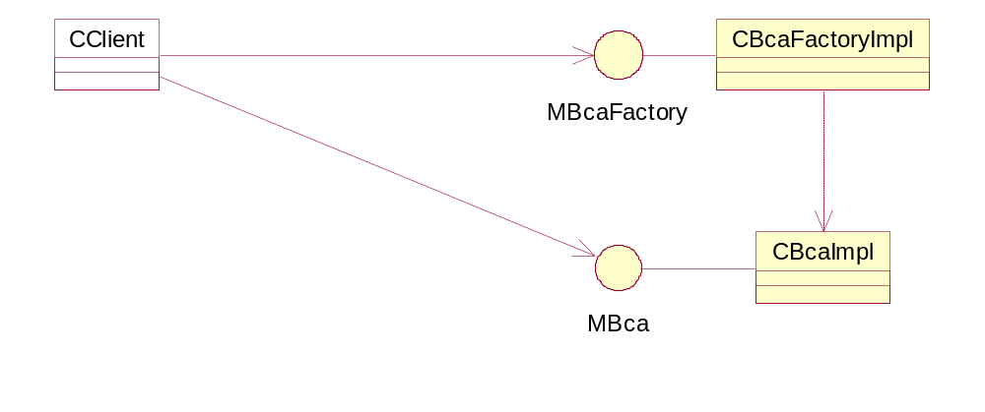
Figure 4: BCA Framework Class Diagram

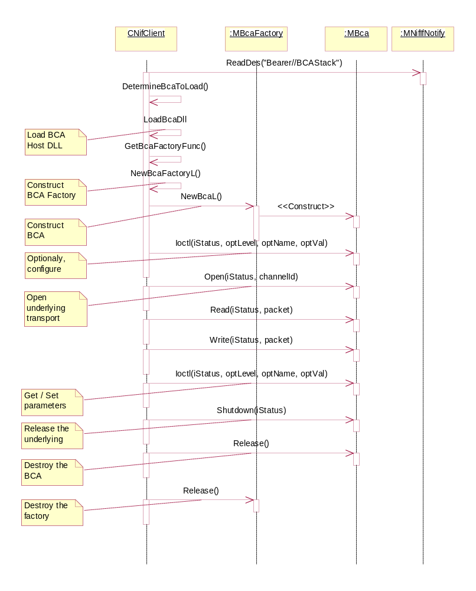
Figure 5: General BCA Use Case Sequence Diagram

Runtime Loading

BCA as a Polymorphic DLL
A BCA is implemented as a polymorphic “.dll” DLL. DLL exports a factory method at ordinal 1. The factory function creates and returns a pointer to MBcaFactory object, which allows creating a concrete BCA using MBcaFactory::NewBcaL() method.
Client loads the desired implementation of BCA based on settings in CommDB Bearer table.
Due to the potential need to stack multiple BCAs, an arbitrary number of entries for BCAs in the Bearer table must be supported.
Implemented solution:
Specify the BCAs in a comma-separated string in a single CommDB column. Find the name of the first BCA and load it. Next, send it the rest of the comma separated list using an ioctl call. This call is identified with control option name “KBCASetBcaStack”. Each BCA is responsible for loading the next BCA in the list and passing the rest of the list to it.
This way the BCA stack can be extended to any arbitrary length. Additionally, duplicate BCA’s are also allowed.
Example (BCA stacking): [PPP] ←→ [BCA: HDLC] ←→ [HDLC: C32] --[C32: ECUART.CSY]
CommDb:
ModemBearer\\IfName=PPP
ModemBearer\\BCAStack=HDLC, C32BCA.
ModemBearer\\CSYName=ECUART
PPP knows that it is the NIF, so it loads HDLC BCA, based on BCAStack.
PPP passes rest of the BCAStack list, i.e. C32BCA, to HDLC
HDLC knows that it is a BCA, so it looks in BCAStack and loads the next BCA: C32.
The BCAStack list is empty. So C32 knows that it does not need to load any BCAs. It relies on C32 framework, and reads the standard field CSYName to load the desired CSY (ECUART).
Alternative solutions would be:
- Introduce an additional column into the Bearer table.
This does not add any real value
- Overload a used column (e.g. CSYName). This is better avoided due to potential regression issues.

BCA Loading
BCA Dll is loaded by the client side code, which implements functionality to find and load the Dll, as well as related error handling.
Implementation of BCA loading is client implementation dependent.

Design Alternative: ECOM Plugin
A BCA can be implemented as ECOM plugin as well.
It is felt that ECOM adds little value to the BCA framework, and there is no sufficient justification (use cases) for the additional complexity. Licensee’s BCA implementers are unlikely to have knowledge of ECOM framework. Usage of this API will increase licensees’ development times.

Required CommDB Support
To support BCA stacking, a new field in CommDB Bearer table (LANBearer, ModemBearer) must be introduced:
String: BCAStack
A string of comma separated BCA implementation names, which are used to load the BCA modules.
Refer to section 4.1.1 on usage.

Capability Query Support
Accessed via MBca::Ioctl method.

Packet-Oriented Interface Capabilities
Packets can be delivered via TDes.
RMBufChain support is unnecessary, because the clients (NIFs) typically convert RMBufChain to TDes before writing it to the underlying transport.

Serial Interface Capabilities
In case BCA’s underlying transport supports a serial-like interface only (no limits on packet size, no guarantees on packet boundary preservation), BCA advertises that via Capabilities and possibly MRU / MTU. MRU and MTU are sent to some arbitrarily large numbers. The client should be able to configure itself appropriately.
Normally, a serial interface provides capabilities to break the incoming stream into discrete segments by setting break conditions and termination characters. When this is enabled, serial BCA Read path follows the same semantics as packet-oriented Read path. If BCA supports serial capabilities, it should not be concerned with packet boundaries on the Write path – the client should be able to queue Writes with arbitrarily large buffers.

Duplex Channel Abstraction
The BCA interface (MBca) declares the following methods:
- Opening
void Open(TRequestStatus& aStatus, const TDesC& aChannelId)
Informs BCA that is required by the client.
Completion of Open with KErrNone signals BCA readiness to carry data, and serves as the initial Flow On notification from the BCA.
aChannelId is an optional identifier of the channel to open. For example, in case of C32 “Shim” BCA implementation, this may be the actual C32 port name, e.g. “COMM::0”. The BCA implementation is responsible for correct interpretation of the channel identifier.
To cancel an outstanding Open, Close() should be called. In this case, Open should complete with KErrCancel
- Graceful shutdown
void Shutdown(TRequestStatus& aStatus).
Informs the BCA that its services are no longer required by the client. The BCA takes an appropriate (implementation-dependent) action, such as disconnecting from the underlying transport.
This method should be called when a graceful shutdown is required. Depending on the underlying transport, completion of the Shutdown call may take some time, due to a potential need to negotiate link severance. This method is primarily intended to support BCA stacking use cases, where the shutdown procedure make take a while
This method should be called by the NIF when the NIF is stopped “normally”. E.g. RConnection::Stop is invoked with EStopNormal, or Nifman Idle timer expires.
Completion status indicates whether an error was encountered during the shutdown.
Note: Shutdown does not destroy the BCA object itself.
To cancel an outstanding Shutdown, Close() should be called. In this case, Shutdown should complete with KErrCancel.
- Immediate shutdown
void Close()
Informs the BCA that it must close (release its resources immediately), with no concern for graceful terminatin. Close cancels all Writes, Reads, Ioctls.
Close() does not return an error code, because the client calling emergency close will not care about it.
This method should be called by the NIF during emergency closing scenarios, such as invocation of RConnection::Stop with EStopAuthoritative.
Note: Close does not destroy the BCA object itself.
Calling Close() when there is an outstanding Open or Shutdown should result in these calls being cancelled.

- Destruction of the BCA object
void Release()

This method destroys the BCA instance itself, de-allocating the memory. This method is used in lieu of a C++ destructor.
Release() can be used with the CleanupStack via the CleanupReleasePushL method. Calling PopAndDestroy invokes Release() and destroys the BCA instance.
- Reading
void Read(TRequestStatus& aStatus, TDes8& aBuf)
Queues a Read.
aStatus: completion status
aBuf: buffer for data to be read
Queues a read.
Upon successful completion of Read, aBuf contains the data read.
Buffer ownership:
The Client must preserve (not modify) the buffer until the Read has completed. The client maintains the ownership of the buffer, and it is client’s responsibility to manage it (e.g. free) it after the read.
- Writing
void Write(TRequestStatus& aStatus, const TDesC8& aBuf)
Queues a Write
aStatus: completion status
aBuf: buffer to be sent
Buffer ownership:
The client must preserve (not modify) the buffer until the Write has completed. The client maintains the ownership of the buffer, and it is client’s responsibility to manage it (e.g. free) it after the write.
- void CancelRead()
Cancels the outstanding Read Operation (Best effort operation)
Data in Read buffer is discarded. The buffer may be reused by the client as soon as CanceRead returns.
The outstanding read should complete with KErrCancel.
- void CancelWrite()
Cancels all Write Operations. (best effort operation)
Data in the Write buffer is discarded. The buffer may be reused by the client as soon as the CancelWrite returns.
The outstanding write should complete with KErrCancel.

BCA internal buffering
Design Decision: BCA does minimal buffering. That is, BCA holds a pointer / reference to only one buffer, corresponding to one Receive / Transmit unit. BCA does not maintain a queue of such pointers / references.
Rationale:
- Principal BCA clients are NIFs. NIFs (e.g. PPP NIF and Raw IP NIF) implement internal buffering themselves. During large data transfers, underlying R-Interface transport is likely to be a bottleneck, internally flowing BCA off. With no internal BCA buffering, the NIF would be flown off by BCA, achieving the same result. Therefore, providing buffering capability in BCA is an unnecessary complication.
- Double buffering (by BCA and NIF) introduces unnecessary overhead:
Buffering inevitably requires flow control, which would be implemented as ActiveObject in case of asynchronous IO. There would one set of active objects in the NIF and another set in the BCA.
- Internal buffering by BCA can mislead the NIF into assuming that the data was sent. That is, assigning all buffering capabilities to NIF concentrates flow control in one place, namely the NIF.
- In situations where R-Interface transport is not a bottleneck (e.g. it is implemented as Shared Memory), additional buffering in BCA adds little value, as buffers can be sent quicker than they are queued by the NIF

BCA Flow Control

Write Path
Completion of Open with KErrNone signals the initial readiness to accept input.
No Writes can be scheduled after invoking Close() or Shutdown, obviously.
Writing follows the general behaviour of Symbian asynchronous service provider: Write service request followed by Active Scheduler triggering RunL().
After the client queues a write by calling MBca::Write, BCA executes the Write and signals its readiness to process more input by signalling the RequestStatus with KErrNone. That is, a return from Write() implicitly flows the client off. Signalling Write completion flows the client on. BCA does not signal Write completion until it can process another Write.
If a BCA cannot queue a Write (due to a transport flowing BCA off, for example), Write completes immediately with an appropriate error code. If BCA cannot complete a queued Write, Write completion is signalled with an appropriate error code.
A sequence diagram below illustrates a scenario where BCA flow controls the client on the Write path via the ActiveObject framework
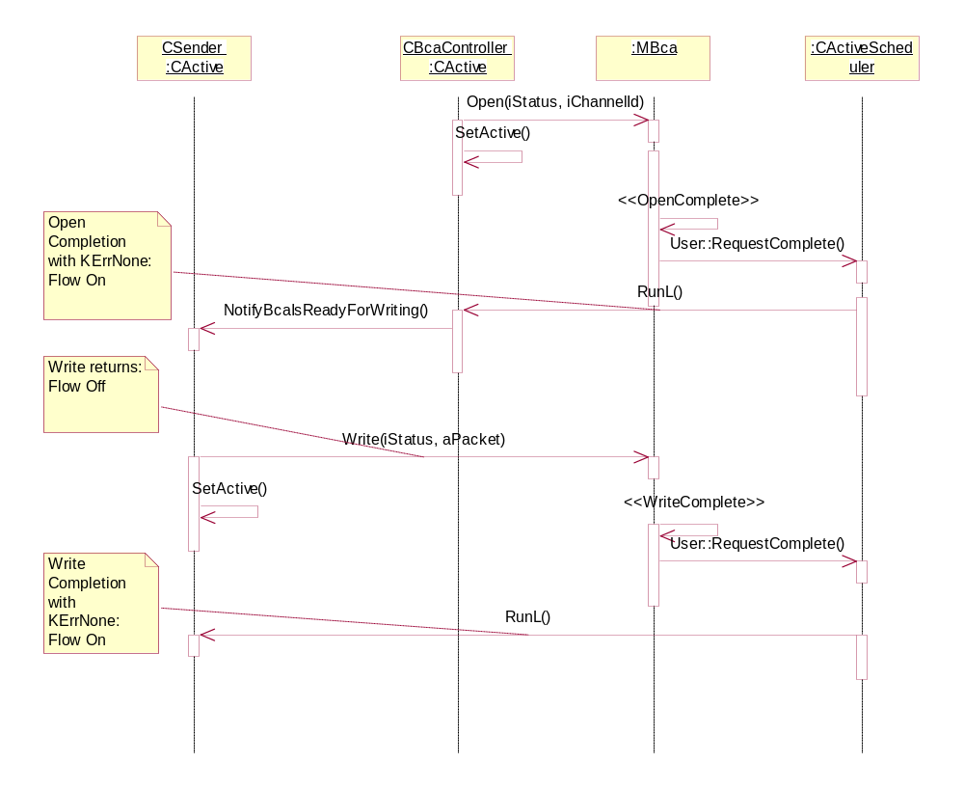
Figure 6: Flow Control on the write path.

Read Path
Read completion is signalled by the ActiveObject framework
It is up to BCA implementation to flow control itself, such that data is read from the underlying transport only when buffer space is available, etc.
Asynchronous reads follow the same sequence as Writes: a queued read is followed by ActiveObject becoming signalled.
If the BCA cannot queue a Read (due to a transport error for example), the read completes immediately with an appropriate error code.
If the BCA cannot complete a queued Read, Read completion is signalled with an appropriate error code.

Note
The details of a flow control are left to specific BCA implementation, and are dependent on the underlying transport’s flow control.
For example, if the transport flows BCA off, BCA implementation may choose to queue a Write and wait for the transport to flow it on, rather than failing outright a client’s write queuing. This is the preferred behaviour if the flow off condition is expected to be of short duration.

Management Support

General
void MBca::Ioctl(TRequestStatus& aStatus, TInt aOptLevel, TInt aOptName, TDes8& aOpt, ) method
aStatus: completion status.
aOptLevel: Option level:
aOptName: Option name
aOpt: packaged option
Implementation note:
Some control options can be applied only when there is no Read / Write queued. It is client’s responsibility to ensure proper sequence of Read / Write / Cancel / Control operations.

Void MBca::CancelIoctl()
This method cancesl the outstanding Ioctl.
The outstanding call should complete with KErrCancel.

Basic Management
Control options that are common to all Bcas
Basic management options are accessed using Option Level = KBcaOptLevelGeneric.

Extended Management
Implementation-specific control options.
Implementation specific control options are accessed using Option Level =- KBcaOptLevelExt{extended functionality Type}, e.g. KBcaOptLevelExtSerial

Platform Security
The BCA Dll capabilities are the same as NIFs, that is:
CommDD PowerMgmt ReadDeviceData WriteDeviceData TrustedUI ProtServ NetworkControl NetworkServices LocalServices ReadUserData WriteUserData
Because BCA can be accessed only from a NIF (or a client with equivalent capacities), BCA does not need to police its APIs.

Scenarios

Write Cancellation
Use case: Client needs to abort and restart the Write sequence. Write cancellation is handled similarly.
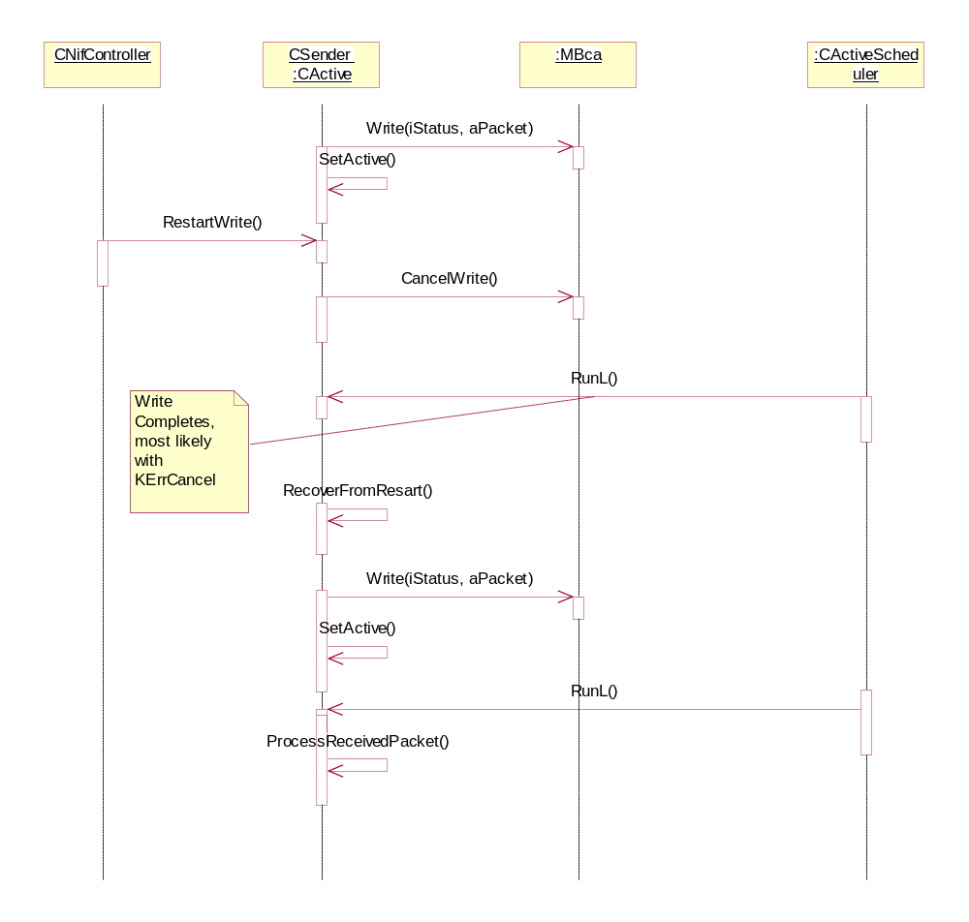
Figure 7: BCA Cancel Write functionality

Extended Control Options

Serial Port Management

Purpose
Management APIs for serial port, as a restricted subset of RComm API.

Targeted Use cases:
- C32 BCA
- Proprietary Licensee BCA with serial capabilities.
Rationale:
- Some clients inherently depend on low-level access to serial port:
  - Raw IP NIF needs to set port number when using 27.010 CSY
  - HDLC need to get / set serial-specific parameters such as terminator character, XON / XOFF flow control enabling, etc.
- In general, assist in porting existing clients, which may be tightly bound to C32, to the new BCA interface.

API
See Appendix B

HDLC

Purpose
Management APIs for BCA implementing HDLC framing.

Targeted Use cases
  - PPPoE
[PPP] ←→[BCA: PPPoE] ←→[Ethernet][Baseband]
  - Implementing an additional BCA to test BCA stacking using cases:
[PPP] ←→[BCA: HDLC] ←→[BCA: C32] [C32]

API
APIs provide access to HDLC-specific settings, such as:
- FCS (FCS16 and alternatives)
- ACFC
- ACCM
The list of settings is incomplete, and will be discussed in GT0233 Phase 2.

Further Information

References
No. | Document Reference | Version | Description
[R1] | “UML Explained” |  | by Kendall Scott  (http://www.amazon.co.uk/exec/obidos/tg/stores/detail/-/books/0201721821/toc/202-4456432-1159001)
[R2] | SGL.GT0233.501.v02Preq398analysis.doc | 0.2 | Architecture Analysis for PREQ398.
[R3] | Raw_IP_NIF_Detailed_Design.doc | 0.1 | Detailed Design of Raw IP NIF.

Open Issues
None.

Glossary
The following technical terms and abbreviations are used within this document.
Term | Definition
ACFC | Address and Control Field Compression (in PPP HDLC)
ACCM | Asynchronous Control Character Map (in PPP HDLC)
BCA | Baseband Channel Adaptor
Client | NIF or another BCA, using the BCA API.
FCS | Frame Check Sequence (CRC)
HDLC | High Level Data Link Control
NIF | Symbian OS Network Interface

- BCA API Summary by Class / Interface
Refer to text for detailed descriptions
  - MBca
    - void Open(TRequestStatus& aStatus)
Informs Bca that is required by client
    - void Shutdown(TRequestStatus& aStatus)
Graceful closure of BCA
    - void Close()
Immediate closure of BCA
    - void Read(TRequestStatus& aStatus , TDes& aBuf)
Queue a Read into a flat buffer.
    - void CancelRead()
Cancel an outstanding read, if any
    - void Write(TRequestStatus& aStatus , const TDesC& aBuf)
Queue a Write of a flat buffer.
    - void CancelWrite()
Cancel an outstanding write, if any.
    - void Ioctl(TRequestSatus& aStatus, TInt aLevel, TInt aName, TDes8& aParam)
Generic Control Options (KBcaOptLevelGeneric)
Option Name | Explanation | Option.
KBcaMru | Get MRU | packaged MRU, as TInt
KBcaMtu | Get MTU | packaged MTU, as TInt
KBcaSpeedMetric | Get BCA Speed Metric | packaged speed, as TInt
KBcaCaps | Get BCA capabilities bitmask | Packaged capabitlies, as TInt
KVersionNumber | Get BCA version. | Packet version, as TUint32. Upper 16 bits represent the Major version, lower 16 bits represent the Minor version.
KBCASetIapId | Sets the IAP number, so that the BCA is able to read CommDB settings | Packaged IAP ID, as TUint
KBCASetBcaStack | Sets the BCA stack, so that the BCA can initialize the next BCA and also send it the remaining list of BCA’s to be generated. | The list of BCA names as TPtr8. e.g. “HDLC,C32”
KBCAResetBuffers | Resets the receive and / or transmit buffer. | Packaged TUInt32:  Bitmask of:  KResetRxBuf to reset the receive buffer.  KResetTxBuf to reset the transmit buffer.

BCA capabilities:
Pos | Bitset | Capability Supported
0 | 0x00 | Illegal
1 | 0x01 | Serial Port capability supported (i.e. supports XON / XOFF flow control, terminator characters, etc). This implies that Serial interface is supported.
2 | 0x02 | Underlying transport uses packet oriented interface: packet boundaries are preserved on Read and Write.(Packet size is: MRU / MTU)
3 | 0x04 | HDLC framing supported (i.e supports FCS16, etc) (for HDLC BCAs)
    - void Canceloctl()
Cancels the outstanding Ioctl
    - void Release()
Destroys the BCA instance. Should be called in lieu of C++ destructor.
  - MBcaFactory
    - MBca* NewBcaL()
Returns a pointer to the newly created BCA instance.
Leaves if creation fails, e.g. due to lack of memory.

    - void Release()
Destroys the BCA factory instance.
Used in lieu of a C++ destructor.
- Extended Control Options
  - BCA with serial capabilities.
OptionLevel: KBcaColLevelExtSerial
(Refer to RComm API for detailed descriptions of different options.)
Option Name | Explanation | Option
KSerialCaps | Retrieve serial capabilities | Packaged TCommCapsV01
KSerialConfig | Retrieve serial port configuration | Packaged TCommConfig
KSerialSetConfig | Set serial port configuration | Packaged TCommConfig
KSerialPortName | Retrieve serial port name | Packaged TBuf
KSerialSetPortName | Set serial port name (before opening) | Packaged TBuf
KSerialSetCommRole | Sets the COMM role (DTE or DCE) of the serial port. | Packaged TCommRole, either ECommRoleDTE, or ECommRoleDCE
KSerialSetCsy | Set CSY name | Packaged TBuf
KSerialTxRxBufferSize | Sets the receiver / transmit buffer size. Provided for compatibility with C32. | Packaged Tint.
KSerialMonitorControlLines | Turn EIA-232 Control line monitoring on / off. | Packaged TUint32:  KMonitorOff: turn the monitoring off (It’s ok to call it when the monitoring is off)  KFailBcaSpecificOnly: use BCA’s default failure settings. For example, DCD or DTR low.  KConfigFail* constants as defined by C32. This specified to fail when the line goes low.

