Raw IP NIF Detailed Design

Security Classification: | Unclassified
Document Reference:
Status: | Issued
Version: | 1.2
Team/Department : | Base Telephony Team, Cambridge
Author(s): | Marco Ferri, Cemile Buke Otkunc
Owner(s): | Emlyn Howell

Approver(s): | Jim Rayner, Emlyn Howell | Distribution: | BTT/Networking Team Members

Contents
1 Introduction 4
1.1 Purpose and Scope 4
1.2 The need for the Raw IP NIF 4
1.3 UIH and the Type 4 Convergence Layer 4
1.4 History of the BTT NIF 4
2 Design overview 6
2.1 General 6
2.2 Raw IP NIF Constraints 7
2.3 Raw IP NIF Design Decisions 7
2.4 IP / 27.010 Packet Flow 8
2.5 Raw IP NIF Design Overview 9
2.6 NIF Buffering 10
2.7 Tag Headers 10
3 Flow Control 11
3.1 Overview 11
3.2 Details 11
3.2.1 PDP Context Suspended 11
3.3 “Tx On/Off” Flag 12
4 Raw IP NIF Initialisation 13
4.1 Flow diagram 13
4.2 Further details 14
5 Raw IP NIF Close Down 15
5.1 Flow Diagram 15
5.2 Further Details 15
6 Raw IP Packet Down “Write” – Flow Diagram 17
7 Raw IP Packet Up “Read” – Flow Diagram 19
8 Other Details 21
8.1 CommDB / PSDAGT interaction 21
8.2 PSDAGT modifications 21
8.3 TCP/IP Protocol Event notifications 21
8.4 Logging 21
8.5 Ini file 21
9 Sequence diagrams 22
9.1 Send an IP Packet 22
9.2 Receive an IP Packet 23
10 Further Information 24
10.1 People 24
10.2 References 24
10.3 Open Issues 24
10.4 Glossary 24
10.5 Document History 24

Introduction

Purpose and Scope
This document is a detailed design for the raw Internet Protocol Network Interface (RawIP NIF). It is intended to show the reader the overall design of the NIF, concentrating on any areas of special interest or complexity.

The need for the Raw IP NIF
The Raw IP NIF is required to support multiple primary PDP contexts (multi-homing over GPRS) on the telephony reference platform.
The development of the Raw IP NIF for the GT185 Base Telephony (TRPv3) project is the result of the change of the reference board used for development. The new reference platform, the Texas Instruments (TI) D-Sample board cannot support multiple instances of the PPP server, so PPP cannot be used. Therefore the Raw IP NIF will be used with the 27.010 CSY (provided by Taproot), making use of the Type 4 convergence layer and UIH frames advanced option to frame the incoming IP packets (see section 1.3).
The development of the Raw IP NIF will reduce time to market for licencees as they will be able to use this Raw IP NIF with the new reference platform rather than having to develop it themselves.
The Base Telephony Team (BTT) have previously developed a BTT NIF as part of the GT139 project (TRPv2), however, this will only be used as a reference for the design of the Raw IP NIF due to some fundamental differences in the way the BTT NIF and Raw IP NIF’s work. These differences are explained in following sections of this document.

UIH and the Type 4 Convergence Layer
As the name suggests the Raw IP NIF will handle IP packets. In order to do this, it is necessary for the CSY that is used to have support for 27.010 Parameter Negotiation and Type 4 Convergence Layer support.
A 27.010 signal can hold a maximum of 127 bytes in basic mode, and is therefore smaller than an IP packet, which can be a maximum size of 1500 bytes (the maximum transmission unit (MTU) used in the TCP/IP protocol). Therefore, the CSY will take the IP packet from the Raw IP NIF and fragment the packet into multiple frames. These frames are then transmitted sequentially to the baseband. At the receiving end, for a channel using the Type 4 Convergence Layer, the CSY defragments the received frames into a complete IP Packet before completing an RComm client’s read request.
The UIH framing is also required to allow escaping of data within the packet which could otherwise be interpreted as the start or end of the IP frame.

History of the BTT NIF
The Symbian OS platform used to have only two NIF implementations (Ethernet and PPP NIFs). A BTT NIF was developed as part of the GT139 Base Telephony (TRPv2) project, and the Ethernet NIF was used as a reference for the initial stage of the design.
The reasons to choose the Ethernet NIF were:
- Modular architecture. Specific functionality for the Ethernet protocol could easily be removed from the design.
- The Ethernet NIF complies with the Network Adapter Framework (NAF) specification [1] as a “non 3G NIF”. There remains only the need to add support for GPRS-specific functionality.
- The NIF provides a working implementation of a NAF compliant design. This reduced the risk on the design phase for the project. There was no need to reinvent the wheel.
The BTT NIF previously developed also handled connection control. The NIF was then responsible for making the PDP connections and the NIF would then contain an internal state machine detailing the state of each connection e.g. Activating, Active, Suspended, Deactivating. [2]
It was decided that for the Raw IP NIF, the connection control would no longer be part of NIF as this functionality is already available for use by the packet switched data agent (PSDAGT). The PSDAGT will need to be modified in order to work with the Raw IP NIF and this is explained further in following sections.

Design overview

General
The two main components which implement the Network Interface are the NIF and Agent modules.
The NIF component for Symbian OS is a collection of classes which implement a particular network connection protocol. The operating system is capable of having multiple such components which are instantiated and used when a network connection is initiated by the user. The position of a typical NIF within the structure of Symbian OS can be shown in the following figure:

Comm DB
TSY
BCA
Underlying layer

ESock
TCP/IP Protocol

Application
TI D-Sample
Network Controller

ETel
IP NIF
NIFMAN
CSY
PSDAGT

The PSDAGT is the packet switched data agent which is responsible for establishing network connections and passing the use of these connections to the NIF [3].
NIFMAN is essentially a manager component for the various available NIFs. NIFMAN will be responsible for creating and starting the appropriate agent (in this case, PSDAGT) and NIF from connection preference settings obtained from CommDB via the NetworkController component. NIFMAN also acts as a router for messages between the Agent and the NIF, allowing the two components to send notification messages to each other. An example of this is that the Agent will inform the NIF of the PDP context state (e.g. Suspended) via a Notification [4].
ESock represents the module which implements network sockets and it is mainly used by the Applications when a network connection is established. The ETel module implements the Telephony services while CommDB is the database that contains all the parameters required for all supported network connections [5]. The Network Protocol (TCP/IP) module implements the stack of a particular network protocol and communicates with the NIFs that use it. BCA [6] interface implements the service of sending and receiving data to and from C32 using BCA Read and Write API. It hides the underlying layer applications from Raw IP NIF.
Finally, the underlying layer represents the low-level interface that allows multiple instances of a NIF to communicate with the hardware, the TI D-Sample.

Raw IP NIF Constraints
The Raw IP NIF is the Symbian OS Network Interface to the TI D-Sample board. According to the NAF specification (see reference [1]) there are two types of NIFs, “non 3G” and “3G” NIFs. As the name indicates 3G NIFs are extension of “non 3G” NIFs that add support for 3G functionality (i.e. QoS & Multi-Homing).
The Raw IP NIF will comply with the NAF specification for a 3G NIF, but it will not support all the functionality described as “3G NIF” functionality. Here are the main constraints to the design:
- Only 1 PDP context per Raw IP NIF instance: The NIF will not support secondary PDP context. However, multiple instances of the NIF can be instantiated at the same time, all using the same GPRS uplink.
- The support for QoS is limited: The NIF will always use the values defined in the CommDB. QoS will be supported when all the “3G NIF” functionality is supported.

Raw IP NIF Design Decisions
Raw IP NIF sends and receives data to and from underlying layer via the BCA interface. It is not dependent on a specific reference board.
Since BCA interface is stackable the Raw IP NIF is responsible for processing BCA stack information. i.e. passing the underlying BCA the list of BCA’s that it is supposed to create.

IP / 27.010 Packet Flow
The diagram below shows the path of IP and 27.010 packets. The left side shows the IP packet traversing from the TCP/IP protocol, through the NIF and BCA, getting fragmented into 27.010 packets in the CSY and then these getting sent to the baseband. The right hand side shows the 27.010 packets coming from the baseband, getting defragmented in the CSY and passed up to BCA and out of the Raw IP NIF as an IP packet.
IP Packet
IP Packet
TCP/IP Protocol
IP NIF
IP Packet
IP Packet
CSY 27.010
Type 4 Convergence Layer
Fragment
Defragment

BCA
Baseband
Type 4 Convergence Layer
Fragment
Defragment

TI CONDAT
27.010 packet: 2
27.010 packet: 1
…
27.010 packet: n
27.010 packet: n
…
27.010 packet: 1

27.010 packet: 2

(Serial comms)
Symbian OS
TI Stack

Raw IP NIF Design Overview
This section provides a class diagram that describes the main components of the NIF (see below). The main class is CIPNifMain, which is the hub that links the different parts of the NIF and provides the link to NIFMAN.
CIPv6ProtocolIf
CActive
CNifIfBase
CNifIfLink
MIpNifObserverBase
CProtocolIfBase
CIPv4ProtocolIf
CIPNifMain
CReceiver
MCsyControllerObserver
CSender
CBcaControll
CBcaIoController
CBcaController
CIPTagHeader
The NIF functionality is divided into 2 parts:
- CIPv4ProtocolIf & CIPv6ProtocolIf: This module implements the functionality necessary for the interoperability between the NIF and the protocol module (TCP/IP). One of its main responsibilities is to implement the Control method defined in the CNifIfBase class. This method is used to supply all the parameters required for setting up and controlling the operations of the NIF (requests for event notifications are implemented via this method).
- BCA: The CBcaController module manages and owns the link to the BCA module. It is an abstract class and therefore contains all common methods needed to communicate to the BCA. The CBcaIoController contains all the specific methods and data for communicating via BCA to the underlying layer. The BCA controller interacts with NIF using an interface defined by a MClass that implements the MIpNifObserverBase interface. The functionality to send and receive packet data is implemented by the CSender and CReceiver active objects. The CIPTagHeader class is used to add and remove 16 bits of protocol data detailing whether the IP packet is IPv4 or IPv6. This is only needed between the NIF and the baseband so the NIF will add the data on the way to the CSY/baseband and remove it in the other direction. The CBcaControl module loads BCA DLL, creates a new BCA and opens the BCA for data transmission. It also controls the BCA shutdown, NIF start and stop. Additionally it supports passing configuration information to the BCA using ioctl calls. Setting IAP id, and setting BCA stack are such information.
If another method of communicating with the reference platform hardware is to be used, then a new class can be derived from the CBcaController class to implement the new protocol.

NIF Buffering
The Raw IP NIF takes write requests from the protocol stack and sends them down to the baseband via the BCA. After each request, the protocol stack is told to wait before sending the next IP packet for transmission. During design of the Raw IP NIF it was decided that it could possible be much more efficient to have some buffering in the NIF to allow several requests to get queued up in the IP NIF and then handled sequentially to the baseband rather than stopping and restarting the protocol stack. This buffering mechanism will be made configurable so that having a buffer size of 0 would mean that the IP packets traverse from the protocol stack through the NIF to the baseband, one by one – or so that the buffer size can be increased at a later stage to improve efficiency.
If the context was to become suspended then all write requests that had been queued in the NIF would be deleted as the information would no longer be required when the connection was resumed.
If the number of queued requests reaches the maximum, then a stop sending message will be passed up to the protocol stack until there is room for the NIF to handle or queue further write requests. This will trigger a resume sending call to the protocol stack.
As the NIF takes ownership of the write request data passed from the protocol stack, it would be the NIF responsibility to ensure the storage space was recovered in all scenarios to prevent possibility of memory leaks.
The size of the buffer is configurable via the ini file. If an ini file is not provided than the default value of “1” buffer size (i.e. double buffering) is used. The default size of 1 is necessary when GuQoS is used because GuQoS handles the buffering. For more information on the ini file please refer to the ini file related section in this document.

Tag Headers
In order to comply with the design of the baseband (TI board) behaviour to support header compressions it was necessary to add some further functionality to the Raw IP NIF. This would add a two byte header to any packets it was passing down to the CSY detailing that the packet being passed was IPv4 or IPv6. This header is then also removed by the Raw IP NIF in the other direction so that the IP protocol stack never receives it – and only receives pure IP packets.
The CIPTagHeader class handles this functionality. It provides two methods: AddHeader() and RemoveHeader(). The AddHeader method will be called from the Sender class when the IP packet data has been copied out into the send buffer. The extra headers will be inserted into the send buffer prior to writing to the CSY/baseband . The RemoveHeader method will be called when the incoming packet has been received and the packet is being packaged to pass up to the IP protocol stack. The added headers will be located and removed prior to sending. This will happen in the CBcaController::Process() method.
The 27.010 CSY code only requires a constant definition change to allow this behaviour, changing the maximum client packet size from 1500 bytes to 1502 bytes.
The addition of the CIPTagHeader class keeps the tag header functionality as maintainable as possible for the future. If necessary, the AddHeader and RemoveHeader methods can easily be modified without having to alter the design. This would allow for the more tag headers to be added or for them not to be used at all by a simple change. It can even be CSY/baseband dependant in the future, adding certain headers when one CSY or baseband is being used and adding different ones for another CSY or baseband if needed.

Flow Control

Overview
The implementation of flow control in the NIF is very important. Without it, “Up Link” (ie. mobile -> base station) packets may be lost because the telephony hardware is not able to process packets at the same speed as the protocol stack. For “Down Link” (base station -> mobile) packets, flow control is not necessary. If the protocol module cannot process any more packets, this is because the applications are not processing them, therefore all those packets may be discarded.
There is one type of event that can cause the packet flow to stop:
- PDP Context Suspended: Occurs when the state of the context managed by the PSDAGT changes to suspend. One of the most common events that will trigger the state change is the activation of a voice call. This will cause the PSDAGT to send a TAgentToNifEventType:: EAgentToNifEventTypeDisableTimers notification. This gets routed to the NIF through NIFMAN. On receipt of this notification, the Raw IP NIF will then update the internal context state flag in the CBcaController to show that the context has been suspended.
When the PDP context status is changed back to active, the PSDAGT will send a TAgentToNifEventType::EAgentToNifEventTypeEnableTimers notification, which gets routed through NIFMAN to the NIF. The NIF will then update the internal context state flag in the CBcaController and the context will be resumed (unless the internal flow control is set to TxOff (see following section)). The CBcaController::UpdateContextStateFlag method will perform this functionality.

Details
To understand how flow control is implemented in the NIF, the reader should be aware of the following facts:
- Flow control is implemented by the TCP/IP module as follows: If there is any packet to transmit, the synchronous Send() method in the NIF will be called, and the return value of that method will indicate whether or not the NIF can accept another data packet. If the value returned is KStopSending then the protocol needs to wait to be notified by the NIF via the StartSending() method in order to send more packets, i.e. call the Send() method.

PDP Context Suspended
As mentioned in the Overview section, the Raw IP NIF will receive notifications from the PSDAGT to inform it of any changes in context state. As there is no direct link between PSDAGT and NIF this is routed through NIFMAN. The Notification method in the NIF will be called and will have a TAgentToNifEventType parameter passed to it. If the state changes to “Suspended” then EAgentToNifEventTypeDisableTimers will be received and the “Tx On/Off” flag within the CBcaController will be updated to “context suspended”. The flag will only be toggled back to normal when EAgentToNifEventTypeEnableTimers is passed into the Notification method.
IP NIF
CIPNifMain
CBcaController
BTT TSY
Tx On/Off = Off
PSDAGT
CPsdOpen
RunL()
Context = Suspended
via NIFMAN
Activate voice call

“Tx On/Off” Flag
In reality the “Tx On/Off” flag consists of two Boolean flags. The combination of both values will indicate whether the NIF is able or not to process more packets. One flag is used for internal flow control and the other is used when the state of the PDP context changes.
Here is a table that shows the different combinations and the respective NIF state for each one of them:

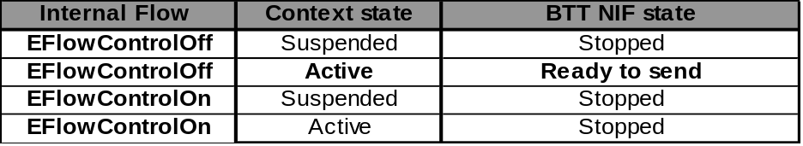

Raw IP NIF Initialisation

Flow diagram
Protocol(TCP/IP)
Comm
DB
NIFMAN
PSDAGT
Raw IP NIF
Csender
CReceiver
CBcaController
TSY
CSY
BCA
Underlying Layer
2
7
14
1
6
8
12
9, 10
13
11
3
4
5
- CNifIfLink::Start() is called in NIFMAN.
- NIFMAN gets the agent to be used (PSDAGT) and creates it.
- PSDAGT gets the connection settings from CommDB.
- PSDAGT creates a new PSD state machine and creates and activates the context via ETel.
- The TSY sends an “AT+CGPADDR” message down the control DLC to retrieve the IP address of the context which is stored into the TSY config data.
- PSDAGT sends a EAgentToNifEventTypeModifyInitialTimer Notification, which is captured by NIFMAN which loads the Raw IP NIF.
- The interface to the NIF is bound to the IP Protocol.
- CRawIPNifMain::Start() is called.
- A Notification call is made to the PSDAGT and back (via NIFMAN) to retrieve the TSY config data, which is used to update the protocol context config store.
- A Notification call is made to the PSDAGT and back (via NIFMAN) to retrieve the connection speed, which is used to update the protocol connection speed store.
- The BCA module is initialised i.e. BCA DLL is loaded, BCA is Opened.
- LinkLayerUp() is called on NIFMAN
- CReceiver::StartListening() is called to start listening for incoming packets from the BCA.
- The StartSending() message is passed up to the protocol stack.

Further details
The NIF will start initialising when the synchronous CNifIfLink::Start() method is called. Therefore, after triggering the initialisation procedures it will complete and return immediately. When all the initialisation steps are successfully completed the MNifIfNotify::LinkLayerUp() method is called. This will indicate that the NIF is initialised and ready to start sending and receiving packets.
The initialisation of the Raw IP NIF is relatively straight forward, as the CNifIfLink::Start() method is only called once the PSDAGT and BTT TSY have been initialised by NIFMAN. As part of its initialisation, the PSDAGT has already created its internal PDP context state machine, and created and activated the PDP context ready to be used by the Raw IP NIF.
The Raw IP NIF initialisation then consists of:
- Retrieve the IP address and store it for later usage in the CIPv4ProtocolIf and CIPv6ProtocolIf modules.
- Retrieve the TSY connection speed and store it for later usage in the CIPv4Protocol and CIPv6Protocol modules.
- BCA Intialisation: Loads the BCA DLL, creates and opens a BCA instance. Starts listening to the data from underlying layer and brings up the linklayer.
The initialisation sequence is controlled by the CIPNifMain::Initialise() method, which will be called by CNifIfLink::Start().
CIPNifMain::Initialise() implements a state machine that will call the Start() method on the CBcaIoController module depending on the initialisation state and error code that are passed in as the argument. In the previous version (BTT NIF), where the NIF was responsible for initialising the TSY and the context, then the NIF initialisation was processed in a recursive fashion where the Initialise() method in the CIPNifMain class was called by all the components that require initialisation. However, this is no longer necessary so the only existing states of the state machine are: EStart, ECsy27020Controller, EInitialised. If no errors are reported, the MNifIfNotify::LinkLayerUp() method will be called in order to finalise the initialisation.
If at any point of the initialisation an error occurs, the initialisation procedure will be stopped and the error will be reported by calling MNifIfNotify::LinkLayerDown().

Raw IP NIF Close Down

Flow Diagram
Raw IP NIF
CReceiver
CSender
CBcaControl

NIFMAN
PSDAGT
1
2

3
4
5
6
7
8
- PSDAGT sends EAgentToNifEventTypeDisableConnection notification to shutdown the NIF.
- NIFMAN intercepts the notification from the Agent
- NIFMAN calls CNifIfLink::Stop(), which in turn calls CRawIPNifMain::Stop()
- The receiver cancels the outstanding CActive request.
- The sender checks if it is currently waiting for a write to be completed and if so cancels this CActive request.
- The CBCaControl cancel any active requests and shutsdown the BCA in normal termination case and closes the BCA immediately in emergency case when the stop error code is KErrConnectionTerminated.
- LinkLayerDown() is called on NIFMAN to signal that the NIF has completed shutdown
- NIFMAN deletes the NIF.

For a remote end close down or an error in the baseband, a read/write request comes back with an error code (other than KErrNone) then the NIF will also call CRawIPNifMain::Stop() itself and steps 4 to 8 are carried out as above.

Further Details
There are three scenarios which can cause the NIF to close.
- An error occurring on startup or at any other time. This will cause the NIF to call MNifIfNotify::LinkLayerDown() and hence be closed by NifMan.
- The CRawIPNifMain::Stop() being called by NIFMAN. This will occur by NifMan calling the synchronous CNifIfLink::Stop() method. NIFMAN will do this when:
a) The PSDAGT sends a TAgentToNifEventType::EAgentToNifEventTypeDisableConnection notification method to the NIF. This notification is intercepted by NIFMAN and not forwarded to the NIF like other notifications. NIFMAN will instead call the CNifIfLink::Stop() method.
b) CNifIfBase::Control() method is called by NifMan with KContextDelete command.
On calling CRawIPNifMain::Stop(), the NIF shutdown procedure begins. This will first call CBcaController::Stop() which will cancel any outstanding read and write requests to the BCA, and then shutsdown the BCA. The NIF will then call MNifIfNotify::LinkLayerDown() to inform NIFMAN that the link has gone down and NIFMAN will then delete the NIF.

It should be noted that as the creation of the Raw IP NIF is dynamic, there is no way of going from a deactivating state in PSDAGT back to activating. The Raw IP NIF will be destroyed after the deactivating state.
According to the NAF specifications, a NIF must always have at least one active PDP context. Therefore if the current state of the PSDAGT is deactivating, the NIF will call MNifIfNotify::LinkLayerDown(), which will shut down the NIF. For more details refer to section 4.2.

Raw IP Packet Down “Write” – Flow Diagram
CIpv4ProtocolIf
CRawIpNifMain
2.
CBcaController
3.
CSender
11.
CIPTagHeader
7.
BCA
10.
8.
Underlying layer
9.
5.
TCP/IP
1.
13.
12.
12b.
12a.
4.
5a.
5b.
6.
4a.
4b.
- CIpv4ProtocolIf::Send() called from protocol stack with IP packet to be transmitted
- The protocol agnostic CRawIPPacket::SendPacket() method called to handle transmission.
- Send() called on the CBcaController.
- Check that the NIF isn’t shutting down, the IP packet passed isn’t greater than the maximum size allowed, that the GPRS context isn’t suspended and that the flow control is set to off.
4a. if the above check is TRUE, continue to 5.
4b. if the above check is FALSE, return appropriate error code to protocol stack and discard packet.
- Check that the NIF isn’t currently in ESending or EWaiting state (ESending is when the NIF is waiting for a write to be completed, EWaiting is used to ensure that queued packets are handled before new packets)
5a. if the above check is TRUE, sets the state to ESending and calls Sender::Send().
5b. if the above check is FALSE, it adds the packet to a request queue
- The CBcaController returns KStopSending or KContinueSending to the protocol stack. KStopSending is sent if the NIF’s requestQueue has reached its maximum level. Otherwise, KContinueSending is returned. The maximum number of packets to be held in the request queue is held in a constant KMaxBufferQueueSize, which can easily be modified if needed for efficiency. At present, it is planned to have this set to 0, which will cause the request queue not to hold any packets and therefore not be used.
- The CIPTagHeader::AddHeader() method is called to add the IPv4 tag header needed by the baseband to support header compressions.
- The packed is written to the underlying layer by calling Mbca::Write. SetActive() is the called so the sender can wait for the write to be completed by the CSY.
- The BCA writes the IP packet to the underlying layer.
- When the BCA has written the IP packet to the underlying layer, the BCA then completes the write to the NIF. This causes the CSender Active object to have its RunL() method called. This will call CBcaController::SendComplete().
- The state will be set to EWaiting.
- Check that the context isn’t suspended or flow control is set to on
12a. If the above check is TRUE, then call ResumeSending(). This will check if there is an item in the buffer queue, pop it off and send it. This will repeat steps 7 to 12. If the queue is empty, then call CIpv4ProtocolIf::StartSending(). Goto 13.
12b. if the above check is FALSE, then do nothing. When the context is resumed and flow control set to off, then step 12a will be occur.
- Notify the IP protocol stack that it can start sending packets.

Raw IP Packet Up “Read” – Flow Diagram
start
CBcaController
BCA
Underlying
layer
3.
CReceiver
2.
4.
11.
5.
CIPTagHeader
7.
CRawIPNifMain
CIPv4ProtocolIf
TCP/IP
10.
9.
9a.
1.
6.
8.
- CBcaController opens the BCA. The BCA will complete any reads on full single IP Packets.
- CReceiver::StartListening() is called using Mbca::Read() calls SetActive() ready for the read to be completed.
- Defragment incoming 27.010 packets until single full IP packet is obtained.
- Complete Read() to NIF. This causes the CReceiver Active object to have its RunL() method called.
- RunL() will pass the received data up to CBcaController::Process().
- The CIPTagHeader::RemoveHeader() method is called to remove the IPv4 tag header needed by the baseband to support header compressions.
- The protocol tag header that was removed will be passed back to the CBcaController so it knows what type of header the current packet is.
- The IP packet and protocol tag header are passed up to the CRawIPNifMain::Process() method.
- Calls CIpv4ProtocolIf::WantsProtocol() with the protocol tag header obtained from the IP packet. This will check to see if the CIpv4ProtocolIf is interested in this header tag returning ETrue if so and EFalse if not. As the CIpv4ProtocolIf is designed to handle IPv4 packets up to and down from the IP protocol stack, it will only return ETrue if the second byte of the 2 byte tag header is set to 0x21 (see Reference [7] for more information).
9a. If ETrue is returned, the IP packet will be sent to CIpv4ProtocolIf::Process()
9b. If EFalse is returned, the received IP packet will be dumped.
- The IP packet will be passed up to the TCP/IP protocol.
- CReceiver::StartListening() will be called to read more packets; steps 2 to 11 will cycle continuously.

Other Details

CommDB / PSDAGT interaction
As specified by the NAF document, the NIF never interacts directly with the CommDB. It must use an agent (in this case, PSDAGT) for that purpose. The agent is used to control the connection (PDP contexts) as well as reading from CommDB via Network Controller component.
The CIpNifMain has a pointer to the MNifIfNotify interface, in order to provide the only point of contact with the agent on the NIF side. Therefore, any module of the Raw IP NIF that requires CommDB information must retrieve it via CIpNifMain.

PSDAGT modifications
In order for the Raw IP NIF to function as required, some modifications to the PSDAGT have to be made. These modifications are needed as the NIF no longer brings up the PDP contexts but still needs to be able to pass the IP address and connection speed up to the CIPv4Protocol module. Therefore the NIF needs to be able to send requests to the PSDAGT, to ask it to retrieve the config data e.g. IP address and the connection speed of that context.
The PSDAGT also needs to be able to send notification replies to the NIF to pass back the retrieved config data and connection speed.

TCP/IP Protocol Event notifications
The protocol uses the CIPv4ProtocolIf::Control() class method to register interest in event notifications. The NAF document [1] specifies all the events that can be generated. Majority of the event notifications are not supported by the Raw IP NIF. The reasons for this are that the PPP NIF does not support them and they are not used by the protocol stack so it was deemed unnecessary to support this functionality.

Logging
Raw IP.NIF uses Flogger for logging packets. Logging is enabled if “__FLOG_ACTIVE” flag is set. The flag is set for debug build unless forced otherwise. “RawIp” tag, and “RawIp.txt” file is used for the log messages. The log output can be seen by modifying the comsdbg.ini file to include “RawIp” tag. Please see the Flogger User Guide for more information. The logs from different instances of RawIpNif is distinguished by a timer counter value that is set when the Nif is created.
Additionally each packet that the Nif passes through is logged using Packet Logger. Packet Logger logs packets compatible to formats that can be viewed with Ethereal. (www.ethereal.com). The output of Packet Logger is also directed to Flogger. Packet Logger is enabled if “__FLOG_ACTIVE” flag is set. “TcpDump” tag and a file named by a timer counter value is used for the log messages.

Ini file
Raw IP.NIF uses “rawip.ini” file for configuring application dependent data. The location of the ini file if “__SECURE_DATA__ “ is defined is c:\private\101f7989\esock\rawip.ini. Otherwise the location of the ini file is “c:\system\data\rawip.ini”.
If the ini file is not found default values are used. The table below lists all possible configurable data and their default values.
Section Name | Variable Name | Default Value
link | highmark | 1

Sequence diagrams

Send an IP Packet

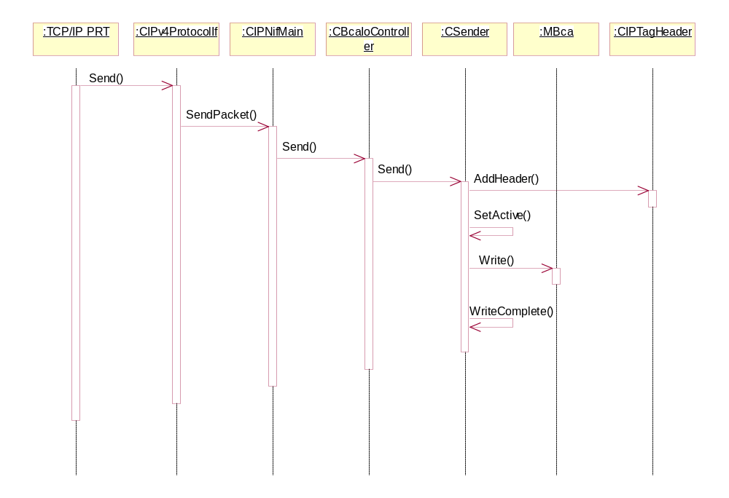

Receive an IP Packet

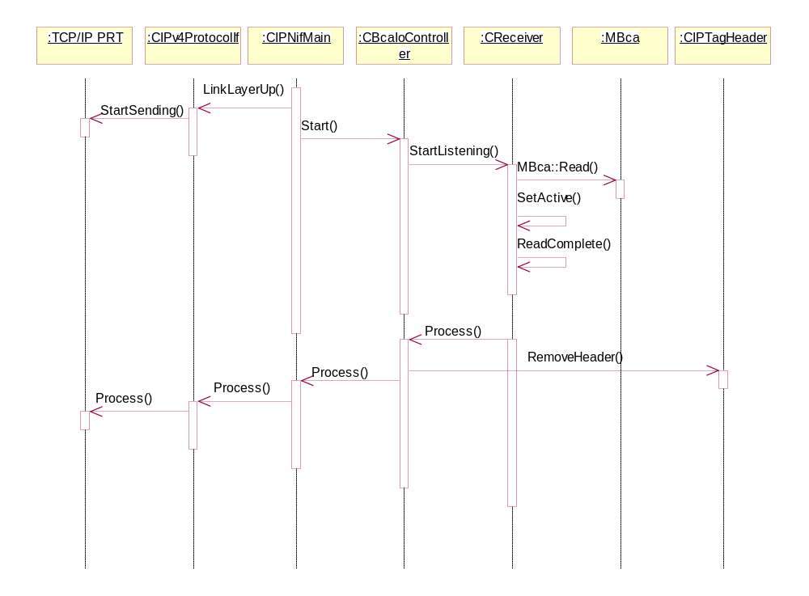

Further Information

People
Role | Person / People
Contributor(s) | Marco Ferri
Reviewer(s) | BTT

References
No. | Document Reference | Version | Description
[1] | SGL.GT0117.274 | 1.01 | NAF specification
[2] | SGL.GT0139.110 | 1.0 | BTT NIF Detailed Design
[3] | SGL.GT0117.290 | 1.1 | Packet Switched Data Agent Design
[4] | SGL.GT0117.298 | 1.0 | NIFMAN Design Document
[5] | SGL.GT0116.202 | 1.0 | Multimode ETel Packet Data API
[6] | SGL.GT0233.701 | 0.9 | NIF-Baseband Channel Adaptation (BCA) Interface Design Document
[7] | xxxx-xxx-04 | 001 | TI - Packet Protocol Transfer Document

Open Issues
The following issues need to be resolved before this document is completed;
- None.

Glossary
Refer to the BTT Glossary document [9].
Term | Definition
BCA | NIF-Baseband Channel Adaptor
C32 | Serial Port Communication Server

Document History
Date | Version | Status | Description
22-05-2004 | 0.1 | Draft | First Draft
25-11-2004 | 0.2 | Draft | Debug logging is documented
01-02-2005 | 1.1 | Draft | Ini file functionality is documented
20.08.2007 | 1.2 | Draft | IPv6 support is added

