Multimode ETel Architecture Design

Owner: | Telephony Team
Last revised: | 26 Jan 2009
Revision: | 1.7
Status: | Issued
Contributors: | Mark Ryan, Neil McAlpine, Rajiv Bajaria
Key Reviewers: | Telephony Team
Distribution | Internal & Licensees
Approved By: |  | Approval Ref.:

Contents
1. Introduction 4
1.1 Purpose and scope 4
1.2 References 4
1.3 Open Issues 4
1.4 Document History 5
2. API architecture design 6
2.1 API Class Model 7
2.1.1 Inheriting from core API 7
2.1.2 Messaging classes 8
2.1.3 Phone Storage classes 9
2.1.4 List classes 10
2.1.5 List Retrieval classes 11
2.1.6 Conference Call class 12
2.2 Compartmentalising API functionality 13
2.3 CMmPtrHolder and its derived classes 13
2.4 Client-server IPC messaging 15
2.5 Synchronous and Asynchronous API methods 15
2.6 API method parameters 16
3. TSY architecture design 17
3.1 Basic TSY structure 17
3.2 Rules and guidelines for TSY development 18
3.2.1 Core ETel API support 18
3.2.2 Multimode ETel API support 18
3.2.3 Completing requests 21
3.2.4 Notifications 22
3.2.5 Two-Phase Retrieval of a list class 23
3.2.6 Handling packaged API parameters 26
3.2.7 Cancelling an asynchronous request 27
3.2.8 Error handling 27
4. Possible platform and product architecture 29
4.1 Multimode upgrade considerations 29
4.2 Reusing a GSM based TSY 29
4.3 “Helper” TSY investigation 30
4.3.1 API Conversion Requirements 30
4.3.2 API Conversion Actions 30
4.3.3 Helper TSY architecture 31
5. Future extension to API 33
5.1 Extending the API 33
5.2 Maintaining Source and Binary Compatibility 33
5.3 Adding W-CDMA support 34
6. Platform Security 35
6.1 Capability Assignments 35
6.2 API Policing 35
Diagrams
Figure 1 - Multimode ETel Architecture block diagram 6
Figure 2 - Multimode ETel API class model 7
Figure 3 - API messaging classes in detail 8
Figure 4 - API phone storage classes in detail 9
Figure 5 - API list classes in detail 10
Figure 6 - API list retrieval classes in detail 11
Figure 7 - API Conference class in detail 12
Figure 8 - API ptr holder classes in detail 14
Figure 9 - Server - TSY interface classes 17
Figure 10 - Passing extended errors from TSY to client 28
Figure 11 - Possible Helper TSY architecture 1 31
Figure 12 - Possible Helper TSY architecture 2 32

Introduction
This architecture design document describes the architecture of the Multimode ETel component developed by two Generic Technology projects (GT59 and GT83). The document mainly concentrates on the design of the client API for Multimode ETel – it describes the API classes and the associations between them.
This document also describes the overall Multimode ETel system – the interface between the API and the ETel server and the role of a TSY. Design guidelines are given for developing a “multimode” TSY.
Finally the place of ETel within an EPOC platform is investigated – how it becomes part of a device and how its future extendibility will be managed.

Purpose and scope
The purpose of this document is to record the internal design of the Multimode ETel API and the overall Multimode ETel architecture.
It is not intended to be a “how to use” API guide for client applications. This information will be provided within Use Case analysis (ref. [3]) and API Definition (ref. [4]) documents.
An initial investigation into possible architectures of the Multimode ETel API has already taken place and the conclusions are described in Ref. [2]. As a result of this study we have decided to proceed with Architecture 2 which is described in more detail in section 2.
Another of the outcomes of this study was a set of non-functional requirements, thought to be necessary for the chosen API design. These requirements are specified by Ref. [1]

References
The following documents are referred to within this document. The interim, work in progress versions can be found under V:\Dev\Gt\Gt 0083 Hurricane Telephony\. The latest approved versions will be baselined and stored on the “Development Baselined Documents” Notes database on SymbianUK01/Symbian server.
[1] | SGL.GT0083.002 Hurricane Telephony Detailed Requirements Specification
[2] | Multimode ETel 1.0 API Architecture Study
[3] | Multimode ETel 1.0 Use Case Analysis and Rational Rose class model
[4] | Multimode ETel 1.0 API Definition
[5] | Multimode ETel 1.0 API Class Model
[6] | Core ETel API Definition ( coreapi.doc ) - released as part of ETEL on //epoc/main/generic
[7] | Platform Security Engineering Guide  http://smglinx.intra/twiki/pub/SMG/PlatSecTechnical/SGL.SM0007.001.Rev2.2.PlatformSecurityEngineeringGuide.doc
[8] | Telephony Architectural Description.doc  Perforce@//EPOC/master/common/generic/telephony/documentation/

Open Issues
Add APIs vs. policing capabilities information to Appendix once this information has been finalised and is stable

Document History
Date | Version | Status | Description
15-11-1999 | 0.01 | Draft | First draft.
25-02-2000 | 0.02 | Draft | Second draft, updated after further architecture analysis that included API parameter packaging, dropping mixin classes and refining the list class implementation.
02-03-2000 | 0.03 | Draft | Updated after GT59 pre T2.1 milestone review. Comments received from: Andy Cloke, Nathalie Doyelle, Mark Ryan, Matt Swan and external teams.
11-04-2000 | 0.04 | Draft | Updated during GT59 Phase 3.1 implementation to remove a few references to functionality or design that was changed during Phase 3.1
15-05-2000 | 0.05 | Draft | Updated during GT59 Phase 2.2 to include more detailed design description of some API classes.  Also updated to include desciption of classes added to API during Phase 2.2 ( e.g. RMobileConferenceCall )
14-07-2000 | 1.00 | Issued | Updated after GT59 T2 design review, according to agreed reviwers comments.
10-11-2000 | 1.01 | Issued | Updated after GT59 Phase 3 and 4 API changes. This includes following  Include new diagram of retrieval classes  Include new diagram of messaging classes  Include new diagram of phone store classes
29-08-2001 | 1.02 | Issued | Updated prior to GT83 T2 design review. Changes include  Allocation of object number to this document  Update of References section to reflect GT83  Change references to TDMA to CDMA as GT83 project removed TDMA support and added CDMA support to the API  Removed references to DFRDs since company strategy and organisation changes in June 2001.  Removed R-class wrapper section as this was never implemented for GT59 or GT83  Changed class model diagrams
01-04-2004 | 1.1 | On Review | Added Platform Security section for v8.1 release.
17-05-2004 | 1.2 | Issued | Document Issued.
30-09-2004 | 1.3 | Issued | Updated with information on new API added in v9.0 release
04-04-2005 | 1.4 | Issued | Updated Two-Phase Retrieval of a list class example code
04-05-2005 | 1.5 | Issued | ETel extended error documentation improvements.
24-04-2007 | 1.6 | Issued | Updated Platform Security section with details of IPCs which require SID checking in addition to Platform Security checking.
26-01-2009 | 1.7 | Issued | Deleted CDMA references as part of PREQ 2002

API architecture design
Key To Diagram

Figure 1 - Multimode ETel Architecture block diagram
Client App 1
(using MM API)
Client App 2
(using MM API)
Multimode API
(contains common mobile + GSM )
Core ETel API
ETEL SERVER

Multimode TSY

Components already developed by Symbian GT – would NOT require modification
Components to be developed and owned by Symbian GT
Components to be developed or modified from existing GSM components by licensees
The chosen Multimode ETel architecture is shown above. There is a new Multimode API that can be considered a “new and improved” version of the telephony API as it provides multimode functionality as well as the previously available GSM services.
The Multimode API would inherit from the core API and provide all the common cellular functionality as well as the specific required features of GSM. It re-uses the development knowledge and design of the GSM API but has its own implementation.
The above is the “ideal” architecture as far as code size is concerned because it assumes that all client applications in the system use the Multimode API and that the TSY is based upon receiving Multimode IPC requests. This would be the minimum set of ETel components required in a Multimode platform.
However it is appreciated that current systems using ETel, will be using the GSM API and “upgrading” these systems to Multimode API may not be possible in the short term. For example, a licensee may already have GSM client applications and/or a TSY that provides GSM functionality and they may wish to reuse these deliverables without modification. For this purpose we have proposed the possibility of a “Helper” TSY whose role would be to convert between Multimode and GSM requests. The “Helper” TSY is investigated further within section 5.3.
However including the GSM API and the Multimode API, as well as a “Helper” TSY in a platform is obviously a code size overhead. This and other multimode issues facing the product deliverables are described in section 5.1.

API Class Model

Inheriting from core API
Multimode ETEL provides a high level API for multimode telephony applications. Multimode ETEL is built on top of the basic ETEL server module Ref. [6] . The API is provided by a single client side session class, RTelServer, and a number of client side subsession classes. The RTelServer class is provided by the core ETEL API, which is defined in the header file ETEL.H. In addition many of the Multimode subsessions inherit functionality from ETEL subsession classes, e.g. RMobilePhone inherits from RPhone. The majority of the functionality is provided by the subsession classes.
By inheriting from the core API, it allows the Multimode API to provide access to basic telephony functionality and also reuses the RTelSubSession methods that manage IPC communication with the ETel server.
Below is the class diagram showing the core ETel API and the proposed new top level of R-classes for the Multimode API. The full class diagram can be found in an accompanying Rational Rose model, Ref. [5].

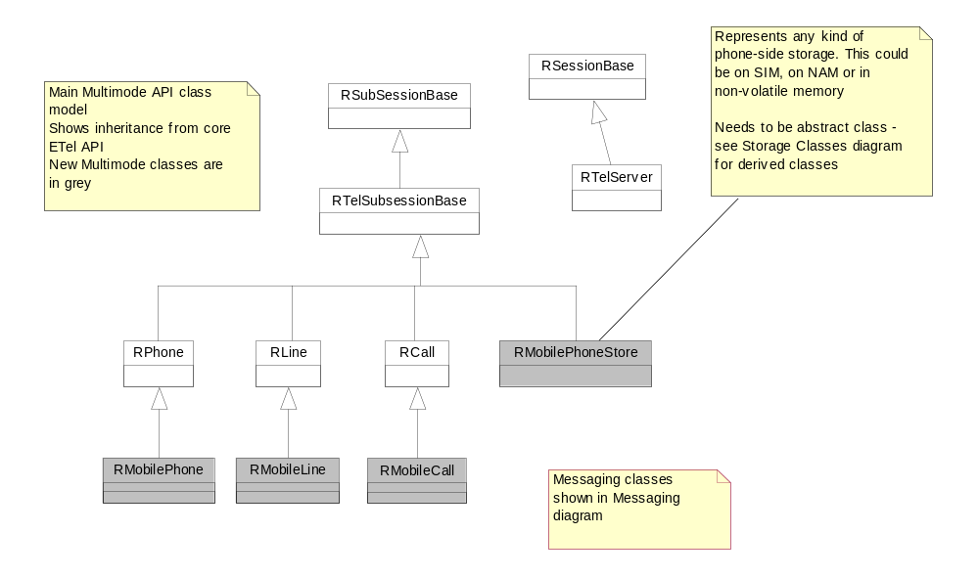
Figure 2 - Multimode ETel API class model

Messaging classes
The messaging classes will provide client access to sending and receiving of mobile phone messages. These messages may belong to different teleservices. For example GSM provides a point-to-point Short Message Service. GSM also offers a Cell Broadcast Service. There is also a transport service called USSD in GSM.
In the class diagram below, the client applications must open handles to the specialised messaging classes directly from the phone.
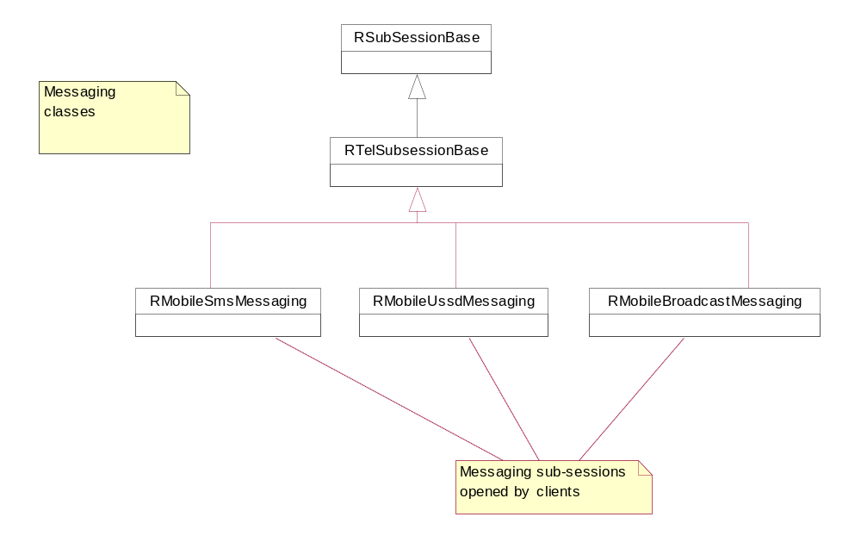

Figure 3 - API messaging classes in detail

Phone Storage classes
Many different forms of information can be stored on the phone, either in a proprietary storage such as an ME based phonebook or in a standardised storage area such as SMS on SIM or network operator details on a NAM.
However the basic operations performed on all these different storage areas are common: e.g. read, write and delete items in the store. It is therefore proposed that an abstract RMobilePhoneStore class can implement these basic storage methods and the derived classes represent the actual different types of storage on an MS. More specialised methods that relate to the particular type of storage the client is using will be placed in the derived classes.
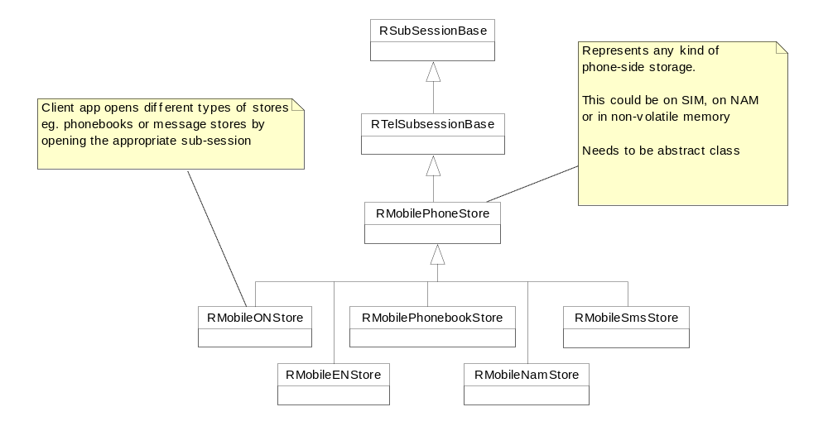

Figure 4 - API phone storage classes in detail

List classes
In order to simplify the management of items stored on the phone side, it is helpful to provide clients with “list” objects that represent the entire contents of a particular storage location. For example a SMS message store on the SIM may contain 10 used entries out of a maximum of 200. The client does not know which SMS message locations are used and which ones are not so reading the whole SMS message store could involve 200 individual read entry requests through the ETel API. This isn’t the most efficient way of reading the whole store, so the API should also offer clients the ability to issue a “read all”, “read batch”, or “write all” request. In the case of the “read all” of the message store, the TSY would service this by reading all SMS message entries in the SIM and any used entries would be added to an instantiation of the CMobilePhoneGsmSmsList class. Once the whole store is read, the TSY completes the “read all” request and then the SMS message list is replicated over to the client. The client can use standard list methods to access each entry in the list.
Because the standard operations on a list are common to all list types, these will be implemented at a base class level and then two thin templates will provide access to these operations. The specialised list class types will provide the definition of the items stored in the list. The following excerpt from the SDK explains the purpose of using the thin-template idiom. For more information on how to implement it, see SDK chapter “EPOC Idioms”.

Figure 5 - API list classes in detail
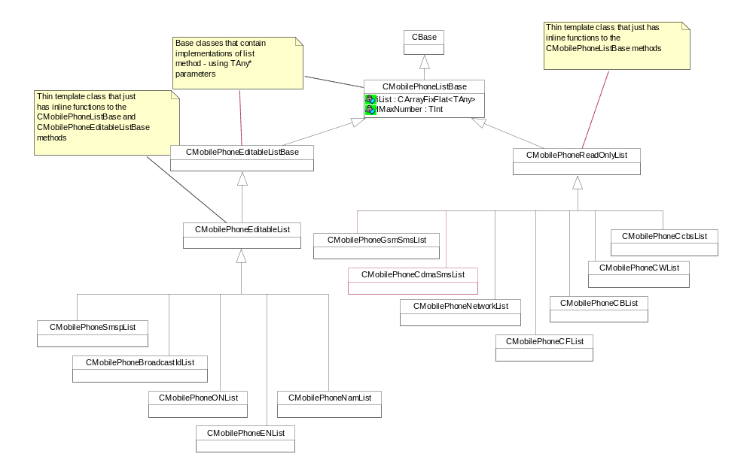The functionality provided by templates is powerful, and highly desirable. Without templates, collection classes usually use void* pointers: as a result, they are not typesafe. Templates can be difficult to manage. A template really defines a whole family of classes. Each member of that family that is instantiated requires its own object code. Avoidance of object code duplication is a difficult issue in a C++ implementation. For EPOC, object code duplication must be avoided at all costs. The solution used in EPOC is the thin template idiom.

List Retrieval classes
The list classes described in the previous section will be retrieved using an asynchronous approach. It is preferable to use an asynchronous method because retrieving and sorting a list from phone-side storage could take a reasonable amount of time.
The list retrieval operation has to be implemented in two phases because the client-side API code has to discover how big the list is and hence how much memory to reserve client-side before copying the whole list into its address space. The MM ETel API manages the asynchronous list retrieval by wrapping the two phases into an active object (termed AO on the diagram below). A client will create the appropriate CActive derived list retrieval class (see diagram below), will call the Start method on this class, passing its own TRequestStatus in as a parameter and will then wait until the whole list retrieval has completed. Meanwhile the list retrieval class has issued the first phase of the asynchronous list retrieval. When the TSY completes this phase, the RunL of the list retrieval class is called and then the second phase starts. When the TSY completes the second phase, the RunL of the list retrieval class is called again but this time it completes the client’s request by setting the client’s TRequestStatus equal to the request status returned by the TSY. Further details of the TSY’s involvement in a two-phase list retrieval are given in section 3.2.5.

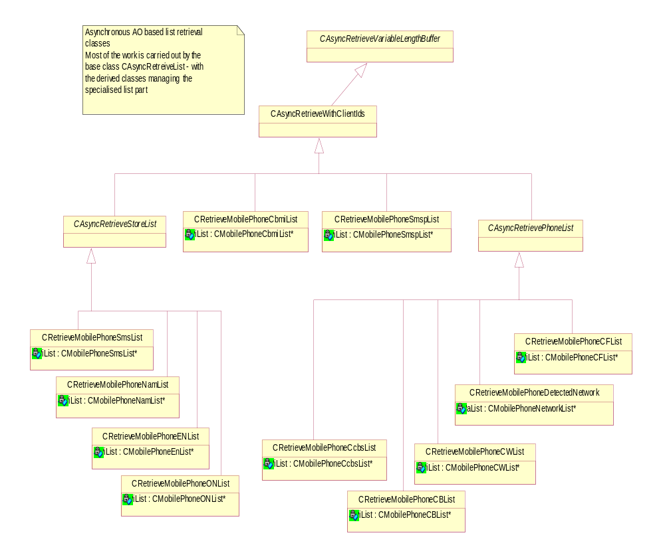

Figure 6 - API list retrieval classes in detail

Conference Call class
Conference calls allow users to conduct multi-connection voice calls, i.e. simultaneous communication to more than one remote party. All participants within a conference call can hear and speak to each other. There is a controlling party that initiates and manages the conference
The Multimode ETel API uses a new sub-session called RMobileConferenceCall as a model for a conference call. The conference call object will be an aggregation of all the RMobileCall objects that are part of the conference call. It will be possible for clients to manipulate both the conference call as a whole and individual calls within a conference call depending on the dynamic capabilities of each of these objects.
Clients that wish to create a conference call will open a RMobileConferenceCall subsession from their RMobilePhone subsession. At this point the conference call object will be empty. When the TSY detects that the phone is in a state where a conference call can be created (i.e. one voice call on hold and another voice call connected), the dynamic capabilities of the RMobileConferenceCall object will reflect this fact. The client can then create the conference call and the two individual RMobileCall objects will become joined and associated with the RMobileConferenceCall object. The valid states of a conference call are idle (i.e. empty), active and hold.
The functionality of RMobileConferenceCall includes putting the conference call on hold, adding new calls to it, notification of conference events or state changes, and termination of the conference call.
Every action that the client performs on the conference call will affect all the calls that are members of this conference call - and indeed may affect separate calls outside of the conference if the client is swapping between a conference call and a single call.
Please note that RMobileConferenceCall is replacing the RCallGroup abstraction used in the GSM API. This was an optimisation decision. The call group abstraction placed a large burden on a TSY to create call groups, monitor the calls in each group and trigger notification when calls were added or moved, probably even when a conference call was not ongoing. Clients will probably only open a RMobileConferenceCall when the user has decided to make a conference call and by having just one object replace three call groups it will also reduce the number of notifications that would trigger in response to conference call events. With a view to the future, without call groups there are also no longer any restrictions to the allowed types of active calls (simultaneous, separate voice and data calls are possible).

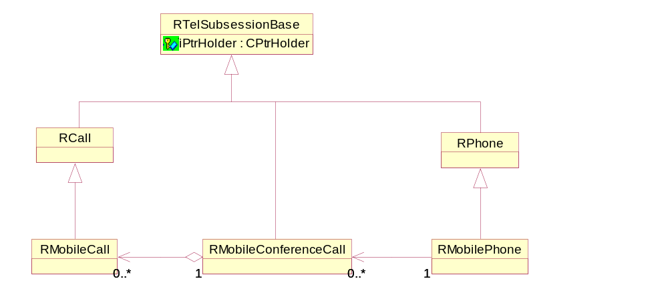
Figure 7 - API Conference class in detail

Compartmentalising API functionality
Mixin classes were used in the GSM API to divide the array of mobile phone functionality into manageable units. Each mixin was related to a separate functional area and then the R-classes inherited from a number of these mixins in order to provide access to all required functionality.
However, this mixin approach causes a number of problems that affect the extendibility and code size of the API. The main problem is that new pure virtual functions can not be added to a mixin class, nor can an entire new mixin be added without breaking binary compatibility.
For the Multimode ETel API, we have decided to abandon the use of mixin classes. This section describes the alternative way of dividing the large R classes within the API into usable functional areas.
It is still possible for clients to discover what functional areas a TSY supports using the RTelServer method IsSupportedByModule( ). The client app will pass a unique “functional unit” number to TSY and then TSY can reply, yes or no to whether it supports the methods defined in that functional unit. The functional units and their contents are defined within the API definition (ref. [4])

CMmPtrHolder and its derived classes
The CMmPtrHolder class and its derived classes are used for storage of data passed between the client application and the TSY.
When a client side subsession issues an asynchronous request to read or write information to the TSY, it must provide the TSY with a descriptor to contain the information. The TSY will either read from or write to this descriptor at a later stage.
Each subsession capable of performing these types of requests will contain a CMmPtrHolder derived object. This object will itself contain a collection of TPtr8s. There will be one TPtr8 for each asynchronous request that passes data to/from the TSY. Before the subsession issues the requests, it initialises the appropriate TPtr8 in its CMmPtrHolder derived object to point to the client’s data. This TPtr8 is then passed as an argument to the asynchronous request. When the ETel server accesses the information in the client’s address space it will do so using the specified TPtr8.
The fact that there is only one TPtr8 per asynchronous request per subsession is not a limitation as the ETEL server will not permit a subsession to have two or more identical API requests outstanding at any one time.
Another purpose of the CMmPtrHolder classes, is to store copies of API parameters that are passed in by value rather than by reference. This data could be stored in the R-classes but in order to be able to keep R-class size constant as the API evolves, it is hidden in these internal API classes.
Below is an excerpt of the CMmPtrHolder hierarchy. It is not complete but it does provide knowledge of the basic structure and implementation.

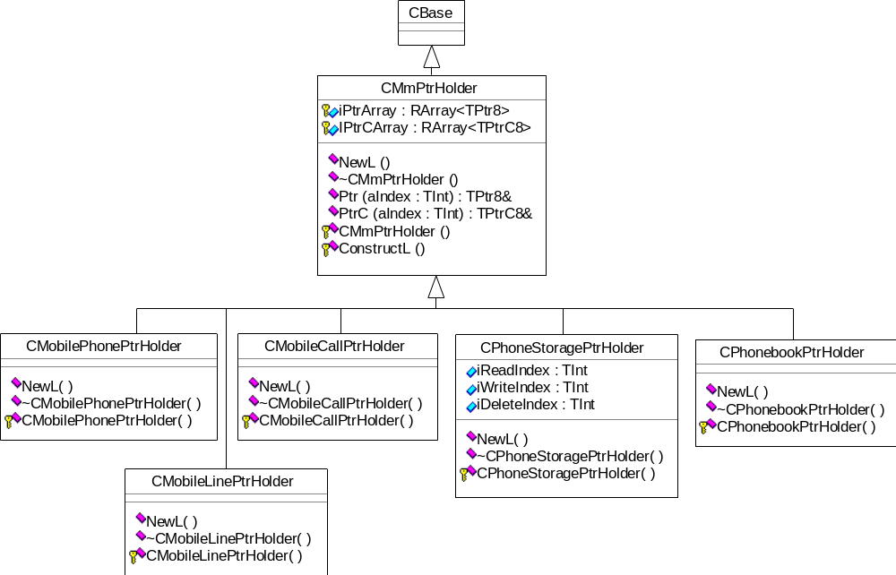
Figure 8 - API ptr holder classes in detail

Client-server IPC messaging
Each ETel API request sent to the ETel server has a unique IPC request number. The implementation of the client-side API methods passes the correct IPC request number into the RTelSubSessionBase IPC messaging method (Set/Get/Blank).
For example here is the implementation of a core ETel API method.
void RCall::Dial(TRequestStatus& aStatus, const TDesC8& aCallParams, const TTelNumberC& aTelNumber)
{
__ASSERT_ALWAYS(aTelNumber.Length()!=0,PanicClient(KErrArgument));
__ASSERT_ALWAYS(iPtrHolder!=NULL,PanicClient(EEtelPanicNullHandle));
(iPtrHolder->PtrC(0)).Set(aCallParams);
Set(EEtelCallDial, aStatus, iPtrHolder->PtrC(0), aTelNumber);
}
The Set( ) method called is found in RTelSubSessionBase and EEtelCallDial is the specific IPC request number assigned to the API’s Dial request.
For the Multimode API the following conventions for naming of IPC requests are proposed:
- The name will start with EMobile
- EMobile will be followed by the name of the object that the R-class represents. eg. all methods defined in the RMobilePhone class will have IPC request names starting EMobilePhone…
- The rest of the IPC request name will be formed by appending the name of that API method. eg. EMobilePhoneGetSubscriberId.

Synchronous and Asynchronous API methods
Each ETel API method is either synchronous or asynchronous. You can see the difference by the method signatures: all asynchronous requests will include a TRequestStatus& parameter whereas a synchronous request will not.
A synchronous request is blocking and the client application that calls it will have to wait while the ETel server receives the request and the TSY processes and completes it.
After calling an asynchronous request, control will return to the client application as soon as the request’s IPC message has been sent. The client application must have supplied a TRequestStatus to an asynchronous API method and this TRequestStatus will signal once the ETel server and TSY have processed and completed the request. A client application that uses asynchronous API requests, must wrap them in an active object. A Start method would call the asynchronous ETel API method and the active scheduler calls the RunL method when the TRequestStatus attribute completes.
Some ETel API requests will have two versions: a synchronous one and an asynchronous one. It is then up to the client application which version they use. A client will use the synchronous version if the request is quickly completed and the client doesn’t mind blocking its thread while it waits for the TSY to complete the thread. If the request takes longer, e.g. involves network access – then the client will probably use the asynchronous version so that it can get on with something else while it waits for its TRequestStatus to trigger as complete.
More details on client-server architecture and sync/async requests in EPOC can be found in the SDK under “E32 User Library”.

API method parameters
One of the main priorities of the Multimode ETel v1.0 architecture design is that the API definition strategy that we adopt can be extended in the future, for example in a v2.0 development without affecting clients built to use v1.0 definitions.
For example, if we define a method called RMobilePhone::GetPhoneInfo and we create a class called TPhoneInfo to represent the phone information, we need to pass back this class to the client when it calls GetPhoneInfo. The simplest API definition would be:
TInt RMobilePhone::GetPhoneInfo(TPhoneInfo& aInfo);
All clients that use v1.0 of MM ETel API would compile against the v1.0 version of TPhoneInfo. This means that if v2.0 of the MM ETel API wished to add some attibutes to the TPhoneInfo class - if it did so, it would break the clients that were still using the v1.0 version.
The v2.0 API will have to define a new version of TPhoneInfo, perhaps called TPhoneInfoV2 which inherits from TPhoneInfo and would contain the new attributes. For clients to upgrade to retrieve v2.0 version of phone information another API method would need to be defined, i.e:
TInt RMobilePhone::GetPhoneInfo(TPhoneInfoV2& aInfo);
If many API parameters require expansion during v2.0 etc. development then this would lead to a duplication of API method versions. This is undesirable for code size reasons so it has been decided to make the API method signature impervious to changes in the actual API parameter. The parameter must be packaged into a descriptor before it is passed to the API method. Hence the API method would be defined as:
TInt RMobilePhone::GetPhoneInfo(TDes8& aInfo);
Clients would create an instance of the required version of TPhoneInfo - either TPhoneInfoV1 or TPhoneInfoV2. The client would then place this class into the appropriate typdef’d TPckg.
For example, client side code :
TPhoneInfoV1 phoneInfo;
// pack the parameter
TPhoneInfoV1Pckg phoneInfoPckg(phoneInfo);
// phone is an already open RMobilePhone sub-session
phone.GetPhoneInfo(phoneInfoPckg);

This parameter packaging approach will be adopted for all methods whose parameters we think are susceptible to change. Details of how a TSY should handle these packaged parameters, including determination of which version the client used is given in section 3.2.6.

TSY architecture design
There are a number of design rules that a TSY implementation has to observe. These rules relate to the ETel Server – TSY interface and the implementation expectations of the ETel API. This section aims to give some guidance to TSY developers who are either starting a Multimode TSY from scratch or modifying an existing TSY to support Multimode.

Basic TSY structure
The concepts of phones, lines and calls are inherent to ETel, where a phone may ‘own’ more than one line, and a line may own more than one call. In addition there are messaging, storage and conference call objects which may be opened from a mobile phone. The ETel server provides abstract base classes for each of these objects from which all TSY modules are expected to derive and implement the virtual functions. Phones are opened from a phone factory object, which similarly has an abstract base class in the server and implementation in the TSY.
Below is a class diagram showing the ETel Server – TSY interface. The names of the TSY side classes are chosen just for example.

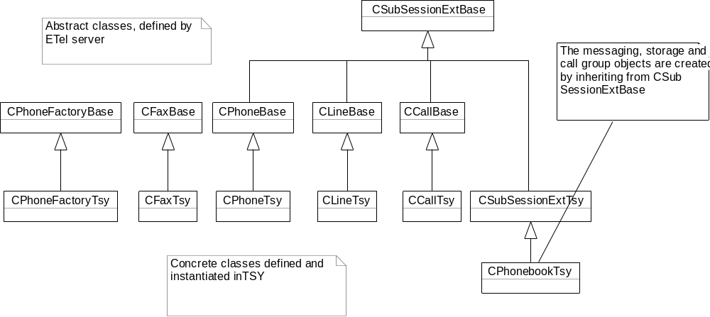
Figure 9 - Server - TSY interface classes

Rules and guidelines for TSY development

Core ETel API support
Every TSY developed should ensure that it implements the core ETel API as described in Ref. 6.
This is required because some Generic Technology platform components such as CSDAGX use the core API. If the core API functionality is not implemented then these EPOC components will not be able to carry out their telephony functionality.
In the ETel server component there are the following header files: et_phone.h and et_tsy.h.
The et_tsy.h file defines the abstract server mixin classes that stipulate what a TSY should implement. This header file makes it clearer to the TSY developer which functions are to be implemented in the TSY and which are not. However these classes are not to be derived from in the TSY but are inherited by base classes in the server. The TSY should derive from CPhoneBase, CLineBase, CCallBase, CFaxBase, CPhoneFactoryBase and for extensions CSubSessionExtBase as was shown in the class diagram in the previous section. The et_phone.h file contains the definition of these base classes.

Multimode ETel API support
The core ETel API can be extended to support more specialised telephony functionality. The ETel server design has a couple of mechanisms for extending ETel’s functionality: add new functionality to the existing sub-sessions or create entirely new sub-sessions.
The Multimode ETel API is going to use both these mechanisms. It extends the existing sub-sessions by inheriting from the core R-classes. For example, RMobilePhone inherits from RPhone, where RMobilePhone contains the required multimode mobile phone functionality. An example of a new sub-session is RMobileConferenceCall or RMobileSmsMessaging, which are created by inheriting from RTelSubSession.
The ETel server will not be aware of the “extended” functionality. Whenever it receives a request with an IPC request number that it does not recognise it will pass it to the TSY to see it the TSY understands it instead. If it does and the TSY supports this request then the TSY will implement setting of the request mode, servicing of the request and cancelling the request. The TSY therefore has to implement its own ReqModeL, CancelService and ExtFunc for each CSubSessionExtBase derived object in the TSY.

ExtFunc
Each ExtFunc method in the TSY will receive the same parameters. These are:
- The Request Handle (TTsyReqHandle aReqHandle)
- The IPC request number (TInt aIpc)
- Any necessary request parameters (TDataPackage& aPackage)
The ExtFunc method will probably consist of a large switch statement containing all the IPC request numbers relevant to that CSubSessionExtBase derived TSY object. For example, assume the CCallTsy class shown in the diagram in section 3.1 supports the Multimode ETel API. This class will have an ExtFunc method and the IPC request numbers expected would be all those beginning with “EMobileCall”.
The TSY does not have to support every Multimode ETel API request. It can indicate non-support of whole functional areas when it receives an IsSupportedBy request (see section 2.3), or it can indicate non-support of certain methods or parameter options when it receives one of the various capability requests.
Despite a clients ability to find out what is and is not supported in advance, if a client goes ahead and calls a request that the TSY does not support, the TSY must return KErrNotSupported against that IPC request number in ReqModeL and ExtFunc. If KErrNotSupported is returned by the TSY, the server will complete the client’s request informing it that the request was not recognised.
If the TSY does support the request, then ExtFunc should start the servicing of that request. It may be possible for the TSY to service and complete that request internally or it may require the TSY to send message(s) to the rest of the mobile phone.
In the former case, the TSY will service the request, signal request completion and then return from ExtFunc with the result code KErrNone.
In the latter case, the TSY will send the request on to the mobile phone, store its request handle and request parameters and then return from ExtFunc with the result code KErrNone. The ETel server will interpret the KErrNone as acknowledgement that the TSY supports the request and will expect the request completion to be signalled in due course. Later on, the TSY will probably receive a response from the mobile phone, which will enable it to complete the original client request.
In all cases, the TSY signals request completion by calling CTelObject::ReqCompleted, passing the Request Handle and the result of the request (KErrNone if it completed successfully).

ReqModeL
When the ETel server receives an “extension” client request, it will pass the IPC request number down to the TSY in order to find out what type of request it is. The virtual method that gets called is ReqModeL.
The TSY can associate one or more of the following attributes to the request.
- KReqModeRePostImmediately
- KReqModeFlowControlObeyed
- KReqModeMultipleCompletionEnabled.
Each request has a mode, which consists of three attributes. These attributes may be either enabled or disabled, giving eight possible combinations. The attributes are described below:
Attribute | Description when enabled
Multiple Completion | When multiple clients make the same request from the same TSY object, the server will only pass the first request to the TSY. Subsequent requests will be stored by the server and completed when the TSY calls the first request’s completion function.
Re-post Immediately | When the TSY completes the request, the server will immediately call the same request on the TSY, on the same call stack. This is done without the client’s knowledge. Most notifications should have this request mode, as it ensures that if an event occurs before a slow client has had time to call the notification function again, the server will buffer that notification completion event.
Obey Flow Control | While the TSY is processing a “flow-controlled” request, the ETel server will buffer other incoming “flow-controlled” requests in a queue. When a “flow-controlled” request is passed to the TSY, the server increments a flow control counter. When the TSY completes the request, the flow control counter must be decremented. If its value is zero, the next buffered command should be submitted.  A “flow-controlled” request is one whose servicing by the TSY requires access to a resource on a “one at a time” basis. For example AT command interfaces are command-response so if the TSY is servicing a request that involves sending AT commands then they can not process another request that also requires sending AT commands until the first request is completed.  N.B. Requests that do NOT have the KReqModeFlowControlObeyed flag set can be passed to the TSY at any time.

The following table gives examples of requests that fit into the eight categories created.
Multiple Completion | Re-post Immediately | Flow Control | Description
Disabled | Disabled | Ignored | TSYs wishing to implement their own buffering algorithm will place all requests in this category.  This category will also be used by the RecoverDataPort request that must be passed to the TSY to indicate that it may use the communications port after a loan.
Disabled | Disabled | Obeyed | Commands that change the state of the phone, e.g. clearing the AoC counter; are commands that the TSY should only deal with one at a time.
Disabled | Enabled | Ignored | Requests that notify a client about a change of state, where the TSY needs to distinguish between different clients.
Disabled | Enabled | Obeyed | This combination should not be used. It provides no useful behaviour and will in fact cause the TSY to “lock-up” and not be able to process anymore flow control obeyed requests while one of them is continuously reposted.
Enabled | Disabled | Ignored | Either  (a) commands that may take some time, but which the TSY can handle more than one of concurrently, or  (b) notifications that the TSY does not wish to be re-posted immediately, so the server does no buffering.
Enabled | Disabled | Obeyed | A command that may take some time and which the TSY can only deal with one at a time.
Enabled | Enabled | Ignored | Requests that notify a client about a change of state. Since these requests do not require the issuing of any modem commands, they do not have to obey flow control. The TSY never gets more than one of these outstanding per CTelObject.
Enabled | Enabled | Obeyed | This combination should not be used. It provides no useful behaviour and will in fact cause the TSY to “lock-up” and not be able to process anymore flow control obeyed requests while one of them is continuously reposted.

CancelService
When a client explicitly cancels an asynchronous API request a “cancel” IPC request number is sent to the ETel server. If the request to be cancelled is an “extension” request, the server will pass the IPC to be cancelled to the TSY via CancelService
Also when the clients close their sub-sessions (eg. by calling RPhone::Close), they may not have cancelled all their outstanding asynchronous requests before closing. It is up to the ETel server to clean up in this situation, so the server will find the list of outstanding requests related to that sub-session object and pass these outstanding IPC request numbers, one at a time, to the CancelService function in the TSY.
Each CancelService method in the TSY will receive the same parameters. These are:
- The Request Handle (TTsyReqHandle aReqHandle)
- The IPC request number (TInt aIpc)
The CancelService methods are similar to the ExtFunc methods. It will probably be a large switch statement of IPC request numbers, and each case statement will lead to an attempt to cancel that outstanding request.
Once the ETel server has cancelled all outstanding requests, it is free to delete that sub-session object in the TSY.
N.B. explicit cancellations of asynchronous requests by client applications are handled differently. In this case a “cancel” IPC request number is sent to the ETel server. If the request to be cancelled is an “extension” request, the server will pass the “cancel” IPC request number to the TSY via ExtFunc. It is therefore necessary for ExtFunc to contain both the request and the cancel request IPC cases.

Completing requests
In section 2.6, the client application’s perspective on sync or async API methods was explained. In this section, the TSY role is explained.
The TSY does not see which version of an API request the client has called. It will simply receive the request via ExtFunc, e.g. “GetCurrentMode”. The TSY has to distinguish each request by determining whether it just involves accessing or setting some TSY-internal data – or whether a message needs to be sent to the rest of the phone and a response waited for.
In the first version, the TSY’s implementation of GetCurrentMode could look something like this.
TInt CPhoneTsy::GetCurrentMode(const TTsyReqHandle aTsyReqHandle, RMobilePhone::TMode* aMode)
{
// retrieve the cached value of current mode
*aMode = iCurrentMode;
// request is complete now so tell server to complete it to client
ReqCompleted( aTsyReqHandle, KErrNone);
return KErrNone;
}
The TSY signals that the request servicing is complete when it calls ReqCompleted.
For the second case, where GetCurrentMode is implemented by asking the phone, the TSY will not be able to call ReqCompleted within the implementation of GetCurrentMode.
Instead the TSY should save the TTsyReqHandle and the associated request data (aMode). The TSY should start the operation that will service this request. The TSY will then exit GetCurrentMode and sometime later when a response is received from the phone, the TSY will process the returned information, place it into the saved request data pointer and then call ReqCompleted using the saved TTsyReqHandle.
There is another issue behind asynchronous request completion – when does the TSY decide that a request is complete? It is important that the TSY completes the request when the API expects it to. In other words, when the phone is in the state that the ETel API expects it to be in when that request has completed. For example the RCall::Dial request should be completed either when the call has successfully connected or when the call set-up attempt has failed for some reason. Client applications that use RCall::Dial will expect the associated call object to be in either the “Connected” or “Idle” state when the Dial request completes. The TSY should NOT complete this request when the call set-up has started but not yet finished, i.e. when the call is in a “Dialling” or “Connecting” state.
Similarly the RCall::AnswerIncomingCall should be completed once the call is either successfully connected or set-up has failed. The RCall::HangUp request should be completed once the call is fully released.
Ref. [4], the Multimode API Definition documentation (and accompanying scenario diagrams) will describe when each API request is expected to complete.

Notifications
Some TSY functions do not require immediate action, but rather are requests to be completed when a certain condition is satisfied. An example of this is CLineBase::NotifyIncomingCall() which should be completed when the TSY becomes aware that there is a waiting call. These are known throughout the ETel documentation as “notifications”.
The ETel server provides mechanisms for helping the TSY manage the notification requests of the API. These notifications are all asynchronous methods, both for the client and for the TSY. In most cases the TSY should save the TTsyReqHandle and notification data pointer passed down in each notification request and then wait until an event occurs that causes the TSY to trigger the notification. Occasionally the TSY may complete the notification request immediately if it already has a “stored” event to notify the client about. Alternatively, the ETel server can help the TSY, by providing a buffer to store events in so that the client never misses events.
In order for this to work, when the ETel server passes the notification IPC number to ReqModeL, the TSY should associate the KReqModeRePostImmediately flag to this request. In fact, for notification requests, ReqModeL would probably set the KReqModeMultipleCompletionEnabled flag too. See section 3.2.2.2 for more details on request modes.
The ETel server would then know that whenever this notification request is completed by the TSY, that the ETel server itself should re-post that notification request immediately. This ensures that the TSY always has an outstanding notification request, which it can trigger if the relevant event occurs. If the notification were not re-posted immediately, the system would have to wait for the client application to recall the notification. Until this happened there wouldn’t be an outstanding notification on the TSY and if the relevant event occurred during this period the TSY would either have to save the event itself or throw it away.
So, to provide the event storage for the TSY, the ETel server re-posts the notification immediately and whenever the relevant event occurs, the TSY completes the notification. The ETel server will handle this notification trigger by either completing it to the (one or more) clients that have requested it – or by saving it to its internal buffer if no clients have currently requested it. There is a buffer in the ETel server for each type of notification and the size of the buffer is determined by the TSY. When the ETel server discovers that a request is “repost immediately” it will ask the TSY how big a buffer it wants by calling CTelObject::NumberOfSlotsL( ). It is up to the TSY developer’s judgement how many buffer slots this method returns for each notification. If there is a danger that a particular notification could trigger frequently and in rapid succession then at least 10 or 20 slots may be required. For a notification that triggers rarely, perhaps 1 or 2 slots is enough.
So if the ETel server has stored a few occurrences of a particular notification, when a client subsequently calls that notification request, the ETel server will complete the client’s request with the saved data. It is the responsibility of the client app to keep calling the notification request if it is interested in being notified of that event. Whenever the notification request is triggered the client app should process the contents AND repost the notification request.
There is also another small detail to the implementation of notifications – the ETel server works out when a client app has first called a particular notification and tells the TSY to “register” that notification. All this means is that it has told the TSY to expect a regular re-posting of that notification up until the time that the ETel server tells the TSY to “deregister” that notification. The purpose of this is to provide a facility whereby a TSY can tell if any clients are interested in a particular notification and if there is no interest it could turn off the messages it receives from the rest of the phone. This could help in power saving if the number of TSY-phone messages can be limited. The ETel server uses CTelObject::RegisterNotification( ) and CTelObject::DeregisterNotification for this purpose.

Two-Phase Retrieval of a list class
The list classes defined within the Multimode ETel API need to be retrieved from the TSY in two phases. This is due to the client-side API code’s need to know the size of the list before it actually copies it across. The client needs to know the size of the list so that it can allocate sufficient client-side memory into which to copy the list contents.
In order to optimise the list retrieval process, the Multimode ETel API has defined a new series of events that TSYs must comply to during list retrieval. The actions that a TSY needs to perform during Phase 1 and Phase 2 of a list retrieval are now slightly different.
- Phase 1 - TSY must retrieve the list from the phone-side storage and then populate a new instance of the appropriate CBase derived list class, e.g. a CMobilePhoneNetworkList class. The TSY then stores the contents of this list into a CBufFlat by calling the StoreLC method on the list class. TSY works out the size of this CBufFlat in bytes, returns the size to the client and stores the CBufFlat for later.
- Phase 2 - TSY copies the contents of the stored CBufFlat into the buffer pointer supplied by the ETel server within the ExtFunc’s TDataPackage.
Here is an example of what a TSY would do to handle each phase. Please note that this test code only implements filling an example list and does not show what would really happen in a TSY - i.e. it does not include sending a request to the phone to read the phonebook, waiting for the responses etc. The error handling is also not properly in place.

TInt CONStoreDMmTsy::ReadAllPhase1(const TTsyReqHandle aTsyReqHandle, RMobilePhone::TClientId* aId, TInt* aBufSize)
{
LOGTEXT(_L8("CONStoreDMmTsy::ReadAllPhase1 called"));
TInt ret=KErrNone;
TInt leaveCode=KErrNone;
TRAP(leaveCode, ret=ProcessReadAllPhase1L(aTsyReqHandle, aId, aBufSize););
if (leaveCode != KErrNone)
ReqCompleted(aTsyReqHandle,leaveCode);
return ret;
};

TInt CONStoreDMmTsy::ProcessReadAllPhase1L(const TTsyReqHandle aTsyReqHandle, RMobilePhone::TClientId* aId, TInt* aBufSize)
{
// read the list, store its content and then return size of this buffer to client
CMobilePhoneONList* list=CMobilePhoneONList::NewL();
CleanupStack::PushL(list);

RMobileONStore::TMobileONEntryV1 entry;

// fill up an example list
for (TInt index=0; index < DMMTSY_ON_STORE_COUNT; index++)
{
switch (index)
{
case 0:
InitONEntry(entry);
entry.iIndex=DMMTSY_ON_STORE_INDEX1;
break;
case 1:
InitONEntry(entry);
entry.iIndex=DMMTSY_ON_STORE_INDEX2;
default:
break;
}
// Add the entry into the list, at the next empty location
list->AddEntryL(entry);
}

// Store the streamed list and the client ID
CListReadAllAttempt* read=CListReadAllAttempt::NewL(aId,aTsyReqHandle);
CleanupStack::PushL(read);

read->iListBuf = list->StoreLC();
CleanupStack::Pop(); // pop the CBufFlat allocated by StoreLC

iONReadAll->AppendL(read);
CleanupStack::Pop(); // pop the CListReadAllAttempt

// return the CBufFlat’s size to client
*aBufSize=(read->iListBuf)->Size();

// Complete first phase of list retrieval after a timeout
iPhone->AddDelayedReq(aTsyReqHandle,this);
CleanupStack::PopAndDestroy(); // pop&destroy list
return KErrNone;
}

TInt CONStoreDMmTsy::ReadAllPhase2(TTsyReqHandle aTsyReqHandle, RMobilePhone::TClientId* aId, TDes8* aBuffer)
{
LOGTEXT(_L8("CONStoreDMmTsy::ReadAllPhase2 called"));
CListReadAllAttempt* read=NULL;
// Find the read attempt from this client
for (TInt i=0; i<iONReadAll->Count(); ++i)
{
read = iONReadAll->At(i);
if ((read->iClient.iSessionHandle==aId->iSessionHandle) &&
(read->iClient.iSubSessionHandle==aId->iSubSessionHandle))
{
TPtr8 bufPtr((read->iListBuf)->Ptr(0));
// Copy the streamed list to the client
aBuffer->Copy(bufPtr);
delete read;
iONReadAll->Delete(i);
ReqCompleted(aTsyReqHandle,KErrNone);
return KErrNone;
}
}
// Should handle error case of not finding the matching client from read all phase 1
return KErrNotFound;
}

TInt CONStoreDMmTsy::ReadAllCancel(const TTsyReqHandle aTsyReqHandle)
{
LOGTEXT(_L8("CONStoreDMmTsy::ReadAllCancel called"));
iPhone->RemoveDelayedReq(aTsyReqHandle);

// Remove the read all attempt from iONReadAll
CListReadAllAttempt* read=NULL;
for (TInt i=0; i<iONReadAll->Count(); ++i)
{
read = iONReadAll->At(i);
if (read->iReqHandle == aTsyReqHandle)
{
delete read;
iONReadAll->Delete(i);
break;
}
}
ReqCompleted(aTsyReqHandle,KErrCancel);
return KErrNone;
}
This test code excerpt handles the client ID information so that the TSY can ensure that it copies the data that it retrieved in Phase 1 to the same client in Phase 2. When performing the first stage of list retrieval to obtain the size of the desired list, the session and subsession handles are passed to the TSY via the aId parameter, by the client API code. The TSY stores these handles in iONReadAll as it will need them at a later stage if it is to successfully complete the second phase. This is required as more than one client subsession can be mapped to a single TSY object by the ETEL server. To perform two phase list retrieval the server side object must be able to distinguish between the different sources of its requests. Consider the following undesirable scenario. Three clients perform stage one, requesting the size of a certain list. However, in between the issuing of each request the list changes in size. So now there are three clients each expecting a different instance of the same list. If the TSY is passed the subsession and session handles of the interested clients it can match stage 1 requests with stage 2 requests and ensure that each client receives the list that they were expecting.

Handling packaged API parameters
Many of the API parameters defined by the Multimode ETel API will actually be passed through the API as packages. Therefore a TSY needs to unpack these parameters when it receives them. Another problem for the TSY is that there may be more than one version of a parameter and the TSY will have to discover which version the client has used and therefore what information they are either getting or setting.
Each API paramter that is liable to expansion will be defined by adding V1 at the end of its name, eg. TNetworkInfoV1. When a client instantiates one of these, the default constructor sets the private member variable iExtension to KETelExtMultimodeV1. This private member will live in the base class of any API parameter hierarchy and a TSY will use it to discover the parameter version it has been passed.
When the ExtFunc method is called by the server, it will supply a TDataPackage whose contents may include a pointer to a descriptor, i.e. a pointer to a packaged parameter. The TSY must cast this pointer to be a pointer to the most advanced version of that packaged parameter. The TSY can then extract the parameter from the package and then call ExtensionId( ) to actually check which version it has. If the TSY has tried to unpack a more advanced version than was actually supplied by the client then the TSY must ensure that it only accesses the contents of the more basic version used by the client.
For example the core ETel API defines a class called TCallParams and the Multimode ETel v1.0 API defines a class called TMobileCallParamsV1 that inherits from TCallParams. A later v2.0 version of Multimode ETel could define a further version call TMobileCallParamsV2 that inherits from TMobileCallParamsV1.
Whichever version the client actually instantiates will be reflected by the iExtension attribute. When the TSY calls ExtensionId( ) it will find out whether the client created a TCallParams, a TMobileCallParamsV1 or a TMobileCallParamsV2.
The following test code is an excerpt that handles the packaged call parameters within a Dial request.
TInt CCallDummyBase::Dial(const TTsyReqHandle aTsyReqHandle,const TDesC8* aCallParams, TDesC* aNumber)
{
// unpack aCallParams into the base class of the call params hierarchy
RCall::TCallParamsPckg* paramsPckg = (RCall::TCallParamsPckg*)aCallParams;
RCall::TCallParams& params = (*paramsPckg)();

// Access the core etel parts of call params
iCallParams.iSpeakerControl = params.iSpeakerControl;
iCallParams.iSpeakerVolume = params.iSpeakerVolume;
iCallParams.iInterval = params.iInterval;
iCallParams.iWaitForDialTone = params.iWaitForDialTone;

// Now check if we have V1 extensions
if (( params.ExtensionId()==KETelExtMultimodeV1 ||
( params.ExtensionId()==KETelExtMultimodeV2 ))
{
// unpack aCallParams into the V1 class of the call params heirarchy
RMobileCall::TMobileCallParamsV1Pckg* paramsV1Pckg = (RMobileCall::TMobileCallParamsV1Pckg*)aCallParams;
RMobileCall::TMobileCallParamsV1& paramsV1 = (*paramsV1Pckg)();
iCallParams.iIdRestrictSetting = paramsV1.iIdRestrictSetting;
iCallParams.iCugSetting = paramsV1.iCugSetting;
}
// Now check if we have V2 extensions
if ( params.ExtensionId()==KETelExtMultimodeV2)
{
// unpack aCallParams into the V1 class of the call params heirarchy
RMobileCall::TMobileCallParamsV2Pckg* paramsV2Pckg = (RMobileCall::TMobileCallParamsV2Pckg*)aCallParams;
iCallParams.iExtraFieldForV2 = paramsV2.iExtraFieldForV2;
}
// Now start Dialling…
return KErrNone;
}

Cancelling an asynchronous request
Asynchronous requests in EPOC are usually handled by clients having active objects whose Start method kicks off the asynchronous request and whose RunL handles the completion of the request. All CActive derived classes have to implement a Cancel method so that asynchronous requests can be cancelled before they complete.
The Multimode ETel API has many asynchronous requests because phone or network access could take an appreciable amount of time. However once a TSY has started a request it is not always possible to then cancel this request. Clients of the Multimode ETel API should therefore consider all asynchronous cancels as “hints to cancellation”. They do not guarantee that the TSY will be able to cancel the previous request.
For example, a client could request to send an SMS. The TSY receives this asynchronous request and instructs the phone to send the SMS. The phone now has to wait for an acknowledgement from the network’s SMS service centre. In the meantime the client may try to cancel the outstanding Send Sms asynchronous request. When the TSY receives the Send Sms Cancel it is too late to actually cancel the sending of an SMS. The best thing for the TSY to do in this case is to proceed as though the Cancel never happened. The server’s call to the TSY cancel function will return synchronously. The TSY then continues to wait for the SMS acknowledgemnt and when it receives it, the TSY will complete the original Send Sms request.
In some situations it will be possible for a TSY to cancel the request. For example a Dial request will lead to the phone sending a call set-up message to the network and then moving to a dialling state. If the client then sends a DialCancel request, the TSY is expected to cancel the call set-up by sending some kind of call release message to the phone. The TSY will wait for the cancellation processing to end and then it will complete the original Dial request with KErrCancel.

Error handling
The global EPOC error space contains a general set of error codes for use by all EPOC components. There is also a small set of comms related ETel error codes defined as part of the Core API.
ETel’s GSM API was enhanced so that “extended” errors originating from the GSM network or other GSM system components can be propagated up through the TSY and ETel server to the client who requested the action that resulted in the error.
For the Multimode API it is currently assumed that two more sets of errors will be defined: one that relates to TDMA network or TDMA phone errors and the other that specifies a small set of multimode errors that may be generated by a multimode TSY. The Multimode ETel API will therefore contain system EPOC errors, ETel basic errors, multimode ETel extended errors, GSM network extended errors and TDMA network extemded errors
The Multimode API will use the same “extended error” mechanism as the GSM API. The following is a description of how extended errors should be implemented.
Clients that wish to receive extended errors must use the core API method RTelServer::SetExtendedErrorGranularity( aGranularity ) and specify aGranularity to equal EErrorExtended.
The ETel server will record this error granularity setting within an attribute of that client’s server-side CTelSession object.
A TSY that supports extended error codes must return, when available, the extended error code in the high 16-bits of the 32-bit error code returned to the ETel server when the TSY calls ReqCompleted. The low 16-bits must contain the basic error code.
Upon receiving a 32-bit error code, the ETel server resolves it into two separate error codes, the extended and the basic error. These errors then reside in the low 16-bits of their respective 32-bit words. As one or the other of these errors will be returned to the client it is important that the basic and extended error spaces do not clash so that the client can distinguish between them.
The ETel server checks whether the client associated with the request has asked for extended errors. If the client has done so, the extended error code will be returned. If the client has not asked for extended errors then the basic error code is returned. In the case of no extended error code available, then the basic error code will be returned regardless of the client’s extended error granularity.
Figure 10 Passing extended errors from TSY to client
“Advanced” Client
Calls SetExtendedErrorGranularity(EErrorExtended)
And also a request (e.g. Dial ( ) ) that fails

“Simple” Client
Calls a request (e.g. Dial( )) that fails
ETel Client API
ETel Server
EErrorExtended recorded in CTelSession for “Advanced” client
ReqCompleted( ) resolves the aError from TSY. The error code in high 16-bits is returned to “advanced” client whereas the error code in low 16-bits is returned to “simple” client.

TSY
Client request fails so aError returned to server, extended error = High 16-bits, basic error = Low 16-bits

CTelObject::ReqCompleted(aError)

CCallTsy::Dial ( +44..)

Possible platform and product architecture
Hurricane is the first version of the Symbian OS that will take the Multimode functionality. Multimode was first listed as a Pearl DFRD 6.2 requirement but including Multimode in this project had a number of knock-on impacts on other GT components and on licensee Pearl-based projects so the requirement for Multimode was moved to the next release.

Multimode upgrade considerations
There are a number of combinations of what the Symbian OS will contain, what licensee projects will contain and what the impact is on affected components.
The Hurricane platform delivered by Symbian will contain Generic Technology components that support “Multimode” functionality. This means the Multimode API will be an included deliverable and GT components that use ETel functionality will have to be upgraded to use the Multimode API.
Hurricane Telephony (GT83) includes work to upgrade many (but not all) of these platform components. See Ref[1] for a full definition of the Multimode upgrade work.
Licensee projects based on Hurricanr may want to be Multimode – but they may also want to be “single-mode”, e.g. GSM-only. How can a licensee create a GSM only product on top of a platform that is inherently Multimode?
The single mode product could use only the “common” mode-specific parts of the Multimode API and its TSY could understand and support the necessary Multimode API requests.
Alternatively a GSM-only product could prefer to reuse an existing GSM TSY and apps written to use the GSM API. However if Hurricane does not contain the GSM API then this route is not possible – this route would force Hurricane to contain both the Multimode and GSM API.
If Hurricane ends up containing both Multimode and GSM API then there are still some conversion problems. A reused GSM TSY will require requests from apps that use the Multimode API to be converted to GSM requests. A Multimode TSY will require requests from apps that use the GSM API to be converted to Multimode requests. We have proposed the development of a “Helper” TSY to provide these conversions. A feasibility study for this component is included in section 5.3.

Reusing a GSM based TSY
The major differences between a Multimode TSY and a GSM TSY will be as follows:
- All IPC request numbers will start with “EMobile…” instead of “EGsm…”
- An existing GSM API method may be slightly re-scoped in order to turn it into a “common” API method that can represent the same action in GSM mode. This re-scoping may lead to a change in method name and/or the parameters of the method.
- There will be new functionality for mode switching.
- Some of the API structure such as phone storage and messaging may have changed slightly in order to aid API optimisation.
TSY developers that are starting with a TSY written to support the GSM API have two choices. They can either update their TSY to be a Multimode TSY or they can try to utilise a “Helper” TSY component. The following points will influence the decision:
- The TSY is going to be reused by a fully multimode product whose apps will use the Multimode API’s mode switching. In this case the TSY must be upgraded to Multimode.
- The TSY is going to be reused in a GSM-only product whose apps all use the GSM API. In this case neither the Multimode API nor the “Helper” TSY are necessary in this product. The TSY can be re-used without modification so long as the Symbian platform version on which it is based contains the GSM API and the GT components still use GSM API rather than the Multimode API.
- The TSY is going to be reused in a GSM-only product, but some of the apps and/or GT components use the Multimode API while others use the GSM API. In this case there are a number of choices. The apps and TSY could be upgraded to Multimode only. Alternatively the apps and TSY could be left as GSM only, both API would be included in the product and the “Helper” TSY would perform conversions from Multimode API request to GSM TSY processing. There are advantages and disadvantages with either approach. Upgrading apps and/or TSY to multimode will mean extra development effort but including both API and a “Helper” TSY means bigger code size, more conversion inefficiencies and extra complexity within the TSY.

“Helper” TSY investigation
Under certain platform configurations it would be necessary to convert a client’s ETel requests from one ETel API form to another. After processing the converted request it will also be necessary to convert the response back to the form expected by the client. The Helper TSY idea could provide this API conversion role, but at this moment this component is not part of GT83 nor is it planned within any other Symbian GT development.
This section therefore just details the outcome of an initial feasibility study of the Helper TSY and hence our reasons for not including it within current developments. These conclusions show that the conversions are probably possible but could be quite costly in code size, efficiency and complexity. We decided it would be simpler and better in the long term if we concentrated effort on upgrading clients and TSYs to Multimode rather than developing the Helper TSY.

API Conversion Requirements
The Helper TSY would need to provide the following conversions:
- Convert a Multimode client’s request and data from the MM API format to the GSM API format if this is the only API that the loaded TSY understands.
- Convert a GSM TSY’s response to a GSM API request back to the MM API format if a Multimode client issued the request.
- Convert a GSM client’s request and data from the GSM API format to the MM API format if this is the only API that the loaded TSY understands.
- Convert a MM TSY’s response to a MM API request back to the GSM API format if a GSM client issued the request.

API Conversion Actions
During the study, the above conversion requirements led to the determination of the following necessary Helper TSY actions.
- It needs to be able to interrogate a TSY to discover which ETel API it supports.
- It needs to keep track of the original client request format, to know if it needs to convert the TSY response or not.
- It needs to convert between the different sets of IPC request numbers used in GSM and MM API. It is necessary to have separate sets just in case a TSY decides to support both API.
- It needs to manage the conversion of API data parameters, both when a request is sent from client to TSY and when the response is sent from TSY back to client.
- ETel server owns storage for the server-side copies of API parameters and it passes pointers to this storage to the TSY (in a TDataPackage in ExtFunc). The Helper TSY will need its own storage for converted parameters and will pass pointers to this conversion storage area to the TSY in ExtFunc instead of the original server storage pointers.
- If the client request is a “Set” data action, then the Helper TSY will have to convert the parameters passed down through the API and stored in the server. They must be converted into the required TSY API version and stored in the conversion storage area. The TSY accesses this conversion storage area in order to get the phone data to “set”.
- If the client request is a “Get” data action, then the original empty parameters are passed down through API and stored in the server. An empty version of the converted parameter must be allocated in the conversion storage area. The TSY uses this conversion storage area in order to write the phone data it “gets”. The Helper TSY will then have to convert these retrieved parameters back to the original API version and write the converted version back to the server storage before completing the client request.

Helper TSY architecture
The best place to locate the Helper TSY module within the ETel architecture also needs to be decided, as well as its class design and interfaces to other parts of ETel. The following alternatives have been identified, but further work is still required to determine which option is best.
- Helper TSY could be placed as part of the Server-TSY inheritance hierarchy. The ETel server currently defines the base classes that a TSY must derive from, eg. CPhoneBase and CLineBase. The Helper TSY could be implemented by inserting another class, so that TSY classes must derive from Helper TSY classes rather than from the ETel server classes.
- Helper TSY could be implemented by separate classes to which the existing licensee TSY classes have an association. When the TSY receives a request from the ETel server, it will ask the Helper TSY to perform the conversions before processing the converted request. The TSY will also ask its associated Helper TSY to convert responses before completing the request.
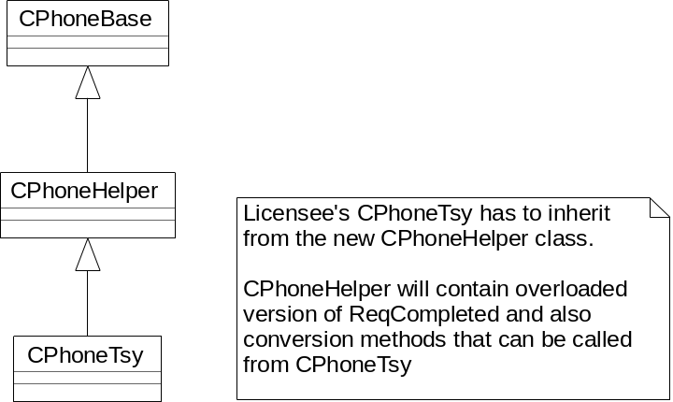
Figure 10 - Possible Helper TSY architecture 1

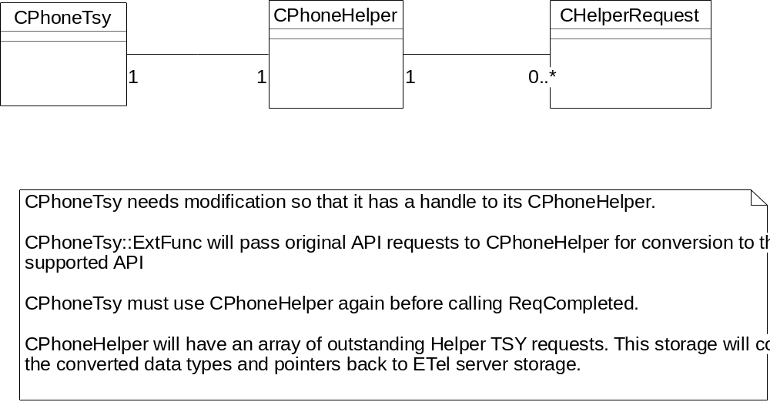
Figure 11 - Possible Helper TSY architecture 2

- The Helper TSY could be implemented within the ETel server, so that the server handles all conversions and the TSY does not need to change at all. Ideally the Helper TSY part would be “plug-in” so that GT can deliver an ETel server without the Helper TSY part too. So far, this option has not been investigated in depth.

Future extension to API
The first version of the Multimode ETel API was initially developed by GT0059 project, Multimode ETel v1.0. However this version of the API was never released within the platform and a subsequent project (GT0083) has adapted the API design and contents and re-scoped it to support GSM mode. This version of the API that will be delivered in the Hurricane platform is therefore still termed the “v1.0” release.
Further versions are definitely expected after Hurricane, both for increases in functionality to supported modes and the addition of entirely new modes.
During development of v1.0 of Multimode ETel we must ensure that future extension is considered and “hooks” are left for new functionality. We also have to ensure that the future versions are binary compatible with the v1.0 delivered to Hurricane.

Extending the API
Section 3.2.2 described how the ETel API can be extended. It is expected that both mechanisms will be used as the API evolves. New GSM specific functionality may be required, so new methods and/or sub-sessions can be added to the API.
A new mode may be required (e.g. W-CDMA) – this may again lead to new methods or sub-sessions but it may also lead to a requirement to modify existing API parts e.g. enums or structures. For example, a TCurrentMode enumeration could consist of EModeGsm in v1.0 of the API. However in v2.0 we may want to add EModeWcdma. This is a simple case and adding this new value to TCurrentMode should not cause any BC or source compatibility problems – however not all cases will be that simple! We have to be careful that adding new elements to structures or enums does not cause problems to existing clients. An initial study into W-CDMA has identified a number of API areas that may require modification during W-CDMA enhancement. These are described in section 6.3.

Maintaining Source and Binary Compatibility
Keeping Binary Compatibility means that we can supply new versions of the Multimode ETel API that can be downloaded onto a platform and then used without breaking applications that were using the previous version. The existing clients will continue to access the same API functionality they always have whereas new clients may be able to use the new version’s new functionality.
Some of the important points behind Binary Compatibility for our API are as follows:
- Ensuring that our exported classes remain at a constant size. The R-classes usually do not contain any instance data - this is hidden away in CPtrHolder derived classes, so that manages any instance data growth. See section 2.4 for details on CPtrHolder class.
- Ensuring that the API exports are kept in a constant "ordinal" order. If you deleted a method and it disappeared from the API's DEF file then all exports following the deleted one would have a new ordinal one less than the previous one. This breaks BC because the existing client apps would be linked against the previous DEF file. Adding exported methods or new sub-sessions is OK, so long as they are added to the bottom of the DEF file - i.e. they get new ordinal numbers, but the existing exports aren't reordered at all. If there are any methods that need to be removed or changed from the API, then the existing DEF file entry should be “nulled” so that this ordinal number is still in the DEF file but the API method no longer exists.
- Ensuring that API method names and signatures are consistent in their definition. Any changes of method or parameter names or contents will break source compatibility and a change in a parameter size, e.g. a change in the size of TCallInfo will break binary compatibility. The API methods and their signatures must be designed in the first version so that subsequent changes are transparent to the exported API definition. The TPckg approach for API parameters is described in section 2.7.
- Removing the use of mixin classes as abstract interface classes that the R-class sub-sessions are derived from. These mixins cause BC problems as it is impossible to add new methods to mixin classes so we have decided to remove them completely from the Multimode ETel API.

Adding W-CDMA support
The task of adding W-CDMA support to the Multimode ETel API will be undertaken by a separate GT project that will deliver to the Tornado platform
However, as GT83 has already started it is important to consider the future W-CDMA requirements.
Initial investigations of the W-CDMA (3GPP) specifications have led to identification of the following affected API functional areas:
- Mode switching and network interaction. The API will have to include W-CDMA as another mode that the phone can support. Network information may also be different for W-CDMA networks.
- Call control. All types of calls may be affected by extra call information available in W-CDMA mode, possible new call control actions, multiple active calls (MultiCall),
- Data calls and packet data services will require enhancement for QoS parameters, secure connection notifications, different bearer services, faster data rates etc.
- USIM – will probably have more files and perhaps different fields within files, eg. phonebook files may include space for email addresses and more than one number per name.
- User profiles – customisable profiles that can be stored on USIM.
The list above is not expected to be complete for W-CDMA - it just gives an indication of the future!

Platform Security
The Platform security architecture is being introduced in a number of stages. Symbian OS v8.0b introduced secure server APIs. Symbian OS v8.1 introduces the enforcement of the capability model as applied to loading binaries. Symbian OS v9.0 provides the enforcement of the API policing model.
For a detailed description of the Platform Security architecture, see [7].
For a platform security architectural overview as applied to this subsystem, see [8].

Capability Assignments
In order to satisfy the capability model rule, that a process cannot load a DLL with less capabilities than itself the following capabilities have been assigned to each of the binaries built from the Etelmm component.
For a full list of the capabilities see [7].
Binary | Loading Process | Capability Assignment
Etelmm.dll | Any¹ | All -Tcb

¹ This is a library DLL which could potentially be loaded into any client process. In order for it to be able to be loaded into any process it must be given all capabilities (minus TCB which is not given to any client processes).

API Policing
In accordance with the platform security API policing model the Etel server is now policing its IPC set. Any client that makes a request to ETel should have the necessary capabilities (as defined by the security policy setting for that IPC) to make that request happen. If the client does not posses the required capabilities, the policy checking mechanism shall return a failure to the client.
A set of capability policies have been defined for each of the IPCs associated with the EtelMM APIs. A full list of the API methods vs. the policing capabilities associated with them can be found in the appendix of the EtelMM API design document.
EtelMM APIs which are policed by SID are custom security checked by the Etel server and are definied in /etel/inc/secure/et_clsvr.h instead of /etelmm/inc/secure/etelmmcs.h.
At present, the following Etelmm IPCs require custom checking:
IPC | API and required capabilities
EMobileCallDialCallControl  EMobileCallDialCallControlCancel | DialCallControl(TRequestStatus& aStatus, const TDesC8& aCallParams, const TTelNumberC& aTelNumber) const;  Requires: SID + NetworkServices + NetworkControl

