ETel Core API Design

Security Classification: | Internal
Document Reference: | N/A
Status: | Issued
Version: | 1.6
Team/Department : | <Converged Comms>
Author(s): | <Andrew Cloke, Matthew Swan, Katie Sheehy, Nathalie Doyelle, Shazia Bhatti, Neil McAlpine, Aleksandar Antonic,  Ravishankar Lakshminarayanan>
Owner(s): | <Dejana Serdarevic>

Approver(s): | <Dejana Serdarevic> | Distribution: | <Converged Comms Team, licensees>

Contents
1 Introduction 5
2 Server Requests 5
2.1 Connecting to the Server 5
2.2 Retrieve Version Information 5
2.3 Enumerate Phones 5
2.4 Get Phone Information 5
2.5 Get Name of TSY by Phone 5
2.6 Load Phone Module 6
2.7 Unload Phone Module 6
2.8 Query TSY about Supported Functionality 6
2.9 Set a Client to be the Priority Client 6
2.10 Set a Client’s desired error granularity 6
2.11 Retrieve Version Information of TSY 7
2.12 Disconnecting from the Server 7
3 Phone Requests 8
3.1 Open a Phone 8
3.2 Controlled Initialisation 8
3.3 Cancel an Initialize Request 8
3.4 Set a Client to be the Emergency Client 8
3.5 Retrieve Capability Information 8
3.6 Capabilities Change Notification 9
3.7 Cancel a Capabilities Change Notification 9
3.8 Retrieve Status Information 9
3.9 Enumerate Lines 10
3.10 Retrieve Line Information 10
3.11 Modem Detection Notification 10
3.12 Cancel a Modem Detection Notification 10
3.13 Phone Class Member Data 11
3.13.1 Get Current Phone Information 11
3.14 Close a Phone 11
4 Line Requests 12
4.1 Open a Line 12
4.2 Retrieve Line Capabilities 12
4.3 Capabilities Change Notification 12
4.4 Cancel a Capabilities Change Notification 12
4.5 Retrieve Status Information 12
4.6 Retrieve Hook Status 13
4.7 Enumerating Calls 13
4.8 Retrieve Call Information 13
4.9 Incoming Call Notification 13
4.10 Cancel Incoming Call Notification 13
4.11 Hook Change Notification 13
4.12 Cancel a Hook Change Notification 14
4.13 Line Status Notification 14
4.14 Cancel Line Status Notification 14
4.15 New Call Added Notification 14
4.16 Cancel New Call Added Notification 14
4.17 Line Class Member Data 14
4.17.1 Get Current Line Information 14
4.18 Close a Line 15
5 Call Requests 16
5.1 Open a Call 16
5.2 Retrieve Call Status 16
5.3 Retrieve Call Capabilities 16
5.4 Capabilities Change Notification 17
5.5 Cancel a Capabilities Change Notification 17
5.6 Retrieve Bearer Service Info 17
5.7 Hook Change Notification 18
5.8 Cancel Hook Change Notification 18
5.9 Call Status Notification 18
5.10 Cancel Call Status Notification 18
5.11 Call Duration Change Notification 18
5.12 Cancel Call Duration Change Notification 18
5.13 Retrieve Call Duration 19
5.14 Call Class Member Data 19
5.14.1 Get Current Call Information 19
5.15 Dial a Call 19
5.16 Cancel Dial Call Command 19
5.17 Immediate Connect 19
5.18 Cancel Immediate Connect 20
5.19 Answer a Call 20
5.20 Cancel Call Answer 20
5.21 Terminate an active Call 20
5.22 Cancel Call Terminate 20
5.23 Loaning the Communication Port to the Client 21
5.24 Cancel Loan Communications Port 21
5.25 Recovering a Loaned Communications Port 21
5.26 Acquiring Call Ownership 21
5.27 Cancel Acquire Call Ownership 22
5.28 Transfer Ownership 22
5.29 Retrieve Ownership Information 22
5.30 Retrieve Call Parameters 22
5.31 Retrieve Fax Settings 23
5.32 Set Fax Settings 24
5.33 Retrieve Reference Count 24
5.34 Close a Call 24
5.35 Adopt Fax Header File in Fax Server 24
6 Fax Requests 25
6.1 Open a Fax Port 25
6.2 Read Fax Information 25
6.3 Write Fax Information 25
6.4 Wait for the End of a Page 25
6.5 Cancel the Fax Session 25
6.6 Retrieve Fax Progress Information 25
6.7 Close a Fax object 26
7 Call Ownership 27
7.1 Overview 27
7.2 Call Ownership Scenarios 28
7.3 Simple Call Ownership Example 28
7.4 Call Ownership Transfer Example 30
7.5 Client Panic Example A 32
7.6 Client Panic Example B 34
8 Fax Session Examples 36
8.1 Fax Dialling and Transmission 36
8.2 Fax Answering and Receiving Example 38
9 ETel Core Error Messages 42
10 ETEL Utilities 43
10.1 TLV structure support 43
11 ETel UDEB Logging 46
11.1 v9.1 and Below: Flogger1 46
11.2 v9.2 and Above: CDU Logging 47
12 References 48
13 Revision History 48
14 Further Information 49
14.1 People 49
14.2 References 49
14.3 Open Issues 49
14.4 Glossary 49
14.5 Document History 49
14.6 Document Review Date 49

Introduction
This document describes the core ETel API, its functions and class abstraction. A section is devoted to each of the class abstractions: phones, lines, call and fax functionality. Additional sections then give examples that illustrate the mechanics of call ownership and fax sessions.

Server Requests

Connecting to the Server
TInt RTelServer::Connect(TInt aMessageSlots)
This function connects the client to the ETel Server with the specified number of message slots. It must be used before any of the other functions listed in this document.

Retrieve Version Information
TVersion RTelServer::Version()
This function returns the version number of the ETel Server in the TVersion structure.

Enumerate Phones
TInt RTelServer::EnumeratePhones(TInt& aCount)
This function returns the total number of phone supported by all the ETel (TSY) modules currently loaded. The number is returned in the aCount variable.

Get Phone Information
TInt RTelServer::GetPhoneInfo(TInt aIndex,TPhoneInfo& aInfo)
This function returns information associated with the phone indicated by the aIndex variable. The phone information is returned in the aInfo structure, described below.
Variable | Description
iNetworkType | The type of telephony connection supported by the phone. This may take one of the following values:  - ENetworkTypeWiredAnalog  - ENetworkTypeWiredDigital  - ENetworkTypeMobileAnalog  - ENetworkTypeMobileDigital  • ENetworkTypeUnknown
iName | The name of the phone.
iNumberOfLines | The number of lines supported by the phone.
iExtensions | The extensions that the TSY module supports.

Get Name of TSY by Phone
TInt RTelServer::GetTsyName(const TInt aIndexOfPhone, TDes& aTsyName)
This function returns the name of the TSY module that the phone indicated by the index aIndexOfPhone belongs to.

Load Phone Module
TInt RTelServer::LoadPhoneModule(const TDesC& aName)
This function loads the ETel (TSY) module specified by the aName variable. The name need not include the TSY extension, this will be added by the server. Once loaded, information about the phone(s) added by the module can be accessed using the EnumeratePhones and PhoneInfo functions.

Unload Phone Module
TInt RTelServer::UnloadPhoneModule(const TDesC& aName)
This function unloads the ETel (TSY) module specified by the aName variable. The name need not include the TSY extension, this will be added by the server.

Query TSY about Supported Functionality
TInt RTelServer::IsSupportedByModule(const TDesC& aTsyName, const TInt aMixin, TBool& aResult)
This function allows a client to query a TSY module about what type of extended functionality it supports. It is assumed the TSY module will support all core functionality. The aMixin parameter is an integer defined in a public header file available both to the client and the TSY which represents a limited subset of functionality, and the aResult parameter is passed back as either TRUE or FALSE. The function will return KErrNotFound if the TSY module specified is not available.

Set a Client to be the Priority Client
TInt RTelServer::SetPriorityClient()
This function is a request to the server to allocate priority status to the client which calls it. The priority status allows the client to become the priority client in the platform and be granted control over any call.
Only one client in the system may have this priority status, and that would typically be the default phone application. That is why this method has its access restricted to allow only the default phone application to successfully call this method – the method is policed with the NetworkControl capability + the SID of the default phone application. This means that only the client with the required capability and the required SID will be able to successfully call this method. If another application attempts to call this API, this function will return KErrPermissionDenied. If the priority client calls this API more then once, the function will return KErrAlreadyExists.
When this method is called, the ETel server will also preallocate extra memory to be used for the emergency requests made by the priority client, for example an emergency dial request. If the priority client then calls an “emergency” request (of which there are none in the core ETel API), the server will use the preallocated memory for the request rather than allocating extra memory to prevent an out of memory error. If the pre-allocation of memory within this method fails, the return error will be KErrNoMemory. Other, non-priority, clients that need to handle emergency requests and wish to preallocate enough memory for their emergency request handling should use the RPhone::SetEmergencyClient() method.

Note to the default phone app developers:
To enable the SID of the default phone application to be easily overwritten by the default phone app developers, the SID will also be defined as a patchdata in the etel.iby file as follows:
patchdata etel.dll @ KPriorityClientSid <0x12345678>
where 0x12345678 is an example SID of the default phone app.
The default phone app developers are expected to modify the etel.iby file prior to ROM building and replace the default SID value with the SID value of their default phone app.
To enable testing of this functionality on the emulator the epoc.ini file needs to be modified to define the following property:
etel_KPriorityClientSid 0x12345678
where 0x12345678 is an example SID value of their default phone app.

Set a Client’s desired error granularity

TErrorGranularity | Description
EErrorBasic | Client is only interested in core errors
EErrorExtended | Client is interested in extended errors

TInt RTelServer::SetExtendedErrorGranularity(RTelServer::TErrorGranularity aGranularity) const
This function is a request to the server to register the specified error granularity against the client which calls it. The ETel server will provide extended errors ( i.e. proprietary client/TSY error definitions outside of the ETel core error space ) to a client that calls this method and specifies aGranularity equal to EErrorExtended. After registering interest in extended errors, this “advanced” client will receive an extended error code whenever one of their requests ends in an error that is translated by the TSY into one of the proprietary extended error codes. If an error occurs that the TSY cannot translate into an extended error then the TSY will return one of the basic errors instead. For this reason, the basic error space and the extended error space must not clash. A client which has not called this method or one which specifies aGranularity equal to EErrorBasic will only receive errors from the small set of ETel and Base basic errors.
Basic error codes are those used and defined by the ETel Core API. These error codes alongside the E32 Base set of error codes collectively form the basic error space. The error codes defined in the ETel extensions, such as ETelMM, ETelSAT, ETelPacket exterror.h in ETel, as well as those defined by Licensees, collectively form the extended error space. The licensee defined extended error space has a range of -21000 to -29999.

Retrieve Version Information of TSY
TInt RTelServer::GetTsyVersionNumber(const TDesC& aTsyName,TVersion& aVersion) const;
This function returns the version number of the specified TSY module in the aVersion parameter.

Disconnecting from the Server
TInt RTelServer::Close()
This function closes the client’s handle on the server.

Phone Requests

Open a Phone
TInt RPhone::Open(RTelServer& aSession,const TDesC& aName)
This function opens the phone specified by the aName variable. The aSession variable must specify a server session which is connected to the server.

Controlled Initialisation
TInt RPhone::Initialise()
void RPhone::Initialise(TRequestStatus& aStatus)
This function allows the client to control when a phone is initialised, or re-initialised. The phone hardware is usually automatically initialised before the first command is sent. However, this operation can take a number of seconds, and may therefore cause a sluggish response. This command gives a client the ability control the initialisation timing.
A client may wish to know when the automatic initialized function has completed, so that it may call a synchronous function that obeys flow control. It can do this by calling this function during the automatic sequence, which will then complete immediately upon initialisation without executing it a second time.

Cancel an Initialize Request
void RPhone::InitialiseCancel()
This function cancels a request to initialise the modem, placed using the asynchronous variant of the Initialise function.

Set a Client to be the Emergency Client
TEmergencyRequests | Description
EEmergencyLCSRequest  =0x00000001 | Preallocate enough memory in ETel and TSY for the LCS (Location Services) emergency request handling.  After this API is called the preallocated memory will be used to service the following emergency LCS requests:  RMobileLocationServices::NotifyMtlr()  RMobileLocationServices::SendMtlrResponse()  RMobileLocationServices::NotifyMeasurementControl()  RMobileLocationServices::SendMeasurementReport()
EEmergencyCSVoiceCallRequest  =0x00000002 | Preallocate enough memory in ETel and TSY for the Circuit Switched Voice Call emergency request handling.  After this API is called the preallocated memory will be used to service the following emergency Circuit Switched Voice Call emergency requests:  RMobileCall::DialEmergencyCall()

TInt RPhone::SetEmergencyClient(const TUint32 aEmergencyRequest)
This method allows the client to instruct the ETel server and the TSY to preallocate extra memory for any potential emergency request handling from this client. It allows other, non-priority, clients who operate under emergency conditions, to have memory preallocated for them in the ETel server. The request gets passed down to the TSY, so that the TSY can also proceed with the necessary memory pre-allocation.
The client specifies the type of emergency requests that it wishes to handle in the aEmergencyRequest parameter. aEmergencyRequests is a bit-mask where each bit-flag represents the emergency request type that the client wishes to handle. See definition of TEmergencyRequests for the emergency request types bit-flag positions.
The memory required is calculated by the server and the TSY according to the aEmergencyRequestType parameter. If the pre-allocation of memory within this method fails, the method returns KErrNoMemory. If the same emergency client calls this method multiple times, the ETel server will return the KErrAlreadyExists error. KErrAlreadyExists will also be returned if another RPhone client created using the same RTelServer session also calls this method.
Please note that ETel allocates emergency heap per client or more precisely per client’s RTelServer session. The client is expected to use only one emergency sub-session of the same type at a time. If the client has a requirement to use multiple, concurrent subsessions that handle the same emergency functionality, then it needs to open separate RTelServer sessions, otherwise ETel might run out of the preallocated emergency memory.
This method is policed with the WriteDeviceData capability. Multiple clients can call this method as long as they have sufficient platsec capability.

Retrieve Capability Information
TInt RPhone::GetCaps(TCaps& aCaps)
This function returns the phone capabilities in the aCaps variable. An instance of the TCaps template must be passed as the aCaps variable. This packages the TCaps structure, which contains one iFlags variable. The possible values for this variable are described below.
Constant | Description
KCapsUnknown | The capabilities of the phone are not currently known.
KCapsData | The phone supports data calls.
KCapsFaxClassOne | The phone supports the fax class 1 interface.
KCapsFaxClassOnePointZero | The phone supports the fax class 1.0 interface.
KCapsFaxClassTwo | The phone supports the fax class 2 interface.
KCapsFaxClassTwoPointZero | The phone supports the fax class 2.0 interface.
KCapsFaxClassTwoPointOne | The phone supports the fax class 2.1 interface.
KCapsVoice | The phone supports voice calls.
KCapsEventModemDetection | The phone supports modem detection events, i.e. it can notify clients when the modem can be or can no longer be detected.
KCapsStealCommPort | The phone supports the ability to take the comms port from whatever component is currently using it.  NB This requires new functionality to be implemented in the Comms Server which is not there at present; ie the ability for one C32 client to snatch the ownership of the comms port from another client.

Capabilities Change Notification
TInt RPhone::NotifyCapsChange(TRequestStatus& aStatus, TCaps& aCaps);
This function completes when the dynamic capabilities of the phone change. See the previous section for values that aCaps may take.

Cancel a Capabilities Change Notification
TInt RPhone::NotifyCapsChangeCancel() const;
This function cancels an outstanding request for notification of the capabilities of the phone changing.

Retrieve Status Information
TInt RPhone::GetStatus(TStatus& aStatus)
This function retrieves information about the status of the phone. This information is returned in the aStatus structure, which is described below.
Primitive Types
TMode
EModeUnknown | The phone is currently in an unknown state.
EModeIdle | The phone is currently idle
EModeEstablishingLink | The phone is currently trying to establish a call.
EModeOnlineData | The phone is in the connected and “on-line data“ state
EModeOnlineCommand | The phone is in the connected and “on-line command“ state

TModemDetection
EDetectedPresent | The phone has detected that the local modem is present.
EDetectedNotPresent | The phone has detected that the local modem is not present.
EDetectedUnknown | The phone has not yet detected the status of the local modem.

Structured Types:
TStatus
iModemDetected | TModemDetection | The current modem detection state. TModemDetection values are described above
iMode | TMode | • The current mode of the phone. TMode values are described above.

Enumerate Lines
TInt RPhone::EnumerateLines(TInt& aCount)
This function returns the number of lines associated with the phone in the aCount variable.

Retrieve Line Information
TInt RPhone::GetLineInfo(TInt aIndex,TLineInfo& aLineInfo)
This function returns information about the line specified by the aIndex variable. The information is returned in the aLineInfo structure, which is described below.

TLineInfo
iStatus | RCall::TStatus | The current line status. The values of this are the same as a call status and are described in the “Retrieve Call Status” section.
iLineCapsFlags | TUint32 | The line’s capabilities flags, described in the “Retrieve Line Capabilities” section.
iName | TName | The name of the line.

Modem Detection Notification
void RPhone::NotifyModemDetected(TRequestStatus& aStatus, TModemDetection& aDetection)
This function allows a client to be notified when the local modem is detected or when a previously connected modem can no longer be contacted. Clearly, this function has no use if the modem (DCE) is permanently attached to the computing device (DTE). If supported, the request will be completed when the phone’s connection status changes. Upon completion the aDetection variable will contain the new status. Values for TModemDetection are described in section 3.6.

Cancel a Modem Detection Notification
void RPhone:: NotifyModemDetectedCancel()
This function cancels an outstanding modem detection notification, placed using the NotifyModemDetected function.

Phone Class Member Data
All the information associated with an instance of the core GSM API phone class is collected together into a single, directly accessible, structure to increase the efficiency of those applications which require access to the majority of the phone’s data.
The following table describes the member variables of the TPhoneInfo class.
TPhoneInfo
iDetection | TModemDetection | The current modem detection state. TModemDetection values are described in section 3.6

Get Current Phone Information
TInt RPhone::GetInfo(TPhoneInfo& aPhoneInfo)
This function retrieves a snapshot of the current phone information, described in the table abovee.

Close a Phone
TInt RPhone::Close()
This function closes the client-side handle on the phone. If this is the last handle on the phone, then it will also delete the server-side phone object.

Line Requests

Open a Line
TInt RLine::Open(RPhone& aPhone,const TDesC& aName)
TInt RLine::Open(RTelServer& aServer,const TDesC& aName)
These functions open a line from a phone and a server connection respectively. The name of the line is given by the aName variable and must match the name passed with the GetLineInfo function.

Retrieve Line Capabilities
TInt RLine::GetCaps(TCaps& aCaps)
This function returns the line capabilities in the aCaps variable. An instance of the TCaps template must be passed as the aCaps variable. This packages the TCaps structure, which contains one iFlags variable. The possible values for this variable are described below.
Constant | Description
KCapsData | The line supports data connections.
KCapsFax | The line supports fax connections.
KCapsVoice | The line supports voice connections.
KCapsEventIncomingCall | The line supports incoming call notification requests.

Capabilities Change Notification
TInt RLine::NotifyCapsChange(TRequestStatus& aStatus, TCaps& aCaps);
This function completes when the dynamic capabilities of the line change. See the previous section for values that aCaps may take.

Cancel a Capabilities Change Notification
TInt RLine::NotifyCapsChangeCancel() const;
This function cancels an outstanding request for notification of the capabilities of the line changing.

Retrieve Status Information
TInt RLine::GetStatus(TStatus& aStatus)
This function returns line status information in the aStatus variable. This variable may take the following values.
Variable | Description
EStatusUnknown | The line status is currently unknown.
EStatusIdle | The line is idle.
EStatusDialling | The line is dialling
EStatusRinging | The line is ringing.
EStatusAnswering | The line is answering.
EStatusConnecting | The line is connecting.
EStatusConnected | The line is connected.
EStatusHangingUp | The line is hanging up.

Retrieve Hook Status
TInt RLine::GetHookStatus(THookStatus& aHookStatus)
This function returns hook the current status in the aHookStatus variable. This variable may take one of the following values.
Constant | Description
EHookStatusOff | The line is currently off hook.
EHookStatusOn | The line is currently on hook.
EHookStatusUnknown | The status of the line’s hook is currently unknown.

Enumerating Calls
TInt RLine::EnumerateCall(TInt& aCount)
This function returns the number of calls opened from the line. The number of calls is returned in the aCount variable.

Retrieve Call Information
TInt RLine::GetCallInfo(TInt aIndex,TCallInfo& aCallInfo)
This function returns information about the call specified by the aIndex variable. The call information is returned in the aCallInfo structure, which is described below.
Constant | Description
iCallName | The name of the call.
iStatus | The call status, described in the “Retrieve Call Status” section.
iCallCapsFlags | The call capabilities flags, described in the “Retrieve Call Capabilities” section.

Incoming Call Notification
void RLine::NotifyIncomingCall(TRequestStatus& aStatus, TName& aName)
This function allows a client to be notified when an incoming call is detected. The function completes when an incoming call is detected or when a cancel of the notification is recognised. The name of the call on which AnswerIncomingCall() should be answered is returned in the aName variable.

Cancel Incoming Call Notification
TInt RLine::NotifyIncomingCallCancel()
This function allows a client to cancel an outstanding incoming call notification, placed with the NotifyIncomingCall request.

Hook Change Notification
void RLine::NotifyHookChange(TRequestStatus& aStatus, THookStatus& aHookStatus)
This function allows a client to be notified when the hook changes status. The request will be completed when the line’s hook status changes. Upon completion the aHookStatus variable will contain the new hook status.

Cancel a Hook Change Notification
void RLine::NotifyHookChangeCancel()
This function cancels an outstanding hook change notification request, placed using the NotifyHookChange function.

Line Status Notification
void RLine::NotifyStatusChange(TRequestStatus& aStatus, TStatus& aLineStatus)
This function notifies a client about a change in the status of a line. The request will complete when the line mode status changes. Upon completion the new line status will be returned in the aLineStatus variable.

Cancel Line Status Notification
void RLine::NotifyStatusChangeCancel()
This function cancels an outstanding line status change notification request, placed using the NotifyStatusChange function.

New Call Added Notification
void RLine::NotifyCallAdded(TRequestStatus& aStatus,TName& aName)
This function notifies a client about a new call being added to the line. Upon completion the name of the new call will be returned in the aName variable.

Cancel New Call Added Notification
void RLine::NotifyCallAddedCancel()
This function cancels an outstanding new call added notification request, placed using the NotifyCallAdded function.

Line Class Member Data
All the information associated with an instance of the core API line class is collected together into a single, directly accessible, structure to increase the efficiency of those applications which require access to the majority of the line’s data.
The following table describes the member variables of the TLineInfo class
TLineInfo
iHookStatus | RCall::THookStatus | The current hook status.
iStatus | RCall::TStatus | The current line status.
iNameOfLastCallAdded | TName | The name of the last call created on that line.
iNameOfCallForAnswering | TName | The name of the call to which a new incoming call will be directed.

Get Current Line Information
TInt RLine::GetInfo(TLineInfo& aLineInfo)
This function retrieves a snapshot of the current line information.

Close a Line
TInt RLine::Close()This function closes the line.

Call Requests

Open a Call
TInt RCall::OpenNewCall(RTelServer& aServer,const TDesC& aName,TDes& aNewName);
TInt RCall::OpenNewCall(RTelServer& aServer,const TDesC& aName);
TInt RCall::OpenNewCall(RPhone& aPhone,const TDesC& aName,TDes& aNewName);
TInt RCall::OpenNewCall(RPhone& aPhone,const TDesC& aName);
TInt RCall::OpenNewCall(RLine& aLine,TDes& aNewName);
TInt RCall::OpenNewCall(RLine& aLine);
TInt RCall::OpenExistingCall(RTelServer& aServer,const TDesC& aName);
TInt RCall::OpenExistingCall(RPhone& aPhone,const TDesC& aName);
TInt RCall::OpenExistingCall(RLine& aLine,const TDesC& aName);
These functions open a call from a server, phone and line respectively. The OpenNewCall() functions are to open a new call, where the aName variable specifies the name of the line to open the call from and the aNewName variable returns the name of the new call. If the new name is not needed by the client opening it the functions without the parameter aNewName may be used. The OpenExistingCall() functions open an existing call by name, the aName variable specifying the name of the call to open. If a call of specified name does not exist the error KErrNotFound will be returned. The final OpenNewCall() function opens a new call from a line and allows the server to select a name for the call.

Retrieve Call Status
TInt RCall::GetStatus(TStatus& aStatus)
This function returns the current call status in the aStatus variable. The values that this variable may take are described in the table below.
Constant | Description
EStatusUnknown | The call status is not currently known.
EStatusIdle | The call is idle.
EStatusDialling | The call is dialling.
EStatusRinging | The call is ringing (an incoming, unanswered call).
EStatusAnswering | The call is being answered.
EStatusConnecting | The call is connecting (immediate call establishment, without dialling).
EStatusConnected | The call is connected and active.
EStatusHangingUp | The call is being terminated.

Retrieve Call Capabilities
TInt RCall::GetCaps(TCaps& aCaps)
This function returns the call capabilities in the aCaps variable. An instance of the TCaps template must be passed as the aCaps variable. This packages the TCapsV01 structure, which contains one iFlags variable. The possible values for this variable are described below.
Constant | Description
KCapsData | The call supports data calls.
KCapsFax | The call supports fax calls.
KCapsVoice | The call supports voice calls.
KCapsDial | The Dial request is currently a valid action.
KCapsConnect | The Connect request is currently a valid action.
KCapsHangUp | The HangUp request is currently a valid action.
KCapsAnswer | The Answer request is currently a valid action.
KCapsLoanDataPort | The LoanDataPort request is currently a valid action.
KCapsRecoverDataPort | The RecoverDataPort request is currently a valid action.

Capabilities Change Notification
TInt RCall::NotifyCapsChange(TRequestStatus& aStatus, TCaps& aCaps);
This function completes when the dynamic capabilities of the call change. See the previous section for values that aCaps may take.

Cancel a Capabilities Change Notification
TInt RCall::NotifyCapsChangeCancel() const;
This function cancels an outstanding request for notification of the capabilities of the call changing.

Retrieve Bearer Service Info
TInt RCall::GetBearerServiceInfo(TBearerService& aBearerService)
This function returns the available bearer service information associated with the call. The information is returned in the aBearerService structure which is described in the table below. Bearer service information is only available if the call is currently active. If the call is not connected, the request will return KErrNotFound.
Variable | Description
iBearerCaps | Indicates the capabilities associated with the bearer. This may take one or more of the following values:  - KBearerCapsCompressionV42bis  - KBearerCapsCompressionMNP5  - KBearerCapsCompressionNone  - KBearerCapsProtocolLAPM  - KBearerCapsProtocolALT_CELLULAR  - KBearerCapsProtocolALT  - KBearerCapsProtocolNone  - KBearerCapsCompressionUnknown  • KBearerCapsProtocolUnknown
iBearerSpeed | Indicates the bearer speed. This may take one of the following values:  - EBearerData57600  - EBearerData33600  - EBearerData31200  - EBearerData19200  - EBearerData14400  - EBearerData12000  - EBearerData9600  - EBearerData7200  - EBearerData4800  - EBearerData2400  - EBearerData1200  - EBearerData75_1200  - EBearerData1200_75  - EBearerData300  • EBearerDataUnknown

Hook Change Notification
void RCall::NotifyHookChange(TRequestStatus& aStatus, RLine::THookStatus& aHookStatus)
This function notifies a client of a change to the hook status. The request completes when the hook status changes. Upon completion the new hook status is returned in the aHookStatus variable.

Cancel Hook Change Notification
TInt RCall::NotifyHookChangeCancel()
This function cancels an outstanding hook change notification request, placed with the NotifyHookChange request.

Call Status Notification
void RCall::NotifyStatusChange(TRequestStatus& aStatus, RCall::TStatus& aCallStatus)
This function notifies a client about a change in the status of a call. The request will complete when the call status changes. Upon completion the new call status will be returned in the aCallStatus variable.

Cancel Call Status Notification
void RCall::NotifyStatusChangeCancel()
This function cancels an outstanding call status change notification request, placed using the NotifyStatusChange function.

Call Duration Change Notification
void RCall::NotifyCallDurationChange(TRequestStatus& aStatus,TTimeIntervalSeconds& aTime)
This function notifies a client of an increase in call duration by one second. Upon completion the new duration is returned in the aTime variable.

Cancel Call Duration Change Notification
void RCall::NotifyCallDurationChangeCancel()
This function cancels an outstanding call duration change notification request, placed using the NotifyCallDurationChange function.

Retrieve Call Duration
TInt RCall::GetCallDuration(TTimeIntervalSeconds& aTime)
This function returns the call duration in the aTime variable, measured in seconds.

Call Class Member Data
All the information associated with an instance of the core API call class is collected together into a single, directly accessible, structure to increase the efficiency of those applications which require access to the majority of the call’s data.
The following table describes the member variables of the TCallInfo class.
TCallInfo
iCallName | TName | The name of the call.
iLineName | TName | The name of the call’s line.
iHookStatus | THookStatus | The current hook status.
iStatus | TStatus | The current call status.
iDuration | TTimeIntervalSeconds | The current call duration

Get Current Call Information
TInt RCall::GetInfo(TCallInfo& aCallInfo)
This function retrieves a snapshot of the current call information, described above.

Dial a Call
TInt RCall::Dial(const TTelNumberC& aTelNumber)
TInt RCall::Dial(const TDesC8& aCallParams, const TTelNumberC& aTelNumber)
void RCall::Dial(TRequestStatus& aStatus, const TTelNumberC& aTelNumber)
void RCall::Dial(TRequestStatus& aStatus, const TDesC8& aCallParams, const TTelNumberC& aTelNumber)
This function attempts to establish a connection using the telephone number specified with the aTelNumber variable. The mode of the connection, i.e. whether it is a data or fax connection, is determined by whether the RCall object has been opened from a data line or a fax line. The call parameters to be associated with this call (see Retrieve Call Parameters for the definition of the structure) may be passed down in a TCallParamsPckg struct, although there are two functions provided that do not take any call parameters but allow the TSY to take the call parameters from the Comms database.

Cancel Dial Call Command
void RCall::DialCancel()
This function cancels an outstanding dial request, placed with the asynchronous version of the Dial function.

Immediate Connect
TInt RCall::Connect()
TInt RCall::Connect(const TDesC8& aCallParams)
void RCall::Connect(TRequestStatus& aStatus)
void RCall::Connect(TRequestStatus& aStatus, const TDesC8& aCallParams)
This function attempts to immediately connect to a remote modem without dialling. It is intended for use when other equipment has been used to dial the call. The mode of the connection, i.e. whether it is a data or fax connection, is determined by whether the RCall object has been opened from a data line or a fax line. The call parameters to be associated with this call (see Retrieve Call Parameters for the definition of the structure) may be passed down in a TCallParamsPckg struct, although there are two functions provided that do not take any call parameters but allow the TSY to take the call parameters from the Comms database.

Cancel Immediate Connect
void RCall::ConnectCancel()
This function allows a client to cancel a connection request, placed using the asynchronous version of the Connect function.

Answer a Call
TInt RCall::AnswerIncomingCall()
TInt RCall::AnswerIncomingCall(const TDesC8& aCallParams)
void RCall::AnswerIncomingCall(TRequestStatus& aStatus)
void RCall::AnswerIncomingCall(TRequestStatus& aStatus, const TDesC8& aCallParams)
This function waits for an incoming call and answers it when it arrives. It will also answer a currently incoming call. The call parameters to be associated with this call (see Retrieve Call Parameters for the definition of the structure) may be passed down in a TCallParamsPckg struct, although there are two functions provided that do not take any call parameters but allow the TSY to take the call parameters from the Comms database.

Cancel Call Answer
void RCall::AnswerIncomingCallCancel()
This function allows a client to cancel an outstanding call answer request, placed using the asynchronous version of the Answer function. If a call has not arrived the TSY merely notes that it should not answer when one arrives; if the call is answering, then an attempt will be made to abort.

Terminate an active Call
TInt RCall::HangUp()
void RCall::HangUp(TRequestStatus& aStatus)
This function terminates an active call established with the Dial, Connect or Answer functions. When using an AT-command based TSY, HangUp can only be called once the call is in a connected state. Whereas in a one-box solution, where the TSY interfaces more directly to the phone, HangUp can also be called from a call ringing state.

Cancel Call Terminate
void RCall::HangUpCancel()
This function cancels an outstanding HangUp request, placed using the asynchronous version of the HangUp function. It should be noted that if the call termination sequence has begun there is little hope of retaining the call even if the HangUpCancel function is used.

Loaning the Communication Port to the Client
TInt RCall::LoanDataPort(TCommPort& aDataPort)
void RCall::LoanDataPort(TRequestStatus& aStatus,TCommPort& aDataPort);
This function allows a client to gain control of the serial communications abstraction used to communicate with the modem. This function should only be called once a connection has been established to a remote modem. If no such connection is in place the server will return the KErrNotReady error. Once this function has successfully completed the ETel server will queue any commands it may have to the modem, leaving the channel free for client data. The server will only retake control of the communications port when the RecoverDataPort() function is called. The details required to open the communications port will be returned in the aDataPort structure, described below.
Variable | Description
iCsy | The CSY module used by the C32 Communications Server to talk to the serial device.
iPort | The port used by the C32 Communications Server to talk to the serial device.

Cancel Loan Communications Port
void RCall::LoanDataPortCancel()
This function allows a client to cancel an outstanding loan communications port request, placed using the asynchronous version of the LoanDataPort function.

Recovering a Loaned Communications Port
TInt RCall::RecoverDataPort()
This function should be used by the client to indicate that it has finished using the serial communication channel and the ETel server can retake control of it. If the communications port is not currently on loan the function will return with the KErrNotReady error.

Acquiring Call Ownership
void RCall::AcquireOwnership(TRequestStatus& aStatus)
When a client makes or answers a data or fax call, it is said to have ownership of that call. Only the client with ownership may terminate the call or gain control of the underlying communications channel (see section 7 for more details). All other clients may just monitor the call and view its state. However, a client may gain call ownership from another client by using the AcquireOwnership request.
This request will complete only in the following cases:
- the current call owner calls the TransferOwnership request, see section 5.28.
- the current call owner closes its handle on the active call (without hanging up first)
- the current call owner client application crashes.
When (and if) the request completes, call ownership will have been transferred to the new client.
The TSY will only accept one outstanding RCall::AcquireOwnership per call object. All subsequent requests will be rejected with KErrInUse until the first is completed.
Note: This method can only be called on a data or fax call. Voice calls should not implement the ownership model. In the event of this method being called on a voice call, KErrNotSupported should be returned by the TSY.

Cancel Acquire Call Ownership
void RCall::AcquireOwnershipCancel()
This function cancels an outstanding request to gain call ownership, placed with the AcquireOwnership function.

Transfer Ownership
TInt RCall::TransferOwnership()
This function allows clients with call ownership to transfer ownership to another interested client. If no clients are interested in the ownership, i.e. none have a pending AcquireOwnership request, the function will return will the KErrEtelNoClientInterestedInThisCall error, and ownership will remain with the client. If the client does not have call ownership, the function will return with KErrEtelNotCallOwner. If, however, everything is in order the function will return KErrNone and ownership will be transferred.
Note: This method can only be called on a data or fax call. Voice calls should not implement the ownership model. In the event of this method being called on a voice call, KErrNotSupported should be returned by the TSY.

Retrieve Ownership Information
TInt RCall::GetOwnershipStatus(TOwnershipStatus& aOwnershipStatus)
This function returns ownership information associated with the call in the aOwnershipStatus variable. This variable may take the following values.
Constant | Description
EOwnershipUnowned | The call is unowned.
EOwnershipOwnedByAnotherClient | The call is owned, but not by this RCall instance.
EOwnershipOwnedByThisClient | The call is owned by this RCall instance.
EOwnershipThisIsPriorityClient | This call is not owned by this (the priority) client.

Retrieve Call Parameters
TInt RCall::GetCallParams(TDes8& aParams)
This function returns the current call parameters. The function must be passed an instance of the TCallParams class in the aParams variable. The returned descriptor packages the TCallParams structure. This structure is described below.
Variable | Description
iSpeakerControl | The monitor speaker control setting. This may take one of the following values:  - EMonitorSpeakerControlAlwaysOff  - EMonitorSpeakerControlOnUntilCarrier  - EMonitorSpeakerControlAlwaysOn  - EMonitorSpeakerControlOnExceptDuringDialling  • EMonitorSpeakerControlUnknown
iSpeakerVolume | The monitor speaker control setting. This may take one of the following values:  - EMonitorSpeakerVolumeOff  - EMonitorSpeakerVolumeLow  - EMonitorSpeakerVolumeMedium  - EMonitorSpeakerVolumeHigh  • EMonitorSpeakerVolumeUnknown
iInterval | The length of a pause created during dialling by the comma character (‘,’) measured in seconds.
iWaitForDialTone | Whether when dialling a call the modem should wait for a dial tone. This may take the following values:  - EDialToneWait  • EDialToneNoWait
TSY Design Note: The call parameters are associated specifically with a call. Many calls may be open on a given line all of which may have different settings. Furthermote, it is not known which call may make the first Dial or Answer request. Therefore, the TSY’s should record these settings and only pass them on to the modem immediately before a call is made or answered.

Retrieve Fax Settings
TInt RCall::GetFaxSettings(TFaxSessionSettings& aSettings)
This function retrieves the current fax settings and returns them in the aSettings structure. This structure is described in the table below.
Variable | Description
iMode | The fax mode. This may take one of the following values:  - EDialAndTransmit  - EDialAndReceive  - EImmediateTransmit  - EImmediateReceive  - EWaitForRingAndTransmit  • EWaitForRingAndReceive  - EDialAndReceivePoll
iFaxRetrieveType | The mode of retrieving faxes. This may take one of the following values:  - EFaxOnDemand  • EFaxPoll
iFaxClass | - EClassAuto  - EClass1  - EClass2  - EClass2point0  - EClass1point0  • EClass2point1
iFaxId | The fax identifier string displayed at the top of the fax.
IMaxSpeed | The maximum transfer speed that should be negotiated.
iMinSpeed | The minimum transfer speed that should be negotiated.
iPreferredECM | The preferred Error Correction Mode.
iFaxOnDemandDelay | The delay used for “Fax on Demand” services. Measured in seconds.
iTxResolution | The prefered transmit resolution. This may take one of the following values:  - EFaxNormal  • EFaxFine
iTxCompression | The preferred compression mode used for negotiation. This may take one of the following values:  - EModifiedHuffman  - EModifiedRead  - EUncompressedModifiedRead  • EModifiedModifiedRead
iTxPages | The number of pages to be transmitted.
iRxResolution | The prefered receive resolution. This may take one of the following values:  - EFaxNormal  • EFaxFine
iRxCompression | The preferred required mode. This may take one of the following values:  - EModifiedHuffman  - EModifiedRead  - EUncompressedModifiedRead  • EModifiedModifiedRead

Set Fax Settings
TInt RCall::SetFaxSettings(const TFaxSessionSettings& aSettings)
This function assigns the fax settings that will be used to receive or transmit a fax. The new settings are passed in the aSettings structure, which is described in the “Retrieve Fax Settings” section.

Retrieve Reference Count
TInt RCall::ReferenceCount() const
This function allows the client to retrieve the reference count of a call object and hence know how many clients in total have an handle open on a call object.

Close a Call
TInt RCall::Close()This function closes the call.

Adopt Fax Header File in Fax Server
TInt RCall::AdoptFaxSharedHeaderFile(const RFile& aSharedFile) const;
NOTE: This method is not intended for public use
This function sends an open file handle to Etel. It is called by the fax client thread during transmission of a fax to allow the fax server to read a file located in the clients private directory containing the fax header information. On receiving the handle Etel will adopt the file (using RFile::AdoptFromClient()) before passing it onto the fax server for use.

Fax Requests

Open a Fax Port
TInt RFax::Open(RCall& aCall)
This function opens a fax port from a call. This operation is only valid if the call is active and the client performing the operation is the call’s owner. If the client is not the owner the server will generate the KErrEtelNotCallOwner error, whereas if the call is not currently active the server will generate the KErrCallNotActive error.

Read Fax Information
void RFax::Read(TRequestStatus& aStatus, TDes8& aDes)
This function is used by the client to read fax data while a fax is being received. The information will be returned in the aDes descriptor. When a complete page has been received a zero length descriptor will be returned. For more information please refer to the “Fax Session” section.

Write Fax Information
void RFax::Write(TRequestStatus& aStatus, const TDesC8& aDes)
This function is used by the client to write fax data while a fax is being transmitted. The information to be transmitted is contained in the aDes descriptor. For more information please refer to the “Fax Session” section.

Wait for the End of a Page
void RFax::WaitForEndOfPage(TRequestStatus& aStatus)
This function is used by the client when a fax page has been transmitted or received and confirmation of the end of page status is sort. Since there may be some time between transmitting or receiving the last piece of data and the page end status being generated this function is asynchronous.

Cancel the Fax Session
TInt RFax::TerminateFaxSession()
This function cancels any outstanding fax read, write or page end requests (placed with the Read, Write and WaitForEndOfPage functions respectively) and terminates the current fax session.

Retrieve Fax Progress Information
TInt RFax::GetProgress(TProgress& aProgress)
his function returns progress information about the fax session in the aProgress structure. This structure is described below.
Variable | Description
iLastUpdateTime | A time stamp indicating the last time the progress information was updated.
iAnswerback | The “Answer Back” string received from the remote fax machine. This normally indicates the remote number.
iPhase | The phase of the fax transmission. This will take one of the following values:  - ENotYetStarted,  • ECallEstablishment  • ESessionNegotiation  • EDataTransfer  • EPostPageStatus  • EDisconnection
iResolution | The fax resolution. This may take one of the following values:  • EFaxNormal  • EFaxFine
iCompression | The fax compression mode. This may take one of the following values:  • EModifiedHuffman  • EModifiedRead  • EUncompressedModifiedRead  • EModifiedModifiedRead
iECM | The Error Correction Mode.
iPage | The number of pages that has been processed by the fax session.
iLines | The number of lines that have been processed from the current page.
iSpeed | The negotiated data rate of the fax session.

Close a Fax object
TInt RFax::Close()
This function closes the fax object.

Call Ownership

Overview
Call ownership allows a client to own a call object and be the only client that can manipulate its status. The concept was introduced to properly handle the scenario where the owning client crashes and avoid “orphaned” call objects. The TSY must always make sure that an active call has an owner, otherwise it means that the owning client has probably crashed or panicked, and the TSY is responsible for hanging up the call and closing it.

Call ownership is only supported for data and fax calls and its implementation is mandatory for TSYs and the ETel Clients to ensure predictable behaviour.

Ownership information is stored in the ETel Server. API methods are available to the the TSY to retrieve/modify this information, see [1] for details.

When a client has ownership of a call object, it can manipulate it and change its status. Other clients that are not owners but have opened a handle on the call can only monitor its status, they can not manipulate it.

A client acquires a call’s ownership automatically, if it is the first client to call one of the following methods when the call is in an unowned state:

- RCall::Dial
- RCall::Connect
- RCall::AnswerIncomingCall

Upon receiving one of these requests, the TSY should set the ownership of the call by calling MCallBaseTSY:: SetOwnership, see [1].[1][1][1]

If the call is already active, and therefore owned, these RCall requests will return the KErrEtelNotCallOwner error.

The client can also acquire ownership of an existing and already owned call object by calling RCall::AcquireOwnership, see section Acquiring Call OwnershipAcquiring Call OwnershipAcquiring Call OwnershipAcquiring Call Ownership5.26 for more details.Acquiring Call OwnershipAcquiring Call Ownership

When the client that owns the call object, calls RCall::HangUp on it, the TSY should reset the ownership status of the call by calling MCallBaseTSY::SetUnowned. This is because a call object should never be owned and idle concurrently.

The table below provides a summary of the ownership status required by a client to call the RCall methods successfully:
RCall method | Ownership status
OpenNewCall | Call is created in an unowned status.
OpenExistingCall | Owner and non-owner can call this method.
Close | Owner and non-owner can call this method.
GetStatus | Owner and non-owner can call this method.
GetCaps | Owner and non-owner can call this method.
NotifyCapsChange | Owner and non-owner can call this method.
GetBearerServiceInfo | Owner and non-owner can call this method.
GetInfo | Owner and non-owner can call this method.
NotifyHookChange | Owner and non-owner can call this method.
NotifyStatusChange | Owner and non-owner can call this method.
NotifyCallDurationChange | Owner and non-owner can call this method.
GetCallDuration | Owner and non-owner can call this method.
Dial | Client becomes the owner of the call if it is the first client to call this method when the call is in an unowned state
Connect | Client becomes the owner of the call if it is the first client to call this method when the call is in an unowned state
AnswerIncomingCall | Client becomes the owner of the call if it is the first client to call this method when the call is in an unowned state
HangUp | Only the owner can successfully call this request. If a client does not have call ownership and attempts to call this method, KErrETelNotCallOwner is returned.
LoanDataPort | Only the owner can successfully call this request. If a client does not have call ownership and attempts to call this method, KErrETelNotCallOwner is returned.
RecoverDataPort | Only the owner can successfully call this request. If a client does not have call ownership and attempts to call this method, KErrETelNotCallOwner is returned.
TransferOwnership | Only the owner can successfully call this request. If a client does not have call ownership and attempts to call this method the server will return a KErrETelNotCallOwner error.
AcquireOwnership | Only non-owners can successfully call this request. If the owner attempts to call this method, KErrEtelAlreadyCallOwner is returned.
GetOwnershipStatus | Owner and non-owner can call this method.
GetCallParams | Owner and non-owner can call this method.
GetFaxSettings | Owner and non-owner can call this method.
SetFaxSettings | Owner and non-owner can call this method.
ReferenceCount | Owner and non-owner can call this method.

Call Ownership Scenarios
The following diagrams illustrate some of the mechanics of gaining call ownership, transfering ownership and ownership cleanup.

Simple Call Ownership Example
This example illustrates two clients that open a handle on a call. One client then dials a number. The other illegally attempts to hang the call up. The owner then hangs the call up and the second client establishes a new connection.
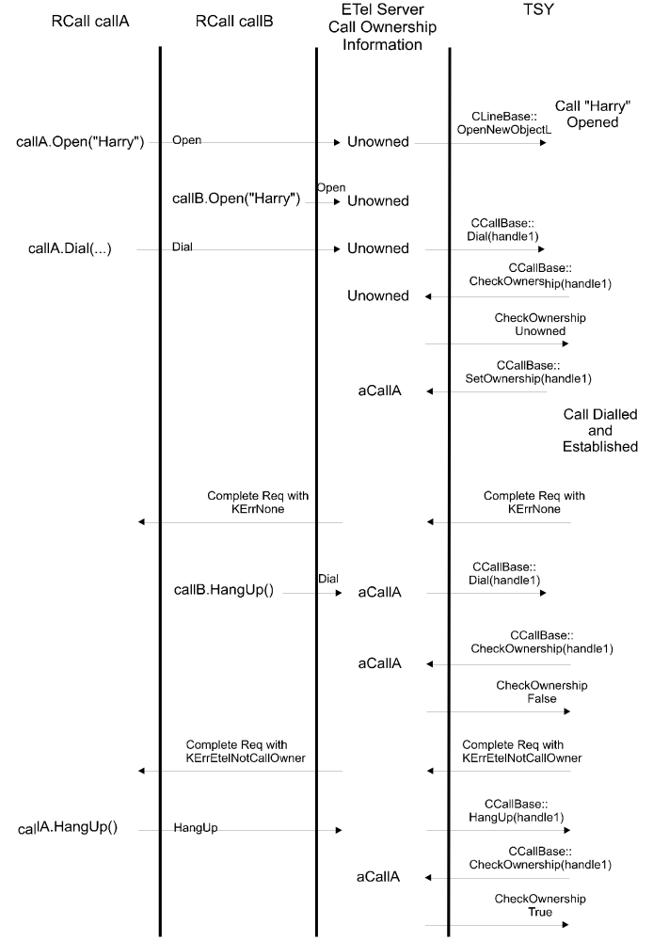
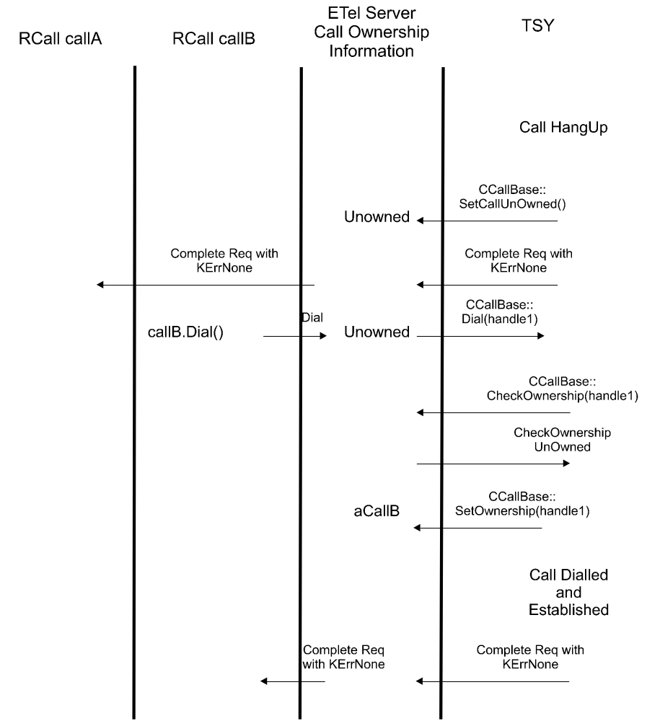

Call Ownership Transfer Example
This example shows one client establishing a connection and then transferring call ownership to another client. The second client then terminates the call.
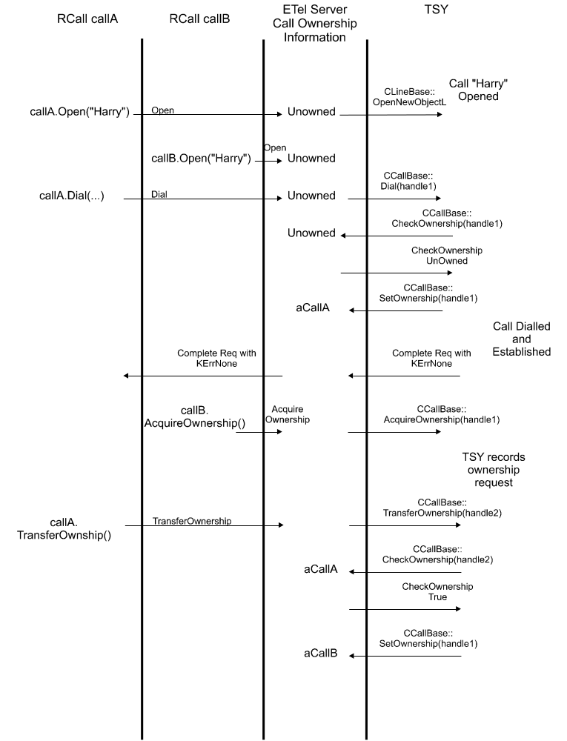
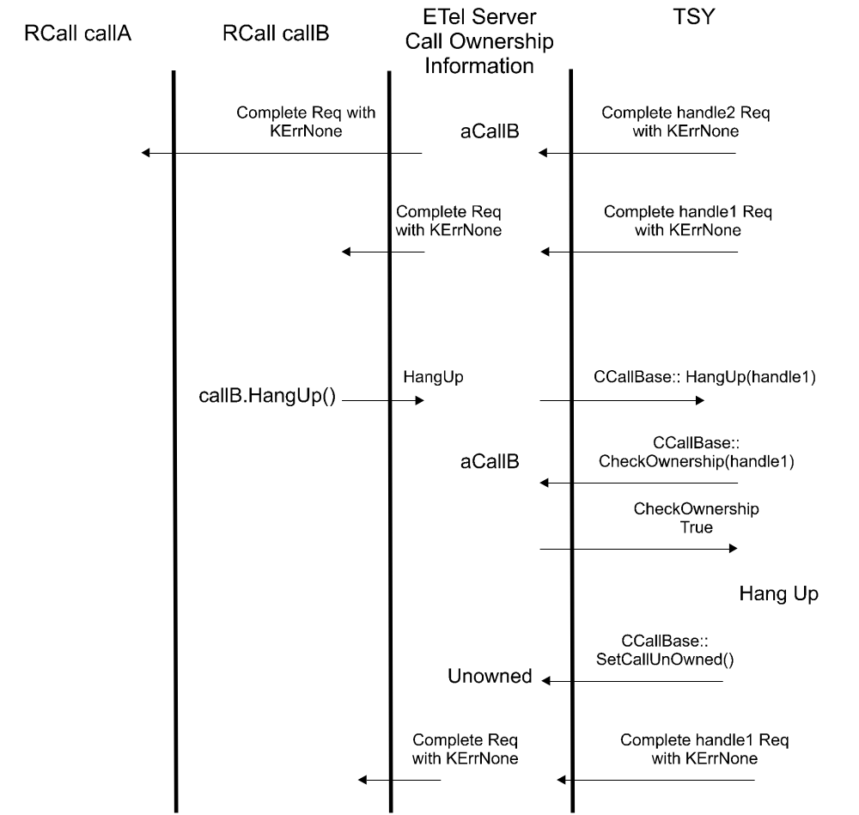

Client Panic Example A
This example shows one way in which a TSY can cope when a client that has call ownership panics or closes its handle on the call. In this example, another client has expressed an interested in acquiring call ownership and so the TSY can clean up by satisfying that request. It is then the responsibility of the second client to eventually terminate the call cleanly. The golden rule here is that an active (i.e. connected) call must have an owner. Although the example shows the client panicking, the same algorithm applies if the owning client closes its handle on the call while the call is still active.
The case where an owning client panics (or closes its call handle) and there are no other clients interested in acquiring call ownership is dealt with in the next section.
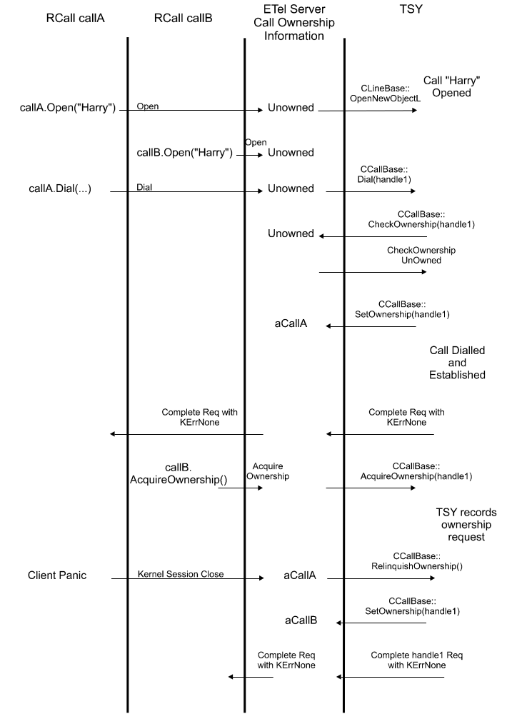
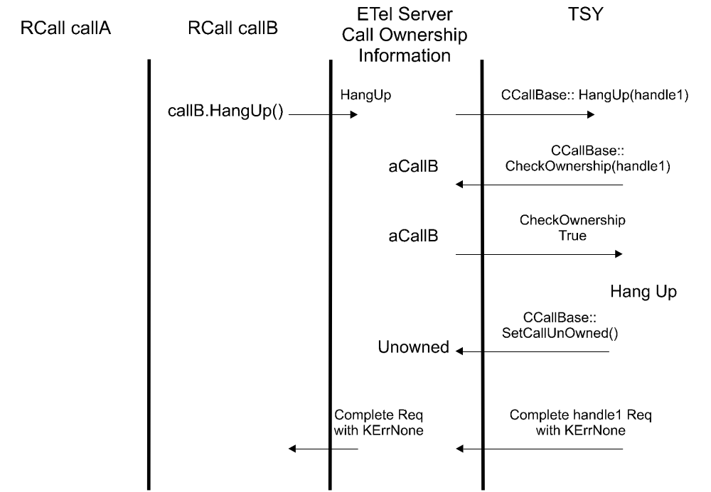

Client Panic Example B
This example illustrates the clean-up of a connected call whose owner panics (or closes its call handle) when there are no other clients interested in acquiring call ownership. The client opens the call, establishes a connection (thereby gaining ownership) and then promptly panics. It is up to the TSY to cleanly terminate the call.
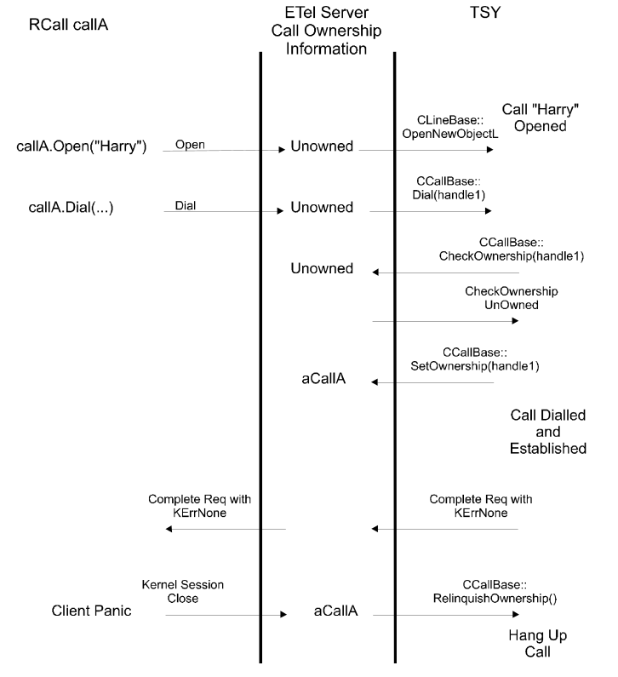

Fax Session Examples
The following examples illustrate the operation of a fax session under a number of scenarios. All the diagrams show the division of labour between the client, server, TSY and fax server.

Fax Dialling and Transmission
This example illustrates a fax connection being established, a successful fax transmission and then the connection termination.
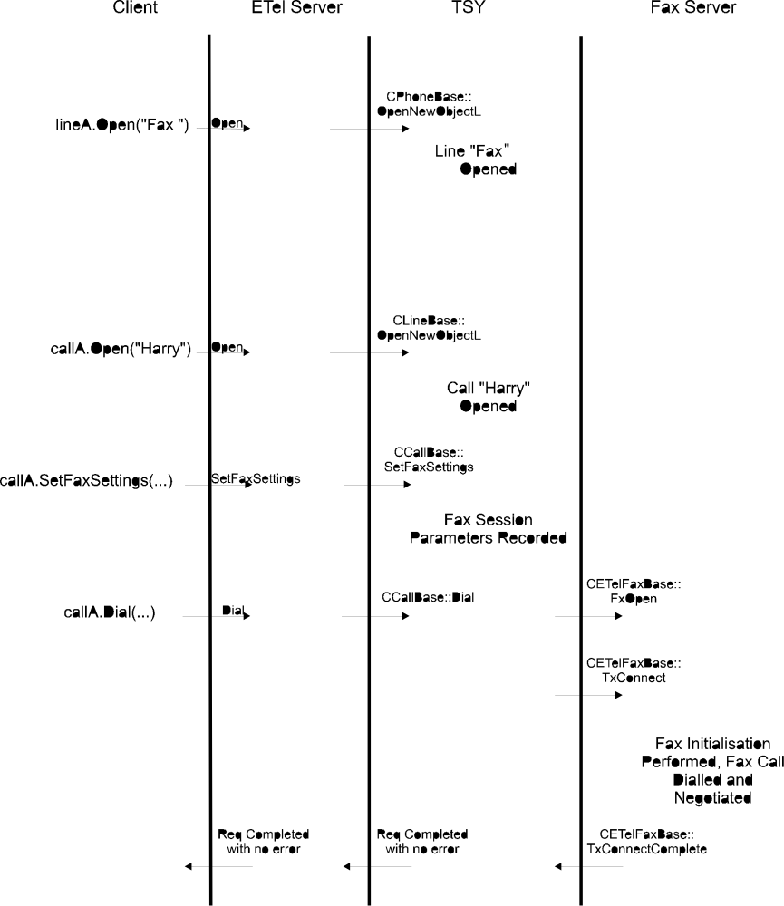

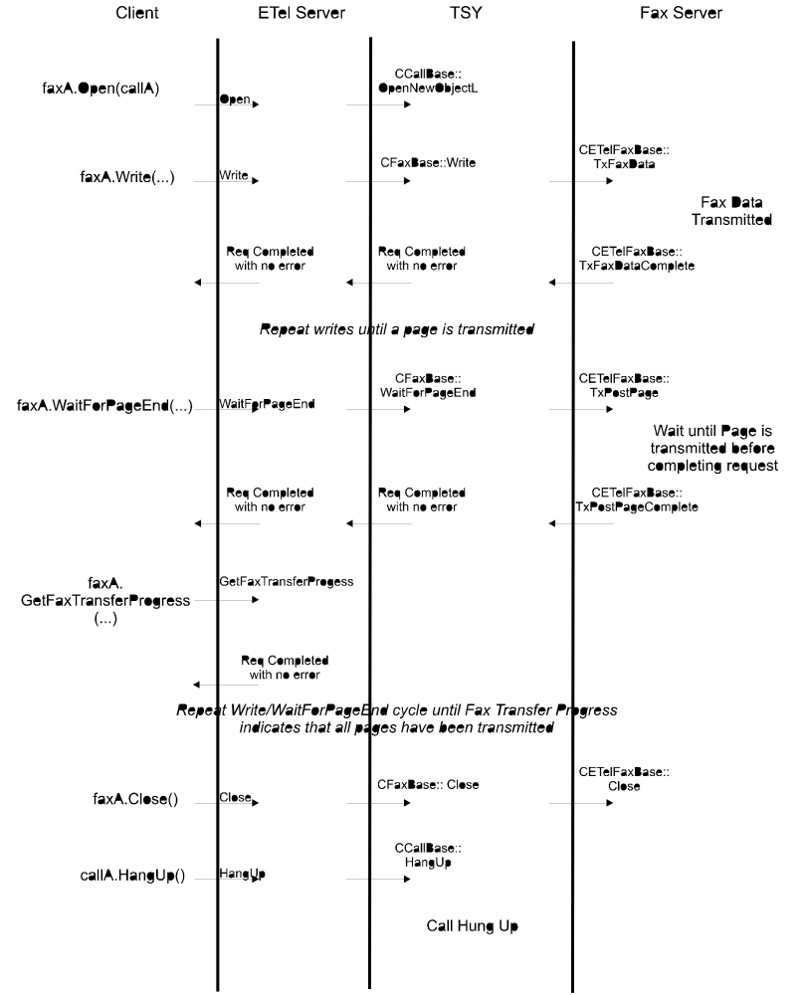
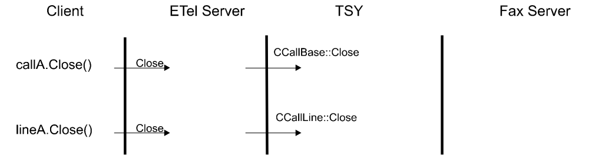

Fax Answering and Receiving Example
This example illustrates a fax call being answered, a successful fax reception and then the connection termination.
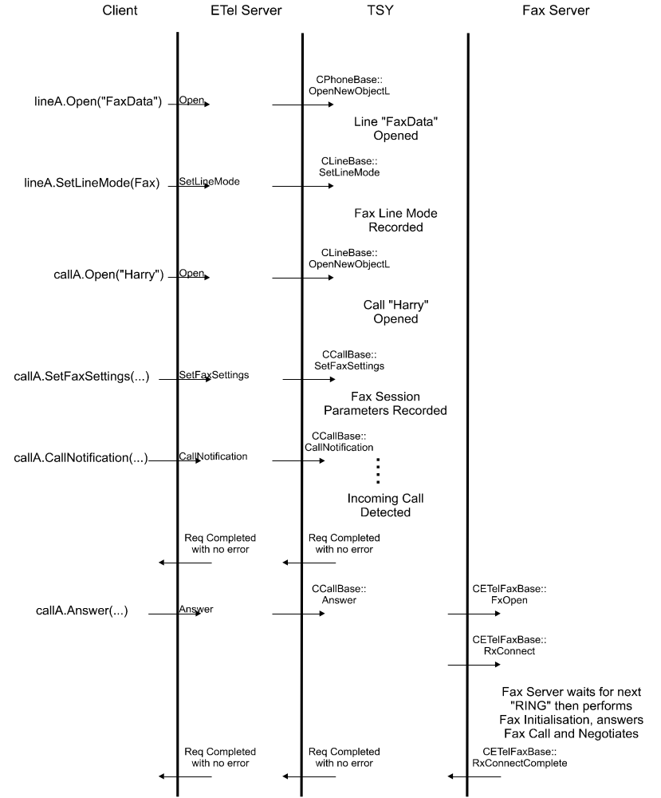

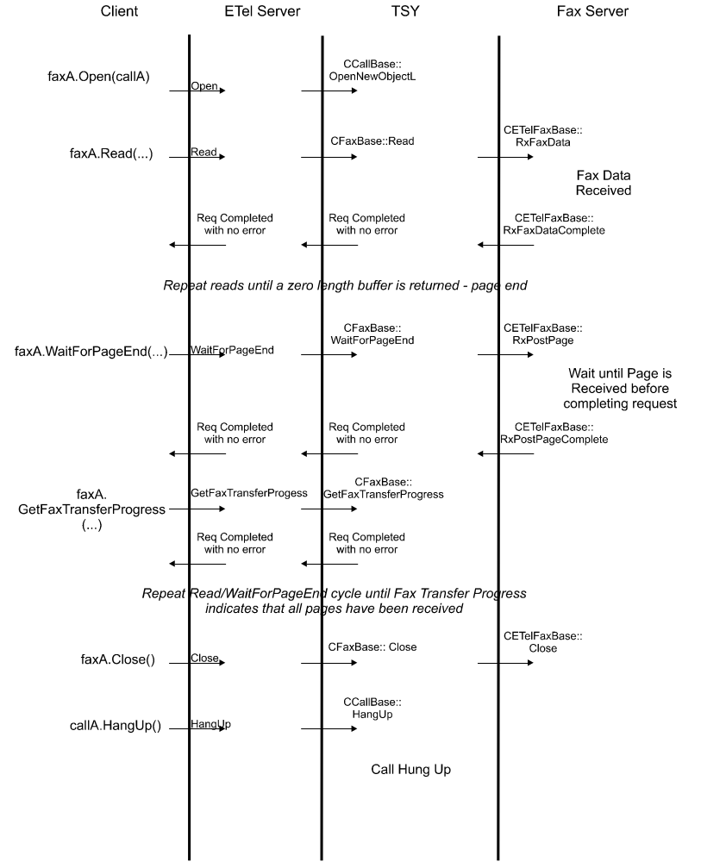
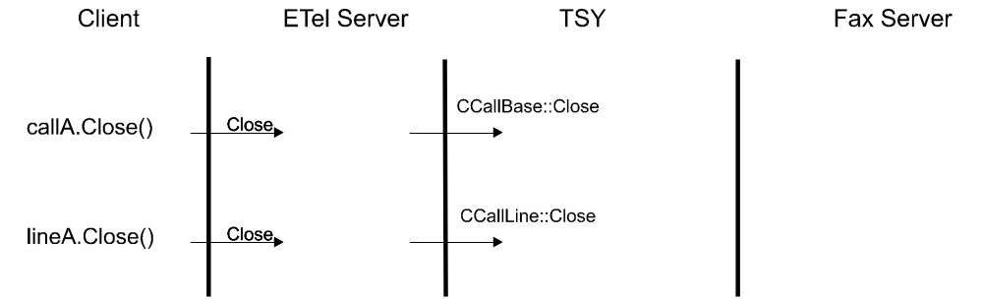

ETel Core Error Messages
The following error codes are used and defined by the ETel Core API. These error codes alongside the E32 Base set of error codes collectively form the basic error space. The error codes defined in the ETel extensions, such as ETelMM, ETelSAT, ETelPacket exterror.h in ETel, as well as those defined by Licensees, collectively form the extended error space. The licensee defined extended error space has a range of -21000 to -29999.
Error | Description
KErrEtelNotCallOwner | The client is not the call owner and has attempted to perform an operation that requires ownership.
KErrEtelDuplicatePhoneName | An attempt has been made to load an ETel (TSY) module which contains a phone with the same name as one already loaded.
KErrEtelAlreadyCallOwner | An attempt has been made to acquire call ownership when the requesting client is already the call owner.
KErrEtelNoCarrier | A connection has been terminated because the carrier has been lost.
KErrEtelBusyDetected | An attempt to establish a connection with the RCall::Dial request has failed because the remote party’s line was busy.
KErrEtelNoClientInterestedInThisCall | An attempt has been made to transfer call ownership, but no other clients are interested in acquiring ownership.
KErrEtelInitialisationFailure | The TSY has failed to initialise the modem.
KErrEtelCallNotActive | An attempt has been made to perform an operation which requires the call to be connected (active). However, the call is not currently connected.
KErrEtelNoAnswer | In response to an RCall::Dial() request, the remote end has not answered.
KErrEtelNoDialTone | In response to an RCall::Dial() request, there is no dial tone.
KErrEtelConfigPortFailure | The configuration of the comms port has failed.
KErrEtelFaxChunkNotCreated | There has been a failure in creating the fax progress memory chunk.
KErrEtelNotFaxOwner | An attempt has been made to establish a fax call using an RCall object which is invalid; that is, that an RFax object has already been opened from a different call object. (Only one fax object may exist at one time).
KErrEtelPortNotLoanedToClient | In response to RCall::RecoverDataPort(), the function RCall::LoanDataPort() has not been called previously.
KErrEtelWrongModemType | The fax class requested is not supported by the modem.
KErrEtelUnknownModemCapability | In response to RCall::SetFaxSettings(), the fax classes supported by the modem are as yet unknown; the client should try again when the modem has been fully initialised.
KErrEtelAnswerAlreadyOutstanding | In response to RCall::AnswerIncomingCall(), this function has already been called on another call object in the TSY. The TSY may only allow one call to be designated the call to answer the next incoming RING - per line, or per phone.
KErrEtelModemNotDetected | No response from the modem has been detected. The modem has probably been disconnected.
KErrEtelModemSettingsCorrupt | The Comms Database is either missing or corrupt.
KErrEtelPortAlreadyLoaned | The port is already loaned.
KErrEtelCallAlreadyActive | The call is already active.

ETEL Utilities

In order to provide generic classes that could be utilised by different telephony components, some utility classes and methods are defined in ETEL.

TLV structure support

Interface to TLV (TYPE- LENGTH-VALUE) structured data, depicted below:

ItemId | Length Of The Item Data | Data Item Data | ItemId | Length Of The Item Data | Data Item Data | …..

is supported via templated class TTlvStruct, and its helper interface classes MTlvItemIdType and MTlvDataLengthType.

Class MTlvItemIdType defines interface for classes that encapsulate identification of items within the TLV structure. Therefore, following methods are defined:

virtual void ExternalizeL(TDes8& aBuffer) const =0; | Externalize object by serializing to provided descriptor
virtual void InternalizeL(TDesC8& aBuffer)=0; | Internalize object by de-serializing of data in provided buffer
virtual TUint SerializedLength() const =0; | The length of serialized data member
virtual TBool IsEqual(const MTlvItemIdType&) const=0; | Compares whether two objects contains the same data

Class MTlvItemDataLengthType defines interface for classes that encapsulate information about the length of data of items within the TLV structure. Therefore, following methods are defined:

virtual void ExternalizeL(TDes8& aBuffer) const =0; | Externalize object by serializing to provided descriptor
virtual void InternalizeL(TDesC8& aBuffer)=0; | Internalize object by de-serializing of data in provided buffer
virtual TUint SerializedLength() const =0; | The length of serialized data member
virtual TBool IsEqual(const MTlvItemIdType&) const=0; | compares whether two objects contains the same data
virtual void SetDataLength(TUint)=0; | Sets length of the data in the item
virtual TUint DataLength() const =0; | Gets length of the item data

Class TTlvStructBase provides foundation to class TTlvStruct (as in thin template pattern) and implements methods such are appending, removal or Iterative lookup for items in container buffer. It utilises interfaces MTlvItemIdType and MTlvItemDataLengthType in order to enable proper encoding and decoding of the first two fields in the unit that corresponds to the item.

class TTlvStructBase methods:

IMPORT_C TTlvStructBase(TPtr8&,TUint8); | Default constructor initializes data members
IMPORT_C TInt AppendItemL(MTlvItemIdType& aId,MTlvItemDataLengthType& aDataLengthType,const TPtr8& aData); | Adds item to the buffer
IMPORT_C TInt RemoveNextItemL(MTlvItemIdType& aIdToRemove,MTlvItemIdType& aId, MTlvItemDataLengthType& aDataLength); | Removes first subsequent item that meets the criteria
IMPORT_C TInt AnyNextItemL(MTlvItemIdType& aIdFound,TPtr8& aData,MTlvItemIdType& aId, MTlvItemDataLengthType& aDataLength); | Retrieves first subsequent item
IMPORT_C TInt NextItemL(const MTlvItemIdType& aWantedId,TPtr8& aData,MTlvItemIdType& aId, MTlvItemDataLengthType& aDataLength); | Retrieves next item that meets the criteria
IMPORT_C void ResetCursorPos(); | Sets position of the cursor to start position (0)

class TTlvStructBase data members:

TPtr8& iPtr; | Reference to external buffer that holds encoded TLV data
TUint iCursorPos; | Cursor indicates last item accessed
TUint iFreeSpacePos; | Position in the buffer that indicates start of the zone that hasn't been assigned to any element.
TUint8 iFreeSpaceChar; | Character used to populate the zone that hasn't been assigned to any element. This free zone ends at the end of the buffer

This class shall not be used directly, but via public interface class TTlvStruct:
This one provides methods to append, remove or perform iterative lookup for items in container buffer.
Classes ItemIdType and ItemDataLengthType have to implement interfaces MTlvItemIdType and
MTlvItemDataLengthType in order to enable proper encoding and decoding of the first two fields
in the unit.

template <class ItemIdType, class ItemDataLengthType>
class TTlvStruct: public TTlvStructBase

class TTlvStruct methods:

inline TTlvStruct(TPtr8&,TUint8); | Constructor that is initialised by descriptor to TLV buffer that is to be read or written to.and character used to populate the zone that hasn't been assigned to any element.
inline TInt NextItemL(ItemIdType aId,TPtr8& aData); | Look up in the buffer for an item with specified identifier.  Look-up starts from the position of the cursor;
inline TInt AnyNextItemL(ItemIdType& aId, TPtr8& aData); | Look up in the buffer for the first subsequent item. Look-up starts from the position of the cursor;
inline TInt AppendItemL(ItemIdType aId,const TPtr8& aData); | Adds item identified by supplied aId argument to the buffer; content of the item is copied from provided descriptor to the buffer.
inline TInt RemoveNextItemL(ItemIdType aId); | Removes item identified by specified identifier (aId) from the buffer, where look-up starts at current cursor position.
TTlvStruct(); | Default constructor is protected in order to enforce proper initialization of reference to external data buffer via provided public constructor. Initializes data members and cursor position to 0.

class TTlvStruct data members:

ItemIdType iItemIdType; | Type of the identifier
ItemDataLengthType iItemDataLengthType; | The type used to define length of data portion of the item

ETel UDEB Logging

In Debug mode (UDEB), ETel can be used in conjunction with logging utilities (Flogger1/2) to extract logs from ETel’s usage in runtime.
Currently, ETel logging functionality exists in two forms;
- an older version in Symbian OS v9.1 and below, where logging is output through Flogger1;
- and a newer version in OS v9.2 and above, which uses Flogger2 (common/generic/comms-infras/CommsDebugUtility/ - also known as CDU)

ETel logs are especially useful for viewing the following information:
- IPC numbers of ETel (and ETel extension) request
- Errors for any request
- TSY request handles
- Request cancellations

v9.1 and Below: Flogger1

Obtaining ETel logs in this form is by simply following these steps:
- Create a folder c:/logs/etel on the Symbian OS device/emulator (i.e. in emulator this should be /epoc32/winscw/c/logs/etel on your system)
- Run your ETel based scenario or test case
- ETel logs outlining its usage will be found at c:/logs/etel/setel.txt

A limitation of this form of logging is that it is impossible to obtain logs from system start-up on ARM hardware, unless a persistent c:/ drive is available; while persistent drives are almost always available on final products, most reference hardware will reset the c:/ drive by default when the device is powered off.
Also, ETel logs provided through Flogger1 are stand alone logs and cannot be interlaced with logs from other components. However, ETel has attempted to overcome this by appending a timestamp to the beginning of every line it logs.

The following Perl script can be used to annotate the setel.txt log file for better comprehensibility:

It is effective only when used in a drive that contains an epoc32 installation/tree from the root of the drive. Type illustrateetellog.pl -h at the command prompt for usage and help.

v9.2 and Above: CDU Logging

CDU allows multiple “LOG…” lines to be specified in the commsdbg.ini file. Logs from all components listed (i.e. including ETel’s) will be interlaced in a file found at:
C:/logs/log.txt

To enable ETel logging, create a file called "commsdbg.ini" (if one does not exist) in the Symbian OS c:/logs/ directory, which must state the following line:
LOG ETel *

After running some scenario to produce logs in the c:/logs/log.txt, you will have the option of reading the logs as they are or use a tool, “splitlog” available in /epoc32/tools/, to split the logs for the various components (i.e. which would have been listed in commsdbg.ini) into individual files.

When using hardware, rather than emulator, the user also has the option of placing this ini file in the device's z:/resource folder, which can enable logging from the early stages of system start-up. (This is simply because you can't build a ROM with c:/logs/..., unless you are using a persistent c:/ drive of course.) This can be done by placing your ini file anywhere in your system, then create a new iby (or edit an existing iby) with the following additional line:
data=<location>commsdbg.ini Resource\commsdbg.ini
where <location> is to be replaced with your system’s location/path to this ini file. When the ROM is built with this iby file, Symbian OS will contain the ini file in the z:/resource/ folder.

There are various techniques that can optimise your usage of CDU, which can be enabled through modification of your commsdbg.ini; please refer to common/generic/comms-infras/CommsDebugUtility/ for more detail.

NB: illustrateetellog.pl attached in section 11.1 can be used to illustrate these CDU ETel logs, but only after using the splitlog tool to isolate ETel’s log output. See the help (-h option) provided through this script for information on how to specify arbitrary input log file name.

References
# | Name | Version | Location
[1] | ETel Telephony Server Design | 12 | //epoc/main/generic/telephony/etel/documentation/SVRDESGN.doc

Revision History
# | Who | When | Changes
1 | AMC | 12/1/97 | Initial release
2 | AMC | 21/3/98 | Updated to reflect modifications to the core API.
3 | MSS | 18/8/98 | Updated to reflect modifications to the core API.
4 | MSS | 27/11/98 | Updated to reflect modifications to the core API.
9 | KAS | 07/06/99 | Updated to remove the “notify on anything” and separate register/deregister methods made in ETEL 554 release.
10 | MSS | 30/06/99 | Updated AnswerIncomingCall.
11 | MSS | 11/01/00 | Added NotifyCapsChange() to RPhone, RLine, RCall. Added missing error codes.
12 | ND | 11/03/02 | Clarify the concept of call ownership
13 | SB | 02/11/02 | Updated to reflect modifications to the core API.
14 | NMc | 31/03/03 | Included extra condition from which RCall::HangUp may be used.Included extra condition from which RCall::HangUp may be used Included extra condition from which RCall::HangUp may be used Included extra condition from which RCall::HangUp may be used Included extra condition from which RCall::HangUp may be used Included extra condition from which RCall::HangUp may be used
15 | NMc | 01/09/04 | Addition of new RCall API

Further Information

People
Role | Person / People
Contributor(s) | Andrew Cloke, Matthew Swan, Katie Sheehy, Nathalie Doyelle, Shazia Bhatti, Neil McAlpine,Dejana Serdarevic,Ravishankar Lakshminarayanan
Reviewer(s) | Telephony Team

References
No. | Document Reference | Version | Description
[1] | ETel Telephony Server Design | 1.0 | //telephony/etel/documentation/ETel_Telephony_Server_Design.doc

Open Issues
No open issue.

Glossary
The following technical terms and abbreviations are used within this document.
Term | Definition
ETel | Symbian OS Telephony Server
TSY | Telephony Driver

Document History
Date | Version | Status | Description
11-01-00 | 11 | Issued | Version of the document inherited from 6.1.
13-03-02 | 0.1 | Draft | - Copy of original document in SGL.PPS001.501 Formal Document Template Rev 6.0  - Clarify call ownership concept  - Add section describing RCall::ReferenceCount
21-11-02 | 1.0 | Issued | Updated to reflect modifications to core API.
31-03-03 | 1.1 | Issued | Fixed defect  - DEF022402 – (Prop frm 7.0) ETel RCall::HangUp documentation misleading  Included extra condition from which RCall::HangUp may be used.
17-09-04 | 1.2 | Issued | Addition of new RCall API.
04-05-05 | 1.3 | Issued | Fixed defect: DEF055591 ETel Extended Errors Documentation needs to be improved.
04-04-06 | 1.4 | Issued | Addition of “ETel UDEB Logging” section
19-01-07 | 1.5 | Issued | Changes to RTelServer::SetPriorityClient() API in section 2.9  Added the RPhone::SetEmergencyClient() API in section 3.4.
26-01-2009 | 1.6 | Issued | Deleted CDMA references as part of PREQ 2002

Document Review Date
Not Applicable.

