ETel Telephony Server Design

Security Classification: | Internal
Document Reference: | N/A
Status: | Issued
Version: | 2.5.
Team/Department : | Converged Comms / Core Development
Author(s): | Alexandros Nikitas , Dejana Serdarevic, Neil McAlpine, Rajiv Bajaria, Ravishankar Lakshminarayanan
Owner(s): | Dejana Serdarevic

Approver(s): | Converged Comms Team | Distribution: | Converged Comms Team & licensees

Contents
1 Introduction 4
2 Requirements 5
3 ETel Architecture 6
3.1 Overview 6
3.2 The Comms Framework. 6
3.2.1 Implementation details 7
3.3 Standard ETel API 7
3.4 ETel Extensions 7
4 Design 9
4.1 Core Client API 9
4.1.1 Root Server Session 9
4.1.2 Phone Sub-Session 10
4.1.3 Line Sub-Session 10
4.1.4 Call Sub-Session 11
4.1.5 Data Port Access 12
4.1.6 Fax Port Sub-Session 12
4.2 Client API Extensions 13
4.3 Server Design 13
4.3.1 Core Server Design Overview 13
4.3.2 Server Extensions 16
4.3.3 Request Modes 16
4.3.4 Handling multiple versions of requests 17
4.3.5 Request Flow Control 20
4.3.6 Type of Request 20
4.3.7 Phone Manager Database 21
4.3.8 Request List 22
4.3.9 Server Request Flow Diagram 23
4.3.10 Server Completion Flow Diagram 25
4.3.11 Emergency Request Handling 26
4.3.12 Priority Client 30
4.4 Miscellaneous Design Notes 32
4.4.1 Multiple Clients Competing to Answer Incoming Calls 32
4.4.2 Call Ownership 32
4.4.3 Notification Buffering 33
4.4.4 Multi-Slot Request Buffering 34
4.4.5 Registration of notifications 35
4.4.6 Provision of extended error codes 35
4.4.7 Phone Name “Mangling” 37
5 Example Procedures 38
5.1 Establishing a Data Call 38
5.2 Answering a Fax Call 38
5.3 Passing a Call Between Clients 39
6 Platform Security 40
6.1 Capability Assignments 40
6.2 API Policing 40
6.3 Policing Custom APIs 41
6.4 Reordering of Etel Serviced IPCs 41
6.5 Global Kernel Objects Support 42
7 Further Information 43
7.1 People 43
7.2 References 43
7.3 Open Issues 43
7.4 Glossary 43
7.5 Document History 44
7.6 Document Review Date 44

Introduction
ETel is the EPOC32 telephony server. It is used to abstract control over the many different types of telephone device, which can be connected to or integrated with an EPOC32 computer. This can include a conventional analog modem, a GSM handset or a desktop telephone with an integrated EPOC32 computer.
The open market development of wired and wireless telephony hardware has created a bewildering array of functions and features. Some of these are useful and some are merely gimmicks. Where useful functionality is supported by a number of manufacturers there is often no agreement on the actual implementation. ETel attempts to manage this diversity by grouping the small sub-set of (near) universally supported functionality into a Core API, and then providing powerful methods for extension. Where many different modems support similar extensions the intention is to provide a standard API extension. The GSM 07.07 standard and voice modem features are good examples where standard API extensions can be proposed. These examples are discussed in more detail at the end of this document.
This document starts by discussing ETel's requirements. It then outlines ETel's architecture and details its core functionality. Finally, a set of extensions for the GSM wireless standard is proposed.

Requirements
The core ETel functionality is designed to fulfil the requirements of a wide range of applications which need to pass information over a telephony link. The core functionality does not provide access to any special features or services offered by the underlying telephony hardware. However, it does provide a generic interface that will allow applications to operate independently of the telephony hardware they are using.
Applications wishing to use the feature and services offered by specific hardware will use one or a number of API extensions. Such applications will gain enhanced functionality from this API, but they will also be limiting the hardware platforms with which they can operate.
The core functionality is listed below. It forms a basic set of common services offered by nearly all telephony hardware.
Functionality | Description | Applications
Status and Capabilities | Obtaining the Capabilities and Current Status of the Telephony hardware. | Call Monitors, Shell indicators
Data Calls | Make data calls, transfer information, then terminate them. | Internet enabled applications (used through ESOCK and the TCP/IP stack)
Fax Calls | Make fax calls, receive or transmit fax information, then terminate them. | Fax enabled applications
Transfer Active Calls between Clients | Pass a call answered (or owned) by one ETel client to another | Automatic switching of calls between a number of applications, based on call content.

ETel Architecture

Overview
ETel is constructed from the modules illustrated in the diagram below.

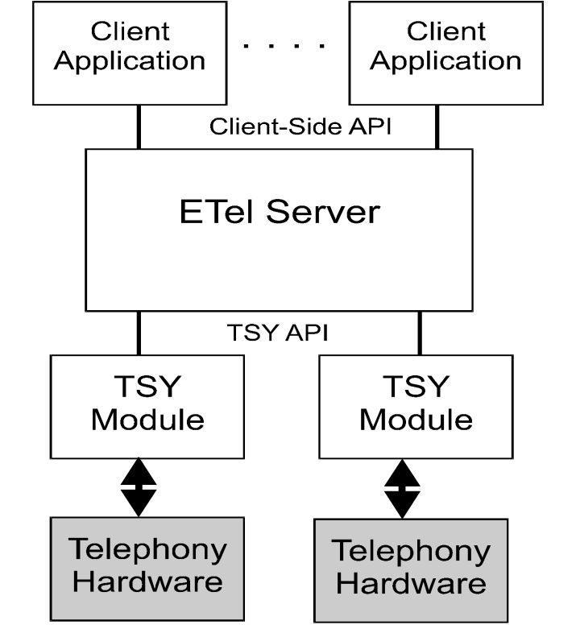

Client applications use the Client-Side API to access the services provided by the ETel Server. The ETel Server translates these into TSY requests which are passed onto the TSY modules. These modules then actually control the telephony hardware to affect the required action. The ETel Server also dynamically loads and unloads TSY modules at the request of clients.
A basic TSY may support core telephony functionality, such as making and terminating calls, on a wide range of hardware. Whereas a more advanced TSY, supporting GSM functionality for example, may only support phone hardware from a specific manufacturer, or even just a single phone.

The Comms Framework.
As ETel is a Comms Provider Module in the Comms Process, it is necessary to support the required functionality for a CPM [2]. This includes:
- • Meeting RThread::Rendezvous() when initialisation is completed.
- • The file type (2nd UID) is KUidCommsProviderModule (0x101f7418)
- • Listen for incoming messages from the RootServer.
In order for the Comms Configurator (c32start, [3]) to initially load ETel, a configuration file, etel.cmi is required, with the following content:

[Loader]
Name=CTelServer
FileName=etel.dll
ThreadFunctionOrdinal=233
IsSticky=1
IsServer=1
Priority=EPriorityNormal
StackSize=12288
StartSequence=5
HeapOption=ENewHeap
MinHeapSize=256
MaxHeapSize=786432
SystemCritical=1
ControlFlags=1

[3] documents the parameters used. During startup the file will be read by the Comms Configurator and the server will be loaded in sequence five as indicated above.

Implementation details
To respond to messages from the Comms Framework, ETel use the CTelChannelHandler class which is derived from the CCFModuleChannelHandler class from CommsFw. The default responses to most CommsFw messages by CCFModuleChannelHandler are fine (e.g. bind and unbind messages returns an error which is fine as ETel doesn’t have sub-modules). However, the Shutdown message requires special handling, so CTelChannelHandler overrides the CFMessageShutdown(…) member to implement controlled shutdown.
The CTelChannelHandler instance instantiated and held by ETel:
class CTelChannelHandler : public CCFModuleChannelHandler
Access | Member
public | CTelChannelHandler* NewL(RCFChannel::TMsgQueues aRxQueues, RCFChannel::TMsgQueues aTxQueues, CTelServer* aServer);
private | CTelChannelHandler(CTelServer* aServer);
private | virtual void CFMessageShutdown(const CommsFW::TCFShutdownMsg& aMessage);
private | CTelServer* iServer;

When receiving a Shutdown message from the RootServer the handler will call CFMessageShutdown (msg) which will call CTelServer::CFMessageShutdown(..) on the CTelServer for processing.
If the Shutdown type is EOptional or EGraceful, CTelServer will shut down the next time it has no active sessions. This could happen immediately or it might have to set iShutGracefully to ETrue which will cause it to shutdown when the last session is closed.

Standard ETel API
ETel introduces the concepts of Phones, Lines and Calls. All requests made to the ETel Server will be made through either a root ETel Server session, phone, line, call or data port. Further descriptions of the functionality made available through these classes are contained in the relevant design sections below.

ETel Extensions
Extended functionality supported by specific telephony hardware must be accessed through a standard API extension. Two such extensions are proposed at the end of this document. It is envisaged that many more may be created in the future. From the explanation of ETel’s operation it is clear that for a given extension to operate correctly not only must the required functions be supported by the hardware, but the extension must also be supported by the TSY module. Where two manufacturers have implemented the same functions in different ways, different TSY modules will be required. Both TSY modules will respond to the same TSY API, but use different commands to control the telephony hardware. It is important that all TSY modules supporting a given extension use the same ETel API standard. It is only though compliance with this standard that ETel can provide the necessary layer of hardware abstraction.

Design
The following sections describe the client-side API. First the core functionality is detailed and then the supported methods for extension are specified.

Core Client API
The following Rose diagram illustrates the classes used to implement the core client-side interface.

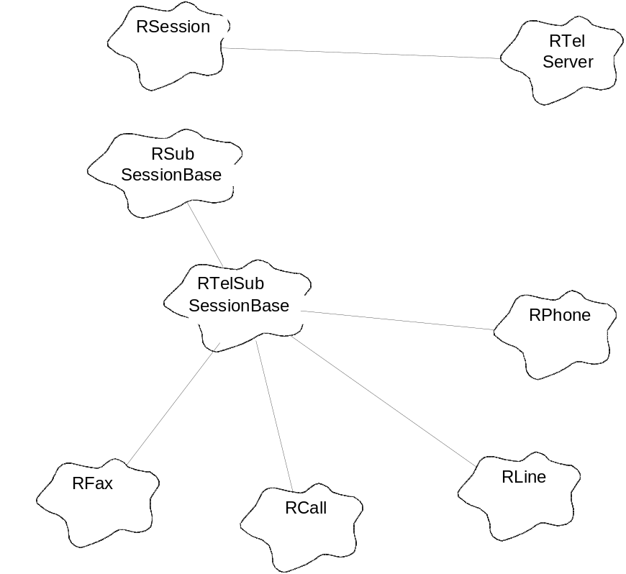

The client-side classes package the specified command and parameters and pass the request on to the ETel Server. The following sections describe these classes in more detail.

Root Server Session
The root Server session provides access to general information and functionality. Clients wishing to use the ETel Server must open a connection with the root session first. From there they may obtain information about the loaded TSY modules, and the phones that they support. To access functionality associated with a specific phone, the client must open a sub-session for that phone.
The functions supported by the root server session are listed in the table below.
Functionality | Description
Connect | Establish a session with the ETel Server.
Enumerate Phones | List the number of phones that are supported by the loaded TSY modules.
Get Phone Information | Obtain information about the phones listed with the Enumerate Phones call.
Get TSY name | Provide the name of the TSY that a particular phone belongs to.
Load TSY module | Load a TSY module by name.
Unload TSY module | Unload a TSY module by name.
Request TSY capability | Determine whether a particular TSY supports a certain group of functionality.
Get TSY version number | Provide the version number of a particular TSY.
Set Priority Client | Sets this client session as the priority session.
Set Extended Error Granularity | Set whether error values returned are basic or extended.
Close | Close an open root session.

Phone Sub-Session
The phone sub-session provides access to functionality associated with a specific phone.
Functionality | Description
Open Phone | Open a sub-session with a specific phone. The root session must be specified when opening the phone.
Capabilities | Obtain information about the phone’s capabilities, e.g. whether it can support fax and/or data calls or the number of lines supported (see next section).
Capabilities Notification | Notify clients that the capabilities have changed.
Status | Obtain information about the current status of the phone.
Enumerate Lines | List the number of lines that are supported by the phone.
Get Line Information | Obtain information about the lines listed with the Enumerate Lines call.
Initialise | Initialise the phone, ie send commands to the phone to put it into a known state.
Modem Detected Notification | Notify clients that the TSY has detected that the modem hardware is connected, or that it is no longer connected, i.e. it is no longer responding or certain asserted control lines have been dropped.
Get Information | Obtain a snapshot of current information about the phone.
Close | Close an open phone.

Line Sub-Session
The line sub-session provides access to functionality associated with a specific line.
Functionality | Description
Open Line | Open a sub-session with a specific Line. The associated phone must be specified when opening the Line.
Capabilities | Obtain information about the line’s capabilities, for example, whether it can support fax, data or voice calls.
Status | Obtain information about the current status of the line.
Hook Status | Obtain information about the current status of the hook.
Enumerate Calls | List the number of calls that are opened on the line.
Get Call Information | Obtain information about the calls listed with the Enumerate Call function.
Get Information | Obtain a snapshot of current information about the line.
Incoming Call Notification | Notify a client of an incoming call.
Hook Change Notification | Notify a client of a change in hook status.
Status Change Notification | Notify a client of a change in line status.
New Call Added Notification | Notify a client of a new call being added to the line.
Capabilities Notification | Notify a client that the capabilities have changed.
Close | Close an open line.

Call Sub-Session
The call sub-session provides access to functionality associated with a specific Call.
Functionality | Description
Capabilities | Obtain information about the call’s capabilities.
Status | Obtain information about the current status of the call.
Open Call By Name | Open a sub-session with a specific Call that is known to exist. The associated line must be specified when opening the call.
Open New Call | Open a sub-session with a new call. The name of the call is returned.
Dial | Dial a number and establish a connection with a remote modem.
Answer | Answer an incoming call, or wait for an incoming call and answer it.
Immediate Connect | Connect to a call which has already been established.
Loan Data Port | Request access to the raw data stream from a Data Call.
Recover Data Port | Relinquish access to raw data stream.
Hang Up | Terminate an active call.
Transfer Ownership | A synchronous function to transfer call ownership to another client.
Acquire Ownership | An asynchronous function to attempt to acquire call ownership from another client.
Get Ownership Status | Obtain information about the ownership of the active call.
Hook Change Notification | Notify clients that the hook status has changed.
Get Bearer Information | Retrieve information about the bearer associated with an active connection.
Capabilities Notification | Notify clients that the dynamic capabilities have changed.
Call Progress Notification | Notify clients that the progress state of the call has changed. The following are states are valid: Not Connected, Ringing, Dialling, Answering, Immediate Connecting, Connected, Disconnecting, Unknown.
Call Progress Status | Return the current progress state of the call.
Call Duration | Return the current duration of the call.
Get Information | Obtain a snapshot of current information about the call.
Get Call Parameters | Obtain the current call parameters.
Set Fax Settings | Set the required settings for a fax call.
Get Fax Settings | Obtain the current settings for a fax call.
Close | Close an open call.
Adopt Fax Shared Header File | Passes an open file from the fax client to the fax server.

Data Port Access
Access to the serial data pipe created by an active connection is provided through the C32 Communications Server API. Loan and Recover functions are added to the RCall sub-session to mark the start and end of the data transfer. The client should first use ETel to establish the call and then call the Loan function before opening a communication server’s port. Once the data transaction has been completed, the client should call the Recover function before using ETel to terminate the call.

Fax Port Sub-Session
The fax port sub-session, if supported by the call, provides access to the fax stream flowing between the local hardware and a remote fax/modem during an active call. The functionality provided is given below.
Functionality | Description
Open | Open a sub-session with a specified Call.
Read Data | Read Data received from the remote modem.
Write Data | Write Data to the remote modem.
Wait for the End of the Page | Wait for the end of the received or transmitted page.
Terminate Fax Session | Allow the fax session to be terminated. This may occur prematurely as a result of an error or user intervention, or at the end of the fax transmission or reception.
Get Progress | Obtain current progress information.
Close | Close an open fax port.

Client API Extensions
There are two methods for extending ETel’s functionality: the existing sub-sessions may be extended by adding additional functions and entirely new sub-sessions can be created.
- Existing sub-sessions may be extended by inheriting from the existing classes to create new classes which implement the required functions. To assist development special protected functions are provided by the RTelSubSessionBase class which pass requests to the ETel Server.
- New sub-sessions may be created by inheriting from the RTelSubSessionBase class. Again, this new class will implement the required functionality, and protected functions are provided in the parent class to ease creation and request submission.

Server Design

Core Server Design Overview
The following Rose diagram illustrates the Core Server design.
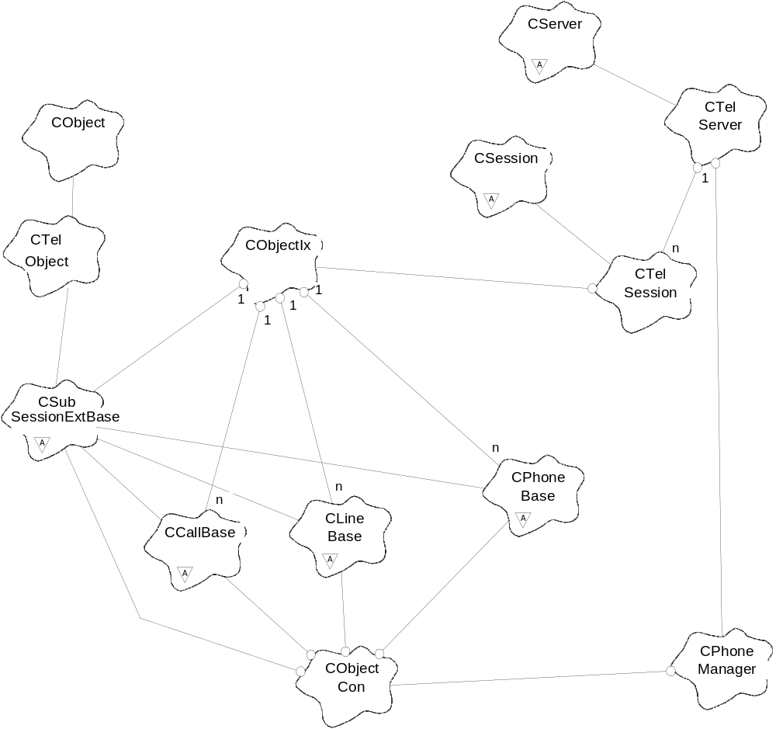
The CTelServer class is created when the ETel thread is started. It receives requests to create new sessions and responds by instantiating new CTelSession classes. Requests passed to the server from the client-side classes are received by this CTelSession class, where they are either processed locally or dispatched to the appropriate Phone, Line, Call or extension base class. The CTelSession also manages references to Phones contained in the CPhoneManager database. When a request is received to open a phone, the CTelSession will examine the CPhoneManager database to see if it already exists. If it does the CPhoneManager will be used to obtain the necessary reference. If it does not, a new instance will be created and logged with the CPhoneManager. Further details of the way in which the server processes requests are contained in the sections below.
The creation of a new phone instance is handled by the CPhoneFactoryBase class. This is an abstract class that is implemented by the TSY module. The base class contains a pure virtual function that returns a new instance of a phone.
The ETel Server TSY API is created by five abstract base classes: those representing phones, lines, calls, faxes and extensions. The following diagram explains the server/TSY interface classes in more detail than the previous diagram. The left hand classes which all begin with M are mixin classes. They contain only pure virtual functions and are all inherited by classes on the right. The mixin classes only exists to help TSY developers know which functions they must implement in the TSY (in classes derived from CPhoneBase, CLineBase etc) and which functions they are able to call in the server. They are all defined in one header file, ET_TSY.h. The right hand classes, from which TSY classes actually derive, are defined in ET_Phone.h.

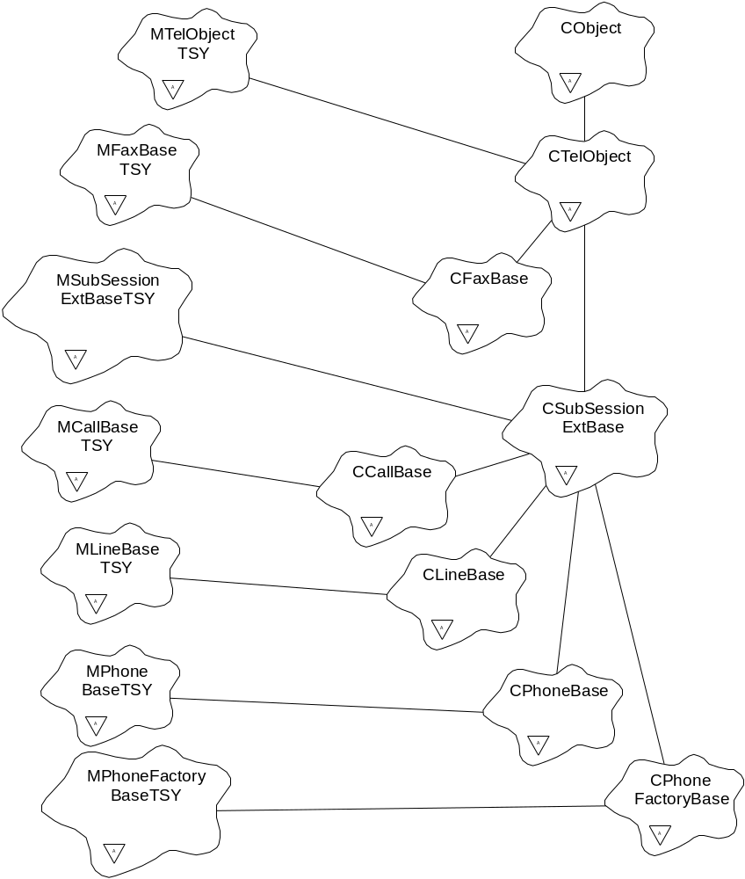

Requests are passed on to these base classes by the CTelSession. Each has at least two functions to support each request. The first is a pure virtual request function and the second a completion function. The request function, implemented by code in the TSY module, passes two parameters: a unique request handle and the parameters necessary to execute the command. The TSY must then perform the required action, which may require some asynchronous operation, and complete the request by calling the completion function. The completion function also takes two parameters: the request handle and a completion status. Once called, the server will then complete the original request made by the client, informing the client of the completion status.
Client requests to open sub-sessions (phones, lines and calls) must be dealt with as special cases. Requests to open phones are directed, by the client-side code, to the root ETel session specified in the parameter list. Similarly, requests to open lines are directed to the relevant phone sub-sessions, and open call requests are directed to lines. In all cases the CTelSession calls the appropriate function to obtain a reference to the required sub-session. This reference is recorded by the CPhoneManager for future use.

Server Extensions
The server must cater for two types of extensions: additions to existing sub-sessions (phone, line and call) and completely new sub-sessions.
In order to support the first type an additional function is included in the CSubSessionExtBase class, from which all extendible sub-sessions are inherited. This function provides a generic extension request function. It takes three parameters:
- The Request Handle
- The IPC number of the command, passed from the client-side, and
- Any necessary command parameters
Extended functions are completed in exactly the same way as core functions, i.e. the TSY must call the CTelObject::ReqCompleted passing the Request Handle and a status value.
Any request not recognised by the server as belonging to the core set will be offered to the relevant CSubSessionExtBase::ExtFunc function. If a KErrNotSupported error is returned by this function the server will complete the client’s request informing it that the request was not recognised. If KErrNone is returned by the CSubSessionExtBase::ExtFunc function the server will assume that the command was recognised and will expect the general completion function to be called in due course.
The second type of extension catered for is the creation of completely new sub-sessions. These are inherited from the CSubSessionExtBase class in the same way as the core extendible sub-sessions. The server uses the generic request function CSubSessionExtBase::ExtFunc function, described above, to pass requests to the TSY. Extendible sub-sessions are opened using the MTelObjectTSY::OpenNewObjectL() function. This function must return synchronously with a pointer to the newly created CTelObject class, or leave if there is an error condition. Upon successful completion of this function the server will add the new instances to the PhoneManager database and the session CObjectIx index.

Request Modes
Each request has a mode which consists of three attributes. These attributes may be either enabled or disabled, giving eight possible combinations. The attributes are described below:
Attribute | Description when enabled
Multiple Completion | When multiple clients make the same request from the same TSY object, the server will check the “version” of the passed parameters determined by the client’s buffer size. The server will use different TSY Request Handles for requests not buffered in the server,  The server will only pass the first request to the TSY, for requests that can be cached. For any other case, the TSY will send multiple requests only for the requests that are different i.e. it will cache any consequent requests with same “version” of parameters.  Subsequent requests will be stored by the server and completed when the TSY calls the request’s completion function.  TSY developers see 4.3.4 for implementation guidelines
Re-post Immediately | When the TSY completes the request, the server will immediately call the same request on the TSY, on the same call stack. This is done without the client’s knowledge. Most notifications should have this request mode, as it ensures that if an event occurs before a slow client has had time to call the notification function again, the server will buffer that notification completion event.
Obey Flow Control | When the Flow Control counter is non-zero, the server will buffer incoming requests on the ‘waiting’ queue. When the request is passed to the TSY the Flow Control counter must be increased. When the TSY completes the request the Flow Control counter must be decreased and checked. If its value is zero, the next buffered command should be submitted.

The following table gives examples of requests that fit into the four categories created.
Multiple Completion | Re-post Immediately | Flow Control | Description
Disabled | Disabled | Ignored | TSYs wishing to implement their own buffering algorithm will place all requests in this category.  This category will also be used by the Data Port Recovery request that must be passed to the TSY to indicate that it may use the communications port after a loan.
Disabled | Disabled | Obeyed | Commands that change the state of the modem, e.g. setting the monitor volume level; in other words, those commands that the TSY should only deal with one at a time.
Disabled | Enabled | Ignored | Requests that notify a client about a change of state, where the TSY needs to distinguish between different clients.
Disabled | Enabled | Obeyed | This combination should not be used. It provides no useful behaviour.
Enabled | Disabled | Ignored | Either (a) commands that may take some time, but which the TSY can handle more than one of concurrently, or  (b) notifications that the TSY does not wish to be re-posted immediately, so the server does no buffering.
Enabled | Disabled | Obeyed | Commands that request information from the modem that is not cached, hence takes a finite amount of time. The TSY should only deal with one of these commands at a time.
Enabled | Enabled | Ignored | Requests that notify a client about a change of state. Since these requests do not require the issuing of any modem commands, they do not have to obey flow control. The TSY never gets more than one of these outstanding per TelObject.
Enabled | Enabled | Obeyed | This combination should not be used. It provides no useful behaviour.

If a TSY requires a special request buffering algorithm that is not covered by the categories above it should not use multiple completion and should ignore flow control. It can then perform any buffering and additional processing internally. It cannot rely on the server for support.

Handling multiple versions of requests
The ETel server provides a mechanism, which allows different versions of packaged parameters to be passed down to the TSY through the same request type. However, this feature is not compatible for requests using multiple completion, which ETel normally caches instead of sending down to the TSY.
ETel server’s handling of different versions of requests requires passing of different packaged objects through requests. These multiple objects should use a common base definition that can hold the version number/type of the packaged parameters. This makes it possible for the TSY to identify the version of the client buffer and handle the request appropriately.
The server internally has a mechanism of comparing the object size of objects to determine whether the request can be cached on the ETel level or not. Requests with different versions of parameters are treated as separate requests. Similar requests with multiple completion enabled that have the same object size are still cached on the ETel server.
The following table represents a set of guidelines that TSY developers have to follow to implement support for multiple versions of requests. The first stage is identifying requests that potentially have multiple versions of parameter types defined that can be used. The problem arises in the case that a descriptor (TDes) is used for passing a reference to data to the TSY. Multiple object types could be available in this case and could be passed by packaging parameters using TPckg. The second column denotes if the TSY if the TSY supports all versions of the packaged parameters and there are scenarios whereby both of these types could be used simultaneously on the same TelObject e.g. RPhone.
Developers that have identified requests with multiple versioned parameters and support in the TSY have to consider the following: a) have these packaged parameters different size? b) Is there a conversion mechanism between versions? The first question is critical, because the ETel Server will try to identify the different versions of parameters based on their size. The second question leads into thinking of converting between the different parameter versions and completing all interested clients by completing the requests with the appropriate packaged parameters’ version. This will ensure that there is no confusion (in the content of parameters) for ETel clients when receiving results or information of requests through ETel.

Does the request use packaged parameters of different versions? | Does TSY support these different versions of parameters ? | Do different versions of parameters have different sizes? | Is there a conversion mechanism available in TSY between parameters of different versions? | TSY Request Implementation  Guidelines
No | No | (not possible) | (not possible) | Complete immediately with KErrNotSupported
No | Yes – Only one version available. | (not possible) | (not possible) | Complete when the operation completes with KErrNone or failure error code.
Yes | No | (not possible) | (not possible) | Complete immediately with KErrNotSupported for unsupported parameter versions  Complete request for all supported when the operation completes with KErrNone or failure code.
Yes | Yes | Yes | No | Two separate requests arrive in the TSY.  Complete independently when operation completes with KErrNone or failure error codes for each request separately.  Independent implementation and completion mechanism of request is required in the TSY implementation
Yes | Yes | Yes | Yes | Complete when the operation completes with KErrNone or failure error code.  Two separate requests arrive in the TSY, but one call to the phone’s signalling stack is sufficient.  Complete both requests when the operation completes and apply the conversion mechanism.  Return the appropriate parameter versions for pending requests.  Independent implementation and completion mechanism of request is required.
Yes | Yes | No | Yes | One request arrives in the TSY.  Complete both when operation completes with KErrNone or failure error code.  The clients should provide a buffer (parameter version) with the appropriate size to prevent overflow in any case.  Conversion should happen on the client side!

Request Flow Control
The server allows phones to have some control over the flow of requests passed by the server to the phone’s objects. This is achieved by TSY up-calls to the CTelObject::FlowControlSuspend and CTelObject::FlowControlResume functions. The server maintains one flow control counter for each phone that counts the number of suspend and resume calls made. The counter will then be used to determine whether requests should be passed to the Phone or any sub-sessions opened directly or indirectly from that Phone (e.g. Lines, Calls, extensions). The suspend function will increment the flow control counter, while the resume function will decrement the counter. If the counter is zero, requests will be passed on. If the counter is non-zero, requests will be buffered in the server.

Type of Request
The ETel server supports several types of requests. A request type is automatically passed to the server by the client whenever a request is made. It defines two aspects of the server’s behaviour. It defines whether parameters must be read from the client address space before the request’s execution, and whether the results from the execution must be written back to the client’s address space after execution. It also defines whether the request will be completed asynchronously by the TSY (a completion function will be called when the request is completed), or synchronous (the request will have completed when the request function returns).
The Request Types supported by the ETel Server are listed in the table below:
Type of Request | Description
EIsaCancelMessage | The request is canceling a previous request. It does not require any parameters, nor does it return any results. It completes synchronously. However, the previous request should then complete as soon as possible with error value KErrCancel (or KErrNone should the cancel have arrived too late).
EIsaNull | The request does not require any parameters, nor does it return any results. It completes asynchronously.
EIsaDesTobeSet | The request requires a single narrow descriptor as a parameter to be read from the client address space, but no results need to be returned. The request completes asynchronously.
EIsaDesTobeRead | The request requires a single narrow descriptor as a parameter to be updated by the TSY and written back into the client address space. The request completes asynchronously.
EIsaDoubleDesTobeSet | The request requires two narrow descriptors as parameters to be read from the client address space, but no results need to be returned. The request completes asynchronously.
EIsaDoubleDesTobeRead | The request requires two narrow descriptors as parameters to be updated by the TSY and written back into the client address space. The request completes asynchronously.
EIsaCancelSubSession | The request cancels all outstanding requests made by the client that calls it. The request returns synchronously.
EIsaNarrowAndUnicodeDoubleDesTobeSet | The request requires one narrow descriptor and one unicode descriptor as parameters to be read from the client address space, but no results need to be returned. The request completes asynchronously.
EIsaNarrowAndUnicodeDoubleDesTobeRead | The request requires one narrow descriptor and one unicode descriptor as parameters to be updated by the TSY and written back into the client address space. The request completes asynchronously.
EIsaUnicodeDesTobeSet | The request requires a single unicode descriptor as a parameter to be read from the client address space, but no results need to be returned. The request completes asynchronously.
EIsaUnicodeDesTobeRead | The request requires a single unicode descriptor as a parameter to be updated by the TSY and written back into the client address space. The request completes asynchronously.
EIsaUnicodeDoubleDesTobeSet | The request requires two unicode descriptors as parameters to be read from the client address space, but no results need to be returned. The request completes asynchronously.
EIsaUnicodeDoubleDesTobeRead | The request requires two unicode descriptors as parameters to be updated by the TSY and written back into the client address space. The request completes asynchronously.

The list of enumerated types of request is in actual fact almost double this length, as there are separate enums used by the priority client. All the above apart from EIsaCancelMessage and EIsaCancelSubSession have an equivalent Priority Client enum. These have been omitted from the table for the sake of clarity.

Phone Manager Database
The Phone Manager Database provides global storage of objects used by all server sessions. It can be used by any session, which are all passed a pointer to it on construction. It contains CObjectCon instances that store pointers to all the TSY modules, phones, lines, calls and sub-session extensions used by the sessions. When a session wants to open one of these objects it first asks the Phone Manager Database to open the required resource. The Phone Manager Database will then search its records for the object. If found, it will increase the reference count on that object and return a pointer to the object. If not found, it will ask the owner object to open a new instance. This new instance will then be added to the relevant CObjectCon structure and, again, a pointer to the new object will be returned to the caller. The owner of an object is effectively the next object up the hierarchy tree as defined by the following table.

Object | Parent
Call | Line
Line | Phone
Phone | Phone Factory
Phone Factory | Not applicable. A pointer to the Phone Factory is derived from the first ordinal of the TSY function export table.

Request List
Each CPhoneBase instance in the server maintains two message lists. One contains all the outstanding requests and the other contains buffered requests. A request is considered outstanding if it has been passed to the TSY, but the TSY has not yet called the completion function. A request is waiting if the ReqModeFlowControlObeyed is being used and flow control was suspended when the server received it from the client, see section 4.3.3.
A request may also be in the active list if ReqModeMultipleCompletionEnabled is being used and another client’s request has already been passed down to the TSY on the same CTelObject. In this case, both requests have the same Request Handle, and the TSY only receives the first request.
The following parameters are stored for each Request List entry.

Parameter | Description | Use
RMessage structure | Kernel object passed into the session with the request. | Used by the server to tell the Kernel the request has finally been completed.
Session ID | Uniquely identifies the session which made the request. | Combines with the sub-session ID, contained in the RMessage structure, to uniquely identify the sub-session.
Buffer containing Parameter Descriptor(s) | Pointer to and Length of the request parameters. If a circular buffer is required, this will contain enough memory to buffer multiple values of the parameters, passed up by the TSY. | Used by the server to read and write the parameters.
TSY Request Handle | A handle that uniquely identifies the request passed to the TSY. | Used to complete multiple client requests from a single TSY “Notification Request” completion.
CTelObject pointer | A pointer to the CTelObject where the request originated. | This information can be derived from the information in the RMessage structure and the session ID. It is an efficiency improvement to store it here.
Request Mode | The request modes allocated to this request by the TSY. | This information is requested from the TSY when the server first receives the IPC from the client. It is stored here so the server need not ask again when the TSY completes the request.
IPC number | The IPC number which identifies the request. | The server uses this when calling the ExtFunc function, and when cancelling a request.
5 Booleans | These allow the server to control requests under certain conditions. | Conditions such as the request is being cancelled; the request is outstanding on the TSY but the client does not currently have the request outstanding; the latest notification event has been made known to the client.

Server Request Flow Diagram
This diagram describes, in general terms, the algorithm performed by the server when a request is received.
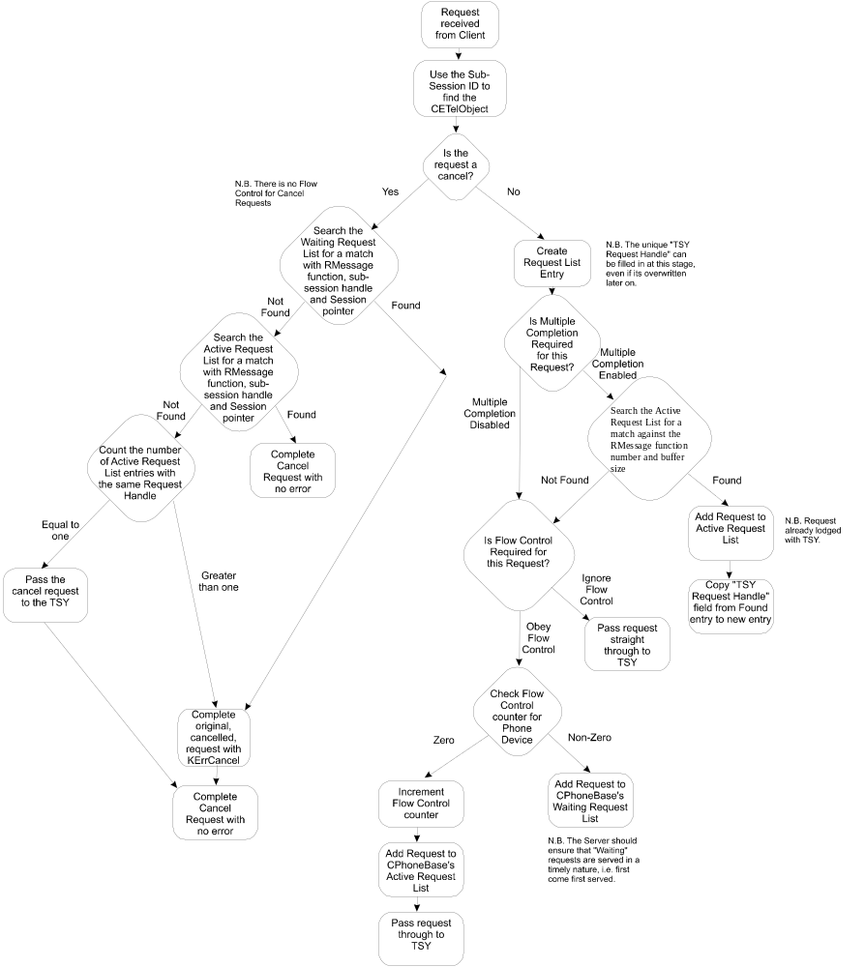

Server Completion Flow Diagram
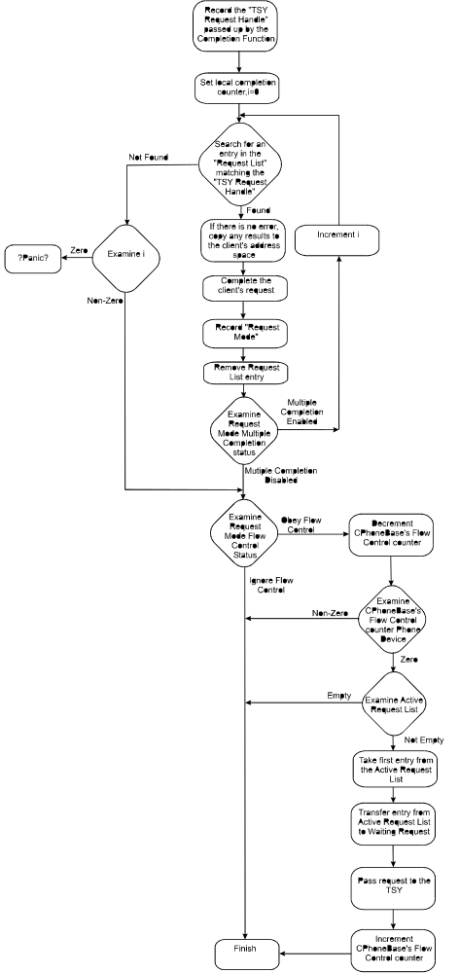
This diagram describes, in general terms, the algorithm performed by the server when a request is completed. It does not cover the case for requests that have the characteristic RePostImmediately.

Emergency Request Handling
ETel provides support for emergency requests handling by ensuring that emergency requests are always processed even in the out of memory situation. ETel is not aware of the actual emergency request details, but it is aware that a request is an emergency one and that it needs special handling.
This section describes how ETel implements this functionality. It should be noted that ETel is only one constituting block in the actual chain for emergency request handling. The client and the TSY are the other blocks in the chain and as such they are also responsible for having a similar system in place to ensure that there is always enough memory for emergency requests to be processed. Please note that this section only refers to the implementation in ETel but it also advises on the responsibilities of the TSY when it comes to servicing emergency requests.

Emergency Heap
ETel normally uses the default thread heap for clients’ request processing, but it also allows clients to request extra memory to be preallocated for requests that need to be serviced unconditionally. This is to ensure that enough memory has been preallocated by the server to process such a request even when it runs out of the default heap. This extra memory is referred to as the “emergency heap” and the requests that use it are called “emergency requests”. To prevent an out of memory error, ETel will always use the emergency heap to process emergency requests, so if at any point a client makes an “emergency” request, the ETel server will use the preallocated emergency heap for the request data instead of allocating memory when the request is made.
ETel preallocates the emergency heap by creating a heap in the local chunk. ETel uses the pre-defined maximum heap size constants to create the heap in the local chunk (please refer to section 4.3.11.3. for how the values for the maximum heap size should be calculated). The heap is preallocated for each client separately so ETel will keep a pointer to this heap (RHeap*::iEmergencyHeap) within the server’s CTelSession implementation for the client-side RTelServer session. Figure 4 shows the class diagram showing the emergency handling responsibilities in ETel.

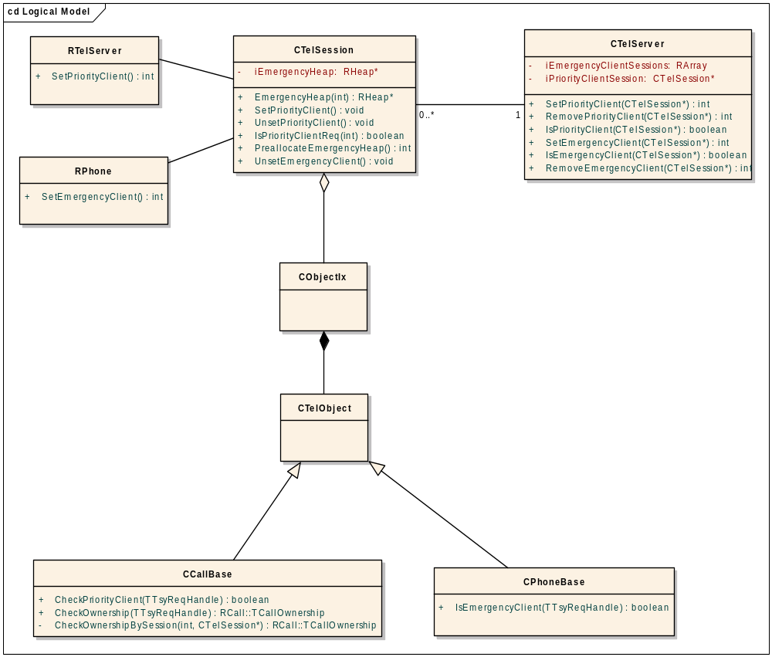
Figure 4 – Emergency and Priority client handling

Requesting Emergency Heap Allocation
ETel will not preallocate the emergency heap for every client as not all the clients will make emergency requests. That is why the emergency heap is allocated only per client’s request. If a client handles emergency requests, it then needs to register as an emergency client with ETel so that ETel can preallocate the emergency heap for that client.
A client registers as an emergency client by calling the RPhone::SetEmergencyClient() API at start-up. This method is only available to the clients that have the WriteDeviceData capability. If the client has the sufficient capabilities, then calling this method will instruct ETel to preallocate the emergency heap for that client. SetEmergencyClient() is called on the RPhone subsession rather than the RTelServer session to allow for the request to go down to the TSY and allow the TSY to preallocate any memory it needs to process the emergency request under the out of memory conditions. Without allowing the TSY to also preallocate the necessary memory, ETel could not guarantee that the emergency request would be processed later on. Later on when the client opens a handle to the subsession, the TSY will use the preallocated memory for the emergency requests. Having SetEmergencyClient() as part of RPhone also allows the ETel server to preallocate its own emergency resources as ETel is aware of the RPhone requests. These two requirements plus the need to maintain binary compatibility with the previous releases, has influenced the way this method is implemented on the server side: when the request reaches CTelSession::ServiceL(), ETel will preallocate the emergency heap for that client, but it will also treat this request like any other ExtFunc() request to ensure it gets passed down to the TSY.
RPhone::SetEmergencyClient() takes in the type of emergency requests that the client wishes to handle (TEmergencyRequest) as an input parameter, as different request types will have different memory requirements. For example, the LCS emergency requests will have different memory requirements to the circuit-switched emergency voice call requests. The client’s call to RPhone::SetEmergencyClient() maps onto CTelSession::SetEmergencyClient() on the server side. It will instruct ETel to preallocate the emergency heap and to store a pointer to the emergency client CTelSession in the CTelServer::iEmergencyClientSessions array. ETel retrieves the heap size value (e.g. KEmergencyLCSClientHeapMaxSize) according to the emergency request type passed in the request, and uses it to preallocate the emergency heap within CTelSession::PreallocateEmergencyHeap().
Please note that ETel allocates emergency heap per client or more precisely per client’s RTelServer session. The client is expected to use only one emergency sub-session of the same type at a time. If the client has a requirement to use multiple, concurrent subsessions that handle the same emergency functionality, then it needs to open separate RTelServer sessions, otherwise ETel might run out of the emergency heap.
If, for some justifiable reason, the user’s of the emergency functionality (i.e. the client code developers) need to open concurrent emergency subsessions of the same type from the same session to the RTelServer, then they needs to specify that as a requirement on Telephony (i.e. the ETel API developer), as well as the maximum number of the emergency subsessions they are planning to use concurrently, so that the required amount of emergency heap can be calculated taking this into account. This should, however, be an exception as the client implementation should only ever need to have one emergency subsession open at a time.
The emergency heap size is calculated by the ETel API developer who, as well as identifying the requests which require emergency heap, also needs to calculate the size required to hold the data expected or supplied by the emergency request. To calculate the emergency heap size the developer should use the formula specified in section 4.3.12.3. The values calculated are then defined as constants in an ETel header file.

Calculating the size for emergency heap
The minimum and maximum emergency heap sizes are defined as constants in the ETel EmergencyClient header file (e.g. KEmergencyLCSClientHeapMinSize and KEmergencyLCSClientHeapMaxSize). They are predetermined by taking the following into account:
- The maximum number of outstanding requests that constitute the emergency request handling. For example, there can be up to four outstanding emergency LCS requests posted concurrently. This includes any notifications that might need to be posted to listen for the incoming data in an emergency scenario.
- The number of slots to be used with each of the notifications used in the emergency scenario. This is required for the re-post immediately notifications, and the number of slots is needed so that the overall size can be multiplied by the number of slots that are expected to be stored by ETel. For more information on the re-post immediately mechanism in ETel, please refer to section 4.4.3.
- The potential maximum size of the data that will be passed in each of these requests.
- Any additional data that might be required for ETel’s internal request processing such as the CBuffer CReqEntry and HETelBufC8 data structures.
The formula is as follows:
((sizeof(TNotifyMtlrV7) * 2) + (sizeof(CBuffer) + sizeof(CReqEntry) + sizeof(HEtelBufC8))) +
((sizeof(TMeasurementControlV7) * 2) + (sizeof(CBuffer) + sizeof(CReqEntry) + sizeof(HEtelBufC8))) +
(sizeof(TMtlrResponseV7) + (sizeof(CBuffer) + sizeof(CReqEntry) + sizeof(HEtelBufC8))) +
(sizeof(TMeasurementReportV7) + (sizeof(CBuffer) + sizeof(CReqEntry) + sizeof(HEtelBufC8))) +
10% of heap size is used as a margin for error.

Freeing up the emergency heap
The emergency heap will get deallocated when the client closes the session to the RTelServer. As part of cleaning up all the resources used by that session CTelSession::UnsetEmergencyClient() will get called, which will instruct ETel to deallocate the emergency memory, if it has been allocated.

Emergency Requests
An emergency request needs to be flagged as such by setting the request type to EIsaEmergencyRequest in the underlying ETel API implementation. For example the following API falls into the emergency request category:
void RMobileCall::DialEmergencyCall(TRequestStatus& aReqStatus, const TDesC& aNumber) const
{
TReqPriorityType type=EIsaEmergencyRequest;
Set(EMobileCallDialEmergencyCall, aReqStatus, aNumber, type);
}
When ETel receives a request it first checks if it is an emergency one. If it is an emergency request, then all of ETel’s internal data memory allocation is done within the emergency heap. In this scenario, each of the internal objects uses its overloaded operator new that takes in the pointer to the emergency heap and allocates a cell of the needed size within this heap (the pointer to the emergency heap is obtained through the CTelSession::EmergencyClientHeap() method). This includes the HEtelBufC8 and HEtelBufC16 objects that actually preallocate buffers (on the emergency heap, if it has been preallocated, otherwise on the default heap) big enough to hold the data required/supplied by the request. The same approach is used by CBuffer’s and CReqEntry’s operator new implementation. This means that ETel will always use the emergency heap over the default heap for the memory allocation, if the emergency heap exists, so it is important that the maximum heap size is correctly calculated otherwise the memory allocation can fail only due to the fact that the required emergency memory has not been calculated correctly.
It should be noted that the core ETel API does not contain any emergency requests; they are all defined in the ETel API extensions, which means that ETel is not aware of individual emergency IPCs, but instead it identifies an emergency request through the request type. Unlike ETel, the TSY is aware of all emergency requests as they are implemented through ETel’s extension (ExtFunc()) mechanism and the TSY uses the request’s IPC number to identify emergency requests. This is why emergency requests need different IPCs to separate them from the non-emergency ones. For example, a normal outgoing call is made using the RCall::Dial() API, whereas an emergency outgoing call is made by calling RMobilePhone::DialEmergencyRequest(), which differentiates it from an ordinary dial through a separate IPC.
If, for some justifiable reason, the same IPC is used for the emergency notifications as well as the non-emergency ones, then the TSY always needs to treat these IPCs as the emergency ones. This means that notifications are always handled as emergency ones regardless of whether they have been posted by an emergency client (the one that has requested SetEmergencyClient()) or not. If this it not done, then if an non-emergency client posts the same notification before the emergency client, the TSY can fail to spot that the request has also been made by an emergency client as the second notification request will never reach the TSY because of ETel’s notification buffering mechanism (section 4.4.3). That is why developers should be discouraged from using the same IPC numbers for emergency and non-emergency requests.

Identifying an emergency client
The TSY can identify if a particular request has been made by an emergency client. ETel provides a TSY up-call method, CPhoneBase::CheckEmergencyClient(), for this purpose. The TSY only needs to supply a reference to the TTsyReqHandle when calling the method. Since the method is CPhoneBase-based, it can be used to interrogate any request on a subsession under RPhone. The TSY would typically use this method with the methods that either set or get information from the TSY, while this method should not be used for notifications as already described in the previous section.

Priority Client
ETel implements the priority client concept, which allows a client to become the priority client on the platform. If the platform needs to have a dedicated application that can be in control of any call or an application that other telephony applications can delegate the UI handling to, then the priority client can become such an application. This concept also allows the TSY to identify the priority client and allow or disallow certain operations to make the platform more robust and secure. For example, by always reserving a call object for the priority client, the TSY can prevent the situations where the static TSY call object allocation model gets abused by a malicious application, which starves the TSY of available call objects by repeatedly opening a handle to a new call object.

Priority client in the platform
A client needs to request the priority status at start-up using the RTelServer::SetPriorityClient() API. This function is a request to the server to allocate the priority status to the client which calls it. Only one client in the system may have this priority status, and that would typically be the default phone application. That is why this method has its access restricted to only allow the default phone application to successfully call this method. This is achieved by policing the API with the NetworkControl capability + the SID of the default phone application. Figure 4 shows the class diagram showing the priority handling responsibilities in ETel.

Restricting priority status to one client
The default phone application will be identified by its SID, so ETel will let only the client with the required PlatSec capability plus the expected SID to successfully call this method. The SID of the default phone application is defined as a constant, KPriorityClientSid, and specified the ETel server’s platform security policy table. If another application attempts to call this API, this method will return KErrPermissionDenied through the PlatSec system implementation.
To enable the KPriorityClientSid constant to be easily overwritten by the licensees, the SID will also be defined as a patchdata. Patchdata is a tool that allows exported constant data patching by allowing licensees to specify values to overwrite declared areas of the executable binary. These are written in at ROM build time so it allows the licensee to customise certain exported constants without rebuilding DLLs. The patchdata syntax is defined as follows:
patchdata DllName @ SymbolName NewValueForTheConstData
where SymbolName is the name of the exported data symbol to be patched,
DllName is the name of the DLL that exports the mentioned symbol, and
NewValueForTheConstData is the new (integer) value that is to be assigned to the given symbol.

Using the above syntax the priority client SID will be specified in the etel.iby file as follows:
patchdata etel.dll @ KPriorityClientSid <0x12345678>
where 0x12345678 is an example SID of the default phone app.
The licensees are expected to modify the etel.iby file prior to ROM building and replace the default SID value with the SID value of their default phone app.

To enable testing of this functionality on the emulator the epoc.ini file needs to be modified to define the following property:
etel_KPriorityClientSid 0x12345678

The ETel server code will then use the following code to retrieve the constant value for the emulator from the epoc.ini file:
#ifdef __WINS__
// for the emulator allow the constant to be patched via the epoc.ini file
UserSvr::HalFunction(EHalGroupEmulator,EEmulatorHalIntProperty,(TAny*)"etel_KPriorityClientSid",&iPriorityClientSid); // read the emulator property (if present)
#endif
The licensees are also expected to modify the epoc.ini file prior to their emulator testing and define the etel_KPriorityClientSid property using the SID value of their default phone app.

Priority client and emergency heap
Another feature of the priority client handling is the emergency heap pre-allocation for emergency requests originated by the priority client. A call to RTelServer::SetPriorityClient()will map on CTelSession::SetPriorityClient() on the server side. CTelSession::SetPriorityClient() stores the pointer to the priority client CTelSession in the server and it calls PreallocateEmergencyHeap() to preallocate the emergency heap for the priority client. The emergency heap will be used for the emergency requests initiated by the priority client.
The priority client does not need to call RPhone::SetEmergencyClient() in addition to RTelServer::SetPriorityClient(), as the emergency heap will get automatically allocated for the priority client when it calls RTelServer::SetPriorityClient(). The implementation for CTelSession::PreallocateEmergencyHeap() will ensure that even if the priority client calls the SetEmergencyClient() API, the emergency heap will only ever get allocated once. Similarly, in this scenario the RPhone::SetEmergencyClient() request will not get passed down to the TSY. For more details on emergency heap and emergency requests please refer to section 4.3.11.
Please note that SetPriorityClient() is called on the RTelServer session and as such the request is not passed down to the TSY. This behaviour is maintained for compatibility as well as the simplicity reasons and it does not cause any problems as the priority client is very likely to make emergency calls, for which the TSY preallocates enough memory at start-up anyway.

Identifying the priority client
ETel allows the TSY to identify if a call-based request is owned by the priority client. The TSY can use an up-call method, CCallBase::CheckPriorityClient(), to identify if a particular request has been made by the priority client. The TSY only needs to supply the request TTsyReqHandle in the up-call method. Please note that this method is a CCallBase method so it can only be used for the requests originated within an RCall or RCall-derived session.
The TSY can also use another up-call method, CCallBase::CheckOwnership(), normally to identify if a call is owned by the priority client. Similarly to the method above, the TSY only needs to supply request’s TTsyReqHandle. As part of the returned call ownership status, the TSY can also find out if the call is owned by the priority client.

Un-setting the priority status
The client’s priority status will be reset when the client closes the session to the RTelServer. As part of cleaning up of all the resources used by that session CTelSession::UnsetPriorityClient() will get called, which will instruct ETel to reset the client’s priority status and also to deallocate any emergency memory that might have been allocated for that priority client.

Miscellaneous Design Notes

Multiple Clients Competing to Answer Incoming Calls
If multiple clients have requested notification of incoming calls, they will all have their requests completed when ETel detects the next incoming call. It is then up to the clients to decide if they wish to answer the call or not. If multiple clients attempt to answer the call, the first to make the request will succeed; the rest will fail. This strategy effectively delegates the call answering priority system to the thread and process priorities maintained by the clients.
However, a client can pre-empt this race by opening a call on the line and calling AnswerIncomingCall() on it, which the TSY will accept to mean that this call is the designated “answerer” of the next incoming call on that line, and will use it to answer automatically when one arrives. All other clients will receive notification of the incoming call but will be unable to answer it themselves, as the TSY will only let one AnswerIncomingCall be outstanding at any one time.

Call Ownership

Overview
ETel maintains the concept of call ownership for data and fax calls. A client that has made or answered a call is said to own that call. The owner has full control over the call. They are able to get the data port associated with the call and terminate the call. Non-owner access is restricted to monitoring functions.
The owner, however, is able to pass ownership to another client. First the new client must register interest in receiving ownership using an asynchronous function supplied by the call class. The TSY will only accept the first ownership request. All subsequent requests will be rejected with KErrInUse until the first is completed. This step is taken to remove any ambiguity over which call should receive ownership. The owner must then request transfer of ownership using a synchronous function provided by the call class. If no other calls have registered interest in receiving ownership, the request will fail and ownership will remain with the first client. If there is call with a request pending, both clients’ requests will be completed successfully and ownership will be transferred. In this successful case the original owner will be left with only monitor access to the call.
Call ownership information is stored in the ETel Server, which provides a set of API methods to be called by the TSY to implement the call ownership model. They can be found in MCallBaseTSY.

Server methods for TSY use
CCallBase derives from CSubSessionExtBase and MCallBaseTSY.
The call ownership information is held by the ETel Server. MCallBaseTSY provides a set of exported ownership related methods to be called by the TSY. Below is a brief description of each method.

MCallBaseTSY Method | Description
TCallOwnership CheckOwnership() | Returns the call ownership status of a call, which can be one of the following:  - EOwnedUnowned: the call is not currently owned  - EOwnedFalse: the call is owned but by a different client  - EOwnedTrue: the call is owned by this client  - EOwnedPriorityClient: the call is owned by this client, which is the priority client
TInt SetUnowned() | Reset the call ownership status to unowned. This method is usual called in one of the following scenarios:  - when the client has hanged up the call  - when a client has closed an active call and no other client is interested in acquiring the ownership of the call  - when the client which owned the call has crashed
TInt SetOwnership() | Sets the current client as the owner of the call object. Called by the TSY when a client acquires ownership of the call by being the first to call one of the following methods on the call:  - RCall::Dial  - RCall::AnswerIncomingCall  - RCall::Connect  Also used in RCall::TransferOwnership by the TSY to set the new owner.
void RelinquishOwnershipCompleted (const TInt aError) | The ETel Server calls the pure virtual MCallBaseTSY::RelinquishOwnership on the TSY when the call sub-session is being closed down by a client.  Upon receiving this request, the TSY checks whether there is another client waiting to take ownership of the call. If there is then the TSY sets this client to be the new owner of the call, otherwise it hangs up the call and sets the ownership status of the call to unowned.  The TSY then calls the completion up call to the ETel Server: MCallBaseTSY::RelinquishOwnershipCompleted.  The ETel Server can then detroy the call sub-session.
void RecoverDataPortAndRelinquishOwnershipCompleted  (const TInt aError) | The ETel Server calls the pure virtual MCallBaseTSY::RecoverDataPortAndRelinquishOwnership on the TSY when the call sub-session is being closed down and the data port is loaned.  Upon receiving this request, the TSY checks whether there is another client waiting to take ownership of the call. If there is then the TSY sets this client to be the new owner of the call and perform a swift initialisation, otherwise it hangs up the call and it sets the ownership status of the call to unowned.  The TSY then calls the completion up call to the ETel Server: MCallBaseTSY::RecoverDataPortAndRelinquishOwnershipCompleted.  The ETel Server can then detroy the call sub-session.

Notification Buffering
If a notification completes to the client and the client wishes to re-post it immediately, there will still be a short period of time during which the notification is not outstanding on the TSY. Should an event occur in this period which would have triggered the notification the result will be loss of information.
To prevent this from happening the server can perform re-posting and buffering of notifications, or more precisely, those requests which the TSY sets to KReqModeRePostImmediately in the ReqModeL() function. When the TSY completes a notification, the server will synchronously send the same notification request back down to the TSY keeping the request entry in the active list. The request entry has a flag indicating whether the client has read this data, which is set to true when the server completes up to the client. If the notification request then completes from the TSY before the client has re-posted the notification the flag is set to false and the request is re-posted on the TSY. Should the client notification request arrive at the server then, it will be completed immediately with any associated data.
If multiple clients are interested in the same notification and the notification has the request mode KReqModeMultipleCompletionEnabled, there is a new request entry created for each in the active list but all are marked with identical TSY request handles. Each one has a pointer to separate CBuffer objects, which contains the memory space for the TSY to fill up. When the TSY completes the notification the server will copy the data from the buffer that the TSY has filled up to all the other clients’ buffers. This architecture was chosen over all clients’ request entries pointing to the same buffer because a slow client could easily miss events if they are occurring often and a fast client is also reading them.
Each RePostImmediately request entry is only removed if the client explicitly calls the equivalent Cancel function when it had the notification outstanding, or when the relevant client closes its handle on the object.

is equivalent to a buffer containing no valid data

is equivalent to a buffer containing data unread by client

Client

Notify() Complete Notify() Complete
Server

Allocate memory space
Notify() Notify() Notify()
TSY ReqCompleted() ReqCompleted()

Multi-Slot Request Buffering
If the TSY sets a particular request to KReqModeRePostImmediately, the server will implement buffering, as explained in Section 4.4.3. The size of the buffer in that example was only one slot; that is, only large enough to contain the data associated with one event. If the TSY called ReqCompleted() for a function twice before a slow client managed to get its request down to the server, the first event would be lost and the client would receive the second event’s data.
In some cases this is perfectly acceptable, but often a notification must receive every event. To allow for this, the number of slots in the buffer must be increased and circular buffering performed, so that the client receives the least recent unread data.
When a notification is first called on the server and the TSY sets it to KReqModeRePostImmediately, the server will ask the TSY how many slots to set up in its buffer using the function MTelObjectTSY::NumberOfSlotsL(). The TSY can make use of a set of default values released with the relevant API DLL, or can choose different values. Once the server has created the buffer it will place the notification request on the TSY, passing in pointers to the first slot in the buffer for the TSY to fill in. When the TSY does so and calls ReqCompleted(), the server will re-post the request on the TSY passing pointers to the second slot in the buffer.
As noted before, each buffer is created on a per client basis; there is no sharing of buffers.
Should the buffer become full of unread data, the oldest data will be overwritten with the new data and the next client completion will be with KErrOverflow, with the next oldest data.

Registration of notifications
Take a notification. Client A calls this notification and the server posts it on the TSY. Client B also calls this notification and, since it has KReqModeMultipleCompletionEnabled set, the server does not pass it to the TSY but stores it in the active list. The TSY will have been given pointers to the data area belonging to Client A’s request, but not to the data area associated with Client B’s request.
Now Client A cancels its notification request. Ideally the server would like to keep the notification outstanding on the TSY because it knows that Client B is still interested. However the data buffer that the TSY has pointers to is no longer valid since it belongs only to Client A’s request entry, so the server must perform the following actions.
- Call the Cancel function of the notification.
- This should cause the TSY to synchronously call CTelObject::ReqCompleted() with the error cause KErrCancel.
- In ReqCompleted(), the server finds Client A’s request entry, completes up to the client and destroys the entry.
- Since the notification is multiple completion, the server then searches for another request entry with the same TsyReqHandle and finds Client B’s request.
- It then posts the notification back on the TSY with the same TsyReqHandle, but with pointers to the data buffer associated with Client B’s request.
Finally, Client B also cancels the notification, causing the server to repeat the steps above bar 5, since it fails to find another request entry for that notification (on that CTelObject).
This would be enough by itself. However, a TSY aiming at efficiency may like to know when exactly clients are interested in a particular notification so that it could power up some lower level device which provides the notification events when they are, and power it down when they are not. One might think this should be easy; simply power it up when the notification request reaches the TSY and power it down again when the associated cancel is called. But bearing in mind the multi-client scenario described above, the Cancel may be called even when a client is still interested. The TSY developer does not want to be powering down a subsystem when a cancel arrives and immediately powering it up again when the server re-posts it.
To solve this problem the server makes use of two other functions: CTelObject::RegisterNotification and CTelObject::DeregisterNotification. It calls the former the very first time a certain notification is called on a CTelObject, and only calls the latter when all interested parties have either cancelled their outstanding notification request or closed their subsession handle.

Provision of extended error codes
The global Symbian OS error space contains a general set of error codes for use by all Symbian OS components and a small set of comms related ETel error codes.
For many clients, especially those accessing the basic and advanced GSM functionality of the ETel API, these system-wide errors are not enough. These clients need to receive a wider range of error codes so they can display more meaningful error messages to the user.
There is a planned system-wide enhancement for “extended” errors, but as an interim solution, the following additional functionality has been added to the ETel API and Server in order to support proprietary client/TSY defined error codes.
Clients that wish to receive extended errors must call the RTelServer API method, SetExtendedErrorGranularity( aGranularity ) and specify EErrorExtended as the parameter. The ETel server will record this error granularity setting within an attribute of that client’s server-side CTelSession object.
TSYs that support the proprietary extended error codes have the option of returning, when available, the extended error code in the high 16-bits of the 32-bit error code returned to the ETel server when the TSY calls ReqCompleted( ) . The low 16-bits must contain the basic error code. If the TSY does not have a specific extended error code to return, then it should return the full 32-bit basic error code within the ReqCompleted call in the same way that a non-extended TSY would.
Upon receiving a 32-bit error code, the ETel server will determine whether the 32-bit error code contains just a single basic error code, or the extended and basic error codes. If needed, ETel server will resolve the 32-bit number into two separate error codes (the extended and the basic errors which reside in the two 16-bits of the 32-bit word). As either a basic or an extended error code may be returned to the client it is important that that the basic and extended error spaces do not clash so that the client can distinguish between them. Remember that a client that has asked for extended errors may receive basic errors instead, if for instance the TSY is lightweight. Therefore only extended error code values should be placed in the high 16-bit word.
The ETel server checks whether the client associated with the request has registered a requirement for extended errors. If the client has done so it can be thought of as “advanced”, and therefore the extended error code will be returned. If the client has not registered a requirement for extended errors then it can be thought of as “simple” and therefore the basic error code is returned. In the case of no extended error code available, then the basic error code will be returned regardless of the client’s extended error granularity.
Basic error codes are those used and defined by the ETel Core API. These error codes alongside the E32 Base set of error codes collectively form the basic error space. The error codes defined in the ETel extensions, such as ETelMM, ETelSAT, ETelPacket exterror.h in ETel, as well as those defined by Licensees, collectively form the extended error space. The licensee defined extended error space has a range of -21000 to -29999.

“Advanced” Client
Calls SetExtendedErrorGranularity(EErrorExtended)
And also a request (e.g. Dial ( ) ) that fails
“Simple” Client
Calls a request (e.g. Dial( )) that fails

ETel Client API
ETel Server
EErrorExtended recorded in CTelSession for “Advanced” client
ReqCompleted( ) resolves the aError from TSY. The error code in high 16-bits is returned to “advanced” client whereas the error code in low 16-bits is returned to “simple” client.

TSY
Client request fails so aError returned to server, extended error = High 16-bits, basicerror = Low 16-bits

CTelObject::ReqCompleted(aError)

CCallTsy::Dial ( +44..)

Phone Name “Mangling”
A problem arises due to the possibility of having more than one TSY module loaded simultaneously, and the fact that when a phone is opened from the RTelServer object, the only way the client can refer to it is by its name. That is, its name must be unique across all TSY modules.
There can be no way, other than some central authority which grants phone names to TSY developers, for this to happen. A far cheaper and easier solution is for some new complexity in the ETel server to allow TSY modules containing phones with identical names to be loaded at the same time, but mangling one of the identical phone names such that clients only see and refer to a new unique name. The TSY never knows about the new mangled name, just the real name. The client never knows about the real name, only the mangled name.
To guarantee a unique name, the server pre-pends the real phone name with the name of the TSY module and a dash; eg if the WCDMA.TSY has a phone name “Phone1”, the mangled name would be “WCDMA-Phone1”. This should be unique because the name of the TSY is unique, given that all TSY modules reside in the same directory on the file system.
Each time a TSY is loaded, the server will scan through its list of currently opened phones and compare the names of the new TSY’s phones with each. Should any be identical, the server creates an entry in a list with the TSY name, the real phone name and the new mangled name. Every time a client requests phone names, this list is scanned to ensure that if a mangled name exists for a phone, the client receives it not the real name. Each time a client opens a phone, the server checks the list to see if the client is using a mangled name and if so converts it back to the original before passing it to the TSY. When a TSY is unloaded, any entries in the list that belong to that TSY’s phones are removed.
All this functionality is implemented in CPhoneManager since this class is the repository for all phone handles, and is accessed each time phones are opened or closed. CTelSession must ask CPhoneManager to do the name conversion when a client asks for phone information.

Example Procedures
This section describes some common client procedures in detail. It also outlines some of the operational characteristics of the interface would not otherwise be evident from the previous descriptions.

Establishing a Data Call
The procedure described below could be used by an ETel client to establish a data call, pass some information and close the connection.
- Open a connection with the Root ETel Server
- Load the relevant TSY module for the modem being used
- Open the phone supported by the TSY module.
- Open the line connected to the phone
- Open a new call on the line
- Select a data call type
- Call the Dial function with the desired number
- Request the Data Port from the call instance
- Open a new Data Port
- Transfer information
- Close Data Port
- Hang up the call
- Close the call
- Close the line
- Close the phone
- Close the Root ETel Server session

Answering a Fax Call
The procedure described below could be used by an ETel client to answer an incoming fax call, maintain a fax session and close the connection. It is important to note that if the incoming call were not a fax call, the fax session would fail during its set up or negotiation phases, i.e. no attempt is made to validate the type of call before answering.
- Open a connection with the Root ETel Server
- Load the relevant TSY module for the modem being used
- Open the phone supported by the TSY module.
- Open the line connected to the phone
- Request notification of an incoming call.
- When this request is completed with a callname, open an existing call on the line with that name
- Select a fax call type
- Call the AnswerIncomingCall function
- Open a new fax port from the call instance
- Transfer the required fax image information
- Close fax port
- Hang up the call
- Close the call
- Close the line
- Close the phone
- Close the Root ETel Server session

Passing a Call Between Clients
The procedure described below could be used by two ETel clients wishing to transfer ownership of a call.
Client A | Client B
1. Open a connection with the Root ETel Server
2. Load the relevant TSY module for the modem being used
3. Open the phone supported by the TSY module.
4. Open the line connected to the phone
5. Open a new call derived from the newly opened line.
6. Establish a call using the Dial function
 | 7. Open a connection with the Root ETel Server
 | 8. Open the phone supported by the TSY module.
 | 9. Open the line connected to the phone
 | 10. Open the existing active call on that line.
 | 11. Register interest in acquiring call ownership
12. Offer to Transfer Call Ownership
 | 13. Call acquisition function is completed
14. Call Ownership transfer returns successfully
Client A has now transferred call ownership | Client B has now acquired call ownership
15. Close the Call
16. Close the Line
17. Close the Phone
18. Close the Root Session
 | 19. Transfer some Information
 | 20. Terminate the Call
 | 21. Close the Call
 | 22. Close the Line
 | 23. Close the Phone
 | 24. Close the Root Session

Platform Security
The Platform security architecture is being introduced in a number of stages. Symbian OS v8.0b introduced secure server APIs. Symbian OS v8.1 introduced the enforcement of the capability model as applied to loading binaries. Symbian OS v9.0 provides the enforcement of the API policing model.
For a detailed description of the Platform Security architecture, see [4].
For a platform security architectural overview as applied to this subsystem, see [5].

Capability Assignments
In order to satisfy the capability model rule, that a process cannot load a DLL with less capabilities than itself the following capabilities have been assigned to each of the binaries built from the Etel component.
For a full list of the capabilities see [4].
Binary | Loading Process | Capability Assignment
Etel.dll | Any¹ | All -Tcb

¹This binary contains a client API and the Etel server code. Since the client API could potentially be loaded into any client process this binary must be given all capabilities (minus TCB which is not given to any client processes). It should however be noted that the Etel server code will run with the same capabilities as the c32exe process, as it is hosted within that process.

API Policing
In accordance with the platform security API policing model the Etel server is now policing its IPC set. Any client that makes a request to ETel should have the necessary capabilities (as defined by the security policy setting for that IPC) to make that request happen. If the client does not posses the required capabilities, the policy checking mechanism shall return a failure to the client. For a detailed description of how to secure a server see [4].
Based on the nature of the IPC requests handled by the Etel server, the following set of capabilities have been identified as necessary for securing the Etel APIs. Telephony specific definitions of these capabilities are provided:
NetworkServices – Grants access to the network/operator services. An application with this capability can dial a number, send a text message, etc.
ReadDeviceData – Grants read access to sensitive system data. An application with this capability can read the settings stored on the phone/ICC (e.g. obtain the service provider name from the ICC) or in the network (e.g. interrogate the status of the supplementary services).
WriteDeviceData – Grants write access to phone settings. An application with this capability can read the settings stored on the phone/ICC (e.g. set lock settings) or in the network (e.g. set the password for supplementary services).
ReadUserData - Grants read access to user data. An application with this capability can read the user settings stored on the phone/ICC (e.g. read phonebook entries or SMS messages).
WriteUserData - Grants write access to user data. An application with this capability can write the user settings stored on the phone/ICC (e.g. write phonebook entries or SMS messages).
NetworkControl – Grants access to modify or access network protocol controls. All other requests that are too sensitive to be granted the above capabilities would require this capability.
Further details of the capabilities assigned to each of the Etel and Etel extension APIs can be found in the relevant API design document.

Policing Custom APIs
It has been identified that when ETel passes its service requests down to the TSY it generally should not need to delegate any capability checking to the TSY as the TSY should require the same capabilities as the ETel server itself. This only applies to ETel core and ETel extension APIs which have been written within Symbian. These have known IPCs associated with them and they can therefore have suitable security policies assigned to them in the ETel server to allow them to be policed.
However, it is understood that Licensees define their own custom APIs which have unknown IPCs associated with them. There is no way for the ETel server to know the nature of any such service requests that it receives. In such cases the ETel server shall defer any capability checking to the TSY as described below.
Deferment of client capability checking to the TSY has been facilitated in the ETel server by providing ETel’s own implementation of CPolicyServer::CustomSecurityCheckL(). This method is generally invoked if Etel Server’s policy table states that the ECustomCheck action should be carried out for a given IPC. IPC ranges 1000000 – 1000499 and 1000500 – 1000999(for cancel requests) have been allocated for the purpose of Custom APIs/IPCs.
The CTelServer::CustomSecurityCheckL() works by using the client’s request message to work out which of the TSY’s CTelObject derived objects would service this call. It then calls that object’s GetRequiredPlatsecCaps() method.
The GetRequiredPlatsecCaps() method is a virtual member function of the MTelObjectTSY interface class. Its role is to take in the IPC number for the custom request made by the client and return a set of capabilities that the client should posses for its call to be successfully processed.
A base implementation of GetRequiredPlatsecCaps() is defined in the server as part of the CTelObject. The base implementation always returns KErrNotSuported. TSY developers who include support for servicing custom APIs in their TSY should therefore ensure that they implement the GetRequiredPlatsecCaps() function in their TSY for each of the TSY’s CSubSessionExtBase derived objects that deal with Custom API requests. It is important that the TSY developer carefully considers the nature of the functionality that services the custom API requests so that the requests can be adequately policed.

Reordering of Etel Serviced IPCs
Every time a client makes an ETel request, the policy server has to search through Etel’s security policy table to obtain the security policy for that IPC request so that it may be checked against decide whether or not to pass the call down to the Etel server.
The security policy structures used to define a server’s security policy allow ranges of IPC values to be specified for IPCs that each have the same capability assignments. This allows for ROM savings and speed improvements (with regard to the policy server searching a policy for a specific IPC entry) to be made if IPCs, having the same capabilities, are grouped in a consecutive range with no holes (i.e. no unused numbers in the range).
As Etel and its various extensions (Etelmm, EtelPckt, EtelSat etc.) declare a large number of IPCs it is therefore beneficial to re-order them into groupings sharing the same capabilities. IPC values that are currently grouped together in functional unit groupings are re-arranged so that they are now grouped together based upon sharing the same capability requirements. The code snippet below demonstrates this change for 5 sample IPCs.
Current ordering:
enum
{
EMobilePhoneFunctionA=1, /*requires ReadUserData*/
EMobilePhoneFunctionB, /*requires ReadDeviceData*/
EMobilePhoneFunctionC, /*requires ReadUserData*/
EMobilePhoneFunctionD, /*requires WriteUserData*/
EMobilePhoneFunctionE /*requires ReadDeviceData*/
}

New ordering after platform security:
enum /* These IPCs all require ReadUserData */
{
EMobilePhoneFunctionA=1,
EMobilePhoneFunctionC
}

enum /* These IPCs all require ReadDeviceData*/
{
/*Start index at 6 to allow gap to add more IPs to ReadUserData range.*/
EMobilePhoneFunctionB=6,
EMobilePhoneFunctionE
}
enum /* These IPCs all require WriteUserData */
{
/*Start index at 11 to allow gap to add more IPs to ReadDeviceData range*/
EMobilePhoneFunctionD=11
}

This example reduces the number of ranges that need to be specified within the security policy from 5 to 3.
As Etel and its extensions have over 1000 IPCs and many do indeed share the same capability assignments there is a significant benefit to be had from implementing this re-organisation.

Global Kernel Objects Support
Introduction of platform security to the Symbian Platform implies that some of the implementation techniques utilised in non-secure platform are not valid anymore: use of globally named kernel objects is one such feature as it opens exploit possibilities to rogue and malicious applications: these may hijack or block access to protected resources, because only information needed to compromise affected telephony servers and their clients is the name of global kernel object these exercise.

The ETel server solves this problem by introducing a pure virtual method in the TSY interface in RHandleBase* MTelObjectTSY::GlobalKernelObjectHandle(), which the TSYs are supposed to implement if required. Default implementation of this method in the CTelObject class returns NULL, implying that no global kernel object is supported – it’s up to TSY implementation of the server side phone object to support this feature, if needed.
The client side is modified to retrieve this information from the server, get access to the global chunk and the mutex using the new EKA2 API SetReturnedHandle() (they exercise new EKA API SetReturnedHandle() to achieve this – see [4]).

ETEL implements this method in order to support FAX component: RHandleBase* CCallBase::GlobalKernelObjectHandle() use of global memory chunk.

Further Information

People
Role | Person / People
Contributor(s) | Andrew Cloke, Roger Nolan, Michael Phan, Jane Sales, Matthew Swan, Nathalie Doyelle, Shazia Bhatti, Chris Notton, Neil McAlpine,Dejana Serdarevic,Ravishankar Lakshminarayanan
Reviewer(s) | Telephony Team

References
No. | Document Reference | Version | Description
[1] | ETel Core API Design | 1.0 | Core ETel API definition document
[2] | Comms Framework API | 1.0 | SGL.GT0167.nnn
[3] | Comms Process Startup-Config Design | 1.6 | SGL.GT0167.nnn
[4] | Platform Security Engineering Guide | 2.2 | http://smglinx.intra/twiki/pub/SMG/PlatSecTechnical/SGL.SM0007.001.Rev2.2.PlatformSecurityEngineeringGuide.doc
[5] | Telephony Architectural Description.doc | 2.0 | Perforce@//EPOC/master/common/generic/telephony/documentation/

Open Issues
No open issue.

Glossary
The following technical terms and abbreviations are used within this document.
Term | Definition
TCB | Trusted Computing Base
DLL | Dynamic Link Library

Document History
Date | Version | Status | Description
26-01-2009 | 2.5 | Issued | Deleted CDMA references as part of PREQ 2002
19-01-2007 | 2.4 | Issued | Added two new sections:  4.3.11 Emergency Request Handling  4.3.12 Priority Client Handling
06-10-06 | 2.3 | Issued | Change to section 3.2 for defect DEF094250. Have added ControlFlags=1 to etel.cmi.
13-07-05 | 2.2 | Issued | Extended the range of IPCs available for Custom APIs from 200 IPCs to 1000 IPCs
04-05-05 | 2.1 | Issued | ETel extended errors documentation improvement.
17-11-2004 | 2.0 | Issued | Updated GlobalKernelObjectHandle() text.
08-10-2004 | 1.9 | Issued | Updated with detailed description of Yankee security changes
26-08-2004 | 1.8 | Issued | Minor update to include new Call subsession API.
13-07-2004 | 1.7 | Issued | Yankee platform security update – added section 6.2.
17-05-2004 | 1.6 | Issued | Document Issued.
01-04-2004 | 1.5 | On Review | Added Platform Security section for v8.1 release.
18-02-2004 | 1.4 | Issued | Updated with the Comms Framework information.
07-01-2004 | 1.3 | Issued | Update to clarify extended error code implementation.
03-06-2003 | 1.2 | Issued | Added Handling of multiple parameters versions of Etel requests
04-11-2002 | 1.1 | Issued | Updated with reference to current ETel design. Version of the document inherited from 6.1
13-03-2002 | 1.0 | Issued | Copy original document into SGL.PPS001.501 Formal Document Template Rev 6.0  Clarify the concept of call ownership  Remove outdated section 6 & 7 that explained the GSM extensions to the ETel Core API.

Document Review Date
Not applicable

