1 Introduction 2
1.1 Purpose and Scope 2
1.2 Terminology 2
2 Details 3
2.1 ECOM usage in the Comms Stack 4
2.1.1 Anatomy of a Comms Framework ECOM plug-in 4
2.1.2 Client Code 6
2.1.3 Factories in Comms Framework 6
2.2 CommsDAT configuration view 6
2.3 Stack Nodes 7
2.3.1 MeshMachine Nodes 9
2.3.2 Data Plane 15
2.4 Tier Manager 18
3 Coding Conventions 18
4 Logs and Debugging 19
4.1 Enabling Logs 19
4.2 Producing Log Output 21
4.3 Debugging Hints 21
5 Performance 21
5.1 Considerations 21
5.2 Measuring 22
6 Further Information 23
6.1 People 23
6.2 References 23
6.3 Document History 23
Appendix A - A sample MCpr code listing 24
Appendix B - Perl script for extracting connection startup timings 30

Introduction

Purpose and Scope
This document provides quick-start guidelines for developers implementing Symbian Comms stack nodes. The objective would typically mean extending the stack with a new layer (a new type of bearer, for instance WLAN) or overriding a (part of an) existing layer.

Terminology

Access Point
An Access Point is an instance of a layer in the comms stack that gives access to a remote service. For example, there maybe two instances of a layer implementing wifi but each communicating with different wifi networks.

Details
A layer in the Comms stack is conceptually equivalent to a layer in the (considered well known) ISO/OSI networking stack model. It represents a particular technology and as implied by the Symbian 3-Plane Comms Architecture [R1] is broken down into planes (data, control and management).
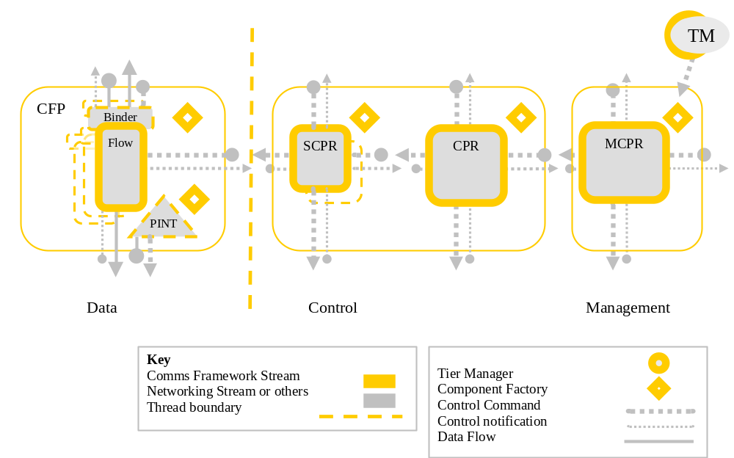
Figure 2-1 - A layer in the Comms Stack
A layer consists of a set of nodes, where each node is a technology specific instance of (respectively to the plane):
- Flow (CSubConnectionFlowBase);
- PINT (CProtocolIntfBase)
- SCPR (CSubConnectionProviderBase);
- CPR (CConnectionProviderBase);
- MCPR (CMetaConnectionProviderBase);
In addition a set of layers is managed by a single entity called Tier Manager (see [2.4]).
Nodes get produced by their factory objects, in other words: each node type (a C++ class) has its factory type. The factory objects are created by the Comms Framework at a suitable time (could be on Comms Framework start or on demand). Each factory object type is an ECOM plug-in identified with a UID. The UIDs are referred by the CommsDAT configuration to describe layers and stacks.

ECOM usage in the Comms Stack
ECOM is a Symbian-proprietary facility intended to provide a common system wide mechanism for instantiating a plug-in component dynamically determined at runtime. The plug-in is represented by an object implementing a specific interface. The (UID identified) interface determines the type of the plug-in. A plug-in developer can register their implementation against a specific ECOM interface. A client can request an instance of the plug-in (supplying the implementation identity) at runtime using ECOM API.

Anatomy of a Comms Framework ECOM plug-in
ECOM maintains a registry that maps plug-in identities (UIDs) to (dll) libraries that implement them. In order to facilitate for that plug-in developers supply registry files along with each plug-in-bearing dll. For instance the registry file for the PDP layer looks as follows:

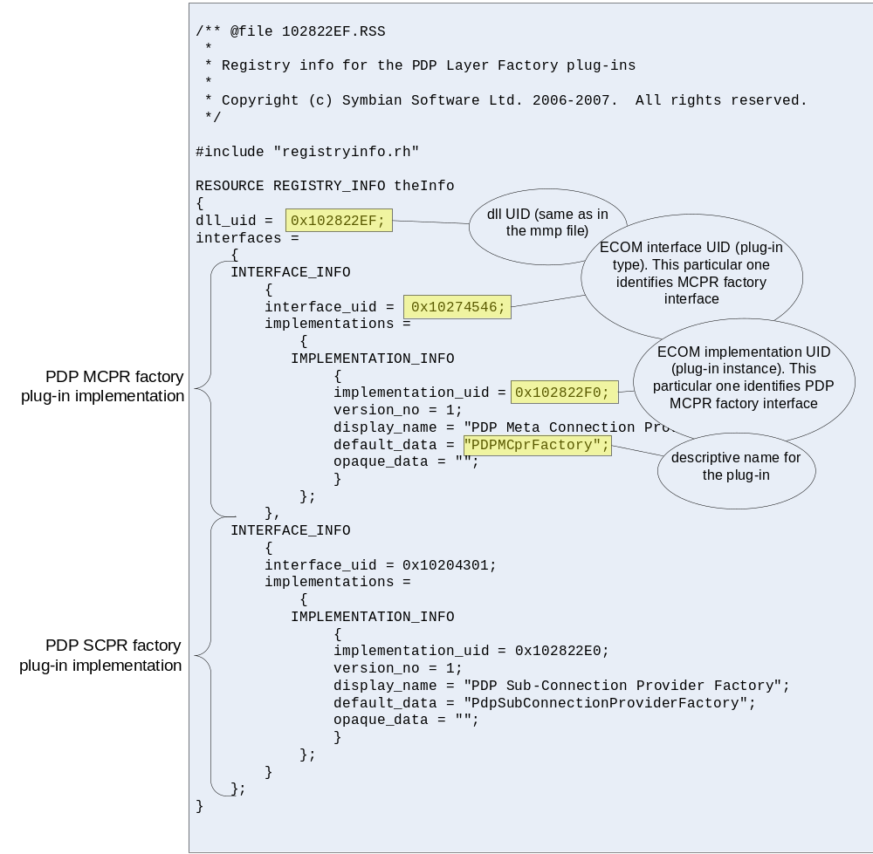
Figure 2-2 - An ECOM registry file
As one can see a single (dll) library can carry a number of ECOM implementations. A plug-in-bearing library (as implied by the ECOM architecture) must not export anything but the plug-in instantiation functions. Again, the PDP layer exports the functions as follows:
const TImplementationProxy ImplementationTable[] =
{
IMPLEMENTATION_PROXY_ENTRY(CPdpMetaConnectionProviderFactory::iUid,
CPdpMetaConnectionProviderFactory::NewL),

IMPLEMENTATION_PROXY_ENTRY(CPDPSubConnectionProviderFactory::iUid,
CPDPSubConnectionProviderFactory::NewL)
};

EXPORT_C const TImplementationProxy* ImplementationGroupProxy(TInt& aTableCount)
{
aTableCount = sizeof(ImplementationTable) / sizeof(TImplementationProxy);
return ImplementationTable;
}

where
class CPdpMetaConnectionProviderFactory
: public ESock::CMetaConnectionProviderFactoryBase
{
public:
enum { iUid = 0x102822F0 };
static CPdpMetaConnectionProviderFactory* NewL(TAny* aParentContainer);

protected:
(...)
};

class CPDPSubConnectionProviderFactory
: public ESock::CSubConnectionProviderFactoryBase
{
public:
enum { iUid = 0x102822E0 };
static CPDPSubConnectionProviderFactory* NewL(TAny* aParentContainer);

protected:
(...)
};

Plug-in instantiation functions are static C++ methods (or C functions) that:
- Implement the NewL signature ECOM requires (either of the following two):
  - <pluginImplementationClass>* NewL();
  - <pluginImplementationClass>* NewL(TAny*); (if the client wishes to pass creation parameters)
- Instantiate (on a heap) and return a pointer to an object implementing the expected interface, where the expected interface is the one declared as interface_uid in the registry file (also see [2.1.2]).
From the code snippet above, it should be now clear how the plug-in instantiation functions are mapped to their implementation UIDs. It should also be obvious that Comms Framework uses ECOM to plug node (SCPR, CPR, MCPR and Flow) factories in.

Client Code
When the client wishes to instantiate an ECOM plugin, they can do this by calling the ECOM API and specifying the implementation ids as shown below:
TAny *ptr = REComSession::CreateImplementationL(aImplementationUid, destroyUid,
reinterpret_cast<TAny*>(&aConstructionParameters));
(tbc...)

Please note that the correlation between the interface UID and the associated C++ interface is implicit, therefore the client needs to perform a “trust cast” from ptr into a meaningful type. The caller is expected to know the type of what is returned for a given implementation UID that it has requested. For instance:
(...ctnd)
CCommsFactoryBase *exPtr = reinterpret_cast<CCommsFactoryBase*>(ptr);

Factories in Comms Framework
Factories, once created, are stored in their respective (CPR, SCPR, Flow, etc) factory containers tagged with their ECOM implementation UIDs. Whenever a node is required, Comms Framework locates the respective factory and calls its ::CreateL().

CommsDAT configuration view
CommsDAT configuration files describe possible stack configurations by defining access points and relations among them. An access point in this context is a specific data-bearing service at a specific stack level. An access point consists of:
- Layer composition (the types of MCPR, CPR, SCPR and Flow that will be instantiated when bringing up the layer);
- Data that configures the instantiated layer to provide the service (e.g.: APN for a GPRS access point, SSID for a WLAN access point or static IP addresses if applicable);
As mentioned earlier CommsDAT uses the ECOM implementation UIDs of the appropriate factories when composing a layer, for instance a CommsDAT *.cfg file could specify:
(...)

############################################################
## SCprTable
##

[SCprTable]
ADD_SECTION
# COMMDB_ID = 1
Name=ipscpr
SCprUid=0x10204308
FIELD_COUNT=2
END_ADD

(...)

ADD_SECTION
# COMMDB_ID = 4
Name=pdpscpr
SCprUid=0x102822E0
FIELD_COUNT=2
END_ADD

(...)

and subsequently:

(...)
[AccessPointTable]
ADD_SECTION
# COMMDB_ID = 254
Id=10000
Name=PDP-RawIP
Tier=0x10281DF5
MCpr=10
SelectionPolicy=10001
Cpr=4
SCpr=4
Protocol=5
CprConfig=1
FIELD_COUNT=8
END_ADD

More details on the CommsDAT configuration (format and semantics) as well as the selection process overview (composing a stack) can be found in [R3].

Stack Nodes
A design perspective of a node is presented by [R1]. This section provides practical information on how to implement a node that can be located, instantiated and function within Comms Framework.
To recap from [R1], a node is an object implementing the ANode interface, i.e.: an object that can receive messages. This however is not sufficient to describe a stack node, i.e.: a node that represents an access point at a given plane. The following class diagram presents three stack node types: SCPR, CPR (control plane) and MCPR (management plane). Although their roles are different, their structure is very similar (they are all MeshMachine-based – see [2.3.1]) and hence they will serve as a good example to present a typical skeleton for a Comms Framework stack node.

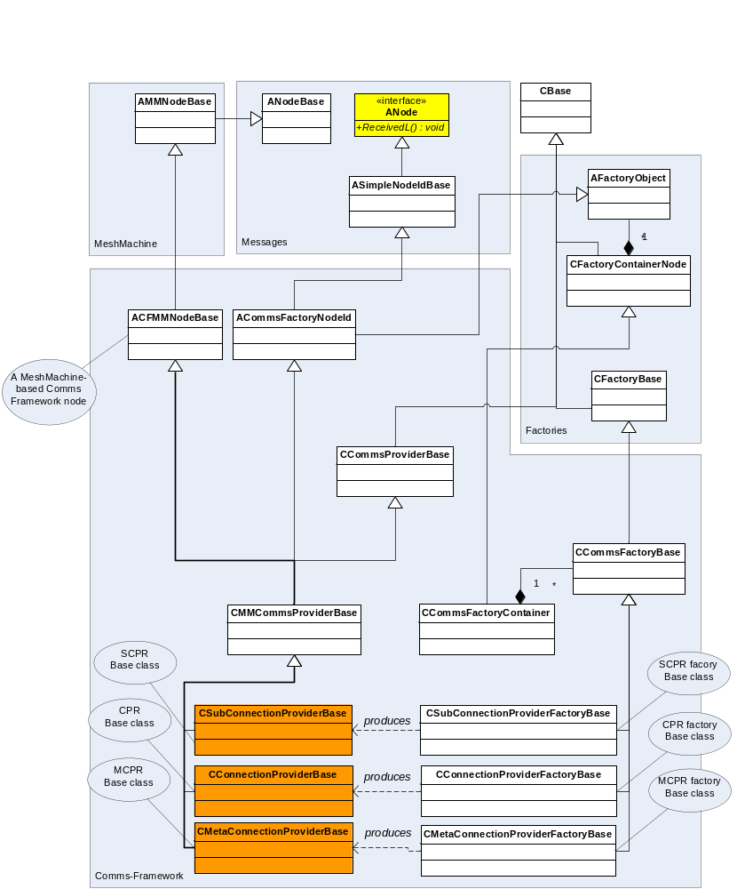
Figure 2-3 - Mesh Machine based stack nodes (in orange).
The following diagrams attempts to capture the steps necessary to produce an MCPR bearing (dll) library.
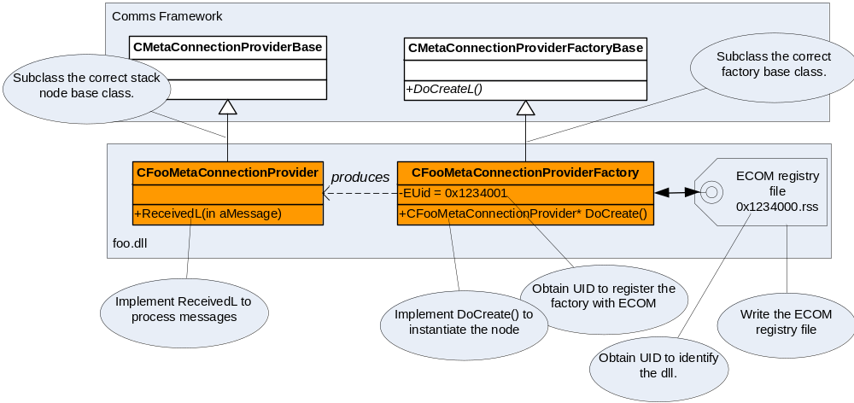
Figure 2-4 - sample MCPR
[Error: Reference source not found] presents a code listing for a bare minimum MCPR. The following sections take a more detailed view on the differences among the stack node types.

MeshMachine Nodes
All stack nodes except data plane nodes are said to be Mesh Machine nodes. The name Mesh Machine originated from the observation that Comms Framework providers cooperating on different planes (data/control/management) and layers (stacked on each other) form a “mesh of nodes”.
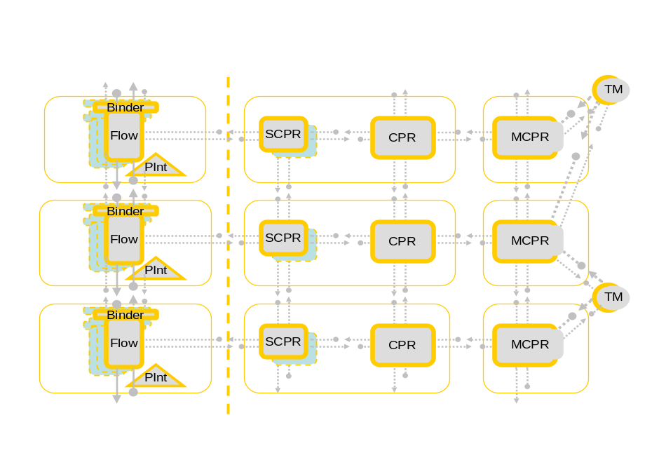
Figure 5 - mesh of nodes
A node wishing to run in this setup needs to be aware of its role, of its peers and of their roles. The nodes, especially ones on the management and control planes have (quite empirically) proven to be very complex. For example they would have nontrivial interactions with several other nodes at the same time. To support this multiple-state handling using procedural programming (e.g.: switch statements) rendered unreadable and un-maintainable code. It has then made it obvious that the complexity needs some form of formalization and higher level logic.
Mesh Machine facilitates simple implementations of complex interactions between nodes. It separated all of the common functionality related to processing events and responding to requests into a separated library so that only the very specific code needs to be provided by the node.
This section doesn’t attempt to describe what Mesh Machine is nor how to implement functionality using it (see [R4] for details on that). This section presents what differentiates a Mesh Machine stack node from what was said about a stack node so far, in particular:
- How does Mesh Machine relate to a Mesh Machine node and how to provision it.
- Which nodes are Mesh Machine nodes and why;
- Mesh Machine development resources (tools).

Mesh Machine and Mesh Machine node
Mesh Machine node needs to feed the Mesh Machine with:
- (build time) – Activities. An activity is a state machine that processes a specific Comms Framework message. A node is fed with a set of activities reacting to the messages the node is expected to receive. One useful analogy in this context is that messages are conceptually equivalent to method names and activities are conceptually equivalent to method bodies. Moving from there, the set of messages a node is expected to handle forms a conceptual interface for that node. which in turn reflects the node’s role in the stack (see [R1]);
- (runtime) – Messages.
A stack node instance receives messages via its ANode::ReceivedL interface. A Mesh Machine stack node will typically pass each message to the Mesh Machine (activities) to handle. For instance (see [Figure 2-3] for class diagram):
void CFooMetaConnectionProvider::ReceivedL(const TRuntimeCtxId& aSender, const TNodeId& aRecipient, TSignatureBase& aMessage)
{
TNodeContext<CFooMetaConnectionProvider> ctx(*this, aMessage, aSender, aRecipient);
CCoreMetaConnectionProvider::Received(ctx); //-> To base class and eventually the Mesh Machine

User::LeaveIfError(ctx.iReturn);
}
Where:
ctx – is a wrapper carrying the processing context for the message. The context holds:
- the message being processed
- the effective address of the sender
- the effective address of the recipient
- the activity object processing the message (assigned by the Mesh Machine as soon as an activity accepts the message)
- the reference to the host node (the message recipient running the Mesh Machine) along with mechanisms allowing to safe cast this reference to its final type (in this case CFooMetaConnectionProvider). This is provided for the activity code (states, forks and transitions) that may want to rely on that type.
- iReturn, which holds the result of the processing of the message.

A Mesh Machine node constructor requires a reference to an activity map. An activity map is in fact an ordered list of activities that a node will implement when constructed against them. Whenever a message reaches Mesh Machine, the Mesh Machine will:
- Scan all the running activities to see whether one of them expects it;
- Scan the activity map to see whether one of them is willing to handle it. The first one accepting the message gets instantiated and the instance becomes a running activity;

An example of an activity map feeding it into a node’s constructor is presented below:
//Activity
namespace FooMCPRNoBearerActivity
{
DECLARE_DEFINE_NODEACTIVITY(ECFActivityNoBearer, activity, TCFMessage::TNoBearer)
FIRST_NODEACTIVITY_ENTRY(CoreNetStates::TAwaitingNoBearer, CoreStates::TNoTag)
LAST_NODEACTIVITY_ENTRY(KNoTag, AgentMCprStates::TSendBindTo)
NODEACTIVITY_END()
}

namespace FooMCprDataClientJoinActivity
{
DECLARE_DEFINE_NODEACTIVITY(ECFActivityDataClientJoin, MCprDataClientJoin, TCFPeer::TJoinRequest)
FIRST_NODEACTIVITY_ENTRY(CoreNetStates::TAwaitingDataClientJoinRequest, MeshMachine::TNoTag)
LAST_NODEACTIVITY_ENTRY(KNoTag, MCprStates::TDecrementBlockingDestroyAndAddDataClientAndRespond)
NODEACTIVITY_END()
}

//Activity Map
namespace FooMCprStates
{
DECLARE_DEFINE_ACTIVITY_MAP(stateMap)
//Foo-proprietary activities
ACTIVITY_MAP_ENTRY(FooMCPRNoBearerActivity, activity)
ACTIVITY_MAP_ENTRY(FooMCprDataClientJoinActivity, activity)
ACTIVITY_MAP_END_BASE(PRActivities, coreActivitiesMCpr) //inherited activities
}

CFooMetaConnectionProvider::CFooMetaConnectionProvider(
CMetaConnectionProviderFactoryBase& aFactory,
const TProviderInfo& aProviderInfo)
: CMetaConnectionProviderBase(aFactory, aProviderInfo,
FooMCprStates::stateMap::Self())
{
}

Subjects
Mesh Machine is suitable for handling complex interactions but it will never be faster than a switch statement. Since nodes on the data plane should be efficient (fast data handling) and simple (intelligence delegated to the control and management planes), nodes on the data plane (flows) are not Mesh Machine based. This leaves MCPRs, CPRs and SCPRs as Mesh Machine nodes.

Resources
Comms Framework provides a set of boiler-plate (referred to as “core”):
- Activities. Core activities provide default processing for the messages they handle. This typically means delegating this processing to the adjacent nodes. A core activity can be used when the node being implemented doesn’t have anything interesting (node proprietary) to add to the default handling.
- Activity building blocks:
  - forks – typical decision points many activities use to differentiate their behaviour.
  - states – synchronisation points (awaiting messages) many activities use.
  - transitions – typical, atomic actions many activities execute.
- Nodes (a.k.a. vanilla nodes). In the similar spirit to core activities, one could imagine an entire node that has nothing to add at the layer it dwells at. For instance a vanilla SCPR could be used by a technology stack layer that has no concept of a logical channel.

The following are examples of core activities and activity building blocks:
The example below shows a core state can be used by activities that expect the TCFDataClient::TStarted message. They do that typically because they send a TCFDataClient::TStart message and would like to handle the response.
EXPORT_DEFINE_SMELEMENT(TAwaitingDataClientsStarted, NetStateMachine::MState,
PRStates::TContext)
EXPORT_C TBool TAwaitingDataClientsStarted::Accept()
{
CoreNetStates::TAwaitingDataClientStarted state(iContext);
if (state.Accept())
{
if (iContext.Node().CountClients<TDefaultClientMatchPolicy>(
TClientType(TCFClientType::EData,TCFClientType::EStarting)))
/* Meaning of the line above: 'Do I have any dataclient which has already
* sent the TStartDataClient message to but hasn't answered with
* TStarted yet?'
*/
{
// YES, so there are more to wait for
iContext.iMessage.ClearMessageId();
return EFalse;
}
return ETrue;
}
return EFalse;
}

The example below shows a core “data client start” activity. An activity that starts the host layer (a.k.a. “shallow start”) and happens to use CoreNetStates::TAwaitingDataClientStarted.
namespace PRDataClientStartActivity
{
DECLARE_DEFINE_NODEACTIVITY(ECFActivityStartDataClient, PRDataClientStart,
TCFDataClient::TStart)

FIRST_NODEACTIVITY_ENTRY(CoreNetStates::TAwaitingDataClientStart,
CoreNetStates::TNoTagOrNoDataClients)

NODEACTIVITY_ENTRY(KNoTag, PRStates::TStartDataClients,
TAcceptErrorState<CoreNetStates::TAwaitingDataClientsStarted>, MeshMachine::TErrorTagOr<MeshMachine::TTag<CoreNetStates::KNoDataClients>>)

LAST_NODEACTIVITY_ENTRY(CoreNetStates::KNoDataClients,
PRStates::TSendDataClientStarted)

NODEACTIVITY_ENTRY(KErrorTag, CoreNetStates::TStopSelf,
CoreNetStates::TAwaitingDataClientsStopped, MeshMachine::TErrorTag)

LAST_NODEACTIVITY_ENTRY(KErrorTag, MeshMachine::TRaiseAndClearActivityError)
NODEACTIVITY_END()
}

The example below shows an activity map that lists PRDataClientStartActivity:
//Activity Map provided by CorePr to be used by SCprs.
//(it is further extended in CoreSCpr).
DEFINE_EXPORT_ACTIVITY_MAP(coreActivitiesSCpr)
ACTIVITY_MAP_ENTRY(PRProvisionActivity, PrProvision)
ACTIVITY_MAP_ENTRY(PRStartActivity, PRStart)
ACTIVITY_MAP_ENTRY(PRStopActivity, PRStop)
ACTIVITY_MAP_ENTRY(PRDataClientStartActivity, PRDataClientStart)
ACTIVITY_MAP_ENTRY(PRDataClientStopActivity, PRDataClientStop)
ACTIVITY_MAP_ENTRY(PRDataClientIdleActivity, PRDataClientIdle)
ACTIVITY_MAP_ENTRY(PRDataClientActiveActivity, PRDataClientActive)
ACTIVITY_MAP_ENTRY(PRDestroyActivity, PRDestroy)
ACTIVITY_MAP_ENTRY(PRGoneDownActivity, PRGoneDown)
ACTIVITY_MAP_END_BASE(PRActivities,coreActivitiesPR)

The following example shows a vanilla node (vanilla SCPR) that inherits coreActivitiesSCpr and defines its own activity map adding a couple of sub-connection specific core activities.
namespace SCprActivities
{
DEFINE_EXPORT_ACTIVITY_MAP(coreSCprActivities)
ACTIVITY_MAP_ENTRY(SCprNoBearerActivity, SCprNoBearer)
ACTIVITY_MAP_ENTRY(SCprParamsRequest, SCprSetParams)
ACTIVITY_MAP_ENTRY(SCprNotification, SCprNotif)
ACTIVITY_MAP_ENTRY(SCprBinderRequestActivity, SCprBinderRequest)
ACTIVITY_MAP_ENTRY(SCprApplyRequest, SCprApplyReq)
ACTIVITY_MAP_ENTRY(SCprRejoinDataClient, SCprRejoin)
ACTIVITY_MAP_ENTRY(SCprDataClientGoneDownActivity, SCprDataClientGoneDown)
ACTIVITY_MAP_END_BASE(PRActivities, coreActivitiesSCpr)
}

EXPORT_C CCoreSubConnectionProvider::CCoreSubConnectionProvider(
CSubConnectionProviderFactoryBase& aFactory)
: CSubConnectionProviderBase(aFactory,SCprActivities::coreSCprActivities::Self())
{
LOG_NODE_CREATE(KCoreSCPRSubTag, CCoreSubConnectionProvider);
}

And finally, the last example presents a node that overrides vanilla SCPR (CCoreSubConnectionProvider) reusing all that has been shown before:
namespace FooSCPRStates
{
DEFINE_ACTIVITY_MAP(stateMap)
ACTIVITY_MAP_ENTRY(FooSCprParamsRequest, fooSCprParamRequest)
ACTIVITY_MAP_ENTRY(FooSCprStartActivity, fooSCPrStart)
ACTIVITY_MAP_END_BASE(SCprActivities, coreSCprActivities)
}

CFooSubConnectionProvider::CFooSubConnectionProvider(
CSubConnectionProviderFactoryBase& aFactory)
: CCoreSubConnectionProvider(aFactory,FooSCPRStates::stateMap::Self())
{
LOG_NODE_CREATE(KFooSCPRTag, CFooSubConnectionProvider);
}

Data Plane
There are two stack nodes types on a layer’s data plane:
- Flow (CSubConnectionFlowBase) – a stateful object representing a single conversation with a peer. Depending on the technology and position in the stack a flow may represent many different concepts, for instance:
  - At the TCP/UDP level a flow would typically represent a socket.
  - At Link a flow would typically represent a logical channel within that link. Some links offer multiple logical channels (e.g.: PDP context in GPRS/UMTS), some don’t (e.g.: PPP).
Flows are owned/controlled by SCPRs and there can be one or more Flows per SCPR. The cardinality of this relation is again technology dependent, for instance:
        - At the TCP/UDP level SCPR represents a group of Flows that share the same characteristics (e.g.: QoS or security associations)
        - At PDP level there would be one Flow per SCPR, each representing a single PDP context at their respective planes.
- PINT a.k.a. Protocol Interface (CProtocolIntfBase) – represents a group of Flows belonging to a single connection (CPR).

When a new conversation is being set up, flows from adjacent layers bind to each other (upper binds to the lower). Binding entails exchanging pointers to 4 separate interfaces:
- ESock::MUpperDataReceiver – data carrying interface supplied by the upper flow:
class MUpperDataReceiver
/**
Class implemented by an "upper" interface module to accept inbound data travelling
upwards from the interface module below.

@since Argus
@internalTechnology
*/
{
public:
virtual void Process(RMBufChain& aData) = 0;
};
- ESock::MUpperControl – control interface supplied by the upper flow.
class MUpperControl
/**
Class implemented by an "upper" interface module to accept control signals from the
interface module below.

@since Argus
@internalTechnology
*/
{
public:
virtual void StartSending() = 0;
virtual void Error(TInt anError) = 0;
};
- ESock::MLowerDataSender - data carrying interface supplied by the lower flow:
class MLowerDataSender
/**
Class implemented by a "lower" interface module to accept outbound data travelling downwards
from the interface module above.

@since Argus
@internalTechnology
*/
{
public:
enum TSendResult
{
// Send Flow Control
// The 0 and 1 values below explicitly match the legacy return values
//from a NIF Send() call.
ESendBlocked = 0, // data accepted, send no more until
// MUpperControl::Unblock()
ESendAccepted = 1 // data accepted, can send more
};

virtual TSendResult Send(RMBufChain& aData) = 0;
};
- ESock::MLowerControl – control interface supplied by the lower flow.
class MLowerControl
/**
Class implemented by a "lower" interface module to accept control signals from the
interface module above.

@since Argus
@internalTechnology
*/
{
public:
enum TBlockOption
{
EDisableAllOtherBindersOnFlow,
EDisableAllOtherBindersOnInterface,
EEnableAllBinders
};

IMPORT_C virtual TInt GetName(TDes& aName);
IMPORT_C virtual TInt BlockFlow(TBlockOption aOption);
IMPORT_C virtual TInt GetConfig(TBinderConfig& aConfig);
IMPORT_C virtual TInt Control(TUint aLevel, TUint aName, TDes8& aOption);
};

The following code listing presents an example of an upper flow binding.
void CFooSubConnectionFlow::ReceivedL(const TRuntimeCtxId& aSender,
const TNodeId& aRecipient, TSignatureBase& aMessage)
{
// Stack nodes on dataplane are not MeshMachine based. They use simple
// switch statement to filter messages.
CSubConnectionFlowBase::ReceivedL(aSender, aRecipient, aMessage);

if ( aMessage.IsMessage<TEBase::TError>() )
{
SubConnectionError(static_cast<TEBase::TError&>(aMessage));
}
else if (TCFDataClient::ERealmId == aMessage.MessageId().Realm())
{
switch (aMessage.MessageId().MessageId())
{
(...)
case TCFDataClient::TBindTo::EId:
{
TCFDataClient::TBindTo&
bindToMsg(static_cast<TCFDataClient::TBindTo&>(aMessage));
TRAPD(err,BindToL(bindToMsg));
ProcessDCIdleState(); // in case we were waiting to send idle
RClientInterface::OpenPostMessageClose(Id(), aSender,
TCFDataClient::TBindToComplete(err).CRef());
// If we have received TCDDataClient::TStart before (when we
// did not yet have a bearer), we complete the start here as well
if (iIsStarting)
{
CompleteStart(err);
}
}
break;
(...)

void CFooSubConnectionFlow::BindToL(TCFDataClient::TBindTo& aBindTo)
/**
Request from control side (at network layer) to indicate that the SubConnection is
up and running and that we should bind to a Flow below.
@param aLowerFlow Flow below to bind to.
*/
{
// provisioning message must come before bindto in case we didn't get
// it after we've joined the sub-connection

ClearNoBearerGuard();
const TNodeId& commsId = aBindTo.iNodeId;
CSubConnectionFlowBase* flow =
Messages::mnode_cast<CSubConnectionFlowBase>(&commsId.Node());

if (flow == NULL)
{
ASSERT(!commsId.IsNull());
iSubConnectionProvider.PostMessage(
Id(), TCFDataClient::TStopped(KErrDisconnected).CRef());
}

// Flows can only be directly bound when running in the same thread
ASSERT(commsId.Thread() == Id().Thread());
if (iLowerFlow && iLowerFlow->Flow() != flow)
{
// Already bound to something else so unbind first
iLowerFlow->Unbind(NULL,NULL);
iLowerFlow = NULL;
iLowerControl = NULL;
iLowerFlow->Unbind();
iFlowShim = NULL;
iFlowShimData = NULL;
}

if (iLowerFlow == NULL)
{
// Protocol binding
iLowerFlow = flow->GetBinderControlL();
iFlowShim = iLowerFlow->GetControlL(KSockDatagram, *this);
iFlowShimData = iLowerFlow->BindL(*this);
}
}

Tier Manager
Access points are aggregated into Tiers. A Tier is a group of access points related to one or more technologies sharing the same selection and availability monitoring logic in the Comms domain (see [R1]). In short, a Tier Manager is a singleton per Tier.
Similarly to stack nodes (see [2.3]), Tier Managers (CTierManagerBase) are Comms Framework nodes created by their respective factories. Similarly to stack nodes, Tier Managers need to support their respective set of conceptual interfaces (see [R1]).
[AccessPointTable]
ADD_SECTION
# COMMDB_ID = 254
Id=10000
Name=PDP-RawIP
Tier=0x10281DF5
MCpr=10
SelectionPolicy=10001
Cpr=4
SCpr=4
Protocol=5
CprConfig=1
FIELD_COUNT=8
END_ADD

Coding Conventions
There is a handful of coding conventions observable in Comms Framework and related code. This section presents the most important ones. The conventions are there to aid code maintainability and readability. It is strongly encouraged to follow these conventions.
States await specific messages, and as such the convention for naming them is to prefix the message they expect with “Awaiting”. It is rare that many messages would be expected by a state, but where more than one message could be expected concatenate them with “Or”. Examples are CoreNetStates::TAwaitingDataClientStart and CoreNetStates::TAwaitingDataClientRejoinOrApplyOrCancel.
Forks are generally named by the tags or values that they return. Examples are CoreNetStates::TNoTagOrDataClientsToStop and CoreNetStates::TNoTagOrBearerPresentOrErrorTag.
Transitions are simply named using a concise description of what they do. Serialized transitions are named in the same way except that the blocking items name is added to the transition name. Aggregated transitions are generally named by concatenating the names of all the transitions they are composed from with “And”. In cases where there are many transitions this convention is waived to avoid unwieldy names. Examples are CoreNetStates::TSendBindTo (transition), ConnStates::TProcessStartBlockedByStop (serialized transition), and ConnStates::TSendFinishedSelectionAndJoinReceivedCpr (aggregated transition).
When writing transitions, states, and forks that are specific to an activity create them in the scope of that activity.

Logs and Debugging

Enabling Logs
The Comms Framework currently uses a mix of two logging mechanisms. Traditional debugging logs are generated through the CommsDebugUtility (see [R5]). This entails having a commsdbg.ini in the c:\logs folder. A newer, and faster logging mechanism is used for logging the creation/destruction of nodes, messages between nodes, and Mesh Machine activities. This utilizes utrace, which is based on top of the btrace logger. It is controlled with the ulogger client (available from the TVK), and the default logging handler writes the logs in binary to c:\logs\ulogger.log. The client must be used to turn on logging filters and start the logging.
Thread and process creation (useful but not required) uses category 3.
Node Messages logs uses category 194.
Mesh Machine logs uses category 195.
Other textual logging uses category 196.
To enable logging for a category use the epoc command: ulogger -ef 3,194,195,196
To start logging use the epoc command: ulogger -r
To stop logging use the epoc command: ulogger -q

The tool utracedecoder (available from common\generic\comms-infras\elements\tools in the source tree) is used to produce a readable text log from the binary log.
utracedecoder --message-def ipmessages.definition.txt ulogger.log > log.txt

Asynchronous message exchange paradigm used by Comms Framework renders the textual logs quite difficult to read; consequently Comms Framework provides a parsing tool available from common\generic\comms-infras\elements\tools\svg.
Using it entails parsing the output from the utracedecoder with parseit.bat in the svg directory.
parseit /log=o:\path_to_log\log.txt

The parser produces output viewable in a web browser (MSIE recommended). The browser needs to have Adobe SVG viewer installed (available for from Adobe). The following is a sample log parsed with the svg viewer.
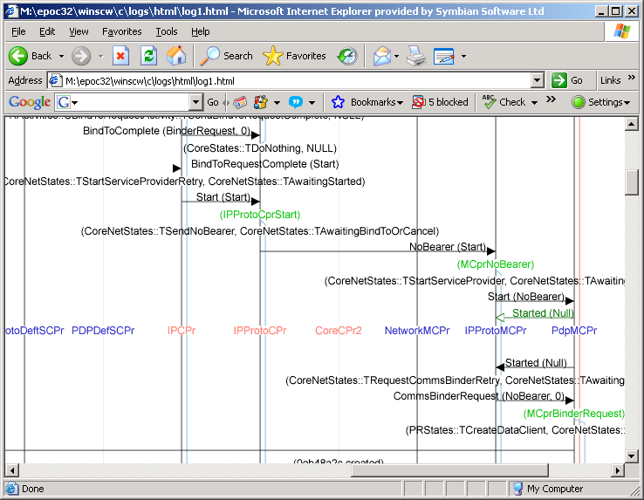
Where:
- Vertical black lines tagged with names (e.g.: IPCpr) represent node lifetimes.
- Vertical lines forking from the node lifetime lines are MeshMachine activity lifetimes.
- Black horizontal lines are message deliveries
- Green horizontal lines are message postings.

If you are using a UREL environment you will need to either use copies of the UDEB versions of your binaries and the libraries listed or rebuild them with the SYMBIAN_TRACE_ENABLED macro defined.
- nodemessages.dll
- meshmachine.dll
- commsfw.dll
- serverden.dll
- esocksvr.dll

Producing Log Output
In order to get name-tagged nodes in the svg output, the node’s constructor must mark its creation and destruction as follows:
CFooSubConnectionFlow::CFooSubConnectionFlow(
CSubConnectionFlowFactoryBase& aFactory, const Messages::TNodeId& aSubConnId,
CProtocolIntfBase* aProtocolIntf)
: CSubConnectionFlowBase(aFactory, aSubConnId, aProtocolIntf)
{
LOG_NODE_CREATE(KCustomSubTag, CFooSubConnectionFlow);
}

CFooSubConnectionFlow::~CFooSubConnectionFlow ()
{
LOG_NODE_DESTROY(KCustomSubTag, CFooSubConnectionFlow);
}

Debugging Hints
- Make extensive use of the svg diagrams. This cannot be understated. You will find it very difficult if you don’t use this tool.
- One problem that arises when debugging the comms-framework is that due to the heavy re-use of code any breakpoints set in transitions, states, or forks will very likely be hit many times. To narrow down the number of hits it is recommended that you set conditional breakpoints in the ReceivedL of the node you expect to be receiving the message.

Performance

Considerations
When considering the performance of a layer the plane of the node should be taken into account. The requirements for responsiveness and speed are far higher in the data plane, and much lower in the management plane. Sometimes making appropriate decisions can take time to process and require more logic (intelligence). These decisions are usually handled in either the control or management planes. This is especially important for the data plane. It should be noted that this “intelligence” refers only to handling of specific events or errors within the framework, and not to decision making intelligence required by such things as traffic routing. Passing these types of frequent decisions to other planes would only degrade performance.
Management
Data
Sub Connection Provider
Flow
Connection Provider
Meta Connection Provider
Control
Faster
Slower
Dumb
Intelligent
Figure 5-6 – Performance requirements in the planes
Taking these considerations on board, it is clear that message processing in the Flow must be kept as minimal as possible. As mentioned earlier in this document this one reason that the mesh machine is not used in flow implementations. Configuration settings and other options should never be retrieved by the flow directly. It should be dumb, and expect its more intelligent peer nodes to provide it with any information it needs. In most cases the MCpr should be intelligent enough to provision all the information needed by the control and data planes. Any configuration data read (especially from commsdat) can be costly. The MCpr will normally only do this the once. Remembering that there will be one flow created per socket is important. To re-iterate, configuration data should never be read in the data plane, and should be avoided as much as possible in the control plane.
When using commsdat to retrieve settings open the CMDBSession once and re-use it as much as possible. If retrieving multiple fields from the same commsdat record it may be more beneficial to load the entire record rather than loading the fields individually.
This may be stating the obvious, but:
- Never, under no circumstances use blocking calls. If there is an asynchronous call to the API being used use it, if there isn’t then it should return very quickly.
- Don’t do more than is absolutely necessary. If you can break from a loop, or return from a method early then do it.
- Remember the data plane is there to process data up and down the stack, not to make decisions.
- Don’t mem copy data unnecessarily.
- Don’t split your providers into separate libraries. This can lead to excessive file server thrashing as the libraries load slowing your startup times.
- It is common practice to mark comms libraries as UNPAGED in their mmp files. This ensures that your library will always be available in memory avoiding delays when it is used. This will have a negative impact on memory usage and so doing this should be a considered decision.

Measuring
Connection startup times and data throughput can be measured using the Network Performance Testing tools as created by PREQ1683. Please see [R6] for details on the configuration and usage of these tools.
When the performance tests are run HTML results files will be generated. For each test a connection will started for the bearer being tested. The time taken for the connection to be started is recorded in each of these files. These timings can be found on the lines that look like:
12:00:58:594 INFO - 97 netperfserver.cpp 612 Summary statistics begin
12:00:58:595 INFO - 97 netperfserver.cpp 614 Connection Startup took 0.04589s
12:00:58:595 INFO - 97 netperfserver.cpp 617 Total client packets transferred: 67
12:00:58:596 INFO - 97 netperfserver.cpp 620 Summary statistics end

The results can be collected together using a simple perl script such as the one in appendix B.

Further Information

People
Role | Person / People
Reviewers | 399 engineers, Comms TAs
Contributors | 399 engineers, Comms TAs
Distribution | Symbian and Licensees

References
No. | Document Reference | Version | Description
[R1] | Design for Flexible Comms Stack.doc |  | ESOCK design document.
[R2] | ECOM Architecture Overview | SGL.TS0017.129 | ECOM Architecture Overview
[R3] | Selection Fundamentals.doc |  | Stack resolution process in Comms Framework
[R4] | MeshMachineFundamentals.doc | 0.5 | Design of and working with Mesh Machine.
[R5] | ComsDbg_Configuring_ Logging_ By_ Comms_Subsystems.doc | 1.0 | CommsDebugUtility manual.
[R6] | Bearer Independent Network Performance Installation and Use Howto.doc  https://developer.symbian.com/sdnpp/docs/sdl/live/doc_source/guide/Networking-subsystem-guide/netperf/index.html |  | Bearer Independent Network Performance tools installation and usage documentation

Document History
Date | Version | Status | Author | Description
07-11-2007 | 0.1 | Draft | Remek Zajac | First draft
17-10-2008 | 0.2 | Draft | Barry Alcock | Updated to reflect EC120 changes and added performance section
05-11-2008 | 1.0 | Issued | Barry Alcock | Updated for review comments and issued

- A sample MCpr code listing
A bare minimum stack node code listing (MCPR used as an example). Bare minimum means:
- The whole listing for an entire component (no ROM-build files).
- Given correct referrals in CommsDAT, the node will be instantiated, but will not function, i.e.: the MCPR role (see [R1]) hasn’t been implemented.
// BLD.INF
//
// Copyright (c) Symbian Software Ltd. 2005-2007. All rights reserved.
//

PRJ_PLATFORMS
DEFAULT

PRJ_EXPORTS

PRJ_MMPFILES
foo.mmp

/**
Copyright (c) Symbian Software Ltd. 2006-2007. All rights reserved.

@file foo.mmp

@SYMPurpose pdp Meta and Sub Connection Providers ECOM plugin
*/

TARGET foo.dll
TARGETTYPE PLUGIN

UID 0x10009D8D 0x1234000
VENDORID 0x70000001

SOURCEPATH ../src
SOURCE foomcprfactory.cpp foomcpr.cpp

SOURCEPATH ../src
START RESOURCE 0x1234000.rss
TARGET foo.rsc
END

USERINCLUDE ../inc

SYSTEMINCLUDE /epoc32/include
SYSTEMINCLUDE /epoc32/include/ecom
SYSTEMINCLUDE /epoc32/include/comms-infras

LIBRARY euser.lib
LIBRARY esocksvr.lib
LIBRARY netmeta.lib
LIBRARY commsdat.lib
LIBRARY esock.lib
LIBRARY commsfw.lib

CAPABILITY CommDD PowerMgmt ReadDeviceData WriteDeviceData TrustedUI ProtServ NetworkControl NetworkServices LocalServices ReadUserData WriteUserData
Highlights:
The UID highlighted is the usual dll identifier and by convention the name for the ECOM resource file.

// foomcpr.h
//
// Copyright (c) Symbian Software Ltd. 2006-2007. All rights reserved.
//

/**
* @file
*
* Foo MCPR
*
* @internalComponent
*/

#ifndef SYMBIAN_FOOMCPR_H
#define SYMBIAN_FOOMCPR_H

#include <ss_metaconnprov.h>

class CFooMetaConnectionProvider : public ESock::CMetaConnectionProviderBase
/** Foo meta connection provider
*/
{
public:
static CFooMetaConnectionProvider * NewL(
ESock::CMetaConnectionProviderFactoryBase& aFactory,
const ESock::TProviderInfo& aProviderInfo);

virtual ~CFooMetaConnectionProvider();

protected:
CFooMetaConnectionProvider (
ESock::CMetaConnectionProviderFactoryBase& aFactory,
const ESock::TProviderInfo& aProviderInfo);

protected:
virtual void ReceivedL(const Messages::TRuntimeCtxId& aSender,
const Messages::TNodeId& aRecipient, Messages::TSignatureBase& aMessage);
};

#endif //SYMBIAN_FOOMCPR_H

// foomcpr.cpp
//
// Copyright (c) Symbian Software Ltd. 2006-2007. All rights reserved.
//

/**
* @file
*
* Foo MCPR
*
* @internalComponent
*/

#include <ss_coreactivities.h>
#include "foomcpr.h"

using namespace ESock;

#ifdef _DEBUG
_LIT8(KFooMCprLogTag, "foomcpr");
#endif

CFooMetaConnectionProvider* CFooMetaConnectionProvider::NewL(
CMetaConnectionProviderFactoryBase& aFactory,
const TProviderInfo& aProviderInfo)
{
CFooMetaConnectionProvider* provider =
new (ELeave) CFooMetaConnectionProvider(
aFactory, aProviderInfo);
return provider;
}

CFooMetaConnectionProvider::CFooMetaConnectionProvider(
CMetaConnectionProviderFactoryBase& aFactory,
const TProviderInfo& aProviderInfo)
: CMetaConnectionProviderBase(
aFactory, aProviderInfo, PRActivities::coreActivitiesMCpr::Self())
{
LOG_NODE_CREATE(KFooMCprLogTag, CFooMetaConnectionProvider);
}

CFooMetaConnectionProvider::~CFooMetaConnectionProvider()
{
LOG_NODE_DESTROY(KFooMCprLogTag, CFooMetaConnectionProvider);
}

void CFooMetaConnectionProvider::ReceivedL(const TRuntimeCtxId& aSender,
const TNodeId& aRecipient, TSignatureBase& aMessage)
{
User::Leave(KErrNotSupported);

// TNodeContext<CFooMetaConnectionProvider> ctx(*this, aMessage,
// aSender, aRecipient);
// CCoreMetaConnectionProvider::Received(ctx);
// User::LeaveIfError(ctx.iReturn);
}

Highlights:
- ss_coreactivities.h header included to import PRActivities::coreActivitiesMCpr
- PRActivities::coreActivitiesMCpr - the boiler-plate MCPR activities for the MeshMachine (see [2.3.1.3]). MeshMachine based node must provide activities.
- ::ReceivedL doesn’t do anything meaningful, i.e.: the node doesn’t implement its role. This is to be filled.
// foomcprfactory.h
//
// Copyright (c) Symbian Software Ltd. 2006.
//

/**
* @file
*
* Foo MCPR Factory
*
* @internalComponent
*/

#ifndef SYMBIAN_FOOMCPR_FACTORY_H
#define SYMBIAN_FOOMCPR_FACTORY_H

#include <ss_metaconnprov.h>

class CFooMetaConnectionProviderFactory : public
ESock::CMetaConnectionProviderFactoryBase
{
public:
enum { iUid = 0x1234001 };
static CFooMetaConnectionProviderFactory* NewL(TAny* aParentContainer);

protected:
CFooMetaConnectionProviderFactory(TUid aFactoryId,
ESock::CMetaConnectionFactoryContainer& aParentContainer);

virtual ESock::ACommsFactoryNodeId* DoCreateObjectL(
ESock::TFactoryQueryBase& aQuery);
};

#endif//SYMBIAN_FOOMCPR_FACTORY_H

// foomcprfactory.cpp
//
// Copyright (c) Symbian Software Ltd. 2006-2007. All rights reserved.
//

/**
* @file
*
* Foo MCPR Factory
*
* @internalComponent
*/

#include "foomcprfactory.h"
#include "foomcpr.h"

#ifdef _DEBUG
_LIT8(KFooMCprLogTag, "foomcpr");
#endif

/*
* Registering the implementation uIds with ECom
*/
const TImplementationProxy ImplementationTable[] =
{
IMPLEMENTATION_PROXY_ENTRY(CFooMetaConnectionProviderFactory::iUid,
CFooMetaConnectionProviderFactory::NewL)
};

EXPORT_C const TImplementationProxy* ImplementationGroupProxy(TInt& aTableCount)
{
aTableCount = sizeof(ImplementationTable) / sizeof(TImplementationProxy);
return ImplementationTable;
}

CFooMetaConnectionProviderFactory* CFooMetaConnectionProviderFactory::NewL(
TAny* aParentContainer)
{
return new (ELeave) CFooMetaConnectionProviderFactory(
TUid::Uid(CFooMetaConnectionProviderFactory::iUid),
*(reinterpret_cast<CMetaConnectionFactoryContainer*>(aParentContainer)));
}

CFooMetaConnectionProviderFactory::CFooMetaConnectionProviderFactory(
TUid aFactoryId, CMetaConnectionFactoryContainer& aParentContainer)
:CMetaConnectionProviderFactoryBase(aFactoryId,aParentContainer)
{
LOG_NODE_CREATE(KFooMCprLogTag, CFooMetaConnectionProviderFactory);
}

ESock::ACommsFactoryNodeId* CFooMetaConnectionProviderFactory::DoCreateObjectL(
TFactoryQueryBase& aQuery)
{
const TMetaConnectionFactoryQuery& query =
static_cast<const TMetaConnectionFactoryQuery&>(aQuery);
return CFooMetaConnectionProvider::NewL(*this, query.iProviderInfo);
}

/** @file 1234000.rss
*
* Registry info for Foo Meta Connection Provider Factory plug-in
*
* Copyright (c) Symbian Software Ltd. 2006-2007. All rights reserved.
*/

#include "registryinfo.rh"

RESOURCE REGISTRY_INFO theInfo
{
dll_uid = 0x1234000;
interfaces =
{
INTERFACE_INFO
{
interface_uid = 0x10274546;
implementations =
{
IMPLEMENTATION_INFO
{
implementation_uid = 0x1234001;
version_no = 1;
display_name = "Foo Meta Connection Provider Factory";
default_data = "FooMCprFactory";
opaque_data = "";
}
};
}
};
}
- Perl script for extracting connection startup timings
#!/usr/bin/perl

sub processPath($);
sub processResultsFile($);

# Get a path to read the results from
my $resultsPath = shift;
if ($resultsPath eq "")
{
$resultsPath = ".";
}

processPath($resultsPath);

sub processResultsFile($)
{
my $resultsFile = @_[0];

open (RESULTS, $resultsFile) || die "Failed to open file $resultsFile: $!";
my @results = <RESULTS>;
close RESULTS;

$resultsFile =~ m/\.?(.*)[\\\/]([^\\\/]+)$/;
my $path = $1;
my $filename = $2;

foreach $line (@results)
{
if ($line =~ m/Connection Startup took ([\d\.]+)s/i)
{
print "$path,$filename,$1\n";
}
}
}

sub processPath($)
{
my @entries;
my $path = @_[0];

opendir (DIR, $path) || die "Failed to open path: $!";
@entries = readdir DIR;
@entries = sort (@entries);
closedir DIR;

foreach $entry (@entries)
{
if (-f "$path\\$entry")
{
if ($entry =~ m/\.htm$|\.html$/i)
{
processResultsFile("$path\\$entry");
}
}
}
}

Please note the correlation between the iUid and the implementation_uid fields in the registry file.
destroyUid is a 32 bit identifier returned by ECom to identify this instance to the framework. ECOM requires to be notified quoting this identifier when the implementation is destroyed.
On top of what is normally required to implement a new (dll) library

