NetMeta Design Document

Status: | <Draft>
Version: | <1.2>
Team/Department : | <Core Development/Networking>

Contents
1 Introduction 2
1.1 Purpose and Scope 2
2 Design Overview 3
3 Detailed Design 3
3.1 Overview 3
3.2 Type ID (STypeId) 3
3.2.1 STypeId Diagram 4
3.3 Virtual Data Table 4
3.3.1 Virtual Data Table Entry Diagram 4
3.3.2 Virtual Data Tables In a Simple Hierarchy (Patrik’s Diagram) 4
3.3.3 Virtual Data Table Iterator 5
3.4 Data Handlers (MMetaType) 5
3.5 Meta-Object Hierarchy (MMetaData) 5
3.5.1 MMetaData 6
3.5.2 SMetaData 6
3.5.3 Meta-Object Hierarchy Diagram 6
3.6 Object Factory 7
3.6.1 SMetaDataECom 7
3.7 Meta-Data Container 7
3.7.1 RMetaDataContainerBase and RMetaDataEComContainer 7
3.7.2 Meta-Data Container Diagram 8
4 An Example 8
4.1 Declaration in .h file 8
4.2 Definition of the Data Virtual Table in .cpp file 8
4.3 Usage 9
4.3.1 Construction 9
4.3.2 Storing 9
4.3.3 Loading 9
4.3.4 Copying 9
5 Design Considerations 9
5.1 Further considerations on static vs. run-time registration 9
6 Future Development 9
7 Further Information 10
7.1 References 10
7.2 Open Issues 10
7.3 Glossary 10

Introduction

Purpose and Scope
This document provides an overview of the data virtualisation component, part of the networking elements. The target audience is members of the Networking Team developing new components or maintaining old ones.

Design Overview
Design goals:
- To provide a mechanism for separation of algorithms operating on data from the data structure itself.
- To minimise memory usage and code redundancy
As the C++ language does not provide a built-in data virtualisation mechanism, the usual approach is to ignore it altogether. This in certain situations leads to complicated, wasteful and redundant code.
By separating commonly used algorithms manipulating with data structures (like copying, cloning, storing, restoring, etc) from the data structures we provide a mechanism by which we can:
- Implement the algorithms only once, in one place
- Drastically simplify the design of the new types (data structures) by stripping the heavy load of the algorithmic functionality from them.
- Provide a transparent (meaning not dependent on components using it) object persistence by combining data virtualisation with virtual constructors (also not supported by standard C++).
- Support (by the way) versioning and identification of types (dynamic interface friendly☺).

Detailed Design

Overview
In principle the data virtualisation mechanism resembles the C++ built-in virtual mechanism. As the C++ (built-in) virtual functionality separates an interface from an implementation, the data virtualisation separates the structure of the data from the algorithms that handle it. Similarly to virtual functionality, data virtualisation can be based on many different solutions, including (compile-time) static tables, run-time type registration or other solutions. While other solutions can offer better flexibility, the static approach offers significantly better performance in terms of both speed and memory usage. In this case it has been decided that NetMeta should be based on the static solution offering enough flexibility and a good performance (please see Design Considerations for more details).
Similarly to the most common implementations of (C++) virtual functionality, this implementation of data virtualisation (NetMeta) is based on virtual data tables (VDTs). This means that each meta-type (a type that adopts data virtualisation) has its own, unique, static table. This table contains enough information to reconstruct and handle (in any needed way) the data structure == all members (their order and content) of this meta-type included in the table (not all data members need to be included though).
Current implementation of the NetMeta component divides its functionality between several subcomponents: a meta-object hierarchy (based on MMetaData), meta-type handlers, a virtual data table iterator, an object factory and a meta-object container.
The meta-object hierarchy defines an abstract meta-object interface and implements data handling algorithms. Currently all meta-types must derive from this hierarchy, but this may not be the case in the future (please see Future Development). The object factory deals with virtual construction of objects, the VDT iterator encapsulates the logic needed to walk through the scattered (and linked) tables and the meta-object container as its name suggests contains meta-objects.

Type ID (STypeId)
To uniquely identify a type of a meta-object at run time we need some kind of type ID. It would normally be stored together with the rest of the object’s meta-data (its external representation) and provided to the object factory when the object is to be instantiated (for example loaded from a persistent storage).
The only functional requirement on the type ID is that is must be unique. It could be for example just one TUint. However, to ease grouping of certain types into single plug-in packages (see object factory) it has been decided that STypeId will consist from a TUid and a TInt32. For more detail why this has been done please see ECom object factory.

STypeId Diagram
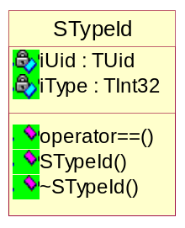

Virtual Data Table
Virtual data table fully describes the structure of the particular meta-type. Each derived meta-type links its table with the one of the base type so that the knowledge of the full hierarchy is accessible through the derived type.
A VDT table is simply an array of SVDataTableEntry. Each SVDataTableEntry contains two members corresponding logically to two columns of the virtual data table: 1) offset in bytes from the this pointer to the particular member and 2) a pointer to a static NewL function constructing a proper “handler” for the particular member’s type (please see Data Handlers).
NULL in the second column of the last row determines the end of the table. The value in the first column (offset) determines if there is any base type’s table linked to this one or not (if there is it contains the pointer to it).

Virtual Data Table Entry Diagram
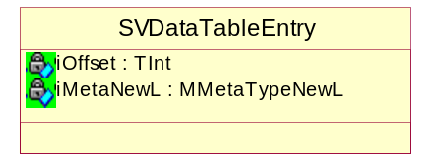

Virtual Data Tables In a Simple Hierarchy (Patrik’s Diagram)
This diagram represents an example hierarchy. Each class in the hierarchy declares some attributes that can all be accessed and handled via a derived type because of the linkage between the tables. One of the interesting features of meta-objects is that – provided the underlying type is CU2 – all six attributes can be handled via CUBase’s pointer!
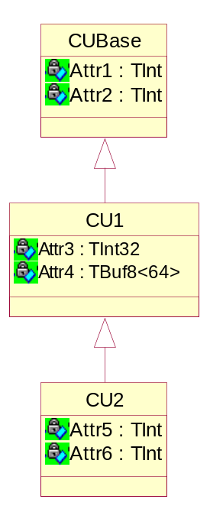
An offset from this
Handler’s NewL
_FOFF(CU2,Attr5)
_FOFF(CU2,Attr6)
TMetaNumber::NewL
TMetaNumber::NewL
NULL
(CU2’s VDT starts at 0x50000000)
0x50001000
_FOFF(CU1,Attr3)
_FOFF(CU1,Attr4)
TMetaNumber::NewL
TMeta<TBuf<64> >::NewL
NULL
(CU1’s VDT starts at 0x50001000)
0x50002000
_FOFF(CUBase,Attr1)
_FOFF(CUBase,Attr2)
TMetaNumber::NewL
TMetaNumber::NewL
NULL
(CUBase’s VDT starts at 0x50002000)
0

Virtual Data Table Iterator
Virtual data table iterator walks through the linked tables. It defines only one, postfix increment operator. Once initialised with a pointer to a table it returns a pointer to an entry at each step until the end of the very base table has been reached. Then it returns NULL.

Data Handlers (MMetaType)
Each virtual data table entry contains a pointer to a NewL function. This function constructs a data handler that knows how to perform defined basic operations on the particular data member. These operations include Length(), Store(), Load(), Copy(), Clone(), etc.
Currently there are three main types of data handlers:
- For simple types (T-types) – TMeta<TYPE>
- For pointers to meta-objects – TMetaPtr<TYPE>
- For meta-objects – TMetaObject<TYPE>
Together they provide a meta-object composition mechanism covering the cases where object can construct itself.

Meta-Object Hierarchy (MMetaData)
The implementation of the data virtualisation mechanism (NetMeta) has been based on run-time type identification and run-time access to the virtual data table. The type id is required for virtual construction of meta-objects and the virtual data table simply describes the data structure.

MMetaData
MMetaData declares an abstract interface to provide exactly this information. Currently all meta-types derive from MMetaData and implement its pure virtual methods. This may change in the future though (please see Future Development).

SMetaData
SMetaData implements algorithms that we may want to apply to a data structure. SMetaData is the one and only place where all the algorithms are implemented. Without data virtualisation we would need to implement these algorithms separately each time we define a new type.

Meta-Object Hierarchy Diagram
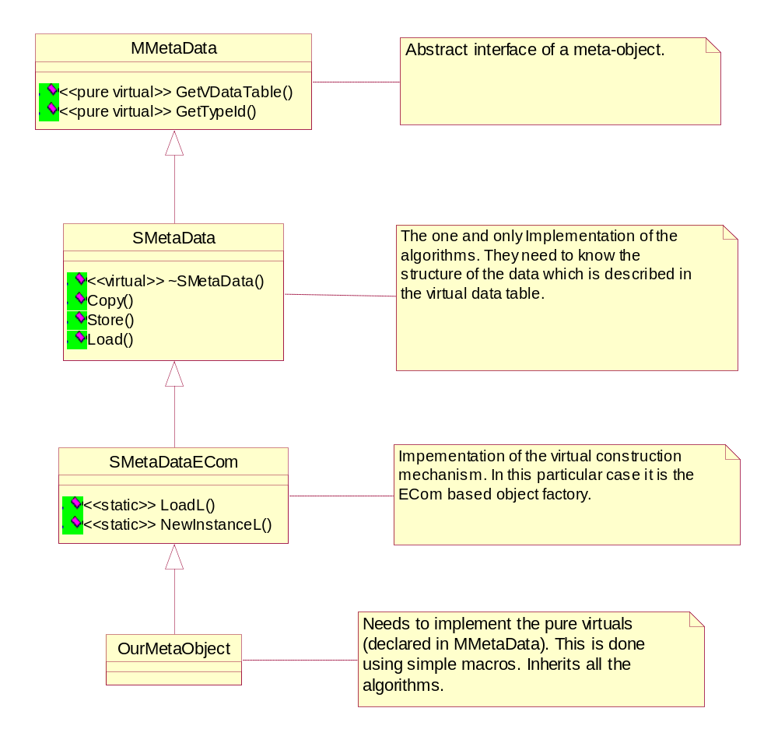

Object Factory
The object factory provides a virtual construction mechanism, which, similarly to data virtualisation isn’t supported by the standard C++. NetMeta can work with many object factories based on many different solutions. Currently it implements one that is based on ECom.

SMetaDataECom
The place where object factory is integrated with the meta-object hierarchy is SMetaDataECom.
For the virtual construction mechanism to work, the knowledge of how to construct a particular meta-type object must be accessible to ECom. This knowledge is provided to ECom in a form of a plug-in. Based on a given type ID, ECom consults the plug-in (advertising this type ID) to construct an object of the particular type.
One ECom plug-in can group knowledge of how to construct a number of related types. In such case the UID part of the type ID would select an implementation and the INT part of the type ID would be passed to the implementation’s NewL function finally selecting the correct meta-type).

Meta-Data Container
Meta-objects have this nice feature that they all can be easily manipulated with (==algorithms applied to) when their type ID and virtual data table is known. Currently this can be done via the base type (please see Future Development).
This easy manipulation (via a single type) means that one container usually fits all, sometimes very sophisticated storage needs.
The container can also implement certain handling functions to store itself, load itself, etc. This allows it to be used as a (parameter to a data handler template) meta-object’s member☺.

RMetaDataContainerBase and RMetaDataEComContainer
RMetaDataContainerBase implements such a simple meta-object container. It inherits from RPointerArray<SMetaData>.
RMetaDataContainer<ELEMENT> implements additionally a static LoadL function. RMetaDataEComContainer is typedef-ed as RMetaDataContainer<SMetaDataECom>.

Meta-Data Container Diagram
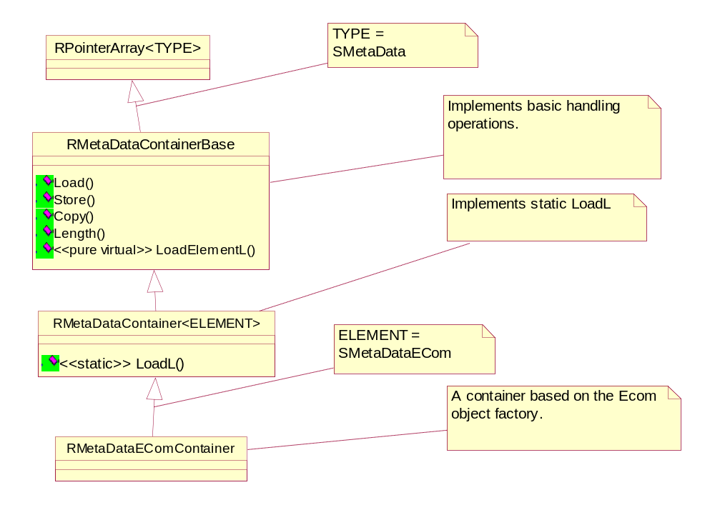

An Example

Declaration in .h file
class CSubConQosIPLinkR5ParamSet : public SMetaDataECom
{
public:
inline static SubConQosIPLinkR5ParamSet* NewL(); //uses ECom object factory
[…]
protected:
DATA_VTABLE;
protected:
RPacketQoS::TTrafficClass iTrafficClass; // Traffic class
TInt iTransferDelay; // Transfer delay
};

Definition of the Data Virtual Table in .cpp file

START_ATTRIBUTE_TABLE( CSubConQosIPLinkR5ParamSet, KSubConIPParamsUid, KSubConQosIPLinkR5ParamsType )
REGISTER_ATTRIBUTE( CSubConQosIPLinkR5ParamSet, iTrafficClass, TMetaNumber )
REGISTER_ATTRIBUTE( CSubConQosIPLinkR5ParamSet, iTransferDelay, TMetaNumber )
END_ATTRIBUTE_TABLE()

Usage

Construction
SubConQosIPLinkR5ParamSet* set = SubConQosIPLinkR5ParamSet::NewL();
set->iTrafficClass = 128;
set->iTransferDelay = 64;

Storing
set->Store(aDescriptor);

Loading
SubConQosIPLinkR5ParamSet* set2 = LoadL(aDescriptor);

Copying
set->Copy(set2);

Design Considerations

Further considerations on static vs. run-time registration
As opposed to run-time registration mechanisms – static tables do not require dynamically allocated run-time storage. This has multiple implications:
- There is no problem of inter-process access to this data (security issues).
- There is no need for persisting (storing somewhere/loading from somewhere) of this data (security issues). The compiler helps to check integrity of this data. But at the same time there is less flexibility. A type has to be defined at the compile-time and cannot be edited without recompiling of the source.
- There is no overhead related to dynamic allocations/de-allocations and other maintenance of the dynamic storage.
- The static Virtual Data Table is linked to a type at compile-time. This means that when an object of a particular type requests an access to its table there is only a minimal overhead involved for this operation (an access to a virtual method).
- There is no overhead related to the registration of the type.

Future Development
Currently all meta-types inherit from SMetaData. In the future we may want to give some meta-types an option of not inheriting form SMetaData.
If implemented, this would decouple the MMetaData hierarchy from meta-objects giving them a full freedom in the way they want to be related to other objects.
As the first example please consider the following structure:
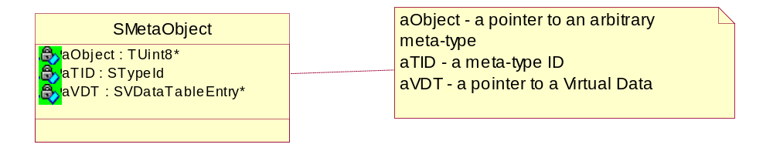
Information in this structure is enough to completely describe a structure of a meta-object (in aObject) at run-time.
Now we could just have few static functions (that are currently implemented as not static in SMetaData) - like Store, Load etc taking this above structure as a parameter. These functions could be used by objects of any (unrelated) meta-types.
Another example could be a container of meta-objects. If there is no defined base type we can’t store meta-objects just like we store SMetaData based objects. But we can easily store their complete descriptions i.e. SMetaObjects.

Further Information

References
No. | Document Reference | Version | Description
[R1]

Open Issues
The following issues need to be resolved before this document is completed;
- Not known

Glossary
The following technical terms and abbreviations are used within this document.
Term | Definition
Object Factory | A mechanism of virtual construction of objects.
Meta-Data | External (i.e. in a descriptor) representation of an object.
Meta-Object | An object of Meta-Type.
Meta-Type | A type that inherits from MMetaData.
VDT | A Virtual Data Table

