Contents
1 Introduction 2
1.1 Abstract 2
1.2 Purpose and Scope 3
1.3 Mesh and what do we mean by it 3
2 State Machine basic concepts 4
2.1 Principles 4
2.2 States and Transitions 5
2.3 Implementation 7
3 Mesh Machine basic concepts 8
3.1 Messages 9
3.2 Activities 11
3.3 Nodes 13
3.4 Mesh Machine Based Nodes 15
4 Mesh Machine Operation Basics 15
4.1 Message Received 16
4.2 Message being processed 17
4.3 Running an activity 19
4.4 Error Handling and Error Recovery – an example from Networking 20
5 Activities 21
5.1 First Transition Activities 22
5.2 Single Triple Activities 22
5.3 Activity Flow Fork 22
5.4 Activities Synchronisation 23
6 Interactions between nodes 25
7 Appendices 26
7.1 People 26
7.2 References 26
7.3 Open Issues 26
7.4 Document History 26

Introduction

Abstract
Creation of highly complex environments (such as for example multi technology Networking or Multimedia solutions for Operating Systems) can not be feasibly achieved using only “standard” approaches based on sequential synchronous or semi-asynchronous processing. By that we mean that an object serves one call at a time and a caller waits for the servicing object to finish its task. In other words: an object1 issues synchronous call (request) to object2 which in turn calls object3 one and so on. Such a scenario seems very simple from the original requestor and the developer angle (as it makes code sequential) but has the following drawbacks:
- Blocks all activity in the thread until the request has been served
- There is no control over the call stack in the code as chain of the objects needed to process a request is given by, possibly very dynamic, environment configuration.
- Synchronous call can either leave or return an error or requestor object can be called back before the original call returns. This makes the requestor state-machine difficult to write as it’s not clear when its state change occurs.
  - Sometimes we could even have a situation that some requests are synchronous, some are asynchronous but with synchronous error path and some are fully asynchronous. That makes it even more confusing
- There is a need that every request is served by a virtual function to achieve polymorphism. That means that we can either supply a base class having all functions defined (which is of course impossible) or introduce a method to ask an object for an interface to serve our request. Having all our communication based on virtual functions means that for any extension and/or modification we need to have another interface as any method addition breaks BC.
- Limits us in case we ever want to let collaborating objects run in different threads or processes.
- Has limited use in real-time environments since it is impossible to say what is going to block where and under what circumstances.
All the above mentioned drawbacks disappear when we say that the requestor doesn’t use function calls but posts a message, the message posting cannot fail (meaning it is guarantied a message will reach its destination) and the message posting is fully asynchronous. This is not to say that we discard a possibility to a request synchronous interface from an object for simple tasks as mentioned later in the document. A fully asynchronous approach brings some challenges however:
- By posting a message (e.g. request) the sender hands over execution to another object. Meaning it changes its state and waits for a message back (e.g. response).
- An object can receive another request (a message that requires response – message back) before the previous one has been processed.
- An object can receive the same request from another sender before the request has been processed.
- C++ doesn’t offer any native mechanism for an object to receive a message
The above mentioned points lead to a conclusion that an object can be simultaneously processing more same/different requests meaning it may be actually running multiple state-machines at the same time.
Now, a classic approach to a state machine is based on a “switch” or “if” statements like this.
Switch (state)
Case 1:
Fn1();state = 2;
Break;
Case 2:
Fn2();state = 3;
Break;
And so on…
Note the above example is as clean as one can get and doesn’t even account for a fork in a state-machine and error handling which is very rare in reality. Even though there are plenty examples when this approach is perfectly valid, especially when speed is paramount like kernel, device drives, even simple protocols, we for our purposes see the following problems with this approach:
- It couples together states and state transition.
- It’s not possible to achieve polymorphism unless the Fn1 and Fn2 are virtual functions and hence the aforementioned problem
- It’s not possible to stick a state/transition in or remove them without rewriting an entire state-machine let alone to do it in runtime.
- It’s not possible to separate and unify error handling and error recovery and let a developer worry only about successful path safe for edge cases.
- No obvious/natural points for optimisation and/or code reuse
- Makes it hard to decouple component from various functionalities it performs. This leads to the whole component being branched whenever a simple modification is needed.
Now the only argument for switch statement like solution would be speed. And of course it is a valid argument and it indeed has its weight in some areas as we mentioned above. However we say that not everything can be optimised for speed only as it would end up incredibly big and complex. Plus we feel that in the control plane the message frequency is not significant. Therefore adding one loop to iterate running and idle activities of a node (as described in 4.2) is not any speed penalty given the rest of the work the control plane does.

Purpose and Scope
The document describes the approach we took to cope with the challenges of asynchronous world and deficiencies of the “switch” statement. This document describes work captured under the MeshMachine element. Throughout the document we assume that the reader is familiar with NodeMessages, NetMeta, NetInterfaces, Factories, VirtualConstructors and partially NetSM elements. We say “partially” since the relevant constructs of NetSM element are explained in the section 2. The target audience are developers wishing to utilise the outlined concept for their work.

Mesh and what do we mean by it
At the heart of the document are the concepts and ideas behind a mechanism that we call “Mesh Machine”. The term “Mesh-Machine” stems from the fact that we say that an object sits in a mesh of other objects surrounding it. We therefore say that such an object is a “node”. A node has “peers”, its immediate neighbours the node knows about. As described in R1 a node becomes a peer of another one by sending a join request message to it upon which the target node remembers the sender as its new peer. A peer could also cease being a peer by sending leave request message upon which reception a node forgets about the sender as the node peer. In other words:
- Mesh-machine is a mechanism to start/run/stop many concurrent state machines which we call activities (see section 3 for details)
- Node utilises the mesh-machine mechanism and adds a capability to receive messages, request custom interfaces and retrieve the node’s runtime address (ref section 3.3 for details)

As an example of peer nodes the following picture shows a node as a part of a mesh as we define it for networking control plane.
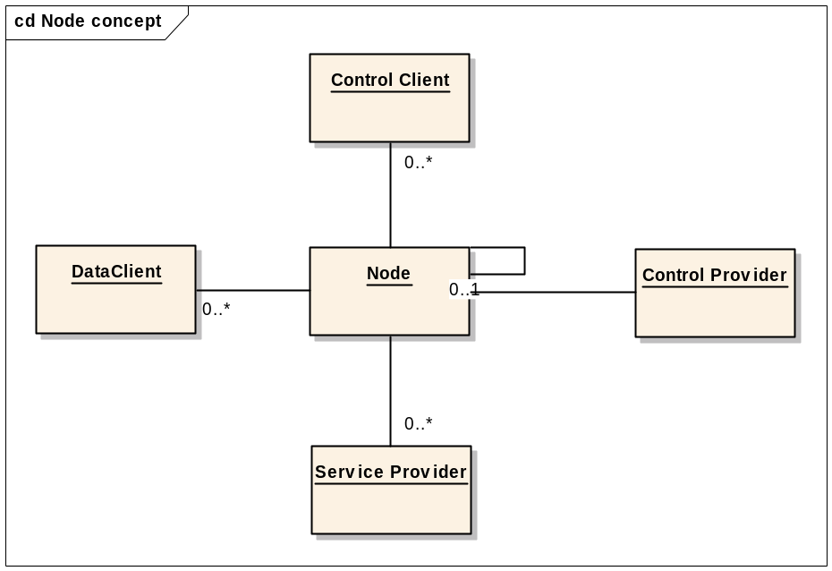
Figure 1-1 Mesh as a networking node views it
Of course every Data Client, Control Provider, Control Client and Service Provider roles are implemented by nodes. As shown on the picture a node can be associated with itself and send messages to itself.
A node can but doesn’t have to be a mesh-machine based. The mesh-machine is a mechanism that allows us to address the issues and challenges we mentioned in 1.1.

State Machine basic concepts

Principles
Let us start by defining what some of the state-machine terms mean from a programmer’s point of view. These should all be well known and understood concepts. We only aim to clearly define every one of them.
1) State.
A state, as the name suggests, is a mode or condition of an entity. It is not a function. A State is stationary, it can only wait for an event, or stop waiting for an event (i.e. be cancelled). It doesn’t do any work and can not produce an error. When asked to accept an event, it can however test or probe certain state and make its acceptance decision based on the outcome of these actions (that could succeed or fail).
2) Event.
Something a state is waiting for. An event can be a message or some other trigger. In the case of the mesh machine, however, it is always a message (see 3.1 for details on message concept). At the end it is the state that receives it and reacts to it.
3) Transition.
It’s a synchronous action in between stationary states. Being a function, a transition can generate errors. Transition action can result in posting a message to another node and so on.
4) State Fork.
State Fork represents the routing decision taker within an activity triple. Simply, it is an algorithm to pick the next transition. It is implemented as an “if” or “switch” statement. We say that a transition brings us to one and only one state but a state fork can decide on the next transition from many given transitions at run-time. We can therefore say that the State Fork is isomorphic to the State Transition Function (please refer to FSM mathematical model). The State Fork function cannot fail and supplies an integer value called “transition tag” based on which the core state machine engine finds the selected next transition. Each transition is marked by a transition tag upon becoming a part of a state-machine (e.g. transition tag is not a part of a transition but says how the transition fits into the concrete state-machine’s State Transition Table). (see Figure 2-2). Please refer to the below table as to how State Fork function represents one row in the State Transition Table.
State / Input | Input 1 | Input 2 | Input 3 | Input 4
State 1 | Transition 1 | Transition 2 | Transition 3 | Transition 4
State 2 | Transition 2 | Transition 3 | Transition 1 | Transition 4
State 3 | Transition 1 | Transition 1 | Error | Error

The State Fork function for the State 1 would look as follows (pseudo-code):
switch (Input)
{
case Input 1:
return Transition 1;
case Input 2:
return Transition 2;
case Input 3:
return Transition 3;
case Input 4:
return Transition 4;
};

5) State machine.
It is a container of states, transitions, and a description of how they relate to each other (i.e. state transition table).

We hope that everybody agrees that one very important aspect of a good design is to keep things small, very specialised, minimal and independent. Of course just how independent and small these things will really be depends on the area we address. As mentioned earlier coupling elements together may be perfectly valid for some cases, however we don’t believe it applies to us as explained in 1.1.
The aforementioned design principle basically says that any element should be complete therefore ideally it never makes any sense to add/modify it. That said we should keep the above named elements small, well specialised, minimal and independent hence we can make them complete.

States and Transitions
Just how do we achieve what we laid out in 2.1 is a task for this section to explain.
Having defined elements of a state-machine we now need means to build a state-machine from these elements. Following on we see that transition, state and transition tag form some kind of an entity that can be statically (compile-time) defined for that particular state-machine. The entity manifests the above mentioned principle that each transition is marked by a transition tag, each transition moves a state-machine to one and only state and each state can decide on the next transition via transition tag. We call such an entity a “State Triple”.
Transition 1
Transition 2
Transition Tag 1
State 1
Transition Tag 2
State 2
Transition 3
Transition Tag 3
State 3
State Triple
State Machine
State Fork 1
State Fork 2
State Fork 3
Figure 2-2 - State-machine made up from State Triples
Classes/structures described in the following 2.x sections are declared / implemented by NetSM in comms-infras\elements\statemachine\....

State Triple (static description of a state-machine)
The state triple is defined as:
struct TStateTriple
{
TStateTransitionCtor iTCtor;
TStateCtor iSCtor;
TStateForkCtor iFCtor;
TInt iTransitionTag : 31;
const TText8* iName; //For logging only but present in all configurations to preserve BC.
};
(This code is inside: …/elements/statemachine/include/sm_statetriple.h)

Where:
- iTCtor - in-place transition constructor
- iSCtor - in-place state constructor
- iFDtor - in-place state fork constructor
- iTransitionTag - transition tag. The highest bit is not used here it can only be set by a state to indicate direction (see below and 5.3).
It should be clear by now that a state-machine is defined by an array of TStateTriple structures. That array is processed by:
class ACore
{
protected:
explicit ACore();

public:
static TBool Accept(const TStateTriple& aFirst, TAny* aContext, TInt aTransitionTag);
void Start( TAny* aContext, const TStateTriple& aFirst);
TBool Next( TAny* aContext);
void Cancel(TAny* aContext);
static const TStateTriple* FindNext( const TStateTriple& aCurrent, TInt aTransitionTag );

// Runs the transition in the given state triple
static void Do(const TStateTriple& aTriple,TAny* aContext, TDes8& aMem);
void DoCurrent(TAny* aContext);

TBool IsIdle() const
void SetIdle()
private:
void DoTransition(MState& aState,TAny* aContext, TDes8& aMem);

private:
const TStateTriple* iCurrent;
};
(This code is inside: …/elements/StateMachine/include/sm_core.h)

The class itself is very tiny. An instance of the class walks the triples in direction given by the highest bit in transition tag supplied by the current state looking for a next transition to execute. The way triples are organised and the fact that a transition tag is returned by currently expiring state means that after a transition we can only be in one given state (given by the triple that contains the transition). However an expiring state can pick any transition it likes to go through to move to the next state.

State
Declared as a class MState that defines the following APIs:
virtual TBool Accept() = 0;
virtual void Cancel() = 0;
(This code is inside: …/elements/StateMachine/include/sm_stateTriple.h)

A state can be asked to accept an event (Accept), and it can be cancelled (Cancel()).
There is no code in a state that can generate an error and no way such an error can be propagated anywhere apart from a proprietary mechanism intrinsic to the state.

State Fork
Declared as a class MStateFork that defines the following APIs:
virtual TInt TransitionTag() = 0; //returns a transition tag + direction
(This code is inside: …/elements/StateMachine/include/sm_stateTriple.h)

It can only be asked what transition tag the activity object should take into account when choosing its next transition (TransitionTag()).
The TransitionTag() function can return KErrorTag as mentioned in 5.3.

State Transition
Defined as class MStateTransition that defines the following APIs:
virtual void DoL() = 0;
virtual void Error( TInt aError ) = 0;
(This code is inside: …/elements/statemachine/include/sm_stateTriple.h)

As can be seen from these, a transition does something in DoL().DoL() can therefore generate an error, in which case the transition is given a chance to recover from it in the Error() function. If it does not recover, the error is being handled by the activity in a standard way (more about it later).

Implementation
Any concrete state needs to implement the MState API and static NewL function having the following signature:
typedef MState* (*TStateCtor)(TDesC8& aMem, TAny* aContext);
Any concrete transition needs to implement MStateTransition API and static NewL function having the following signature:
typedef MStateTransition* (*TStateTransitionCtor)(TDesC8& aMem, TAny* aContext);
Any concrete state fork needs to implement MStateFork API and static NewL function having the following signature:
typedef MStateFork* (*TStateForkCtor)(TDesC8& aMem, TAny* aContext);
By now the reader is perhaps wondering how all these states, transitions and forks can work when no function takes any parameters? The answer is the aContext parameter passed to the static NewL function defined by user and understood by the states and transitions. More on the context later in the document.
States and transitions are not allocated on heap (as aMem parameter indicates) since this would be slow and could fail.
So how does the ACore class know how much memory to reserve when calling TStateTriple::iCTor/iSCTor/iFCTor? In fact, states, transitions and state forks should be very tiny classes owning only a reference to the context. These are created using memory allocated on the ACore stack meaning that these objects are only valid during one function call.
A simple element that implements these principles is NetSM. NetSM also defines a few helper templates and macros to declare and define states, transitions and triples. If one uses macros supplied by NetSM to declare triples than the size of the state, transition and state fork classes will be checked at compile time. Section 2.2 explains how we utilise this element for the mesh-machine purposes.

Mesh Machine basic concepts
To reiterate, the term; “Mesh machine” stems from the fact that a node sits in a mesh of nodes serving potentially many requests at a time. For the network control plane purposes we view the mesh as pictured on Figure 1-1. The basic mechanism we are looking for here should allow for:
- Start, stop and run state-machines to serve requests
- Support for synchronisation of concurrently running state-machines
- Decoupling of error handling from general functionality
- Support for error recovery
- Management of communication channels to node peers
To our terms defined in 2.1, we should now add:
6) Activity.
It is a state-machine serving particular request made up from state triples (Figure 2-2). It performs a task that can be viewed as a communication protocol from the point of view of a node. An object becomes an activity by deriving from CNodeActivityBase.
7) Message.
Information passed between nodes. In the mesh machine, a message is a structure that carries parameters for the receiving activity, info about its destination node and a means to be identified by its destination node. An object becomes a message by deriving from TSignalBase and by adhering to particular requirements as we see later on.
8) Node.
An entity sitting in a mesh grid, interacting with other nodes using defined communication protocols implemented in terms of activities. A node can, but doesn’t have to make use of the mesh-machine engine. It’s recommended, though, that a node uses the mesh-machine especially if it needs to run multiple activities at the same time. An entity becomes a node by implementing MNode interface as described in 3.3. If a node wishes to use the mesh-machine engine it needs to derive from AMMNodeIdBase.
9) Originator.
When a node “A” sends a message to a node “B” starting an activity “B1” on node “B” we say that the node “A” is an originator for the activity “B1”. BUT, if the activity “B1” can serve different originators at the same time, “A” will simply join the already-running-activity. More on this in 4.
NODE

Node Activities
Activity 1
Activity 2

Activity 3

Figure 3-3 - Node as a collection of Activities

Messages
Messages are the basic way to allow fully asynchronous communication among nodes. We’ve defined the following properties for an object to be a message:
- Based on TSignalBase.
- Must have a simple structure (e.g. it’s possible to binary copy it) meaning we don’t support messages carrying complex structures as arrays, references that need reallocation, and so on. We believe that a need for complex message is a sign of something somewhere being too complicated.
- Must be able to dispatch itself. E.g. deliver itself to its destination or execute its own code.
- Must be able to serialise itself.
- Must have a virtual constructor that cannot fail
- Must decouple signature (parameters) from request/notification id (function)
We’ve also defined the following types of messages:
- Received by a node (TSignatureBase based). Such a message assumes that target object implements MNode interface.
- Looking for a specific interface (TClientItfExt composed). Such a message uses the MNode interface on the target object to find out whether the object supports desired interface.
- Performing a specialised task (template<>TMessageDispatcher composed). We call that such a message is a “Self-dispatched” message.

Message Hierarchy
The picture below shows static message class hierarchy. It might look very scary at first sight but once we realise that all these classes are actually very tiny ones and have precisely defined purpose it might start looking a little bit less frightening. We describe the purpose of these classes and templates inthe following paragraphs. It’s recommended to set zoom to 150% to see the text.

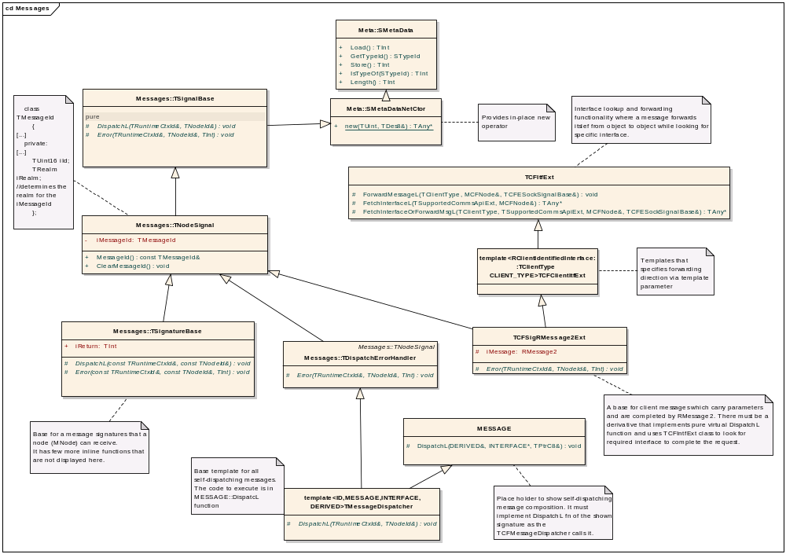
Figure 3-4 Static message class hierarchy

Brief Class Description:
- SmetaData - serialisation and type checking (implemented by NetMeta comms-infras\elements\netmeta\....)
- SmetaDataNetCtor - in-place operator new that cannot fail (implemented by NetMeta comms-infras\elements\netmeta\....)
- TSignalBase - abstract self-dispatching and built-in error handling capabilities, destination verification, self-posting functionality
- TNodeSignal - adds message Id (function Id) so that the purpose of the message signature can be interpreted by the destination node and activity.
- TSignatureBase - adds return value used to hold an error caused by the node while processing the message and valid only on the destination node. Implements DispatchL and Error that work with the assumption that the destination node implements the MNode interface.
- template<>TDispatchErrorHandler - basic error propagation for self-dispatched messages
- template<> TDispatchErrorHandler - simple type safe wrapper to dispatch and handle an error for self-dispatched messages that supply their code in the MESSAGE::DispatchL function.
- TItfExt - supply interface lookup and forwarding functionality meaning that the message can hop from one node to another while looking for an interface. Forwarding algorithm is given by derived class.
- template<> TClientItfExt - supplies a forwarding algorithm as a template parameter
- TSigRMessage2Ext - a base for client messages which carry parameters and are completed by Rmessage2. There must be a derivative that implements a pure virtual DispatchL function and uses the TIntfExt class to look for the required interface to complete the request.
We believe that looking at the class hierarchy after reading the brief class description make it a lot easier to understand. One should see that every member of the hierarchy adds one very specific and very simple bit of functionality. The composition than allows us to combine these bits and get a broad range of very rich, message related behaviour that is both extremely robust and keeps ROM and RAM footprints at minimum
It is completely up to the message transport (as mentioned in Error: Reference source not found) how to turn a message into a buffer and back. We supply TID, OID, virtual constructor and serialisation capabilities to work with.

Activities
As explained above (section 3), an activity is a state-machine running on a node to perform some coherent task. The following picture shows the base hierarchy of activity classes on which custom activity classes can be built. Even though we allow for a custom activity, it is envisioned that for most activities the basic hierarchy will be enough. The picture displays only the main methods significant for the class purpose along with all class attributes. Even though there are only a few methods missing, plus traditional two-phase constructors for “C” classes. The recommended zoom is 150% to see the text.
cd Mesh-machine - Activities
CBase
ACore
-
iCurrent: const TStateTriple*
+
Accept(TInt, TAny*, TStateTriple) : TBool
+
Start(TStateTriple&, TAny*) : void
+
Next(TAny*) : TBool
+
Cancel(TAny*) : void
AContextStore
#
iContextDesc: RBuf8
-
iRetryingForMessageId: TUint:16
+
Retry() : TInt
+
StoreContext() : TInt
+
RetryingForMessageId() : TUint
+
CanRetry() : TBool
#
LoadContext() : TInt
AActivitySemaphore
-
iSignalActivitySigId: TInt
+
ParkTransitionL(TNodeContextBase&) : void
#
Signal() : TInt
+
ParkState(TNodeContextBase&) : TInt
AApiExtBase
+
FetchExtInterfaceL(TSupportedCommsApiExt) : void
#
DoFetchInterfaceControlL(TSupportedCommsApiExt) : void
So that we can fetch
AContextStore and/or
ActivitySemaphore
interfaces
NetStateMachine::ACore
NetInterfaces::TInterfaceControl
CNodeActivityBase
#
iOriginators: RArray<TNodePeerId>
#
iPostedToId: TNodeId
-
iActivitySig: TNodeActivity&
+
OriginatorsCount() : IMPORT_C TInt
+
SetIdle() : IMPORT_C void
+
ActivitySigId() : TUint
+
KickOffMessageId() : TUint
+
Originators() : RArray<TNodePeerId>&
+
FindOriginator(TNodePeerId&) : IMPORT_C TInt
+
FindOriginator(RClientIdentifiedInterface&) : IMPORT_C TInt
+
PassToOriginators(TSignatureBase&) : IMPORT_C void
+
SetSentTo(TCommsId&) : IMPORT_C void
+
SendRequestTo(RClientIdentifiedInterface&, CommsFW::TSignalBase&) : IMPORT_C void
+
SendRequestTo(TCommsId&, CommsFW::TSignalBase&) : IMPORT_C void
#
Accept(TNodeContextBase&, TNodeActivity&, TInt) : NetStateMachine::TStateTriple*
#
Cancel(TNodeContextBase&) : IMPORT_C void
#
Abort(TNodeContextBase&) : IMPORT_C void
#
Match(TNodeChannelId&) : TBool
CNodeParallelActivityBase
+
CNodeActivityBase: IMPORT_C
+
TUint: IMPORT_C
#
iActivityId: TUint16
#
CNodeParallelActivityBase(TNodeActivity&, TUint)
INTERNAL_IMPLEMENTERHIERARCHY_1
CNodeRetryActivity
+
CNodeActivityBase: IMPORT_C
+
ReturnInterfacePtrL(AContextStore*&) : IMPORT_C void
#
CNodeRetryActivity(TNodeActivity&)
AActivitySemaphore
INTERNAL_IMPLEMENTERHIERARCHY_1
CNodeSynchronisedParallelActivity
+
CNodeActivityBase: IMPORT_C
#
TInt: IMPORT_C
+
ReturnInterfacePtrL(AActivitySemaphore*&) : IMPORT_C void
#
CNodeSynchronisedParallelActivity(TNodeActivity&, TUint)
AActivitySemaphore
INTERNAL_IMPLEMENTERHIERARCHY_1
CNodeSynchronisedActivity
+
CNodeActivityBase: IMPORT_C
#
TInt: IMPORT_C
+
ReturnInterfacePtrL(AActivitySemaphore*&) : IMPORT_C void
#
CNodeSynchronisedActivity(TNodeActivity&)
Figure 3-5 Base activity classes hierarchy
Why do we have so many classes? Following the principle stated in 2.1 and realising that cramming all the code into one class wouldn’t really save us any ROM we would only loose a clear sense of structure and responsibilities plus we would actually waste RAM, things may already look a bit different.
Brief Class Description:
- ACore - walks the state-machine triples (see 2.2.1)
- AapiExtBase - facilitates interface extension, implemented by the base hierarchy and possibly custom activities
- CNodeActivityBase - manages activity originators, has set of utility methods to be used by states and transitions, can start, stop, run and cancel activity. It also holds an activity Id and the id of the most recent node to which the activity has sent a message.
- AContextStore - an extension that allows an activity to store its current context so that it can be suspended and resumed later.
- CNodeRetryActivity – extends the base activity class giving it retry capability by employing the AContextStore class.
- AActivitySemaphore – an extension that facilitates activity synchronisation. Any activity that needs to synchronise itself should use this extension
- CNodeSynchronisedActivity – extends an activity, giving it synchronisation capabilities by employing AactivitySemaphore.
- CNodeParallelActivityBase – an activity that can run in more than one instance on the node. E.g. such an activity will always have only one originator per activity instance.
- CNodeParallelSynchronisedActivity – extends an activity, giving it synchronisation capabilities by employing AactivitySemaphore
- CNodeParallelRetryActivity – extends the base activity class, giving it retry capability by employing AContextStore class.

Node Activity (static definition)
An activity performs a well-defined task within a node. An activity is a state-machine run by the mesh-machine engine within a node that uses the mesh-machine. Any activity must:
- Be uniquely identified within the node. Please refer to Error: Reference source not found for details why we have this requirement
- Have an unambiguous “kick off” message. I.e. one particular message id that starts the activity. We don’t think there is a need for an activity to serve more than one request (message). This approach also has the nice effect that we always precisely know what it means when an activity fails or succeeds (what request has actually failed). It is theoretically possible to omit the kick off message in the activity definition but is never needed in a sound design.
- Be or be derived from the class CNodeActivityBase
- Point to the first triple in its state-machine triple array
Taking a similar approach to defining the states and transitions (see 2.2), we define an activity as the following structure:
struct TNodeActivity
{
typedef CNodeActivityBase* (*TstaticActivityCtor)( const TNodeActivity& aActivitySig, const AMMNodeBase& aNode );
const Tuint iId : 8;
const Tuint iKickOffMessageId : 16;
const NetStateMachine::TstateTriple& iFirstTriple;
const TstaticActivityCtor iCtor;
const Ttext8* iName; //logging purposes only
};
(This code is inside: …/elements/meshmachine/inc/mm_activities.h)

MeshMachine component defines in mm_activities.h file useful macros to facilitate static definition of activity and activity map for a node as described in 2.2 and 3. For examples of activities and activities’ map definitions please refer to comms-infras/esock/coreproviders/.... The activity map is essentially an array of TNodeActivity structures.
Struct TNodeActivityMap
{
typedef const TNodeActivityMap& (*TstaticNodeActivityMap)();
typedef const TNodeActivity& (*TstaticNodeActivity)();
const TstaticNodeActivity& iFirstActivity;
};
(This code is inside: …/elements/meshmachine/inc/mm_activities.h)

The structure member iFirstActivity is reach the first TNodeActivity instance. The reason behind iFirstActivity being a function rather than directly the TNodeActivity instance is a deficiency of Symbian ARM linker that prevents it to import exported static const variables. We need to export defined activities (reacheable via TstaticNodeActivity function) and activity maps in order to offer the Core providers building blocks.
A static description of a MeshMachine activity can be expressed by the following syntax:

Opening:
DECLARE_DEFINE_NODEACTIVITY(id, name, kickoff_message) |
DECLARE_DEFINE_CUSTOM_NODEACTIVITY( id, name, kickoff_message, activity_ctor ) |
DEFINE_EXPORT_NODEACTIVITY(id, name, kickoff_message) |
DEFINE_EXPORT_CUSTOM_NODEACTIVITY(id, name, kickoff_message, activity_ctor) |
DEFINE_NODEACTIVITY(id, name, kickoff_message)

Closing:
NODEACTIVITY_END()

First triple:
FIRST_NODEACTIVITY_ENTRY(state, fork)

Last triple:
LAST_NODEACTIVITY_ENTRY(tag, transition)

Standard triple:
NODEACTIVITY_ENTRY(tag, transition, state, fork)

Transient triple (no state):
THROUGH_NODEACTIVITY_ENTRY(tag, transition, fork)

Single triple:
SINGLE_NODEACTIVITY_ENTRY(transition, state)

Routing triple:
ROUTING_NODEACTIVITY_ENTRY(tag, fork)

Tags, transitions, states and forks were described in section 2.2.

CNodeActivityBase
This class deserves a closer look as it is a base class for any type of node activity. Its role is to manage activity originators and provide utility methods to help writing collaborating states and transitions. As to how exactly nodes and transitions get hold of their state-machine object we should remember a context mentioned in 2.3 and refer to 4.3.

Nodes
A node is a basic entity of the mesh and can send and receive messages. A node can but doesn’t have to be a mesh-machine based. Every node must implement MNode interface and every node is identified by TNodeId structure (please refer to R1 for details on node addressing).
Class MNodeId
{
virtual const TNodeId& NodeId() = 0;
};

//comms node entry point
class MNode : public MNodeId
{
public:
//if Received returns != KerrNone than the dispatcher will send a TError to the
//originator of the message
virtual Tint ReceivedL(TSignatureBase& aMessage) = 0;
IMPORT_C virtual NetInterfaces::TinterfaceControl* FetchNodeInterfaceControlL
(TInt aInterfaceId);
IMPORT_C Tany* FetchNodeInterfaceL(TInt aInterfaceId);
};
(This code is inside: …/elements/nodemessages/inc/nm_node.h)

Where:
NodeId - node identification
ReceivedL - allows a node to receive messages
FetchInterfaceControlL - retrieves an interface control for a particular custom interface
FetchNodeInterfaceL - retrieves an instance of a custom interface supported by the node
The following picture displays full hierarchy of aggregation classes that implement most common functionality.
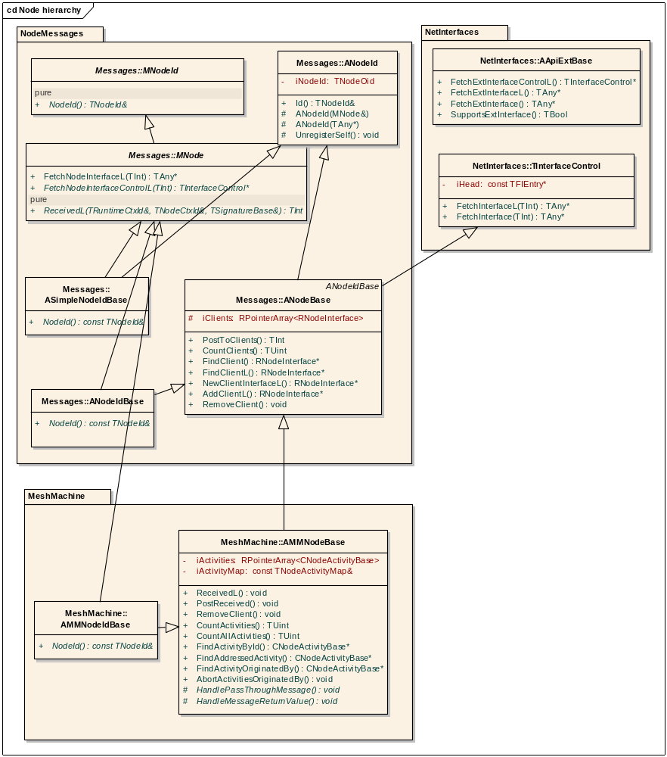
Figure 3-6 Node aggregation classes hierarchy
Brief class description:
- MNodeId - allows an object identify itself as a node
- MNode - allows an object receive messages therefore to behave as a node
- ANodeId - implements functionality related to node identification and registration.
- ANodeIdBase - implements NodeId() pure virtual for nodes that don’t utilise mesh-machine.
- ANodeBase - (non-mesh-machine) node essentials like iClients table etc
- AMMNodeBase - mesh-machine engine
- AMMNodeIdBase - base for nodes that utilise mesh-machine engine
More observant reader may have noticed that ANodeId class that owns node identification doesn’t own TNodeId instance but TNodeOid one. Structure TNodeOid is derived from TNodeId and facilitates automatic node interface registration/deregistration upon the node construction/destruction

Mesh Machine Based Nodes
These nodes make use of ANodeBase and AMMNodeBase classes to start, stop, run, cancel, facilitate synchronisation of activities and manage the node peers. To be able to do all that the AMMNodeBase needs to know what activities a node might run, have some place to keep running activities and have an array of the node peers. If we look back at the Figure 3-6 we see that this is exactly what AMMNodeBase attributes are:
ANodeBase:
- iClients - array of the node peers e.g. of a nodes that have sent a join request message to the node. There could of course be additional nodes here based on the node purpose. The clients are distinguished by bit array identification shown on Error: Reference source not found.
AMMNodeBase:
- iActivities - array of running activities
- iActivityMap - first entry of the node activity map. Node activity map is essentially an array of pointers to struct TNodeActivity described in 3.2.1. Why we say “essentially”? The answer is: peculiarities of the way how ARM would export but wouldn’t import static const variables. mm_activities.h defines a few helpful macros to declare activities and activity map.

Mesh Machine Operation Basics
For the mesh-machine engine to operate correctly it needs to follow a set of principles. It needs to be simple/minimal enough and comprehensive enough to force desired behaviour. The principles we’ve gone for can be summarised as follows:
- Message driven approach
  - A node sends and receives messages
  - Messages are
    - Requests – starting/joining activity on target node (sent by an originator node). Cancellation request is also in this category.
    - Responses – sent by running activities to their originators upon an activity end (sent to an originator node)
    - Notifications – sent by running activities to signal a change.
  - A node can have many concurrent activities active at the same time to serve many requests (node state-machines)
  - Each activity has zero or more originators (entities that started activity or joined already running one)
  - Received messages can be from the node peers (mesh closest neighbours the node knows about – peer messages), from some other node (no-peer messages) or the node itself. The reason for peer/no-peer messages being that some messages only make sense when sent by a node peer. That way we avoid checking for existing peer in the serving activity itself since we provide it on the mesh-engine level as a node wide functionality.
  - For any given originator there can be one and only one activity instance running at the node at a time. This makes sense and is very important for the model to work. For example cancellation request are addressed to activities based on the uniqueness of their originators, etc.
  - Received message passes through states of active activities, may start new activity or falls through
  - Activity can only be started by a peer message with exceptions defined by the node.
- Optimistic approach
  - Developer only programs successful path unless the built in error handling cannot be used and a special error handling needed
- Error handling
  - Errors caused by the node itself are
    - Caused by Mtransition::DoL() and served by the transition Mtransition::Error() function. Default implementation sets TSignatureBase::iReturn to the error code and lets the built in error handling to handle the error.
    - Served by the mesh-machine engine by sending TError to the activity originators
  - Errors received as a response to a request
    - Served by the target activity – usually no recovery possible
    - Served by designated error activity on the target node – error recovery solicited by the error activity
The following sub-topics describe main tasks and principles of the mesh-machine engine in detail.

Message Received
For the mesh engine to be put to work a node has to receive a message through MNode::ReceivedL overwrite. Received message is a type of TSignatureBase. A typical node (or set of a node types) would overwrite MNode::ReceivedL and write something like this
void CCoreConnectionProvider::Received(TNodeContextBase& aContext)
{
TNodeSignal::TMessageId noPeerIds[] = {
TMessage::TDataClientJoined::Id(),
TMessage::TDataClientJoinRequest::Id(),
TMessage::TCtrlClientJoined::Id(),
TMessage::TCtrlClientJoinRequest::Id(),
TNodeMessage::TError::Id(),
TNodeSignal::TMessageId()
};
AMMNodeBase::Received(noPeerIds, aContext);
AMMNodeBase::PostReceived(aContext);
}

void CCoreConnectionProvider::ReceivedL(const TRuntimeCtxId& aSender, const TNodeId& aRecipient, TSignatureBase& aMessage)
{
TNodeContext<CCoreConnectionProvider> ctx(*this, aMessage, aSender, aRecipient);
CCoreConnectionProvider::Received(ctx);
User::LeaveIfError(aMessage.iReturn);
}
(This code is inside: …/comms-infras/esock/coreproviders/src/corecpr.cpp)

What that translates to is this:
- A node specifies which messages are allowed to start an activity even though the node does not recognise the sender of the message as its peer (noPeerIds[]). Any message from the node’s peer is always allowed to start an activity.
- The node creates its context to be passed to running states and transitions. The context for the mesh engine has the following form:
struct TNodeContextBase
{
CNodeActivityBase* iNodeActivity;
Messages::TSignatureBase& iMessage;
AMMNodeBase& iNode;
Messages::RNodeInterface* iPeer; //iPeer can point to iTemporaryPeer or to a valid peer itf
const Messages::TRuntimeCtxId& iSender; //Reference to an opaque sender's address (from this node's point of view)
const Messages::TNodeId& iRecipient;
};

template <class TNODE, class TBaseContext = TNodeContextBase, class ACTIVITY = CNodeActivityBase>
class TNodeContext : public TBaseContext
/**
@internalTechnology
@prototype
*/
{
public:
TNodeContext(TNODE& aNode, Messages::TSignatureBase& aMessageSig, const Messages::TRuntimeCtxId& aSender, const Messages::TNodeId& aRecipient, CNodeActivityBase* aNodeActivity = NULL)
: TBaseContext(aNode, aMessageSig, aSender, aRecipient, aNodeActivity)
{
}

TNODE& Node() {return static_cast<TNODE&>(TBaseContext::Node());};
const TNODE& Node() const {return static_cast<const TNODE&>(TBaseContext::Node());};
ACTIVITY* Activity() { return static_cast<ACTIVITY*>(TBaseContext::Activity()); }
const ACTIVITY* Activity() const { return static_cast<const ACTIVITY*>(TBaseContext::Activity()); }
};

(This code is inside: …/elements/meshmachine/inc/mm_context.h)

- The node calls mesh engine to process the message
- The node calls AMMNodeBase::PostReceived to let the mesh handle error, clean up finished activities and handle potential synchronisation.
From the look at the above context declaration we see that every state and transition get to see the following:
- iNodeActivity - The activity instance pointer which is NULL for the first state and a special first transition case as described in 5.1 and 5.2.
- iMessage - The message received reference
- iNode - The node instance reference

Message being processed
Upon reception of a message, when AMMNodeBase::ReceivedL is called, the mesh engine does the following actions:
- It iterates through the list of all currently running activities, asking each of them if they do accept the event.
- If an activity accepts the event, the event is consumed.
- If none of the currently running activities accept the event the node iterates through the map of all possible activities (defined for the node) asking if they want to start. Important thing to notice here is that an activity that “starts” can actually be an already running one. It just so happened that a message has been received that matches the start conditions of existing activity therefore the activity is gaining a new originator. Activity map is walked in order of its declaration the top activity first.
- If such activity wishes to start, the event is consumed.
- If no activity accepted or started based on the event, the mesh will try to find target activity and if successful it will forward the message to the activity originators, if not the message will be silently dropped as a stray one. There is a special handling for error recovery messages (networking control plane specific one) about which later in 4.4.
The figures below translate the above bullet points into few more detailed sequences.
sd Node Message Processing - Message Dispatch
Logical
Model::TSignatureBase
Node::MNode
Node
(from Logical Model)
Node::AMMNodeBase
CCommsTransportImpl
TSignatureBase
sees MNode and a
Node implements
MNode to receive
message.
StartNewActivitiesL is only
called if no running activity
Accepts the message.
HandlePassThroughMessages
is always called.
TInt:= VerifyDestination
FatDispatchL
DispatchL
TInt:= ReceivedL
TInt:= ReceivedL
ReceivedL
TBool:= Accept
StartNewActivitiesL
HandlePassThroughMessages
PostReceived
HandleMessageReturnValue
Figure 4-7 – Message Dispatches itself on MNode interface
CCommsTransportImpl class is briefly explained in Error: Reference source not found.
sd Node Message Processing - Activity Starts
Node
(from Logical Model)
Node::ANodeBase
MeshMachine::CNodeActivityBase
MState
StateMachine::ACore
Static function called
in loop while walking
the node activity map.
First activity that
accepts breaks the
loop.
From now on the activity
object is placed into
AMMNodeBase::iActivities
array hence becoming a
running activity.
MTransition
This appends new originator into
CNodeActivityBase::iOriginators
array.
ReceivedL
StartNewActivityL
TBool:= Accept
TBool:= Accept
TBool:= Accept
StartActivityL
CNodeActivityBase*:= TStaticActivityCtor
StartL
Start
MState*:= TStateCtor
DoTransition
TInt:= TransitionTag
FindNext
Do
MTransition*:= TTransitionCtor
DoL
Figure 4-8 – Node Activity Starts
sd Node Message Processing - Activity Runs
Node
(from Logical Model)
Node::AMMNodeBase
MeshMachine::CNodeActivityBase
MState
StateMachine::ACore
The function is call in a
loop for each activity in
AMMNodeBase::iActivities
array. The first one
returning ETrue breaks the
loop.
Checks
address
against the
activity atributes.
Node Message
Processing : Node
Message Processing
- Activity Starts
See this diagram for
details on what
DoTransition does.
ReceivedL
Accept
TBool:= Next
TBool:= Match
TBool:= Next
MState*:= TStateCtor
TBool:= Accept
DoTransition
Figure 4-9 – Node Activity Runs

Running an activity
As said before; an activity is a state-machine run by the mesh engine. It contains code that performs certain concrete task. The reader should know by now what we mean by an activity and what it is composed of as described in 3.2. If we were to depict an activity lifespan it would look like this:
- Waiting for a start event – activity object doesn’t exist, static CNodeActivityBase::Accept is called to check for start
- Starting – the first activity state has accepted an event.
- Running – activity object has been created and inserted into ANodeBase::iActivities array. Once in this array the activity will be asked to progress to its next state whenever a message arrives by calling CNodeActivityBase::Next. The activity can also gain new originators as explained in 4.2. Note that some activities may never get into this stage as they only have one transition. We call them “Single Transition Activities”. More about this later in 5.2.
- Suspended – in case activity is waiting for error recovery or synchronisation signal. From the nature of this state is obvious that it may or may not happen during the activity life-time.
- Idle – The activity instance has finished its task and is about to be removed from AMMNodeBase::iActivities array and destroyed. This brings the activity back to “Waiting for a start event” state.
For the mesh engine to recognise individual activity types and address individual activity instance we use a concept of activity id. Now, why do we exactly need this when we have activity object pointer already? Well, there are few reasons for not using the object pointer:
- Pointer is only known when activity object is created which is too late plus some activities are never actually created as objects (5.2 Single Triple Activities).
- Pointer is 32bit value that we thought was unnecessary big
- Activity Ids can be used to override activities in the subclasses. This point deserves a bit of an explanation.
CNodeBase
CNode
Activity Map for CNode
Activity Map for CNodeBase
The schematic picture above shows that one can “derive” activity maps the similar way as one derives C++ classes. That way one can prepare “basic” activity map that could be linked in by many other activity maps each adding/overwriting specific activities and used by specialised nodes.
We have two kinds of activity Ids which can, and should, be viewed as activity TID(type id) and OID(object id). As the naming suggests one id is static part of TNodeActivity (TNodeActivity::iId) and the second one is runtime activity identification (returned by CNodeActivityBase::ActivityId()) used for the activity addressing as detailed in 6.

Error Handling and Error Recovery – an example from Networking
Every domain would have its own approach to error handling and recovery. Here we describe the one used in the Networking (Comms) domain as an illustration of a more generic idea.
This is part which is tailored for networking control plane mesh layout as pictured in Figure 1-1. The following picture shows the basic idea:
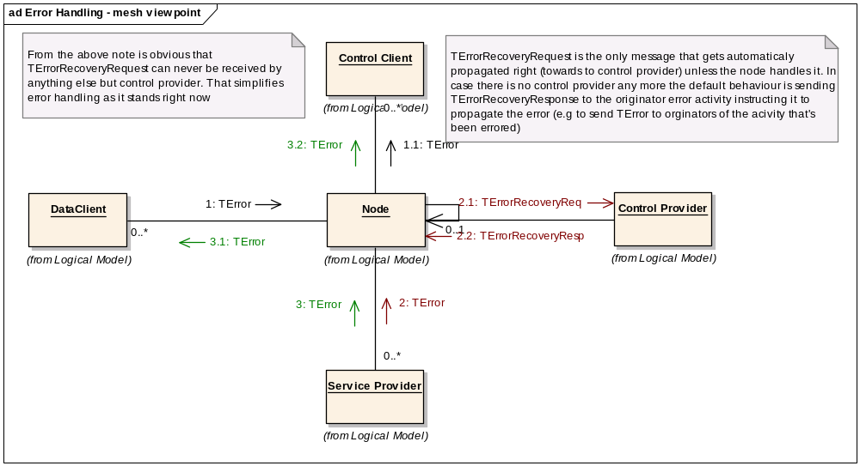
Figure 4-10 Error Handling and Recovery from mesh viewpoint (node as a black box)
As see from the picture there are two possible cases a node can receive TError message here:
- TError received from the node data client (shown by the sequence group 1.x). In this case the node would propagate the error to all activity originators and the activity goes “Idle”.
- TError received from the node service provider (shown by the sequence group 2.x). In that case the mesh engine will try to find an error recovery activity in the node activity map (based on well known activity id). If it finds one it starts it, suspends the target activity and hands it over to the error recovery one. If it doesn’t find one the previous bullet point applies.
Next picture shows how the error recovery activity is employed
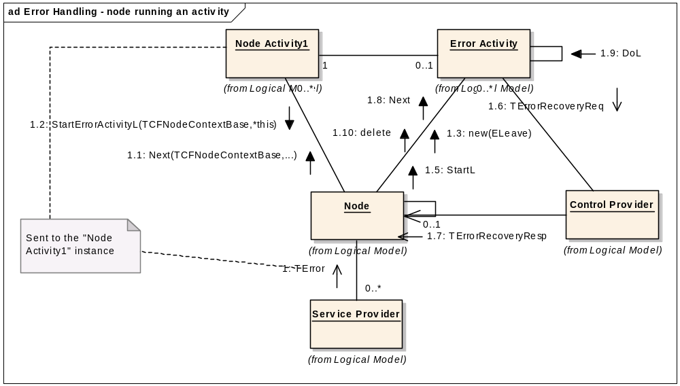
Figure 4-11 Error activity for the node viewpoint (node as a white-box)
What happens here goes as follows:
- TError message arrives and the target activity lets it through
- The mesh engine looks up the target activity (based on the message channel Id described in Error: Reference source not found).
- An instance of error activity is started given a reference to the errored one
- The error activity sends a TerrorRecoveryRequest to the node control provider.
- It gets back TerrorRecoveryResponse instructing it what to do next:
  - Propagate the error to the errored activity originators and set it to idle.
  - Retry the very recent transition. Here we assume that some other action should have taken place before TerrorRecoveryResponse is sent. It could be MCPR sending TreBind after having established alternative connection or so on. Note that for an activity to be able to retry it must utilise AcontextStore class.
  - Ignore error, meaning to resume normal flow of the errored activity. Here we assume that whatever happened as a result of the TerrorRecoveryRequest must cause our activity to receive another message.
- The error activity goes idle.
TerrorRecoveryRequest and TerrorRecoveryResponse are the only messages that are forwarded by the mesh-engine if not processed by any activity.
What we described here is an error handling and recovery mechanism built into AMMNodeBase class logic. However as creation of the states, transition and activities is highly polymorphic one is free to supply completely different handling even scaled down to individual transitions. It means that for the error mechanism to kick in the target activity must not process TError message so that it falls through.

Activities
This is a section that looks at activities from a slightly different angle than 3.2 in light of what we have learnt so far. As we already know we have two basic types of activities:
- Ones that can only ever run one instance at a time and any new originator joins the activity in its current state
- Ones that can run many instances at the same time so that each instance only ever have one originator that has started that particular instance
As seen from the Figure 3-5 every activity can support additional two features:
- Retry/Resume by utilising AContextStore class
- Synchronisation by utilising AActivitySemaphore class
Also the way one builds an activity from state triples can vary as described in the following sections.

First Transition Activities
One would wonder why the first transition would be something special. However if we remind ourselves of the simple principles described in 2.1 where we say that a transition brings us to a defined state but the state can decide on the next transition, we see that there actually shouldn’t be any first transition there only a next one. In other words: First state triple of an activity should have its iCtorT member set to NULL as we need a state to choose the next transition first after it has accepted a message. Therefore the first state triple should have only set the iCtorS member and transition tag should be NetStateMachine::KexecuteAlways meaning exactly what it says on the tin.
The first transition is special as we can see from the above. The special part is that if we set iCtorT of the very first state triple to point to a transition than, unlike all of the other transitions, this one cannot be “chosen” by any state (except very special case mentioned in 5.3) and is being run for each originator joining the activity (first originator starting the activity as well as any other one joining in). Note that the activity first state is still required to accept a message before the first transition is executed however when this has happened it is always executed transition tag regardless.
If we want the first transition to be present we use NODEACTIVITY_ENTRY is used rather than FIRST_NODEACTIVITY_ENTRY macro as we would normally use for the first triple definition of an activity.
It usually does not require the activity object itself to be constructed, which makes it possible to have “Single Triple Activities” more about which below.

Single Triple Activities
As the title suggests this is not really a state-machine as it only ever has one state triple executing one transition (the first transition). Such activities are required to employ the above mentioned “first transition” otherwise they wouldn’t do anything. Single triple activity acts as a “virtual function call” without BC headache and with mesh-support. When executing such an activity the activity instance is not actually created as oppose to “classical” activity with more state triples.
One would ask: why bother with an activity when we can just call a function? The answer has two parts. First part relates to our reservations to use virtual functions for anything but abstract mechanisms that don’t change (see 1.1). Second part would be a question back: Why would we devise any different mechanism to serve messages when we already have one? This is not to say that a node cannot overwrite MNode::ReceivedL function to apply a “switch” and/or “if” and call a function. Of course in that case such a node looses all the error handling and recovery plus activity synchronisation support.
We use SINGLE_NODEACTIVITY_ENTRY macro for the single triple definition of an activity.

Activity Flow Fork
Activity flow fork represents an “if” within a state-machine. The reason being trivial: we don’t have a state-machine to always execute the same sequence of states and transitions. We may be strict, and we are strict, about the fact that an activity only ever has one entry point (refer back to 3.2.1 please), that said we have to allow for different transition sequence based on run-time conditions. Just how do we do it is a task for the “transition tag” to solve. Please look back at 2.1 and remind ourselves what the transition tag is for. Each activity state triple is marked by its transition tag that is the activity specific value. We have predefined two transition tags (sm_stateTriple.h):
- KExecuteAlways - if returned by the state then the following triple in the array of triples is always executed no matter what the triple transition tag says. It is meaningless to specify this tag when defining static state triple.
- KNoTag - a “default” tag, this transition is executed when a state returns KNoTag.
- KErrorTag - a “default” error tag.
Any activity can define any number of different transition tags. The transition tag has two parts: Static one which is the actual tag 30bits wide and run-time one which is a direction (backward/forward) 1bit wide. 1 bit is reserved for the MeshMachine usage. How it all works:
When a state accepts a message (MState::Accept returns Etrue) the MStateFork::TransitionTag is called. The function can check any conditions it likes and returns an integer (transition tag and direction). The direction (the most significant bit) says which way the state-machine engine will walk the state triples to find the next transition to execute. The tag determines that transition. If the transition is not found the state-machine goes idle e.g. as if it has finished its task (except for a diagnostic panic in UDEB). If the triple is found the transition is executed and the state-machine stays in the state defined by the found triple.
Backward direction is, for example, very useful in cases when a state would like the state-machine to stay in the same state (looping). Walking activity triples backward is the only possibility to have the first transition (5.1) executed as a part of “normal” state-machine.

Activities Synchronisation
As said before a node can potentially serve many request concurrently. It may result in many instances of the same or different activity types running. These activities, in most cases, don’t really need to know about each other but in some cases they do. As a node effectively runs a “non-pre-emptive multitasking” we only need a very simple support for activity synchronisation. The mesh engine supports the following:
- Synchronisation – an activity2 can check for any other activity1 running (or any other event it whishes to be synchronised with) and suspend itself until that activity1 has finished its task. It is of course the activity2 responsibility to check and call AActivitySemaphore::ParkTransitionL or AActivitySemaphore::ParkState methods. When the activity1 has finished, the mesh engine calls CNodeActivityBase::Signal virtual function to resume activity2. Note that the Figure 5-12 shows the ParkTransitionL functions being called from activity2 transition. The function ParkState could, however, be called from the activity1 state as well if appropriate. There is a set of useful templates in mm_states.h to facilitate writing of synchronised activities. These are ASerializableTransition and ASerializableState.
- Exclusivity – an exclusive activity aborts everything running on the node and than runs itself. To abort all activities except the caller the activity calls AMMNodeBase::AbortActivitiesOriginatedBy and supplies NULL originator TNodeId.
The following two pictures show in detail how an activity may use the synchronisation support.
sd Synchronisation - Serialisation
External Node
Node
(from Logical Model)
Node Activity1
(from Logical Model)
Node Activity2
(from Logical Model)
Transition of
Node Activity2
:External Node
Let's assume that this is
the very last transition
and the Node Activity1
finishes meaning that
IsIdle comes back with
ETrue.
Obviously Signal need to call
CountActivities but I cannot show the call
here since it wrecks the diagram for some
strange reason only the EAP guys would
know maybe.
Called only after
Activity2 has checked it
should wait.
In this case the check
for Activity 1 showed
there was no instance
running.
TSignatureBase
StartNewActivityL
StartL
TSignatureBase
StartNewActivityL
StartL
DoL
TBool:= ParkTransitionL(iContext)
TInt:=
Signal(ActivitySigId)
TInt:= CountActivities(ActivitySigId)
StoreContext(iContext)
TSignatureBase
TBool:= Next
TBool:= IsIdle
delete
TInt:= Signal
Retry(aContext)
DoL
TSignatureBase
Figure 5-12 Serialisation Support
sd Synchronisation - Exclusivity
External Node
Node
(from Logical Model)
Node Activity1
(from Logical Model)
Node Activity2
(from Logical Model)
Transition of
Node Activity2
Node Activity 2
continues normally.
:External Node
All activities except the one
given as a parameter are aborted
and subsequently deleted.
TSignaturBase
StartNewActivityL
StartL
TSignatureBase
StartNewActivityL
StartL
DoL
TSignatureBase
AbortActivitiesOriginatedBy(iContext.iNodeActivity,KNullCommsId)
SetIdle
delete
TSignatureBase
Next
Figure 5-13 Exclusivity Support

Apart from the aforementioned support a specific node maintains states of its peers (please refer to the Figure 1-1 for details on example peer roles). As explained in Error: Reference source not found a node uses specific RNodeInterface class to communicate with its peers. The class defines enum TClientType that is used to identified the peer role (in networking this would be data client, control client,…) and the peer state if needed.

Interactions between nodes
Please refer to R1 for more details on how nodes actually communicate and how a message gets from one node to another. Here we will only repeat after R1 the basic addressing concepts in context of the message type.
When a node sends a request to another node, it has no way to tell which activity instance will actually react upon it (if any). This leads to the conclusion that when sending a request to another node we address it simply by the node’s TNodeId. Similarily there is no difference (and no way of telling) between requesting from a MeshMachine or non-MeshMachine based nodes.
When replying to originator, we would always use the full originator’s address. In fact we would use it in an opaque way since it makes no difference to the serving node what particular node/node-acticity/any other entity requested the service. This way it is quaranteed the response will be delivered directly to the requesting entity.
When sending any message the sender must provide it’s full address in the sender field.

All instances of TNodePeerId are kept in CNodeActivityBase::iOriginators array as an activity can have many originators.
On posting a response the servicing activity/node uses the information held by previously created TNodePeerId instance to address destination.

Appendices

People
Role | Person / People
Reviewers | Remek Zajac, Drew Reed, Dino Livanos and Corinne Dive-Reclus,Viki Turner
Reviewer | Ivan De Marino
Contributors | Michal Zurowski
Distribution

References
No. | Document Reference | Version | Description
[R1] | ../../NodeMessages/documentation/ | V1.0 | AsyncObjectCommsFundamentals.doc
[R2] | N/A | V1.0 | API Extensions

Open Issues
None

Document History
Date | Version | Status | Author | Description
11-04-2006 | 0.1 | Draft | Michal Zurowski | New Document
07-08-2006 | 0.2 | Draft | Petr Smrz | Prepared for review
24-08-2006 | 0.3 | Draft | Petr Smrz | Updated after the first review by Remek Zajac, Drew Reed, Dino Livanos and Corinne Dive-Reclus
06-10-2006 | 0.4 | Draft | Petr Smrz | Updated with Viki’s comments
12-07-2007 | 0.5 | Draft | Ivan De Marino | - Highlighted important points (i.e. useful for new employee)  - Added the path to the files containing the reported code
23-03-2008 | 1.0 | Released | Michal Zurowski | Productisation and split of the big all-encompassing document into separate documents describing relevant elements.

