1 Introduction 3
1.1 Purpose and Scope 3
1.2 System Context 3
2 Overview 4
2.1 Problem Description 4
2.1.1 Asynchronous Operations 4
2.1.2 System Deployment 4
2.1.3 Polymorphism 5
2.1.4 State calculation 5
2.2 Solution Overview 6
3 Addressing class hierarchy 7
3.1 TRuntimeCtxId 7
3.2 TNodeId 7
3.3 TNodeCtxId 7
4 Node class hierarchy 8
4.1 ASimpleNodeIdBase 8
4.2 ANodeIdBase 8
5 Message class hierarchy 9
5.1 Signals 9
5.1.1 Non-message signals 9
5.2 Message Signatures 10
5.2.1 TNodeSignal 10
5.2.2 TSignatureBase 10
5.2.3 Predefined Signatures 11
5.2.4 Custom Signatures 13
5.3 Messages 15
5.3.1 All Protocols 16
5.3.2 TEPeer 17
5.3.3 TEChild 17
5.3.4 TEErrorRecovery 18
5.4 Requirements and Limitations 19
5.5 Error Handling 19
5.6 Cancellation 19
6 Transport 21
6.1 MTransportSender 21
6.2 MTransportReceiver 22
7 Appendices 23
7.1 People 23
7.2 References 23
7.3 Open Issues 23
7.4 Document History 23

Introduction

Purpose and Scope
NodeMessages component groups the fundamental primitives that can be used to build a (cross thread and cross process) Distributed Componentry. The primitives are:
- Node - i.e.: an actor in the distributed system;
- Message – i.e.: the signal carrier the Nodes use to communicate;
- Node Identity – i.e.: the address that can be used to send a Message to a Node;
- Transport Abstraction – i.e.: the interface that can be used to send a Message to a Node;
The NodeMessages component doesn’t:
- Define means of delivering a Message from one Node to another (i.e.: transport implementation);
- Aspire to define multi-device Distributed Componentry as it assumes interoperability requirements beyond what Symbian OS can secure in a foreseeable future;
- Define the lifetimes/ownerships/relations/etc for and between nodes;
Throughout the document we assume that the reader is familiar with NetMeta and VirtualConstructors.

System Context
NodeMessages dwells quite low in the Symbian OS component dependency chain and is presently used by Multimedia, Comms Framework, IWS, Multimedia Protocols - all of which follow the migration performed by Comms Framework in Symbian OS v9.5.
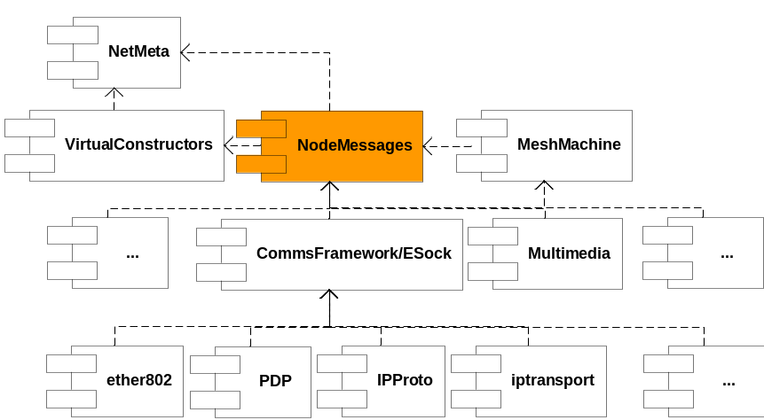
Figure 1-1 - System Context

Overview

Problem Description
Creation of highly complex and dynamic environments (such as for example multi technology Networking or Multimedia subsystems for Operating Systems) can not be feasibly achieved using only “standard” approaches based on sequential, synchronous processing. By that we mean that an object serves one call at a time and a caller waits for the servicing object to finish its task.
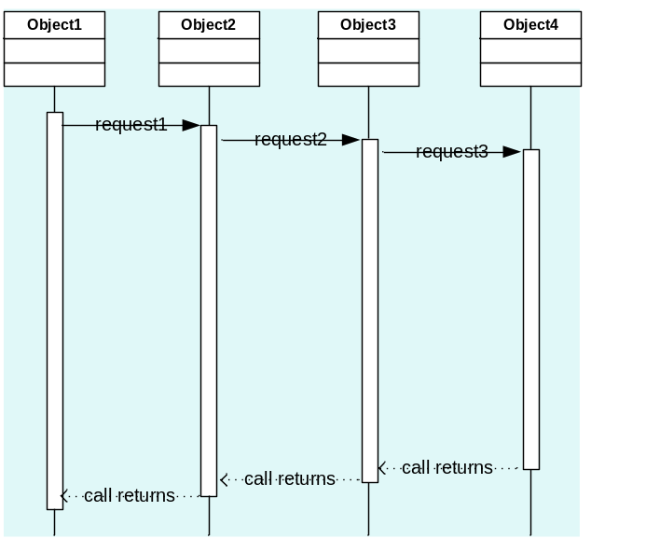
Figure 2-2 - Sequential, synchronous processing.

Such a scenario is very easily implemented but has some very fundamental drawbacks.

Asynchronous Operations
Some operations are asynchronous and they are asynchronous because executing them in a synchronous fashion would block the caller for an unknown (and possibly significantly long) period of time. Such blocking isn’t acceptable for callers having (any flavour of) real time requirements. Some operations are asynchronous by their nature (e.g.: associating with a WLAN access point), some become asynchronous as the system develops and their execution paths gets distributed, some are asynchronous only in certain implementations (e.g.: starting an abstract connection, be it with a WLAN access point, be it with a statically configured Ethernet).
Relaxing the real time requirements on the caller (without relaxing the real time requirements on the use-case) isn’t really a practical option as it would harm other properties of the system, i.e.: serving every call in a separate system thread would flood the scheduler and force system components into the complexities of multithreading.
It is truly difficult to model operations (interfaces and their implementations) in this environment and often the only way out is assuming every (or nearly every) operation is asynchronous.

System Deployment
In this context system deployment translates to distributing the function of that system across multiple execution contexts (i.e.: CPUs, processes, threads). Deployment is used to solve various aspects of system robustness/stability, security, performance, access synchronisation, etc. It is a very powerful tool and requirements on that tool are predisposed to change quite frequently. Unfortunately redeploying system function tends to be costly because its implementation tends to be deployment dependent. This is especially the case for the sequential, synchronous processing under the discussion. Direct calls are only possible within the single process (or even only within the single thread of execution). Whenever a fragment of a system function needs to be split and redeployed, the cheapest outcome is reimplementation.

Polymorphism
There is a need that every request is served by a virtual function to achieve polymorphism. That means that one can either supply a base class having all functions defined (which is of course impossible) or introduce a method to ask an object for an interface to serve our request. Having all our communication based on virtual functions means that for any extension and/or modification we need to have another interface as any method addition breaks binary compatibility.

State calculation
Synchronous calls can either leave or return an error or requestor object can be called back before the original call returns. This makes the requestor state-machine difficult to write as it’s not clear when its state change occurs. Situations could also arise where a request is asynchronous but its failure can be flagged synchronously, which adds even more to the burden of the state calculation.

Solution Overview
All the drawbacks mentioned in the problem description (see [2.1]) disappear when the requestor abandons function calls and switches to posting messages.
NodeMessages provides a solution for a message-passing-based distributed system and the class diagram below presents the main actors in this solution.
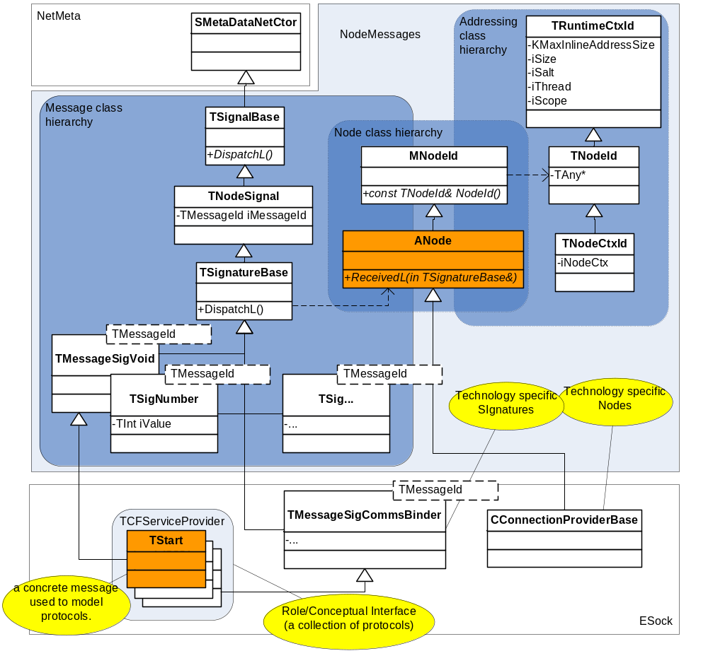
Figure 2-3 - NodeMessages class hierarchy – Overview.

The following sections describe this class hierarchy in more detail.

Addressing class hierarchy
The addressing class hierarchy identifies the recipient of a message. The way this hierarchy is split reflects how NodeMessages splits the function of message delivery:
- Transport – to a correct runtime context (thread of execution) – see [6].
- Signature – to a correct Node – see [5].
- Node – the rest of the delivery chain – see [4].

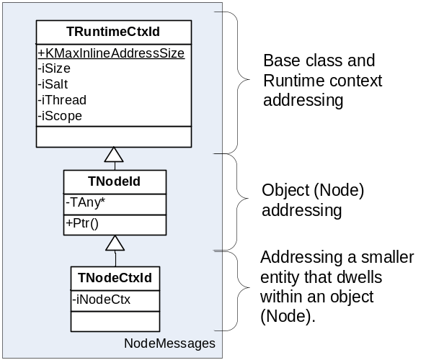
Figure 3-4 - Addressing class hierarchy

TRuntimeCtxId
TRuntimeCtxId holds the part of the address that identifies the runtime context:
- iThread – identifies the thread of execution within the scope limited by iScope;
- iScope – identifies a group of threads. Such a group could be the same as a process, but iScope won’t necessarily be identical to a process id.
Additionally, TRuntimeCtxId (being a baseclass for all addresses in NodeMessages) comes with a couple of extras:
- iSalt – address reuse protection. It is possible that two objects dwelling in the same address space in disjoint periods of time will share the same memory address. As TRuntimeCtxId can be generated against a memory address (see TNodeId [3.2]) it is then possible that a stale TRuntimeCtxId (i.e.: TRuntimeCtxId describing a message recipient that no longer exists) could in some circumstances become a valid address for another message recipient. iSalt prevents this from happening.
- KMaxInlineAddressSize – the limit for the maximum size of any TRuntimeCtxId subclass. As TRuntimeCtxId (similarly to messages, see [5]) needs to be infallibly (de)serialised, TRuntimeCtxId has to make a promise about its maximum size.

TNodeId
TNodeId carries the part of the address identifying an object. Within NodeMessages, objects capable of receiving messages are referred to as Nodes (see [4]).

TNodeCtxId
TNodeCtxId carries the part of the address that identifies a smaller entity (e.g.: an activity) dwelling within a node.

Node class hierarchy
A node is an object that can receive Messages (see [5]) and NodeMessages abstracts such objects with the ANode class.
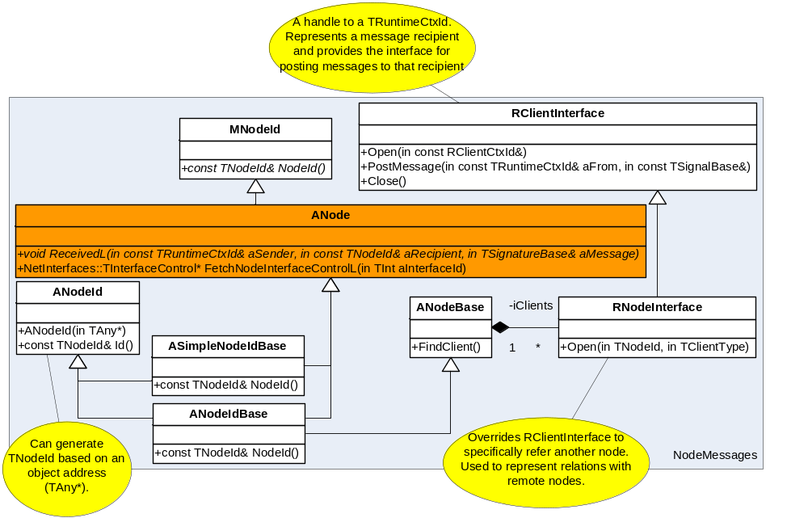
Figure 4-5 - Node
The most important traits of a Node are:
- It can receive Messages (implements ::ReceivedL that someone can call to deliver a message, see [5.2.2])
- It has identity (implements ::NodeId()) so it can be addressed (see [3.2]).
Let it be noted again that Node’s creation and its life-cycle are not of interest for NodeMessages.

ASimpleNodeIdBase
ASimpleNodeIdBase is the simplest override of ANode ready to be used to define technology specific nodes.

ANodeIdBase
ANodeIdBase represents a Node that has other nodes as peers (is related to other nodes). How and why these relations form is out of scope for this document. ANodeIdBase still has the ability to accumulate references to other nodes and collect information about them:
- RNodeInterface is inheritable in order to store any technology specific information about peers;
- RNodeInterface::Type() and RNodeInterface::Flags() is a predefined (rudimentary, but very practical) way of collecting information about the peers.

Message class hierarchy

Signals
Signal (TSignalBase) is, above all, an object designed to be delivered from one ‘place’ to another. Signal doesn’t make any assumptions about the nature of these ‘places’ (e.g.: doesn’t assume it’s getting delivered to/from a Node) and signal is not a message (i.e.: it has no semantics).
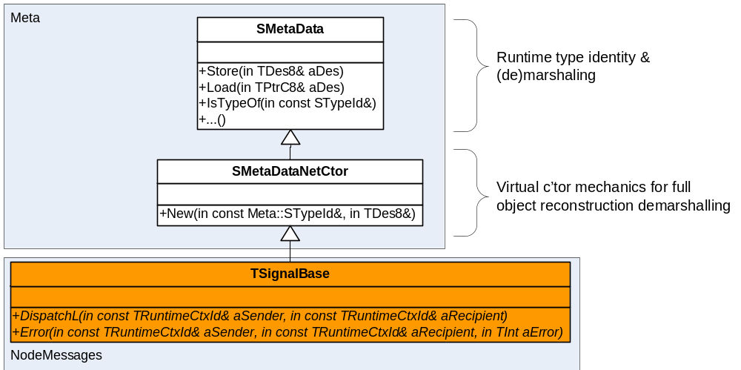
Figure 5-6 – TSignalBase
Signals use NetMeta (see [R2]) for:
- Runtime type identity – so a signal holder can find out (and possibly cast to) the exact subclass of TSignalBase.
- Marshalling – so a signal can be flattened into a buffer of raw data (and possibly sent somewhere).
- Virtual Construction - so that a specific subclass of TSignalBase can be constructed just against its runtime type identity.
- DeMarshaling – so that a signal can be reconstructed from a (previously marshalled into) buffer of raw data.
It is expected that when a signal is received (fully reconstructed by the transport), the transport will call its pure virtual TSignalBase::DispatchL for further delivery. This makes the delivery function split clear - the transport’s sole role is delivering a message to the correct runtime context (correct thread of execution). See [6].
It also assumed that when TSignalBase::DispatchL leaves, the transport will call TSignalBase::Error for error processing (see [5.5]).

Non-message signals
The TSignalBase class is not only useful to messages. It is quite obvious that the ability to post an object to another runtime context and have it execute anything it wants (TSignalBase::DispatchL) can be quite a powerful tool. TSignalBase subclasses with custom implementations of ::DispatchL are called self dispatching signals. Examples of self dispatching signals are known to:
- Roam the stack self-sending themselves along found relations and seek for a node that implements a desired interface;
- Performing a specialised task for the sake of the sender;
- Spawn a new node in a remote runtime context;

Message Signatures
Message Signature classes enrich the definition of a signal (see [5.1]) to fully support messages. A message signature however is not a message (for message definition see []). It is a data structure that can carry a message (can carry its semantics) and can deliver itself to a node (see [4]).
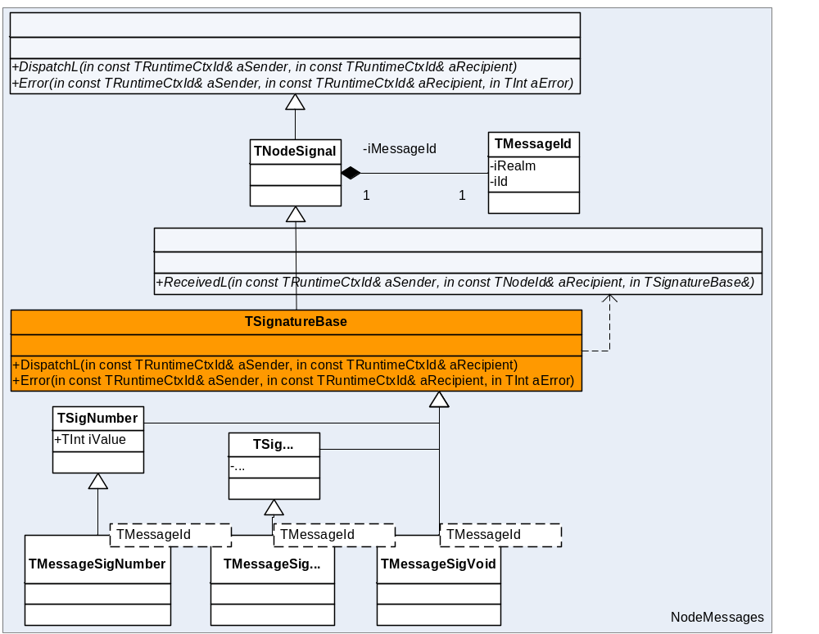
Figure 5-7 - Message Signature

TNodeSignal
TNodeSignal is a small, but important addition to a TSignalBase. TNodeSignal makes the signal carry the message id i.e.: message semantics.
Message id (TSignalBase::TMessageId) uniquely identifies a message. It consists of two integers called ‘realm’ and an ‘id’. The realm identifies a group of messages; the id identifies a message within its realm. The realm (typically allocated as a UID for uniqueness) has been introduced to provide a scope for private message numbering (i.e.: ids). The message grouping however needs be meaningful and it typically denotes a conceptual interface (see [5.3]).

TSignatureBase
The only thing TSignatureBase does is implementing the two pure virtuals implied by TSignalBase and thus delivering itself (the message) to the Node.
EXPORT_C void TSignatureBase::DispatchL(const TRuntimeCtxId& aSender,
const TRuntimeCtxId& aRecipient)
{
const TNodeId& nodeId =
address_cast<TNodeId>(aRecipient); //This message type operates on nodes
ASSERT(nodeId.Ptr());
nodeId.Node().ReceivedL(aSender, nodeId, *this);
}

Predefined Signatures
Message Signatures are signatures in a similar respect as are (C++) method signatures, i.e.: they describe different sets of (message/method) parameters. Fortunately for C++ developers, the compiler generates the code responsible for putting the method call parameters onto the call stack. Unfortunately for NodeMessages, the equivalent operation in a message passing environment ((de)marshalling message parameters) has no C++ language support and some code needs to be written.
Oddly, as it may sound, NodeMessages provides predefined signatures for typical messages, e.g.: messages that take one integer as a parameter or for messages that take a TNodeId as a parameter.

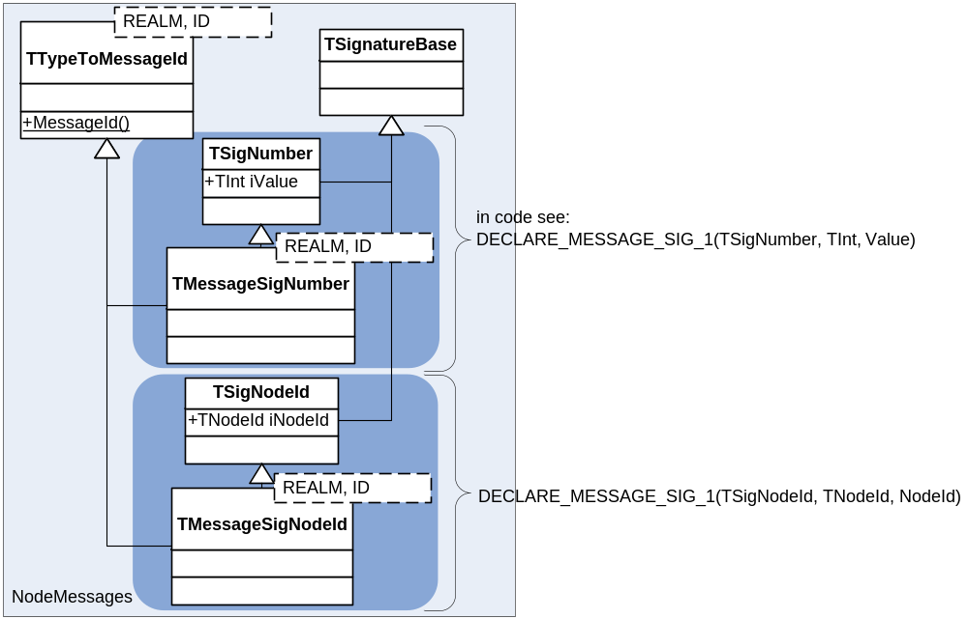
Figure 5-8 - TSigNumber & TSigNodeId
Each predefined signature consists of two classes:
- The immediate TSignatureBase override that defines the custom data structure and performs all necessary registrations to satisfy NetMeta (see [5.1]), i.e.: it will be this very override instantiated on the receiver’s end;
- The ‘absolute-thin’ template class for assigning message semantics (TMessageId) on the type level (rather than the object level) as a message (once constructed) will never change its semantics. ‘Absolute-thin’ meaning that the TSignatureBase override (from bullet one) will need to be castable to this template on the receiver’s end, like this:
...
typedef TMessageSigNodeId<1,2> TSomeMessage;
TSigNodeId signature; //transport will construct the signature
TSomeMessage& message = static_cast<TSomeMessage&>(signature); //receiver
//wants to see the message
...

A snapshot of these predefined signatures is listed below:
template<TInt id, TInt32 realm>
struct TMessageSigVoid : public Messages::TSignatureBase,
public Messages::TSignatureBase::TTypeToMessageId<id, realm>
{
explicit TMessageSigVoid() :
Messages::TSignatureBase(Messages::TNodeSignal::TMessageId(id, realm))
{ }
};

DECLARE_MESSAGE_SIG_1(SigNumber, TInt, Value)
DECLARE_MESSAGE_SIG_1(SigUid, TUid, Uid)
DECLARE_MESSAGE_SIG_1(SigAny, TAny*, Ptr)
DECLARE_MESSAGE_SIG_1(SigNodeId, TNodeId, NodeId)
DECLARE_MESSAGE_SIG_1(SigRMessage2, const RMessage2, Message)
DECLARE_MESSAGE_SIG_1(SigMetaDataPtr, Meta::SMetaData*, Ptr)
DECLARE_MESSAGE_SIG_1(SigClientType, Messages::TClientType, ClientType)
DECLARE_MESSAGE_SIG_2(SigNodeIdNumber, TNodeId, NodeId, TInt, Value)
DECLARE_MESSAGE_SIG_2(SigNodeIdClientType, TNodeId, NodeId, TClientType, ClientType)
DECLARE_MESSAGE_SIG_2(SigNumberNumber, TInt, Value1, TInt, Value2)
DECLARE_MESSAGE_SIG_2(SigAnyNumber, TAny*, Ptr, TInt, Value)
DECLARE_MESSAGE_SIG_2(SigUidNumber, TUid, Uid, TInt, Value)
DECLARE_MESSAGE_SIG_2(SigNodeIdAny, TNodeId, NodeId, TAny*, Ptr)
DECLARE_MESSAGE_SIG_2(SigNodeIdNodeId, TNodeId, NodeId1, TNodeId, NodeId2)
DECLARE_MESSAGE_SIG_2(SigNumberRMessage2, TInt, Value, RMessage2, Message)
DECLARE_MESSAGE_SIG_2(SigClientTypeUid, Messages::TClientType, ClientType, TUid, Uid)
DECLARE_MESSAGE_SIG_2(SigMessageIdNumber, TNodeSignal::TMessageId, MsgId, TInt, Value)
DECLARE_MESSAGE_SIG_3(SigNodeIdNumberNumber, TNodeId, NodeId, TInt, Value1, TInt, Value2)
DECLARE_MESSAGE_SIG_3(SigNumberNumberNumber, TInt, Value1, TInt, Value2, TInt, Value3)
DECLARE_MESSAGE_SIG_3(SigNodeIdNodeIdNumber, TNodeId, NodeId1, TNodeId, NodeId2, TInt, Value)
DECLARE_MESSAGE_SIG_3(SigNumberUidNumber, TInt, Value1, TUid, Uid, TInt, Value2)
DECLARE_MESSAGE_SIG_3(SigClientTypeUidClientType, Messages::TClientType, ClientType1, TUid, Uid, Messages::TClientType, ClientType2)
DECLARE_MESSAGE_SIG_4(SigNumberNumberNumberNumber, TInt, Value1, TInt, Value2, TInt, Value3, TInt, Value4)

NodeMessages could have provided some class hierarchies and macros generating individual signatures for every message, unfortunately signatures cost ROM footprint.
It is perhaps worth mentioning in this place that TSignatureBase::iMessageId is orthogonal (unrelated) to TSignatureBase::STypeId(), i.e.: the former identifies semantics, the latter identifies structure. Consequently, one can have:
- Two messages with the same structure, similarly as one can have two methods that take identical parameters:
class Foo
{
Start();
Stop();
};
- One message that could be conveyed by two different structures, similarly as one can have two overloads of the same method:
class Foo
{
Stop();
Stop(TInt aError);
};

Custom Signatures
NodeMessages clients are free to create custom signatures and this involves writing a new data structure that inherits from TSignatureBase and satisfies the resulting specification (most notably that of SMetaDataNetCtor), i.e.:
- Implements and registers its virtual constructor;
- Implements (de)marshalling code;
Header file example code (this code is also generated by DECLARE_MESSAGE_SIG_X):
struct TFooSignature : public Messages::TSignatureBase
{
protected: //not to be instantiated directly – this is just a signature;
inline TFooSignature {}
explicit TFooSignature(const TNodeSignal::TMessageId& aMessageId, TInt aFooValue)
:Messages::TSignatureBase(aMessageId),
iFooValue(aFooValue)
{}
public:
DECLARE_MVIP_CTR(TFooSignature) //virtual constructor declaration (from SMetaDataNetCtor);
EXPORT_DATA_VTABLE_AND_FN //virtual data table declaration (from SMetaData), see [R2];

TInt iFooValue; //custom data
};

template<TInt id, TInt32 realm> //for message id
struct TMessageFooSig : public TFooSignature,
public Messages::TSignatureBase::TTypeToMessageId<id, realm>
/*
Flat template class with public constructor used directly to declare message types against.
*/
{
explicit TMessageFooSig(TInt aFooValue) :
TFooSignature(Messages::TNodeSignal::TMessageId(id, realm), aFooValue)
{}
};

cpp file example code
static const TInt KCustomSignaturesImplementationUid = KUniqueUID;
enum EMessageTypeId
{
EFooSignature,
};

....

EXPORT_START_ATTRIBUTE_TABLE_AND_FN( TFooSignature , KNodeMessagesImplementationUid, ESignatureErrContext )
REGISTER_ATTRIBUTE( TFooSignature , iFooValue, TMetaNumber )
END_ATTRIBUTE_TABLE_BASE( TSignatureBase, ESignatureBase )

....
DEFINE_MVIP_CTR(TFooSignature);
....
//One SignatureImplementationTable per many messages
const TImplementationProxy SignatureImplementationTable[] =
{
...
MVIP_CTR_ENTRY(EFooSignature,TFooSignature), //2
...
}
...

//Each SignatureImplementationTable must be registered with the destination runtime context
//This means that the following method must be called in the destination thread before any of the messages
//reach that thread;
/*static*/ void RegisterL(CGlobals& aGlobals)
{
aGlobals.RegisterInterfaceL(
TUid::Uid(KCustomSignaturesImplementationUid),
sizeof(SignatureImplementationTable) /
sizeof(SignatureImplementationTable[0]),
SignatureImplementationTable);
}

/*ststic*/ void DeRegister(CGlobals& aGlobals)
{
aGlobals.DeregisterInterface(TUid::Uid(KCustomSignaturesImplementationUid));
}

Messages
Messages are Message Signatures (see [5.2]) with assigned semantics (assigned iMessageId).
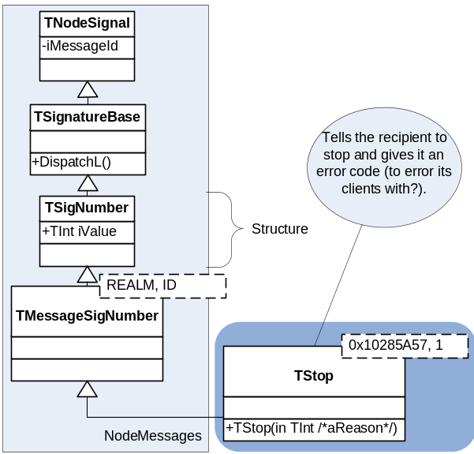
Figure 5-9 – A Message
Messages are closest equivalents to C++ methods and Nodes are the closest equivalents to C++ objects and as one would rarely say ‘a method’, one would also rarely say ‘a message’ (in favour of, say: ‘start method’ or ‘start message’).
From this point onwards there is little NodeMessages imposes. The infrastructure is in place and it can be used to design sub-systems using (possibly) various design methodologies. Nonetheless it can’t be ignored that Symbian OS is an object oriented operating system written in C++ and it clearly (see this document) favours UML.
If messages are equivalents of methods and nodes are equivalents of objects, there probably are equivalents of interfaces and classes.
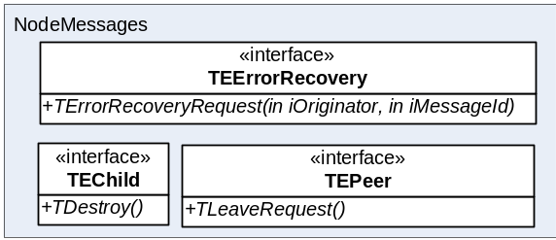
Figure 5-10 - NodeMessages predefined roles;
The diagram above depicts the roles (notional interfaces) predefined by NodeMessages. If messages are closest equivalents to methods, then, despite messages are not methods, UML can still be useful in modelling them. For instance the TLeaveRequest entry in TEPeer means that a Node implementing the TEPeer role needs to respond to TEPeer::TLeaveRequest message by removing the sender from the array of its peers (see ANodeIdBase::iClients in [4.2]) and responding with TEPeer::TLeaveComplete. In other words, the Node needs to adhere to a certain protocol and because that protocol is triggered by the TEPeer::TLeaveRequest message, perhaps it could also be named after the message. It definitely generates a unique protocol name and a handy convention that this document follows. To formalize, a role in NodeMessages is a group of protocols the role needs to implement on the serving end (needs to respond to the request messages). A protocol in turn is a description of a coherent message exchange between two nodes (a requestor and a serving end) and a clear functional result (an action the serving end performs).
The UML convention discussed above can be (and in NodeMessages is) mapped in-code as follows:
class TEPeer
{
private:
enum
{
ELeaveRequest = 1,
ELeaveComplete = 2,
};

public:
enum { ERealmId = 0x10285F3C };

/*==========================================================================
[Name]: TLeaveRequest
[Semantics]: Request to sign off out from the recipient's clients' list.

[Type]: Request for TLeaveComplete.
[Fallible]: No.
[Cancellable]: No

[Structure]:
===========================================================================*/
typedef TMessageSigVoid<ELeaveRequest, TEPeer::ERealmId> TLeaveRequest;

/*==========================================================================
[Name]: TLeaveComplete
[Semantics]: Success response to TLeaveRequest.

[Type]: Response to TLeaveRequest.

[Structure]:
===========================================================================*/
typedef TMessageSigVoid<ELeaveComplete, TEPeer::ERealmId> TLeaveComplete;
};

All Protocols
If messages are equivalents for methods then there are probably a lot of message protocols that consist solely of a request and response (e.g.: TStart and TStarted) and consequently there is room for establishing (non-limiting) conventions for such protocols to follow so that they are easier to design and analyse.
NodeMessages define two core, low level messages:
- TEBase::TError – a universal failure response for all request messages. I.e.: any request that fails to be satisfied must be responded to with TNodeMessage::TError (see more on error handling in [5.5]);
- TEBase::TCancel – a universal request to cancel any request, i.e.: the sender of a request message can (in general case) cancel that request by posting TEBase::TCancel to the same recipient (see more on error handling in [5.6]);
As a consequence one can see three notional types of messages emerging from these conventions:
- Request – the message is a request, i.e.: the sender requires that the recipient performs an action and acknowledges this action with a response;
- Response – is a message that acknowledges completion of a previous request.
- Notification – is message that informs the recipient about something (possibly the state of the sender), but there is no explicit action associated with a notification, nor there is a response to it.
Please note that this classification is informal and there is nothing in NodeMessages that renders certain messages requests or responses. It’s only the notional semantics assigned by the author.

TEPeer
TEPeer is an interface that can be used to tear down a relation between two nodes. How this relation came into being is not TEPeer concern, however, one could speculate a domain that fills this gap:
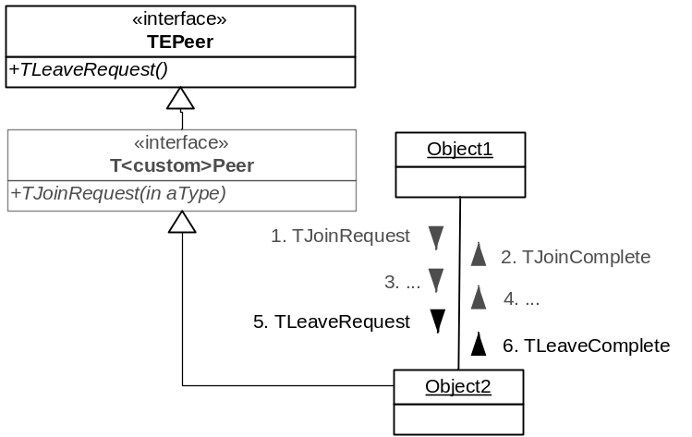
Figure 5-11 TEPeer
TEPeer (perhaps contrary to what the role name may suggest) is unilateral – i.e.: the fact that one node is another’s node TEPeer doesn’t mean the reverse is true.

TEChild
TEChild denotes an ownership/aggregation relation with another node. The reverse facing role isn’t defined by NodeMessages because there’s nothing technology agnostic that NodeMessages could imply on it (one could speculate the existence of a T<custom>Parent in a dependant technology domain). The speculated parent however owns the child (among many other children perhaps). It has probably requested the child’s creation and it will certainly make sure the child gets destroyed when no longer needed. A parent-child relation is as ubiquitous and essential as is the concept of containment in a typical design.
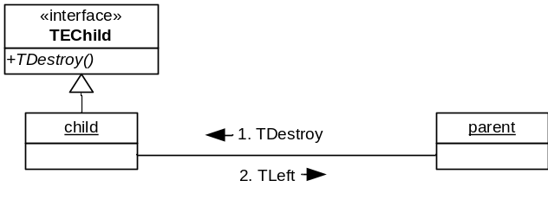
Figure 5-12 – TDestroy

TEErrorRecovery
NodeMessages provides a predefined role/protocol for requesting rescue in error conditions. It is anticipated that technology domains may want to split their algorithmic function from their decision making/policy function and distribute those among different roles/nodes. When doing so they may conclude that the ability to react to various error conditions should be delegated.
Nodes attempting to recover from an error condition by delegating are encouraged to send TEErrorRecovery::TErrorRecoveryRequest to request rescue and the recipients of TEErrorRecovery::TErrorRecoveryRequest are expected to attempt to recover and subsequently respond with TEErrorRecovery::TErrorRecoveryResponse instructing the recipient to propagate the error or retry the failed request.
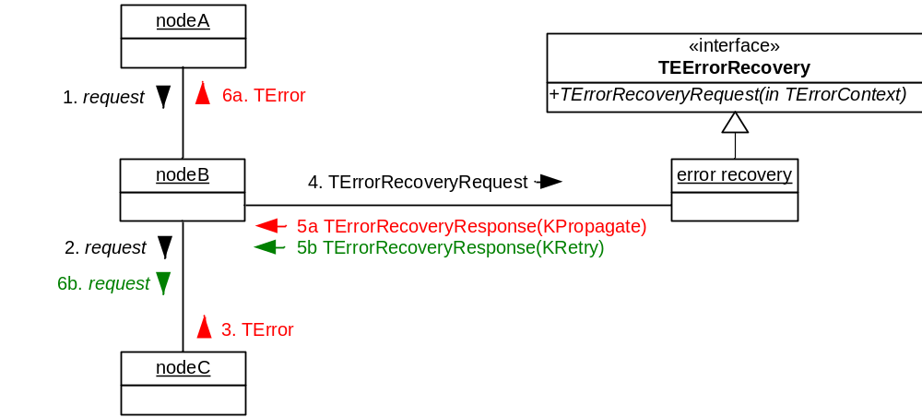
Figure 5-13 - Error recovery on failed requests
An error condition may also arise without involving a request, that is: error condition may be propagated as an event. In this case the nodes sending TEErrorRecovery::TErrorRecoveryResponse may also expect to be instructed to ignore the error (because the node providing the rescue has recovered).
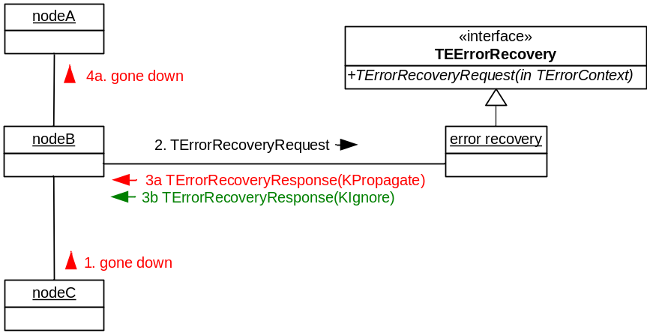
Figure 5-14 - Error recovery for notifications.

Requirements and Limitations
As mentioned before, posting a message is a closest equivalent to calling a method. Calling a method however cannot be expensive and cannot fail (the execution of a method can fail, but not its sole invocation). NodeMessages secures that the same is true for posting a message. This generates a couple of limitations on messages/signatures/signals:
- Must have a virtual constructor that cannot fail;
- Must have a simple structure (e.g. it’s possible to binary copy it) meaning NodeMessages doesn’t support messages carrying complex structures as arrays, references that need reallocation and so on. We believe that a need for complex message is a manifestation of an over-complicated design.
- Must be small (TSignalBase::KMaxInlineMessageSize == 224) so it can be reconstructed on the recipient stack (and not fallible heap).

Error Handling
NodeMessages defines some default, rudimentary error handling that should be sufficient in simple scenarios. For that it defines a core message TEBase::TError (see []) which is the recommended failure response to any request.
NodeMessages will automatically send TEBase::TError to the sender behind any leaving TSignatureBase::DispatchL.
EXPORT_C void TSignatureBase::Error(const TRuntimeCtxId& aSender, const TRuntimeCtxId& aRecipient, TInt aError)
{
NM_LOG((KNodeMessagesSubTag, _L8("TSignatureBase %08x:\tError(%d)"), this,
aError));
if (!aSender.IsNull())
{
NM_LOG((KNodeMessagesSubTag, _L8("Sending TError")));
RClientInterface::OpenPostMessageClose(aRecipient, aSender,
TNodeMessage::TError(MessageId(), aError));
}
}

Cancellation
As mentioned earlier (see [5.3.1]) NodeMessages prescribes the way to cancel requests. Not all requests can be cancelled (for instance sending an e-mail can’t be) and those that can, can only be cancelled before they complete. Nothing but the implied semantics distinguishes cancellable and non-cancellable requests (NodeMessages certainly can’t tell them apart). A cancellable request can be cancelled by the (precisely the same) requestor sending TEBase::TCancel to the recipient. TEBase::TCancel is to be acknowledged with TEBase::TError marking the completion of the cancellation (and the completion of the original request at the same time).
Due to the asynchronous nature of the environment imposed by NodeMessages the requestor may end up cancelling a request while that request has already been completed (the response is already en route to the requestor whilst TEBase::TCancel goes away).
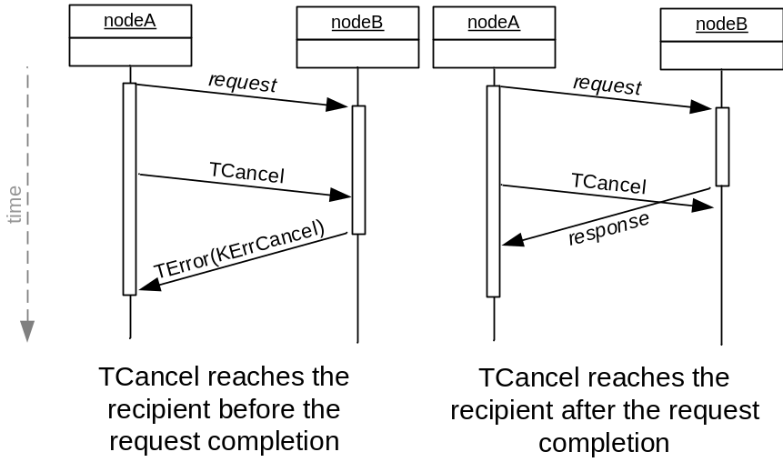
Figure 5-15 – TEBase::TCancel – The race condition.

Transport
NodeMessages defines the transport abstraction, but provides no implementation (see [R1]) for an example implementation). The abstraction consists of two interfaces:
- Sender’s abstraction: MTransportSender (see [6.1]);
- Receiver’s abstraction: MTransportReceiver (see []);

MTransportSender
class MTransportSender
/** Defines the interface used for sending messages to a peer worker thread. Various functions are present, supporting different message sizes and different policies for coping with the inability to send. Behaviours common to all Send...() operations are finding a transport to the peer based upon its cookie and panicking if no transport is available (the sender has corrupted the peer cookie or is using it after termination of
the transport service - either case is serious misbehaviour)
*/
{
public:
/** Blocking send functions. If no outbound queue space is available they
block until either space becomes available or a GENEROUS time limit is exceeded,
in which case it panics diagnostically. This relieves the caller of the burden
of supporting an error case which will only be seen in a grossly malfunctioning
system and so will be hard to test and difficult to recover from. To avoid
deadlock due to the peer being in the same state the inbound queue is drained
while waiting for space. The receipt order is always preserved.
*/
virtual void PostMessage(const TRuntimeCtxId& aPostFrom,
const TRuntimeCtxId& aPostTo,
const Meta::SMetaData& aMessage) = 0;
};

NodeMessages needs an implementation of MTransportSender when posting a message, i.e.:
void RClientInterface::PostMessage(const TRuntimeCtxId& aPostFrom, const TRuntimeCtxId& aPostTo, const TSignalBase& aMessage) const
{
__ASSERT_DEBUG(iTransportSender, User::Panic(KMessagesPanic, ETransportNotOpened));
// Interface not properly initialised; needs transport for this sending thread
__ASSERT_DEBUG(aPostTo.Size()>0, User::Panic(KMessagesPanic, EAddressNotValidPanic));

iTransportSender->PostMessage(aPostFrom, aPostTo, aMessage);
}

The code snippet quoted above is the only reference to MTransportSender::PostMessage in NodeMessages. MTransportSender implementation can be supplied with RClientInterface::Open, but it will also be expected in the Thread Local Storage (TLS):
EXPORT_C void RClientInterface::Open(const TRuntimeCtxId& aPostTo,
MTransportSender* aSender)
{
iTransportSender = aSender? aSender : &TlsGlobals::Get().TransportSender();
RecipientRef() = aPostTo; //This a deep copy
}

The transport will be expected in TLS because in some circumstances (see error handling in [5.5]) NodeMessages will send messages on its own (without the client creating RClientInterface).

MTransportReceiver
MTransportReceiver isn’t directly involved in message reception, but it is expected on the receiving end (receiving runtime context of every message).
NodeMessages facilitates for a recipients’ registry and it does so to enable runtime recipient verification. Recipients are registered with their addresses. Because of type safety (TAny* TNodeId::iNode, see [3.2]) NodeMessages doesn’t allow to freely create instances of TNodeId, instead it automatically generates them against Nodes (ANode class instances). Each time a new ANode gets created, its address gets registered against MTransportReceiver. Each time an ANode gets destroyed, its address gets deregistered.

class MTransportReceiver
{
public:
virtual TInt RegisteredCount() const = 0;
virtual void RegisterAddress(Messages::TRuntimeCtxId& aNodeId) = 0;

/** Relinquish an address.
Note that this is also required for addresses other than object handles
for logging, debug support, and code sanity reasons.
*/
virtual void DeregisterAddress(Messages::TRuntimeCtxId& aNodeId) = 0;
virtual TInt VerifyDestination(const Messages::TRuntimeCtxId& aDestination) = 0;
};

Appendices

People
Role | Person / People
Reviewers
Contributors
Distribution

References
No. | Document Reference | Version | Description
[R1] | comms-infras\Elements\  commsfw\Documentation\Transport.doc | non existent/ | CommsFW transport design document,
[R2] | comms-infras\Elements\NetMeta\Documentation\NetMeta_Design_Document.doc | 1.2 | NetMeta Design Document

Open Issues
None

Document History
Date | Version | Status | Author | Description
09-04-2008 | 0.1 | Draft | Remek Zajac | New Document
11-04-2008 | 0.2 | Draft | Michal Zurowski | An update
21-05-2008 | 0.3 | Draft | Remek Zajac | More update
10/10/2008 | 1.0 | Issued | Remek Zajac | Final updates

Capitalised as referring to a reasonably well known (http://en.wikipedia.org/wiki/Software_componentry) approach to distributed systems (like CORBA or MS DCOM), i.e.: systems based on entities exchanging asynchronous messages and dwelling in separate execution contexts. NodeMessages is a Symbian OS component that baselines some definitions and solves some problems related to Distributed Componentry, but by no means it aspires to match the existing standards in their comprehensiveness.
NodeMessages favours the word ‘role’ over ‘interface’ as the latter may be implicitly associated with a C++ interface (whilst roles are message based interfaces).
NodeMessages predefines roles in order to establish conventions and allow code reuse. The roles have been captured empirically when establishing what two (relatively disjoint) problem domains of Comms and Multimedia have in common. It may be that these predefined roles grow in numbers and expression as more clients emerge.
This is the most atomic version of a protocol (communication must involve at least two parties) and larger protocols (involving more than two nodes) can be built aggregating smaller ones. Yet as they grow it becomes handy to call them ‘scenarios’.
Symbian OS Comms and Multimedia subsystems do this defining control (algorithmic) and management (policy) planes.
In Comms an error condition may arise from a spontaneous failure on one of the protocol stack levels (e.g.: entering a tunnel or plugging out a cable).

