Contents
1 Introduction 3
1.1 Purpose and Scope 3
2 Concepts 3
3 Requirements 3
4 Design 4
4.1 RCommsBuf 4
4.2 RCommsBufChain 6
4.3 RCommsBufPond & TCommsBufAllocator 7
4.4 RCommsBufPondOp 8
4.5 MCommsBufPond 9
5 Allocation algorithm for shared buffers 10
6 Further Information 11
6.1 People 11
6.2 References 11
6.3 Open Issues 11
6.4 Glossary 11
6.5 Document History 11

Introduction

Purpose and Scope
This document provides a design view of the Comms Subsystem migrating away from the MBufManager towards the system wide shared data buffer APIs. The migration is enabling for zero-copy between the (c32exe.exe resident) Comms Stack and the (Kernel resident) device drivers. The migration implements PREQ2106. The migration enables zero-copy but does not remove the copies unless the interfaces between the bottom of the Comms Stack and the drivers migrate towards using the shared buffers.

Concepts
The design uses the shared data buffer concept introduced along with the Flexible Memory Model [R1].
The following primitives are available as part of the Flexible Memory Model:
- RShBuf
- RShPool
RShBuf, the user side representation of a shared buffer, has been intentionally kept sparse of metadata (only buffer’s length) to allow the kernel to concentrate solely on memory management.
RShPools are the sole sources of RShBufs. An RShPool is an unordered collection of RShBufs that share the following properties:
- Specific DMA requirements such as physical memory location, caching and alignment;
- buffer size;
- Growth patterns;
An RShPool must be opened in every process whishing to ever peruse RShBufs coming from that RShPool. RShPools must be then shared between processes before the RShBufs can be shared.
This design introduces the following, new, Comms specific concepts:
- RCommsBuf
- RCommsBufChain
- RCommsBufPond
- TCommsBufIter
RCommsBuf is the COMMS specific metadata and payload representation of a shared buffer ie; RShBuf
RCommsBufChain is the linked list representation for RCommsBuf. The RCommsBuf is linked with another RCommsBuf which is the next. RCommsBufPond is a collection of RShPools with different buffer sizes.
The existing MBufMgr component will be renamed to CommsBufs component. Subsequent sections use the term CommsBufs. More details on these are given in below sections.

Requirements
The main requirements for the implementation of CommsBufs are:
- Use the shared data buffer scheme (Flexible Memory Model) embodied by RShBufs.
- Backwards compatibility with MBufManager (which CommsBufs replaces);
- Implementation of newly introduced RCommsBufPond, RCommsBuf, RCommsBufChain & TCommsBufIter classes
- A default pond mechanism via TLS in the CommsBufs;
- ROM build-time variability point allowing device creators to allocate from the Comms Data Plane local heap (unsharable/legacy) or shared memory area.

Design
The overall class diagram of the CommsBufs is shown below.
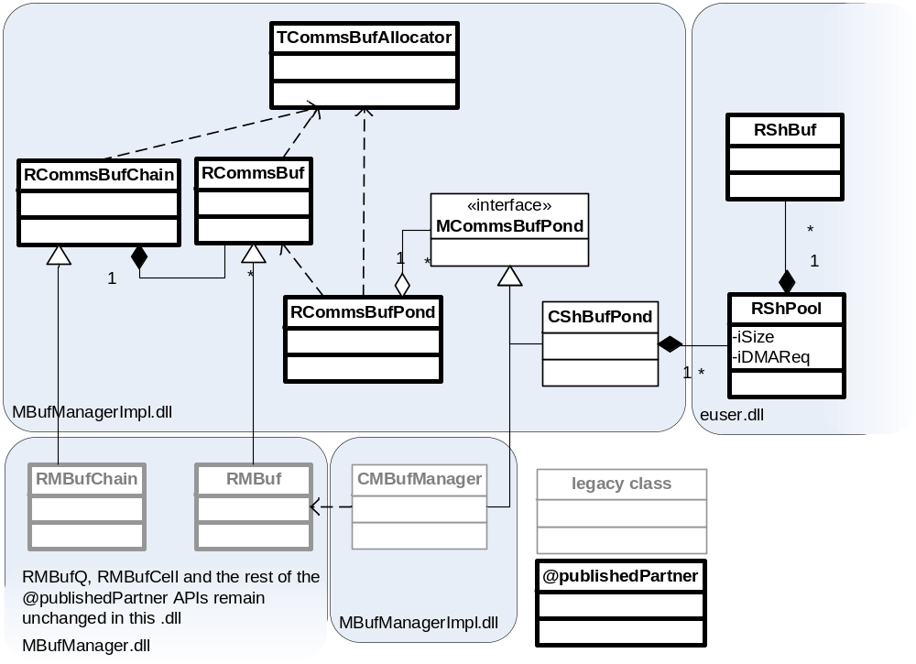
Figure 4-1 - Overview
The sections below describe each individual class in detail.

RCommsBuf
RCommsBuf is a Comms specific specialisation of RShBuf and it is designed for carrying packets within the Comms Data Plane. RCommsBuf is a slow replacement of RMBuf, i.e.: Comms Framework continues support for RMBufs but it encourages transfer to RCommsBufs. The motivation for replacing RMBufs with RCommsBufs is that the former collected a number of comments/complaints that couldn’t have been addressed without introducing a new API.
RCommsBuf implements this design by describing RShBuf with additional (Comms specific) meta data and by providing a suitable API (both of which are described below). The meta data lives physically at the end the shared buffer to keep the ‘is a’ relationship with RShBuf (clients may want to write at the start of the buffer).
The RCommsBuf metadata is towards the end of the memory segment represented by the RShBuf. It is so to allow, whoever writes to it, not to pay attention to the meta and write at the beginning of the segment (drivers/DMA are anticipated to need this).
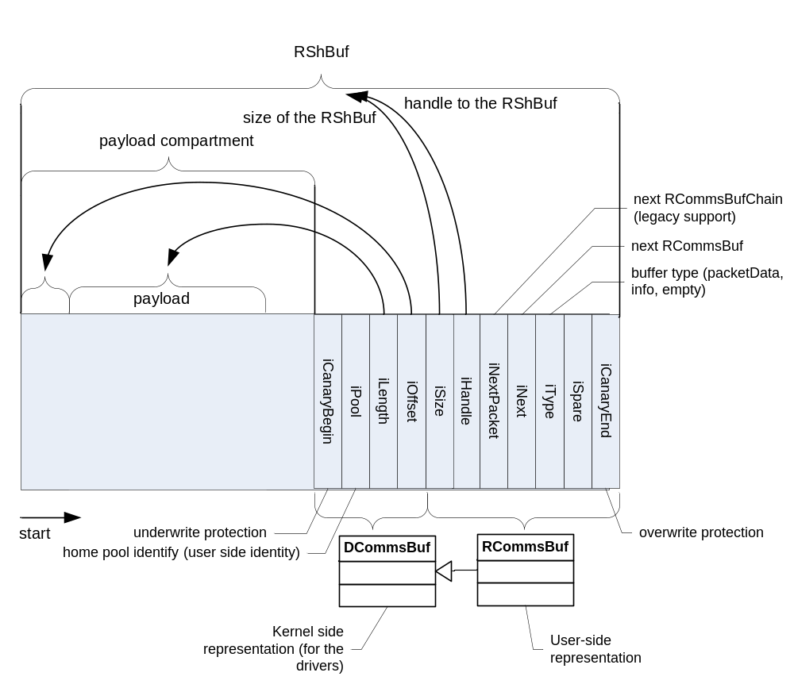
Figure 4-2 – RCommsBuf
class RCommsBuf
/**
RCommsBuf.

@publishedPartner
@prototype
*/
{
public:
IMPORT_C static RCommsBuf* Alloc(TUint aSize,
TCommsBufAllocator& aAccessor);

// Simple access to the data
inline TPtrC8 DesC8() const;
inline TPtr8 Des8();

inline const TUint8* RawBase() const;
inline TUint8* RawBase();
inline TInt RawSize() const;

inline const TUint8* Ptr() const;
inline TUint8* Ptr();
inline TInt Length() const;
inline TInt Offset() const;

inline TUint8 operator[] (TInt aPos) const;
inline TUint8& operator[] (TInt aPos);

inline void Reset();
IMPORT_C void Write(const TDesC8& aSrc, TInt aOffset =0);
IMPORT_C void Read(TDes8& aSrc, TInt aOffset =0) const;

// Maximum number of bytes which can be appended
inline TInt AppendLimit() const;
IMPORT_C void Append(const TDesC8& aSrc);

// Maximum number of bytes which can be prepended
inline TInt PrependLimit() const;
IMPORT_C void Prepend(const TDesC8& aSrc);

// Raw manipulation
inline void SetDataRange(TInt aOffset, TInt aLength);
inline void AdjustDataStart(TInt aDelta);
inline void AdjustDataEnd(TInt aDelta);

// Free the RCommsBuf
IMPORT_C void Free();

protected:

(...)
private:

(...)
};

RCommsBufChain
RCommsBufChain is a list of RCommsBuf.
class RCommsBufChain
/*
A chain/list of RCommsBufs

@publishedPartner
@prototype
*/
{
public:
inline RCommsBufChain();
inline RCommsBufChain(RCommsBuf* aHeadBuf);

inline TBool IsEmpty() const;

IMPORT_C TInt Length() const;

IMPORT_C void Assign(RCommsBufChain& aChain);

IMPORT_C void Append(RCommsBufChain& aChain);
IMPORT_C void Append(RCommsBuf* aBuf);
IMPORT_C TInt Append(TInt aLen);

IMPORT_C void Prepend(RCommsBufChain& aChain);
IMPORT_C void Prepend(RCommsBuf* aBuf);
IMPORT_C TInt Prepend(TInt aLen);

IMPORT_C TInt Alloc(TInt aSize, TCommsBufAllocator& aAccessor);
IMPORT_C TInt Alloc(TInt aSize, TInt aMinBufSize,
TCommsBufAllocator& aAccessor);
IMPORT_C TInt Alloc(TInt aSize, TInt aMinBufSize, TInt aMaxBufSize,
TCommsBufAllocator& aAccessor);

IMPORT_C TInt Split(TInt aOffset, RCommsBufChain& aNewChain);

IMPORT_C TInt Align(TInt aSize);

IMPORT_C void Write(const TDesC8& aDes, TInt aOffset =0);
IMPORT_C void Read(TDes8& aDes, TInt aOffset =0) const;

IMPORT_C void Free(); // Free the chain.

IMPORT_C void TrimStart(TInt nBytes);
IMPORT_C void TrimEnd(TInt anOffset);

protected:
(...)
};

RCommsBufChain gives the perception of being a contiguous bloc of memory, but it does allow for visiting the RCommsBufs it owns with TCommsBufIter.

RCommsBufPond & TCommsBufAllocator
The RCommsBufPond is a user (allocator’s) view of a collection of RShPools. Each pool in the pond has a different size of buffer. RCommsBufPonds are sources (can allocate) of RCommsBufs.
TCommsBufAllocator is an opaque, storable token that RCommsBufs understand (they don’t understand RCommsBufPonds) and can perform the allocation against. TCommsBufPond is (maps to) RCommsBufPond, but in theory it could map to other sources of RCommsBufs.
The Control Plane will provision (message TCFDataClient::TProvisionConfig) RCommsBufPonds and TCommsBufAllocators to its flows so the flows can allocate RCommsBufs.
The flows can retain references to the RCommsBufPond or/and TCommsBufAllocator for as long as they exist, but they must not share them with anybody without the Control Plane consent (the Control Plane owns the ponds).

/**
The RCommsBufPond represents a collection of RShPools. Each pool in the pond has a different size of buffer. The pond is responsible for creating, allocating and freeing these pools.

@publishedPartner
@prototype
*/
class RCommsBufPond
{
public:
IMPORT_C RCommsBufPond();

IMPORT_C RCommsBuf* Alloc(TInt aSize,
TInt aMinBufSize, TInt aMaxBufSize);

IMPORT_C TInt BytesAvailable() const;
IMPORT_C TInt BytesAvailable(TInt aSize) const;
IMPORT_C TInt NextBufSize(TInt aSize) const;
IMPORT_C TInt LargestBufSize() const;

IMPORT_C TCommsBufAllocator Allocator();

IMPORT_C void Free(RCommsBuf* aBuf);

inline TBool IsNull() const;

private:
(...)
};

RCommsBufPondOp
RCommsBufPondOp is an internal class representing the creator’s/modifier’s view of the pond (see [4.3]). Flows are typically the entities that will need to allocate buffers, but they will not need to create the ponds (they can rely on the ponds being supplied).
class RCommsBufPondOp : public RCommsBufPond
{
public:
IMPORT_C RCommsBufPondInternalOp();
IMPORT_C TInt Open(RArray<TCommsBufPoolCreateInfo>& aPoolInfo);
IMPORT_C void Close();

private:
(...)
};

Where TCommsBufPollCreateInfo is the description of the pools requested for creation.
struct TCommsBufPoolCreateInfo
{
TInt iBufSize; // Buffer size for the pool
TInt iInitialBufs;// No. of buffers initially allocater buffers
TInt iGrowByBufs; // The minimum number of buffers that the
//pool will grow by
TInt iMinFreeBufs;// Minimum no. of free bufs. If the value falls
//below this number
// the buffer manager system will grow.
TInt iAlignment;
TInt iCeiling; // Pool ceiling. Maximum no. of buffers the pool
//can have.
};

RCommsBufPondOp remains internal as, until there’s evidence to the contrary, there will ever need to be one pond in the data plane and hence the Comms Framework (and not individual access points, control plane implementations) can be made responsible for and supplying it to where it’s necessary. Comms Framework will insert the one and only default pond to the Data Plane’s TLS, but this is not to be relied upon. The one and only default pond will be configured (similarly to the MBufManager it replaces) with c32start.ini (stating what stated in TCommsBufPoolCreateInfo).

MCommsBufPond
MCommsBufPond is an abstraction for the implementation of the RCommsBufPond. PREQ2106 comes with two implementations:
- RShBuf-based and suitable for cross process zero-copy (dependent on PREQ1490 and Flexible Memory Model)
- Risk avoiding, legacy CMBufManager, not allowing for zero copy and falling back to the pre zero copy, RHeap based setup.
The choice is made during ROM build time.

Allocation algorithm for shared buffers
Probably put this algorithm in another editor for better viewing.
/**
Assumption
1. The buffer sizes are configured with big to small order in c32start.ini
2. More than one buffer may be allocated and linked, if the requested buffer size doesn't directly satisfy with the configured buffer sizes

Algorithm tries to do the best-fit allocation.

Input parameters

Size - Requested total size.
Minimum Size - The size that the allocated buffer "must" have
Maximum Size - The size that the allocated buffer "can" have.

var array pool; // Assume pool is already initialized.
var ineger chosenpoolindex; // Initialize to notfound
var integer poolcount; // Initialize to the no. of pools in the array

function alloc ( integer size, integer minsize, integer maxsize )
var integer index = 0; //
while index < poolcount and size > 0
if pool[index].bufsize is inbetween minsize and maxsize
chosenpoolindex = index; // choose the pool index
endif

if chosenpoolindex is not equal to notfound
// Check whether we really need to allocate from this pool
if size < pool[index].bufsize and index + 1 less than poolcount
// Maybe we will get more acceptable pool.
increment index by 1 // Go for another acceptable pool
else
// ok we can allocate from this pool
Allocate from the pool[chosenpoolindex]
if allocation is success
link the allocated buffer
decrement and assign size with allocated size
// No poolindex increment here, as we again try to allocate from the same pool or any other lesser pool.
else
increment the index by 1 // Maybe we will get a chance to allocate from another pool
endif

endif
elif
increment the index by 1
endif
endwhile
end
*/

Further Information

People
Role | Person / People
Reviewers | Tom Goodfellow, Remek Zajac, Ivan Kelly, Chris Gorman
Contributors | Thomas Goodfellow, Remek Zajac, Ivan Kelly, Subramanian RS

References
No. | Document Reference | Version | Description
[R1] | http://onesymbiandocsuk.symbian.intra/ucm/idcplg/webdav/Contribution Folders/PsiSoft/Dev/TS/TS0022 Kernel/RequirementsAnalysis/ProductRequirements/PREQ1490 - Flexible Memory Model/ | v0.4 | Design sketch for system wide shared buffers on which this design is based.
[R2] |  | In writing | Reference device driver and utilities API.

Open Issues

Glossary
Term | Definition

Document History
Date | Version | Status | Author | Description
17-02-2009 | 0.4 | Draft | Subramanian RS | Modified the document to incorporate review comments
09-02-2009 | 0.3 | Draft | Subramanian  RS | Modified the document to reflect the introduction of new classes
08-12-2008 | 0.2 | Draft | Subramanian RS | Incorporated Pre-review comments of Tom
08-12-2008 | 0.1 | Draft | Subramanian RS | First draft based on SGL.PPS001.501 Formal Document Template Rev 8.8
08-12-2008 | 1.0 | Issued | Remek Zajac | Updates, following review.

