ESock Design Document

Status: | ISSUED
Version: | 2.00
Team/Department : | Networking Technologies/Core Development

Contents
1 Introduction 5
1.1 Purpose and Scope 5
1.2 Reading guidelines 5
2 Design Overview 6
2.1 ESock Client 6
2.2 ESock Server 6
3 Detailed Design 9
3.1 Client Implementation 9
3.2 Server Implementation 9
3.2.1 The Worker Thread 9
Owns 10
3.2.1.1 Messaging 10
Worker Thread messaging 10
Application to Worker communication 13
3.2.2 The Dealer 14
3.2.2.1 Session handling 14
ServiceL 15
Closing a session 15
3.2.2.2 Words on orphanage 16
3.2.2.3 Handling a Bind message and installing protocols 16
3.2.2.4 SSA changes 17
3.2.3 The Player 18
3.2.3.1 Receiving an introduction message from the Main Dealer. 19
3.2.3.2 Processing Messages 19
3.2.3.3 Providers 20
3.2.3.4 The session proxy 20
3.2.4 The Pit Boss 20
Owns 21
3.2.4.1 Global protocol list - iProtocolPairHead 23
Overview 23
Populating the list 23
Deleting from the list 23
3.2.4.2 Worker Thread surveillance 24
Registering a Worker Thread. 24
Initial Worker death handling 24
The RedShirt and Final phase of cleanup 24
3.2.4.3 SSA Changes 25
3.2.5 The sub-session container 25
Overview 25
Implementation details 25
3.2.6 Optimal Connect 27
Overview 27
Implementation details 27
Client code examples 28
3.2.7 Socket Transfer 28
Overview 28
Implementation details 28
Naming a socket 28
Performing the transfer 29
Client code examples 29
3.2.8 Un-Binding workers 29
Overview 29
Implementation details 30
3.2.9 RSocket::Accept 30
Creating the null socket 30
Performing the Accept 32
3.2.10 Shutdown 32
Overview 32
Implementation details 33
3.2.11 Multi-homing Server API Classes 35
3.2.12 ESock Server Classes 36
3.2.12.1 CConnection 36
CConnection Method Description 36
3.2.12.2 MShimControlClient 39
3.2.12.3 CSubConnection 40
CSubConnection Method Description 41
3.2.12.4 CInterface,CSubInterface, MConnectionNotify and MSocketNotify 42
3.2.12.5 CServProviderBase 42
3.2.12.6 CControlledServProviderBase and CControlledServProviderShim 42
3.2.12.7 CHostResolvProvdBase 42
3.2.12.8 RSocket 43
3.2.12.9 RHostResolver 43
3.2.12.10 CConnectionProvdBase 43
3.2.12.11 CConnectionProviderBase 43
3.2.12.12 CSubConnectionProviderBase 43
3.2.12.13 CSockSession and MSockSessionObserver 44
3.2.13 NIFMAN Classes 44
3.2.13.1 CNifSession and MAgentSessionNotify/MNifSessionNotify 44
CNifSession Method Description 45
CConnectionProvdBase API methods 45
MNifSessionNotify Methods 47
MAgentSessionNotify Methods 47
MNetworkControllerObserver Methods 48
3.2.13.2 Idle Timeout Functionality 48
3.2.13.3 Implementation Overview 48
3.2.13.4 Effect of ESock Sessions on Idle Timer 49
3.2.14 Platform security considerations in ESock 50
3.2.14.1 Securing RConnection “clone” open 50
Overview 50
Code Examples 50
Implementation details 51
3.2.14.2 Securing RConnection::Control(...) options implemented within ESock 51
3.2.14.3 Policing RConnection::Start()/Attach()/Stop() 52
3.2.15 Platform Security considerations in NIFMAN 52
3.2.15.1 Policing RConnection::Start()/Attach()/Stop() 52
Omissions 52
3.2.15.2 Policing RGenericAgent and RNif 53
3.2.16 Scenarios 53
3.2.16.1 Implicit Connection Startup via RHostResolver::GetByName() 53
3.2.16.2 Implicit Connection Startup via RSocket::Connect() 54
3.2.16.3 Implicit Connection Startup via RSocket::SendTo() 55
3.2.16.4 Explicit Connection Startup via RConnection::Start() 55
3.2.16.5 Progress Notification 56
3.2.16.6 Opening an RSocket associated with an RConnection 56
3.2.16.7 Opening an RHostResolver associated with an RConnection 57
3.2.16.8 Loopback 58
3.2.16.9 Opening an RSocket which uses the RSocketServ default connection 58
3.2.16.10 Attaching to a connection via RConnection::Attach() 58
3.2.16.11 Implicitly attaching to an existing interface 59
3.2.16.12 Starting an interface (NIFMAN perspective) 60
3.2.17 Server startup 62
3.2.17.1 Binding ESock CPMs 62
3.2.18 Configuring the Socket Server 63
Configuration files and parameters 63
Module relationships 63
A few words on queue lengths 64
3.2.19 Reference configuration 64
3.3 Logging 65
3.3.1 Client side 65
3.3.2 Server side 66
Other logs 66
4 Further Information 67
4.1 References 67
4.2 Glossary 67
4.3 Document History 69
4.4 Table of figures 69
5 Appendices 71
A.1 Multihoming changes as introduced in release 7.0s 71
A.2 Bearer Mobility as introduced in release 9.1 71
A.3 MDL model 72

Introduction

Purpose and Scope
Describe the design of ESock the Symbian OS Socket Server, in Symbian OS v9 onwards (alias ESockV3 alias ESockMT).
ESock is composed of a client API (ESock.dll), providing client interfaces, and the multithreaded server implementation (ESocksvr.dll), which hosts the service-providing protocol modules and (through collaboration with the Connection Arbitrator) network interfaces.
This document is intended for people involved in the future development and maintenance of these components and accordingly focuses upon the design and implementation: other reference material describes the use of the client interfaces [R6].
This document has historically been a collection of scattered design ideas and details, rather than a complete and fulfilling design document for ESock. This state is unchanged with the current version as projects, such as ESockV3 (making the Socket Server multi-threaded) have added only design details pertaining to those particular changes. For this reason this document can not be considered a complete and fulfilling introduction to the subject, but rather a source of information to the maintainer as well as the designer of new changes to the component.

Reading guidelines
UML is often used to describe class structures and relations, but due to the complexity of the component it is always in little sub-sets (conceptual cut-outs) of the entire thing, often based around one or two classes being described.
The UML diagrams don’t usually show any operations or attributes, unless in some way significant to the design or the surrounding text. The same applies to the document in general. Specific methods and attributes and descriptions of them are only mentioned where deemed useful.
Readers are strongly advised to familiarise themselves with comm.-infras stackable connection providers’ architecture and design described in [R11] and [R12].

Design Overview
ESock provides a common interface for client software to access communications protocols, such as TCP/IP and IRDA. Not all protocols support all client API features (indeed some such as datagram vs. stream transport are mutually exclusive).

ESock Client
The client interface consists in large part of service-providing classes:
- RSocket – data transport services akin to the BSD sockets.
- RHostResolver – textual to/from binary address name resolution services
- RServiceResolver – textual to/from binary service number conversions (akin to *nix IP “services” file)
- RNetDatabase – broader purpose data storage and retrieval, e.g. for IRDA LM-IAS
- RConnection – control and monitoring of NIF-based network connections.
- RSubConnection – control of a channel within a connection that has specific properties
All of these are opened as sub-sessions of an RSocketServ session.

ESock Server
As well as implementing a Symbian OS server interface that the client API sub-sessions make requests of, the ESock server provides APIs and base classes for protocol modules and the Connection Arbitrator.
These are implemented in ESocksvr.dll, to which server side components such as protocol modules, NIFMAN, and NIFs link.
At runtime, the ESock server (Socket Server) is a collection of Comms Provider Modules (CPMs) loaded by the RootServer [R9] and responding to the CPM interface (a CPM is a thread run in the Comms Process, loaded by the Root Server and responding to Root Server control messages). The individual instances of ESock will shut down when requested to do so by the RootServer. Some of them will implement the Symbian OS client/server IPC interface and some will exist only to provide protocol services to others.
The collection of CPM instances comprising ESock communicates partly via Comms Channels [R9] and partly by accessing data-structures in shared memory.

The ESock server contains three distinct roles:
- A Dealer implements an IPC server for an ESock session. The Dealer provides a number of protocols to the client. It will receive requests from client sessions and in most cases pass them (in form of the RMessage2) to the appropriate Player. Thus the Dealer is a very light-weight entity meant to very quickly and efficiently pass on the IPC requests.
- A Player hosts various protocols by means of .PRT plug-in DLL files, each containing the implementation of a protocol family. The Player performs the actual work for processing a request by synchronous calls into the provider code and it is responsible for completing the RMessage2 when ready.
- The PitBoss oversees the interaction of the Dealers and Players. It owns shared data structures, such as the list of protocols supported by the server and it has the responsibility for safely cleaning up after a socket server thread panic, which involves some bookkeeping and resource management.

The main socket server thread (often referred to by its thread name “ESock_Main”) contains the PitBoss and a Dealer with the server name “!SocketServer” to which client sessions initially connect. Only one PitBoss instance is allowed in the process and to assure stability no Player is allowed in the Main thread. This is non-configurable.
All other “Worker Threads” (any ESock instance has a worker thread) can contain a Dealer, a Player, or both (in the following often referred to as a DealerPlayer). If the Worker contains a DealerPlayer, the Dealer is also said to be an Optimal Dealer, as clients can create connections directly to it and thus avoid a thread context shift between Dealer and Player when IPC messages are processed.
Messages are passed between threads by Comms Channels (the message queue abstraction offered by the CommsFw component), except in the case of a Dealer and a co-resident Player in which synchronous function calls are made. Dealers perform the absolute minimum amount of work to track sessions and the sub-sessions contained within them as they are mainly IPC message dispatchers.
Which Dealer is associated with a client session must be decided when the client first connects to “!SocketServer”. The client can supply information to guide this decision: in the near-term this is the protocol group that the client intends to (predominantly) use with the session, but other such information could include the level of QoS to be requested by sockets in that session (which might require elevated capabilities or only be granted to well-trusted clients such as the multi-media framework). This is implemented as an overload of RSocketServer::Connect() supporting a protocol group argument and some reserved additional argument (the parameter class has a few reserved fields for future use, e.g. QoS). The client remains connected to “!SocketServer” if no DealerPlayer is available directly supporting this Protocol family (either they used the legacy Connect() or the information supplied couldn’t be better satisfied).

This approach to multithreading has benefits:
- The choice of configuration is inherently soft and is established at boot time by the RootServer Configurator. This makes fine-tuning for a particular device or usage profile easy.
- It naturally extends to supporting QoS by running multiple threads for a single protocol group (e.g. “IP” and “IP Real-time”), which is a probable future requirement.

Figure 2-1 show three client sessions, connected variously to Dealers (for simplicity only the SMS and IP protocol groups are shown, however normally BT and IRDA will also be present).

Although there is use of shared memory, each ESock instance is allowed to have its own heap (configurable). This has a number of benefits:
- Better robustness, if an instance dies its heap can be cleaned up and freed.
- Memory leak detection is much easier.
- OOM testing can be better targeted.
There is still no protection against random memory overwrites from bad protocol implementations, thread starvation and many other problems. So although robustness is an important issue with a multi threaded ESock, it is a best effort sort of robustness and it is not meant to be the sort of robustness that just hides problems, i.e. purpose is to increase runtime stability.
“!SocketServer” Dealer
SMS Group Player
SMSPROT
WAPPROT
SMS-CPM
RSockServ 1
IP-CPM
IP Group
Player
TCPIP6
IPSEC

NIF
NIFMANifman
AGENTSgents
ESock-CPM
RSockServ 2
RSockServ 3
IP Group
Dealer
Figure 2-1 - example set-up and communication paths

Legend:
- All CPMs are instances of the CPM implementation offered by ESockSvr.dll with different configurations determining which protocol group they operate: ESock, IP, SMS.
- Thick lines with solid arrowheads are synchronous calls between a Dealer and its co-resident Player.
- Thick dotted lines with solid arrowheads are message queues (in the form of Comms Channels) between Dealers and other Players.
- Thin lines with hollow arrowheads are client sessions.
- Dashed lines are thread boundaries; the heavy horizontal one is also the IPC boundary.

“RSockServ 3” in Figure 2-1 is a session connected by a “modern” client which knew to nominate the IP protocol group when it connected. IP traffic sent via it is processed synchronously within the IP-CPM thread, i.e. effectively the same situation as in the Symbian OS v8.1 single-threaded ESock. SMS traffic sent on this session is forwarded on the Comms Channel to the SMS-CPM, which is slightly lesstefficient than IP traffic for this particular RSockServ connection.
The reference configuration delivered with Symbian OS v9 is shown in 3.2.19.

Detailed Design

Client Implementation
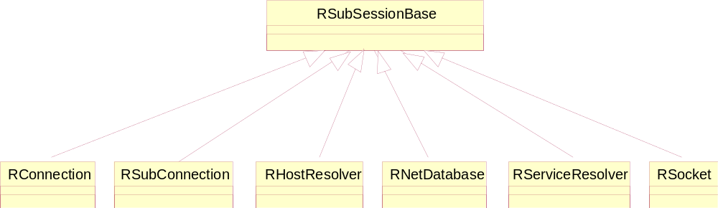
Figure 3-2 – Client API class hierarchy

Figure 3-2 shows the main client API classes used with RSocketServ sessions.
The other functionality supported by the client library consists of T classes used in the client/server interface.
As in the traditional Symbian OS client/server models, the client consists of some very thin classes derived from RSessionBase and RSubSessionBase, using SendReceive to communicate with the server.

Server Implementation

The Worker Thread
The Worker Thread (CWorkerThread, see Figure 3-3) is the generic base class for all ESock threads. It is the holder of the relevant ESock objects in the CPM instance, e.g. the PitBoss, the Dealer and the Player (depending on configuration). It is also in charge of inter-thread communication as it holds the object enabling communication with the RootServer (CWorkerRootServChannelHandler) and a list of objects for communication with other Worker threads (CWorkerTransport).
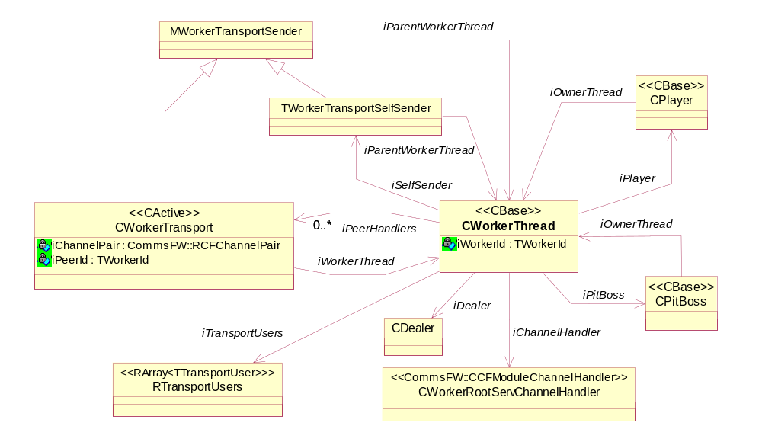
Figure 3-3 - The Worker Thread class hierarchy

Owns
CWorkerRootServChannelHandler* iChannelHandler;
“Communication device” (class hiding the Comms Channels) connected to the Root Server.

CWorkerTransport* iPeerHandlers;
List of communication devices connected to other Worker threads.

RTransportUsers iTransportUsers;
A list of plug-ins capable of consuming messages not internal to ESock (often referred to as transport messages).

Messaging
Sending a message to a worker thread can be done in three different contexts:
- Sending the message between different Worker threads.
- Sending the message within the same Worker thread.
- Sending the message from outside the process.

Worker Thread messaging
Three categories of messages are available to ESock and users of the ESock Comms Channels, as can be seen in Table 1 (showing the three categories with all the message types available).
Case | Message | Handling
1 | TWorkerMsg::EMainIntroduction  TWorkerMsg::EMainIntroductionResp  TWorkerMsg::ECleanupDeadPeer  TWorkerMsg::ECleanupDeadPeerResp  TPlayerMsg::ESessionClose  TPlayerMsg::ESessionCloseResp | Lifetime control.  These messages are related to the life and death of worker threads and sessions.
2 | TPlayerMsg::EForwardRequest | These messages are sub-session requests. Deliver to co-resident Player with ProcessMessageL(…).
3 | Unknown message code (non-ESock message) | Assume to be Transport Message destined for plug-in which knows how to handle it. Give it to TransportMessageReceived(…).
Table 1 - Message handling at destination

Now what is the purpose of case 3, supporting “unknown” incoming messages?
Since the ESock instances are connected via Comms Channels it is entirely possible that one would wish to send messages other than those internal to ESock to implement extra functionality. It would be a shame to have all these Comms Channels between the ESock threads without providing the opportunity to use them for any sort of communication and not just a few select ESock messages.
One example of such need to communicate safely across threads is RInternalSocket, which is sort of a peripheral plug-in to ESock. More on how this is handled in the following.

For a Worker to send a message to another Worker (inter-thread or intra-thread) it will acquire the “sender” using one of the following methods:
- CWorkerThread::SenderForProtocol(…, MWorkerTransportSender*& aSender)
- CWorkerThread::SenderForProtocolByName(…, MWorkerTransportSender*& aSender)
- CWorkerThread::SenderForWorkerId(…, MWorkerTransportSender*& aSender)

These methods will find the appropriate Worker and return a MWorkerTransportSender which, if it turns out to be the same thread, is the TWorkerTransportSelfSender instance and if it is another thread will be the CWorkerTransport instance. This MWorkerTransportSender can then be used to send the message by means of its SendReceive(…) method. This method is modelled after the similar named TInt RSessionBase::Send()/::SendReceive(…) which is used in the IPC interface supporting the Symbian OS Client/Server model.

The difference in the meaning of “sending” lies in the implementation of the SendReceive(…) method; for CWorkerTransport it simply does a blocking send on the Comms Channel connected to the receiving Worker. The receiving end will wake up asynchronously and call CWorkerThread::PeerWorkerMessageReceivedL(…) to process it.

Figure 3-4 shows the chain of events when a Worker sends a non-ESock message (Table 1, case 3) to another Worker thread.
TInt MWorkerTransportSender::SendReceive(…)
Thread boundary
TInt CWorkerTransport::BlockingSend(…)
CommsFW::RCFChannelPair::Send(…)
CWorkerTransport::RunL(…)

CWorkerThread::PeerWorkerMessageReceived(…)

Send and wait for completion with User::WaitForRequest(iStatus)
Then return iStatus or error.
CWorkerThread::TransportMessageReceived(…) (…)

TRequestWrapper::RequestComplete(…)
(…)

Calling into plug-in.
The plug-in will finally call this function.
It will do a RThread::RequestComplete(…) on the originating thread.
TTransportUser->CWorkerTransportReceiver::ProcessMessage(...)

Figure 3-4 - Sending non-ESock message with receiver in other Worker thread

If the MWorkerTransportSender was a TWorkerTransportSelfSender instance it will do things differently; In this case the destination is within the same thread and it makes no sense to send it over a Comms Channel. Also we know that it is not an internal ESock message as they are never handled like this if for the same thread (a Dealer simply calls ProcessMessageL(…) directly on its Player, this could be changed to use this “Self-sender mechanism” for consistency). So this implementation will directly call TransportMessageReceived(…) on the owning CWorkerThread (thus ending up the same place as last case in the table above, if the message code was unknown).
Figure 3-5 shows the chain of events when a Worker sends a non-ESock message (Table 1, case 3) to the same Worker thread.

TInt MWorkerTransportSender::SendReceive(aStatus…)
TInt TWorkerTransportSelfSender::SendReceive(…)
Return TRequestWrapper::iStatus all way back to original caller.
Tint CWorkerThread::TransportMessageReceived(…)

TRequestWrapper::RequestComplete(…)
(…)

Calling into plug-in.
The plug-in will finally call this function.
It will set aStatus and return.
TTransportUser->CWorkerTransportReceiver::ProcessMessage(...)

Figure 3-5 - Sending non-ESock message with receiver in same Worker thread

This functionality is provided in an extensible and soft-configurable way by the means of Transport Users. As indicated in the table, any type of message received by a Worker, which is not an internal ESock message will be assumed to be a Transport message destined for a plug-in installed in iTransportUsers.
The message code is assumed to be an Interface Id and if a plug-in in iTransportUsers can be found that supports that Interface Id, that user will be given the message by a call to its ProcessMessage(…). If nothing is found, ESock will first try to install a new TTransportUser supporting the Interface Id by locating and installing it using ECom if possible. If nothing could be found by ECom supporting the interface Id, a log entry is generated and an ASSERT called to catch it at debug time.

It is assumed that all such messages generate a return code and that it will be completed by the plug-in when having processed the message. However, as mentioned above there are two cases:
- The message was received from a Comms Channel and need asynchronous completion.
- The message was originated within the same thread and was the result of a synchronous down-call.

In case 1) it is easy to handle it, we simple use User::RequestComplete(…) to complete the status and signal it to the thread. In case 2) it would be a waste to set the status and then complete ourselves when we know we have already finished. It is cheaper to just set the status with the appropriate error code and return.

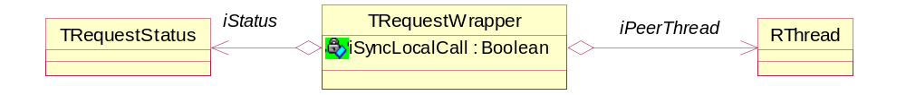
Figure 3-6 - The request wrapper

To hide the differences in approach, we use the TRequestWrapper (Figure 3-6) instead of the TRequestStatus directly. If it is a synchronous local call, its RequestComplete(…) will simply set the status to the given error code and return. When we return from CWorkerThread::TransportMessageReceived(…) and ultimately from
MWorkerTransportSender::SendReceive(…) the status is already set and the message is completed, synchronously.
If it is a asynchronous call coming in from a Comms Channel, the TRequestWrapper will do a fully fledged User::RequestComplete(...) and the source Worker of the message will wake up and return from its synchronous SendMessage(…).

Application to Worker communication
It is also possible for client applications outside of the Comms Process to send messages to an ESock Worker thread (actually to any CPM instance in the process) by name. This is done through the Root Server SendMessage(..) method. The message is received by the destination ESock Worker in the CFMessageForward(..) member, which will deal with it accordingly.
Note that completion of the client request is the responsibility of the recipient.
Currently supported message type is TCFMessageType::EFactoryMsg destined for one or more CProtocolFamilyFactoryBase instances from globals->iProtocolFamilyFactories. ESock will traverse through this list and deliver (by calling SendMessage()) the message content to every instance present there.
The message content for such a message sent to an ESock Worker is required to be based on CNetMessage class.

The Dealer
The Dealer is an implementation of the Symbian OS server (CServer2), that will give the IPC messages it receives to the appropriate Player, and as such one of its most important possessions is the list of CSession2’s kept by the CServer2. On a conceptual level one can say that the CWorkerDealer owns the CSockSession’s due to their inherited relationship (see Figure 3-7).
Sub-sessions are also supported in the form of the CSockSubSession and its derivatives (CSocket, CHostResolver, etc. sometimes referred to as the Providers). These are owned by the provider container (CSubSessionIx) in the CSockSession.
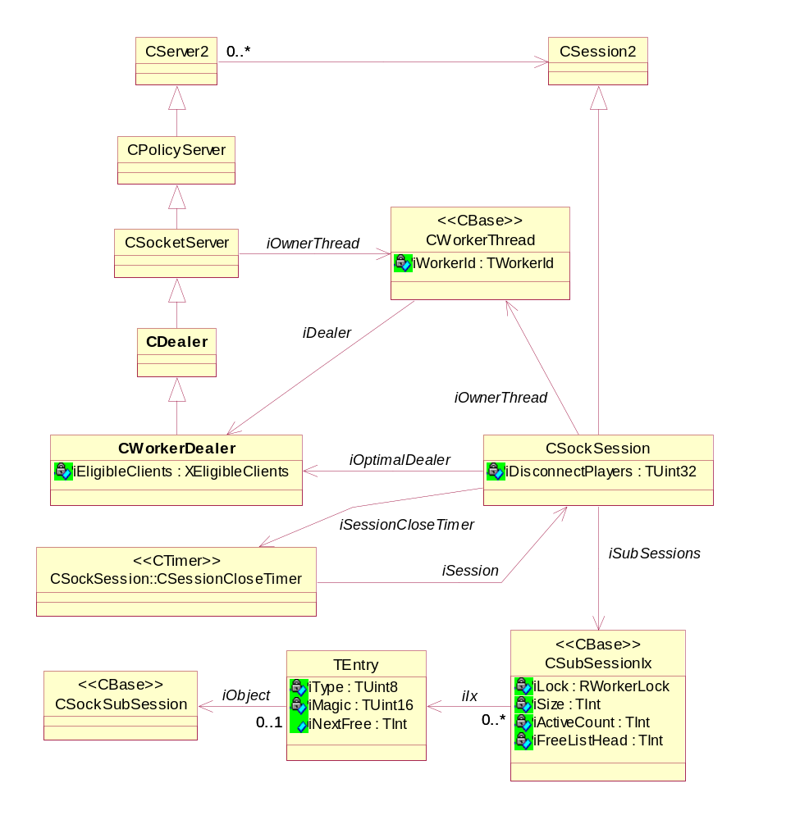
Figure 3-7 - The Dealer class hierarchy

Session handling
The CDealer is derived from CSocketServer, which is the owner of CSockSession. Sessions can only be created and deleted by the Dealer, whereas sub-sessions are controlled by the Player.
However, the sub-sessions are stored in iSubSessions (a CSubSessionIx) in the session instance. This container is thread-safe by a lock, as Players add/remove directly from it by calling e.g. PitBoss().AddSubSession() – which operates directly on the Session.

ServiceL
CSockSession::ServiceL handles the IPC messages in the following way:
  - Sub-session creation messages (e.g. ESoCreate, EHRCreate, ESRCreate, ENDCreate, ECNCreate and ECNCreateWithName) messages are handled by looking up the protocol in the global (PitBoss) protocol table and forwarding the request to the corresponding Player.
  - Sub-session closing messages (ESoClose, EHRClose, ESRClose, etc.) messages will cause the sub-session to be removed from its sub-session index in the session it belongs to after which, the message will be forwarded to the Player owning the sub-session.
  - ESoCreateNull is handled by the co-resident Player if there is one, otherwise forwarded to a Player determined by the PitBoss (see 3.2.9).
  - Protocol query ESSNumProtocols is handled immediately from a lookup in the global protocol table (again, global means owned by the PitBoss).
  - ESSProtocolStart and ESSProtocolStop are forwarded to the appropriate Player.
  - ESSInstallExtension is not supported (CPM files and boot-time configuration are the replacement). No known dependencies.
  - ESSExclusiveMode and ESSClearExclusiveMode are not supported – layering of a protocol over another group, via RSocket, no longer deadlocks if they are in different threads (e.g. IP and BT). RInternalSocket allows for creating sockets within the same thread.
  - All other requests are handled by looking up the provider in the provider container and forwarding the request to the identified Player, or panicking the client if the lookup fails.

The forwarding of messages to the appropriate Player is done by the method ForwardMessageL. If the Player is co-resident this function will call ProcessMessageL directly on the Player, otherwise it will be forwarded to the Player over the Comms Channel to the appropriate Worker Thread.

Closing a session
Player side housekeeping must be done when a Session is closed (as the Player is responsible for the sub-sessions and also have its own list of them). But a Socket Server session can potentially have sub-sessions on several Players, so the session must monitor to which Players messages have been forwarded from a Session.
For this purpose each CSockSession maintains a bit-mask – iDisconnectPlayers. If a message is forwarded to Player n, in ForwardMessageL, the corresponding n’th bit will be set in iDisconnectPlayers (which is a bit-field with at least as many bits as there are players). iDisconnectPlayers is a 32 bit entity, leaving room for future expansion.
This n’th bit is set is done each time a message is forwarded, which might seem a bit wasteful since we don’t need to set the bit again if it is already set, but on ARM shifting and setting a bit is very few instructions and it is probably as expensive to test as to set. The bit is cleared when the session is disconnected.
A number of access methods are provided by CSockSession to handle operations on the Disconnect list:
TBool IsPlayerInDisconnectList(TWorkerId) const;
TBool IsDisconnectListEmpty() const;
void AddPlayerToDisconnectList(TWorkerId);
void RemovePlayerFromDisconnectList(TWorkerId);

When an RSocketServ session is closed by the client, a Disconnect message will be generated and CSockSession::Disconnect called on the server side. All Players to which the session have ever had sub-session will be in the disconnect list and they will be notified of the session close to get a change to clean up sub-sessions and session observers (the Session proxies, see 3.2.3.4).

- Remove all sub-sessions from the provider index.
- For each Player in the Disconnect List:
  - If not co-resident send a Session Close message to the Player, else call CPlayer::CloseSession directly on the co-resident Player.
- If the Disconnect List is empty call Disconnect on the base class immediately, else start a CSessionCloseTimer that time out after twice the amount of time given as deadline to the Players to send a Session Close response.
In detail: Under normal conditions, Players will send back the Close Session response quickly and when the last response arrives the Dealer will delete the Session and complete the client’s session close.
If not all the expected responses come back within the deadline set in the Session Close message, the CSessionCloseTimer will fire and the session will be deleted by the Dealer. This is usually due to a Player somehow being unreliable and shouldn’t normally happen. The purpose of the timeout is to avoid blocking the client.
Disconnect will be called on the base class, which will remove the session from the server and delete it.
The Session destructor does the following:
- Cancel and delete the Session Close timer
- If iOptimalDealer is set (see 3.2.6), remove ProcessId of owning process from the optimal dealers list of eligible ProcessIds (using iOptimalDealer->iEligibleClients). As this is done directly on the other dealer it requires locking.
- Mark all remaining sub-sessions as orphaned (see 3.2.2.2), so the Player know that the session is gone, and remove them from iSubSessions.

Words on orphanage
As mentioned in 3.2.2.1, the session destructor might mark remaining sub-sessions as orphaned. Usually this will not happen, but it a safeguard against error situations.
Imagine that a Dealer sends a Session Close message to a Player, but the Player doesn’t respond within the deadline. What to do now? The Dealer needs to delete the session but the Player might have sub-session attached to it. If the Dealer just deletes it now the Player might wake up (maybe it was just blocked for a while due to a silly protocol implementation) and try to do things that are now illegal. For example if the Player tries to complete RMessage2s on the sub-session after the session was closed, and before noticing the Session Close message waiting in the incoming Comms Channel, the kernel will PANIC the Player.
The solution is to mark all the sub-sessions related to the session as “orphaned” and then delete the session. All methods completing messages (for example CSockSubSession::CompleteMessage(…) and CSocket::FinalCompleteAllBlockedMessages(…)) will check whether the sub-session is orphaned before doing anything, as a safeguard.
This measure is by no means a catch-all solution to problems and bad code. However, it will provide added robustness in some easily imaginable cases. When this happens a Player has already gone astray and main concern was to prevent further problems.

Handling a Bind message and installing protocols
The Comms Channel is the mechanism through which the threads become aware of each other. Until an initial exchange of messages have happened through the Channel between a new thread and ESock_Main, there will be no knowledge of e.g. the PitBoss pointer and no protocols installed. The binding of two modules will cause the introduction messages to be exchanged, PitBoss pointers received, protocol modules installed and PitBoss informed of supported protocol modules.
A Bind message is handled in CWorkerThread::CFBindMessageReceived, which will first determine the WorkerId of the peer by decoding (convert from text to integer) the sub-module name [R9], which is subsequently used to index into the array of peer handlers owned by the CWorkerThread instance. Using this approach allows direct access to a given channel handler for an ESock CPM, as opposed to e.g. storing by name and searching.
If the ESock CPM is ESock_Main (which contains the PitBoss) then the PitBoss will send a TWorkerMainIntroductionMsg to the peer and wait for response (a TWorkerMainIntroductionRespMsg). Once the response have been received and dealt with it will send Bind response to the RootServer. A Player or DealerPlayer on the other hand, will just install a new handler and respond back to the RootServer Bind request immediately. It will then do nothing until it receives the TWorkerMainIntroductionMsg.
Sequence diagram describing an example of the binding and protocol initialisation after both modules have loaded:
RootServer
ESock_Main Dealer
Player
BindMsg
BindMsg
BindMsgResp
TWorkerMainIntroductionMsg
TWorkerMainIntroductionMsgResp
BindMsgResp
Set-up protocol pairings
RootServer usually sends all BindMsg’s at the same time, but as ESock Main Dealer runs at higher priority than Players it will often discover the message first (not guaranteed though).
There are also no guarantees as to whether the Player will process the main introduction message or the BindMsg first.
Figure 3-8 - Binding Main Dealer and a worker

When the Main Dealer receives the TWorkerMainIntroductionRespMsg it will create a CPeerDeathNotifier to monitor the worker. In case of the worker dying it is up to the PitBoss to clean up its resources if leaked. For this purpose it opens a RHeap handle on the worker and if it is a DealerPlayer it also holds open an RServer2 handle which was duplicated by the peer and given to it in the message.
The PitBoss will then iterate through the Players list of protocols and add a protocol pairing for each to the globally accessible (by means of PitBoss access operations) list of protocol pairings.
A Protocol Pairing (TProtocolPairing) is a pentuple consisting of Address Family, Socket Type, Protocol Number, Protocol Name and WorkerId. It implements a single linked list as it also contains a pointer to the next pairing. So all worker threads can access this list of pairings, but still avoid locking, workers are allowed to read from the list. The only thread allowed to insert/modify the list is the one containing the PitBoss (ESock_Main).
Finally the PitBoss will send a Bind Response to the Root Server, as such informing that the binding is complete and the protocols supported by the worker are now available to client applications. This is why the Bind Response can only be sent now, as an earlier response might cause clients to attempt connection while the list of protocols is not yet complete.

SSA changes
CDealer gains a new member:
struct TSessionMessagePair
{
RMessage2 iMessage;
CSockSession* iSession;
};
typedef RArray<TSessionMessagePair> RMessageArray;
RMessageArray iIndeteminateRequests;
This holds the list of client requests that could not be satisfied because the protocol information was incomplete when they were received. This can arise in these requests:
- Requests invoking CPitBoss::GetWorkerForProtocol() (ESoCreate, ESSProtocolStart, etc). When this function returns NULL CPitBoss::ModuleConfigurationComplete() is checked, and the requested appended to CDealer::iIndeteminateRequests if configuration is incomplete.
- ESSNumProtocols - CPitBoss::ModuleConfigurationComplete() is checked, and the requested appended to CDealer::iIndeteminateRequests if configuration is incomplete.
If appending fails then the request is completed with the error.
A new function is added to CDealer:
void ProcessConfigurationComplete();
which is called when the PitBoss signals configuration completion. This then drains iIndeteminateRequests, iterating through the queue of sessions to check the validity of the session pointer before dispatching the message through CSockSession::ServiceL(). Although this iteration results in a nested loop it won’t be very expensive in any practical case since we’re blocking synchronous operations and not for very long.
Once iIndeteminateRequests has been drained it is Reset() to reclaim the heap occupied.

The Player
The main responsibility of the Player is receiving the provider operations/queries from the Dealer and serving them using the protocol plug-ins.
It is also responsible for adding/removing sub-sessions from the provider container in the related session object as well as keeping a list of all sub-sessions handled by the Player instance (iSubSessions).
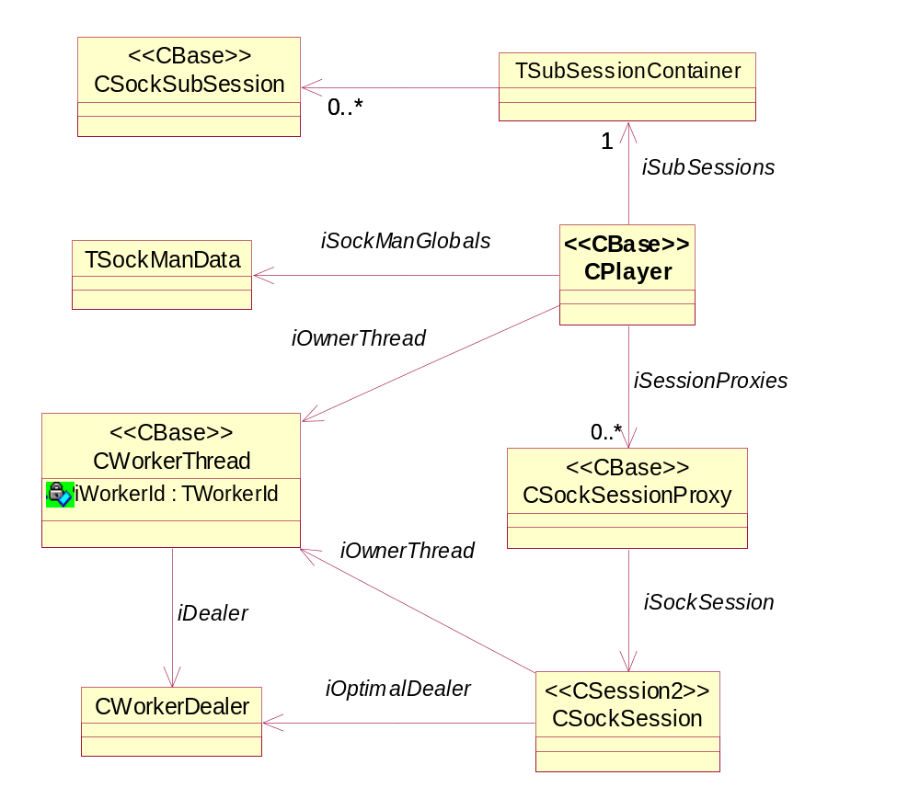
Figure 3-9 - The Player class hierarchy

Receiving an introduction message from the Main Dealer.
When a player receives the TWorkerMainIntroductionMsg it will read from disk only the .ESK files from the list given in the message, that match the masks stored in the Players iEskMaskList. This way, the only time the file-system is searched for the complete list of .ESK files is when ESock_Main starts and the .ESK files are only ever read from disk once as the CESockIniData instance created, with all the ESK information, are stored to be reused whenever necessary.
Having read all the .ESK files into a CESockIniData instance, ProtocolManager::ProcessIniDataL will be called, which will cause the creation of a CProtocolFamilyRef instance for each .PRT and a CProtocolRef instance for each protocol. Protocol dependencies will also be resolved at this time.
Finally a TWorkerMainIntroductionRespMsg is sent back to the Main Dealer with the list of protocols.

Processing Messages
The player is the entity that really deals with the IPC messages as most of them are forwarded to the Player from the Worker thread message handler. This handling is done in the ProcessMessageL function, which performs the role normally fulfilled by ServiceL in traditional single threaded servers.
ProcessMessageL will either be called directly from ServiceL in a Player co-resident with the Dealer or it will be called from CWorkerThread::PeerWorkerMessageReceivedL when a message is received from a non co-resident Dealer.
All request completion goes through CSockSubSession::CompleteMessage() which checks whether the sub-session has been orphaned (see 3.2.2.2), if not completes the message.

Providers
Upon creation of a provider the Player inserts it into the appropriate Dealer sub-session container and the Player is also responsible for deleting the provider when it is closed. However, when the Player receives the sub-session close request (e.g. EsoClose) the Dealer will already have removed it from the sub-session container in the session object before passing it on.
When destroying a provider it checks whether no providers remain and if shutdown has been commanded. If both of these conditions hold then it marks itself for shutdown and triggers the worker shutdown call-back.

The session proxy
The purpose of the session proxy is two-fold:
- To maintain the (backwards compatible) behaviour whereby an implicit connection is kept on the long timer even when the last sub-session leaves the session
- To support the (to be deprecated) "default connection" mechanism whereby an RSocket can be automatically associated with an RConnection on the same RSocketServ.
In the first case, the session proxy acts as a client towards the connection provider. In the second case, the proxy session is used to store a list of all connections associated with a session, which can be interrogated when an implicit socket is to be connected.

The CSockSessionProxy is created when a new sub-session is created. The Player will call CPlayer:: FindOrCreateSessionProxyL, which will determine whether there already is a proxy for the session instance (they are stored in the iSessionProxies double linked list) or create a new one to associate with the session if needed.
Whenever a new sub-session is created its protocol instance will also be added to the associated session proxy, which will keep the protocol handle open and close it when the session is closed and the proxy is deleted. At this point it will also notify all observers that the session is closing.
Deletion of the proxy happens when the Player receives a TPlayerMsg::ESessionClose message from the Dealer owning the session.

The Pit Boss
The PitBoss has responsibility for global resources and gross error handling (panics, etc). The Pit Boss thread must be started by the Configurator before any worker threads. The ESock instance loading it must be the only one having the WorkerId 0.
The PitBoss has two main responsibilities:
- Maintain global data structures, which are stored on the Worker 0 heap, accessible to all Workers to which the PitBoss pointer is published (through the TWorkerMainIntroductionMsg). Mostly the workers will access this data using PitBoss access functions which are thread-safe, taking special measures to guarantee this where needed.
- Manage Worker thread start and death: Registering Workers and installing protocols when they start and do a best effort cleanup if they die due to some error condition.

Apart from these, the PitBoss also provides some minor but important services. For example as all ESock instances can have their own heap sometimes it happens that one Worker needs to do something that might cause allocation or freeing on another workers heap, such as inserting a sub-session into a Dealer’s session. So the PitBoss offers a function that can determine whether a different heap is needed (maybe the two workers have different heaps, maybe they share one heap) and does the switch.
It also has AddSubSession(…) and RemoveSubSession(…) methods used by the Player, assuring this happens on the right heap for operations like socket transfers.
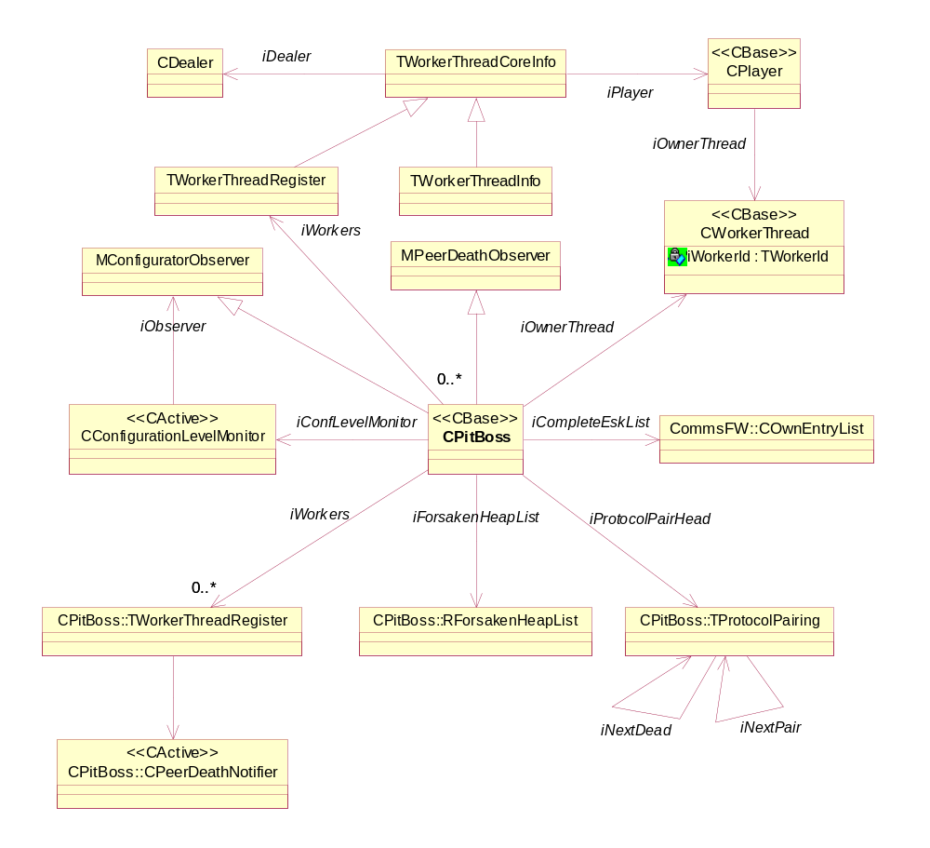
Figure 3-10 - The PitBoss class hierarchy

Owns
CWorkerThread* iOwnerThread;
The Worker thread instance in which the PitBoss lives.

TWorkerThreadRegister iWorkers[TWorkerThreadInfo::EMaxWorkerThreadId + 1];
This is the array of Workers that comprise the Socket Server, where Worker/entry 0 is ESock_Main with the PitBoss.
NB: Highest possible player id TWorkerThreadInfo::EMaxWorkerThreadId is an inclusive bound in this array.

CommsFW::COwnEntryList* iCompleteEskList;
Complete list of .ESK files found across all drives in the data caged directory. Kept here and sent to the Workers with the TWorkerMainIntroductionMsg to avoid having each Worker search the drives.

TInt iPendingIntroResponses;
Incremented when a TWorkerMainIntroductionMsg is sent to a worker and decremented when response is received. When this goes back to 0, it is an indication that initialisation have finished and data relating to initialisation only (e.g. .ESK data) can be deleted.

TProtocolPairing* iProtocolPairHead;
List of “protocol pairings” is a lookup list for Workers, mainly Dealers, who need to search for specific protocols by name or number and possibly look up the Player that supports the protocols.

TProtocolPairing* iDeadPairHead;
List of pairings no longer supported by any active Player.

TBool iShuttingDown;
ETrue if the PitBoss is in the process of shutting down. Set when optional or graceful shutdown is received by ESock_Main from the RootServer.

TBool iSessionShutdownComplete;
Set ETrue when immediate shutdown is received by ESock_Main from the RootServer or if optional/graceful shutdown has been received at some point and the last session is closed.

TBool iPeerShutdownComplete;
Set ETrue when all Worker threads have finished tidying up during a shut down procedure. The ESock_Main instance will only shut down when this is ETrue.

TBool iImmediateShutdownMark;
Set ETrue when immediate shutdown is received from the RootServer.

RWorkerLock iImmediateShutdownLock;
This is used by Worker threads (as well as ESock_Main) during immediate shutdown. As a Worker could potentially delete a sub-session at the same time as the Dealer trying to mark it orphaned, these two operations need to be protected during immediate shutdown (but not normally).

CConfigurationLevelMonitor* iConfLevelMonitor;
This is an object owned by the PitBoss, which will monitor the configuration level of the Comms Process. Once the level becomes >= RootServer::ECoreComponentsStarted, it means that that the Socket Server has become fully configured and no more bind request can be expected. At this point it will call the OnCoreComponentsConfigured() function (currently on the PitBoss), which will delete the complete list of .ESK files owned by the PitBoss, which is no longer interesting.
Note that if we should support loading new Socket Server modules at run time, sometime after system start, this will need to be changed so the list is always available to new modules.

Global protocol list - iProtocolPairHead

Overview
The global protocol list is a list of TProtocolPairing, which contains the following information:
- Address family.
- Socket type.
- Protocol number.
- Name of protocol.
- WorkerId.
- Pointer to next pairing.
- Pointer to next “dead” pairing (see below on “Deleting from the list”).
The list of protocols is available to read/search from any worker, though the PitBoss access functions, although writing/modification is only done from the ESock_Main thread.
The list is used by Dealers which will need to look up e.g. which worker supports a given protocol.

Populating the list
When receiving the TWorkerMainIntroductionRespMsg, ESock_Main will iterate through the list of protocols supported by the Worker that sent the message. Each protocol will result in a new instance of TProtocolPairing to be created and put into the global list of pairings owned by the PitBoss.
Apart from deletions this is the only time at which the list is modified / written to, making it safe to do so without potentially expensive and complicated locking, if implemented carefully. Only requirement is that the insertion is handled in such a way that another Worker iterating the list at the same time won’t walk over the edge. To ensure this it is a singly linked list which is not using e.g. the TSqlQue implementation as it is not guaranteed to be thread-safe.
The custom implementation providing the thread-safety uses the knowledge that writing a 32bit word is an atomic operation and the final insertion is just one such, performed by step 3 below:
- Create new TProtocolPairing.
- Point the new TProtocolPairing to the current first TProtocolPairing in the existing list
- Point the list head to the new pairing

Deleting from the list
When a Player thread shuts down the hosted protocols must be removed from the protocol list.
Without locking, deleting from the list can be more complicated as other workers might still be traversing it. This is accomplished by having a “shadow list” of dead protocol pairings. When removing a pairing it is simply moved into the list of “dead pairings” instead, in a similar atomic fashion to insertions. So Workers pre-empted in the process of traversing it aren’t disturbed by e.g. letting them step into suddenly de-allocated memory. Doing so earlier requires judgement when it is safe, whereas the main thread always is the last to shutdown.
The dead pairings are not actually deleted until the PitBoss is destructed as this seems a safe time to do so. If some sort of hot-swapping of protocols is implemented in the future, this could potentially turn into memory bloat, if somebody decided to play yo-yo with a protocol (or with a module if some ingenious fail-safe modules restart is deployed). In this case maybe some scheme for deleting the dead pairings earlier could be considered.
For now this is only ever done during a shutdown as ESock doesn’t support hot insertions/removals of protocol modules. For that, a few extra details need to be considered. E.g. how to detect the changes? By monitoring the file-system/.ESK files? Also CPitBoss::GetLocalProtocolIndex(…) needs to be rewritten as the way in which it finds the local Player protocol index from the global PitBoss index would break when protocol modules were hot-swapped.

Worker Thread surveillance
One of the responsibilities of the PitBoss is to keep a close eye on the Worker Threads and if they die, to do a best effort at cleaning up any resources allocated/used by those threads, the main focus being to avoid other threads, including clients, being hung or crashed.

Registering a Worker Thread.
This starts with registering the Worker and its resources when it starts, which is done as the ESock_Main thread receives a TWorkerMsg::EMainIntroductionResp from the Worker.
From here CPitBoss::ProcessWorkerIntroductionResponseL will be called for the PitBoss to handle the registration after the following algorithm:
- Check that the WorkerId is bigger than 0 (WorkerId of ESock_Main) and less than TWorkerThreadInfo::EMaxWorkerThreadId. Otherwise a critical configuration error has happened.
- Store the received TWorkerThreadRegister structure in array of workers. As usual we index directly into this array as each worker in uniquely numbered. Amongst others this structure contains a duplicated RServer2 handle if the Worker contains a Dealer. Pointers to the Player/Dealer and a pointer to an opened RHeap object.
- Create a new CPeerDeathNotifier which does an RThread::Logon() to the thread.
- If the Worker is a Player, add protocol pairings for each of the protocols it supports (see 3.2.2.3).
- Decrement the iPendingIntroductionResponse counter to indicate that a message was received.
In short, the PitBoss now have some level of control over the Worker, as it has hold of the RHeap, Dealer, Player and RServer2 “resources”. If the Worker Thread dies, its heap and server objects will not be closed until the PitBoss has done its part and does that last close on them.

Initial Worker death handling
When a Worker dies the CPeerDeathNotifier in ESock_Main will notice this and call CPitBoss::OnPeerDeath() which will do the following:
- Delete the now needless Death Notifier (consequently the Notifier must do nothing after the OnPeerDeath() call as its data is gone).
- Call CDealer::CleanupDeadWorker() on ESock_Main.
- For all other workers known to the PitBoss:
  - Set a flag in TWorkerThreadRegister:: iPendingPeerCleanups that the peer has a cleanup pending, relating to the dead Worker.
  - Send a TWorkerCleanupDeadPeerMsg to peer.
- Close/delete channel handler to dead Worker.
- If all peers have completed cleaning up (checked by seeing if TWorkerThreadRegister:: iPendingPeerCleanups, for the dead Worker is 0, do final phase of cleanup by the PitBoss by calling CPitBoss::CompleteWorkerThreadCleanup.
- If the dead worker was a Player, remove al protocol pairings for the dead Worker.

The RedShirt and Final phase of cleanup
The final phase of the cleanup is handled by the PitBoss in CPitBoss::CompleteWorkerThreadCleanup, which has the somewhat dangerous task of making sure that all sub-sessions belonging to the dead Player are gone. This is dangerous as the sub-sessions could live in a half deleted / half completed state (the Player could have died in the middle of closing a sub-session, in any other place for that matter or it could have done bad things to its own memory). So to prevent the Main thread used by the PitBoss from being PANICed or in other ways being terminated, a RedShirt thread is created which will traverse the list of sub-session of the dead player and call FinalCompleteAllBlockedMessages(KErrAbort) on each.
If the RedShirt thread fails without cleaning up all sub-sessions, this has been a best effort to handle things and nothing more can be expected.
The PitBoss will wait for rendezvous on the RedShirt and after it has ended will close its reference to the dead Workers heap and RServer2 and ECom.

SSA Changes
CPitBoss::OnCoreComponentsConfigured() sends a new TModuleConfigurationCompleteMsg to all workers to signal that the Configurator has finished start-up (and hence whether further ESOCK modules can be expected; note that the Configurator cannot signal this until the bind is complete and the PitBoss only signals this after introduction completes, ie the list of protocols has been determined).
A new public accessor is added:
TBool ModuleConfigurationComplete() const;
which is used to test whether the Configurator has completed start-up and hence whether the set of protocols is now determinate. The likely implementation for this is simply testing iConfLevelMonitor == NULL.

The sub-session container

Overview
For storing and keeping track of sub-sessions some sort of container is needed and it has a few interesting requirements:
- It must be able to generate unique handles for sub-sessions.
- It must provide fast access for certain types of operations as one of its main uses will be to get a sub-session pointer from a handle each time there is an incoming IPC request.
- It must guarantee thread-safety as sub-sessions can be accessed from different threads.
- It must be possible to add, remove and replace entries (the replacement requirement stems mainly from the Accept call which is easiest implemented if a sub-session entry can be replaced in the container).
- It must support iteration through its contents.
The object containers offered already, to manage storage/handles, didn’t seem to fit all of these requirements. They are complex to use, do not support replace and offer features, such as object names, unnecessary for ESock.
However, DBMS is using an alternative implementation, which have been assimilated for ESock (the ability to replace an entry have been added).

Implementation details
This container (CSubSessionIx) will maintain its own array of TEntry cells in memory as arrays provide for quick access in some situations. There will be two types of cells in the array; cells carrying pointers to sub-sessions and a virtual list of free cells (see Figure 3-11).
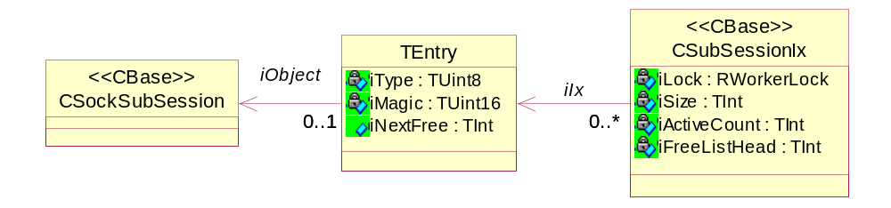
Figure 3-11 - The sub-session container

Each TEntry instance carries a union of iObject* and iNextFree. If iType is CSockSubSession::ENull, then it is a member of the free-list and iNextFree is the index of the next free TEntry instance otherwise it is an iObject* and points to a sub-session instance.
iType can be one of the following defined in CSockSubsession::TSubSessionType: ENull, ESocket, EHostResolver, EServiceResolver, ENetDatabase, EConnection, ESubConnection2.
This layout means that with a handle, the entry holding the sub-session can be looked up in the container directly and if needing to insert a new entry the first free cell is indicated by iFreeListHead.
This gives performance characteristics that are a good match for the needs of ESock (see Table 2, which is sorted by order of importance).

Operation | Worst case | Strategy
Get CSockSubSession* having a handle | O(1) | Extract table index from handle.
Insert new entry | Common case:  O(1)  If container is full:  O(1)+O(n)+Heap | Where n is EIndexGranularity  If free cell (the common case), insert immediately, otherwise re-allocate on heap and initialise new cells before inserting.
Get handle having a CSockSubSession* | O(n) | Where n is the number of entries in the array.  Search through array until pointer is located.
Table 2 - Sub-session container behaviour

The array will grow with EIndexGranularity each time it runs out of free entries. However, it maintains a high watermark and will never shrink.

The handles are defined by TSubSessionHandle, which in the current architectures is a 32 bit word (see Figure 3-12), constructed as needed. It is simple to deduce from the context so there is no need to store it.
Type
Magic
Index

8
16
31
Figure 3-12 - Sub-session handle

The three components comprising the handle are:
- Index - 16 bit value. The position in the array.
- Magic - 8 bit value. Ensures that handles are not re-used immediately. Each time an entry is re-cycled this value is incremented, rolling around when reaching max.
- Type - 8 bit value. One of the members of CSockSubsession::TSubSessionType, nominating the type of sub-session the handle represents (e.g. CSocket, CHostresolver, etc.)

The container also provides locking but as only some of the functions require locked access and for others it is optional (depending on the context) it is left to the user of the object to lock/unlock. However, the functions that require locking will assert that the caller have indeed locked before calling them.

Optimal Connect

Overview
In order to allow connections with a need for lower latency on e.g. socket operations, there has in Symbian OS v9 been introduced an extra Connect method: RSocketServ::Connect that takes a TSessionPref parameter.
No guarantees are provided to the client that using this function will provide for better performance or if it does what kind of better performance it provides. It is merely a way of hinting at what kind of traffic is desired to be optimised, if in any way possible.
The function creates a standard connection to “!SocketServer”, then uses the function ESSRequestOptimalDealer with the TSessionPref parameter to see if there is a more “optimal” server (Dealer) for the type of protocols specified and if so it will reconnect to that server. If no optimal server, the original connection to “!SocketServer” will be used (see Figure 2-1).
The approach for a “reconnect” is to first connect to the new server name, then close the original connection as the “reconnect” is only allowed while the original connection is alive.

Implementation details
When ESock_Main receives an ESSRequestOptimalDealer request it will ask the PitBoss for an “optimal” dealer for a connection with the preferred socket type/protocol given in the TSessionPref parameter. If not available, KErrNotFound will be returned.
If a better dealer was found, ESock_Main will call AddEligiblePidL directly on that dealer instance to add the ProcessId of the requesting client to the list of clients allowed to connect directly to that Dealer. ESock_Main will then return the name of the optimal Dealer to the calling client so it can connect directly to that server name. The session object on ESock_Main will remove the PID again from the Optimal Dealer in its destructor; this means that the new connection to the WorkerDealer has to take place before closing the original session on ESock_Main.
A client can only make one successful Optimal Dealer request on the same session, this mainly to prevent an attacking client from filling up the table of eligible clients in the targeted WorkerDealer. Since there are a limited number of simultaneous requests (due to the short-lived nature of the “transfer”) we can thus keep the list relatively small.
When a WorkerDealer receives a Connect it will check its list of eligible ProcessIds and return KErrPermissionDenied if no match is found.
The access functions to the list of eligible clients are protected by a locking mechanism (RWorkerLock - an RFastLock derivative) to allow for the possibility of direct simultaneous access from ESock_Main and the WorkerDealers.
The list and access to it is contained in the class XEligibleClients (see Figure 3-13). It is an X-class as it has an unusual pattern of being embedded in the containing C-class (CDealer) yet has a necessary ConstructL() and destructor (as it has to create and close the lock).
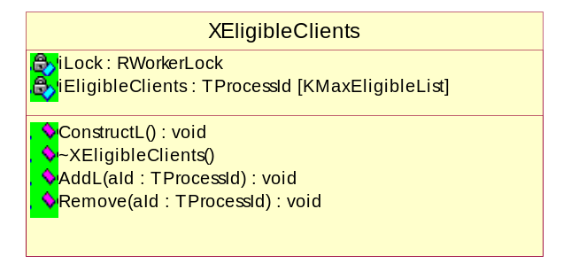
Figure 3-13 - XEligibleClients

Client code examples
- Specify the family and protocol that should have the best possible “operating conditions”.
const TSessionPref pref = {KDummyAddrFamily, KDummyThree};
- Connect to the Socket Server using these preferences.
RSocketServ server;
TInt result = server.Connect(pref);

Socket Transfer

Overview
RSocket::Transfer(...) method allows the transfer of a socket from one ESock session to another by using this socket’s unique global name, obtained by RSocket::Name(). This operation is policed because ESock sessions can belong to different processes.
To achieve this, the “donor” process (the process that owns the socket being transferred) must give permission to transfer the socket to another ESock session, specifying capabilities for the process that receives or “pulls” the socket. If the process that tries to transfer socket into its context does not have the appropriate capabilities, the operation fails with KErrPermissionDenied.
On a successful transfer the socket “marking” is removed.
Such a mechanism of transferring sockets between ESock sessions compensates for the fact that capability checking on its own does not work in this situation. For example, a TCP/IP local loop-back socket requires no capability to be used by any process, yet may still be conveying sensitive information and can be hijacked.

Implementation details
To enable socket transfer to the process with the given capabilities, the “donor” process “marks” this socket as ready for transfer and supplies the capabilities set that the “recipient” or “pulling” process must have. If the socket is not enabled to be transferred, RSocket::Transfer(...) will fail with KErrPermissionDenied.
Enabling socket transfer is done by using RSocket::SetOpt() with option level KSOLSocket an option name KSOEnableTransfer and an option data object represented by TSecurityPolicy class. The owning Player will read the socket option TPckgBuf<TSecurityPolicy> and store it in CSocket::iTransferSecPolicy, also it will set CSocket::iSecTransferEnabled=ETrue.
Setting the option KSODisableTransfer will “unmark” the socket and disable its transfer.

Naming a socket
Before making a socket transfer a client will request the name of the socket. For this purpose a name of the form “<WorkerId> <SocketAddress>” is generated. For example, if a socket for worker 1 had a socket on address 0x0b7e016c, RSocket::Name would cause the name “1 0b7e016c” to be returned to the client.
It is assumed that the name makes little sense to the client. From the client point of view it is merely a string that can be used for identification purposes – or for socket transfer. For the socket server it is a useful “cookie” that can be used for identifying the socket when a handle is not available as well as for logging purposes.
There are no guarantees provided to the client that the name will remain the same after a transfer as it is composed of WorkerId and it could end up in a different worker thread.

Performing the transfer
When receiving an ESoTransfer request, the Dealer will extract/decode the WorkerId and sub-session pointer from the name using the static function CSocket::CrackSocketName(…) which also validates the socket address by searching for it in the list of sub-sessions belonging to the Player for the WorkerId specified in the socket name.
Having validated the WorkerId and CSocket pointer encoded in the socket name, the Dealer will forward the ESoTransfer IPC Message to the Player owning the Socket.
When the Player owning the socket subsequently receives the ESoTransfer request (initiated by the client owning the receiving session) it will first extract the pointer to the socket from the memory address encoded in the socket name. This might sound perilous, but the pointer have already been tested and verified by the Dealer when identifying to which Player to forward the request, so it is perfectly safe.
With the socket in hand the Player will call ProtocolManager::TransferSocket which will check that:
- The socket has iSecTransferEnabled=ETrue.
- The capabilities of the receiving client match those stored for the sockets iTransferSecPolicy by the donor client.
If these checks pass the protocol to which the socket is associated, will be added to (and opened by) the session proxy in that Player.
All pending requests on the socket are cancelled.
The socket is added to the receiving session (locked) and subsequently is removed from the source session index (locked). This is done using the heap-safe functions in the PitBoss as the two sessions easily could be on different heaps.

Client code examples
- Specify the capabilities set for the process that is going to “pull” the socket.
_LIT_SECURITY_POLICY_C2(KProcPolicy, ECapabilityNetworkServices, ECapabilityNetworkControl);
- As an alternative, it is also possible to use recipient process’s SID to define Security Policy:
_LIT_SECURE_ID(KPullingProcessSId, 0x1234567);
_LIT_SECURITY_POLICY_S0(KProcPolicy, KPullingProcessSId);
- Set the option KSOEnableTransfer to enable socket transfer to the process with specified capabilities, without this transfer will fail.
nRes = sock1.SetOpt(KSOEnableTransfer, KSOLSocket, KProcPolicy().Package());
- Disable socket transfer if we changed our mind about transferring the socket. If the transfer has already happened this does nothing, but it is up to the donor and recipient to avoid this situation.
sock1.SetOpt(KSODisableTransfer, KSOLSocket);

Un-Binding workers

Overview
This refers to the case where a worker receives a CommsFW::TCFUnbindMsg from the RootServer, instructing it to un-bind from another Worker CPM.
This could happen if e.g. the other CPM suddenly dies, some client application with sufficient privileges has requested the RootServer to unbind the two modules or as is most often the case: Test code wants to shutdown ESock causing the RootServer to send unbind messages to all ESock instances.
It is not possible to unbind as long as there are dependencies between the two workers, i.e. related sessions and sub-sessions unless it is during shutdown or one of the workers die.

Implementation details
When a worker receives the unbind message, it will end up in CWorkerThread::CFUnbindMessageReceived(…) this function will immediately send back a TCFUnbindCompleteMsg if the sub-modules were unknown or there was no handler installed for the particular worker. Otherwise it will call CWorkerThread::MaybeCompleteUnbinding(…) which will send back an affirmative TCFUnbindCompleteMsg if:
The local Dealer doesn’t have any outstanding sub-sessions terminating in the peer and it doesn’t have any sessions with outstanding closes against the peer (see 3.2.2.1 "”). This is all checked by TBool Dealer::CanUnbindFromWorker(…).
- The local Player doesn’t have any sub-sessions belonging to a session in the peer. This is all checked by TBool Player::CanUnbindFromWorker(…).

If it wasn’t able to send a response immediately it depends on trying again later from another context. Therefore it (MaybeCompleteUnbinding(…)) is also called if a TWorkerMsg::ECleanupDeadPeer is received (usually sent by the PitBoss to other workers if a worker dies) and from another related function: MaybeCompleteUnbindings().
MaybeCompleteUnbindings() will go through the list of peer workers know to the module and try completing unbinding on each one. It is called when a Player or a Dealer has finished shutting down.
As can be deduced from this, if the unbind doesn’t succeed immediately it will only be completed when the local Dealer or Player shuts down. So effectively unbinding only works during a complete ESock shutdown or if the peer thread dies.
The reason for it still working during shutdown if there is inter-dependent sessions/sub-sessions across the two CPMs, is that requesting the RootServer to unload with the EImmediate flag will cause it to send out unbind messages immediately followed by shutdown messages and so the modules will shutdown no matter what.
For ESock to unbind effectively during runtime MaybeCompleteUnbindings() or maybe more effectively MaybeCompleteUnbinding(…) (which doesn’t traverse everything) have to be called more often, e.g. when sessions are closed. It could also be argued that the Worker should return an unbind error to the RootServer immediately if unable to complete, instead of just “hanging”.
If planning to later bind the same CPM again, the protocol list handling must be improved as described in 3.2.4.1.
However, right now there is no requirement or convincing use-case to make the unbind support more flexible. On end-user equipment it is never know when clients will have sessions or how long they will last and it is impossible to unbind if it breaks sessions.

RSocket::Accept
Accept is a case that requires special consideration in a multithreaded world, due to the need to replace one socket with another, possibly on a different Player or even heap, without invalidating the clients handle.

Creating the null socket
First step is for the client to create a blank (or “null”) socket. It will do an RSocket::Open() without specifying any protocol or in any way indicating to ESock which type of socket it might end up being, but even if a null socket it must belong to a Player. So, when the Dealer receives the ESoCreateNull IPC request it will identify a Player in the following way:
- If the Dealer has a co-resident Player (because it is a DealerPlayer / optimal Dealer), forward the request to that one.
- If no co-resident Player, use CPitBoss::GetWorkerForNullSocket() to identify a Player to forward to. Currently the PitBoss will always return the IP Player for this purpose as it is considered the most likely one to be the final owner after the Accept.
The Player will create a null socket, on its own heap, and place it in the session container as well as its own sub-session container.

Performing the Accept
Early contemplated solutions, when the containers didn’t support replace, included having the null socket becoming a “proxy” socket that would point to the accepting one, potentially on a different Player/heap. It would have become very complicated to manage and maintain. This solution with the sub-session container allowing replacement of entries makes the Accept handling very simple.

When a Player receives the ESoAccept call from a client it will
- Receive the pointer to the null socket by looking it up in the sub-session container by its handle.
- Create a new “accepting” socket.
- Lock the session sub-session container.
- Remove the new accepting socket from the sub-session container (NewSocketL will have added it).
- Replace the null socket with the accepting socket in the sub-session container.
- Switch heap to that of the Player owning the null socket (using CPitBoss::MaybeSwitchHeap(…)).
- Close the null socket (this will remove it from the owning Players sub-session container and delete it).
- Switch back to own heap if necessary.

Shutdown

Overview
ESock has no single place to request shutdown for all its modules. If an application wishes to shutdown ESock, it will have to enumerate the list of ESock CPM’s currently active and request the Root Server to shut each of them down.

Shutdown type | ESock support
CommsFW::TCFShutdownType::EGraceful | Supported.  ESock will shut down immediately if there are no sessions open or as soon as the last session has closed.
CommsFW::TCFShutdownType::EUngraceful | Supported.  This is done entirely by the Root Server (i.e. killing the CPM in question). ESock just have to be able to deal with one or more of its instances dying.
CommsFW::TCFShutdownType::EOptional | Not supported.  A typical way of supporting EOptional would be to check if there are any sessions open or agents loaded and shutdown if not, otherwise forget about it. But checking for these things and agreeing on things across several different ESock threads seems far too difficult to be worth the effort as there is no demand or use-case for it at this time.
CommsFW::TCFShutdownType::EImmediate | Supported.  Abandon all data structures, sessions, etc. and shut down the thread immediately. This means potential for resource leaks, PANICed clients, etc. So this type of shutdown is last resort and may be chosen, e.g. when wanting to avoid a test-harness hanging whilst waiting for ESock to shutdown.
Table 3 - Supported shutdown options

As seen in table Table 3, EGraceful and EImmediate shutdown are supported by ESock. These two options are useful for testing purposes. E.g. first ask ESock to shutdown gracefully and if it hasn’t after sat, a minute, due to active/ hanging sessions ask it to shut down immediately, ignoring the hanging sessions. Then report error in test harness if shutdown had to be forced this way.
This way it is evident whether the code precipitating the shutdown has leaked any sessions as e.g. the final test step unloading ESock would show that clearly (did it manage to do it with EGraceful or did it have to use EImmediate).

Implementation details
When a shutdown message is sent from the Root Server, it will eventually be notified to the Worker Thread by the channel handler calling CWorkerThread::CFShutdownMessageReceived(…).
If the type is EImmediate it will set the immediate shutdown flag in the PitBoss (CPitBoss::SetImmediateShutdownPresent()). This is an indication to anyone interested that they mustn’t access data structures owned by other ESock instances/threads as that would just mess things up further as everything is going down immediately and thus quickly becoming invalid as heaps are closed, etc.
Now the Worker Thread will set its own flag for shutting down (iWorkerShuttingDown) as well as setting the iShutdownGracefully flag in SockManGlobals and then notify its three “interested parties” in shutting down:
- Dealer()->ProcessShutdownRequest(type);
If the shutdown type is EImmediate or there are no sessions on this dealer this function will signal to the owning Worker Thread that shutdown is complete for the dealer (setting the CWorkerThread::iDealerShutdownComplete flag).
Also if it is the Main dealer it will either start the PitBoss shutdown procedure (CPitBoss::StartShutdown()) or signal that it is ready for shutdown now (if immediate or has no sessions left, calling CPitBoss::SessionShutdownComplete()).
- Player()->ProcessShutdownRequest(type);
This function is very simple. It will signal to the owning Worker Thread that shutdown is complete for the dealer (setting the CWorkerThread::iPlayerShutdownComplete flag) only if type is EImmediate.
Similar to the worker thread the player has a MaybeSetPlayerShutdownComplete() function, signalling that shutdown is complete if there are no more sub-sessions or protocol families loaded.
- iTransportUsers.Shutdown(EFalse);
This function calls Shutdown on all the TTransportUser entries in the array, notifies ECom that the implementations have been destroyed and closes the array.

Finally it will call CWorkerThread::MaybeTriggerThreadShutdownCallback(). This function is called not only here but also when a session is closed/deleted, in the CProtocolFamilyBase() destructor, when deleting a CSockSubSession, and when an ECleanupDeadPeer message is received. The reason for this is that, as described below, this function might defer the shutdown to later and it must be called again later at appropriate places to see if the shutdown can finally be performed.
The function will perform the final and “executive” stage of shutdown if all the requirements are fulfilled. They are as follows:

If immediate shutdown:
Do TriggerThreadShutdownCallback().
If not immediate shutdown:
If Dealer and Player have finished the shutdown and all channel handlers deleted
Do TriggerThreadShutdownCallback()

CWorkerThread::TriggerThreadShutdownCallback() simply activates the CShutdownWatchDog active object. When running this active object will stop the active scheduler and the thread ends.
There is a special case, in that if the thread is ESock_Main it will only shutdown (call TriggerThreadShutdownCallback()) when all other Worker Threads have shutdown, even if it is an immediate shutdown. This is because all Worker Threads use the PitBoss for various purposes, so the thread owning the PitBoss will remain until the last is gone before going down itself.
The PitBoss is notified every time a worker thread ends, so it will check each time it happens whether the shutdown flag is present, all workers have gone and it should shutdown itself.

Summary:
- Shutdown message received
- Start Dealer Shutdown. May finish now or later. When done sets flag in worker thread.
- Start Player Shutdown. May finish now or later. When done sets flag in worker thread.
- Shutdown and delete transport users.
- Maybe shutdown now. May do nothing if 1 and 2 didn’t set completion flags.

- Maybe shutdown now. Run/test on different events, finally Dealer and Player have set their shutdown flags and if ESock_Main also that all workers are gone.
- Trigger shutdown now.

Multi-homing Server API Classes
See Appendices especially A.2 for the reference to a design document of the recent control side changes.

IPCPR + Selector

Comms Factories
CHostResolver
RHostResolver
CSubConnection
RSubConnection
ShimClient
ShimSCPR
ShimCPR + Selector
CConnection
Colour Legend:
New - Temporary

New

Modified
omponentsaneselection is done ent of bearer details.
mented by the licensee depending on licensee specific requirementselection is done ent of bearer details.
mented by the licensee depending on licensee specific requirement
Existing
Network layer
Shim/Link layer
NIFMAN
AGT
NETCON
NIF
NIFMAN – current bottom of the connection stack
RSocket
RConnection
ESOCK Client

ESOCK – top of the connection stack
CSocket
CControlledServProvider

IPSCPR
TCPIP.PRT
QoS
Framework

GuQos Plugin

Figure 3-14 High Level ESock related networking block diagram

The following table is a summary of the main objects described above.
Object name | Description | Associated (owned/dependant) objects
CConnection | ESock server side class corresponding to RConnection | Points to a CConnectionProviderBase
CSubConnection | ESock server side class corresponding to RSubConnection representing a sub-connection found within a CConnection | Points to a CConnection and CSubConnectionProviderBase
IPSCPR | CSubConnectionProviderBase based IP network layer sub-connection provider. | Points to a “lower” CSubConnectionProviderBase layer
CSocket | ESock server side class corresponding to RSocket | Points to a CControlledServerProvider
CHostResolver | ESock server side class corresponding an RHostResolver | Points to a CSubConnectionProviderBase
CControlledServProvider | Creates a link between MSocketControlledNotify(SAP) and CSubConnectionProviderBase(SCPR) | Points to a MSocketControlledNotify and CSubConnectionProviderBase
IPCPR | CConnectionProviderBase based IP network layer connection provider. At the moment responsible for the idle timers only | Points to a “lower” CConnectionProviderBase layer
ShimCPR | CConnectionProviderBase based IP link layer connection provider. Effectively making NIFMAN look like a connection provider | Owns CNifSecureSession & ShimSCPR generated instances
ShimSCPR | CSubConnectionProviderBase based IP link layer sub-connection provider shielding NIFMAN sub-connection related functionality. | Points to a ShimCPR and provides sub-connection data monitoring & notifications
ShimClient | The former CSubConnection replacement | Points to ShimSCPR and is associated with CConnection.
MConnectionNotify | Base class of CConnectionSelectorShim used to observe messages from NIFMAN
CNifSession | NIFMAN class owned by CConnectionSelectorShim, handed over to CConnectionProviderShim and CConnectionProviderFactoryShim. | Points to a CNifAgentRef and an MConnectionNotify
MNifSessionNotify | Base class of CNifSession used to observe messages from CNifAgentRef
MAgentSessionNotify | Base class of CNifSession used to observe messages from CAgentBase
CNifAgentRef | NIFMAN class representing an interface | Owns a list of MAgentSessionNotify (CNifSession) objects
CConnectionProvdBase | Base class defining messages from ESock to NIFMAN. Implemented by CNifSession.

ESock Server Classes

CConnection
The CConnection class derives from CSockSubSession and is used to implement the RConnection API calls. There is a one-to-one relationship between an RConnection instance and a CConnection instance. CConnection interacts with the underlying CConnectionProviderBase class to implement much of the RConnection functionality. CConnection objects mirror the lifetime of the corresponding RConnection object. They come into being on an RConnection::Open() and are destroyed on an RConnection::Close().

CConnection Method Description
The following is a description of the more important CConnection methods:
inline TBool IsConnectionActive() const;
This method returns ETrue if the CConnection instance is associated with an underlying provider (CConnectionProviderBase instance) that is active (ie: has passed the SelectComplete() call).
inline TBool IsMonitorMode() const;
Returns ETrue if the associated RConnection has attached to an interface in monitor mode via RConnection::Attach(…, EAttachTypeMonitor);
TBool ServiceL(const RMessage& aMessage);
Method called from CSockSession::ServiceL() in order to process all RConnection requests. This routine is essentially a large switch statement dispatching out to helper routines dealing with various RConnection requests.
The return value indicates whether the request should be completed straight away (ETrue) or whether it will be completed later (EFalse).
void SelectComplete(CConnectionProviderBase* aConnProvider, TInt aError)
Called when CConnectionProviderBase instance selection has completed. If aError == KErrNone the aConnProvider contains the selected instance. In case aError != KErrNone the outstanding start/attach request is completed.
void JoinInterface(CSocket& aSocket)
Associates a CSocket object passed with the same provider as this CConnection. Used to implement the new RSocket::Open(…, RConnection&) API method.
void JoinInterface(CHostResolver& aHostResolver)
Associates a CHostResolver object passed with the same provider as this CConnection. Used to implement the new RHostResolver::Open(…, RConnection&) API method.

TBool StartL(const RMessage& aMessage)
Implements RConnection::Start() to select and start a provider with or without overrides. It asks the factory associated with the CConnection address family Id to select one if this CConnection instance is not already associated with one. A copy of the original RMessage is also stored in order to be able to complete the message later when the interface has come up (see CConnection::LayerUp() / CConnection::SelectComplete()).
TBool StopL(const RMessage& aMessage)
Implements RConenction:Stop(TConnStopType aStopType) to stop an identified connection. The request is passed to the CConnectionProviderBase which performs the actual task. Once the connection has been stopped if there is an outstanding CConnection::StartL() then it is completed with KErrCancel.

TBool StartWithPrefsL(RMessage& aMessage)
Implements RConnection::Start(TConnPref&) to start an interface with overrides specified. This operates in a very similar manner to the Start() method without overrides.
TBool ProgressL(const RMessage& aMessage)
Implements RConnection::Progress() to retrieve the current progress of the interface. This simply calls the corresponding method in CConnectionProviderBase in order to process the request. The resulting progress is then written back to the client buffer.

TBool LastProgressErrorL(const RMessage& aMessage)
Implements RConnection::LastProgressError() to retrieve the last progress which had an error. This operates in the same manner as the ProgressL() method.
TBool RequestProgressNotificationL(const RMessage& aMessage)
Implements RConnection::ProgressNotification() to receive progress notifications for the interface. There are two types of progress notification; Selected and Normal. Selected progress completes the client request whenever a specified stage is reached or an error occurs. Normal progress completes on every stage. The routine first determines what type of progress that has been requested by the client. It then determines whether there are any queued progress notifications pending. If there are, the routine attempts to complete the client request immediately from the queued progresses.
If a Normal progress has been requested, the first progress is de-queued and written to the client buffer. The routine then returns ETrue to cause the request to complete immediately. If a Selected progress has been requested, progress entries are de-queued one-by-one until one is found which matches the stage number specified by the user. The matching progress is written to the client buffer and the routine returns ETrue to complete the request.
If there were no entries in the queue, or the queue was exhausted whilst looking for a suitably matching Selected progress, then the client request remains pending until a new progress notification is received (see CConnection::ProgressNotification()).
TBool CancelProgressNotification(const RMessage& /*aMessage*/)
Implements RConnection::CancelProgressNotification() to cancel a request for progress notification. This simply cancels any pending client request for progress.

TBool EnumerateSubConnectionsL(const RMessage& aMessage)
Implements RConnection::EnumerateSubConnections(TUint&) to establish the number of currently active sub-connections. CConnection passes this request down to the CConnectionProviderBase instance.
TBool GetConnectionInfoL(const RMessage& aMessage)
Implements RConnection::GetConnectionInfo() to retrieve the identity (ie: IAP ID and Network ID) about a particular interface. Note that a prior call to EnumerateConnectionsL() has already created a buffer in iConnectionInfoBuf which contains the connection information for all interfaces. This routine extracts the information for the particular interface specified by the client (by index number). This buffering effect is used present a consistent snapshot of the interface situation to the client.

TBool RequestServiceChangeNotificationL(const RMessage& aMessage)
Implements RConnection::ServiceChangeNotification(). A copy of the original RMessage is stored away for later completion, and the request passed to the corresponding CConnectionProviderBase instance.
TBool CancelServiceChangeNotification(const RMessage& /*aMessage*/)
Implements RConnection::CancelServiceChangeNotification(). The original RMessage is completed with KErrCancel.
TBool GetIntSettingL(const RMessage& aMessage)
TBool GetBoolSettingL(const RMessage& aMessage)
TBool GetDes8SettingL(const RMessage& aMessage)
TBool GetDes16SettingL(const RMessage& aMessage)
TBool GetLongDesSettingL(const RMessage& aMessage)
These routines implement the RConnection API methods of the similar names for reading CommDb settings. They all operate in the same manner by retrieving the field name to read from the client, calling CConnectionProviderBase to get CConnectionSettings derived class to do the work of reading the database entry, and filling in the client buffer with the resulting value. Note that this operation is synchronous and completes the original client request by returning ETrue from the routine.
void ProgressNotification(TInt aStage, TInt aError, const TDesC8& aInfo)
This routine is called from the underlying CConnectionProviderBase instance whenever a progress notification occurs on the interface. This routine is called for all CConnection instances associated with the interface (ie: for all RConnection instances).
The first part of the routine is involved with completing any outstanding Start() or Attach() operation pending. Any progress notifications with an error cause Start() and Attach() operations to complete with the error.
The second part of the routine deals with handling any RConnection::ProgressNotification() requests from the client. If there are no such requests pending on the client, the notification is placed onto a queue associated with the CConnection instance. The queue is currently 4 deep and will overwrite older entries.
If there is a request pending on the client to receive all progress notifications (ie: not selected progress), and there are no prior queued entries, then the pending client request is completed immediately with the new progress. The progress is written to the client buffer and the RMessage completed. If there are queued requests present, however, the new progress is placed onto the end of the queue – the next ProgressNotification() request from the client will complete immediately with the first entry in the queue.
A pending selected progress request from the client is handled slightly differently. If the new progress matches the selection criteria (ie: matches the progress stage specified by the client without error, or there is an error on any stage), then the progress is written to the client buffer and the request is completed. However, if the new progress does not match the client selection criteria, it is discarded. This matches the behaviour of the RequestProgressNotificationL() method (called on the original RConnection::ProgressNotification() request).
TBool ControlL(const RMessage& aMessage)
This routine implements calls to RConnection::Control(). Control() calls with a level of KCOLConnection are intended to be handled within ESock. All other levels are passed over to CConnectionProviderBase instance for processing. The first part of the routine deals with the KCOLConnection level and dispatches out to an appropriate routine to handle the particular option requested.
The remainder of the routine assumes that the request is destined for CConnectionProviderBase instance. The original client Control() request includes a pointer to an option buffer which can be used to send parameters, receive results or a combination of both, depending upon the particular option. Two bits in the option number itself encode which of these operations is required for the option. If the KConnReadUserDataBit is set, it indicates that the option buffer contains parameters associated with the option. These are read from the client option buffer and copied into a local server buffer to be transmitted to CConnectionProviderBase as part of the request. If the KConnWriteUserDataBit is set in the option number, it indicates that result data is expected back from the call. In this case, the contents of the local server buffer are copied back to the client option buffer after the call to CConnectionProviderBase.

TBool AttachL(const RMessage& aMessage)
This call implements the RConnection::Attach() request. The routine first deals with error conditions. Attempting to perform an Attach() when there is a Start() already outstanding results in a KErrInUse error. The same error occurs if the RConnection is already associated with an interface.
In the main part of the routine, the connection information of the interface to attach to (ie: IAP Id and Network Id) is first read from the client arguments. CConnection asks its factory (the one matching address family Id) to find or create a matching CConnectionProviderBase. CConnectionProviderBase::ConnectionControlActivityL with the apropriate attach type is then called and the call completes synchronously.

TBool AllSubConnectionNotificationL(RMessage&)
If there is already an allsubconnection notification request outstanding then KErrInUse is returned.
Assuming there is not already a request outstanding CConnection::AllSubConnectionNotificationL then checks for notifications in iSubConnectionEventQueue. If there are any values available then the oldest notification held is returned. If there are presently no notifications held in the notification queue then the request is stored pending an incoming notification.
TBool CancelAllSubConnectionNotification(RMessage&)
CConnection::CancelAllSubConnectionNotification checks that there is a request outstanding and if so completes it with KErrCancel.

TBool SubConnectionEvent()
Upcall from CConnectionProviderBaseinforming us of a subconnection event. If there is an outstanding notification request then complete it otherwise buffer the event.

MShimControlClient
This is an interface seen by ESOCK and implemented by the ShimClient object inside of the ShimSCPR plug-in(see Figure 3-14) that serves the calls of former CSubConnection. All RConnection sub-connection related calls are being dispatched by a static function CSubConnection::ServiceL (see 3.2.12.3). The implementation of the interface ultimately uses CNifSecureSession instance to process requests.See [R11] for details.
TBool StopL (const RMessage& aMessage)
Implements RConnection::Stop(TSubConnectionUniqueId aSubConnectionUniqueId) to stop a specific sub-connection.
TBool RequestSubConnectionProgressNotificationL (const RMessage& aMessage)
Implements RConnection::ProgressNotification(TSubConnectionUniqueId, TNifProgressBuf&, TRequestStatus&, TUint) to retrieve the latest progress specific to the identified sub-connection. The sub-connection is identified using the TSubConnectionUniqueId.
TBool CancelSubConnectionProgressNotification(const RMessage& aMessage)
Implements RConnection::CancelProgressNotification(TSubConnectionUniqueId) to cancel a sub-connection notification request placed by RequestSubConnectionProgressNotificationL.

TBool GetSubConnectionInfoL(const RMessage& aMessage)
Implements RConnection::GetSubConnectionInfo(TUint, TDes8&) to retrieve sub-connection information for a sub-connection specified either by an index value or the unique sub-connection identifier within the TDes8.

Tint GetCurrentProgress(TNifProgress& aProgress)
Retrieves the last progress received by the sub-connection provider.

TBool DataTransferredL(const RMessage& aMessage)
Implements RConnection::DataTransferredRequest(TSubConnectionUniqueId, TPckg<TUint>&, TPckg<TUint>&, TRequestStatus&) to find out how much data has been sent and received. The value in the TSubConnectionUniqueId indicates whether the request is for a specified sub-connection or for the entire connection.
TBool DataTransferredCancel(const RMessage2& aMessage)
Cancels pending data transferred request.
TBool DataSentNotificationRequestL(RMessage&)
Request notification when the specified (absolute or relative) volume of data has been sent.
TBool DataSentNotificationCancel(RMessage&)
Cancels the data sent notification request.
TBool GetDataReceivedNotificationRequestL(RMessage&)
Request notification when the specified (absolute or relative) volume of data has been received.
TBool DataReceivedNotificationCancel(RMessage&)
Cancels the data received notification request.
TBool IsSubConnectionActiveRequest(const RMessage2& aMessage)
Indicate whether the subconnection is active or not. Uses internal timer to check the activity after the user requested timeout.
TBool IsSubConnectionActiveCancel(const RMessage&)
Cancels the ongoing sub-connection active request.
void CheckSubConnectionActivity()
Checks for activity on the subconnection since the last call to IsSubConnectionActiveRequest(). If the data transferred volumes haven't change but the client thinks the connection is active then either update the volume counts and trigger the timer (in the case that more data has been transferred) or (if data has not been transferred) simply complete the request.
If the client thinks the sub-connection is not active then either complete the outstanding request (if data has been transferred) or (if data has not been transferred) update the counts and trigger the timer.

CSubConnection
The CSubConnection class derives from CSockSubSession and is used to implement the RSubConnection API calls. There is a one-to-one relationship between an RSubConnection instance and a CSubConnection instance. CSubConnection interacts with the underlying CSubConnectionProviderBase class to implement all of the RSubConnection functionality. CSubConnection objects mirror the lifetime of the corresponding RSubConnection object. They come into being on an RSubConnection::Open() and are destroyed on an RSubConnection::Close().

CSubConnection Method Description
The following is a description of the more important CConnection methods. Firstly, let’s look at the methods invoked by the client (via the RSubConnection API). All these methods return true if the request can be complete immediately and false if the request should be completed at a later point (used for asynchronous calls):
static TBool ServiceL(MShimControlClient& aShimControlClient, const RMessage2& aMessage)
Dispatches RConnection sub-connection related calls (see 3.2.12.2). The aShimControlClient instance is looked up by CPlayer based on unique sub-connection identifier and CConnection reference with a help of CConnectionProviderFactoryShim.
TBool RequestEventNotificationL(const RMessage2& aMessage);
The client is requesting to be notified about events coming from the underlying sub-connection provider. Th aMessage can contain filtering information such as the set of events it wishes to be notified about. A common set may be the generic set of events provided to all sub-connections.
TBool CancelEventNotification(const RMessage2& aMessage);
The client is requesting to be cancel its request to be notified about events. This method will always return ETrue as it is not possible to fail a cancel request. The notification message will now be completed with KErrCancel.
TBool AddSocketL(const RMessage2& aMessage);
The client is requesting to add a socket to the sub-connection. The RMessage2 contains the sub-session handle of the socket to be added. The method can return ETrue, indicating to complete the message straight away, in error conditions e.g. when the underlying provider does not allow it because it is out of memory. The addition of a socket to a sub-connection is usually asynchronous and therefore this method will usually return EFalse.
TBool RemoveSocketL(const RMessage2& aMessage);
The client is requesting to remove a socket from the sub-connection. The RMessage2 contains the sub-session handle of the socket to be removed. The method can return ETrue, indicating to complete the message straight away, in error conditions e.g. when the socket sub-session handle cannot be found. The removal of a socket from a sub-connection is usually asynchronous and therefore this method will usually return EFalse.
TBool SetParametersL(const RMessage2& aMessage);
The client is requesting to set the parameters of this sub-connection. The RMessage2 will contain the requested and acceptable parameters. This request is performed synchronously as it only sets the parameters locally. The actual granting of the parameters by the Network will happen later and is indicated to the client via a separate event using the event notification mechanism mentioned earlier.
TBool GetParametersL(const RMessage2& aMessage);
The client is requesting to fetch the parameters of this sub-connection. The RMessage2 will contain the buffer it has reserved, in its client space, for the requested parameters. This fail if the parameters have not been set (KErrNotReady), otherwise it will contain the requested and acceptable parameters as well as the granted parameters if the Network has already granted them. This request is performed synchronously as it only fetches the locally stored parameters.
TBool GetParametersLengthL(const RMessage2& aMessage);
The client is requesting to fetch the length of the buffer required to store the current parameters of this sub-connection. The RMessage2 will be complete with an error, if the parameters have not been set (KErrNotReady), or the length of the buffer required. This request is normally performed synchronously as it only fetches the length of the locally stored parameters.
TBool ControlL(const RMessage2& aMessage);
The client is sending a specific control message to the underlying provider. This method allows the API to be extended for proprietary sub-connection providers.
TBool ServiceL(const RMessage& aMessage);
Method called from CSockSession::ServiceL() in order to process all RSubConnection requests. This routine is essentially a large switch statement dispatching out to helper routines dealing with various RSubConnection requests.
The return value indicates whether the request should be completed straight away (ETrue) or whether it will be completed later (EFalse).

CInterface,CSubInterface, MConnectionNotify and MSocketNotify
The CInterface and CSubInterface classes have been removed and replaced by CConnectionProviderBase & CSubConnectionProviderBase. MConnectionNotify has become deprecated and replaced by MConnectionClient derivatives. MSocketNotify has become deprecated as well being replaced by MSocketControlledNotify.See A.2 for a detailed reference to the control side ESock changes.

TSockManData
…
CSocket
sub-sessions associated with an interface
…
CHostResolver
CInterface
global interface list
…
CConnection
CInterface

…

8 (with a few exceptions).

Figure

CServProviderBase
There have been no additions to this class, but a new SetOption() operation KSoConnectionInfo has been created to allow ESock to indicate to TCP/IP the interface over which a particular CSocket is to be routed. The argument is a pointer to a descriptor containing the Connection Info (IAP Id and Network Id) of the interface. It is called by ESock as soon as the Connection Info of the desired an interface is known, which occurs when on SelectComplete() call.

CControlledServProviderBase and CControlledServProviderShim
These classes are newly defined in release 9.0 of Symbian OS. It is derived from CServProviderBase and provides additional functionality by enabling communication between the CServProviderBase derived objects and the sub-connection provider.
CControlledServProviderBase proxies the up-calls (via MSocketNotify) so that it can process them and inform the sub-connection of the socket's state. It does this by hiding the MSocketNotify interface and implementing Notify methods which call the relevant virtual methods on MSocketNotify. Although this has a small run-time overhead, it adds the benefits of exporting non-virtual instead of virtual methods, helping BC preservation, and allows the class to implement functionality based on the up-calls.
To allow CServProviderBase derived classes to use this new provider, a shim has been created that preserves SC. ESock creates the shim for all Protocol Families so that CSocket always interacts with CControlledServProviderShim. The specialised CServProviderBase object is than created and the shim passes itself as the MSocketNotify interface implementer. The main functionality lies in servicing the Bearer() and NoBearer() calls from data plane. These methods are used by the TCP/IP stack only to indicate what interface SAP’s are associated with and to request interface startup.
void NoBearer()
Upcall from TCP/IP into ESock to indicate that it cannot find a bearer (interface) over which to route the CSocket. Used by TCP/IP as a means to indicate that a new connection is to be initiated. It is typically called on a SendTo() or Connect() operation on a SAP which is not yet bound to a route. It can also occur on a SetOption(KSoConnectionInfo) operation when indicating to the stack which interface a socket it to be bound to. This is a replacement for the original Nif::BindL() functionality utilised by the stack.
void Bearer(const TDesC8& aConnectionInfo)
Upcall from TCP/IP into ESock to indicate that it has found a bearer over which to route the CSocket. This occurs when the underlying TCP/IP flow has been attached to a route after an interface has come up and CProtocolBase::StartSending() has been called.

CHostResolvProvdBase
In a similar change to that made to CServProviderBase, a new SetOption(KSoConnectionInfo) operation has been added to allow ESock to indicate to TCP/IP the interface over which a particular CHostResolver is to be routed. The argument is a pointer to a descriptor containing the Connection Info (IAP Id and Network Id) of the interface. It is called by ESock as soon as the Connection Info of the desired an interface is known, which occurs on SelectComplete up-call. Note that only the Network Id part of the Connection Info is honoured – the lookup will occur over any interface which terminates in the specified Network.

RSocket
A new Open() method has been added to RSocket in order to allow clients to open a Socket and associated it with a particular interface. The definition of the new method is given below
TInt Open(RSocketServ& aServer,TUint addrFamily,TUint sockType,
TUint protocol, RConnection& aConnection);
This method was formed by copying an existing Open() method and adding the new RConnection& argument. This new argument specifies an RConnection that has previously been Open()’d and Start()’d. The new RSocket is associated with the same interface as that underlying the RConnection specified. See section 3.2.16.5 for a description of how this is implemented.
An additional new method has been added to RSocket in Release 9.0 of Symbian OS. It allows the creation of the a socket that will be associated with a sub-connection. Its prototype is:
TInt Open(RSocketServ& aServer,TUint addrFamily,TUint sockType,
TUint protocol, RSubConnection& aSubConnection);
For this method to succeed, the sub-connection must already have been successfully opened.

RHostResolver
Similar to RSocket, a new Open() method has been added to RHostResolver to allow clients to open a Host Resolver and associated it with a particular interface. The definition of the new method is given below:
TInt Open(RSocketServ& aSocketServer,TUint anAddrFamily,TUint aProtocol,
RConnection& aConnection);
This method was formed by copying an existing Open() method and adding the new RConnection& argument. This new argument specifies an RConnection that has previously been Open()’d and Start()’d. Requests over this Host Resolver will be directed to the Network associated with the same interface as that underlying the RConnection specified. It is not guaranteed that the requests will go over the interface specified, only via an interface that terminates in the same network. See section 3.2.16.6 for a description of how this is implemented.

CConnectionProvdBase
This base class is defined by ESock and defines the messages between ESock and NIFMAN. It is a base class of CNifSession, which implements the functionality it defines. See description of CNifSession for more details.

CConnectionProviderBase
The new connection provider has been added to replace CInterface, CSubInterface & CSubConnection and allow for connection provider stacking. It also allows third parties to develop their own protocol families’ specific provider plug-ins. Each plug-in is expected to implement specialised CConnectionProviderFactory based classes to create/select a specialised provider instance. The provider uses MConnectionClient derivatives to communicate “horizontally” and vertically”. More details in [R11].

CSubConnectionProviderBase
This new provider has been added to allow sub-connection provider plugins to be created and used. ESock uses the ECOM plug-in framework to load sub-connection providers using specialised CSubConnectionProviderFactory classes to create each specialised provider instance. Each protocol family is able to install one sub-connection factory into ESock. ESock will only allow a CControlledServProviderBase derived object to attach to a CSubConnectionProviderBase derived object if is in the same protocol family. The provider uses MSubConnectionClient derivatives to communicate “horizontally” and vertically”. More details in [R11].

CSockSession and MSockSessionObserver
MSockSessionObserver interface is no longer used and has therefore been deprecated. The functionality

Has been replaced by XSessionProxyEntry class see 3.2.13.4.

NIFMAN Classes
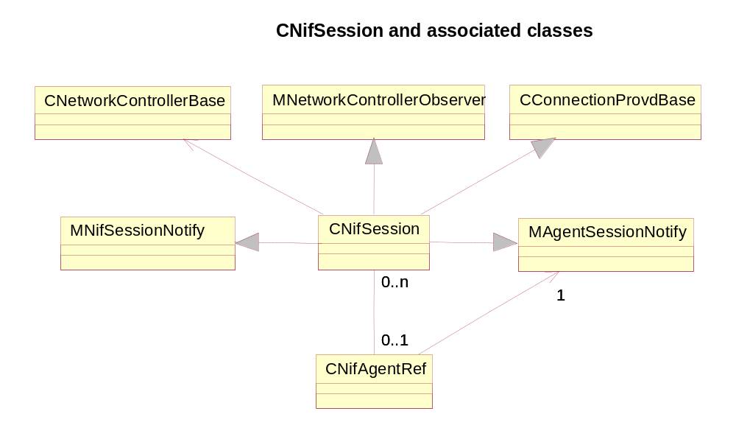
Figure 3-15 - CNifSession class hierarchy

CNifSession and MAgentSessionNotify/MNifSessionNotify
The CNifSession class implements the ESock/NIFMAN interface as defined by the CConnectionProvdBase base class, and is the means by which ESock requests connection management activity (eg: start or stop a connection, read CommDb etc) from NIFMAN. A CNifSession object is created and owned by a ShimCPR plug-in. There is always a one-to-one relationship between a ShimCPR plug-in instance and its CNifSession object in NIFMAN (see [R11] for the overall class relationship between NIFMAN and ESock).
The CNifSession object communicates with the Network Controller (NETCON) when starting an interface, and hence derives from MNetworkControllerObserver to receive responses from NETCON. The CNifSession object also communicates with CNifAgentRef as part of the interface startup process, as well as for other functions as necessary (eg: reading CommDb, requesting service change notification, stopping the interface etc). CNifSession derives from MAgentSessionNotify and MNifSessionNotify in order to register as an observer with CNifAgentRef. This allows the reception of progress notification and service change notification events that are then forwarded to the corresponding CConnectionProviderBase object:

Class MAgentSessionNotify
{
public:
virtual void ServiceChangeNotification(TUint32 aId, const TDesC& aType) = 0;
};

Figure 3-16 - MAgentSessionNotify class
Class MNifSessionNotify
{
public:
virtual void ProgressNotification(TInt aStage, TInt aError)=0;
virtual void ProgressNotification(TSubConnectionUniqueId aSubConnectionUniqueId, TInt aStage, TInt aError)=0;
virtual void NotifyDataSent(TSubConnectionUniqueId aSubConnectionUniqueId, TUint aUplinkVolume)=0;
virtual void NotifyDataReceived(TSubConnectionUniqueId aSubConnectionUniqueId, TUint aDownlinkVolume)=0;
virtual void SubConnectionEvent(const TSubConnectionEvent& aSubConnectionEvent)=0;
};
Figure 8 - MAgentSessionNotify class

CNifSession Method Description
The following is a description of the main CNifSession methods. For clarity, it is split into sections according to the various base classes.

CConnectionProvdBase API methods
This section describes the methods in CNifSession that implement the virtuals defined in CConnectionProvdBase that define the ESock to NIFMAN interface.
void StartL(TConnStartType aConnectType)
void StartL(TConnStartType aConnectType, const TConnPref& aPref)
CConnectionSelectorShim calls these methods whenever a connection needs to be started. There are variants for requests with and without connection preference overrides. To start a connection, the NETCON SelectAgent() method is called to select an IAP. The CNifSession::SelectComplete(…) method is called back later to indicate success or failure (described later).
void AttachToConnectionL(const TDesC8& aConnectionInfo,
TBool aMonitorAttach)
This method is called by ShimCPR when it wishes to associate itself with the connection specified by the Connection Info passed in aConnectionInfo.
CNifMan::FindByConnectionInfo() is first called to determine if there is a CNifAgentRef corresponding to the connection specified. Assuming there is, the CNifSession object adds itself as an observer of events via CNifAgentRef::AddObserver(). The success or failure of the attach is communicated back to ESock via a KFinishedSelection progress notification.
void Stop()
This method is called to bring down an interface immediately. It basically calls CNifAgentRef::Stop() to initiate connection closedown. The connection will go through several closedown progress notifications before finally being closed. Consequently, returning from this call does not necessarily mean that the interface is down.
void ProgressL(TNifProgressBuf& aBuffer) const
void LastProgressError(TNifProgressBuf& aBuffer)
These calls are used to retrieve the current progress of the interface and the last progress that caused an error respectively. ProgressL() basically calls CNifAgentRef::Progress() and LastProgressError() returns the last progress in error that the CNifSession instance observed from CNifAgentRef.
void GetIntSettingL(const TDesC& aSettingName, TUint32& aValue)
void GetBoolSettingL(const TDesC& aSettingName, TBool& aValue)
void GetDes8SettingL(const TDesC& aSettingName, TDes8& aValue)
void GetDes16SettingL(const TDesC& aSettingName, TDes16& aValue)
HBufC* GetLongDesSettingLC(const TDesC& aSettingName)
These methods are used to retrieve CommDB settings. The methods operate synchronously and basically call the corresponding CNifAgentRef method.
void EnumerateConnectionsL(TUint& aCount,
HBufC8*& aConnectionInfoBuffer)
This method is used to retrieve the current number of interfaces (CNifAgentRef instances) and the Connection Info for the interfaces. The information is used by ESock for servicing the RConnection::EnumerateConnection() and GetConnectionInfo() calls.
TBool AllInterfaceNotificationL()
Used by ESock to implement the RConnection::AllInterfaceNotification() API. Registers the current CNifSession object as an observer of global interface state change notifications.
void ControlL(TUint aOptionLevel, TUint aOptionName, TDes8& aOption)
Used to implement the RConnection::Control() API. This is a general mechanism for passing miscellaneous control commands from ESock to NIFMAN.
The main options implemented at the NIFMAN level (option level KCOLProvider) are:
KConnDisableTimers Enable/Disable the idle timer for an interface
KConnGetInterfaceName Retrieve the name(s) of the interface. This is the name of each CNifIfBase binder object that the underlying NIF assigns. It is can be used to interface information returned from RConnection::GetConnectionInfo() with interface information returned from the TCP/IP stack (for example, via KSoInetNextInterface).

void SetUsageProfile(TUint aProfile)

This call from ESock is used to communicate to NIFMAN whether there are any RConnection instances using the interface associated with the CNifSession object. This information is used by the corresponding CNifAgentRef to determine the idle timeout period at any one time. The aProfile argument is intended to be opaque to some degree to allow for future functionality to be easily added. It is only interpreted by CNifAgentRef, and can contain the following values:
KConnProfileInUse Indicates that one or more RConnection objects are using the interface.
KConnProfileIdle Indicates that no RConnection objects are using the interface.
Note that, for efficiency reasons, this call does not give an indication of how many RConnection objects are using the interface. It is only called when the number of such objects transitions from zero to non-zero or vice versa.
CNifAgentRef uses this information to determine whether the “medium” timeout value should be employed (ie: only RConnection objects using the interface, but no RSocket or RHostResolver objects).
void Stop(TSubConnectionUniqueId)
[Overload function was implemented for Connection Manager]
Calls straight through to CNifAgentRef::Stop(TSubConnectionUniqueId).
TInt EnumerateSubConnections(TUint&)
Calls straight through to CNifAgentRef::EnumerateSubConnections(TUint&).
TInt GetSubConnectionInfo(TUint, TDes8&)
This calls straight through to CNifAgentRef::GetSubConnectionInfo(TUint, TSubConnectionInfo&).
TInt GetSubConnectionInfo(TDes8&)
This calls straight through to CNifAgentRef::GetSubConnectionInfo(TSubConnectionInfo&).
TInt DataTransferred(TsubConnectionUniqueId, Tuint&, Tuint&)
This calls straight through to CNifAgentRef::GetDataTransferred(TSubConnectionUniqueId, TUint&, TUint&, TRequestStatus&).
TInt DataTransferredCancel(TsubConnectionUniqueId)
Cancel a request for the amount of data sent and received
TInt SetDataSentNotificationGranularity(TSubConnectionUniqueId, TUint)
Make a request for notifications about data sent at the specifed granularity on a specified subconnection. Calls through to CNifAgentRef::SetDataSentNotificationGranularity(TSubConnectionUniqueId, TUint).
TInt DataSentNotificationCancel(TSubConnectionUniqueId)
Cancel a request for notifications about data sent on a specified subconnection. Calls through to CNifAgentRef::DataSentNotificationCancel(TSubConnectionUniqueId).
TInt SetDataReceivedNotificationGranularity(TSubConnectionUniqueId, TUint)
Make a request for notifications about data received at the specifed granularity on a specified subconnection. Calls through to CNifAgentRef::SetDatareceivedNotificationGranularity(TSubConnectionUniqueId, TUint).
TInt DatareceivedNotificationCancel(TSubConnectionUniqueId)
Cancel a request for notifications about data received on a specified subconnection. Calls through to CNifAgentRef::DatareceivedNotificationCancel(TSubConnectionUniqueId).
TInt AllSubConnectionNotification()
This calls straight through to CNifAgentRef::AllSubConnectionNotification().
TInt SetDataSentNotificationGranularity(TSubConnectionUniqueId, TUint)
Make a request for notifications about data sent at the specifed granularity on a specified subconnection.
Calls straight through to CNifAgentRef::SetDataSentNotificationGranularity(TSubConnectionUniqueId, TUint).
TInt DataSentNotificationCancel(TSubConnectionUniqueId)
Cancel a request for notifications about data sent on a specified subconnection.
Calls straight through to CNifAgentRef::DataSentNotificationCancel(TSubConnectionUniqueId).

MNifSessionNotify Methods
The MNifSessionNotify methods implemented by CNifSession are used to observe interface events from the corresponding CNifAgentRef.
Void NotifyDataSent(TSubConnectionUniqueId, TUint)
Upcall from CNifAgentRef passing on a new data sent notification from a nif. Calls straight through to CConnectionProviderShim::NotifyDataSent(TSubConnectionUniqueId, TUint).

Void NotifyDataReceived(TSubConnectionUniqueId, TUint)
Upcall from CNifAgentRef passing on a new data received notification from a nif. Calls straight through to CConnectionProviderShim::NotifyDatareceived(TSubConnectionUniqueId, TUint).

Void ProgressNotification(TInt, TInt)
Upcall from CNifAgentRef passing on new progress values from a nif/agent. Calls straight through to CConnectionProviderShim::NotifyDatareceived(TInt, Tint).

Void ProgressNotification(TSubConnectionUniqueId, TInt, TInt)
Upcall from CNifAgentRef passing on new progress values from a nif/agent. Calls straight through to CConnectionProviderShim::NotifyDatareceived(TSubConnectionUniqueId, TInt, Tint).

Void SubConnectionEvent(const TSubConnectionEvent&)
Upcall from CNifAgentRef passing on a new event notification from a nif/agent. Calls straight through to CConnectionProviderShim:: SubConnectionEvent (TSubConnectionUniqueId).

MAgentSessionNotify Methods
The MAgentSessionNotify methods implemented by CNifSession are used to observe interface events from the corresponding CNifAgentRef.
void ServiceChangeNotification(TUint32 aId, const TDesC& aType)
This method is used to receive Service Change notifications.

MNetworkControllerObserver Methods
These implemented methods are used to observe events from NETCON during connection establishment.
void SelectComplete(const TDesC& aName)
void SelectComplete(TInt aError)
These methods are called when NETCON has completed selection of an IAP and Agent. CNifSession::StartL() would have previously initiated selection of an IAP by calling the NETCON SelectAgent() method as the first act in connection startup. The overloaded method with aName argument is called on success with the unique name of the new Agent, and the method with the aError argument is called on an error.
See section for a description of starting a connection from the NIFMAN perspective.
Upon error, connection preference retries are implemented and, if all connection preferences have been exhausted, a KFinishedSelection progress with error is signalled back to ESock.

Idle Timeout Functionality
The Idle Timer functionality has been enhanced with the addition of a “Medium” timeout in addition to the existing “Short” and “Long” timeout. The Medium timeout is used for the scenario where there are RConnection objects associated with an interface, but no Sockets or Host Resolvers. It was felt that RConnection objects are not as “important” as Sockets and Host Resolvers, and should not cause an interface to stay in the Long timeout. On the other hand, the presence of an RConnection object means that an application has some interest in controlling an interface, and hence should not cause a transition to the Short timeout. Introducing a Medium timeout allows some flexibility in choosing a suitable timeout value. There is no reason why the Medium timeout cannot be set to the same value as the Short or Long timeouts.
Note that “monitoring” RConnection objects (ie: those on which an Attach(…, EAttachTypeMonitor) operation has been performed) do not to affect the idle timeout. Only RConnection objects on which a Start() or Attach(…, EAttachTypeNormal) has been performed are counted in the Medium timeout.

Implementation Overview
The Idle Timer is still implemented in CNifAgentRef in NIFMAN. There are a few important changes to the implementation:
- The polling of the TCP/IP stack by NIFMAN via the IfUserIsNetworkLayerActive() method has been removed. Instead, the TCP/IP stack calls into NIFMAN via the OpenRoute() and CloseRoute() methods in MNifIfNotify to indicate if there are flows attached to an interface or not. The presence of flows on an interface causes it to stay in Long timeout mode. This represents a change in the use of the OpenRoute()/CloseRoute() methods, which used to be used to indicate packet activity.
- A new MNifIfNotify::PacketActivity() method has been added which the TCP/IP stack calls to indicate packet activity on transmit or receive. As mentioned in the previous bullet point, the stack uses this method instead of the OpenRoute() immediately followed by CloseRoute() sequence of the 7.0 release.
- DND will only keep open its UDP socket for as long as a DNS request is active. Once complete, the socket is closed in order to avoid keeping the interface in Long timeout mode.
- ESock communicates to NIFMAN dynamic information about the RConnection objects and ESock sessions associated with an interface. NIFMAN can then decide whether to keep the interface in Long or Medium timer mode based on this information. This communication happens via the SetUsageProfile() methods in IPCPR plug-in, CNifSession and CNifAgentRef.
The main responsibilities of each of the participating classes is summarised below:
ShimCPR Dynamically monitors the number of (non-monitoring) RConnection objects and ESock sessions associated with an interface.
IPCPR Makes a decision as to whether this implies the interface must be in at least Medium or Long mode and communicates this information to CNifAgentRef via underlying provider (ShimCPR).
CIp6Interface (TCP/IP)
Calls OpenRoute() and CloseRoute() in CNifAgentRef to indicate that there are flows attached to an interface. Also calls PacketActivity() to indicate that packets have flowed over an interface.
CNifSession Communication path between CConnectionProviderShim, CConnectionSelectorShim, CConnectionProviderFactoryShim and CNifAgentRef.
CNifAgentRef Implements the idle timer functionality using inputs from ShimCPR/CNifSession and CIp6Interface. Determines which mode the Idle timer should be running in (Short, Medium, Long) and ensures that packet activity will reset the Long timer.
CInterfaceShimCPR
CNifSession
CIp6Interface
CNifAgentRef
SetUsageProfile()
SetUsageProfile()
OpenRoute(), CloseRoute(),
PacketActivity()
Information about RConnection objects and ESock sessions
Information about flows connected to interfaces and packet activity
Figure 3-17 – Main classes involved in Idle Timer Functionality

In CNifAgentRef, there are two variables that control the mode the Idle timer operates in:
iRouteCount Reference count used to determine whether Idle timer should stay in Long mode. Incremented/decremented on OpenRoute()/CloseRoute() calls from the TCP/IP stack. Also incremented/decremented as a result of SetUsageProfile() calls from CConnectionProviderShim via CNifSession (for functionality whereby ESock sessions keep timer in Long mode).
iUserCount Reference count used to determine whether Idle timer should stay in (at least) Medium mode. Incremented/decremented as a result of SetUsageProfile() calls from CConnectionProviderShim via CNifSession (for functionality whereby RConnection objects keep timer in Medium mode).

Effect of ESock Sessions on Idle Timer
The only responsibility of IPCPR is to ensure that the Idle Timer behaviour with regard to ESock sessions is correctly implemented. The requirement for this comes from a need for backward compatible behaviour to ensure that 6.1 BC functionality works correctly. In particular, if an interface is started implicitly via a Socket, then the Idle Timer needs to remain in Long mode until the ESock session has disappeared, not just the Sockets using it. Note that this behaviour is only enabled an interface is started implicitly on an ESock session. For explicitly started interfaces, this behaviour does not occur.
For this reason, the XSessionProxyEntry class has been created (see section 3.2.12.13 . When a Socket or Host Resolver is used to implicitly start an interface on an ESock session, then the corresponding CSockSessionProxy instance registers an XSessionProxyEntry instance as an MConnectionControlClient of the connection provider to determine when the connection provider disappears.
Figure 3-18 below illustrates the class layout of the above mentione mechanism. Basically, each CSockSession maintains an array of MSockSession observers that have registered with it, and steps through the array calling each SessionClosing() virtual method from the CSockSession destructor. Each CSockSessionProxy instance maintains an array of XSessionProxyEntry instances that art in fact connection control clienth. This array is used as follows:
- When a Socket is used to implicitly start an interface, the routine CSockSessionProxy::RegisterProviderForIdleTimerL is called with the connection provider instance passed as argument. This will create and register XSessionProxyEntry instance as an ESession control client.(see [R11] for details on control client types).

- When CConnection::LayerUp is called with KErrNone the CSockSessionProxy::RegisterProviderForDefaultConnectionL is called with the connection provider instance passed as argument. This will create and register XSessionProxyEntry instance as an EMonitor control client.(see [R11] for details on control client types)

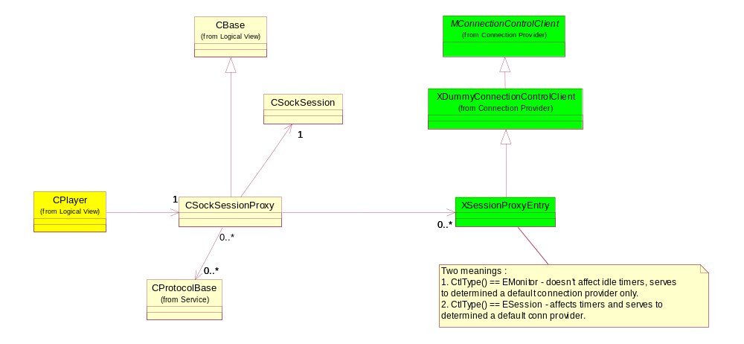
Figure 3-18 – Detail of mechanism whereby XSessionProxyEntry acts as connection control client

Platform security considerations in ESock

Securing RConnection “clone” open

Overview
The security mechanism employed is to allow the definition of a security policy, on a per-RConnection basis, which processes must conform to before they can remotely clone the RConnection. To this end, two KCOLConnection level RConnection::Control(...) options level are defined:
- KCoEnableCloneOpen. Allows specification of a security policy that processes must conform to in order to clone this RConnection. The option argument is a security policy as defined by _LIT_SECURITY_POLICY_* macros (see Code Examples below).
- KCoDisableCloneOpen. Disallow clone open. This option takes no option argument.

Code Examples
- Specify the security policy of processes that can clone the RConnection. In this example, the policy restricts cloning to a process with a particular SecureID (SID):
_LIT_SECURE_ID(KCloningProcessSId,0x1234567);
_LIT_SECURITY_POLICY_S0(KProcPolicy, KCloningProcessSId);
Note that, by default, no clone opening is allowed until a security policy has been set.
- Enable clone opening of the RConnection according to the security policy:
nRes = conn1.Control(KCOLConnection, KSOEnableCloneOpen,
KProcPolicy().Package());
- The ability to clone this RConnection remains enabled until it is explicitly disabled by the owning process:
nRes = conn1.Control(KCOLConnection, KSODisableCloneOpen, KNullDesC8());

Implementation details
The CConnection class receives two new data members:
TBool iCloneOpenEnabled:1;
TSecurityPolicy iCloneOpenPolicy;
The iCloneOpenEnabled flag indicates whether clone opening is enabled for the corresponding RConenction or not. If set to false, then a clone open of this RConnection returns KErrPermissionDenied immediately. If set to true, then the iCloneOpenPolicy member stores the security policy that the process attempting the clone open must conform to.
On a KSoEnableCloneOpen Control(...) call, the following takes place:
- iCloneOpenEnabled is set to true
- iCloneOpenPolicy is initialised from the security policy given as argument.
On a KSoDisableCloneOpen call, iCloneOpenEnabled is set to false.
On an RConnection::Open(..., TName&) call, the security policy of the requesting process is checked against the security policy stored in the iCloneOpenPolicy member of the CConnection referenced by the TName& argument.

Securing RConnection::Control(...) options implemented within ESock
The following Control(...) options (at KCOLConnection level) are implemented entirely within ESock (as opposed to being passed down to NIFMAN as is normally the case):
KCoEnumerateConnectionClients
KCoGetConnectionClientInfo
KCoEnumerateConnectionSockets
KCoGetConnectionSocketInfo
These options are policed as they expose internal information about which threads are using which connections and socket addresses, and are not intended for “ordinary” applications. This checking is achieved by making use of the CPolicyServer::CustomSecurityCheckL(...) virtual method. The ESock security policy for the IPC corresponding to RConnection::Control(...) (ECNControl) is set to the value TSpecialCase:: ECustomCheck. This causes the CustomSecurityCheckL(...) method to be called when that IPC is called (and, in fact any IPC marked with ECustomCheck). The implementation of the method will check that it is being invoked on the ECNControl IPC, that the option level is KCOLConnection and, for each of the above options, that the process has the correct capability.

Policing RConnection::Start()/Attach()/Stop()
The policing of these methods is delegated to NIFMAN as, in future, different connection providers may be technology specific. In order to enable connection providers like NIFMAN to perform security checks on the process originating a request, ESock passes down the RMessagePtr2* of the originating request on to NIFMAN. This enables NIFMAN to call TSecurityPolicy::CheckPolicy(RMessagePtr2, ...) to check security policies against the originating request.
CConnectionProvdBase has const RMessagePtr2* argument to the StartL(...), AttachToConnectionL(...) and Stop(...) methods (including their overloads).
The implicit start-up code for CSocket and CHostResolver also call StartL(...) but supplies a NULL RMessagePtr2* In the case of sockets, the implicit startup can be caused either by an RSocket::Connect() or SendTo() operation, so we rely on either .PRT, in case of RSocket to secure the request (Host Resolver is not secured in DND, but is secured in the resolver socket in the PRT, so all security is done in the PRT effectively).

Platform Security considerations in NIFMAN

Policing RConnection::Start()/Attach()/Stop()
CNifSession methods include a const RMessagePtr2* argument to allow for security checking. The policing itself is implemented in a new CNifSecureSession class derived from CNifSession.
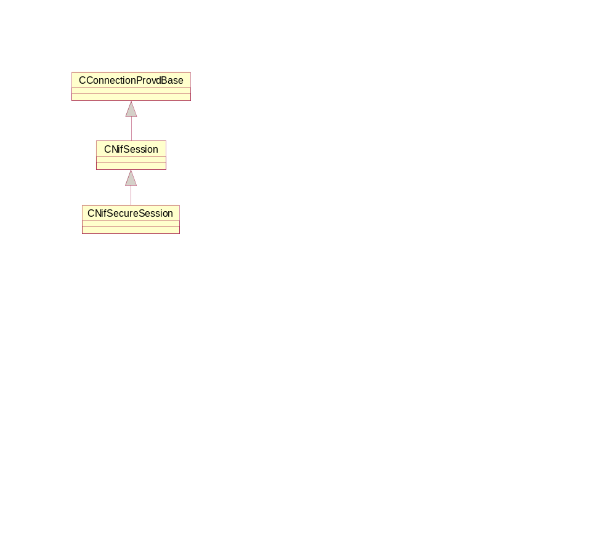
Figure 3-19 - CNifSecureSession class hierarchy

CNifSecureSession implements those methods on which it wishes to perform security checking (e.g. StartL(...)/AttachToConnectionL(...)/Stop(...)). Each method performs a security policy check (via a new CheckPolicy(...) method) and, if successful, calls the corresponding CNifSession base class method. For example:
CNifSecureSession::StartL(TConnStartType aConnectType, const RMessagePtr2* aMessage)
{
User::LeaveIfError(CheckPolicy(EStartPolicy, aMessage));
CNifSession::StartL(aConnectType, aMessage);
}
The CheckPolicy(...) method checks a policy corresponding to a request (the example shows how the caller selects EStartPolicy). The policies are defined internally in CheckPolicy(...) via the standard _LIT_SECURITY_POLICY_* macros.

Omissions
Note that CNifSecureSession does not police all RConnection requests. In particular, the policing of the database access methods (i.e. Get{Int,Bool,Des,LongDes}Setting) is delegated to lower layers.

Policing RGenericAgent and RNif
The underlying implementation of the RGenericAgent and RNif APIs is via the same CNifSecureSession class that ultimately implements the RConnection API. Consequently, no further Platform Security changes are required over and above those for CNifSecureSession.

Scenarios

Implicit Connection Startup via RHostResolver::GetByName()
This scenario describes how a connection provider is started up via a GetByName() operation when the host resolver has not been associated with any sub-connection.

The TCP/IP stack receives the request and forwards it on to DND. The DNS lookup is performed by DND locally first (ie: in the Hosts files). Assuming that the name is not found locally, DND will realise that it cannot go on to perform a remote lookup as there are no interfaces present. DND will not attempt to start an interface, but will indicate to ESock that it could not find the name locally by calling QueryComplete with KErrCompletion. This is a special error code that ESock interprets as meaning that an interface is to be started up for DND to perform its lookup remotely.

.
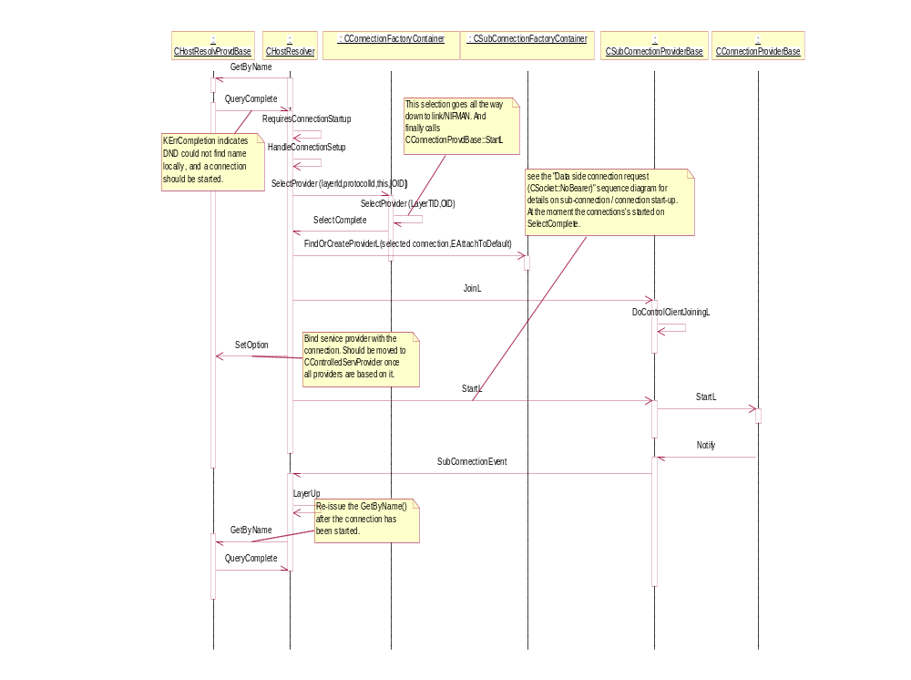
Figure 3-20 - GetByName() implicit connection startup
Figure 3-20above describes the sequence of events. The call to RequiresConnectionSetup() checks whether the protocol supports this special KErrCompletion error code or not (only acted upon for TCP/IP). The HandleConnectionSetup() call bngins the process of starting an implicit connection. Assuming that there is no default interface on the same RSocketServ session that the CHostResolver can be associated with, the host resolver asks factory to select a connection provider. Once the provider has been selected (CHostResolver::SelectComplete has been called) The connection info is communicated to the host resolver service provider via a new SetOption(KSoConnectionInfo).and host resolver can now join default sub-connection of the selected connectio

The next major event that takes place in the sequence is that the CHostResolver::SubConnectionEvent is called indicating that the host resolver can nowjre-issue the quere. This event is communicated to the CHostResolver which then re-issues the GetByName() operation. This time around, DND looks up the interface locally as before, cannot find the name, but can now look up the name remotely as an interface is present. Note that there is an in-efficiency in that the name is looked up locally twice, but this only occurs in the situation where a CHostResolver is as yet un-associated with an interface (ie: the first time it is used). Once the request has been looked up remotely, QueryComplete() is called with the final result code (ie: KErrNone or a system wide error code, but not KErrCompletion).

Implicit Connection Startup via RSocket::Connect()
This scenario describes how an interface is started as a result of a Socket Connect() operation. Referring to Figure 3-21 below, the sequence in fact starts with an ActiveOpen() operation being performed on the SAP but the picture shows the sequence from NoBearer call on. The TCP/IP stack will first determine whether the destination address can be routed locally (ie: via loopback) or via any interfaces present. Assuming that there are no external interfaces up, the stack will indicate that the SAP cannot be routed via a NoBearer() call torCControlledServProviderBase (note that this occurs within the same stack frame as the ActiveOpen()).
ESock then determines whether there is a default interface on the same RSocketServ that the CControlledServProviderBase can be associated with without starting a new interface. Assuming that there is no default provider, ESock proceeds to start up an implicit connection. The CSocket asks factory to select a connection provider.

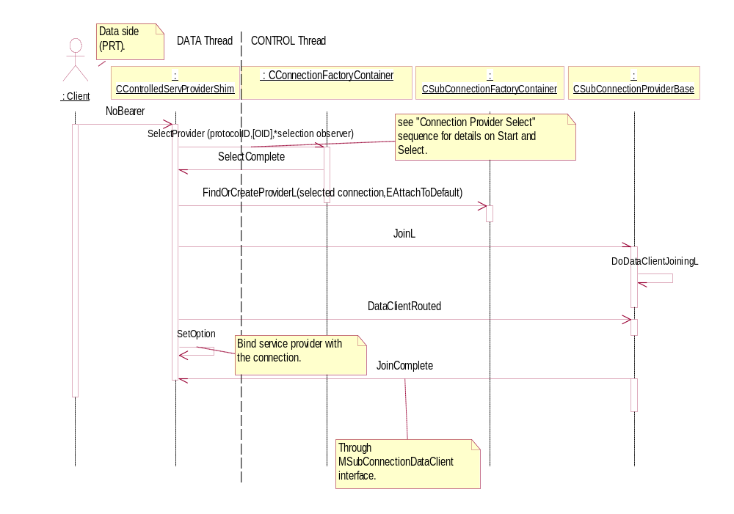
Figure 3-21 - Connect() implicit connection startup

Once the provider has been selected (CControlledServProviderBase::SelectComplete has been called) the connection info is communicated to the socket service provider via a new SetOption(KSoConnectionInfo).and controlled service provider can now join default sub-connection of the selected connection.. The routing info is supplied via CSubConnectionProvider::DataClientRouted call causing outstanding join to complete.

Once the link layer interface has come up and CProtocolBase::StartSending() has been called from the NIF, TCP/IP issues a Bearer() call torCControlledServProviderBase to indicate that the Socket flow has been attached to the interface specified. TCP/IP will start packet transfer at this stage. The Bearer() call is informational only, and does not serve any particular purpose (in this scenario). The KLinkLayerOpen progress stage is also communicated from NIFMAN to ESock

Implicit Connection Startup via RSocket::SendTo()
This scenario is the same at the one concerned with implicit connection startup via Connect() (section ), except that the ActiveOpen() call is replaced with Write().

Explicit Connection Startup via RConnection::Start()
This scenario describes a client which is explicitly starting up a connection provider via RConnection::Start(). Figure 3-22 below shows the client asking factory to select a connection provider as a response on RConnection::Start() call. In this case the client on the picture is CConnection instance created vig an RConnection::Open() calt.

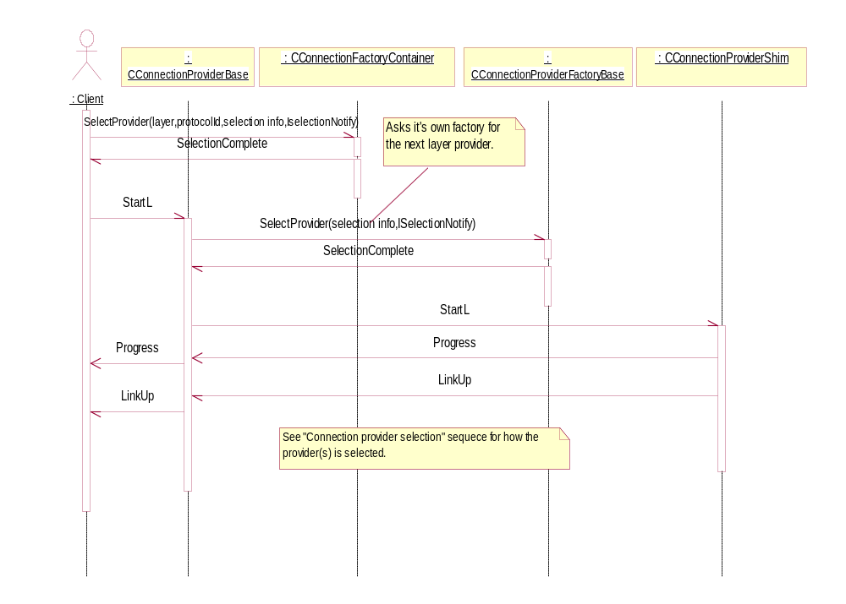
Figure 3-22 - RConnection explicit connection startup
Once the provider has been selected (CConnection::SelectComplete has been called) the selected provider is started and CConnection instance joins the selected provider (Figure 3-23 below). The provider start does at the moment nothing since the provider is started as a part of NIFMAN selection process. However it is envisioned that we separate selection from start.

Once the CConnection::LayerUp call occurs the session proxy monitor is registered (3.2.13.2) and the outstanding start message is completed.

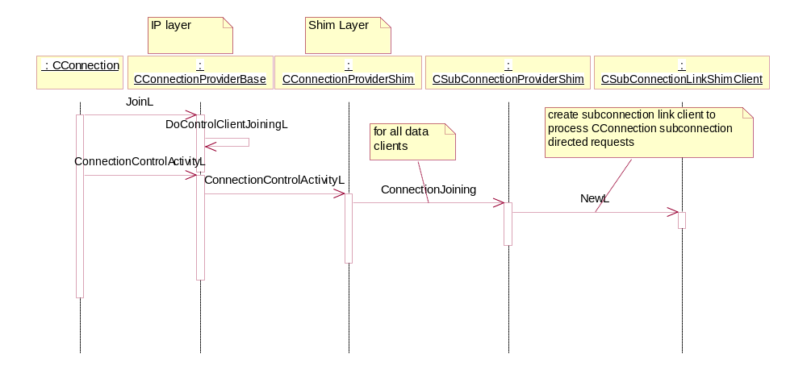
Figure 3-23 - CConnection joins connection provider

Progress Notification
This scenario describes how a client can receive progress notifications on the connection provider.a. Two scenarios can occur here:
- Client issues a request for progress notifications on an interface, which is completed some time later when a notification occurs. The call simply ends in CConnection instance which registers the fact that the client is waiting for progress and stores a copy of the originating RMessage.
- Sometime later, a progress notification occurs. The progress notification flows through connection provider’s stack and is propagated to all CConnection objects, including the one on which the client request is pending. The progress message is written to the client buffer specified in the original request, and the request is completed.

A progress notification occurs before the client has issued the RConnection::ProgressNotification() request. The progress notification flows through connection provider’s stack and is propagated to all CConnection objectst. In this instance, however, there is no pending client request to complete. Consequently, the progress notification is placed onto a 4-deep FIFO queue within the CConnection
Sometime later, the client issues the RConnection::ProgressNotification(). This propagates through CSockSession to CConnection::RequestProgressNotificationL(). This method checks the progress queue and notices a queued entry. This entry is removed from the queue and used to complete the client request immediately after the client buffer is filled with the progress information.

Opening an RSocket associated with an RConnection
In this scenario, the new RSocket::Open(…, RConnection&) method is used to open a Socket associated with an interface. The example in Figure 3-24 below assumes that an RConnection object has previously been opened and started via RConnection::Start(). The RSocket::Open() client side code extracts the RConnection handle and checks that it is on the same ESock session as the RSocket. If this is not the case, the client is panic’d as this is considered a serious programming error in the use of the API. After this, on the server side the call propagates through to CSockSession::NewSocketWithConnectionL(). This reads the RConnection handle from the client and confirms that it is valid and retrieves the corresponding CConnection object via CSockSession::CConnectionFromHandle(). It then checks that the connection that has been started and is active via CConnection::IsConnectionActive()).
After validating the RConnection object, the new CSocket is created via CSockSession::NewSocketL(), and a call to CConnection::JoinInterface() is made to associate the CControlledServProviderBase with the same underlying interface as the CConnection. This method works by retrieving CControlledServProviderBase instance that is at the moment CControlledServProviderShim, finding default sub-connection provider based on connection provider and address family and calling CControlledServProviderShim::JoinSubConnectionL() to make the association between the CControlledServProviderShim and the found CSubConnectionProviderBase. The last call is to set connection info on CControlledServProviderShim to let the data side know the association so that the socket can be routed over the right connection
Note that the association is made between the CControlledServProviderShim and CSubConnectionProviderBase rather than CSocket and a CInterface as it was previously. Consequently, it is possible to close the RConnection after this association has been made without affecting the CSocket.
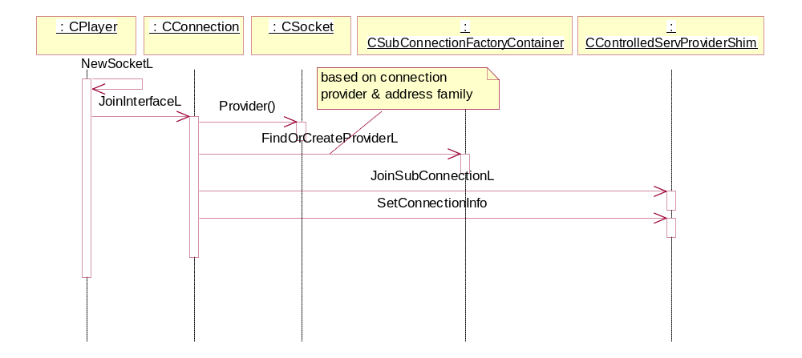
Figure 3-24 - Opening an RSocket associated with an RConnection

Opening an RHostResolver associated with an RConnection
  - In this scenario, the new RHostResolver::Open(…, RConnection&) method is used to open a Host Resolver that is associated with a connection. The sequence diagram in Figure 3-25 below describes the events that occur. This example is exactly the same as the scenario described in section 3.2.16.5 above for RSocket::Open(…, RConnection&), except that a CHostResolver object is used instead of a CSocket object. Also CHostResolver instance joins sub-connection as a control client rather than as a data client via CControlServProviderShim.s
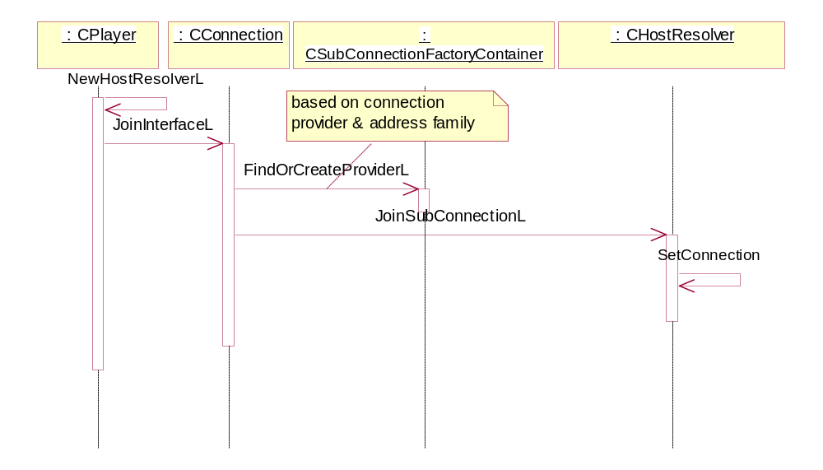
Figure 3-25 - Opening an RHostResolver associated with an RConnection

Loopback
The data side (TCP/IP only at the moment) calls CControlledServProviderShim::Bearer() with connection info indicating local bearer. The ::Bearer method verifies local bearer by calling TConnectionInfo::IsLocalBearer(). In case of local bearer the current sub-connection provider, if any, is left and no new association is created for loopback

Opening an RSocket which uses the RSocketServ default connection
In this scenario, a Socket is opened using the “traditional” RSocket::Open() call (ie: not specifying an RConnection) and is automatically assigned to a default connection. The circumstance in which this occurs is that an RSocket is opened on an RSocketServ which has already had one (and only one) connection provider started on it. In other words, a prior RSocket, RHostResolver or RConnection object on that RSocketServ has resulted in an implicit or explicit connection being started.
It begins as scenario the difference is that whenrCControlledServProviderBase::NoBearer calls CSockSessionProxy::DefaultProvider() the method returns a CConnectionProviderBase instance. Once the default connection provider is foundrCControlledServProviderBase:: SelectComplete is called and since than the sequence continues as described in . The behaviour has been deprecated by BR1408 and will not be discussed further.

Attaching to a connection via RConnection::Attach()
This scenario describes the operation of the RConnection::Attach() operation. A client can use this method to connect to an existing interface by specifying its Connection Info. This operation is mutually exclusive with RConnection::Start() – only one or other operation can be performed on an RConnection
Figure 3-26 below shows the sequence of operations (note that this assumes that the RConnection::Open() has already been performed). The RConnection::Attach() from the client is propagated through CSockSession to CConnection::AttachL(). This first calls IsConnectionActive() to determine whether the CConnection is already associated with an interface or not. If so, then a KErrInUse error would result. In this scenario, this error does not occur.
The next stage is to ask factory to find or create a connection provider based on connection info and address family. In case the returned provider instance doesn’t have associated link layer (shim layer) provider the shim factory is asked to find or create one based on connection info. Now the CConnection instance can join the top layer provider and call CConnectionProviderBase::ConnectionControlActivityL to advise lower layer and ultimately NIFMAN that CConnection is attaching to the connection. NIFMAN finds a matching CNifAgentRef object based on connection info and indicates connection activity to adjust idle timers in EAttachNormal case. The operation attach is synchronous so that the user message is completed by CConnection::AttachL function

.
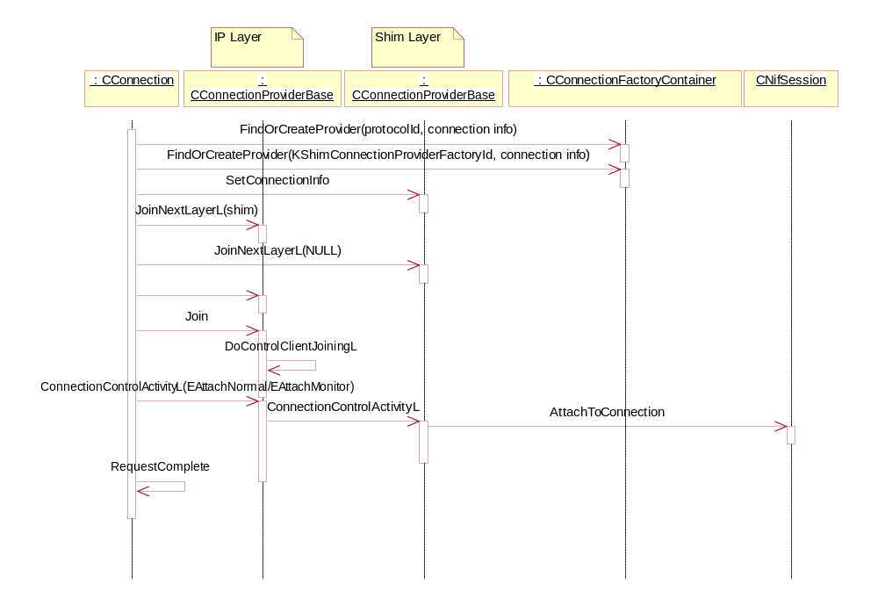
Figure 3-26 - RConnection::Attach() operation

Implicitly attaching to an existing interface
In certain circumstances, an interface can be up and running although it is unknown to ESock. In particular, if all CSocket, CHostResolver and CConnection sub-session objects previously associated with a provider are destroyed, then the top “network” layer provider is gone but the link (shim) layer provider still exists since its life time copies CNifAgentRef instance life time. However, the link interface can still be active and known to both NIFMAN and TCP/IP, although it will be slowly timing out due to the NIFMAN idle timer. This brings up the possibility of ESock receiving a MSocketNotify::Bearer() call from the TCP/IP stack indicating that it has bound a socket to a link interface represented by shim connection provider that can be asked for via factories. In such a situation, on receiving CControlledServProviderBase::Bearer call the controlles service provider ask factory to find a sub-connection provider based on address family and connection info. Once the CControlledServProviderBase found a sub-connection it joins it.
Figure 3-27 below describes such a scenario. Assume that there is an interface up and running in NIFMAN but with no sub-session objects associated with it. Consider a client performing an RSocket::Connect() operation that can be un-ambiguously routed to the interface (there are various ways to achieve this, including the use of KSoInterfaceIndex socket option to indicate directly which interface to use, use of an IPv4 mapped address with the Scope Id identifying the interface, or the use of an IPv6 global address). The RSocket::Connect() request results in an ActiveOpen() call to the SAP. The TCP/IP stack finds that it can associate the Socket with the interface immediately, and responds with a Bearer() call rather than the usual NoBearer(). The argument passed to ESock in the Bearer() call is the Connection Info of the interface that TCP/IP associated with the Socket.

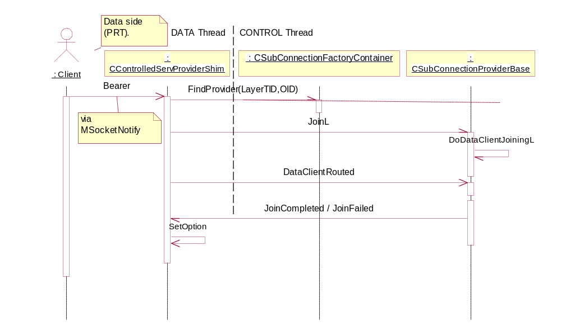
Figure 3-27 - Implicitly attaching a socket to a link interface

Starting an interface (NIFMAN perspective)
The sequence in Figure 3-28 below describes the steps taken in initiating connection startup in NIFMAN.
The steps are:
- CNifSession::Start() begins by signalling KStartingSelection progress back to ESock.
- A request to NETCON to start selecting an IAP is made via SelectAgent().
- Some time later (perhaps after prompting the user), a SelectComplete() callback is issued from NETCON, giving the unique name of the Agent selected,
- the CNifSession object obtains a pointer to the associated CNifAgentRef via a call to CNifMan::FindByUniqueName(), and then adds itself as an observer of the CNifAgentRef (see MAgentSessionNotify method description).
- the Connection Info for the interface is retrieved and posted back to ESock with a KFinishedSelection progress notification,
- A CNifAgentRef::StartL() call is issued which starts the connection process in the Agent,
- The CNifMan::AgentGoingUp() call is used to signal any CNifSession objects that are awaiting global interface state change notification (this is used to implement RConnection::AllInterfaceNotification()).
After this point, various progress notifications proceed from the Agent and NIF until the interface reaches the KLinkLayerOpen stage.
: ShimCPRCInterface
: CNifSession
: CNifAgentRef
: CNifMan
:
CNetworkControllerBase
:
CNifAgentBase
1: StartL(TConnStartType)
2: ProgressNotification(TInt, TInt)
3: ProgressNotification(TInt, TInt)
4: PostProgressToConnection(TInt, TInt, TDesC8&)
5: ProgressNotification(TInt, TInt)
6: SelectAgent( )
7: SelectComplete(TDesC&)
8: FindByUniqueNameL(const TDesC&)
9: AddObserverL(MAgentSessionNotify*)
10: GetSelectionInfoL(TSoIfConnectionInfo&)
11: SetConnectionInfo(const TSoIfConnectionInfo&)
12: PostProgressToConnection(TInt, TInt, TDesC8&)
13: SelectionComplete(TInt, const TDesC8&)
KStartingSelection
progress
KFinishedSelection
progress with
Connection Info
Find
CNifAgentRef
and become
observer of it
14: StartL(TConnStartType)
15: Connect( )
16: AgentGoingUp(CNifAgentRef&)
Inform any CNifSession
waiting for interface state
change notification
Retrieve
Connection Info
and store in
CNifAgentRef
: ShimCPRCInterface
: CNifSession
: CNifAgentRef
: CNifMan
:
CNetworkControllerBase
:
CNifAgentBase
1: StartL(TConnStartType)
2: ProgressNotification(TInt, TInt)
3: ProgressNotification(TInt, TInt)
4: PostProgressToConnection(TInt, TInt, TDesC8&)
5: ProgressNotification(TInt, TInt)
6: SelectAgent( )
7: SelectComplete(TDesC&)
8: FindByUniqueNameL(const TDesC&)
9: AddObserverL(MAgentSessionNotify*)
10: GetSelectionInfoL(TSoIfConnectionInfo&)
11: SetConnectionInfo(const TSoIfConnectionInfo&)
12: PostProgressToConnection(TInt, TInt, TDesC8&)
13: SelectionComplete(TInt, const TDesC8&)
KStartingSelection
progress
KFinishedSelection
progress with
Connection Info
Find
CNifAgentRef
and become
observer of it
14: StartL(TConnStartType)
15: Connect( )
16: AgentGoingUp(CNifAgentRef&)
Inform any CNifSession
waiting for interface state
change notification
Retrieve
Connection Info
and store in
CNifAgentRef
Figure 3-28 - Starting an interface (NIFMAN perspective)

Server startup
When starting, every ESock CPM creates a CWorkerThread instance which forms the basis of the module. To communicate with the RootServer it has a CWorkerRootServChannelHandler, which is created with the queues given with the IniData (parameter to the main thread function) as well as the appropriate classes to deal with its configured roles.
The second level constructor will initialise after the following algorithm:

Determine WorkerId and role from IniData
Initialise SockManGlobals
Create CDealer
Create CWorkerDealer
Create CPlayer
If Player
Create CRootServerChannelHandler
Create CPitBoss
If Dealer and it is the Main thread
If DealerPlayer
In case of Dealer and WorkerDealer the server is started (StartL) from their respective ConstructLs.
If the CPM is a Dealer, it means it is the Main Dealer of which the can be only one (otherwise it is a WorkerDealer). In this case the name of the server is “!SocketServer”. The server names a WorkerDealer is defined at run-time as “!Socket-Server-<WorkerId>-<ThreadId>”. This gives better visibility for debugging purposes and the client library can’t connect directly by name anyway, it must connect to “!SocketServer”, obtain the current name of the optimal dealer, if any, and then reconnect.

To communicate with other ESock CPMs it has an array of CInterWorkerChannelHandler (individual instances of which are created as bind requests arrive from the RootServer).

Binding ESock CPMs
Once satisfied all the ESock CPMs have been started, the Configurator will send out the requested bindings, it is with the creation of these bindings that the PitBoss become aware of the Players and what protocols are installed.
The sub-module name of an ESock CPM, to which other ESock CPMs can Bind must be the WorkerId. E.g. “Esock_IP:1” would be the “bind-able” sub-module address of the ESock_IP CPM.
As each ESock CPM has a different WorkerId, these are conveniently used to index the array of channel handlers. E.g. iPeerHandlers[n] is the channel handler used for communicating with the CPM of WorkerId n. This creates the restriction that there can not be two bindings between the same two modules, which is why ESock will refuse (and ASSERT_DEBUG) a second request to create the same binding.
A further consequence is that any Dealer can only forward client requests for protocols in threads it is bound to.

Configuring the Socket Server

Configuration files and parameters
The configuration and loading of the SocketServer is handled through the standard Configurator/RootServer mechanism – each CPM being configured by a .CMI file specifying load parameters and bindings used when loading the module. Also in this file is specified parameters (known as “IniData”), passed on directly to the CPM.

The parameters expected by an ESock instance:
- Role = Player | Dealer | DealerPlayer – Job specification for the module: Player only, main Dealer (there can only be one) or both a Dealer and a Player. Mandatory.
- WorkerId = 0..8 – Integer number specifying an “id” to the PitBoss for this instance. Must be unique across all ESock instances. Max value is defined by EMaxWorkerThreadId in ss_common.h. Current value is 8, which allows for the 5 modules in the reference configuration as well as 3 modules used for test purposes. Mandatory.
- EskMask = Prefix.*.ESK – A mask determining which .ESK protocol configuration files should be read by this instance. An example is IP.*.ESK, which would load modules such as ip.tcpip.esk, ip.qos.esk, etc. Mandatory for Player or DealerPlayer, ignored for Dealer.
- EskMask[1..8] = Prefix.*.ESK – As above but allowing for additional masks, e.g. a module could have the additional mask EskMask1 = bt.*.esk, specifying to load these files in additional to the mandatory EskMask. There must be no jump in sequence, i.e. if the IniData contains EskMask1 and EskMask4, the latter will be ignored. Optional for Player or DealerPlayer, ignored for Dealer.

If a module is loaded without the mandatory options from above specified in the IniData it will terminate with a diagnostic panic as this is a serious configuration error.

Module relationships
As mentioned in 2.2, dealers are connected to players using Comms Channels. Since it is necessary that the client can use any protocol no matter which Dealer it is connected to, it is desireable that all Dealers are connected to all Players.
The consideration of whether a given instance of a Player should have a co-resident Dealer is one of memory resources versus latency. A co-resident Dealer would take extra heap memory and extra kernel memory, while these will be saved if using a non co-resident Dealer. But if not having a co-resident Dealer every IPC message to the Player will have to be forwarded over a Comms Channel which adds extra latency (note that only clients using the optimal connect can benefit).
When responding to the message (RMessage.Complete()) it is done directly by the Player.
One could say that when doing a context shift there is the danger of another process taking over altogether, potentially making the latency much bigger, but if this happens it is because that process has higher priority, which means it is more important anyway.
The bindings are specified in the .CMI files loading the modules as they are set up using the standard CommsFw/RootServer mechanism for creation. Once the modules have been loaded, the RootServer will send the bindings to the modules which will then start to communicate directly and e.g. exchange information of available protocols. When the modules have signalled to the RootServer that bindings are completed, they are ready for “normal” operation (protocol services available to clients).

A few words on queue lengths
If an ESock module can not send a message due to a Comms Channel overflow, it blocks while trying to send “for a while” (5 seconds). If it doesn’t manage to send within 5 seconds, the message will be discarded and in debug mode it will ASSERT (as always with Symbian OS, it is assumed that protocol implementers keep RunL’s short and doesn’t block the thread).
It is important to realize that messages could end up getting discarded when deciding the queue length of the bindings. Too conservative sizes might bring on an overflow, too big a number is a waste of resources.
Consider whether the ESock instances are high usage or low usage modules. E.g. Worker Threads with the IP stack will probably serve a lot of traffic, while Worker Threads with just a single protocol, like Bluetooth might justify fewer slots in the message queues. Not so much because Bluetooth is “narrow band” (Bluetooth 2.0 has theoretical max of 12 Mbps), but because one will probably find less clients access the protocol simultaneously.
So, it is better to not be conservative and have good long queues.
The reference configuration (see 3.2.19) has 7 channels, which is a total of 14 queues. Each slot has the size: sizeof(CommsFW::TMessageCarrier). On current 32bit architectures that amounts to a 44 octets.
So the total kernel memory consumed for message queues for (14*44*<slots>), where number of slots per queue is e.g. 32, will be 19.25K octets.

Reference configuration
The current reference configuration offered to licensees and used in the default builds contains two dealers and four players. The IP instance of ESock has its own Dealer as it might in some cases require the lowest possible latency, but the IR (Infrared related protocols), BT (Bluetooth related protocols) and SMSWAP (SMS, WAP related protocols) will have to be used through on of the other two Dealers as they are considered to have less simultaneous usage.
As mentioned in 3.2.1, the latency penalty of forwarding an IPC message to one of the three Dealer-less instances is ~3us on the reference hardware, which seems fine for the protocols being serviced here. Even with different phone hardware this number should, as a rule of thumb, stay within the same order of magnitude.
If an issue, it is soft-configurable, as any licensee can create a customised set of .CMI files configuring the Socket Server with different numbers of Players/Dealers. It is recommended not to have too many protocols in the same ESock instance as it could impede performance in unpredictable ways, e.g. by putting many active objects on the same active scheduler.

The current reference configuration:
ESock_Main
Role=Dealer
WorkerId=0

ESock_IR
Role=Player
WorkerId=3
EskMask=IR.*.ESK

ESock_SMSWAP
Role=Player
WorkerId=4
EskMask=SMSWAP.*.ESK

ESock_BT
Role=Player
WorkerId=2
EskMask=BT.*.ESK

ESock_IP
Role=DealerPlayer
WorkerId=1
EskMask=IP.*.ESK

IPC Interface
IPC Interface
PRT
PRT
PRT
PRT
PRT
PRT
PRT
PRT
PRT
PRT
PRT
PRT
Figure 3-29 - ESock reference configuration

Logging
Investigating issues in the Socket Server, protocol implementations, even in client code is often difficult without sensible logging. Therefore ESock has logging implemented on both the server side and in the client DLL.
However, it is difficult to anticipate precisely what logging is most useful in future situations so the logging statements inserted into the code during development of new code and to a lesser degree whilst fixing defects. It is expected (an encouraged) that the future maintainer / developer will add further logging where useful, but please observe below guidelines.
See the ESock HowTo for more information on configuration and logging: [R10].

Client side
The client library has a logging helper class which does all the logging. It is defined / implemented in es_flog.h / cs_log.cpp and offers the ESockLog class with two static Printf methods, offering logging of 8-bit or Unicode strings.

The implementation uses CommsDebugUtility for logging and is configured in c:\logs\commsdbg.ini with the logging tags “esock” and “esock.txt” as defined by KESockLogFolder and KESockLogFile.
The second tag (“esock.txt”) has its name for historical reasons; it could be considered to rename it to e.g. “client” in the future but it is not of great importance.

Server side
The server side logging use CFlog, the CommsFw CommsDebugUtility enhancement, and is defined / implemented in ss_log.h / ss_log.cpp. It also offers an ESockLog class, but offering more methods than the client side peer as it offers Printf(…) methods taking a first parameter specifying the secondary logging tag (see Table 4).
The Printf(…) methods in the class not taking a secondary tag should be removed at some point, forcing a decision on which tag to use when adding logging.

Tag | Value | Usage
KESockComponentTag | Esock | This is the primary logging tag for all ESock logging.
KESockClientTag | Client | This was meant to be the common client-side case, but as of now the client has its own logging solution.
KESockServerTag | Server | The common server-side case.
KESockBootingTag | Booting | Grim and verbose details of booting and shutting down details.
KESockSessDetailTag | Detail | Detailed session handling and MT logs.
KESockConnectionTag | Conn | Connection related handling, e.g. connection set-up and break down scenarios.
KESockLockTag | Lock | Can be used for verbose logging of locks, such as RWorkerLock, etc.
Table 4 - Server side logging tags

It is important when adding new logging to consider which tag is most appropriate. Obviously there are no firm guidelines. Use common sense and see how they have been used in related code.

Other logs
When debugging ESock one might also consider enabling logging for CommsFw (in commsdbg.ini), but be aware that it produces a huge output and rarely is useful to know what e.g. the Comms Channels transfer as ESock also logs when a message is received, but in a more relevant way.
Start-up problems can sometimes be resolved quickly by looking at the c32start logs (likewise in commsdbg.ini) as they are often due to a faulty configuration which will be logged either by c32start, ESock or both.

Further Information

References
No. | Document Reference | Version | Description
[R1] | “UML Explained” |  | by Kendall Scott  (http://www.amazon.co.uk/exec/obidos/tg/stores/detail/-/books/0201721821/toc/202-4456432-1159001)
[R2] | RConnection API.doc | latest | Description of the RConnection API from the client application perspective.
[R3] | Multihoming Design.doc | latest | Outdated and no longer available.
[R4] | Connection Manager.mdl | latest | Outdated and no longer available.
[R5] | MBufMgr design doc | latest | Located in: V:\Dev\GT\GT 0167 Networking\Milestones\A2\Designs
[R6] | Symbian OS v7.0s Platform SDK | latest | http://web.intra/Dev/Sysdoc/devlib_70s/doc_source/index.html
[R7] | SGL.GT0167.nnn Root Server Design Document.doc | latest | Design of Root Server
[R8] | SGL.GT0167.nnn Root Server API Reference.doc | latest | Client API for Root Server
[R9] | SGL.GT0167.nnn Comms Framework API.doc | latest | Comms Framework design and message API
[R10] | ESock HowTo.doc | latest | How-to on how to configure and debug the socket server.
[R11] | BM Architectural Description.doc | latest | Architectural changes introduced by bearer mobility work. Connection providers’ stacking
[R12] | BM model | lates | UML design describing connection providers’ stacking

Glossary
The following technical terms and abbreviations are used within this document.
Term | Definition
API | Application Program Interface or Application Programming Interface. The interface (calling conventions) by which an application program accesses operating system and other services. An API is defined at source code level and provides a level of abstraction between the application and the kernel (or other privileged utilities) to ensure the portability of the code.
ARM | Advanced RISC Machine. Originally Acorn RISC Machine). A series of low-cost, power-efficient 32-bit RISC microprocessors for embedded control, computing, digital signal processing, games, consumer multimedia and portable applications.
BC | Binary Compatibility. Is achieved if existing binaries keep working.
BM | Bearer Mobility. The ability to change bearer on a device without closing the connection so that the user can continue using e.g. her Internet session whilst moving between areas with different bearers such as UMTS, GSM, WLAN, etc…
BSD | Berkeley Software Distribution. A family of Unix versions developed by Bill Joy and others at the University of California at Berkeley, originally for the DEC VAX and PDP-11 computers, and subsequently ported to almost all modern general-purpose computers. BSD Unix incorporates paged virtual memory, TCP/IP networking enhancements and many other features.
BT | Bluetooth. A low-power specification for short-range radio links between mobile computers, mobile phones, digital cameras, and other portable devices.
CommsFw | Comms Framework. Component in the comms-infras sub-system. Provides a set of utilities and classes easing the implementation of and communication between CPMs.
Connection | Term used interchangeably with “Interface”. The underlying interface in NIFMAN.
Connection Info | The unique identity of an interface composed of the IAP Id and Network Id. Manipulated as a TDesC8 descriptor within ESock for opaqueness, but as a TSoIfConnectionInfo within NIFMAN and TCP/IP.
CPM | Comms Provider Module. An entity launched and running in the Comms Process by the RootServer. Usually has one thread known to the RootServer although implementation might use more.
Dealer | An ESock IPC server for an ESock session, receiving requests from client sessions and passing them (in form of the RMessage) to the appropriate Player.
DealerPlayer | A Worker thread, containing both a Dealer and a Player.
Default Connection | Functionality in ESock whereby an RSocket or RHostResolver upon opening is automatically associated with an existing interface already started on the same RSocketServ.
DLL | Dynamically Linked Library.
EKA2 | The version 2 kernel in Symbian OS. Provides pre-emption of parts of the kernel as well as other real-time related enhancements.
ESK file | Configurations file for ESock. Specifies PRT to load and protocol bindings.
ESock | The Symbian OS Socket Server.
Explicit Connection | A connection which has been started via an RConnection::Start().
Connection provider | CConnectionProviderBase based class
IAP | Internet Access Point.
IAP Id | Part of the Connection Info – the CommDb Id of an entry in the IAP table.
Implicit Connection | A connection which has been started via an RSocket or RHostResolver operation (eg: Connect(), GetByName()).
IPC | Inter Process Communication.
IPsec | IP Security. A protocol that provides security for transmission of sensitive information over unprotected networks such as the Internet. IPsec acts at the network layer, protecting and authenticating IP packets between participating devices ("peers")
IrDA | Infrared Data Association. A non-profit trade association providing standards to ensure the quality and interoperability of infrared (IR) hardware. IrDA typically uses direct infrared i.e. point-to-point, line-of-sight, one-to-one communications.
Network Controller (NETCON) | The module that partially replaces the function of the old GenConn agent. Used to select an IAP and Agent when starting up a connection.
Network Id | Part of the Connection Info – the CommDb Id of an entry in the Network table.
Optimal Dealer | A Dealer co-resident with a Player in a Worker thread. “Optimal” because clients can connect directly to it bypassing the Main Dealer and avoid a thread context shift when processing IPC messages.
PID | Process Identification. Currently a unique integer number associated with a specific process.
PitBoss | Oversees the interaction of the Dealers and Players. It owns shared data structures, such as the list of protocols supported by the server and it has the responsibility for safely cleaning up after a socket server thread panic, which involves some bookkeeping and resource management.
PitBoss (2) | An employee who supervises the gambling in a casino, he must know the games and be able to protect them. He must be able to make fast judgement on the gamers and what to do with them.
Player | The part of ESock that performs the actual work for processing a request by synchronous calls into the provider code and when appropriate completes the RMessage2.
PRT | Protocol module. A DLL with the suffix .PRT designed to be loaded by ESock, providing protocol implementations.
QoS | Quality of Service. The performance properties of a network service, possibly including throughput, transit delay, priority. Some protocols allow packets or streams to include QoS requirements.
RedShirt | To the new, hitherto unknown member of the Star ship Enterprise crew (wearing the standard red uniform), which was sure to be the first (and only) one dying if attacked or if sent with away-team to explore unknown planets surprisingly inhabited by mind-bogglingly powerful creatures of malicious intent.
RedShirt thread | Threads created for the sole purpose of cleaning up after another dead thread. Does a best effort and can safely die or panic without bringing down ESock.
RISC | Reduced Instruction Set Computer. A processor whose design is based on the rapid execution of a sequence of simple instructions rather than on the provision of a large variety of complex instructions (as in a Complex Instruction Set Computer). Features which are generally found in RISC designs are uniform instruction encoding (e.g. the op-code is always in the same bit positions in each instruction which is always one word long), which allows faster decoding; a homogenous register set, allowing any register to be used in any context and simplifying compiler design; and simple addressing modes with more complex modes replaced by sequences of simple arithmetic instructions.
SAP | Service Access Point.
SAP (2) | A CServProviderBase or CHostResolvProvdBase derived object. Usually instantiated by a protocol instance.
SMS | Short Message Service. Using SMS, a short alphanumeric message (160 alphanumeric characters) can be sent to a mobile device to be displayed there, much like in an alphanumeric pager system. The message is buffered by the phone network until the phone becomes active.
Sub-session | E.g. a CSocket, CHostResolver or CConnection object.
TCP/IP | Transmission Control Protocol over Internet Protocol. The de facto standard protocols incorporated into 4.2BSD Unix. TCP/IP was developed by DARPA for internetworking and encompasses both network layer and transport layer protocols. While TCP and IP specify two protocols at specific protocol layers
UML | Unified Modelling Language. A non-proprietary, third generation modelling language. The Unified Modelling Language is an open method used to specify, visualise, construct and document the artefacts of an object-oriented software-intensive system under development. The UML represents a compilation of "best engineering practices"
WorkerId | Worker Identification. Currently a unique integer number associated with a specific instance/thread of ESock.

Document History
Date | Version | Status | Description
21-06-2002 | 0.01 | Draft | Original version of document which includes RConnection API as well as design.
02-09-2002 | 0.02 | Draft | New version which contains only ESock/NIFMAN internal design, with RConnection API description for Client’s separated into new document [R2].
29-11-2002 | 1.00 | Issued | Fixed some typos. Moved to Issued status.
15-01-2003 | 1.01 | Issued | Updated for Idle Timers and ESock sessions work. Clarified to show several RConnections can map to one interface.
07-04-2003 | 1.02 | Issued | Added details from Connection Manager Project
14-05-2003 | 1.03 | Draft | Added details for Comms Framework changes
08-11-2003 | 1.04 | Issued
03-08-2004 | 1.05 | Draft | Added a section about Platform Security, Securing RSocket::Transfer in particular.
27-09-2004 | 1.06 | Draft | Added RSubConnection/CSubConnection2 description
04-02-2005 | 1.07 | For review | Added ESockV3 design.
18-04-2005 | 2.0 | Issued | Updated after review.
16-05-2005 | 2.1 | Draft | SSA changes

Table of figures
Figure 2-1 - example set-up and communication paths 8
Figure 3-1 – Client API class hierarchy 9
Figure 3-2 - The Worker Thread class hierarchy 10
Figure 3-3 - Sending non-ESock message with receiver in other Worker thread 12
Figure 3-4 - Sending non-ESock message with receiver in same Worker thread 12
Figure 3-5 - The request wrapper 13
Figure 3-6 - The Dealer class hierarchy 14
Figure 3-7 - Binding Main Dealer and a worker 17
Figure 3-8 - The Player class hierarchy 18
Figure 3-9 - The PitBoss class hierarchy 20
Figure 3-10 - The sub-session container 24
Figure 3-11 - Sub-session handle 25
Figure 3-12 - XEligibleClients 27
Figure 3-13 High Level ESock related networking block diagram 34
Figure 3-15 - CNifSession class hierarchy 43
Figure 3-16 - MAgentSessionNotify class 43
Figure 3-17 – Main classes involved in Idle Timer Functionality 48
Figure 3-18 – Detail of mechanism whereby XSessionProxyEntry acts as connection control client 49
Figure 3-19 - CNifSecureSession class hierarchy 51
Figure 3-20 - GetByName() implicit connection startup 52
Figure 3-21 - Connect() implicit connection startup 53
Figure 3-22 - RConnection explicit connection startup 54
Figure 3-23 - CConnection joins connection provider 55
Figure 3-24 - Opening an RSocket associated with an RConnection 56
Figure 3-25 - Opening an RHostResolver associated with an RConnection 57
Figure 3-26 - RConnection::Attach() operation 58
Figure 3-27 - Implicitly attaching a socket to a link interface 59
Figure 3-28 - Starting an interface (NIFMAN perspective) 60
Figure 3-29 - ESock reference configuration 64

Appendices
  - Multihoming changes as introduced in release 7.0s
In the release 7.0 design, the functionality for starting and controlling Network Interfaces (NIF’s) was implemented in NIFMAN and the functionality for supporting Sockets and Host Resolvers was implemented in ESock. There was no need to co-ordinate the activities of RSocket/RHostResolver objects and underlying NIF’s as only a single NIF could be active at one time. The decision as to which NIF an RSocket/RHostResolver object should use was fixed and obvious.
With the possibility of several interfaces being active at once, it was necessary to provide a means of associating each RSocket/RHostResolver objects with an underlying interface. The decision as to which interface to use is not one that the TCP/IP stack can necessarily make un-ambiguously in all circumstances. For example, only local loopback and IPv6 global addresses can be un-ambigously routed. This leads to the requirement that Applications be able to specify which interface they wish to use for their RSocket and/or RHostResolver traffic. This requires greater co-ordination between interfaces created in NIFMAN and RSocket/RHostResolver objects created in ESock. A new API is also required for applications to be able to explicitly specify which interface their traffic is to use.
The RConnection API [R2] is a new API that replaces the RNif/RNifMonitor and RGenericAgent APIs and will provide the main functionality supported by those APIs. Formerly, a server in the NIFMAN component implements both the RNif and RGenericAgent APIs, although in the case of RGenericAgent, NIFMAN passes on the messages to the GENCONN component without interpreting them. All other APIs provided by the Networking Subsystem are implemented by a Server in the ESock component, e.g. RSocketServ, RSocket and RHostResolver. The ESock server will now provide the RConnection API. The server in NIFMAN remains for BC support of the deprecated APIs, and GENCONN is removed.
In order for both the RConnection API and the association between RSocket/RHostResolver objects and interfaces to be implemented, the concept of an interface will be extended from the domain of NIFMAN and introduced into the ESock component. This entails the introduction of a new class (CInterface) into ESock that represents the underlying interface that an RSocket/RHostResolver object is associated with, as well as a communication channel between ESock and NIFMAN for the management of the interface.
The RSocket/RHostResolver APIs will be enhanced with the addition of an Open(…) method that can be used to open an RSocket/RHostResolver which is associated with a particular underlying interface.
In the release 7.0 design, the TCP/IP stack used to communicate directly with NIFMAN to start up interfaces “implicitly”. In other words, an RSocket Connect()/SendTo() or RHostResolver GetByName() operation where an underlying interface is not already up. In the new scheme, the TCP/IP stack asks ESock to start an interface instead, via new NoBearer() and Bearer() methods added to MSocketNotify (described in detail later).
  - Bearer Mobility as introduced in release 9.1
Bearer Mobility work substantially changed ESOCK control side internals. The main points to mention are as follows:
- CInterface / CSubInterface / CSubConnection have been removed and replaced by stackable CConnectionProviderBase / CSubConnectionProviderBase.
- Hard coded dependency on NIFMAN as the only link layer connection provider has been removed and replaced by a possibility to define which providers to load for what protocol family.

For detailed description of the architectural changes see [R11] and [R12].

  - MDL model
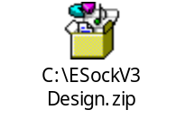

The reference connection arbitrator is NIFMAN
An employee who supervises the gambling in a casino, he must know the games and be able to protect them. He must be able to make fast judgement on the gamers and what to do with them.
In principle multiple Dealers or Players could co-reside in one thread but this runs counter to the stability and performance concerns addressed by this architecture and it wouldn’t provide any added benefit.
Because the client handle may be immediately aliased. A desirable extension to the current EKA2 client/server support would be the ability to “re-connect” a client session to a different server, so that during the session lifetime a more optimal Dealer could be substituted. This idea has been discussed with the Base team but the work required would be non-trivial and would need to be raised as a requirement for them to estimate.
An interesting aside: Nifman also creates a CESockIniData instance which has to search the file system and read the file contents. It would be a nice bonus for start-up performance if it could somehow use the instance already stored in the Player.
Referring to the new, hitherto unknown member of the Star ship Enterprise crew (wearing the standard red uniform), which was sure to be the first (and only) one dying if attacked or if sent with away-team to explore unknown planets surprisingly inhabited by mind-bogglingly powerful creatures of malicious intent.
See sequence for session destructor in 3.2.2.1 “Session handling”.
Note that the stack may choose only to route based upon the Network Id and not IAP Id.
The behaviour of a mixture of Implicit and Explicit connections on an ESock session is yet to be established.
currently NetworkControl
Note that this SetOption() can result in another NoBearer() call which ESock ignores.
The extra latency due to thread context shift has been measured to ~3us on an ARM926ej based core (running at 192MHz with a 96MHz 16bit memory bus) with Symbian OS v9. This number does not include the overhead of using the message queue and active scheduler.
Using the Nif::BindL() API

