Contents
1 Introduction 2
1.1 Purpose and Scope 2
2 The Mobility Protocol 2
2.1 The mobility handshake 2
3 Mobility Protocol Messages 4
4 Client Side Mobility APIs 7
4.1 RCommsMobilityApiExt API 7
4.2 CActiveCommsMobilityApiExt API 11
5 Sequence Examples 13
5.1 Seamless: An example scenario 13
5.2 Non-seamless: Mobility Client Rejects a Carrier it previously chosen to migrate to 13
5.3 Non-seamless: Mobility Client Rejects a Carrier it previously chosen to migrate to and an error occurs during the following migration handshake 14
6 Code Examples 15
7 Overview of The API Extension Mechanism 15
8 Further Information 16
8.1 Glossary 16
8.2 People 18
8.3 References 18
8.4 Open Issues 19
8.5 Document History 19

Introduction

Purpose and Scope
This document describes the client-side APIs in the Comms server that enable bearer mobility on a Symbian OS device. It also shows the way these APIs should be used, explaining the simple handshake protocol between the client of a connection and the Comms server that completes the migration of a connection from one bearer to another.
The APIs, both declared in cs_mobility_apiext.h, are
RCommsMobilityApiExt
CActiveCommsMobilityApiExt
These are extension APIs for RConnection and are both equivalent alternatives (the latter is simpler, but requires the presence of active scheduler). The API extension mechanism is also briefly described here.
These APIs have been introduced into the 9.2 release of Symbian OS, in advance of a Bearer Mobility implementation on the platform, so that they can be used by licensees and other third parties who are implementing their own Bearer Mobility solution.
The protocol and the API support both non-seamless and seamless bearer mobility, though the initial Symbian OS implementation will be for the non-seamless case, requiring involvement of the client of a connection to complete the migration to a new bearer.
This document is intended to be read by any developer using these APIs.

The Mobility Protocol
This section presents an overview of the Mobility handshake protocol.
For example scenarios, please see sequences in section 5.

The mobility handshake
The client of a connection registers for bearer mobility by opening the bearer mobility extension API for its connection and listening for migration notifications. There are three main mobility scenarios with many use case scenarios for each of these:
- Non-seamless mobility requiring client interaction;
- Seamless mobility with notification to client;
- Seamless mobility with no client involvement;
The last option clearly requires no use of the client facing bearer mobility APIs. The two other scenarios are roughly sketched here and presented in greater detail in section [3].

Migration handshake for non-seamless bearer mobility
1/ Client opens the mobility API to register for mobility notifications.
2a/ Server monitors availability of preferred carriers and notifies when one is available.
or
2b Client rejects the currently started connection and the server offers an alternative, if one is available.
3/ Client decides whether to accept or reject the migration
4/ Server migrates the connection
5/ Client re establishes sockets over migrated connection and confirms (or not – see below) validity of the connection to the server. Sub-connections will be renegotiated with the same parameters and therefore usual procedure applies.
Should the socket re-establishment fail, a new migration handshake will be triggered. This time a new carrier should be offered to the client, however, if no relevant blacklisting mechanism is provided, the same old carrier will be offered again provided it is still available and preferred.

Migration handshake for seamless bearer mobility with client interaction
The same protocol can be used when mobility of a connection is managed seamlessly, with the Comms Stack handling migration of any open sockets or sub-connection channels as well as migration of the connection.

Migration handshake for seamless bearer mobility with migration notification
If a client registers for notification of seamless bearer mobility they will be informed with this message when a service has been migrated, but no response will be expected.
Any response that should be sent by client following NewCarrierActive will be ignored.

Mobility Protocol Messages
This section describes the Messages exchanged between the client and the server during the mobility handshake.
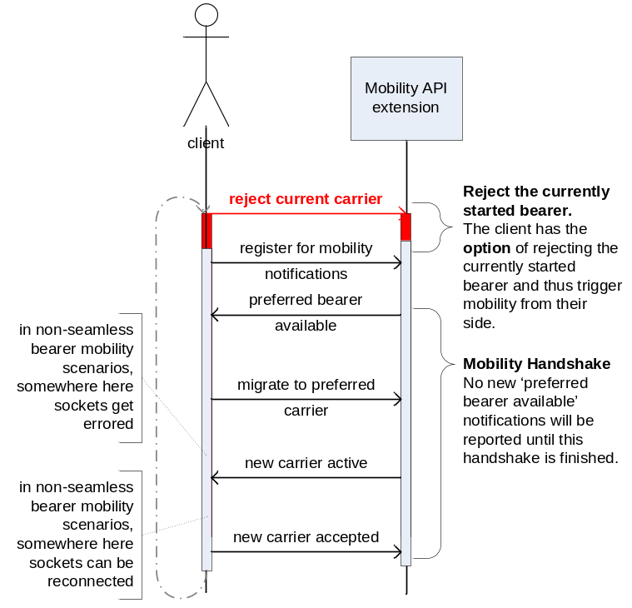
Figure 3-1 - Mobility Protocol - success case
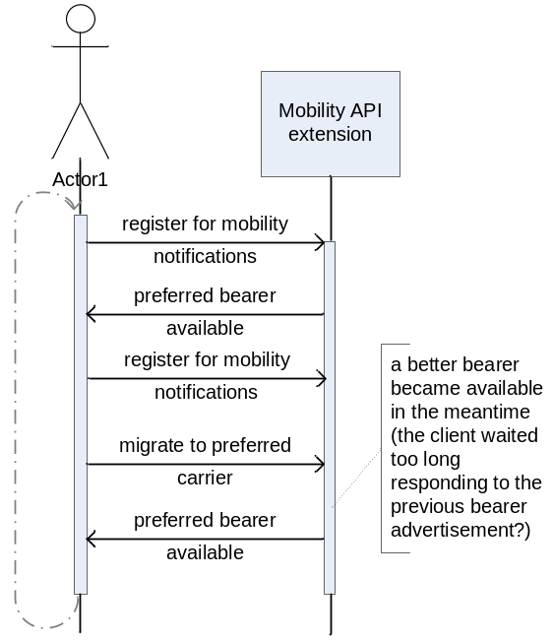
Figure 3-2 - Mobility Protocol - handshake pre-emption.
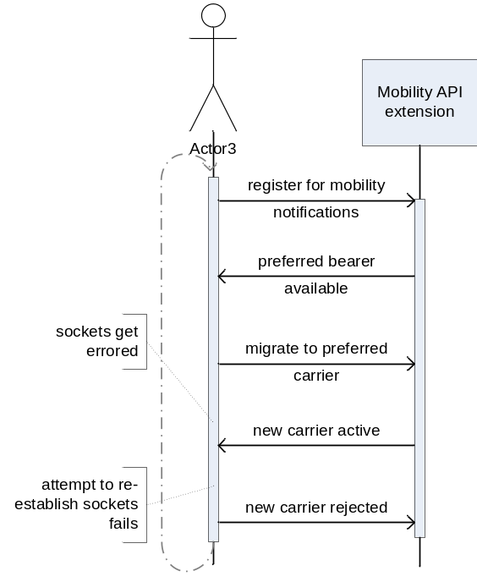
Figure 3-3 - Mobility Protocol - failure case – the new bearer unsuitable.
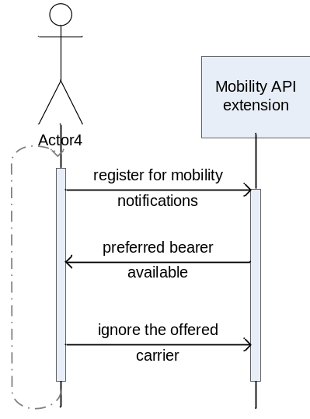
Figure 3-4 - Mobility Protocol - the new bearer ignored
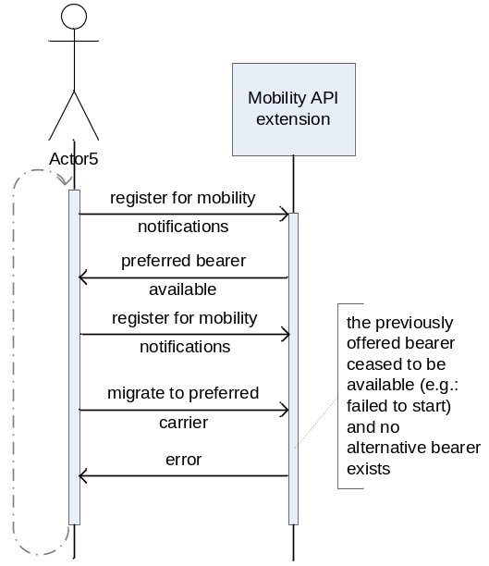
Figure 5 - Mobility Protocol - failure case (no more beaers)
The client will perceive an error from the mobility protocol when there are no bearers available.
The following sections describe the code constructs (the APIs) that enable the message exchanges depicted above.

Client Side Mobility APIs
There is currently no Mobility Implementation for Symbian OS. The APIs have been provided in advance to be validated by licensees. Currently there are two client-side Mobility APIs provided. These are: RCommsMobilityApiExt and CActiveCommsMobilityApiExt. Both APIs provide access to the Bearer Mobility Protocol Implementation. Both enable semantically identical communication between the Mobility Client and the Server. But there are differences in the way both APIs are used:
- RCommsMobilityApiExt does not require a running Active Scheduler in the client’s thread, CActiveCommsMobilityApiExt does.
- CActiveCommsMobilityApiExt is easier to use than RCommsMobilityApiExt, because it doesn’t expose the IPC messages, unpacking of mobility parameters (attributes of the Mobility message), managing life spans of buffers that need to be valid for the duration of asynchronous calls, etc). CActiveCommsMobilityApiExt hides all this work behind a simple APIs while RCommsMobilityApiExt leaves all this to be done by the Client.

RCommsMobilityApiExt API
RCommsMobilityApiExt can be used by any client, one running an Active Scheduler and one that is not. However, if the Active Scheduler is present, it is recommended to use CActiveCommsMobilityApiExt (see [4.2]) which is much simpler (please see the “Sequence Examples” section below for some comparisons).
class RCommsMobilityApiExt : public RCommsApiExtension<EMobilityApiExt>
/**
Comms Mobility API extension for a client not running an Active Scheduler.

This class can actually be used by any client, running an Active Scheduler
and one that is not. However, if the Active Scheduler is present,
it is recommended to use CActiveCommsMobilityApiExt which is much simpler.

@see CActiveCommsMobilityApiExt
@internalTechnology
@prototype
*/
{
public:
/**
The default and only constructor.
*/
IMPORT_C explicit RCommsMobilityApiExt();

/**
Close this API extension handle. For ::Open, see class RCommsApiExtension
@see RCommsApiExtension
*/
IMPORT_C void Close();

/**
The generic mobility notification registration API. All mobility messages
(CCommsApiExtRespMsg) are conveyed to the client by completing the TRequestStatus
passed to this method. The mobility messsages are:
-EPreferredCarrierAvailable (notification),
-ENewCarrierActive (completion of MigrateToPreferredCarrier()),

An example code for extracting the message is below:
===================================================
CCommsApiExtRespMsg* msg = NULL;
msg = CCommsApiExtRespMsg::NewL(*aResponseEventBuf);
if (msg->IsTypeOf(STypeId(KMobilityMessagesImplementationUid,EPreferredCarrierAvailable)))
{
//handle EPreferredCarrierAvailable here
...
}
...
===================================================
As mobility messages can be notifications or responses to requests (completions),
consequently RegisterForMobilityNotification is also used as the request error
path.

@param aResponseEventBuf - serialised mobility messages from the server;
@param aStatus - for request responses; the completion error status;
*/
IMPORT_C void RegisterForMobilityNotification(TDes8& aResponseEventBuf,
TRequestStatus& aStatus);

/**
Cancels the previously requested subscription for Mobility notifications;
@see RegisterForMobilityNotification
*/
IMPORT_C void CancelMobilityNotification();

/**
Requests that the Implementation should migrate the Client to the newly offered preferred
carrier (or, in case of the current carrier becoming unavailable, to the less preferred
but available carrier).
Migration confirmed flagged with ENewCarrierActive;
@see RegisterForMobilityNotification
*/
IMPORT_C void MigrateToPreferredCarrier();

/**
Requests that the Implementation ignores (doesn't migrate) the Client to the newly offered
preferred carrier and that the Client wishes to continue using the current carrier.
There is no response to this request.
*/
IMPORT_C void IgnorePreferredCarrier();

/**
Informs the Implementation that the Client wishes to use the new carrier it has been
migrated to.
*/
IMPORT_C void NewCarrierAccepted();

/**
Instructs the Implementation that the Client wishes to reject the new carrier it has
been migrated to and be offered another preferred carrier unless nothing else is
available. In case nothing else is available this request completes with an error.
*/
IMPORT_C void NewCarrierRejected();
};

CCommsApiExtensionMsg – communication from the Mobility Implementation to the Mobility Client
In case of RCommsMobilityApiExt, the communication from the Implementation to the Client has the form of a registration and a response, where the latter comes in a form of a message. RCommsMobilityApiExt exposes all of the corresponding IPC messages to the Client which needs to understand and process each message to learn what mobility notification and with what information it has received. Currently there are two different Mobility notifications in form of two messages (all based on CCommsApiExtensionMsg):
class CPreferredCarrierAvailable : public CCommsMobilityApiExtRespMsg
/**
Preferred carrier available message. Informs about newly available preferred carrier.

@publishedPartner
@prototype
*/
{
friend class CMobilityMsgFactory;

public:
/**
Dispatches the message.

@param aProtocol The protocol used for dispatching the response message.
*/
void DispatchL(MMobilityProtocolResp& aProtocol);

/**
Creates a new CNewCarrierActive response message

@return A pointer to a message instance if successful, otherwise leaves with error code.
*/
inline static CPreferredCarrierAvailable* NewL();

/**
Returns the current access point information.

@return The value of iOldAP.
*/
inline TAccessPointInfo OldAPInfo() const;

/**
Sets the current access point information.

@param aAPInfo The "current access point" information - iOldAP will be set to that value.
*/
inline void SetOldAPInfo(TAccessPointInfo aAPInfo);

/**
Returns the new access point information.

@return The value of iNewAP.
*/
inline TAccessPointInfo NewAPInfo() const;

/**
Sets the new access point information.

@param aAPInfo The "new access point" information - iNewAP will be set to that value.
*/
inline void SetNewAPInfo(TAccessPointInfo aAPInfo);

/**
Returns whether the new access point is an upgrade to the current or a downgrade
(because the current access point ceases to be available).

@return upgrade/downgrade indication.
*/
inline TBool IsUpgrade() const;

/**
Sets upgrade/downgrade information (see IsUpgrade())

@param aIsUpgrade - upgrade/downgrade indication.
@see IsUpgrade()
*/
inline void SetIsUpgrade(TBool aIsUpgrade);

/**
Returns the seamless/non-seamless migration indication. If non-seamless
re-establishment of sockets required.

@return The value of iIsSeamless.
*/
inline TBool IsSeamless() const;

/**
Sets the the seamless/non-seamless migration indication (see IsSeamless()).

@param aIsSeamless - seamless/non-seamless migration indication.
*/
inline void SetIsSeamless(TBool aIsSeamless);

...
};

(Please refer to 8.1as to how legacy IAP is to be supported)
class CNewCarrierActive : public CCommsMobilityApiExtRespMsg
/**
New carrier active message, i.e.: the confirmation that the new carrier which
has been accepted by the Client is now the current one.

@publishedPartner
@prototype
*/
{
friend class CMobilityMsgFactory;

public:
/**
Dispatches the message.

@param aProtocol The protocol used for dispatching the response message.
*/
void DispatchL(MMobilityProtocolResp& aProtocol);

/**
Creates a new CNewCarrierActive response message

@return A pointer to a message instance if successful, otherwise leaves with error code.
*/
inline static CNewCarrierActive* NewL();

/**
Returns the new access point information.

@return The value of iNewAP.
*/
inline TAccessPointInfo NewAPInfo() const;

/**
Sets the new access point information.

@param aAPInfo The "new access point" information - iNewAP will be set to that value.
*/
inline void SetNewAPInfo(TAccessPointInfo aAPInfo);

/**
Returns the value of the seamless flag.

@return The value of iIsSeamless.
*/
inline TBool IsSeamless() const;

/**
Sets the new access point information.

@param aAPInfo The "new access point" information - iNewAP will be set to that value.
*/
inline void SetIsSeamless(TBool aIsSeamless);
...
};
When a Client registers for Mobility notifications, it is calling this API: RCommsMobilityApiExt::RegisterForMobilityNotification(TDes8& aResponseEventBuf, TRequestStatus& aStatus). It passes a buffer (TDes8) and a TRequestStatus object as parameters.
The buffer must of course be valid for as long as this call completes (either on its own or after being cancelled via CancelMobilityNotification()).
The Implementation may then send a notification to the Client by copying an IPC Mobility message into the buffer provided by the Client and completing the Client.
If no error has occurred (aStatus.Int()==KErrNone), the buffer contains one of the Mobility Notification Messages. If any error has occurred (including KErrCancel) there is no valid information in the buffer.
To get hold of the message something like the following sequence is necessary. This is also an example of the CActiveCommsMobilityApiExt’s much superior simplicity over RCommsMobilityApiExt where there is no need for this kind of processing.
Assuming that “iBuffer” was the first parameter to previously issued RCommsMobilityApiExt::RegisterForMobilityNotification(), this is the sequence necessary to get access to notification’s attributes.

CCommsApiExtensionMsg* msg = NULL;
TRAP(error,msg = CCommsApiExtensionMsg::NewL(iBuffer));
if (error != KErrNone)
{
//Error handling
…
}

//check types
STypeId preferredCarrierAvailableTID(KMobilityMessagesImplementationUid,
EPreferredCarrierAvailable);
STypeId newCarrierActiveTID(KMobilityMessagesImplementationUid, ENewCarrierActive);

if (msg->IsTypeOf(preferredCarrierAvailableTID))
{
…
}

else if (msg->IsTypeOf(newCarrierActiveTID))
{
…
}
delete msg;

CActiveCommsMobilityApiExt API
CActiveCommsMobilityApiExt can be used by a client that is running an Active Scheduler. Whenever an Active Scheduler is present this API is recommended over RCommsMobilityApiExt because of its simplicity. With few important exceptions, CActiveCommsMobilityApiExt exports very similar APIs to RCommsMobilityApiExt:
class CActiveCommsMobilityApiExt : public CActive
/**
Comms Mobility API extension for client running an Active Scheduler.. Whenever an Active
Scheduler is present, this API is recommended over RCommsMobilityApiExt because of its simplicity.

With few important exceptions, CActiveCommsMobilityApiExt exports very similar APIs to RCommsMobilityApiExt

@see RCommsMobilityApiExt

@publishedAll
@released
*/
{
public:
/**
The construction method for CActiveCommsMobilityApiExt.

@param aExtensionProvider - the RConnection object this API extension should be openned against.
@param aProtocol - client implementation of MMobilityProtocolResp for callbacks.
@see MMobilityProtocolResp
*/
IMPORT_C static CActiveCommsMobilityApiExt* NewL(RCommsSubSession& aExtensionProvider,
MMobilityProtocolResp& aProtocol);
IMPORT_C ~CActiveCommsMobilityApiExt();

/**
Requests that the Implementation should migrate the Client to the newly offered
(offered with MMobilityProtocolResp::PreferredCarrierAvailable) preferred carrier
(or, in case of the current carrier becoming unavailable, to the less preferred
but available carrier).
Migration confirmed with MMobilityProtocolResp::NewCarrierActive() or failed with
MMobilityProtocolResp::Error()
@see MMobilityProtocolResp
*/
IMPORT_C void MigrateToPreferredCarrier();

/**
Requests that the Implementation ignores (doesn't migrate) the Client to the newly offered
(offered with MMobilityProtocolResp::PreferredCarrierAvailable) preferred carrier
and that the Client wishes to continue using the current carrier.
There is no response to this request.
*/
IMPORT_C void IgnorePreferredCarrier();

/**
Informs the Implementation that the Client wishes to use the new carrier it has been
migrated to.
*/
IMPORT_C void NewCarrierAccepted();

/**
Instructs the Implementation that the Client wishes to reject the new carrier it has
been migrated to and be offered another preferred carrier unless nothing else is
available. In case nothing else is available this request completes with
MMobilityProtocolResp::Error().
*/
IMPORT_C void NewCarrierRejected();

protected:
...
};

MMobilityProtocolResp APIs – communication from the Mobility Implementation to the Mobility Client
Contrary to RCommsMobilityApiExt, using TRequestStatus for asynchronous communication, CActiveCommsMobilityApiExt the uses a call-back interface of: MMobilityProtocolResp.
MMobilityProtocolResp call-back methods are semantically equivalent to CCommsApiExtensionMsg messages (see [4.1.1]) used with RCommsMobilityApiExt, but the work of marshalling messages and accessing its attributes is done internally by CActiveCommsMobilityApiExt. The Client does not need to be concerned about that (lifespan of the buffers, checking message types, etc) and is simply being called via one of the MMobilityProtocolResp‘s APIs.
When a Mobility notification arrives from the server to the client-side CActiveCommsMobilityApiExt extension it is being dispatched via MMobilityProtocolResp.
class MMobilityProtocolResp
/**
Comms Mobility API extension protocol - client implemented callback interface.
Used with CActiveCommsMobilityApiExt to register for mobility response messages.

@publishedAll
@released
*/
{
public:
/**
Comms mobility notification about a preferred bearer becoming available.
This call is an equvallent of the EPreferredCarrierAvailable mobility
message (CCommsApiExtRespMsg).

@param aOldAP - information on the current access point;
@param aNewAP - information on the offered (proposed) access point;
@param aIsUpgrade - if set, the new carrier is a preferred
than the current one, if cleared, the new carrier is
preferred from the rest of the carriers because the current
one is no longer available.;
@param aIsSeamless - seamless/non-seamless migration notification. If non-seamless
re-establishment of sockets required.
*/
virtual void PreferredCarrierAvailable(TAccessPointInfo aOldAP,
TAccessPointInfo aNewAP, TBool aIsUpgrade, TBool aIsSeamless) = 0;

/**
A response (completion) to CActiveCommsMobilityApiExt::MigrateToPreferredCarrier.
This call is an equvallent of the ENewCarrierActive mobility message
(CCommsApiExtRespMsg).

@param aNewAP - the information on the new access point;
@param aIsSeamless - seamless/non-seamless migration notification. If non-seamless
re-establishment of sockets required.
*/
virtual void NewCarrierActive(TAccessPointInfo aNewAP, TBool aIsSeamless) = 0;

/**
An error response (completion) of the previous request.

@param aError - the error code;
*/
virtual void Error(TInt aError) = 0;
};

Sequence Examples
This section presents some examples of the use of the mobility protocol.

Seamless: An example scenario
The same scenario using both APIs:

RCommsMobilityApiExt
1) RCommsMobilityApiExt::Open(RCommsSubSession& aExtensionProvider)
The client application opens RCommsMobilityApiExt on RConnection/RCommsManager that is associated with a particular connection.
2) RCommsMobilityApiExt::RegisterForMobilityNotification(TDes8& aResponseEventBuf, TRequestStatus& aStatus)
Using the Mobility extension, the client registers for Mobility Notifications. It may or not be already sending data (having and using a socket) over the connection.
3) aStatus completed with KErrNone.
The Mobility Implementation sends a notification of a new carrier being active. The client does not need to undertake any further actions and can continue to use its sockets.

CActiveCommsMobilityApiExt
1) CActiveCommsMobilityApiExt::NewL(RCommsSubSession& aExtensionProvider,
MMobilityProtocolResp& aProtocol)
The client application creates a new extension CActiveCommsMobilityApiExt on RConnection/RCommsManager that is associated with a particular connection. It provides its own implementation of the MMobilityProtocolResp. The client may or not be already sending data (having and using a socket) over the connection.
4) MMobilityProtocolResp::NewCarrierActive(TAccessPointInfo aNewAP)
The Mobility Implementation sends a notification of a new carrier being active. The client does not need to undertake any further actions and can continue to use its sockets.

Non-seamless: Mobility Client Rejects a Carrier it previously chosen to migrate to
The same scenario using both APIs:

RCommsMobilityApiExt
1) RCommsMobilityApiExt::Open(RCommsSubSession& aExtensionProvider)
The client application opens RCommsMobilityApiExt on RConnection/RCommsManager that is associated with a particular connection.
2) RCommsMobilityApiExt::RegisterForMobilityNotification(TDes8& aResponseEventBuf, TRequestStatus& aStatus)
Using the Mobility extension, the client registers for Mobility Notifications. It may or not be already sending data (having and using a socket) over the connection.
3) aStatus completed with KErrNone.
A new, preferred (upgrade, non-seamless) carrier becomes available and the Mobility Implementation sends a corresponding notification. The client processes the received message and decides to migrate.
4) RCommsMobilityApiExt::MigrateToPreferredCarrier()
The Client decides to migrate to the new carrier.
5) RCommsMobilityApiExt::RegisterForMobilityNotification(TDes8& aResponseEventBuf, TRequestStatus& aStatus)
The client also reregisters for Mobility notifications
6) aStatus completed with KErrNone.
The Mobility Implementation sends a confirmation of the new carrier being active. The client processes the received message. In case of the non-seamless mobility (as indicated in the PreferredCarierAvailable notification), the client reconnects all of its sockets. Then the Client tries to use the new carrier (i.e. send data) which is unsuccessful.
7) RCommsMobilityApiExt::NewCarrierRejected()
The Client rejects the new carrier.
8) A new migration handshake takes place here.

CActiveCommsMobilityApiExt
1) CActiveCommsMobilityApiExt::NewL(RCommsSubSession& aExtensionProvider,
MMobilityProtocolResp& aProtocol)
The client application creates a new extension CActiveCommsMobilityApiExt on RConnection/RCommsManager that is associated with a particular connection. It provides its own implementation of the MMobilityProtocolResp. The client may or not be already sending data (having and using a socket) over the connection.
2) MMobilityProtocolResp::PreferredCarrierAvailable(TAccessPointInfo aOldAP, TAccessPointInfo aNewAP, TBool aIsUpgrade, TBool aIsSeamless)
The client receives notification of a new, preferred (upgrade, non-seamless) carrier becomes available.
3) CActiveCommsMobilityApiExt::MigrateToPreferredCarrier()
The Client decides to migrate to the new carrier.
4) MMobilityProtocolResp::NewCarrierActive(TAccessPointInfo aNewAP, TBool aIsSeamless)
The Mobility Implementation sends a confirmation of the new carrier being active. The client processes the received message. In case of the non-seamless mobility (as indicated in the PreferredCarierAvailable notification), the client reconnects all of its sockets. Then the Client tries to use the new carrier (i.e. send data) which is unsuccessful.
5) CActiveCommsMobilityApiExt::NewCarrierRejected()
The Client rejects the new carrier.
6) A new migration handshake takes place here.

Non-seamless: Mobility Client Rejects a Carrier it previously chosen to migrate to and an error occurs during the following migration handshake
The same scenario using both APIs:

RCommsMobilityApiExt
1-8) Sequence as in the previous example “Mobility Client Rejects a Carrier it previously chosen to migrate to”
9) RCommsMobilityApiExt::RegisterForMobilityNotification(TDes8& aResponseEventBuf, TRequestStatus& aStatus)
The client registers for Mobility Notifications.
10) aStatus completed with an error code (KErrNotFound).
Normally, there would be a new migration handshake taking place here (i.e. PreferredCarierAvailable). But in this case, the only carrier (which the client has been using before) become unavailable and can not be proposed to the client again.

CActiveCommsMobilityApiExt
1-6) Sequence as in the previous example “Mobility Client Rejects a Carrier it previously chosen to migrate to”
7) MMobilityProtocolResp::Error(Tint aError)
Normally, there would be a new migration handshake taking place here (i.e. PreferredCarierAvailable). But in this case, the only carrier (which the client has been using before) become unavailable and can not be proposed to the client again.

Code Examples

It is intended to provide code examples as they become available.

Overview of The API Extension Mechanism
The API extension mechanism is described elsewhere in Elements documentation [R1]. A brief overview is supplied here.
An extension API is opened and initialised with the instance of the API that it extends – RConnection, for example.
An extension API currently allows for three types of messages to be sent from the client side API to the server side implementation and back from the Implementation to the client-side API.
Message: from an extension API to the implementation where no response is required from the implementation.
Request: from an extension API to the implementation where a response is required from the implementation.
Response: to an API request, returned from the implementation to the client API
Messages are sent transparently to the client when one of the extension’s APIs is being used (for example RCommsMobilityApiExt). Receipt of a message results in a call being made on the Implementation’s side (for example on MMobilityProtocolReq).
Requests also originate from a corresponding call to one of the APIs on the particular extension, and arrive at the Implementation via one of the calls it implements.

Further Information

Glossary
Access Point (AP) = Service access point. A point at which any layer of the connection stack (but the bottom) can obtain services from the next, lower layer. The next layer is a bearer for this layer (see Bearer). The picture below shows the AP philosophy. The physical layer however is at the moment somewhat merged with link layer. (see IAP).

Network layer
Link layer
IP
Physical layer
GPRS
WiFi
CSD
MCP
AP
AP
AP
AP
AP
Figure 8-6: Definition of an access point. At each layer of the connection stack, each bearer provides its access point(s) through which an upper layer can obtain its services

Bearer = Provider of a particular connection (e.g. WiFi, LAN, IP,…). A bearer advertises access points as an access to services (see Access Point).
Carrier = An Access Point that belongs to a layer where the Mobility (bearer switch) takes place as seen by the Mobility client.
Connection Provider = An object (instance) representing an access point.
Default SNAP = A default AP (on the network layer).
IAP = Internet Access Point. It is a specialisation of AP for a link layer. IAPs identify a service to access via a very concrete link layer bearer. It at the moment comprises Link bearer type, service type and physical bearer type. Please note that mobility API refers to AP instead of IAP. IAP is effectively link tier AP. To keep BC with application referring to IAP rather than link tier AP commsDat must make sure that for every IAP there is one link tier AP having the same physical value.
Legend:
generalization
Access Point (AP)
Internet Access Point (IAP)
Service Network Access Point (SNAP)
Figure 8-7 “Hierarchy” of Access Points

Mobility Client = A client application that uses a Mobility Extension API.
Mobility Implementation = A server side implementation that provides Mobility functionality enabled by the Mobility Extension APIs. Usually implemented as part of a Connection (or a Meta Connection) Provider.
Next layer = layer immediately below.
Plugin = (ECom plugin) = An implementation that can be instantiated in the client’s process by the ECom component via especially provided dlls.
Policy plugin = An implementation of a policy logic (pluggable logic, algorithm).
Preferred Carrier = A Carrier that the Mobility client prefers to the one currently used.
Previous layer = layer immediately above.
Service Network = Destination Network plus required service (e.g. IMAP on Symbian network).
SNAP = Service Network Access Point. It is a specialisation of AP for a network layer. A concept developed especially for bearer mobility to identify a Service Network with a service to be accessed on this network. It decouples this information from any particular bearer (see AP).
While the old concept of IAPs (Internet Access Points – and in fact a link layer access points) works fine for connections (even with Multihoming – where the device can connect to multiple networks at the same time) in a non-bearer mobility environment, it is inadequate for bearer mobility environments. An IAP is always tied up to (represents) a particular link layer bearer and as such cannot be used to specify bearer independent selection preferences.
Service Network Access Point (SNAP = network layer access point) has been introduced to address the needs of applications to specify access points on service networks for particular services without the need to care about any particular link layer bearers.
For the purpose of this document it is also possible to think of a SNAP as a collection of IAPs that specify the same network and the same service on that network. This document describes the simplest SNAP selection policy forming such a collection of IAPs (one or more IAP ordered by their desirability to access the particular service).
Internet – provides services X & Y.
Symbian
Vodafone
1. WiLan
2. Ethernet
3. GPRS
4. WiLan
A firewall which blocks service X, but allows service Y
SNAPX: 4,3.
SNAPY: 1,2,4,3.
App
MS
Figure 8-8 An application X may want to use service X while another application Y may want to use service Y (in this example on the same service network). In this example access via Symbian’s network is preferred as well as WiLan is preferred over GPRS. Somewhere in between Symbian and Internet there is a firewall blocking all traffic of type X. Of course each application could simply be trying each IAP one by one but it could also specify a SNAP it wants to use. Since then all the work of the bearer selection and mobility will be done for the application.

People

Role | Person / People
Reviewers | Petr Smrz, Viki Turner, Richard Collin
Contributors | Michal Zurowski, Viki Turner, Remek Zajac
Distribution | Anyone using or maintaining the Mobility APIs.

References
No. | Document Reference | Version | Description
[R1] | N/A | v2.0 | API Extensions design

Open Issues
More scenarios will be added to complete the use cases for the API

Document History
Date | Version | Status | Author | Description
11-04-2006 | 0.1 | Draft | Michal Zurowski | New Document
21-04-2006 | 0.2 | Draft | Michal Zurowski, Viki Turner | Initial revision
26-04-2006 | 0.3 | Draft | Michal Zurowski, Petr Smrz | Updated after review
11-04-2008 | 1.0 | Issued | Remek Zajac | Updates after feedback.
03-04-2009 | 1.1 | Issued | Remek Zajac | Updates to allow for the client to reject the currently started carrier outside of the mobility handshake and thus trigger mobility.

