C32 Design Document

Security Classification: | Internal
Document Reference: | N/A
Status: | Issued
Version: | 1.21
Last Revised Date: | 2nd April 2007
Team/Department : | Converged Comms/Core Development
Author(s): | Stephen Burden, Prasoon Jaiswal
Owner(s): | Ser-Comms TA

Approver(s): | Ser-Comms TA | Distribution: | XXX

Contents

Please note it seems Word won’t update this TOC until the change history is removed.
1 Introduction 4
1.1 Purpose and Scope 4
1.2 Document conventions 4
2 Design Overview 5
2.1 CSY Co-operation via multiple threads 6
2.1.1 Threading model 7
2.1.2 Overview of CMI file configuration 8
3 Detailed Design 9
3.1 C32 Client 9
3.2 The C32 Server 9
3.2.1 Division of responsibilities 9
3.2.2 Server Startup 10
3.2.3 Server Shutdown 10
3.2.4 The Worker Thread 11
3.2.5 On-Demand Module Loading and binding of CPMs 13
3.2.6 The Dealer 13
3.2.7 Overview of C32 APIs 21
3.2.8 Forwarding requests to other threads 22
3.2.9 Session Creation and Close 23
3.2.10 Loading a CSY Module 25
3.2.11 Unloading a CSY Module 27
3.2.12 The Player 28
3.2.13 Opening a Comm Port 28
3.2.14 Closing a Comm Port 30
3.2.15 Read/Write operation on Comm Port 31
3.2.16 CExtra class and pre-emption 32
3.2.17 Notifiers 32
3.2.18 Multiple access co-ordination in CPort 33
3.2.19 Logging 33
4 Platform Security 35
4.1 Capability Assignments 35
4.2 API Policing 35
4.3 Protected Server Name for EKA2 37
5 CSY interface: CPort and CSerial 38
5.1 CPort and CSerial API classification 38
5.2 CCommTimer and the TLS 38
6 Supplied CSYs 38
6.1 ECUART CSY 39
6.2 Loopback CSY 39
6.3 Dummy* CSYs 40
6.4 CSY27010.csy 40
7 Further Information 41
7.1 Outstanding issues 41
7.2 People 41
7.3 References 41
7.4 Glossary 41
7.5 Document History 42
8 Appendices 43
A.1 Future Possible Improvements to Performance 43
A.1.1 Extended RCommServ API 43
A.1.2 Make CSY active object priorities configurable 43
A.1.3 Enhance Shutdown for use in Production cases 43
A.2 Future Possible Improvements to C32’s integration to Comms 43

Introduction

Purpose and Scope
The purpose of this document is to show the detailed design for the C32 component. C32 has been changed to a multi-threaded system, which for distinction from previous versions of C32 is referred to as C32MT.
The C32 component predates this design document and as such this document does not give full coverage of the design, but only coverage of those parts of C32 that have been modified during the lifetime of this document.

Document conventions
Please note that due to the similar nature of the multi-threaded design in C32 to that in Esock, several of the high-level classes in both designs represent the same roles and so have similar names. To differentiate between them the classes in C32 have “C32” in the names. It was considered that the class names could be the same between Esock and C32 and instead use a namespace in C32 to differentiate them. However, this makes documentation of the design somewhat confusing as both designs would refer to the same class name, but be referring to different actual classes.
With Serial Server being a part of the Comms system, this design makes periodic references to components from the Comms Infrastructure subsystem such as Rootserver, Configurator, Comms Framework and Comms Debug Utility. It is expected that the reader already has a basic understanding of these components and access to their documentation, although this document makes every effort to briefly describe any necessary terminology and concepts.

Design Overview
The C32 component provides the C32 server (also known as the Serial Server) to manage multiple client access to serial ports. Plug-in modules, called CSYs (Comms SYstem plugins), provide the specific serial ports that are accessed by the client through C32. C32’s client API, as defined in c32comm.h, consists of RCommServ which gives the client a session to the server and RComm, which is a sub-session within the RCommServ session and provides an API to a serial port. An RComm sub-session represents precisely one serial port and once created must be destroyed before it can represent another port. The RComm API allows client access to a serial port in order to do the following:
- Send serial data
- Receive serial data
- Configure the serial port
- Monitor the hardware control lines of the serial port
The serial service provider API, defined in cs_port.h, is C32’s interface to the CSYs. It consists of two classes: CSerial, a factory class with essentially only one function that is overridden in the CSY and exposed by it so that C32 can ask the CSY to create a new serial port; and CPort, representing within C32 an open and potentially shareable serial port. CPort attempts to implement as much common functionality as possible, and as such has quite a large API. A CSY then derives from CPort in order to provide the remaining port functionality and behaviour.

Figure 1 shows how a client’s RCommServ session and RComm sub-session is represented by the server as a CCommSession and CCommSubSession object respectively, with a single CPort object referenced by the CCommSubSession managing the single serial port.
The Ser-Comms subsystem includes one CSY module (ECUART.CSY) that drives the hardware’s built-in serial ports (COMM::0 and, under WINS, COMM::1), and two CSYs used in testing: Loopback and Dummy. None of these CSYs may necessarily ship in an actual phone, and it is usually the case that manufacturers will also ship their own CSYs.

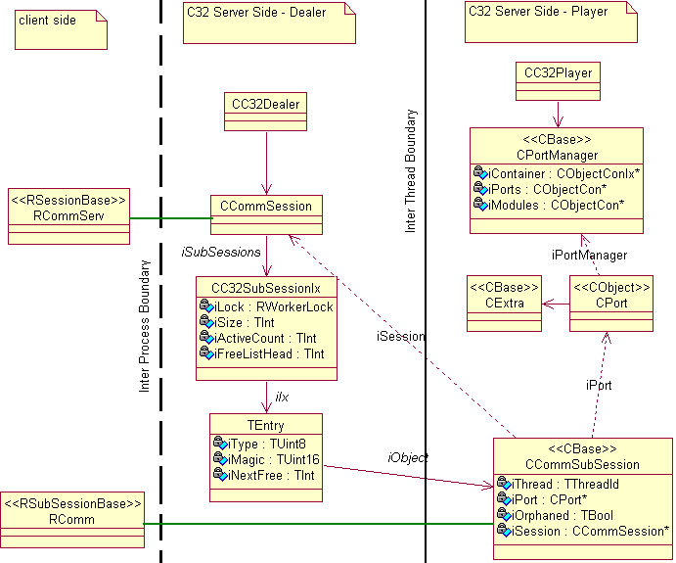
Figure 1 - C32Server class diagram (showing dealer, player & relationship with client classes)

CSY Co-operation via multiple threads

C32 operates a multi-threaded system in order to help alleviate various problems with managing CSYs. This move to a multi-threaded system from the previous single-thread system has had a large effect on the design on C32, and so the reasoning behind the multi-threading choice is given here.

In an ideal situation C32 would have all its CSYs running in one thread in co-operation with scheduling via Active Objects since this has the smallest memory footprint and highest execution performance. However, this is a somewhat unrealistic model since it would require all CSYs – which came from different vendors - to fully co-operate with each other. Co-operation problems include:
- If the CSY was badly written and performed synchronous operations unnecessarily, or otherwise blocked, it would hold up all other CSYs,
- a CSY could easily starve other CSYs if the priority of its Active Objects was higher than in other CSYs
- As an extension of (2), different mobile phone products have a different emphasis on different features (eg email, music or video) which may put different emphasis on different CSYs. However, there was no means of declaring these priorities to C32.

Hence in Symbian OS 9.4 a new approach to scheduling the CSYs was taken and C32 was made multithreaded, with the threads being configurable by licensees.
This helps solve the above problems since:
- Each CSY or a group of CSYs (configured using CMI files) running in its thread is isolated from the others, so it cannot be starved or blocked by the misbehaviour of another CSY.
- Threads are scheduled by the kernel scheduler, which is the most optimal scheduler available on Symbian OS. Thus, all threads used by C32 to run CSYs are assured equal time.
- Throughput may be increased (eg for high speed USB), by running one thread at a higher priority than the others

Examples of CSYs which have high performance requirements are the USB CSY which in some cases must respond to a request within a limited number of milliseconds; and the high throughput needs of a CSY interacting with the baseband chipset. The baseband connection has several possible configurations:
- Etel -> TSY -> ECUART.CSY. The TSY connects to a known COMM port on which the baseband resides and Etel then uses a protocol such as the Hayes “AT” protocol
- Etel -> TSY -> 27.101 CSY. Etel uses a specific CSY to use a different protocol, or even uses a partner’s CSY using a proprietary protocol

The downside to a multi-threading scheme is that the CSYs in threads other than the main thread will suffer a performance drop on each message transfer due to the context switch between the threads involved.

Threading model
The threading concept chosen is a simplified version of the proven Esock multithreading system whereby a thread running the C32 server acts as the main thread and receives all client requests. Where the intended CSY is in a different thread, the main thread (C32_Main) “deals” the request out, so the mechanism to forward all requests to the threads is known as the Dealer. Threads which run the CSYs have some C32 code to receive the request and perform any operations before passing it to the actual CSY. This code is known as the “Player”. Figure 3 illustrates this layout. The C32_Main can also contain a player (not shown).

Rootserver Process
WorkerId 1
C32 Player
Serial CSY
BT CSY
C32 Player
IRDA CSY
Client Process
C32 Dealer
C32_Main
(WorkerId 0)

WorkerId 2
USB CSY
C32 Player
WorkerId 3
Baseband CSY
Figure 2 – Illustration of Dealer and Player threads with a typical configuration of CSYs

If a player thread panics, the current behaviour for any rootserver thread is for this to cause the phone to reboot since all threads are marked as System (unless a Licencee chooses to alter this). Thus, only limited consideration has been given to recovery from a thread dying through a panic. It is possible that in future this will change and cleanup will need to be incorporated.

Overview of CMI file configuration
A typical organisation of the CSYs would be to place them in player threads with no CSYs in the main thread (C32_Main), as shown earlier in Figure 2.
A possible optimisation for performance would be to place high performance CSYs in the main thread (C32_Main), and all other CSYs in other threads, and set the main thread priority to be at least equal to the priorities of the other threads. In this way the high performance CSYs will not be affected by the other CSYs.
The downside to having CSYs in the main thread is that any problems with these CSYs will hold up the Dealer and thus eventually all CSYs. For this reason the default CSY configuration supplied does not have any CSYs in the main thread.
With CSYs in separate threads, some of the C32 server code must be run in each thread, and also execution performance is lost with the need to context-switch between the threads.

Detailed Design

C32 Client

RCommServ is created by the client to represent a session with the C32 Server. RComm is a sub-session of RCommServ and represents a single communications port.

The C32 Server
Rootserver Process
WorkerId 1
C32 Player
Serial CSY
BT CSY
C32 Player
IRDA CSY
Client Process
USB CSY
270.10 CSY
C32 Dealer
C32_Main
(WorkerId 0)

WorkerId 2
C32 Player (co-resident)
Figure 3 - Example co-resident player configuration
Figure 3 shows configuration of CSYs in order to show how a Licensee might decide to organise the CSYs, and especially to show a co-resident Player inside the main thread. A Comms Provider Module (CPM) thread contains the C32 Dealer, as well as the USB and Baseband CSYs (shown as 270.10 in this example). USB and 270.10 have been placed co-resident with the main thread since they require high throughput and low latency. All threads in C32 are actually CPMs, so the term CPM and thread can be used interchangeably in this design.

Division of responsibilities
Sessions are created and owned entirely by the Dealer, while sub-sessions are owned by the Players. All the APIs in RCommServ are handled foremost by the Dealer with some possible requests being sent to the Player for completion, while all the APIs (with the exception of Open and Close) of RComm are simply passed straight through to the appropriate Player by the Dealer. The Player is aware of the CSerial factory that creates CPort objects while the Dealer is not aware of either the CSerial nor the CPort classes.

Server Startup

On Rootserver’s introduction, C32 became a module (CPM) that was started as part of the device bootup – this is in contrast to the earlier behaviour where C32 was started when the first client connected. As part of the work to multi-thread C32, Configurator was enhanced to allow modules to be loaded when required after device boot, rather than always on startup (although possibly very late in startup). This functionality is known as “on-demand” CPM loading. However, C32 itself will remain part of the boot process, with the rationale being that normally Etel’s TSY uses C32 to connect to the hardware. This means that to use any phone functionality, C32 must be loaded.
However, only the C32 server itself will be loaded at bootup, with no CSYs loaded. This means that on bootup only one thread is started in order to house the Dealer and its server.
If the server fails to start this is normally reported back to the Configurator. The server has some means to recover if there is a problem with the mapping of CSYs to threads as described in the cmi files since it can in the worst case ignore the cmi files and load all CSYs into its own thread.

Server Shutdown
Normally once the C32 server is started it will never shutdown, even if all clients disconnect.
Server shutdown is provided so that automated integration testing can unload and reload the C32 system with different configurations in order to test different thread configurations. Another important use of server shutdown is that this is the only way to test for any leaks in a CSY – a facility that will be useful to CSY-writers outside Symbian. Server shutdown is not designed to be used in a production system, although some consideration has been taken to allow this future possibility.
Ordinarily C32 never destroys any threads it creates – once a Player thread is created to house a CSY, it will keep running even if all the CSYs in it have been unloaded. It was felt that the complexity and execution cost in unloading a thread outweighed the small amount of resource involved in keeping the thread alive given that the CPM would be loaded again should the CSY be needed again.
Server shutdown for testing essentially involves the following steps. The action taken is graceful where possible but still assumes that in the majority of cases there should not be any active clients:
- Client that wants to stop C32 connects to Configurator and locates Dealer module by iterating through the C32SerComms group until the module with “Role=Dealer” is found.
- Client then asks Configurator to unload the Dealer Module.
- The Dealer receives this request and begins its shutdown by marking itself as shutting down and rejects all further client communication, although it keeps existing sessions open for the Players to complete requests on
- Dealer sends a message to all players stating it is about to shut them down. In the case of the co-resident player a direct function call is made.
- Dealer waits for players to send back a response saying they have unloaded any resources
- Dealer then closes any outstanding subsessions and then the sessions and unloads all its structures and resources
- Dealer then connects to Configurator and requests a graceful module shutdown for each player CPM
- Server waits for each player thread to exit by waiting on the transports to close
- Server then stops itself and its thread unloads

If the player receives a “graceful” unload without having received a shutdown message from the Dealer, it ignores the unload message. If a player receives an “immediate” unload, it unloads potentially leaking memory since it assumes the state of the main thread is unknown.
The Dealer must stop all players when it receives the unload message since players without a dealer are pointless
This approach seemed cleaner than having to iterate through all C32 modules and asking the rootserver to unload them as this causes too many race possibilities.
A disadvantage with the above approach is that a client wanting to shut down C32 Ser comms needs to find out its module name from CMI files via Configurator, rather than just call an API as might be expected. Also, the above shutdown scheme is quite involved and would possibly take some time to complete.
It was considered to add a debug-build shutdown API to RCommServ, but was felt that performing the operation through Configurator instead followed the pattern already set by Esock, and saved a new API that would need policing. By using Configurator, the policing is already done for us there.

The Worker Thread
The Worker Thread (CC32WorkerThread, see Figure 4) is the generic base class for all C32 threads. It is the holder of the relevant C32 objects in the CPM instance, e.g. the Dealer and the Player (depending on configuration). It is also in charge of inter-thread communication as it holds the object enabling communication with the RootServer (CCommChannelHandler) and a list of objects for communication via Comms Channels with other Worker threads (CCommsTransport)
When RootServer is asked by configurator to start a thread, RootServer calls the CWorkerThread’s ThreadEntryPoint function and passes in the module configuration information, and the worker thread from this then determines whether to start a dealer or player inside this thread. In the current C32MT, the dealer can have a co-resident player for high throughput CSYs.
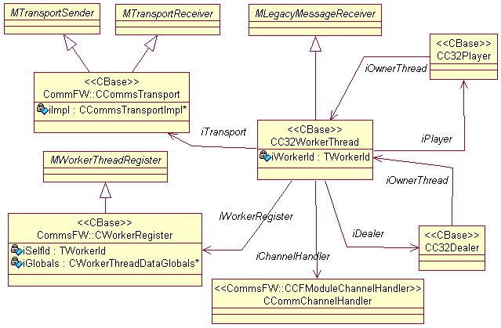
Figure 4 - The Worker thread class diagram
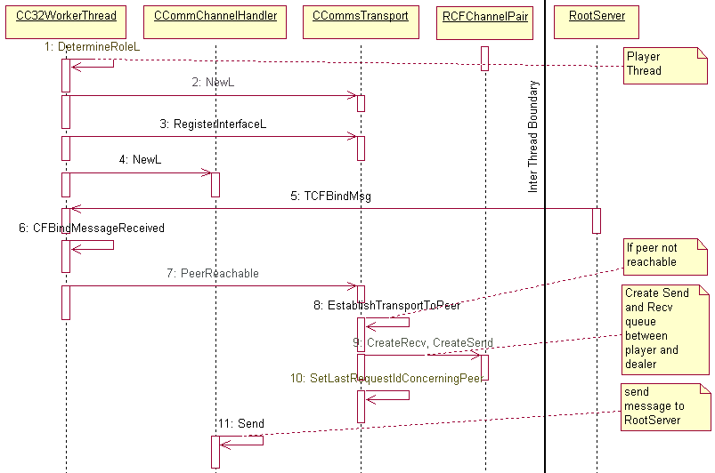
Figure 5 - Construction of Player thread showing Transports
The above sequence diagram shows the construction of the Player thread where transports are established. When bind message is received from the RootServer, the reachability of peer is checked and if peer is not reachable, transports are established using message queues. This way of spawning Player thread is similar to the Esock scheme which currently uses the legacy version of new Transport Mechanism. In future, it is expected that Esock will make use of more advanced features of the transport such as object interfaces. After a proving phase with Esock, C32s own transport may likewise be changed if this proves advantageous.

On-Demand Module Loading and binding of CPMs
When a request to load a CSY is received by the Dealer, the Dealer determines if the Player to which the message needs to be forwarded is running or not. If the Player is not running, then the dealer connects to configurator and starts the new CPM for the Player. Loading of CPMs is asynchronous, so an active object is employed to handle this, which is implemented by the CCPMLoader class. When the Player starts, a Comms channel is established between the RootServer and player thread, which results in a bind message being sent to the WorkerThread. The WorkerThread responds to it in two ways:
- If it is a player, send bind response immediately
- If it is the main thread (C32_Main), send Introduction response to player and postpone bind response to the root server until the introduction response message has arrived back from the player. This ensures that the two modules are bound and Root Server is notified that binding is complete.
By deferring the bind response message, the dealer assures, that the configurator only increments the Sequence start level (SSA level – used by Symbian OS to specify the boot order) when the player has actually bound to the main thread. In practice, however, it is likely that the boot process will be over by the time most CSYs are being loaded, so the Configurator will not have any further SSA levels to increment to.
N.B. There are two kinds of messages – bind messages which are sent from RootServer to WorkerThreads and the other is transport message which is sent from Dealer to Player (after bind message is received by Dealer from RootServer) to exchange information and ensure binding is complete between the Dealer and the Player.

The Dealer
The Main thread is a worker thread that has the task of managing the sessions with the clients, the creation of other threads to accommodate CSYs and manage communication between the threads.
One of the Dealer’s most important possessions is its thread manager structure, known as the C32 Thread Manager (CC32ThreadManager). This structure provides a mapping of CSYs to threads and the states of these entities. It is used primarily to support the API of the RCommServ class, since this class operates on global aspects of the system such as load/unload and querying of modules (CSYs). The structure is essentially a list of elements representing each CSY, the thread the CSY should live in and whether the CSY is loaded.

Storing the CSY Configurations
A problem with moving to a multiple-thread system for C32 was how to let C32 known which CSYs should be loaded into which thread. The decision of which CSY in which thread needed to be easily configured since different hardware configurations usually require different CSY organisation. The solution chosen was to keep the concept begun with Esock that a CMI file provided to the Configurator contained all the system information for a single thread, both the CPM options Configurator understood, as well as other information outside of Configurator’s scope. For example, the concept of a CSY is outside the scope of Configurator, so the [IniData] section for the CMI has been utilised for the purpose of storing C32’s own thread information. This follows the Esock scheme. C32 still uses Configurator, however, to actually fetch the iniData. In the rest of the discussion in this document, references to C32 “reading” the CMI files is used as shorthand for C32 actually querying the CMI files through Configurator. Figure 6 shows the CMI files for a C32 system with just two threads and what the data section would look like. See section Error: Reference source not found for full details of the recognised [inidata] parameters for C32.

C32.cmi
[Loader]
Name=C32_Main
FileName=c32.dll
..
Group=C32SerComms
OnDemand=0
[inidata]
Role=Dealer
WorkerId=0
CSYList=USB,Baseband

C32_Default.cmi
[Loader]
Name=C32_Default
FileName=c32.dll
..
Group=C32SerComms
OnDemand=1
[inidata]
Role=Player
WorkerId=1
CSYList=ECUART,IRDA,BT,*

Figure 6 – Example CMI files for a 2-thread C32 system

In this example the main thread has two CSYs that will load into it: USB and Baseband; while the only Player thread (C32_Default) will load all other CSYs (due to the “*” wildcard). C32 only needs to read these CMI files once – and it does this during its startup before it starts the C32 server. From the data in the CMI files, C32 is able to build up all the information it needs to populate its Thread Manager structure. This structure would initially list all the k nown CSYs and what thread they are in, but would NULL all other parameters. The elements in this structure are known as CSY Information (CCSYInfo) records.
A CSYInfo record inside the Thread Manager stores the following information:
- CSYName – the CSYs filename, added on element creation
- CSYPortPrefix – the CSYs “internal” name – or that which it recognises when a port creation request is received. This field is only known once the CSY is loaded.
- The thread number that this CSY will be loaded into
- A handle to the CSY that is provided by the Player and recognised by the Player. This is stored by the Dealer and passed back to the Player for each operation on this CSY so that the player is saved from having to do its own lookup of the CSY handle
- An Access count of the number of unique sessions that have opened this CSY
- A boolean indicating that the CSY is loaded
- Load Index - An integer recording the number of CSYs that were already loaded (minus 1) at the point this CSY was loaded so that the GetPortInfo(index variant) API can be supported
The CSY list inside the thread manager structure is an array of pointers to the CSY information records – and the records once created are only destroyed when the server shutdown occurs (refer to section 3.2.3).
An early attempt to split this list into two lists to separate loaded from unloaded CSYs was abandoned since it required memory allocation once the Dealer confirmed the Player had loaded the CSY, leaving the Dealer with no reasonable way to rollback if the memory allocation failed. A variant of the GetPortInfo() API takes an index number and in the previous versions of C32 this mapped directly to the index the CSYInfo record occupied in an array that listed every loaded CSY. However, with the introduction of the concept of C32 knowing about some CSYs before they are loaded, the array now contains both loaded and unloaded CSYs. To support this API the original, a central index is mimicked by each loaded CSYInfo record recording what “virtual” index it would have. During the unloading of a CSY these indexes are adjusted appropriately for each active CSYInfo record at a higher index than the CSY just unloaded.
An earlier iteration of the design of C32MT had an index number stored in each CSYInfo record held by the Thread Manager that was the local index that was then sent to the Player, since each Player has its own array of the CSYs it has loaded. However, as a small efficiency the Thread Manager stores a handle that the Player uses to directly locate the CSY – a pointer to the CSerial object that the Player has for the CSY. As this handle is useful in several other scenarios, this trade-of that has the Dealer storing data that is internal to Player was felt to be justified.
For each client request destined for the Player, after indexing the CCSYInfo record in the Thread Manager’s loaded CSY list, the Dealer sends the CSY handle to the Player so it can complete the mapping to the relevant CSY. Figure 7 shows the sequence involved in a call to GetPortInfo when the client sends the CSY index number

The CSYPortPrefix is needed by the C32 Dealer so that it can service a port open API request, since a port open request does not mention the CSYs filename, but the CSYs port prefix. For example, the ECUART CSY is loaded via the name “ECUART”, but to open a port the client must supply “COMM” (eg “COMM::1”). Once a CSY is loaded, the Player informs the Dealer of the CSY’s port prefix name in the response message.

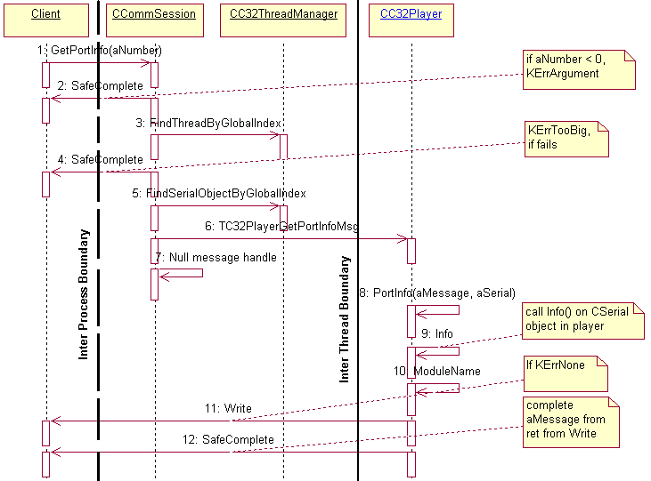
Figure 7 - Sequence diagram for GetPortInfo (aNumber) - showing typical usage of CC32Threadmanager

Besides loading a CSY, the only other time the loaded CSY structure changes is when a CSY is unloaded. In this case, the Manager marks the CSY as unloaded and resets the handle and port prefix for the CSY, as well as decrementing the load indexes of any CSYs with higher indexes.
Figure 8 below shows a slightly more complicated snapshot of sample data in the Thread Manager after a few load and unload CSY operations have taken place.

iCSYName=”ECUART”
iLoaded=1
iCSYPortPrefix=”COMM”
iThreadNum=0
iPlayerCSYHandle=0x4eff00a
iAccessCount=1
iLoadIndex=0
iCSYName=”LOOPBACK”
iLoaded=0
iCSYPortPrefix=LOOPBACK
(This CSY was loaded earlier, but is now unloaded)
iAccessCount=0
iThreadNum=0
iPlayerCSYHandle=Nul

iCSYName=”HSDPA”
iLoaded=1
iCSYPortPrefix=”H”
iThreadNum=0
iPlayerCSYHandle=0x420fed
iAccessCount=1
iLoadIndex=2

iCSYName=”FCOMM”
iLoaded=0
iCSYPortPrefix=””
iGlobalIndexNumber=-1
iThreadNum=1
iPlayerCSYHandle=Nul
iAccessCount=0

iCSYName=”DUMMY”
iLoaded=0
iCSYPortPrefix=””
iGlobalIndexNumber=-1
iThreadNum=2
iPlayerCSYHandle=Nul
iAccessCount=0

iCSYName=”ABCDEF”
iLoaded=1
iCSYPortPrefix=”ABC”
iThreadNum=2
iPlayerCSYHandle=4xef01a3
iAccessCount=1
iLoadIndex=1
(This CSY was not listed in the CMI files)
Legend:
iCSYName – filename of the CSY
iCSYPortPrefix – the name the CSY gives to its ports
iLoaded – True if the CSY is loaded
iGlobalIndexNumber – index of this CSY amongst all loaded CSYs
iThreadNum – id of the thread this CSY is hosted by
iPlayerCSYHandle – set by the player and sent back when addressing this CSY
iAccessCount – a count of the number of unique sessions that have opened this CSY

Loaded CSY List
Index 0
Index 1
Index 2
Index 3
Index 4
Index 5
Figure 8 - Scenario showing data for Thread Manager
The order of operations that resulted in the above data in Thread Manager was:
- On C32 startup the data for “DUMMY”, “ECUART”, “FCOMM”, HSDPA” and “LOOPBACK” were read from the CMI files and added. As Configurator does not guarantee the order it reads the CMI files, the order these modules had their data added is arbitrary. At this point all the CSYs are in the unloaded list and the CSYPortPrefixes are all Null. Also, C32 has found from the CMI data that thread 2 is to be the default thread (not shown) since it has the wildcard in the CSY list.
- A client then requests that LoopBack be loaded, so it becomes marked as loaded and its Port Prefix and PlayerCSYHandle are set, and its load index is set to 0.
- Module “ECUART” is loaded after a client request.
- Unknown module “ABCDEF” is loaded. As Thread Manager has no CMI data for “ABCDEF” it adds it to the default thread which in this example is thread 2.
- The client using the Loopback module closes and the Loopback CSY is unloaded. Thus its PlayerCSYHandle and port prefix are set to Null. As it had a Load Index of 0, all the other loaded CSYs have their indexes decemented (ECUART becomes 0 from 1, ABCDEF becomes 1).
- A client loads the “HSDPA” CSY so it becomes the CSY with a load index of 2.

In Figure 8, if a client was to iterate through the list of loaded CSYs via the GetPortInfo API, the CSYs they would get, in order, would be: ECUARA, ABCDEF, HSDPA.

The Thread Manager also has a few other things to look after. These are:
- To store which thread is the default thread into which all CSYs not mentioned in the CMI files will be loaded. This is normally read from the CMI file, but if no CMI file has the wildcard that denotes the default thread, then C32 selects the first player, or the Dealer if there are no Players.
- The name of all the CMI modules in the C32SerComms group as defined in the CMI files, since this is needed by Configurator when starting a CPM..
- Transient Active Objects to handle the loading of CPMS in order to wait for the Configurator’s response

The Thread Manager is only ever updated by the Dealer and so no synchronisation objects are used to control access to it.

The CC32Dealer class
The CC32Dealer class owns the Server class as well as all the channels to the player threads and it owns all the sessions, as illustrated in Figure 9.
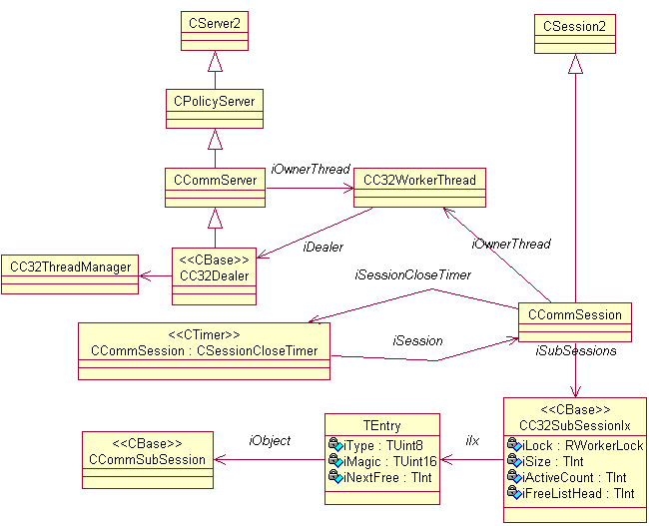
Figure 9 - Dealer class diagram

Managing Multiple Sessions connecting to Multiple CSYs
A CCommSession object represents for the C32 server a client’s session. One of the features of the C32 API is that a single session can be used to load multiple CSYs and then open ports on each of these CSYs. To support this, C32 needs to track what CSYs and ports have been opened so that it can:
- track the access count for each CSY and port for the purposes of freeing the CSY and port resources when the respective access counts reach zero
- ensure that if the client closes the session without closing its ports and CSYs first, the server can still perform all these closures automatically
- ensure that for every request to unload a CSY or close a port in a session, the session has already opened the CSY or port and is not performing an errant double-close. Likewise to ensure a double-open is caught and disallowed.

The C32 server runs entirely in the main thread, so for the purposes of this discussion the terms are interchangeable. Thus, the Dealer owns all the CCommSession objects as a list inside the main class for the Dealer. In the resource tracking problem above the tracking of (1) is done by both the Dealer and the Player while the tracking for (2) and (3) is done by the Dealer. The Dealer tracks (1) because it needs to know when the Player is imminently going to close the CSY so that at that point the Dealer can mark the CSY as unloaded ahead of the Player actually unloading it. This is so that the Player does not receive further requests on the now closed CSY.
CCommSession maintains two arrays, one for the CSY modules that have been loaded by the client, and the other for the ports that have been opened by the client. The port array is actually a list of handles to the Player’s own CCommSubSession objects, while the CSY module array contains the names of the CSYs that the session has loaded..These are explained later in 3.2.9 Session Creation and Close.

In this way several different clients can load a CSY already loaded by another client and when the last closes their CSY reference, the CSY can be unloaded. Similarly, different clients can open the same port simultaneously.
The list of loaded modules is also used on CSY load to ensure a request is not made to reload an already loaded CSY by the same client, and on CSY unload to ensure a request is not made to unload a module that was never loaded.

Co-resident Player

C32 supports an optional Player inside the Dealer's own thread. This is not used in the default configuration but a Licensee can make use of this feature if they choose. A Player in the main thread allows the elimination of the overhead involved with the normal Dealer-Player inter-thread communication, and removes the cost associated with the context switch between threads. However, the disadvantage is that by having the Player with the Dealer the Dealer is now not protected from errant behaviour of any CSYs inside that Player, such as blocking or running at high priority.
The Co-resident Player uses the same CC32Player class as any other player, and the WorkerThread for the Dealer simply has a pointer to the co-resident player as well. The only difference is that the Dealer does not talk to it via a Comms Channel, but directly calls functions on the Player. These functions also ensure that they return any response to the Dealer directly through parameters and return values, since there is no return Comms Channel either from the Co-resident Player to the Dealer.

Creating and Destroying Threads

It is the responsibility of Main (C32_Main) thread to create and destroy all threads in the system. However, the majority of the work involved in this is performed outside the main thread by Configurator. In order to load a module (CPM) the main thread connects to the Configurator and calls “LoadCPM”. After this point the main thread then finds out the result by scheduling an active object to wait for the reply. (Usually if the thread is successfully loaded the bind request from the new thread arrives before Configurator completes the request). When the CPM is loaded, it will know it is a Player thread by the data passed to it by the Configurator. In this way the main CPM then completes the initial transport bind and updates its Thread Manager (CC32ThreadManager) structure with the running state and can then interact with it as any other Player.
The Player’s initialisation process ensures that it does not let Configurator know that it is running until it has reached a point where its startup cannot fail. In this way, a failed Player startup will always result in the Dealer being informed of this via an error code from Configurator. In the event that Configurator reports that the CPM failed to load, the Dealer can then clean up any temporary allocations made as part of the load. Such temporary allocations include adding to the Thread Manager a record for an unknown CSY in the event that a client requests the load of an unknown CSY, since until the CSY is loaded the Dealer does not know if the CSY is legitimate.

The Dealer uses the global data shared between the CPMs and accessed via the Thread Local Storage to detect the presence or absence of a CPM. In this way the Thread Manager does not store the running state of threads.

The Dealer should be the only entity in the C32 system that destroys a Player CPM, and this would only occur if a request to the C32 server to shutdown has been received (see 3.2.3). In this case the Dealer ensures any ports and modules are unloaded from the Player, and then requests Configurator to destroy the Player via “UnloadCPM”.
The maximum number of threads allowed in the C32 system is decided by KMaxWorkerThreadId,constant defined in cs_common.h file. Testing on Target (H4) with KMaxWorkerThreadId = 28 and c32 boot time CPMs showed that all CPMs were loaded successfully, although working of only 5 CPMs is tested in c32 tests.
The C32_Main heap usage increases by 48 bytes for a single increment to KMaxWorkerThreadId after re-compiling the source.
The C32_Main heap usage increases by 440 bytes for each player that is loaded.

Active Object Priorities in the Dealer Thread

Active Object Description | Priority | Reasoning
C32’s ServiceL | 1000 | Preserves the existing priority. It is probable that this priority was set so high so that it would be higher than the priorities of any CSYs. In the multi-threaded version this will now be less of a problem, since errant CSYs can be completely isolated in their own threads.
CCommChannelHandler for communication with Rootserver | EPriorityStandard (0) | Set by Commsfw
CCommsTransport Chipper for communication between worker threads | EPriorityStandard (0) | Set by Commsfw
CCommsTransport one-Shot object used to queue up purging of chipper death row on dropped transport | EPriorityLow (-20) | Set by Commsfw
LoadCPM to collect the response from Configurator regarding loading the Player CPM. | EPriorityStandard (0) | The priority is fairly unimportant since this AO has very little responsibility: in a normal case the healthy Player will emerge before configurator gets a chance to respond that the load succeeded, while in the failure case this AO does not need to run ahead of any others.
Each Co-resident CSY will have at least one AO. | Dependent on 3rd party CSY implemetation | It is possible that in future the priority of CSY AOs will be set by C32 itself, (although in practice a CSY could always get around this) or some other rules created to police them. But in practice the ability to isolate CSYs away from the Dealer makes the inability to know and control the priority of a CSYs AO much less relevant.
SessionCloseTimer - used to detect and orphan a closing session that takes too long. | EPriorityLow (-20) | Runs as a background task since it is timing a long event.

Overview of C32 APIs
This section gives a brief overview of the C32 API and how C32 handles each API request in order to give a quick starting reference. More details in the in-source doc for the APIs, and in the sections in this design that refer to the API procedures in detail.

RCommServ - session APIs

Connect()
Used to connect to C32 Server in C32Dealer.

LoadCommModule()
Is used to load CSY, the function argument is the CSY filename The player is responsible for loading the csy while the dealer is responsible for sending the message to the appropriate player, which is found via a linear search of all known CSYs by checking the filename of each CSY record in ThreadManager. Message is passed using the transport if player and dealer are in different threads. If the CSY is unknown, a new record is added to ThreadManager.

UnloadCommModule()
Is used to unload a CSY using the portprefix as function argument. This argument cannot be csy filename which will fail with KErrNotFound when portprefix and csy filename differ (e.g. in case of RS232 – csy filename - ECUART, portprefix – COMM) The dealer performs a linear search of ThreadManager’s CSY records until it finds a record with the matching port prefix, and from the record it reads the serial object reference stored by ThreadManager and calls close on it by switching heap if necessary. In this way the entire close operation – including altering the player’s structure - is performed from the Dealer thread. ???Is this safe??? What if the player is adding a record at the same time – it will be adding, while the dealer is removing??

GetPortInfo()
This API provides information about a CSY like CSY description, portprefix, low and high unit numbers. It has two versions –
  - Argument is index number – dealer does a linear search of ThreadManager’s CSY records until it finds the one with the matching index number, reads the CSerial object from the CSY record and sends it to appropriate player thread
  - Argument is portprefix – dealer performs a linear seach of ThreadManager’s CSY records until it finds an active CSY with the matching name by either filename or port prefix and then uses the CSY record’s stored thread number to forward the message to the appropriate player.

NumPorts()
Returns the number of CSYs loaded by C32 Server. The dealer maintains an integer that tracks the number of loaded/active CSYs so this API simply returns this number.

CreateThreadInCommProc()
Returns KErrNotSupported This API is deprecated and no longer used.

RComm - subsession APIs

Open()
Opens a CPort using the CSerial factory in player. The Dealer uses the portname supplied by the client to search ThreadManager for a CSY since the portname includes the CSY port prefix in it (eg “COMM::1”). It then forwards the message to player handling that CSY.

Close()
Closes the CPort in player. The Dealer uses the handle it has stored in the kernels subsession handle to find the Dealer’s own subsession record (CCommSubSession) and this has a reference to the appropriate Player. Message is forwarded to player

Read() and other sub-session APIs
Read/Write and other sub-session APIs behave similarly. The Player is located in the same way as Close() above and the Message is forwarded to the player.

Forwarding requests to other threads
Message passing between the threads is performed using Comms Channel-derived classes, since this provides a proven 2-way communication pattern between threads. Comms Channels are provided by the Commsfw component and essentially involve a message queue and an Active Object in the two threads that wish to communicate. In this way, 2-way communication is possible along the channel, since each side can send a message to the other via the message queue, and each thread’s Active Object runs when the other sends a message.
CCommsTransport forms the transport layer between two worker threads for message passing. It provides interfaces for sending and receiving messages of type TCFMessage2. During CC32WorkerThread construction, the receiving interface pointer is registered and a cookie is obtained for sending messages to peer. The pointer in this case is the interface base class i.e. MLegacyMessageReceiver, as was illustrated in the WorkerThread class diagram in Figure 4.
When forwarding the message a check is made to see if the peer and the WorkerId of the current thread are identical. If so, then a straight functional call to ProcessMessageL() is made, otherwise a message is passed via the comms channel (RCFChannelPair).
Based on existing API of RCommServ and RComm, messages passing through the comms-channel are classified in two categories, as shown in Table 1.

Case | Message | Handling
1 | TC32WorkerMsg::EMainIntroduction  TC32WorkerMsg::EMainIntroductionResp  TC32PlayerMsg::ESessionClose  TC32PlayerMsg::ESessionCloseResp  TC32PlayerMsg::ELoadCommModuleMsg  TC32PlayerMsg::ELoadCommModuleResp  TC32PlayerMsg::ELoadCommModuleFailureResp  TC32PlayerMsg::EUnloadCommModuleMsg  TC32PlayerMsg::EGetPortInfo | Lifetime control.  These messages are related to the life and death of worker threads and sessions.
2 | TC32PlayerMsg::EForwardRequest | These messages are sub-session requests. Deliver to co-resident Player with ProcessMessageL(…).
Table 1 - Message handling at destination

Session Creation and Close
When a client connects to C32 server, it maintains a session with it. Inside this session, requests are made to load CSYs and open sub-sessions, which are represented as CPorts. During session close, the resources allocated during session creation (CPorts opened and CSYs loaded) must be freed to avoid leaking memory. Two containers are used in each C32 session which each correspond to CSYs and CPorts in order to track these resources for freeing. The CC32SubSessionIx container is also used to generate, validate and maintain a handle (TSubSessionHandle) for the sub-session. An RPointerArray of Descriptors records the names of the CSYs loaded in the session while for sub-session (CPort) a specialised container is used. This container is used to index the sub-session (CCommSubSession) object owned by the player. However there are certain requirements of this container:
- It must be able to generate unique handles for sub-sessions.
- It must provide fast access for certain types of operations as one of its main uses will be to get a sub-session pointer from a handle each time there is an incoming IPC request.
- It must guarantee thread-safety as sub-sessions can be accessed from different threads.
- It must be possible to add, remove entries.
- It must support iteration through its contents.

CC32SubSessionIx shown in Figure 10, will maintain its own array of TEntry cells in memory as arrays provide for quick access. There will be two types of cells in the array; cells carrying pointers to sub-sessions and a virtual list of free cells.
Each TEntry instance carries a union of iObject* and iNextFree. If iType is CCommSubSession::ENull, then it is a member of the free-list and iNextFree is the index of the next free TEntry instance otherwise it is an iObject* and points to a sub-session instance.
iType can be one of the two defined in CCommSubsession::TSubSessionType: ENull, ECPort.
This layout means that with a handle, the entry holding the sub-session can be looked up in the container directly and if a new entry needs to be inserted, the first free cell is indicated by iFreeListHead.

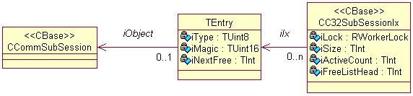
Figure 10 The sub-session container
The container provides locking but as only some of the functions require locked access and for others it is optional (depending on the context) it is left to the user of the object to lock/unlock. However, the functions that require locking will assert that the caller has indeed locked before calling them.
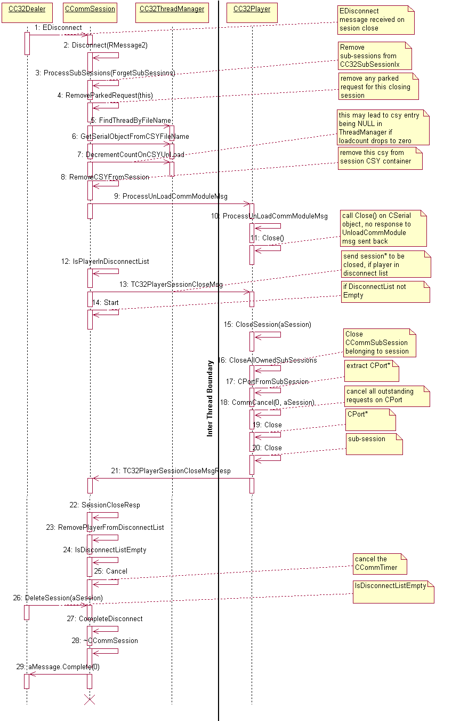
Figure 10. Session Close
When RCommServ::Close is called, a EDisconnect message is generated by the kernel and CSession2::Disconnect() will be called. Since we need to do cleanup activity of sub-sessions in players before closing the session, CSession2::Disconnect function is overridden which ensures Players have closed sub-sessions before session is deleted, else the player will panic.
CCommSession::Disconnect() removes the sub-sessions from the CC32SubSessionIx container in dealer, sends Session close message to the player (ESessionClose) and ticks off a timer. After dealer receives ESessionCloseResp from the players, it deletes the timer and calls base class Disconnect().
During session close, the dealer sends session close message to the player. The message has the RMessage2 and session pointer of the session that needs to be closed. The player which has a container of CCommSubSessions (TSubSessionContainer), iterates through all sub-sessions and deletes the sub-sessions which belong to the above session(CloseAllOwnedSubSessions). Before deleting a sub-session, the player calls CommCancel() on CPort, which cancels all outstanding requests on CPort (completes message with KErrCancel) and then calls Close() on CPort and close on subsession.
When a client sends RHandleBase::Close(), close() doesn’t wait so the C32 server can complete the message at any time.

Loading a CSY Module
When C32 starts, the main thread gets created and no CSYs are loaded in it. Loading a CSY is performed when the server receives a request to do so via the RCommServ::LoadCommModule API.
On receiving such a request, the Dealer performs a simple check of the supplied CSY filename for its validity – that it isn’t empty nor too long. If valid, it is added to the session CSY container, TCSYFileNameContainer and then a check is made to see if this is a duplicate. The LoadCommModule API supports loading of the same CSY in the same session multiple times (it is not known why the API allows this – probably that it just wasn’t checked) so the session needs to manage this. Thus, duplicates in the filename container are allowed, but if a duplicate is found then there is no further loading work required so the message is completed. If no duplicate is found, then a lookup is done in ThreadManager to find the thread to which the message needs to be forwarded to.
Before sending the message to the Player, the Dealer must be sure it has made all memory allocations it needs to complete the operation. This is because once the Player responds that it has completed the CSY load, the Dealer has no reasonable way of rolling back in the case of any out of memory issues when performing post-load bookkeeping. For this reason the Dealer adds a new CCSYInfo record to ThreadManager at this point in time if the CSY is not already known to it.
There are two kinds of messages sent from player to dealer in response to whether the load is successful or not.
Successful Load [TC32PlayerLoadCommModuleRespMsg]
- CSerial*, RMessagePtr2 and pointers to TPortName and CSYFileName are sent to the dealer. When the dealer receives this message, it updates the TPortName and CSerial* for the corresponding CSYFilename.
- The player completes the message on successful load with KErrNone.
Load failure [TC32PlayerLoadCommModuleFailureResp]
- RMessage and load failure return value sent from player to dealer.
- Dealer extracts CSYFilename and removes the CSYFilename from this session previously added, memory de-llocated for the failed csy and then dealer completes the message with error code sent from player.
The above scheme for load failure ensures that client is hanging till the time the CSYFilename is removed from the session CSY container. This will take care of multiple load and unload attempts.
The Thread Manager also tells whether the thread to which message needs to be forwarded is running or not. If not, then the dealer asks the configurator to load, On-Demand, the appropriate Player module and then forward the message. For more information about creation of on-demand modules, refer to section 3.2.5– On-Demand Module Loading and binding of CPMs.
In this way the Player’s do not need to be aware of what CSYs are in their threads for most operations.

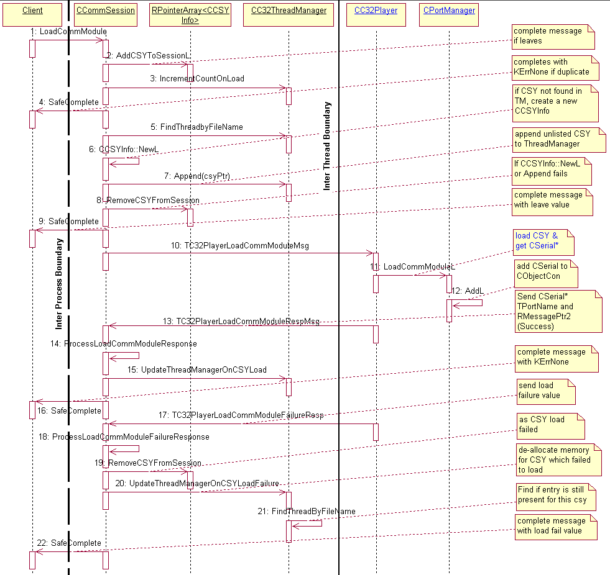
Figure 11. Sequence diagram for loading of CSY, the Comm Module

Unloading a CSY Module
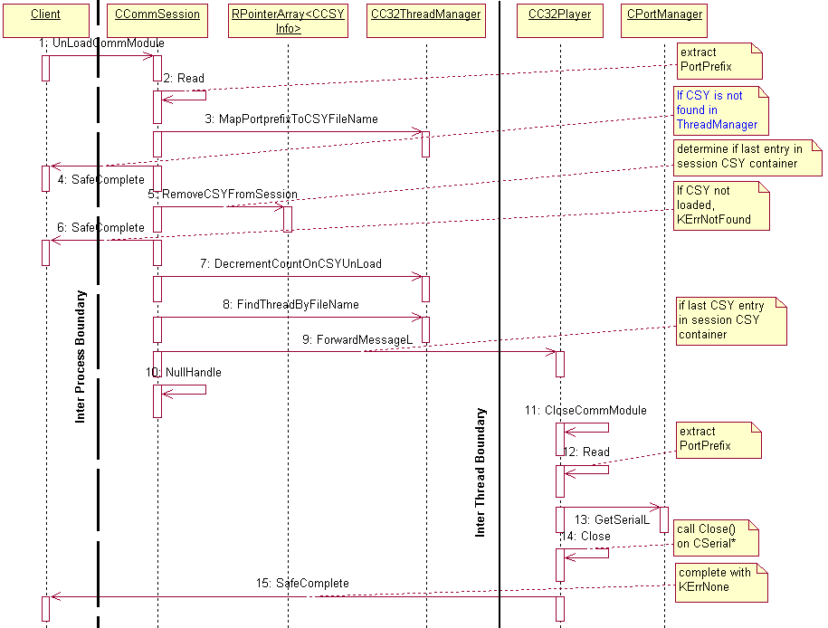
Figure 12 Close Comm Module
When a client calls CloseCommModule in the session, the Dealer reads the port-prefix (eg “COMM” in case of ECUART) from the message, maps the portprefix to CSYFilename. To ascertain whether the CSY is loaded in “this” session it is checked in the session CSY container and if found, is removed. At this point a check is made as to whether the CSY filename container for the session still contains a reference to the CSY, which would be the case if the client loaded the same CSY twice. In this case the removal of the CSY filename from the container is all that is required, so the message is completed. If this was the last reference to the CSY in the container, message is forwarded to player and Close() is called in CSerial on the player heap.
The closing of the CSerial class decrements the usage count on this class. If the usage count reaches zero then the CSY automatically unloads due to there being an outstanding active object created for this job at CSY load time. The CSerial class in the CSY has a pointer to the CLibUnloader object which is a one-shot active object set on CSY creation to point to the CSY library. The close method of the CSerial class asks the one-shot CLibUnloader to run, which performs the library unload (via a simple “Close()” on the RLibrary handle).
It was considered whether C32 should attempt to delay unloading of the CSY in case a request comes shortly afterwards to load it again. This would help combat any rogue process trying to use loading and unloading of CSYs to slow down C32. However, it was felt that the complexity was not justified given that the kernel itself already does part of the job by delaying the unload of a DLL by several seconds. This would mean that if an attack came in the form of repeated load/unloads, the execution cost would come mainly in the processing of the Dealer’s and Player’s data structures while the CSY’s actual DLL would remain loaded all the time.

The Player
The Player is a WorkerThread which has the CC32Player class in it, responsible for loading CSYs, creating comm ports, doing various operations on comm ports (read/write, signal notify etc.) and managing them. It receives messages from dealer and completes them by performing the requested operation. The CC32Player class can also potentially be in the main thread to act as a co-resident Player.
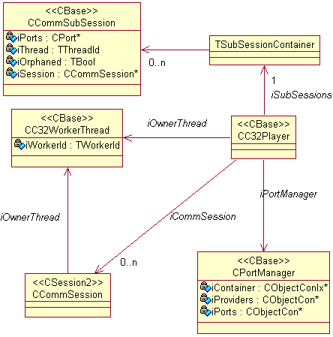
Figure 13 - The Player class diagram
The player processes messages from the Dealer through its ProcessMessageL() function, which performs the role normally fulfilled by ServiceL() in traditional single threaded servers.
ProcessMessageL will either be called directly from ServiceL in a Player co-resident with the Dealer or it will be called from CWorkerThread::DispatchL when a message is received from a dealer in another thread.
The player has two containers – CPortManager and TSubSessionContainer.
- CPortManager has two object containers [CObjectCon* - CSerial* and CPort*]. When a new CObject derived object is created it is added to the container depending upon its type (CSerial* or CPort*).
- TSubSessionContainer is an RPointerArray of CCommSubSessions maintained by player. This is used to track related sub-sessions for the purpose of closing them during session close from client.

Opening a Comm Port
When a client requests a new comm port be opened using the RComm::Open() API, the Dealer sends a message to the appropriate Player and includes the Dealer’s own CCommSession* so that the Player can store this reference in the CCommSubSession class.
On receipt of the message, the Player creates the CPort object for the sub-session, which it then uses to scan its list of existing CCommSubSessions for the session to see if the sub-session has been opened before by this session. If it has, then it reuses the same CCommSubSession by writing the handle to the existing CCommSubSession back to the subsession of the client and incrementing a count on CCommSubSession to track this, and completing the message. If the CPort has been used before, then the create operation actually results in just an open, which increments the usage count on the CPort.
If the port has not been opened before by the session, it creates an instance of the CCommSubSession class that it will use to store extra information about the sub-session that is not inside the CPort class. The CCommSubSession class is necessary since the CPort class is publishedAll and so cannot be extended. After a new CPort object is created, it is added to the CCommSubSession instance which is added to the Player’s own list of CPorts.
The Player then adds the CCommSubSession to the CC32SubSessionIx container kept by the Dealer for the session. After this addition, the ownership of the handle for the CCommSubSession in CC32SubSessionIx is handed over to the Dealer. Since potentially many players may add/remove sub-sessions simultaneously to the sub-session container in dealer, before add/remove operation, locking is required. This is provided by RWorkerLock. Upon addition of sub-session (CCommSubSession) handle is generated by CC32SubSessionIx which is then written back to the client by the player as Int3 of the message, as is usual for sub-sessions. After the sub-session handle is written back to the client as Int3() of message, the message is completed by the Player.
If the Writing of sub-session handle fails and if it’s a new sub-session, then sub-session index is removed from CC32SubSessionIx container in dealer.

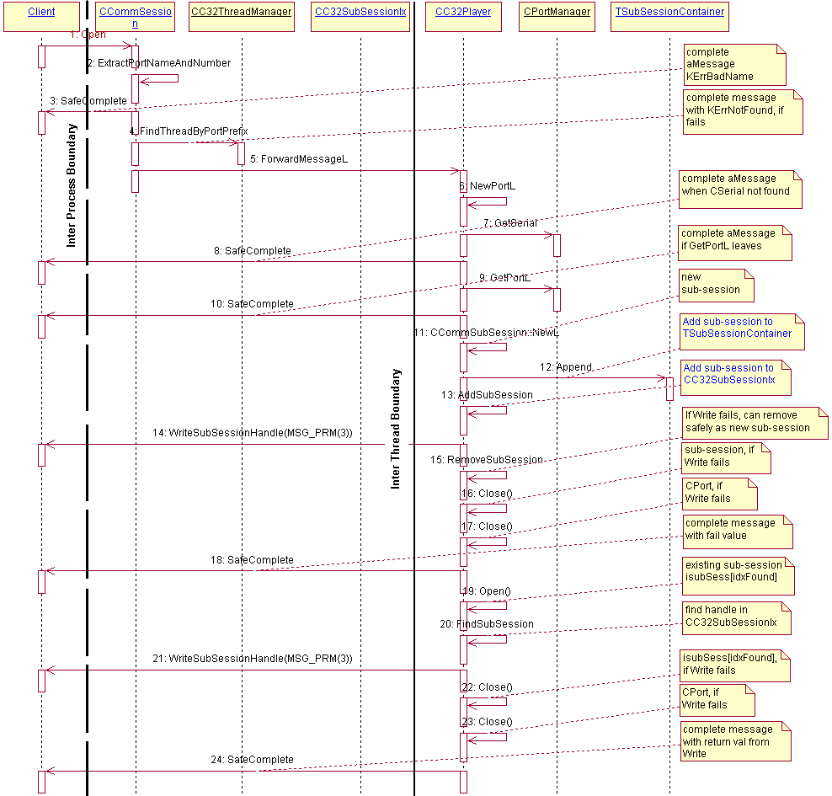
Figure 14: Opening a New Comm Port

Closing a Comm Port
When closing a comm port, the client sends a message which contains the index (TSubSessionHandle) as aMessage.Int3(). This is used by the Dealer to find the CCommSubSession (owned by the player) in CC32SubSessionIx. The message is forwarded to the Player using ForwardMessageL(). The player extracts CPort* from CCommSubSession and calls Close() on CPort and CCommSubSession, SafeComplete()s the message with KErrNone. In the case where the CPort is opened more than once by the same session, only Close() on the subsession when the access count is 1 results in the destruction of the port, while other Close() calls only result in the decrementing of the access count in the CCommSubSession instance and on the CPort.
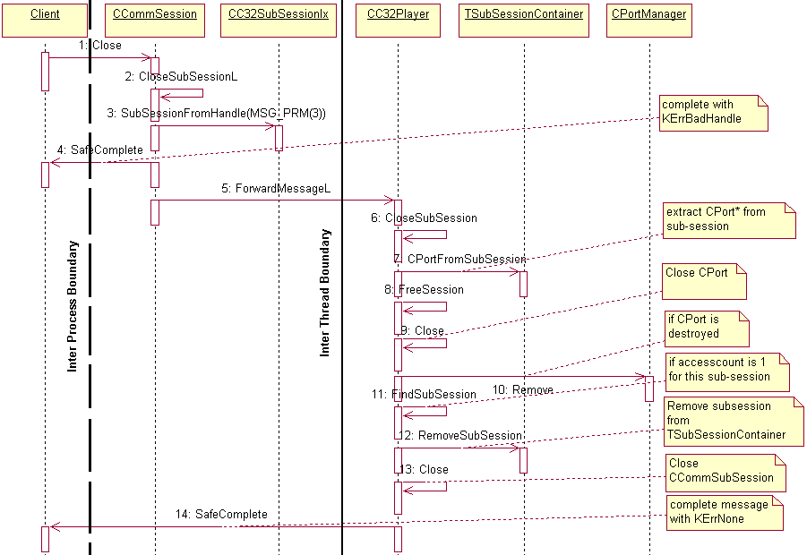
Figure 15 Closing a Comm Port

Read/Write operation on Comm Port
When CCommSession receives a message from the client via a RComm-based sub-session, it uses the TSubSessionHandle stored in the int3 of message to locate the CCommSubSession object in CC32SubSessionIx. This CCommSubSession object is used by the player read/write operation to the CPort.

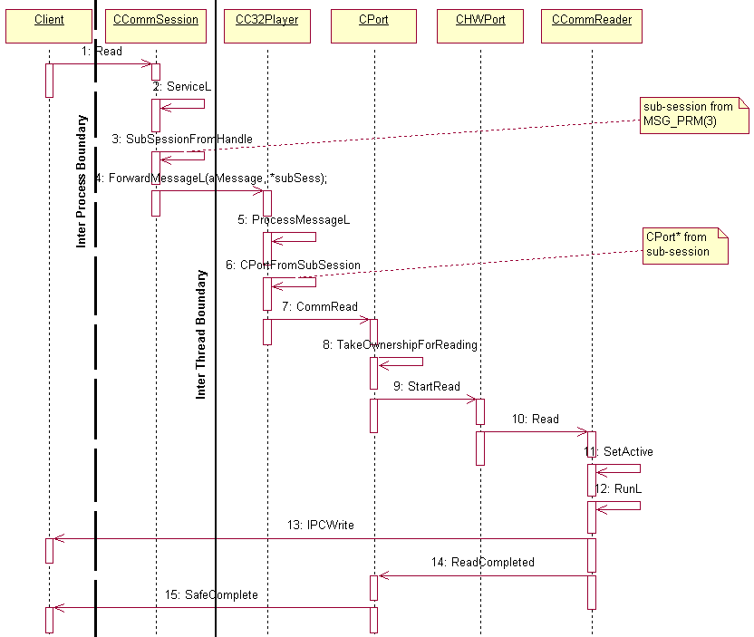
Figure 16. Read operation on Comm Port (ECUART as example)

CExtra class and pre-emption
When an existing port is opened, it can be set to a different access mode (TInternalCommAcessMode). This is done using the CExtra class. It checks for the mode in which the port was previously opened and then using a set of rules determines if the port can be re-opened in the new access mode, if not then a suitable error code is returned to the client.

Notifiers
The pattern is similar to read/write operation (3.2.15) See footnotes Error: Reference source not found and

Multiple access co-ordination in CPort
An instantiation of a CPort-derived class inside a CSY represents precisely one serial port. However, if the port is shareable, several clients may connect to it to use it. To manage this, CPort maintains a series of handles, one for each type of outstanding request:
- Read
- Write
- Signal
- flow control
- config
- break notify
- data available notify
- output empty notify
The handles point to the client session that made the request to ensure that only one client at a time is allowed to make a particular request. In this way several clients can have different requests outstanding simultaneously, as long as the requests are all of different types. If a client tries to make a request that another client already has outstanding, KErrInUse is returned.
As well as a handle to the session, the CPort object also preserves a copy of the message so that it can be completed when the CSY finishes handling the asynchronous request.

Logging

C32 uses the CDU wrapper for its logging, and uses the static macros of CDU since at the time C32MT was written it was thought they would be the fastest after the introduction of the now-cancelled system Tracer. C32 defines a small class - C32Log - that is a wrapper for C32 logging on top of CDU in order to allow the workerId to be inserted at the beginning of every log line. C32 then provides macros to map to C32Log's functions.

All C32's logging is logged to the tag "C32SerComms". The second tag used provides a log level, with the following table giving a description of each. These levels are not mandatory, only a guide and so may not necessarily be rigorously adhered to in the code.
Log Level | Representative Action
Bootup | Actions during C32's start up until the time C32 sees the Rootserver publish that booting has finished
Shutdown | Actions taken once C32 receives notice that it should shut down.
Warning | Any serious warning or error. Normally even the most minimal C32 log tracing would include these.
Dealer | Logging of events in the main thread which are not part of Bootup, shutdown or thread communication (Player has almost no Bootup role)
Player | Logging of events in a Player thread, or inside the Co-resident Player in the main thread
CommsTrspMsg | Details of messages sent between Dealer and Players via the Comms Transport
Detail | Verbose detailed logging only enabled in rare circumstances
Client | Events on the client side of C32’s DLL.

CSYs have their own logging mechanisms which are described in section 6 Error: Reference source not found.

Platform Security
The Platform security architecture was integrated into C32 in Symbian OS v9.0.
For a detailed description of the Platform Security architecture, see [R3].
For a platform security architectural overview as applied to this subsystem, see [R4].

Capability Assignments
In order to satisfy the capability model rule, that a process cannot load a DLL with less capabilities than itself the following capabilities have been assigned to each of the binaries built from the C32 component.
For a full list of the capabilities see [R3].
Binary | Loading Process | Capability Assignment
C32.dll | Any¹ | All -Tcb
Ecuart.csy | C32 Comms Process² | CommDD PowerMgmt ReadDeviceData WriteDeviceData TrustedUI ProtServ NetworkControl NetworkServices LocalServices ReadUserData WriteUserData

¹ This binary contains a client API and the c32 server code. Since the client API could potentially be loaded into any client process this binary must be given all capabilities (minus TCB which is not given to any client processes).
² Serial communication modules are loaded by the C32 server into the C32 Comms Process. They are not intended for use in any other processes and therefore are just required the same capabilities as given to the C32 Comms process.

API Policing
In accordance with the platform security API policing model the C32 server is now policing its IPC set. For a detailed description of how to secure a server refer to [R3].
The nature of the IPC requests handled by the C32 server are such that the following two existing user and system capabilities are sufficient to secure the C32 API’s.
- None – No capabilities are required to use this functionality (e.g. Load or close a Comms module, get Port information, Read/Write Data, Get/Set Capabilities, Notifications etc.).
- Deferred – The capability check is deferred in order to determine which capabilities are required to access a particular port depending on the nature of the specific CSY being loaded. These APIs will most likely require either None, NetworkServices and/or LocalServices capabilities (e.g. used for opening of Comm ports).
The following table details the policing that is assigned to each C32 IPC.
IPC | Security Policy
ECommLoadCommModule | None
ECommCloseCommModule | None
ECommPortInfo | None
ECommPortInfoByName | None
ECommPortInfoByNumber | None
ECommNumPorts | None
ECommStartServerThread* | None
ECommOpen | Defer
ECommRead | None
ECommReadCancel | None
ECommQueryReceiveBuffer | None
ECommResetBuffers | None
ECommWrite | None
ECommWriteCancel | None
ECommBreak | None
ECommBreakCancel | None
ECommCancel | None
ECommConfig | None
ECommSetConfig | None
ECommCaps | None
ECommSetMode | None
ECommGetMode | None
ECommSignals | None
ECommSetSignalsToMark | None
ECommSetSignalsToSpace | None
ECommReceiveBufferLength | None
ECommSetReceiveBufferLength | None
ECommClose | None
ECommDbgMarkHeap | None
ECommDbgCheckHeap | None
ECommDbgMarkEnd | None
ECommDbgFailNext | None
ECommDbgSetDebugPrintMask | None
ECommDbgDoDumpDebugInfo | None
ECommGetRole | None
ECommNotifySignals | None
ECommNotifySignalsCancel | None
ECommNotifyFlowControl | None
ECommNotifyFlowControlCancel | None
ECommGetFlowControl | None
ECommNotifyConfigChange | None
ECommNotifyConfigChangeCancel | None
ECommNotifyBreak | None
ECommNotifyBreakCancel | None
ECommNotifyDataAvailable | None
ECommNotifyDataAvailableCancel | None
ECommNotifyOutputEmpty | None
ECommNotifyOutputEmptyCancel | None
ECommSetAccess | None
ECommDebugState | None
ECommOpenWhenAvailable | Defer

* ECommStartServerThread is now deprecated and its functionality has been removed as management of the threads in the Comms process is via the Rootserver.
As can be seen, policing is only applied when a client requests to open a port. At the server level the C32 server does not know what serial port is intended to be used until the port is actually accessed. This is distinguished by what type of CSY has been loaded (e.g. Ecuart.csy for serial port. Ircomm.csy for IR ports, etc.). The capabilities required for each of the serial ports depends entirely upon the nature of the external hardware that it communicates with. E.g. talking to the baseband should require NetworkServices, while talking to IR or Bluetooth devices, will require LocalServices. Conversely talking to a standard serial port (i.e. a physical serial port) will require no capabilities at all, as it cannot be determined what hardware it is connected to.
This, therefore, necessitates the CSY to provide the security policy to be applied when opening a comm port using the RComm:Open and RComm::OpenWhenAvailable API’s. This mechanism is more commonly referred to as ‘deferring’ capability checking.
To enable this mechanism a new virtual API has been added to the CSerial interface.
virtual TSecurityPolicy CSerial::PortPlatsecCapability (TUint aPort) const;
A base implementation is provided in CSerial which returns a TSecurityPolicy::EAlwaysFail which will result in the clients request failing with KErrPermissionDenied regardless of their capabilities. It is therefore imperative that CSYs must override this virtual in their CSerial derived classes to provide the correct security policy applied to each of the ports that the CSY supports.
The Ecuart.CSY re-implements the virtual PortPlatsecCapability with the following characteristics.
- For ports named “Comm::0” to “Comm::<max ports>” return TSecurityPolicy::EAlwaysPass.
- For ports of any other names (attempted to be opened using Ecuart,csy) return TSecurityPolicy::EAlwaysFail.
NOTE 1: Ecuart.csy provides access to serial RS232 ports on a device. Because it cannot be known how the port is being used the CSY must assume that it requires no capabilities to open the port.
NOTE 2: Although an open port request may pass the capability check there is no guarantee that the open request will actually succeed. For example, the requested port name may not be supported on the device and thus a completion code of KErrNotSupported would be received by the client.

Protected Server Name for EKA2
To prevent spoofing of key OS servers a special naming convention is adopted for EKA2 Platform Security. The name of key servers now begins with ‘!’ and the kernel enforces that only processes with the ProtServ capability may create servers with such a name. As such the Comm server has been assigned the name ‘!CommServer’ for EKA2, and remains ‘CommServer’ for EKA1.

CSY interface: CPort and CSerial

A serial communications service is implemented using a polymorphous DLL whose extension is conventionally .csy. The ordinal-1 export from this DLL – as specified in the DEF file - is a factory function for a CSerial-derived class. All CSYs must provide the factory function at ordinal one. The main virtual function of the CSerial class is NewPortL(), which creates a CPort-derived class. The virtual functions of CPort provide implementations of all functions required by the client API in RComm.

CPort and CSerial API classification
CPort and CSerial are marked publishedAll, which is unusual when compared with many other plug-in architectures which are normally publishedPartner. The classification is due to the goal of keeping the possibility for anyone (provided they got the capabilities for their DLL) to extend the OS with virtual ports as CSYs. Also, there was the possibility that Licencees could be integrating CSYs written by non-Symbian partners. So, major improvements to the interface would probably best be served via a new interface.

CCommTimer and the TLS
This little class was probably (given the header file it is in) only meant to be part of the CSY interface as a means of providing timers for CSYs. It is also used internally to C32. However, it is publishedAll which means that it could potentially have been used by any software, including software in other processes. This was a problem since CCommTimer uses the TLS, and the MT version of C32 also needs the TLS to store some other things.
As a result, C32 could not simply include the CCommTimer data inside a larger structure that was then set for the TLS with CCommTimer updated to index it. Instead, a means was required for CCommTimer to know whether it was running in the C32 process, or in a client process. In the case of the C32 process the TLS references the CCommTimer data plus the rest, while in the client process CCommTimer would only need the TLS for its own data.
The solution was to implement a redirection class that was set in the TLS for both the C32 process and the client process. When CCommTimer read the TLS the structure would always be the same: a value indicating whether this was a client or C32, and a pointer to either the full C32 structure, or just the CCommTimer structure. For the C32 process, this structure is set on worker thread creation. For a client, the structure is set if CCOmmTimer finds that the TLS is null.

Supplied CSYs

The CSYs in the MCL (as of March 2006) are:
CSY filename | Description | Location
Owned by Comms-infras team
PKTLOOPBACK.CSY | Simulated loopback CSY that reads/writes individual packets (as opposed to reading/writing as a stream). This is the behavior expected by RawIP.nif. | networking\test\PacketLoopbackCSY\group\PacketLoopback.mmp
ecuart.csy | Serial port CSY – used in phones. | ser-comms\c32\group\ECUART.MMP
Loopback.csy | Loopback facilities used for testing, Incorporates all the functionality from the former cdma, etel3rdpart and simtsy loopbacks and so is used extensively by teams for testing. Built into production code but not to be shipped in ROMs. | Ser-comms\c32\loopback\loopback.mmp
DUMMY.CSY | Test CSY s. See C32s Test documentation for more information. | ser-comms\c32\TE_C32\dummy.mmp
Owned by other teams
btcomm.csy | Bluetooth CSY – used in phones. | bluetooth\latest\bluetooth\btcomm\src\btcomm.mmp
ircomm.csy | Infra-red CSY – used in phones. | infra-red\irda\group\IRCOMM.MMP
ECACM.CSY | USB CSY – used in phones. | ser-comms\usb\csy\group\ECACM.MMP
ecacm.csy | USB performance test CSY | ser-comms\usb\group\t_headlessecacm.mmp
csy27010.csy | 27.010 CSY supplied with TRP. Not yet used in a phone, but may one day. | telephony\trp\csy\csy27010\group\Csy27010.mmp

ECUART CSY

Implements a generic CSY that connects to the Logical Device Driver (ECOMM.LDD) and Physical Device Driver.( ECDRV.PDD) that come with Symbian OS in order to provide RS232 services. It can be shipped on phones but not without modification since it provides no security for the ports, and it needs to be modified with knowledge of how many RS232 ports it should provide. This is currently the only reference CSY within the C32 component, since the other C32 CSYs have functionality oriented towards testing only.

The ECUART CSY has logging using CDU which can be enabled via the following line in the CDU ini file: “LOG C32SerComms ECUART”.

Loopback CSY
This CSY allows up to two simulated serial ports to be created, ports “0” and “1”. By default each port is created in the ECommRoleDTE role, although this should be changed for one to ECommRoleDCE to ensure proper signaling. On completion of the creation of both serial ports, the CSY links the two ports together so that data transferred on either one can be read on the other.
One example of this CSY in use is in Etel testing with a TSY connected to the Loopback CSY and the test harness providing a second thread that connects to the other Loopback port to respond to the TSYs requests.
Test.dll
Thread2
Etel
MMTSY
Loopback.CSY
Figure 18. TSY making use of LoopBack CSY in testing

The Loopback CSY has logging using its own log framework on top of RFile, which can be enabled by creating the folder C:\LOGS\Etel and then the logs will appear in the file LOOPBACK.TXT.

Dummy* CSYs
All of these CSYs are used in the test harness for C32 only. Please refer to the test documentation for more information.

CSY27010.csy

Maintained by the Telephony team. The 27010 CSY has logging using Flogger. To enable logging, create the following folder on the device:
C:\LOGS\TRP\CSY
And flogger will write the logging to the following file in this folder:
csy27010.txt

Further Information

Outstanding issues

The following are issues that need to be addressed before this document can be released
- many c32 UML diagrams are in Rational Rose Enterprise edition, which Symbian does not have licences for – these should be redrawn in the new Enterprise Architect when needing to be updated.

People
Role | Person / People
Contributor(s) | Neil McAlpine, Klaus Nielsen
Reviewer(s) | Thomas Goodfellow, Networking Team

References
No. | Document Reference | Version | Description
[R1] | Comms Framework API.doc | 1.0 | SQL.GT0167.nnn. Description of the Comms Framework API.
[R2] | Comms Process Startup-Config Design Document.doc | 1.12 | SQL.GT0167.nnn. Description of the start-up procedures and of the Comms Configurator.
[R3] | Platform Security Engineering Guide | 2.3 | http://smglinx.intra/twiki/pub/SMG/PlatSecTechnical/SGL.SM0007.001.Rev2.2.PlatformSecurityEngineeringGuide.doc
[R4] | SerComms Architectural Description.doc | 1.0 | Perforce@//EPOC/master/common/generic/Ser-Comms/documentation/
[R5] | Comms Framework API.doc | 1.5 | Perforce@//EPOC/master/common/generic/comms-infras/commsfw/Documentation/

Glossary
The following technical terms and abbreviations are used within this document.
Term | Definition
API | Application Program Interface or Application Programming Interface. The interface (calling conventions) by which an application program accesses operating system and other services. An API is defined at source code level and provides a level of abstraction between the application and the kernel (or other privileged utilities) to ensure the portability of the code.
C32MT | A name to denote the version of C32 that supports multi-threading. C32MT was delivered to the MCL in July 2006.
C32 System | The collection of threads that make up the functionality of C32. In the C32 System, the threads have their own numbering scheme that has the server thread with Thread id 0, and the other threads that host CSYs at indexes above this
C32_Main | The main thread in C32 with WorkerId = 0
Comms Channel | A mechanism provided by the comms framework for communicating between threads. It consists of two message queues – one in each thread – and each queue is attached to an active object.
CommsFw | Comms Framework. Component in the comms-infras sub-system. Provides a set of utilities and classes easing the implementation of and communication between CPMs.
CPM | Comms Provider Module. An entity launched and running in the Comms Process by the RootServer. Usually has one thread known to the RootServer although implementation might use more.
CSY | Comms SYstem – a plugin to the C32 Server which models a protocol as a serial port to C32 and communicates with a driver to provide the communication service.
Dealer | The class that owns the C32 server into which all client’s connected. The Dealer then has responsibility for “dealing” these requests out to the other threads in the C32 system. The Dealer itself does not perform much processing of these requests since this is the job of a Player. The Dealer always occupies thread 0 in the C32 system.
DLL | Dynamic Linked Library
Module | - A CSY  - A CPM
PortPrefix/PortName | PortName of CSY e.g. “COMM” incase of ECUART. PortPrefix or PortName used interchangeably
TCB | Trusted Computing Base
Transport | Communication channels between threads in C32 – the transport is implemented by Comms Framework and works similarly to the Comms Channels but is based on a different message size to the Comms Channels, and different functionality. At the time C32MT was written, the Transport was also being written for a different project and it thus supports two variants of which C32 uses the “legacy” variant. This variant is based on the transport that Esock V3 used internally and was stable for C32’s needs. The Transport also supports a “cookie” variant that is more flexible and powerful but was still under development so C32 may move to this variant at a later time.
WorkerId | Worker Identification. Currently a unique integer number associated with a specific instance/thread of C32.

Document History
Date | Version | Status | Description
08-04-2003 | 0.1 | Draft | First draft based on SGL.PPS001.457 Component Design Document Template Rev 2.0
08-11-2003 | 1.0 | Issued | Updated after review and issued.
06-01-2004 | 1.1 | Issued | Minor update  – Corrected copyright dates  – Removed coloured text
31-03-2004 | 1.2 | On Review | Added Platform Security section for v8.1 release.
17-05-2004 | 1.3 | Issued | Document Issued.
27-07-2004 | 1.4 | Issued | Added section detailing API policing of the C32 server.
16-08-2004 | 1.5 | Draft | Added section 4.2: Protected server names to platform security section.
16-09-2004 | 1.6 | Issued | Merged Telephony and CDMA versions of document.
07-2005 | 1.7 | Draft | C32 multi-threading design added. Sent for early review.
14-07-2005 | 1.8 | For Review | Major additions to the C32 multi-threaded design.
30-08-2005 | 1.9 | For Review | Minor updates to C32 Multi threaded design with usage of OnDemand and Group field mentioned in CMI file.
15-10-2005 | 1.10 | Draft | Major updates for multi-threading
7-11-2005 | 1.11 | Draft | More major updates for multi-threading. Purged Word’s doc history.
9-11-2005 | 1.12 | Draft | More updates as design progresses.
11-11-2005 | 1.13 | Draft | Another version of this esteemed document. Created as another checkpoint during design
14-11-2005 | 1.14 | Draft | Checkpoint before Prasoon returns to Bangalore.
16-11-2005 | 1.15 | Draft | Checkpoint – last version before re-review.
16-11-2005 | 1.16 | For Review | Removed Word’s document history
9-03-2006 | 1.17 | For Review | Corrected several problems post-review and incorporated all changes made as a result of implementation.
12-05-2006 | 1.19 | Issued | Design updates after formal review
2-04-2007 | 1.21 | Issued | Updates made after re-read post submission of things changed in final months.

Appendices

  - Future Possible Improvements to Performance

    - Extended RCommServ API
It is possible that in future the RCommServ API could be extended to allow a client to connect directly to a nominated CSY and thus avoid the overhead of the main dealer possibly routing all the communications over a thread boundary. This only gains an execution advantage where the CSY is in a different thread from the main dealer, since in the case of the CSY being in the same thread as the main dealer the advantage is minimal at best.
The implementation would consist of an extra parameter sent at the time of the RCommServ session creation which would nominate the CSY, much like the overloaded Esock “DealerPlayer”’s via TSessionPref.
The new API could be designed to be a lot more “MT-friendly” than the current one by:
- Renaming some of the poorly-named API calls (NumPorts, GetPortInfo)
- Removed some of the currently allowed behaviour that is naff, such as being able to load a CSY twice.
- Remove the ability to have subconnections on two different CSYs – only allow one connection per CSY, although sub-connections to different ports. This allows session-handoff to relevant Player.
- Use a different RComm that used a different CSY that supported a different CPort backend that was:
  - PublishedPartner rather than PublishedAll.

    - Make CSY active object priorities configurable

This would involve CSYs either receiving via a function call or reading via a config file the priorities of their active objects.

    - Enhance Shutdown for use in Production cases

In order for the shutdown mechanism to become ready for use in production situations, the following known challenges would need to be addressed:
  - safe cleanup of unclosed client sessions and subsessions
  - Timeouts on closing CSYs with forced destruction in case of timer expiry

  - Future Possible Improvements to C32’s integration to Comms

The Symbian OS Communications Framework is evolving into a stackable and modular system so that the protocols, providers, selectors and other comms pieces can be provided as plugins and the connections between them can be specified for a particular product to match particular requirements. This separates the tasks of negotiating and controlling a data path from the task of passing data on the path which allows for throughput and latency to be better controlled.
In its current form C32 and the CSYs it manages do not fit well into this structure since C32 acts as a mediator through which all CSY traffic passes, and each CSY manages control and data. A future change could see the C32 server and API separated out as a wrapper over each CSY and each CSY split into control, management and data CSYs so that CSYs can be plugged directly into the framework. Further thought on this is required though and whether it is really suitable for a serial-style protocol.

The C32 Dealer and Player are shown in different colours for illustration purpose only, even though they all are identical C32 CPMs in that they all load the same DLL code.
As is discussed later, the Dealer actually does store pointers to the CSerial objects, but only to pass them back to the Player as an efficiency gain and never to actually use them.
For all you Esock readers wondering where it is, C32 hasn’t got a WorkerDealer implementation yet. This was considered but felt to be better as a later delivery since at the same time moves could be made to improve the API and other aspects in the same change.
At one time the RPointerArray actually pointed to the CSYInfo records, but this was changed when it was realised that all searches performed on this array would be comparing 16-bit CSY names supplied by a client, whereas the CSYInfo records store the CSY names in the 8-bit format from the cmi files. As this 8 to 16-bit conversion would need to take place on each search, storing the 16-bit names seemed a reasonable compromise: saving execution speed and complexity but costing extra RAM usage.
Code migration notes for Read/Write and other operations on CPort from original C32 to C32MT version: - The code in CCommSession::Read() and CCommSession::Write() functions are moved to player as part of CPort::IPCRead() and CPort::IPCWrite() functions. This ensures that we are not accessing any CCommSession* from player. - The aMessage.Int3() which was previously a handle to CPort will now be handle pointing to CCommSubSession. Code in TakeOwnership functions changed accordingly. - The handles checks in CommCancel functions were modified to ensure new handles are assigned and checks made against new handles.
Code Migration notes for Notifiers CommSession::Write() code is moved to player and is now a part of ConfigChangeCompleted, SignalChangeCompleted, ConfigChangeCompleted, CommGetRole, CommGetFlowControlStatus and FlowControlChangeCompleted functions.

