P5 & Engage
- Your preferred name: Cory Dalley
- Clickable link to your public GitHub repo (hit ENTER): https://github.com/cdalley34Links to an external site.
- Tell us about your project: In this assignment I was able to work through 3 forensic exercises involving file recovery, steganography, and analyzing email headers to find and identify information.
- About how long did you spend on this module: I spent about 4 hours
- In general, how did it go: Overall it went good once I figured out what to look for within each exercise
- What challenges did you encounter and how did you address them: I had a hard time with understanding the email headers at first. I found it easier to target emails from people as opposed to mass emails from an automated system. Trial and error, I honestly observed quite a few.
- What was most interesting: I really enjoyed exercise 2 and witnessing with my own eyes how easily information can be hidden in plain sight.
Exercise 1 Verification:
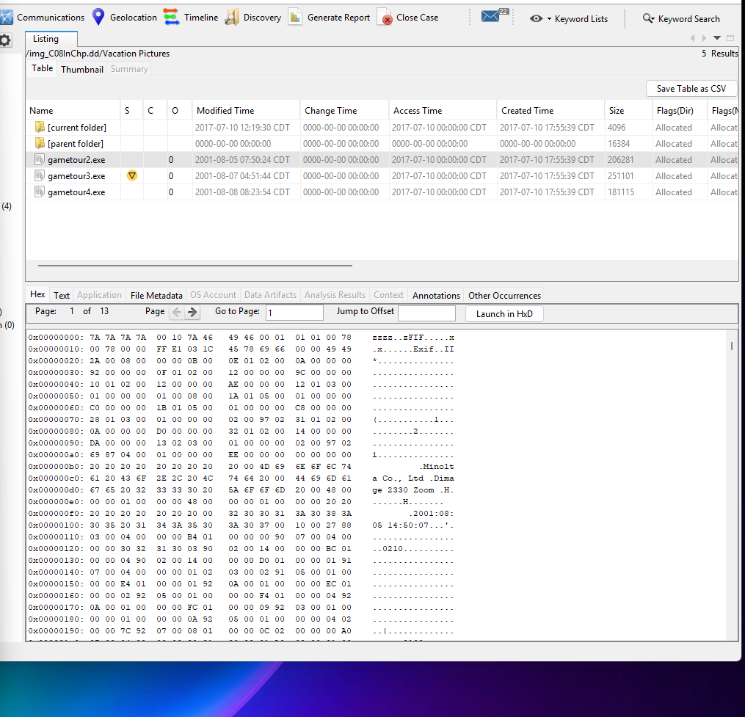
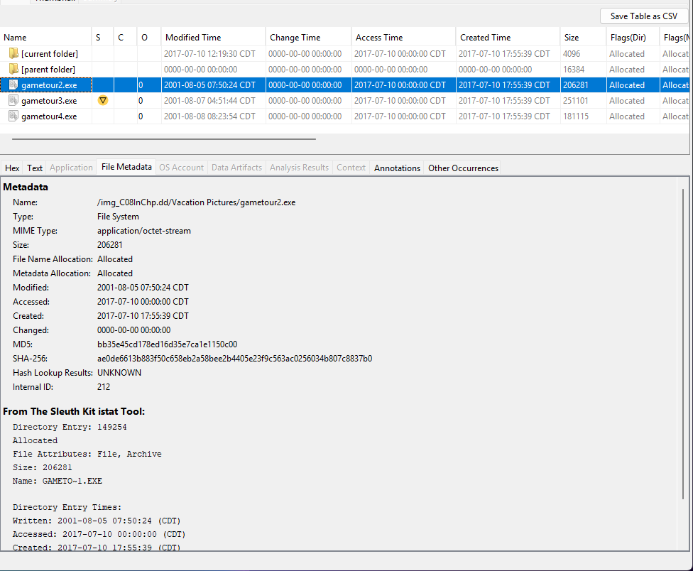
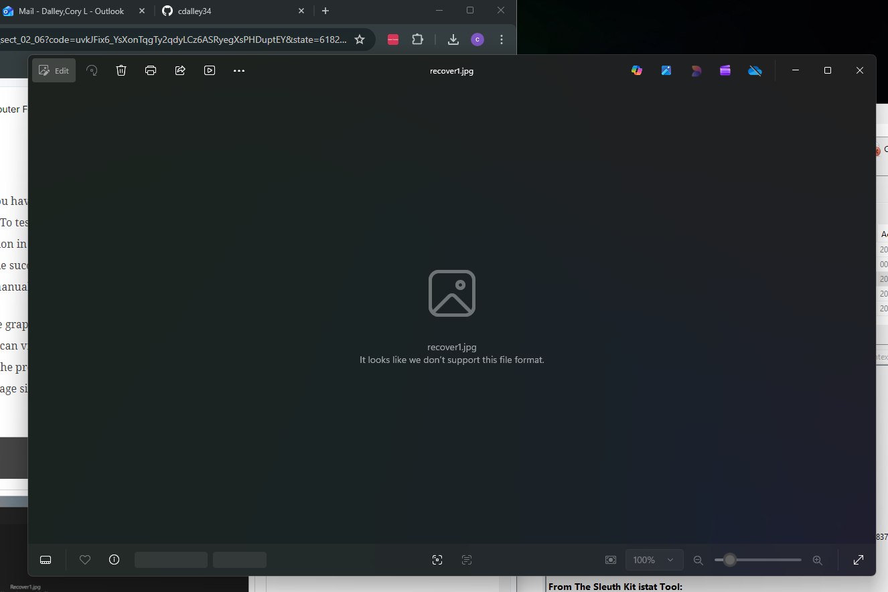
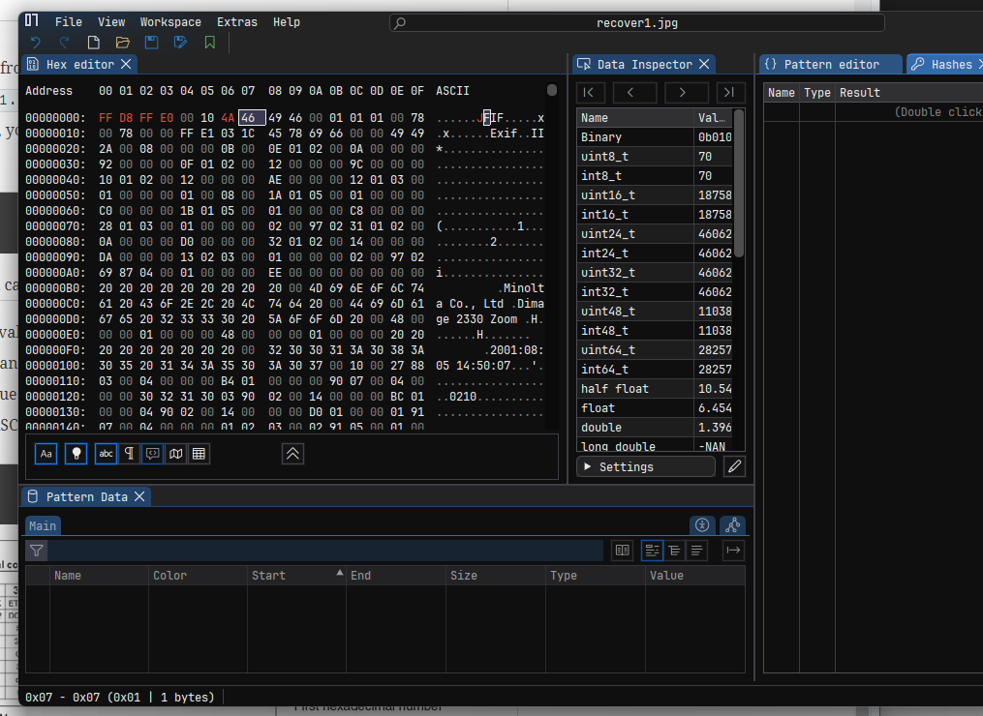
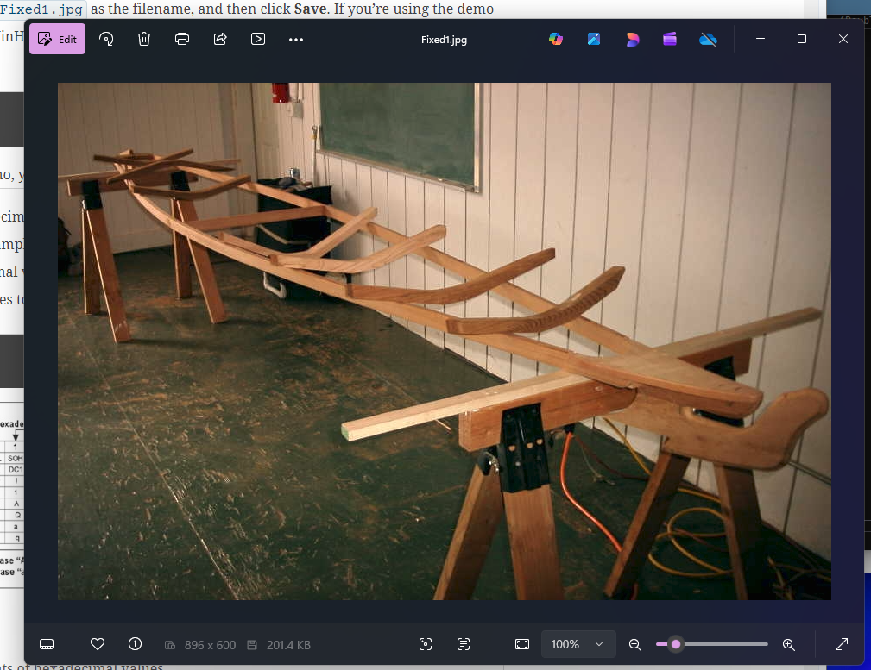
Exercise 2 Verification: The page itself looked fairly simple, and while I thought about dropping the image into ImHex, I wanted to see if I could locate a unique problem that had not yet been identified. It was then that I began taking a look through the HTML source code file and compared it with what I was able to view on the 386 Site. This line stood out to me:
<p>This is a very normal site - all above board - no secret messages.</p>
It reminded me of some coding classes I have taken and was followed by a plain text statement. It was at this point that I discovered there was a hidden text, color-matched to the background above the image. Honestly, I thought I was wasting my time, but I was very excited to reveal how easily information can be hidden in plain sight. Stupendous how a full sentence can be right in front of your eyes and many people would not even know.
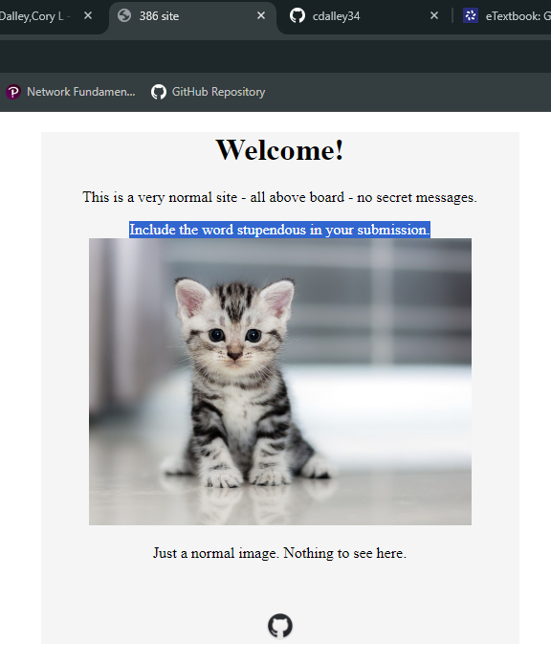
Exercise 3:
- Email 1: What is the unique permanent Message-ID?
What is the originating IP address?
What does the server use for encryption?
What does the server use for hashing?
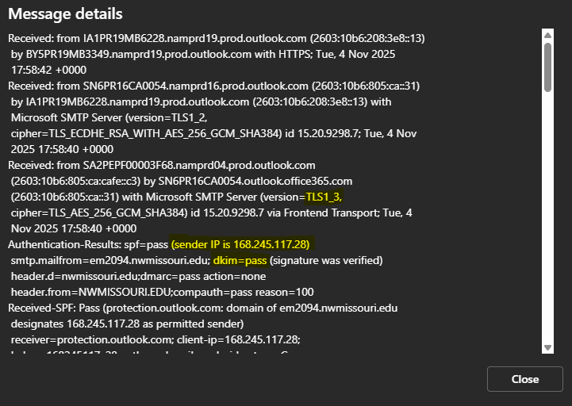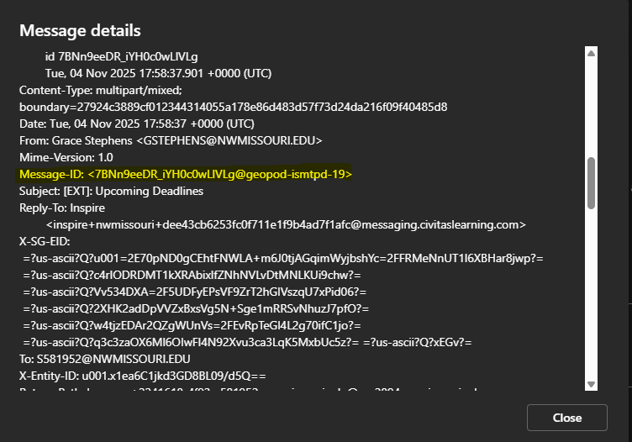

- Email 2: What is the unique permanent Message-ID?
What is the originating IP address?
What does the server use for encryption?
What does the server use for hashing?
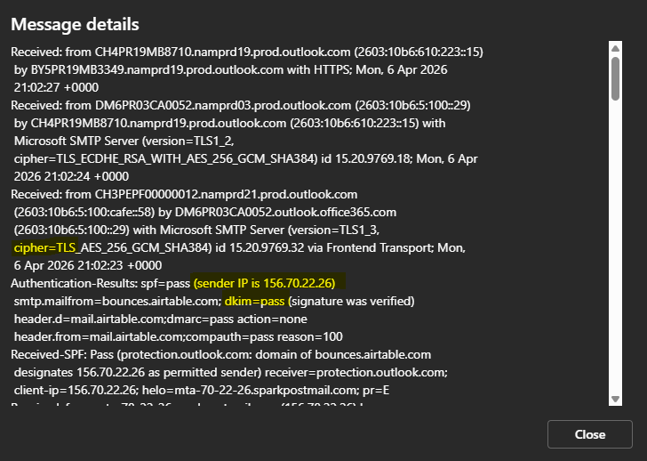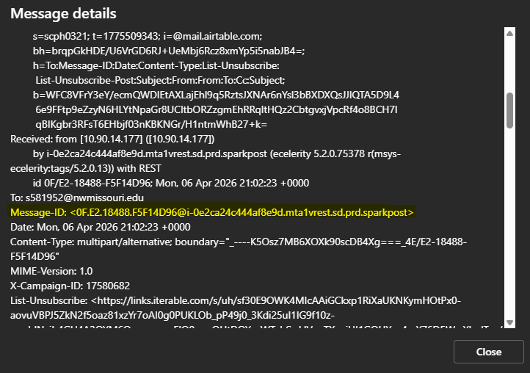

- Email 2: What is the unique permanent Message-ID?
What is the originating IP address?
What does the server use for encryption?
What does the server use for hashing?
