CTF RESIDUAL FORMULATION OF SOLID LIQUID COUPLING

**C. Dances1, V. Mousseau2 and M. Avramova1**

1: Department of Mechanical and Nuclear Engineering, The Pennsylvania State University, 137 Reber Building University Park, PA 16802, USA

2:Computer Science Research Institute, Sandia National Labs, 1450 Innovation Parkway, Albuquerque, NM 87123, USA

[cad39@psu.edu](mailto:cad39@psu.edu), [vamouss@sandia.gov](mailto:vamouss@sandia.gov), [mna109@psu.edu](mailto:mna109@psu.edu)

# ABSTRACT

Nuclear engineering codes are being used to simulate more challenging problems and at higher fidelities than they were initially developed for. In order to expand the capabilities of these codes, state of the art numerical methods and computer science need to be implemented. One of the key players in this effort is the Consortium for Advanced Simulation of Light Water Reactors (CASL) through development of the Virtual Environment for Reactor Applications (VERA). The sub-channel thermal hydraulic code used in VERA, COBRA-TF (Coolant-Boiling in Rod Arrays - Three Fluids), is partially developed at the Pennsylvania State University by the Reactor Dynamics and Fuel Management Research Group (RDFMG). The RDFMG version COBRA-TF is referred to as CTF.

In an effort to help meet the objectives of CASL, a version of CTF has been developed that solves the residual formulation of the one-dimensional single-phase conservation equations. The formulation of the base equations as residuals allows the code to be run semi-implicitly or fully implicitly while clearly defining the original conservation equations. This paper outlines work to integrate one dimensional solid conduction equations into the residual formulation. This allows the coupling between the solid and liquid equations to be either explicit or implicit. Different physical models, such as the homogeneous liquid solid energy model, can be readily implemented by adding the residual functions and variables. A simple test problem consisting of a single liquid channel and fuel pin is used to compare the different numerical and physical models available from the new residual formulation to an analytical solution. The methods are compared both for steady state and transient conditions to quantify the accuracy and stability of each method. The ability to choose appropriate numerical methods and physical models allows for greater fidelity and decreases computational expenses.

# KEYWORDS

CTF, thermal hydraulic, residual, Jacobian, solid liquid coupling

# INTRODUCTION

For the past several decades, the primary focus in nuclear engineering within the United States has been on light water reactors (LWR). Commercially, all nuclear reactors are either boiling water reactors (BWR) or pressurized water reactors (PWR). Correct computation of the thermal hydraulics within the reactor core leads to efficient design and accuracy in the safety analysis. A popular subchannel code for modeling the hydrodynamics within the reactor core is CTF, which is a subchannel thermal-hydraulics code developed from COBRA-TF [1]. This FORTRAN based code solves 8 conservation equations for liquid, entrained droplet, and vapor phases, plus one conservation equation for non-condensable gases. A residual formulation of the code has been created that is able to solve the 1-D single-phase fluid solution. While other residual formulations have been formed for other versions of CTF [2], none have been integrated into the CASL version of CTF. This paper outlines the initial work in coupling the liquid and solid solutions for the residual formulation. Explicit and implicit coupling between the solid and liquid solutions are considered for transient and steady state problems. The steady state calculations are compared to the analytical solution for accuracy.

# CTF

The thermal hydraulics of a LWR core is an important part of nuclear reactor design. CTF has the ability to solve for the temperature and pressure of water within the rod structure of a LWR reactor core. Currently, the conservation equations analytically reduce into a pressure matrix in a semi-implicit method with rod temperatures solved for explicitly. The residual formulation of the code currently solves the 1-D axial single-phase liquid and 1-D radial solid energy conservation. This residual formulation allows for greater flexibility in the selection of the numerical methods as well as easy parameter exposure work.

## 2.1. 1-D Single Phase Liquid Conservation Equations

For the single-phase formulation of the Euler equations, the unknown variables are pressure P, velocity u, enthalpy h, and density . To solve for these variables, three conservation equations and one equation of state are used. The conservation of mass given in equation (1) is the most basic with the rate of change in density equal to the advection from the upwinded cell. The conservation of momentum in equation (2) balances the time rate of change of momentum, the advection of momentum from adjacent cells, the gradient of pressure, and body forces. The conservation of energy equation (3) contains two temporal terms; the time rate of change of the enthalpy, and the time rate of change of the pressure. These temporal terms are balanced against the advection of the enthalpy.

|  |  |  |
| --- | --- | --- |
|  |  | (1) |

|  |  |  |
| --- | --- | --- |
|  |  | (2) |

|  |  |  |
| --- | --- | --- |
|  |  | (3) |

### CTF fluid meshing

The finite volume structure in CTF in Figure 1 is for a one-dimensional channel in the axial direction with n number of cells. The first and last cells at 0 and n + 1 are ghost cells and act as the boundary conditions for the problem. Pressure, enthalpy, and density are averaged over the cell volume and are located at the center of the cell. Mass flow rate and velocity are located at the faces in between cells. The cells are represented with an index i, and the faces with indexes of i+ or i-. This project focuses on this 1D configuration and does not take into account adjacent subchannels.

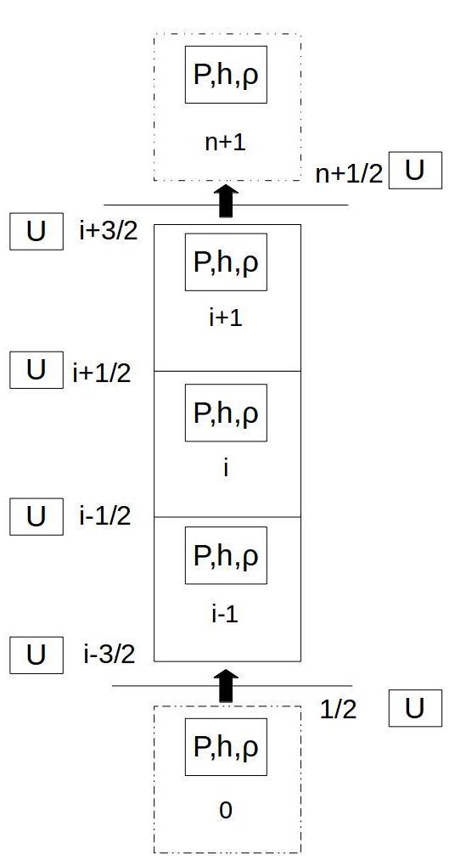

Figure . CTF Fluid Volume Meshing

### Fluid finite difference equations

|  |  |  |
| --- | --- | --- |
|  |  | (4) |

|  |  |  |
| --- | --- | --- |
|  |  | (5) |

|  |  |  |
| --- | --- | --- |
|  |  | (6) |

# 1-D Radial Solid Conduction Equation

|  |  |  |
| --- | --- | --- |
|  |  | (7) |

## CTF rod meshing

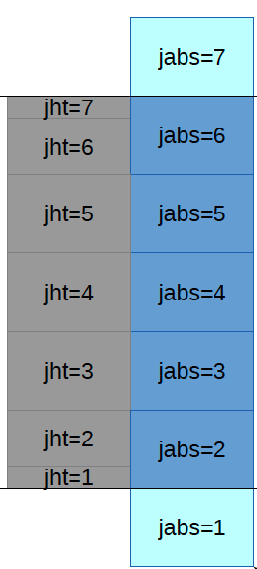

Figure 2. Axial Rod and Channel Meshing

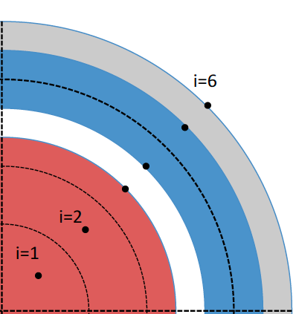

Figure 3. Radial Meshing of Nuclear Fuel Rod Type

* + 1. **Solid finite difference equations**

|  |  |  |
| --- | --- | --- |
|  |  | (8) |

## Residual Formulation and Jacobian Construction

A residual is simply the difference between the value at some future iteration k + 1 and the value at the current iteration k. Currently in CTF, the future iteration is taken to be the next time step n+1 and the current iteration is the current time n. The residual can be expressed for desired variables or conservation equations. For example, the residual for density, , is the difference between iterates levels k+1 and k, . The residuals for the equations are determined by substituting the residuals into the discretized equations, which should effectively change all n+1 into k. Each cell will have three fluid residual variables and three residual equations. For the entire solution, we will then have a residual variable array, and a residual function array F(X) which defines a linear system =F(X). The Jacobian matrix is defined as the derivative of each response of the function F**j** with respect to each variable X**i**. The derivative can be calculated numerically as shown by equation (4) where is a small numerical value. Since the system is assumed to be linear, the approximation of the Jacobian matrix in this manner is also assumed to be accurate. As a check, the numerically computed Jacobian matrix was reduced to a pressure matrix using Gaussian simulation and compared to the analytical pressure matrix from CTF.

# TEST PROBLEM

# Problem Description

# Analytical Solution

# Steady State Solution

# Transient Solution

# CONCLUSIONS

Present your summary and conclusions here.

# NOMENCLATURE

|  |  |
| --- | --- |
| Symbol | Variable |
|  | Pressure |
|  | Enthalpy |
|  | Velocity |
|  | Density |
|  | Temperature |
|  | Time |
|  | Channel Axial Direction |
|  | Rod Radial Direction |
|  | Specific Heat |
|  | Thermal Conductivity |
|  | Heat Rate |
|  | Heat Generation Rate |
|  | Heat Transfer Coefficient |

# ACKNOWLEDGMENTS

# REFERENCES

# APPENDIX A