Week 1

Use Case Diagram

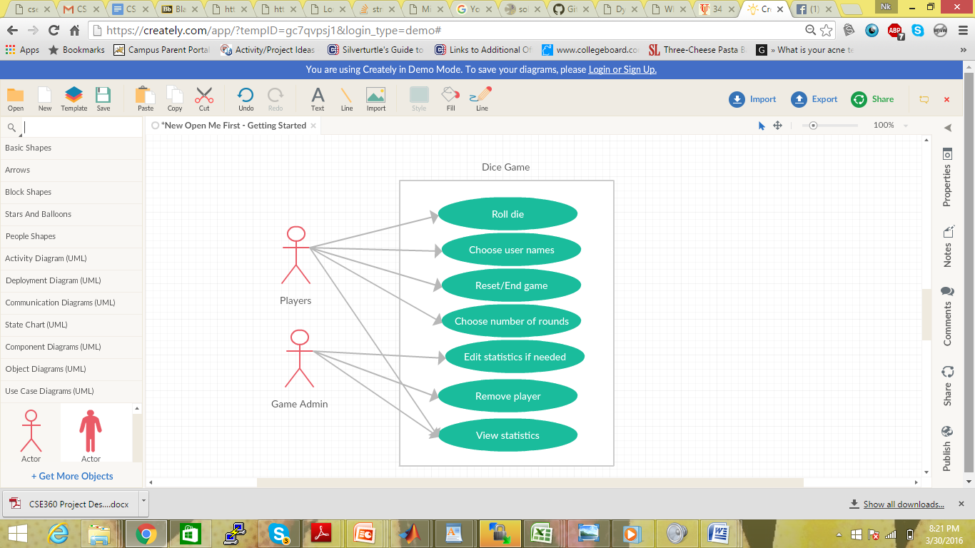

User Stories

1. As a player, I want to roll a die so that I can begin a game.
2. As a player, I want to choose my user name to identify among other players.
3. As a player, I want to choose when to begin and end the game, so that I can easily exit or begin.
4. As a player, I want to choose the number of rounds I would like to play so that I do not play an infinite number of games.
5. As a player, I want to view my stats so that I can compare my wins and losses.
6. As an administrator, I want to edit statistics if needed so that inappropriate statistics are removed.
7. As an administrator, I want to remove players so that inappropriate user names are removed.
8. As an administrator, I want to view players’ stats so that I can edit them if needed.