**AN INTELLIGENT TOOL TO ASSIST IN MAKING SMARTER PROPERTY DECISIONS**

Project ID: 19-010

Project Proposal Report

Mrs. M.P.A.W. Gamage

Mrs. Pasangi Rathnayake

|  |  |
| --- | --- |
| Bimali Y.M.Y | IT 16 42 3534 |
| Rodrigo U.S.D. | IT 16 15 4490 |
| Denuka Dharmaseelan | IT 16 11 6566 |
| Kamaleswaran Thayalini | IT 15 15 6884 |

Bachelor of Science (Honours) in Information Technology Specialized in Information Technology/ Software Engineering

Department of Information Technology

Sri Lanka Institute of Information Technology

Sri Lanka

March 2019

**AN INTELLIGENT TOOL TO ASSIST IN MAKING SMARTER PROPERTY DECISIONS**

Project ID: 19-010

Project Proposal Report

(Proposal documentation submitted in partial fulfilment of the requirement for the Degree of Bachelor of Science Special (Honors)

40 mm

20 mm

20 mm

25 mm

In Information Technology)

Bachelor of Science (Honors) in Information Technology Specialized in Information Technology/ Software Engineering

Department of Information Technology

Sri Lanka Institute of Information Technology

Sri Lanka

March 2019

**Declaration**

We declare that this is our own work and this proposal does not incorporate without acknowledgement any material previously submitted for a degree or diploma in any other university or Institute of higher learning and to the best of our knowledge and belief it does not contain any material previously published or written by another person except where the acknowledgement is made in the text.

|  |  |  |  |
| --- | --- | --- | --- |
| **Student ID** | **Name** | **Signature** | **Date** |
|  |  |  |  |
|  |  |  |  |
|  |  |  |  |
|  |  |  |  |

The above candidates are carrying out research for the undergraduate Dissertation under my supervision.

**Supervisor**

**…………………………..**

Mrs. M.P.A.W. Gamage

**Co-supervisor**

………………………….

Mrs. Pasangi Rathnayke

**Abstract**

Real Property are the most valuable possession of most of the common people. Getting the proper valuation for these real properties is very much important. This document analyses an innovative solution proposed to facilitate land valuation based on recent sales, prediction of future price and the effect of proposed development work on the land, so that real-estate customers and owners of real estate companies can be benefitted and make smarter property related decisions.

This intelligent tool can help people to identify the land they are willing to buy. Our first priority would be given to current valuation of the land since it is difficult to find out the reliable average prices of the land around manually, especially if the area is unfamiliar. We can get the service of a professional valuer, but that process is known to be subjective to the person and time.   
Since Sri Lanka is a rapidly developing country, there are many ongoing and proposed road and infrastructural development projects. If someone needs to find out the effect of such development work on the selected land, it is very difficult to gather and find out such data based on the current weak digital infrastructure available in Sri Lanka.

Artificial intelligence, Machine learning and optimization are the main research components of this proposed system. The user can input the location of the land, then, as the first step an Artificial Intelligent (AI) model gathers available data of the recent sales happened during an optimum time period, within a predefined radius of the area. The AI model then provides the current value prediction for the location, which goes through the optimization process. After that, AI model calculates and provides the future value prediction of the land as well as a report stating the effect of the proposed development projects in the area.   
This proposed system would be of great assistance to make better property decisions, which adds value to user’s money spent on buying land plots, which is a massive investment as well as a very important decision in one’s life.

Keywords - Artificial Intelligence, Optimization, Land Valuation, Machine Learning

**Table of Contents**

**Declaration**iii

**Abstract** iv

**1.** INTRODUCTION 1

1.1 Background and Literature Survey 1

1.1.1. Background 1

1.1.2. Literature Survey 3

1.2 Research Gap8

1.3 Research Problem9

2. OBJECTIVES 10

2.1 Main Objectives 10

2.1 Specific Objectives 10

2.1 User Specification 11

3. METHODOLOGY 12

3.1 High level architecture diagram12

3.2 Software Development Life Cycle16

3.2.1. Concept 17

3.2.2. Inception 17

3.2.3. Iteration/Development 17

3.2.4. Release 17

3.2.5. Production 17

3.2.6. Retirement 17

4. DESCRIPTION OF PERSONAL AND FACILITIES…………..……………………………19

4.1 Rough Valuation based on the recent sales happened in the area19

4.2 Optimization of the rough valuation by analyzing and evaluating the manual procedure of mass appraisal21

4.3 Predicting the future commercial value based on the fluctuation rates for past 10 years and weather effects23

4.4 Predicting the effect of future development projects on future commercial value25

5. EVALUATION 27

5.1 Potential of Entrepreneurship/ Marketability27

5.2 Accuracy27

5.3 Responsiveness27

5.4 Scalability27

5.5 Cost and Complexity27

6. TECHNOLOGIES 28

6.1 Hardware requirements28

6.2 Software requirements28

7. BUDGET AND BUDGET JUSTIFICATION29

8. REFERENCE LIST30

**List of Figures**

Figure 1.1: Different stages of the appraisal process for estimating the market value 2

Figure 1.2: Brief Neighbourhood analysis- Trulia6

Figure 1.3: Historical Sales analysis-Trulia 6

Figure 3.1: Architecture Diagram 12

Figure 3.2: Work Flow Diagram 13

Figure 3.3: Work Breakdown Structure 14

Figure 3.4: Gantt Chart 15

Figure 3.5: Phases of agile methodology 16

Figure 3.6: Outline of Agile Sprint 18

Figure 4.1: System Diagram for current value prediction unit 20

Figure 4.2: System Diagram for optimization of current value prediction unit 22

Figure 4.3: System Diagram for feature prediction 23

Figure 4.4: Flow chart for feature prediction 24

Figure 4.5: Work flow diagram for effect of future development prediction 26

Figure 4.6: Use case diagram for effect of future development prediction 26

**List of Tables**

Table 1.1: Average absolute percentage error of the 12-month forecast- Zillow 3

Table 1.2: Trulia accuracy report 4

Table 1.3: Comparison of existing systems 7

Table 7.1: Budget Plan 29

1. **INTRODUCTION**

**1.1 Background and Literature Survey**

**1.1.1. Background**

Real Property are the most valuable possession of most of the common people. In Sri Lankan culture, most of the people tend to think that owning a real estate is a better investment than having that money saved in a bank. Therefore, getting the proper valuation for these real property is very much important.

Land valuation is the process of assessing the characteristics of a given piece of land based on experience and judgment.[1] The determination of a land parcel value depends on a number of physical and economic characteristics which must be taken into consideration very carefully in a land valuation procedure.[1] These values can be affected by various social factors too. For example, if there is a crime happened in that land, it can cause a negative effect on the value..

Hence, real estate appraisal it is a challenging multidimensional problem that involves estimating many facets of a property, its neighborhood, and its city.[2]

Since, Sri Lanka is lacking a good data platform to gather all these data, considering all these factors can take ages to do proper valuation considering all these factors.

The manual process is a time consuming slow task which needs to be done by an experienced professional valuer. The valuation approaches used by those professionals are limited due to the lack of digital data in Sri Lanka. Also, it is a known fact that the valuation process can be so subjective to the person.

Ideally, the systematic process of valuation consists of four different stages as follows.

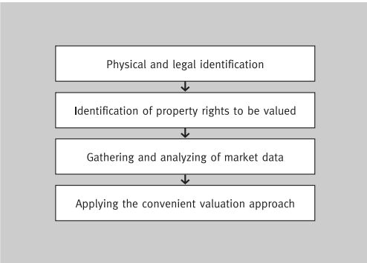

Figure 1.1: Different stages of the appraisal process for estimating the

market value

*Source: Schulz, R. (2003). Valuation of properties and economic models of real estate markets. Erscheinungsort nicht ermittelbar: Verlag nicht ermittelbar.*

The major convenient valuation approaches are,

1. Sales Comparison Approach
2. Income Approach
3. Cost Approach [3]

Analyzing the previous land sale details and trends in those fluctuations and considering those data to predict the valuation is called the sales comparison approach.[3]

The task of automatically estimate the market value of houses can be seen as a regression problem, where the price (or the price per square meter) is the dependent variable, while the independent one is the available information that could help to determine the price correctly. [2]

When the neighbourhood economical value is combined with effect of neighbourhood factors such as walkability etc. we believe it is possible to give a accurate, fair prediction of the value of the land.

The influence of technology on daily life of the Sri Lankans has increased immensely. People tend to use traffic data, online shopping more than ever.

Since the manual process is too slow and dependent to make a quick better decision of the worthiness of the land and suitability of it for the purpose of the customer, our attempt is to digitally assist the people in property related decision making by providing them accurate predictions of the values and future studies of the land.

**1.1.2. Literature Survey**

**Existing solutions**

The use of AI for residential value forecasting has been suggested in the literature from 1990s. [4]. Although Sri Lanka is lacking an automated land valuation system, many up and running, reliable solutions have been implemented in developed countries like New Zealand, England and Wales, USA etc. It is obvious with the well-structured digital data infrastructure of those countries, they can implement very accurate systems. Our intention is to identify the ways to use their underlying methodology in a suitable manner in Sri Lankan context.

**1.Zillow Zestimate**

Zillow is an online real estate database company that was founded in 2006, and was created by Rich Barton and Lloyd Frink, former Microsoft executives and founders of Microsoft spin-off Expedia. [5] Zillow.com supports United States of America (USA) and Canadian property listing. Zillow compliments that Zestimate provides forecast for 12 months with below accuracy rates.

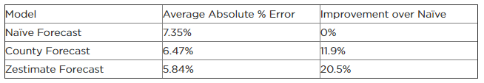

Table 1.1: Average absolute percentage error of the 12-month forecast.

Source: *https://www.zillow.com/research/zestimate-forecast-methodology/*

Features :

* Estimates for 12 months

Zestimate determines an estimation for 12 months for a house based on neighbourhood comparable houses. Accuracy of zestimate depends on the amount of data used as the underlying approach is Hedonic regression analysis based proprietary algorithm [6] which analyses of several features of the house. The forecasted value is interpolated using cubic spline to connect to current value. [6]

**2.Trulia**

Trulia is also a product offered in USA, which offers a range of services for real estate sector. The price estimates are based on publicly available information the home’s physical characteristics (e.g. location, number of bedrooms, etc.), Property tax information, Recent sales of similar nearby homes.

It involves more community interaction, for example, Trulia Neighbourhoods provide photographs, drone footage, etc. so that who are interested about the neighbourhood can refer. Trulia provides price using public data which shows the price fluctuation of a house, comparative to the other homes with same ZIP code.

Below is the accuracy report of Trulia estimates.

|  |  |  |  |  |
| --- | --- | --- | --- | --- |
| National | Within 5% of Sale Price | Within 10% of Sale Price | Within 20% of Sale Price | Median Error |
| United States | 48.2% | 67.7% | 82.3% | 5.3% |

Table 1.2: Trulia accuracy report

Source:*/www.trulia.com/info/trulia-estimates/*

Features -

* Crime map - Crime map data is sourced from CrimeReports.com and SpotCrime.com, which aggregate crime data from law enforcement agencies and news reports.
* Local schools with schools rating - Data of the schools around the premises with details such as Grades taught, GreatSchool Score.
* Commute times at a glance - Using data from OpenStreetMaps and General Transit Feed Specification (GTFS) feeds, the user can get an idea of commute times at a glance.[7]

**3.QV.co.nz - QV homeguide**

Quotable Value (QV) provides independent and authoritative information on any home in New Zealand on or off the market [8] QV.co.nz and their mobile App QV homeguide is known to be providing more accurate values of real estate property and key details to assist people to make instant decisions regarding property. QV with CoreLogic, a company which analyzes information assets and data to provide clients with analytics and customized data services provide a range of reports valuable to the user.

Features - QV homeguide app

* Online Value Estimation - Provides the likely selling price of a property during that particular time
* Sales activity - Sales activity specific property found on the app
* Suburb Demographics - Median price data, Demographic data, Current listings, and latest auction results [9]
* E-Valuer Report - Subjected to a fee complete valuation report of the property can be downloaded.

**4.HousePrice.ai**

Creating a methodology that would bring more sophisticated information, greater accuracy and analytical rigor to the United Kingdom (UK) residential property market is the motivation behind HousePrice.ai. Their proprietary model provides a combination of multi-disciplinary experiences of AI and Big Data to provide most accurate estimations. HousePrice.ai has Horizon app, which calculates capital, rental and gross development values for a single property or an entire portfolio. [10]

Features-

* Current and Future value prediction - Produces accurate property valuations both in the present time and can offer future predictions. Valuations are based on objective measurable values, creating a fact-based result as opposed to a subjective one [11]. This tool allows the user to adjust, add and remove factors within the surrounding areas to determine how external changes will affect property prices
* Distance to Schools, commutes etc.

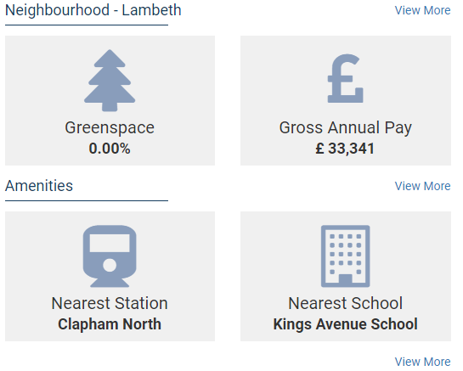

Figure 1.2: Brief Neighbourhood analysis

Source : *Sample Valuation Report - HousePrice.ai , Horizon*

*https://myhorizon.io/valueReport?id=59ddcdc7a699d278745b81e1*

* Historical data relevant to location

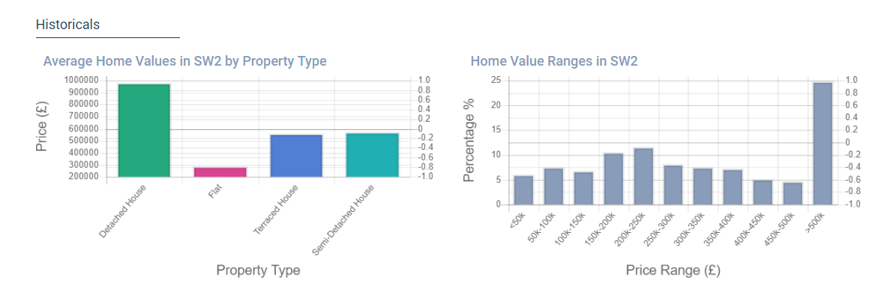

Figure 1.3: Historical Sales analysis

Source : *Sample Valuation Report - HousePrice.ai , Horizon*

*https://myhorizon.io/valueReport?id=59ddcdc7a699d278745b81e1*

**Comparison of Existing Systems**

|  |  |  |  |  |  |
| --- | --- | --- | --- | --- | --- |
|  | Zillow | Trulia | QV- CoreLogic | HousePrice.ai | Our Product |
| Current Value Prediction | Yes | Yes | Yes | Yes | Yes |
| Use of AI/ Machine Learning | Yes | Unknown | No | Yes | Yes |
| Future Value forecasting | For 12 months | No | Yes, with E-Valuer report | For 3 years | For 5 years |
| Future Development effects prediction | No | No | Yes | No | Yes |
| Available for Sri Lanka | No | No | No | No | Yes |

Table 1.3: Comparison of existing systems

**1.2 Research Gap**

During the AI Asia Summit 2018, the summit panelists Dr. Yasantha Rajakarunanayake, Dr Rukshan Baduwita , Dr. James Shanahan and Dr. Chrisantha Fernando agreed that Sri Lanka is behind in terms of AI startups[12], despite the fact software industry is vastly growing area. According to the survey conducted under research done by Karunanda *et al*[13], carried out in 2014, this is due to the lack of popularity, knowledge, experts, requirements and sponsorship for the AI related software projects[13].

But when analyzing local news we can see that AI based applications has become a trend. For Example Dialog has its own AI powered voice service to support its product service framework.

There are researches that have been conducted to predict the Stock prices of Sri Lanka with the usage of Artificial Intelligence and Machine Learning approaches, tilted *A recurrent neural network approach in predicting daily stock prices an application to the Sri Lankan stock market*[14], and *Comparison of Support Vector Regression and Artificial Neural Network Models to Forecast daily Colombo Stock Exchange*[15].According Li *et al,* [16]to the real estate valuation researches evaluating the use of GIS technology have been conducted. But there is no information regarding application of AI technology in real estate value prediction in Sri Lankan context.

Our proposed system uses AI model to do the estimations and forecasts. We design the application as much as inexpensive and cost effective to the user, simplified user interfaces, with accurate results which provides a concise but complete report of the analysis of the land.

**Inexpensive and Cost effective for user** - We provide all the estimations and predictions for a fair price which is beneficial in terms of time and cost over the manual method of valuation.

**Simplified User Interface and Concise Report** - User Interface should be appealing to the users despite of their educational or social level for an application to be useful. We believe our application will provide services to all categories of users, mostly the buyers, then surveyors, valuation officers etc. We can provide a simple user interface to input the location of the land and ultimately produce the report which includes current estimation, future value prediction, and details of possible development projects of the area which can be referred and understood by almost anyone.

**Accuracy** - Since AI and related algorithms which were proven to be suitable for Real Estate valuation will be used accuracy of the predictions can be guaranteed.

**1.3 Research Problem**

The main research problem is to develop an automated system to evaluate the land based on its neighbourhood economical value and identify the possible effects of development work on the value of the land in the future. This requirement of a solution to predict the current value and future value came from an expertise. While reviewing the literature, by means of supervisor meetings, we identified another aspect as an improvement, which is to predict the effect of future development work on a particular land, since Sri Lanka is a developing country, although the rate of development may vary, infrastructure development projects are carried out frequently.

We can never underestimate the duty of a valuation officer as the estimations are affected by numerous factors of particular to the area. But these factors are subjected to perception of each other’s experience, according to Vaz J.[17], the discretionary and the appraisers’ subjectivity that characterize traditional real estate valuation are still allowed to take part in the formation of the asset price even when respecting international standards (EVS, IVS) or Appraisal Institution´s regulations (TEGOVA, RICS, etc.). For example, an experienced valuer who is familiar with the area maybe biased towards the effect of regional factors, social factors, than the physical factors compared to a fairly new valuer who still sticks to the land valuation theories and follow the proven procedure. Therefore, manual valuation can be considered as a more sensitive approach.

Our intention is to provide people with fair accurate prediction of the land they are going to buy, so that they can decide the investment is fruitful for them. We believe this is an area improvement is needed because we can assist people in making decisions related to property, which would be the largest investment most probably in many people’s lives.

**2. OBJECTIVES**

The goal is to assist people by providing them with accurate valuation, facts about how the land is going to be affected by various means of development projects, ultimately to decide whether it would be useful for their expected purpose.

**2.1 Main Objectives**

The main objective of our research is to develop a portable application which can provide instant report of a selected land parcel which can provide the users with an insight of the land with current value and future value.

**2.2 Specific Objectives**

* Identifying the most accurate algorithm from conventional Multiple Regression Analysis (MRA) and non-conventional Artificial Neural Networks (ANN) in the domain of providing values in the domain of current value prediction following the Sales Comparison Approach
* Identifying methods to optimize the values provided as current value prediction so that the procedure could be used as a reliable option.
* Identifying method to predict future value based on the fluctuation rates and records of weather conditions.
* Identifying the effect of proposed development plans on the future price of the selected land plot
* Creating a concise yet complete report based on the selected land plot which can be used to assist in making smarter property related decisions.

**2.3 User Specification**

This application should be hosted to be accessible by public. We can add new features like

* Giving a suggestion of the type of suitable building to be built whether it is of some business value, suitable for residence etc.
* Prediction of possible schools a child can enroll when living in that area
* Check for neighborhood suitability, crime rate in the area etc.

to replace the entire valuation process.

**3. METHODOLOGY**

**3.1 High Level Architecture Diagram**

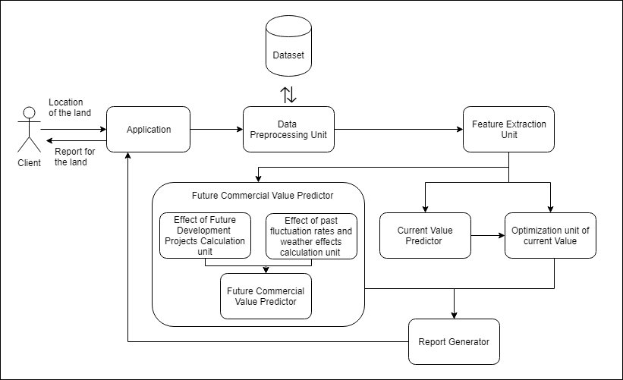

Figure 3.1: Architecture Diagram

**How Predictions are made for a certain land plot?**

When a customer goes to a land he is willing to buy, they can input the current location through the application. Based on that location, the suitable recent sales data is selected. Then those data will be analyzed by the AI model to predict the current value. That predicted value is optimized to produce the most accurate current value. Then the future value will be predicted by collaboration of two units, one which considers the fluctuation rates of past pricing values and weather effects, while the other calculates the effect of proposed development projects in the area. All these units generate a report which depicts these two types of data with relevant other data in a simpler way anyone can understand.

**A close up of a piece of paper

Description generated with high confidence**

Figure 3.2: Work Flow Diagram

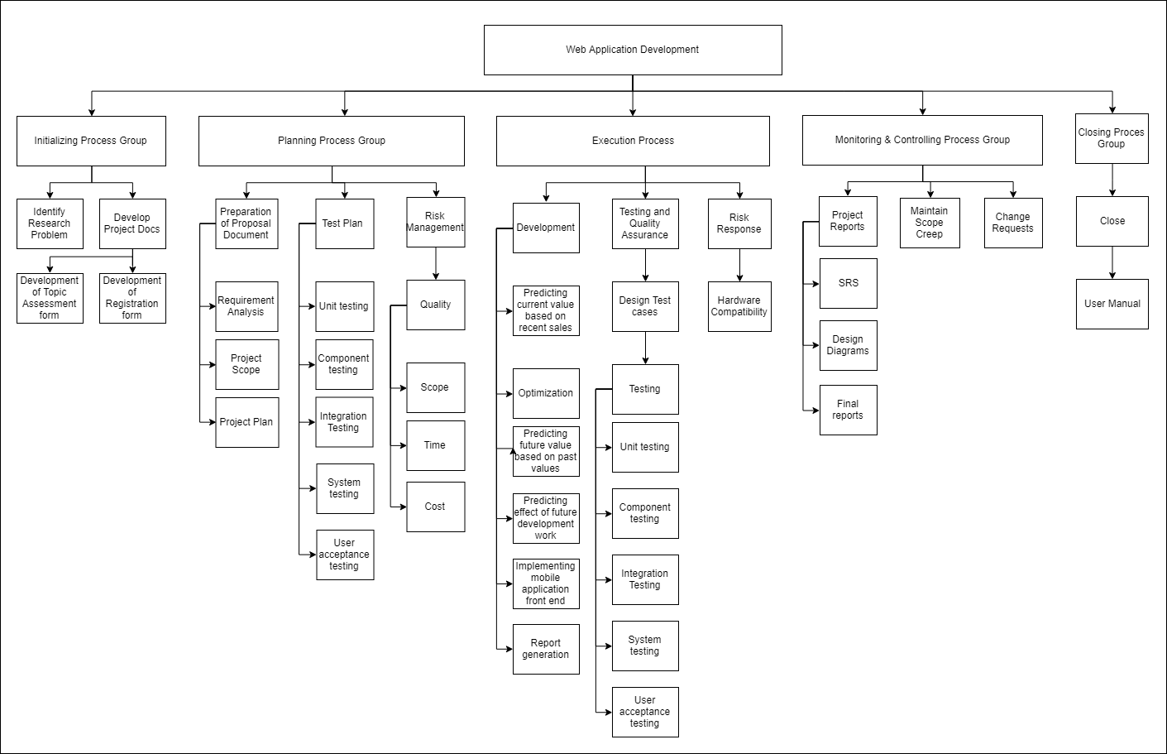**Work Breakdown Structure**

Figure 3.3: Work Breakdown Structure

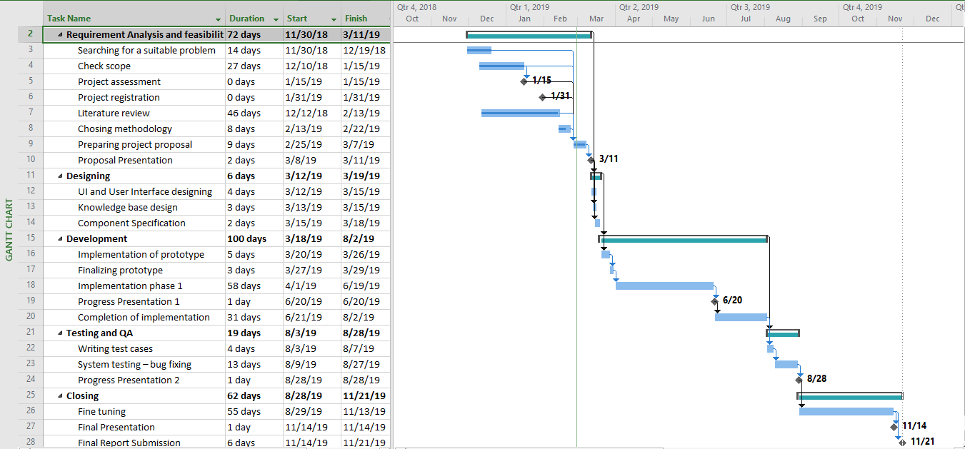**Gantt Chart**

Figure 3.4: Gantt Chart

**3.2 Software Development Life Cycle Model**

Based on the following factors inherent to this type of research problem,we will be following the Agile Methodology.

1. The high level of uncertainty of the project
2. The need of creativity and innovation than by being controlled by a traditional plan

Since the subject is area new and we have to constantly research and arrive at the conclusions by trial and error, at the same time have to implement a working software in a short time period, a blend of adaptive development which focuses on collaboration and learning as a technique to build complex systems[18] and agile modelling would be the best option to follow in implementing a high quality software and making rich documentation.

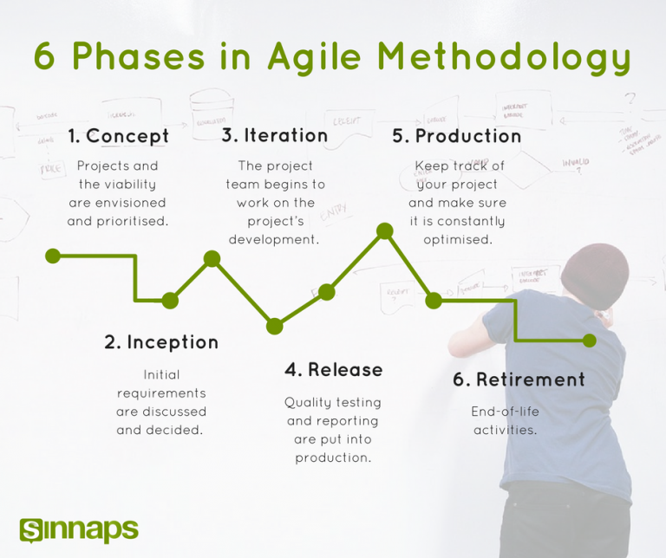

Figure 3.5: Phases of agile methodology

Source:*https://www.sinnaps.com/en/project-management-blog*

**3.2.1 Concept**

This phase is to identify the scope and different tasks and prioritize them appropriately. Under this phase, we planned the system, identified the area to center the project around and identified the business opportunity for the product. Also resources such as datasets which are necessary and ways to gather them was also decided. The topic selection and topic assessment tasks can be taken into this phase.

**3.2.2 Inception**

The requirements of the system and feasibility of the requirements is identified in this phase. We limited our product to provide services as mentioned above which should follow researching and testing frequently to conclude the results. We divided our components among the team members according to their willing since the development techniques are new and no one had prior knowledge of AI or machine learning etc. We need to gather the datasets needed for training AI models in this phase. High level UML diagrams should also be designed in this phase.

**3.2.3 Iteration / Implementation**

This phase will consist of several implementation iterations, which include range of tasks of the system from User Interface (UI) designing to implementing a launchable product based on the sprint requirements.

**3.2.4 Release**

The Quality Assurance (QA) process , addressing any defects of iteration and integration, finalize system and user manual documentation comes under this part.

**3.2.5 Production**

The team is responsible for smoothly running system and the product is introduced to the clients in this phase.

**3.2.6 Retirement**

The system release is removed from production in this phase when the system is outdated and the objectives which the system design was centered around initially becomes obsolete.

## **Agile software development sprint planning**

In this agile development approach work is divided in to sprints. Normally a sprint lasts for 10 working days. The workflow of a sprint can be outlined as follows.



Figure 3.6: Outline of Agile Sprint

**Plan -** The sprint begins with a sprint planning meeting, where team members come together to lay out components for the upcoming round of work[18].

**Develop -** Design and develop the product according to approved guidelines

**Test/QA -** Complete thorough testing and component is verified with the sprint plan

**Deliver -** Present the working product or software to stakeholders and customers

**Assess -** Get feedback from the stakeholders and information needed for next sprint.

**4. DESCRIPTION OF PERSONAL AND FACILITIES**

**4.1 Rough Valuation based on the recent sales happened in the area - Bimali YMY (IT16423534)**

Current value prediction is the first service offered to the client to decide whether that particular land plot is suitable for their requirement. According to Williams, S. [19], Sales Price Comparison approach is the most suitable approach that could be used to valuate vacant lands.

Therefore, in this component the dataset is filtered according to the location to get the recent sales happened in the area.

Our training environment determines the best out of conventional Multivariate Regression Analysis (MRA) and non-conventional Artificial Neural Networks (ANN) methods to do the most accurate prediction. According to Sampathkumar, et al. [20], both the models are found to be well fit with the data set of the land price in all locations, the model using NN (correlation 98%) shows better accuracy than the regression model (correlation 96%), while Zurada, Levitan and Guan, 2011[21] concludes no single obvious non-conventional method that can be expected to consistently outperform traditional multivariate linear regression in predicting residential real estate sales prices. In the least, the non-conventional methods may be used as a complement to the traditional, multiple regression based methods[21].

Chaphalkar et al [4], have compared use of ANN, use of fuzzy logic, use of expert system and genetic algorithm and other techniques such as decision tree by previous literature aggregation and suggest that ANN performs better than MRA but its black box nature has lead to reach different conclusions in the observations.

Therefore it is the better option to use both these techniques in the testing environment and select the most accurate model. Then we can apply the best approach taken from the testing environment and predict the current commercial value of the land parcel. Hence this current value prediction unit is designed as follows.

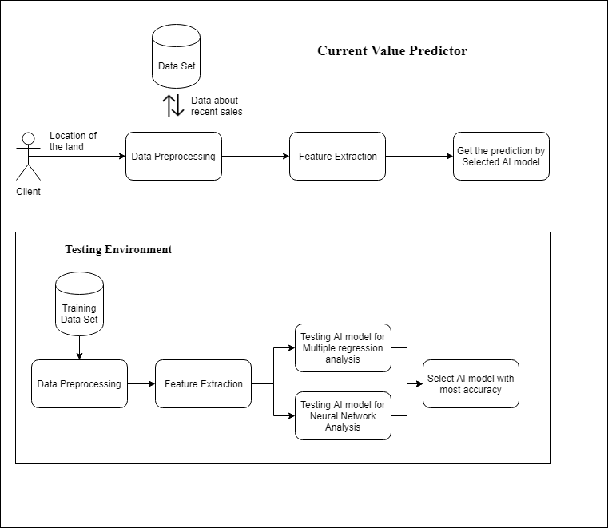

Figure 4.1: System Diagram for current value prediction unit

**4.2 Optimization of the rough valuation by analyzing and evaluating the manual procedure of mass appraisal - Rodrigo U.S.D. (IT16154490)**

Optimization in the field of machine learning is to minimize or eliminate the error of a prediction done by an AI model. It can be minimization of objective error function here, Current value predicted based on recent sales is optimized by Gradient Descent Technique. Gradient Descent is the most important technique and the foundation of how we train and optimize Intelligent Systems. It is the most popular Optimization algorithm used in optimizing a Neural Network. [22]

Mainly there are two optimization categories. The First Order Optimization techniques are easy to compute and less time consuming , converging pretty fast on large data sets.[22]Second Order Techniques are faster only when the Second Order Derivative is known otherwise, these methods are always slower and costly to compute in terms of both time and memory.[22]

Gradient Descent comes under first order optimization techniques. Therefore, for this kind of scenario, gradient descent would be the best approach. Since there are numerous methods of analysing gradient descent, we would prefer Stochastic Gradient Descent (SGD) method which considers the global minima except for local minima while arriving at conclusions. But, Sallinen, S. et al. [23], developed several highly optimized implementations of SGD, and analyzed factors which contribute to their statistical and hardware efficiency. They conclude intercore communication as the key impediment to SGD scaling on modern multi-core shared-memory systems. Therefore, while developing this optimization unit, tradeoffs might be made among optimization techniques.

The design of optimization unit would be as follows.

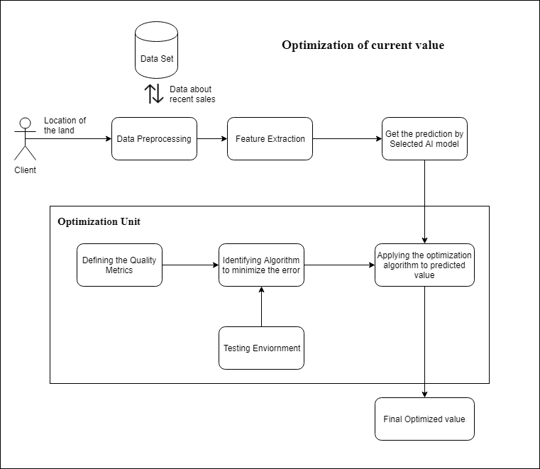

Figure 4.2: System Diagram for optimization of current value prediction unit

**4.3 Predicting the future commercial value based on the fluctuation rates for past 10 years and weather effects - Denuka Dharmaseelan (**I**T16116566)**

Initial step is to implement an algorithm to create a suitable model preceding by the development of model using algorithms to forecast the future commercial value of the land selected, by comparing the past values and feature values of the land market.Then the percentage fluctuation of past value and feature commercial value is found out and graph to those comparisons using statics will be generated. The K-NN algorithm is one of the methods used for classification analysis, but the last few decades the KNN method has also been used for prediction[24]. Geographic Information System (GIS) is an information system used to enter, store, recall, process, analyze and produce geo-referenced data or geospatial data, to support decision making in land use planning and management, natural resources, environment, transportation, City facilities, and other public services[24]. Google Maps uses HTML and Javascript programming languages to make it possible to place Google Maps apps on another web[24].Last 10 year price values will be used to train the model for feature values. To update the weather conditions, Artificial Neural Network is going to be used in this component.

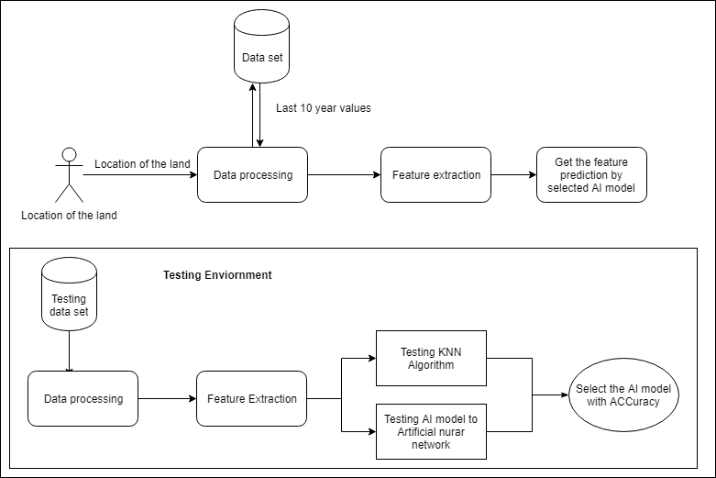

Figure 4.3: System Diagram for feature prediction

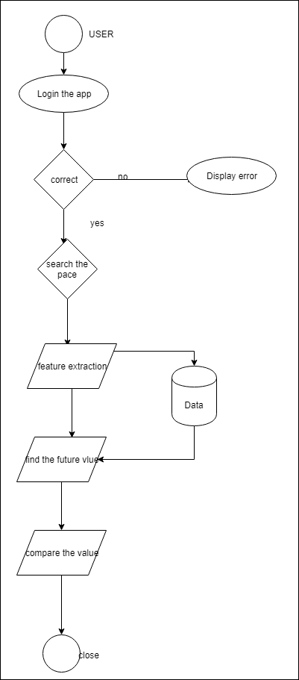

Figure 4.4: Flow chart for feature prediction

**4.4 Predicting the effect of future development projects on future commercial value - Kamaleswaran Thayalini (IT15156884)**

It contains effect of future development projects in determining the value of a particular land. This implies that if someone is going to buy a land, the system will automatically find the current land value and compare with future development infrastructure facilities such as future apartments, hospital, railway station, bus stand, airport and schools and calculating the commercial value of the land. Value prediction is mainly targeting five important infrastructure facilities. If a customer buys a land, land value can increase or decrease based on environment. There are some main reasons that reduces the value of a land such as War, Flooding etc. In the same way the land value will be increased if the area where the land is located based on future development projects. If upcoming projects are good, land value will increase. Every land value has to predict with using upcoming projects or infrastructure is determined to find the land value.

The research is useful since solving the problems in this study, it can be derived and produced a simple model of the influence of infrastructure development on the estimation of the land values, specifically described as follows:

1. A representative model can be identified for estimating the value of land in an area where the infrastructure development is dominant.

2. Can contribute positively to valuation of land in areas that are experiencing more dominant infrastructure development.

The study focuses on Colombo which experienced relatively high infrastructure development, which made it possible to become the study area in this study. It aims to determine the condition of the field and facilitate the preparation of observation strategies in the surrounding area which is expected to have a relatively large influence and the most appropriate analysis method to be developed in decision making in this study.

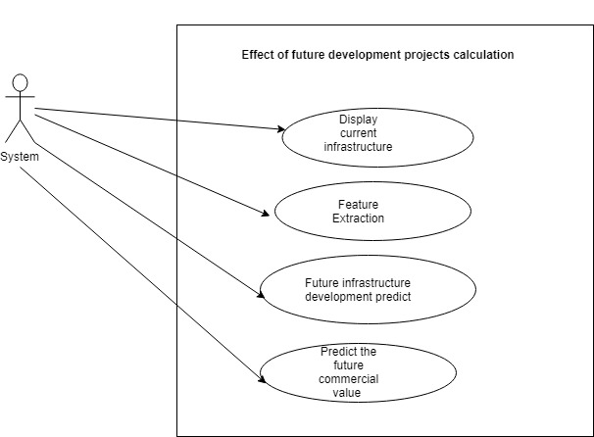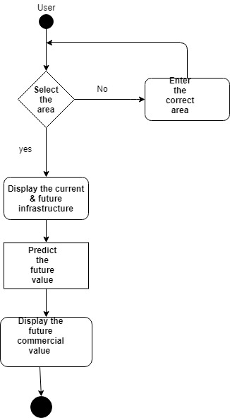

Figure 4.6: Use case diagram for effect of future development prediction

Figure 4.5:Work flow diagram for effect of future development prediction

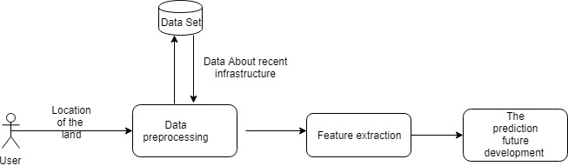

Figure 4.7: System diagram for effect of future development prediction

**5. EVALUATION**

**5.1 Potential of Entrepreneurship/ Marketability**

We believe our product is going to be a better option for entrepreneurship since this is the first of its kind in Sri Lanka. This application would be useful for regular customers as well as land developers, and land sale owners. Also the facts mentioned under section 1.3 above makes the application unique and useful for the users. We hope to offer a free trial of the product for a month and then have an option to subscribe with the system for a reasonable fee than offering few services for free and then providing the report document subjected to a fee. The latter option might be suitable if the reports are recognized by local authorities, banks like organizations as a substitute to a valuation report provided by a valuation officer in the future. Therefore we believe, there are numerous other features which can be added to the application which makes it more valuable.

**5.2 Accuracy**

Accuracy of the system is determined through the training/testing environment of AI model development. Our intention is to provide the best predictions by finding out the most accurate algorithms to be used with AI model.

**5.3 Responsiveness**

We expect our application to provide the outputs within an optimal minimum time so the users identify the product as instant, reliable and effective one of its kind which makes their effort on identifying the lands they are going to buy easier. Since we will be developing a web application UI responsiveness is also important until a Android/IOS apps are developed.

**5.4 Scalability**

We consider about the scalability of our product to be of the same importance as accuracy because there can be number of users accessing the resources at a time when the product is published.

**5.5 Cost and Complexity**

The system complexity can affect the cost of the services provided. But the service would be much more cheaper than the manual process since it can tradeoff the indirect costs and effort of travelling, gathering data etc.

**6. TECHNOLOGIES**

**6.1 Hardware Requirements**

Computer with

* CPU: Quadcore Processor
* RAM: At least 8 GB
* Storage: 1 TB

**6.2 Software Requirements**

* Python (Numpy, Pandas, Matplotlib, scikit-learn)
* Anaconda distribution,
* AngularJS/ReactJS
* Google API
* Elasticsearch

**7. BUDGET AND BUDGET JUSTIFICATION**

|  |  |
| --- | --- |
| **Item** | **Cost** |
| Hosting Cost | Rs. 5000 |
| Stationeries | Rs. 5000 |
| Travelling | Rs.2000 |
| Total | Rs. 12,000 |

Table 7.1: Budget Plan

**8. REFERENCE LIST**

[1] Li, L., Prussella, P.G.R.N.I., Gunathilake, M.D.E.K., Munasinghe, D.S. and Karadana, C.A., 2015. Land Valuation Systems using GIS Technology Case of Matara Urban Council Area, Sri Lanka. Bhumi, The Planning Research Journal, 4(2), pp.7–16.

[2] Nadai, M. D., & Lepri, B. (2018). The Economic Value of Neighborhoods: Predicting Real Estate Prices from the Urban Environment. *2018 IEEE 5th International Conference on Data Science and Advanced Analytics (DSAA)*. doi:10.1109/dsaa.2018.00043

[3] Schulz, R. (2003). Valuation of properties and economic models of real estate markets. Erscheinungsort nicht ermittelbar: Verlag nicht ermittelbar.

[4] Chaphalkar, N.B, & Sayali Sandbhor. (n.d.). Use of Artificial Intelligence in Real Property Valuation. Retrieved from <http://www.enggjournals.com/ijet/docs/IJET13-05-03-087.pdf>

[5] Zillow. (2019, February 21). Retrieved from <https://en.wikipedia.org/wiki/Zillow#Zestimate> [Accessed 23 Feb. 2019].

[6] Hagerty, James R. "How Good Are Zillow's Estimates?", The Wall Street Journal, 2007-02-14. Retrieved on 2009-02-25.[Accessed 23 Feb. 2019].

[7] Trulia. (n.d.). Retrieved February 22, 2019, from <https://en.wikipedia.org/wiki/Trulia> [Accessed 23 Feb. 2019].

[8] “QV Homeguide App Now Available.” New Zealand Property Investors Federation, 3 Mar. 2015, [www.nzpif.org.nz/news/view/56971](http://www.nzpif.org.nz/news/view/56971). [Accessed 24 Feb. 2019].

[9] “Part 4: Quotable Value Limited's QV Homeguide Application.” Office of the Auditor-General New Zealand, [www.oag.govt.nz/2018/digital-access/part4.htm](http://www.oag.govt.nz/2018/digital-access/part4.htm). [Accessed 24 Feb. 2019].

[10] “ABOUT US.” Houseprice.AI-What's the Fair Price ?, [www.houseprice.ai/about](http://www.houseprice.ai/about). [Accessed 24 Feb. 2019].

[11] “Introducing Houseprice.AI: The Must Have Tool for Every Developer.” Bridging Loans | Development Loans | AvamoreCapital, 29 May 2018, avamorecapital.com/introducing-houseprice-ai-the-must-have-tool-for-every-developer/. [Accessed 24 Feb. 2019].

[12] De Andrado, M. (2018). *Aiming for a Smarter Future With the AI Asia Summit 2018 – README*. [online] README. Available at: https://www.readme.lk/slasscom-ai-asia-summit-2018-post-event/ [Accessed 20 Feb. 2019].

[13] Karunananda, A., Asanka, P., Fernando, H., Adhikari, T. and Pathirage, I. (2014). *State of Artificial Intelligence in Sri Lankan Software Industry*. [online] Available at: https://www.researchgate.net/publication/281224224_State_of_Artificial_Intelligence_in_Sri_Lankan_Software_Industry [Accessed 17 Feb. 2019].

[14]A. J. P. Samarawickrama and T. G. I. Fernando, "A recurrent neural network approach in predicting daily stock prices an application to the Sri Lankan stock market," 2017 IEEE International Conference on Industrial and Information Systems (ICIIS), Peradeniya, 2017, pp. 1-6.

[15] Chandrasekara, Vasana & Tilakaratne, Chandima. (2011). Comparison of Support Vector Regression and Artificial Neural Network Models to Forecast daily Colombo Stock Exchange.

[16] Li, L., Prussella, P., Gunathilake, M., Munasinghe, D. and Karadana, C. (2015). Land Valuation Systems using GIS Technology Case of Matara Urban Council Area, Sri Lanka. Bhumi, The Planning Research Journal, 4(2), p.7.

[17] Vaz, J. (2015). REAL ESTATE APPRAISAL AND SUBJECTIVITY. *European Scientific Journal March 2015*, ISSN: 1857 – 7881(e - ISSN 1857- 7431), pp.55, 63.

[19] Williams, S. (2019). *The Real Estate Investor's Guide to Valuing Vacant Land*. [online] REtipster. Available at: https://retipster.com/valueofland/ [Accessed 25 Feb. 2019].

[20] Sampathkumar, V., Santhi, M. and Vanjinathan, J. (2015). Forecasting the Land Price Using Statistical and Neural Network Software. Procedia Computer Science, 57, pp.112-121.

[21] Zurada, J., Levitan, A. and Guan, J. (2011). Non-Conventional Approaches To Property Value Assessment. Journal of Applied Business Research (JABR), 22(3).

[22] Towards Data Science. (2019). Types of Optimization Algorithms used in Neural Networks and Ways to Optimize Gradient Descent. [online] Available at: https://towardsdatascience.com/types-of-optimization-algorithms-used-in-neural-networks-and-ways-to-optimize-gradient-95ae5d39529f [Accessed 25 Feb. 2019].

[23] Sallinen, S., Satish, N., Smelyanskiy, M., Sury, S. S., & Re, C. (2016). High Performance Parallel Stochastic Gradient Descent in Shared Memory. 2016 IEEE International Parallel and Distributed Processing Symposium (IPDPS). doi:10.1109/ipdps.2016.107

[24] Mukhlishin, M. (2017). *Predicting house sale price using fuzzy logic, Artificial Neural Network and K-Nearest Neighbor - IEEE Conference Publication*. [online] Ieeexplore.ieee.org. Available at: https://ieeexplore.ieee.org/document/8276357 [Accessed 19 Feb. 2019].