Summary of the species part of the cultivation-depensation model.

The model:

Modified version of the model presented in in Biggs et al. (2009). I’ve modified the model to transform the forage fish species in their model to a second harvest species with adult and juvenile states. The model still contains foraging arena dynamics but, for the moment, does not contain shoreline development effects on interspecies interactions.

Conceptual figures showing the modifications I made to the Biggs model.

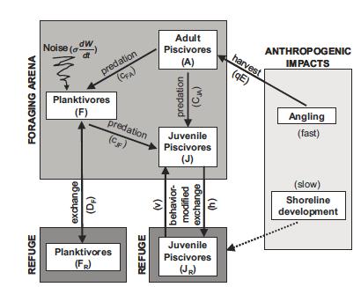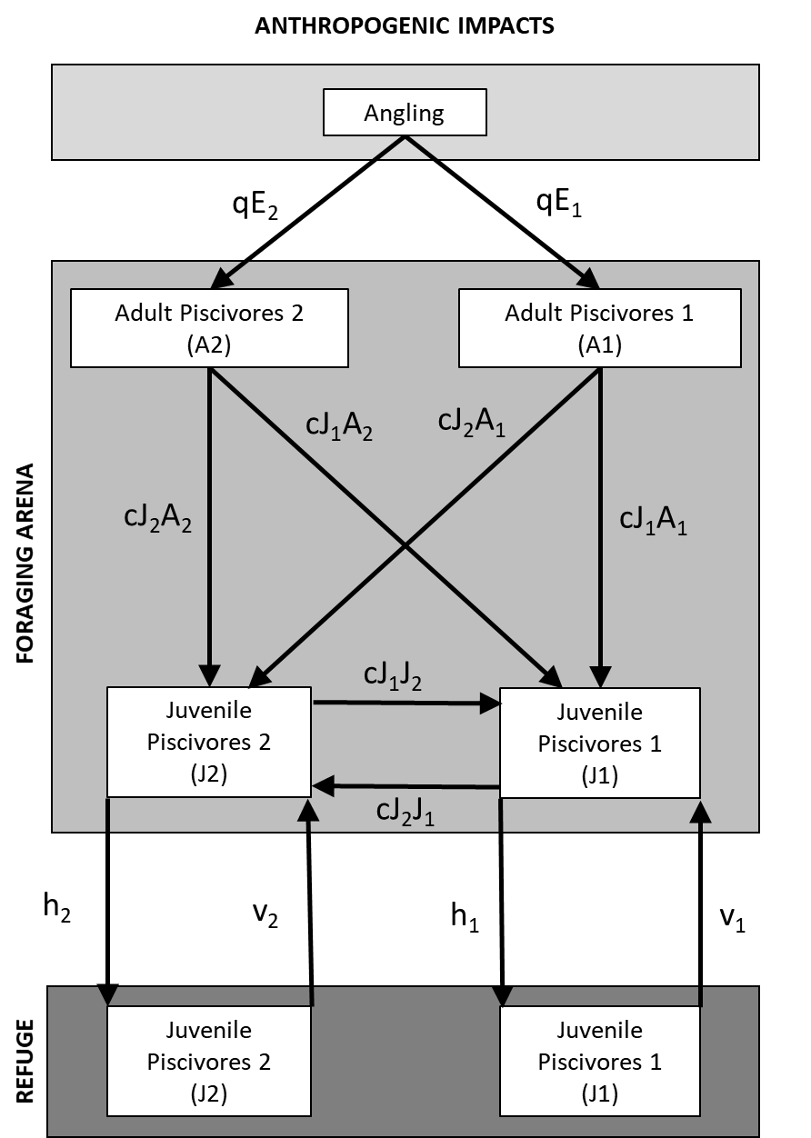

**Biggs Model**

**Modified Model**

Demonstrating alternative stable states and hysteresis

To test for multiple states and hysteresis I ran the model to equilibrium under conditions where the parameter values for each species were the identical except for harvest on species 1 which increased with each run to equilibrium. I did this for two scenarios, one where species 1 was initially more abundant and one where species 2 was more abundant. This allowed me to see under what angling scenarios each species dominates and if it’s dependent on who’s more abundant. If that’s the case then there are multiple stable states.

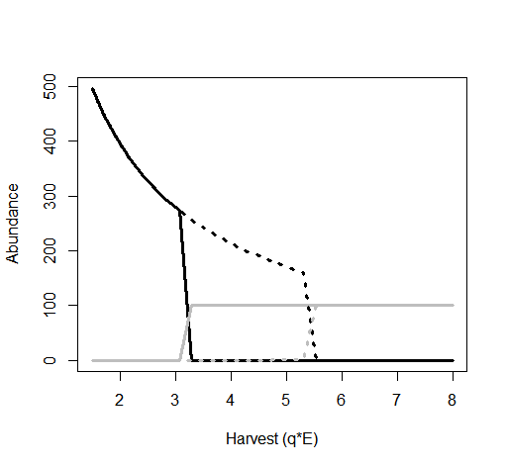First the original Biggs model, the piscivore is the black lines and the forage fish is grey. Run 1 where the piscivore is initially more abundant is the solid line and run 2 where the forage fish is initially more abundant is the dashed line.

Above we see that depending on who’s initially more abundant, a harvest of ~3 to ~5.5 results in two different states, one where the piscivore dominates when it starts out more abundant and one where the forage species dominates when it starts out more abundant. At very low and very high harvests the initial abundance doesn’t matter and the system reaches the same equilibrium no matter what (overlapping lines).

Modified version of the model.

Here black is species 1 and grey is species 2, the solid and dashed lines are still the two runs where solid lines are for when species 1 was initially more abundant and dashed is for when species 2 is initially more abundant.

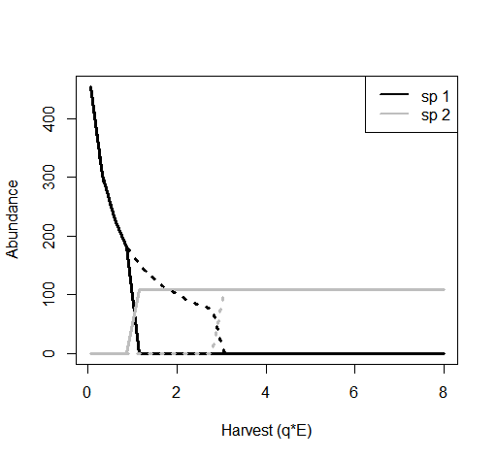With the modified version of the Biggs model we get the same dynamics where at high and low harvests the initial abundance of either species doesn’t matter but at an intermediate harvest there are two states that depending only on who as the edge in initial abundance.

The spaces these alternative states occupy on the both the x and y axis will change depending on the value each of the different parameters take. In general, the presence of alternative stable states is robust to differences in parameter values between the two species. I’ve only explored this in scenarios where just one parameter is different and all others are equal, I haven’t tried this we different combination of parameter differing. So far, one exception to the idea that parameter values don’t effect the presence/absence of alternative states is the cannibalism parameter, if it is different between the two species (with all else being equal) no alternative states will exist. I haven’t looked to see if tweaking other parameters would allow for alternative stable states to exists despite differences in cannibalism. Only when the difference in cannibalism is really small to we still get alternative stable states

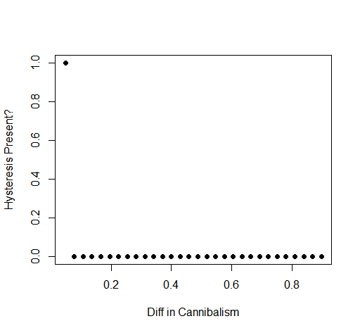

Cannibalism

There are also 2 other parameters (survival & fecundity) that, when different between the two species, will or will not produce alternative stable states depending on the magnitude of the difference.

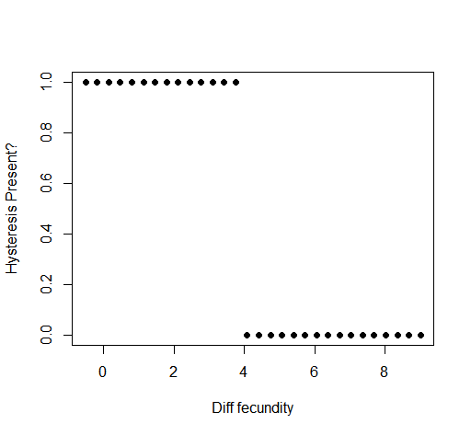Fecundity

Here a value of 1 means there is alternative stable states, including hysteresis as before, and 0 means no. As the magnitude of the difference in fecundity increases and species 1 becomes very productive, the effect of initial abundance is overcome and the same stable state is reached at each harvest level no matter what

Survival

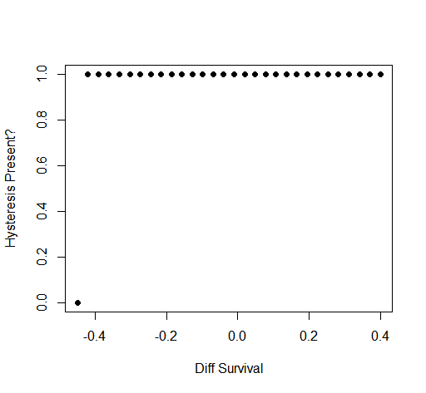Here we see that alternative states are almost always present except when the difference in survival between the two species is large and favors species 2. Other than that survival differences generally don’t have an effect on the presence of alternative stable states.