**Characterizing the Angling and Tribal Spearing Walleye Fisheries in the Ceded Territory of Wisconsin, 1990-2015**

**Joseph T. Mrnak*and Stephanie L. Shaw**

*Wisconsin Department of Natural Resources, Escanaba Lake Research Station,*

*3110 Trout Lake Station Drive, Boulder Junction, Wisconsin 54512, USA*

**Lawrence D. Eslinger**

*Wisconsin Department of Natural Resources, Woodruff Treaty Fisheries Assessment Team,*

*8770 Highway J, Woodruff, Wisconsin 54568, USA*

**Thomas A. Cichosz**

*Wisconsin Department of Natural Resources, Bureau of Fisheries Management,*

*101 South Webster Street, Madison, Wisconsin 53707, USA*

**Greg G. Sass**

*Wisconsin Department of Natural Resources, Escanaba Lake Research Station,*

*3110 Trout Lake Station Drive, Boulder Junction, Wisconsin 54512, USA*

*Corresponding author: Joseph.Mrnak@sdstate.edu

*Abstract*

**Assessment of the angling and tribal spearing Walleye (*Sander vitreus*) fisheries in the Ceded Territory of Wisconsin (CTWI) is critical for the sustainability of this resource. Key to these assessments is an understanding of harvest demographics, exploitation, catch and harvest efficiency, and relationships between catch/harvest and adult density. We characterized the size distribution and the means for length of harvested Walleye, harvest, exploitation rate, and catch (angling) or harvest (spearing) rate for both fisheries during 1990-2015. Then, we evaluated catch and harvest rates in relation to adult density and tested for self-regulation/hyperstability in each fishery. Size distribution and mean length of harvested Walleye in both fisheries were statistically different, but biologically similar. Anglers harvested significantly more Walleye and the mean exploitation rate was greater in the angling fishery. Spearfishers had significantly higher mean harvest rates compared to angler catch rates. Catch and harvest rates followed an asymptotic relationship with adult density, with the spear fishery showing more hyperstability than the angling fishery. In the CTWI, naturally reproducing Walleye populations are managed for densities ≥ 7.4 adults/ha. Our results suggest that maintaining adult Walleye densities near the point of diminishing returns of the asymptotic relationship (10-15 Walleye/ha) will result in a sustainable fishery that also maximizes tribal harvest and angler catch. However, maintaining adult Walleye densities within this range in unproductive lakes typical of the CTWI may be unrealistic. Due to the hyperstability observed in each fishery, active management of the spear fishery should continue, and monitoring of the angling fishery should also continue given recent declines in natural recruitment and production observed in the CTWI to maintain Walleye populations in a “safe operating space”. An empirical understanding of CTWI Walleye angler and spearfisher effort dynamics is critically needed to mechanistically explain the observed hyperstability in each fishery.**

Sustainable fisheries management relies on knowledge of key attributes of exploited fish populations (e.g., harvest demographics, catch and harvest efficiencies, relationships between catch/harvest and fish density, and angler behavior) and how they may change over time. Knowledge of these factors is particularly important when fisheries are exploited by multiple sources (e.g., angling, subsistence, commercial). To manage exploitation, and in some cases fisher effort, regulations such as minimum length limits, bag limits, quotas, and seasonal closures are often used (Kohler and Hubert 1999). These regulations may influence population size-structure (Brousseau and Armstrong 1987; Goeman et al. 1993; Isermann et al. 2002; Mosel et al. 2015), abundance (Slipke et al. 1998; Allen and Pine III 2000; Fayram et al. 2001), and natural recruitment rates of the population (Madenjian et al 1996; Hansen et al. 1998; Boxrucker 2002; Tsehaye et al. 2016). However, minimum length and bag limit regulations generally need to be quite conservative to effectively reduce harvest (Cook et al. 2001; Isermann and Paukert 2010; Mosel et al. 2015). Closed seasons and quotas are sometimes used in inland recreational fisheries; however, direct effort limitation in open access fisheries is less common. Closed seasons and quotas are more commonly used in commercial and subsistence fisheries (Sztramko 1985; Holey et al. 1995; Cox and Walters 2002; Post et al. 2008). Continual assessment of diagnostic metrics (e.g., angler behavior, fish abundance, exploitation rates) is critical for sustainable fisheries management, because angler dynamics (Allen et al. 2008; Hansen et al. 2015a; Gilbert and Sass 2016; Eslinger et al. 2017), fish communities (Krueger and Hrabik 2005; Gaeta et al. 2015), and environmental conditions may change over time (Hansen et al. 2016). As such, continual monitoring and assessment are tools used to ensure that defined goals of the fishery are met.

Managers monitor exploited fisheries to assess long-term sustainability by testing for relationships among population attributes (i.e., size structure and fish density), fisheries attributes (i.e., harvest rates, catchability, self-regulation, hyperstability), and associated regulations. Size structure data are a commonly used assessment tool, as they reflect rates of recruitment, growth, and mortality of the target population (Neumann and Allen 2007). Further, size structure data aid in evaluating regulations (Webb and Ott 1991; Lauer et al. 2008). Managers monitor various fishery aspects such as the number of fish harvested per lake and catch and harvest rates through creel surveys. Harvest per lake in combination with fish density can provide exploitation rate. High exploitation rates can lead to recruitment overfishing, whereby harvest may depress a population to the point that recruitment is directly affected (Allen et al. 2013). Catch and harvest rates are equally important to continually assess as diagnostic metrics related to fish abundance, angler behavior, exploitation rates, and future recruitment (Hansen et al. 2000; Margenau et al. 2003; Hansen et al. 2005; Hunt et al. 2011). Lastly, relationships between catch or harvest rate and fish density are important aspects of the fishery to monitor and assess (Hansen et al. 2000; 2005). Catch and harvest rates are often assumed to be proportional to fish density (i.e., self-regulating; Beard et al. 1997; Hansen et al. 2000), although this is not the case for all fisheries (i.e., hyperstability; Post et el. 2002; Ward et al. 2013; van Poorten et al. 2016; Tidd et al. 2017). Relationships between catch and harvest rate and density aid in determining the gradient of self-regulation (catch rates change proportionally with population size) and hyperstability (catch rates remain elevated when population declines) in a fishery (Ricker 1975; Hansen et al. 2000; Harley et al. 2001; Walters and Martell 2004; Hansen et al. 2005; Erisman et al. 2011). If a fishery is not self-regulating, then various applied management strategies may be needed for the sustainability of the fish stock long-term (e.g., “safe operating space”; Carpenter et al. 2017).

Walleye (*Sander vitreus*) support important recreational, commercial, and subsistence fisheries across their native and introduced range (Baccante and Colby 1996; Schmalz et al. 2011). In the Ceded Territory of Wisconsin (CTWI; the northern third of the state), Walleye are the most popular sport fish and the key species of interest in the joint angling and tribal spear fisheries. In 1983, the 7th Circuit Federal Court of Appeals reversed an earlier court decision (1978) and reaffirmed the allowance of off-reservation hunting, fishing, and gathering rights specifically reserved by Chippewa tribes in the treaties of 1837 and 1842. As such, off-reservation Chippewa spearfishing was initiated in the CTWI in the spring of 1985 (Staggs et al. 1990; Nesper 2002). This court decision resulted in a joint fishery comprised of high efficiency tribal methods (primarily spearing) and low efficiency angling directed mostly toward Walleye and Muskellunge (*Esox masquinongy*). Wisconsin’s joint Walleye fishery components differ in their regulations, but both are harvest-oriented fisheries (Gaeta et al. 2013; Hansen et al. 2015b). Thus, monitoring population and fishery attributes over time is important to ensure sustainability.

Hansen et al. (2000) first characterized the CTWI joint Walleye fishery during 1990-1997. Initially using 118 lake-years of data, Hansen et al. (2000) found that angler catch rates were linearly related to adult Walleye density, while spearfishing harvest rates were exponentially related to adult Walleye density. Hansen et al. (2000) concluded that the CTWI Walleye angling fishery was density-independent and more self-regulating, whereas the spear fishery was density-dependent and less self-regulating (i.e., hyperstable). After correcting for measurement error in population, catch, and harvest rate estimates and using a more appropriate statistical procedure, Hansen et al. (2005) later concluded that both fisheries showed relatively high degrees of hyperstability and less self-regulation. An additional 12 years of data are now available following the Hansen et al. (2005) study. Thus, our goal was to characterize the Walleye angling and spear fisheries within the CTWI during 1990-2015. Our objectives were to test for differences in: 1) size structure and mean length of harvested Walleye; 2) mean harvest/ha/lake-year and exploitation rate; and 3) catch and harvest rates in relation to adult Walleye density between the fisheries across the CTWI. Additionally we tested for the degree of self-regulation/hyperstability in both fisheries.

<A>Methods

<C>*Study area and fishery surveys*

We used Walleye population and angler creel data collected within the CTWI by the Wisconsin Department of Natural Resources (WDNR) and spear harvest data collected by the Great Lakes Indian Fish and Wildlife Commission (GLIFWC) during 1990-2015. As a result of the joint fishery, methods for estimating adult density, conducting creel surveys, and collecting demographic information from Walleye have been standardized since 1990 (Beard et al. 1997). Standardized surveys are intended to represent the range of available lake types and designed to survey all exploited populations at least once per generation time (Sass and Shaw 2018). Lakes were sampled in a stratified random manner, with some trend lakes identified and sampled more frequently, while others were randomly sampled across key strata (e.g., region, recruitment source). Mean ± SE surface area and maximum depth of the lakes used in our analyses were 362.2 ± 38.3 ha (range 9 – 6197 ha) and 12.6 ± 0.4 m (range 1.5 – 45.4 m), respectively.

Adult Walleye density was estimated in about 25-30 lakes per year using Chapman’s modification of the Petersen mark-recapture estimator (Ricker 1975). Walleye were captured using fyke nets set on spawning areas immediately after ice out; captured Walleye were marked with a year-specific fin clip and released. Marking continued until about 10% of the adult population was marked (based on previous population estimates or recapture rates in the nets). Once marking was completed, Walleye were recaptured at the peak of the spawn using an AC or pulsed DC boat electrofishing run of the entire lake shoreline (Beard et al. 1997). We only included population estimates with a coefficient of variation (CV) ≤ 0.4 in our analyses like Beard et al. (1997) and Hansen et al. (2000; 2005).

Angler creel surveys were conducted each year (from the first Saturday in May to the first Sunday in March of the following year, excluding November due to low angler effort and unsafe ice conditions) for a subsample of lakes in which adult Walleye density was estimated. Angler creel surveys used a random stratified roving access design described in detail by Hansen et al. (2000). Creel clerks made instantaneous counts of the number of anglers on the waterbody and conducted interviews on a subset of anglers (recording hours fished, total catch by species, harvest, and species targeted). All harvested fish were measured for total length and examined for marks (i.e., fin clips). Based on complete-trip creel survey interviews, estimates of total and species-specific (targeted) angler effort, catch, and harvest were derived for each surveyed lake. Angler exploitation rates were also estimated for gamefish species using creel survey data. Angler exploitation rates were estimated as *u =* *R*/*M,* where *R* was the projected harvest of recaptured, marked fish and *M* was the total number of marked fish (Ricker 1975). During 1990-2014, the standard CTWI Walleye angling regulation was a minimum length limit of 381 mm with a sliding angler daily bag limit of 1-5 fish/day established after annual tribal harvest from an individual Walleye population; angler daily bag limits declined accordingly with a greater proportion of the total allowable catch harvested by spearfishers (Staggs et al. 1990; Beard et al. 2003). Since 2015, the “default” CTWI Walleye angling regulation was a 381 mm minimum length limit, 508 – 610 mm protected slot, with only one Walleye ≥ 610 mm allowed and a daily bag limit of 3 fish/day. In addition to these regulations, several other Walleye angling regulations have also been or are currently used to meet certain management goals of individual populations (e.g., various bag limits not to exceed 5 fish/day and no minimum length limit, only one fish ≥ 356 mm allowed, 457 mm minimum length limit, and a 711 minimum length limit).

Spearfishing occurs almost exclusively during the spring spawning period. Nightly permits are issued to tribal members by tribal agents at either the tribal headquarters or at a specified boat launch on the lake to be speared. The number of permits issued and the quantity of fish allowed for spearing with each permit are variable and dependent on the remaining tribal quota and the number of spearers requesting permits. Spearfishers may receive multiple permits per lake/night if available. Tribal members may spear any Walleye ≤508 mm, but are only allowed one Walleye between 508-610 mm and one Walleye of any size. At each lake, tribal creel clerks or wardens record hours fished, number and species of all fish speared, and the total lengths of most fish. From these data, harvest per unit effort, total harvest, and the size-structure of spear-harvested Walleye are summarized for each lake-year. Tribal exploitation is estimated as *u = H/PE* where *H* is the total number of Walleye harvested and *PE* is the adult Walleye population estimate.

Although some Walleye populations were sampled multiple times in our dataset, we did not account for repeated measures in our analyses because 75% of the populations were only sampled once or twice over our 26 year study period, with the remaining 25% of populations sampled 3-6 times. Most of the Walleye populations in our dataset were maintained by natural reproduction (68%). However, some were maintained by a combination of natural reproduction and stocking, and some were maintained solely by stocking (32%). We decided to not limit or separate our dataset to any or all three maintenance methods because our goal was to characterize the overall CTWI, which contains all the aforementioned.

<C>*Harvest size structure and exploitation*

Size structure of harvested Walleye between fisheries were compared using length-frequency histograms and differences were tested for with the Kolmogorov-Smirnov (K-S) test (Neumann and Allen 2007). For each fishery, summary statistics were produced using the Summarize() function from the FSA package v.0.8.18 (Ogle 2017) in the RTM statistical environment v3.4.3 (R Development Core Team 2017). We used a one-way ANOVA to test for statistical differences in the mean length, fish/lake-year, fish/ha/lake-year, and exploitation rate of harvested Walleye between fisheries. We used an α=0.05 to determine statistical significance with the null hypothesis of no difference in the variables of interest between the fisheries.

<C>*Catch rates, harvest rates, and self-regulation/hyperstability*

Catch per unit effort (CPUE) for the angling fishery was defined as specific catch rate (i.e., total catch/hr by anglers specifically targeting Walleye), while harvest per unit effort (HPUE) for the spear fishery was defined as harvest/hour (as there is no catch-and-release in this fishery). Although HPUE may be a better indicator of the overall resiliency of the angling fishery, we decided to examine and model CPUE because: 1) it paints a more complete picture of general use within the CTWI; 2) angling HPUE is substantially lower and less variable than CPUE primarily due to regulations limiting harvest; and 3) angling CPUE has been found to be correlated with Walleye density (Beard et al. 1997; Hansen et al. 2000; 2005). We tested for differences and summarized CPUE or HPUE as described above using a one-way ANOVA and the Summarize() function from the FSA package (Ogle 2017) in RTM.

We tested for a relationship between CPUE or HPUE and adult Walleye density using the flexible model developed by Richards and Schnute (1986):

$$U = (p + qD) / (1 + rD)$$

where *U* represents the CPUE or HPUE (Walleye/hr), *D* is an adult Walleye density estimate (Walleye/ha), and *p*, *q*, and *r* were estimated parameters used to define the shape of the relationship. This model allowed for the testing of multiple hypotheses regarding the relationship between CPUE or HPUE and adult Walleye density, including:

(1) Asymptotic model (*p* held at 0): $U = (0 + qD) / (1 + rD)$

(2) Proportional linear model (*p* and *r* held at 0): $U = (0 + qD) / (1 + 0D)$

(3) Horizontal (no relationship) model (*q* and *r* held at 0): $U = (p + 0D) / (1 + 0D)$

Hansen et al. (2000) found that an exponential model best described the HPUE versus adult Walleye density relationship in the spear fishery. Thus, we also tested the exponential model form as a fourth hypothesis (Peterman and Steer 1981; Hansen et al. 2000):

(4) Exponential model: $U= αD^{β+1}$

where $α$ and $β$ were treated as unit-less parameters used to define the shape of the exponential model. Raw data were characterized as having a multiplicative residual error structure, thus we used a lognormal likelihood to fit each model to the data. We used Akaike information criterion (AIC) to determine which model had the highest probability of fitting the data. Recommendations for determining likelihood of model fit was based on Anderson (2008), where models with a ΔAIC value >8 were considered to have little to no plausibility, ΔAIC values <8 and >4 have low empirical support, ΔAIC values <4 included models with some empirical support, and a ΔAIC value of 0 was considered the model with the highest likelihood of fitting the data.

We tested for the degree of self-regulation/hyperstability in catch/harvest rates with declining adult Walleye density for each fishery according to Hansen et al. (2005). Briefly, we used equation (2) as per Hansen et al. (2005); derived from Ricker (1975) and Peterman and Steer (1981). Ordinary least squares (OLS) iterative methods were conducted in Microsoft Excel using Solver to estimate the α and β parameters and assess the relationship between catch/harvest rates and adult Walleye density for each fishery. Because adult walleye density is measured with error, we used the OLS method of Hansen et al. (2005) because it resulted in the least bias and was the best way to address this error. β values closer to 1 indicated a greater degree of self-regulation and values closer to 0 indicated a greater degree of hyperstability (Hansen et al. 2005). β values were interpreted as a gradient between total self-regulation (β = 1) and hyperstability (β = 0).

<A>Results

<B>Harvest Size Structure and Exploitation

Size structure of Walleye harvested in the CTWI from the angling and spearing fisheries differed statistically (K-S *P*<0.001), but were biologically similar (Figure 1). In both fisheries, Walleye initially became vulnerable to harvest at about 250 mm total length, were fully vulnerable to harvest by 300 mm total length, and harvest declined at total lengths from 400-700 mm (Figure 1). Mean length of harvested Walleye differed significantly between fisheries (*n*=147,566, *F1,147564*=1351, *P*<0.001). For the angling fishery, the mean ± SE total length of harvested Walleye was 383 ± 0.3 mm (range 102 - 787 mm; Figure 1). The mean ± SE total length of harvested Walleye for the spear fishery was 398 ± 0.3 mm (range 132 - 818 mm; Figure 1). Mean ± SE exploitation rates were significantly higher in the angling fishery (0.09 ± 0.005) compared to the spear fishery (0.04 ± 0.002; *n*=988, *F1,986 =* 83.6, *P* < 0.001; Figure 2).

<B>Catch Rates, Harvest Rates, and Self-Regulation/Hyperstability

On a mean/lake-year basis, anglers harvested significantly more Walleye than spearfishers (*n*=822, *F1,880*=26.6, *P*<0.001; Figure 3). Anglers harvested a mean ± SE of 943 ± 130 Walleye/lake-year, while spearfishers harvested a mean ± SE of 195 ± 13 Walleye/lake-year during 1990-2015 (Figure 3). On a mean/ha/lake-year basis, similar results were observed where anglers harvested significantly more Walleye/ha than spearfishers (*n*=4261, *F1,4259*=1428, *P*<0.001; Figure 3). Anglers harvested a mean ± SE of 1.8 ± 0.09 Walleye/ha/lake-year, while spearfishers harvested a mean ± SE of 0.4 ± 0.005 Walleye/ha/lake-year during 1990-2015 (Figure 3). Spearfishing harvest rates were significantly higher than angler catch rates (*n*=889, *F1,887*=97.2, *P*<0.001; Figure 4). Mean ± SE angling CPUE was 0.24 ± 0.01 Walleye/hr and mean ± SE spearfishing HPUE was 16.7 ± 0.61 Walleye/hr during 1990-2015 (Figure 4).

For both fisheries, CPUE/HPUE and adult Walleye density relationships were best-fit by the asymptotic model (i.e., hypothesis 1; Figure 5). For the angling fishery, the asymptotic model was the most likely (ΔAIC 0.0; Table 1). There was no support for the proportional linear, horizontal (no relationship), or exponential models (ΔAIC 41.2, ΔAIC 136.2, and ΔAIC 297.8, respectively; Table 1). The most likely model for the spear fishery was also the asymptotic model (ΔAIC 0.0; Table 2). The proportional linear (ΔAIC 53.4), horizontal (ΔAIC 92.9), and exponential (ΔAIC 131.2) models were implausible (Table 2). Hyperstability was observed in catch/harvest rates with declining adult Walleye density in both fisheries. The degree of hyperstability (β) was greater in the spear fishery (α=10.1, β=0.41) than in the angling fishery (α=0.08, β=0.53).

<A>Discussion

Angling and spearing Walleye fisheries in the CTWI differed in total harvest (by lake-year and ha/lake-year), exploitation rate, and catch/harvest rate. Though statistically different (due to frequency of occurrences), both fisheries exploited similar lengths of Walleye across lakes in the CTWI. Anglers harvested more Walleye and applied more effort to CTWI Walleye fisheries than did spearfishers. Anglers harvested about 5x more Walleye than spearfishers per lake-year and per ha/lake-year. However, spearfishers had significantly higher harvest rates compared to angler species-specific catch rates. Spearfishers were more efficient and thus, were able to harvest a given proportion of the Walleye population with less effort than anglers. Nevertheless, the harvest of Walleye by spearfishers remains a small proportion of the total harvest of Walleye in the CTWI.

Size structure of harvested Walleye in both fisheries were biologically similar; however, likely for different reasons. In the CTWI, the current “default” angling regulation for Walleye is a minimum length limit of 381 mm, a protected slot length limit of 508-610 mm, a daily bag limit of three, with only one fish allowed ≥ 610 mm. Prior to 2015, the “default” CTWI Walleye angling regulation was a 381 mm minimum length limit with a sliding daily bag limit depending on tribal harvest in spring (e.g., bag limits of 5, 3, 2 or 1). Nevertheless, many exemptions to these “default” regulations have been implemented on CTWI lakes to achieve population-specific management goals, which may allow for the harvest of immature fish in some populations. The lower end of the angler harvested length-frequency distribution was accounted for by immature or nearly mature fish harvested under “non-default” angling regulations (on average, Walleye in the CTWI mature at around 381 mm; G.G. Sass, Wisconsin Department of Natural Resources, unpublished data). Angler harvest from populations with minimum length limits contributed primarily to the middle and upper portion of the length-frequency distribution, with most of the fish being ≥ 381 mm minimum length limit with frequency declining thereafter due to the harvest-oriented nature of this fishery (Gaeta et al. 2013).

The length-frequency distribution of the spear fishery harvest largely reflected the maturation schedule of Walleye, and in particular male Walleye which comprised the majority of the spear harvest (Myers et al. 2014). Male Walleye mature 1-2 years earlier than female Walleye, at smaller sizes due to sexually dimorphic growth (Sass 2001; Henderson et al. 2003), and aggregate on spawning grounds for 3-6 weeks compared to a night or two for individual females (Eschmeyer 1950). The upper end of the spear fishery length distribution may be slightly truncated by the regulation that only allows spearfishers to harvest at most two fish >508 mm per permit; however, spearfishers may spear multiple lakes per night or receive multiple permits per single lake night.

Anglers harvested more Walleye per lake-year and ha/lake-year than did spearfishers likely due to the large difference in total effort applied in each fishery. Likewise, the mean exploitation rate in the angling fishery (0.09) was more than 2x that of the spear fishery (0.04). Wisconsin had about 1.25 million licensed anglers participating in the open access fishery that spans roughly 10 months of the year in 2011 (U.S. Department of the Interior et al. 2011). In contrast, the number of spearfishers ranged from 345 to 514 participants annually during 1990-2014 (Krueger 1999; Hmielewski 2015), with most of the effort occurring during the spring spawning period that lasts about 5-6 weeks (Colby et al. 1979).High angler effort and open access to Wisconsin’s lakes combined to result in a greater number of angler harvested Walleye per lake-year and ha/lake-year compared to the tribal fishery, which is constrained by limited participation, the duration of the Walleye spawning period, and lake-specific harvest quotas.

Spearfishers had higher harvest rates (~70x) than angler catch rates. Spearfishing occurs when Walleye are more vulnerable (i.e., aggregated in near shore spawning areas in spring) compared to the angling fishery. Walleye angling CPUE was greatest during spring (April, May) and fall (September, October) on Escanaba Lake, Vilas County, WI where there is no closed season on Walleye (S.L. Shaw, Wisconsin Department of Natural Resources, unpublished data). For all other CTWI Walleye fisheries, the angling fishing season is restricted to the first Saturday in May through the first Sunday in March of the following year. Thus, a good portion of the angling fishing season is often closed when Walleye may be most vulnerable to angling.

Active capture of spawning aggregations by spearfishing is much more efficient than passive capture of dispersed populations targeted by angling. Further, Walleye may not always be vulnerable to angling due to refractory periods, low periods of feeding, environmental conditions, and differences in angler skill (Walters and Juanes 1993; Cox et al. 2002; Ward et al. 2013; van Poorten et al. 2016). At the same time, spearfishers are still subject to poor weather conditions that may reduce efficiency. Spearfishers must also gain knowledge of optimal spawning locations in a lake to maximize efficiency.

Hyperstability in catch/harvest rates with declining adult Walleye density was evident in both fisheries, with this pattern being more pronounced in the spear fishery. Hyperstability has been frequently documented in various fisheries (Paloheimo and Dickie 1964; Peterman and Steer 1981; Winters and Wheeler 1985; Swain and Sinclair 1994; Hansen et al. 2000; 2005; Harley et al. 2001; Walters and Martell 2004) and has been explained mechanistically by differences in angler experience/skill (Ward et al. 2013; van Poorten et al. 2016) and angler/fleet innovation (Tidd et al. 2017). As the stock declines, the area occupied by that stock shrinks, generally to concentrate in optimal habitat areas, and anglers and spearfishers can target a larger proportion of the remaining stock per unit of effort depending on angler/spearfisher experience/skill and innovation (Walters and Martell 2004; Ward et al. 2013; van Poorten et al. 2016; Tidd et al. 2017). The differential degree to which this occurs in the angling and spearing fisheries was evident in the β parameters of these relationships for each fishery (spearfishing β = 0.41 = more hyperstability = less self-regulation; angling β = 0.53 = less hyperstability = more self-regulation). Hyperstability as density declines could be problematic given that a greater proportion of the adult population can be harvested with a single unit of effort, which may also mask an effective collapse of the population (Post et al. 2002; Walters and Martell 2004; van Poorten et al. 2016). We reason that the hyperstability observed in the spear fishery at low adult Walleye density is likely the result of the concentration of remaining individuals on the spawning grounds and perhaps the skill level of tribal members fishing low density Walleye populations (Erisman et al. 2011; Ward et al. 2013; van Poorten et al. 2016). Hyperstability in the angling fishery, albeit lower, was likely a function of effort sorting with more experienced/skilled anglers still achieving acceptable catch and harvest rates at low adult Walleye densities and innovations in fishing technology (e.g., social media, GPS, sonar, specialized gear and tackle). The level of self-regulation we observed in the CTWI Walleye fisheries suggests that, as density declines, so too will catch and harvest rates to a point. However, our observed hyperstability and lack of self-regulation is also somewhat concerning and suggests a need to continue to monitor both fisheries and does not support the lack of a need to actively monitor the angling fishery due to the self-regulation previously concluded by Hansen et al. (2000). We acknowledge that Walleye adult density estimates, angler catch rates, and spearfishing harvest rates are measured with error (Hansen et al. 2005). However, we did not explicitly account for this because our AIC analyses identified identical relationships to Hansen et al. (2005). We also used the same equation and methodology as Hansen et al. (2005) to test for hyperstability/self-regulation (Hanson et al. (2005) β, spearfishing = 0.66, angling = 0.83; current study β, spearfishing = 0.41, angling = 0.53) and we only used adult Walleye population estimates with a CV ≤0.4 (Hansen et al. 2005). Therefore, a better understanding of angler and spearfisher effort dynamics at low adult Walleye densities, including the influences of effort sorting and innovation, is critically needed to sustainably manage CTWI Walleye fisheries.

The asymptotic nature of the CPUE or HPUE and adult Walleye density relationship indicated that for both fisheries, catch or harvest rates increased with increasing adult Walleye density to a certain point (i.e., diminishing returns above 10-15 adult Walleye/ha). Above the point of diminishing returns, catch or harvest rates were largely unrelated to adult Walleye density. However, once the density of adult Walleye drops below the point of diminishing returns, catch and harvest rates decline with adult Walleye density (albeit with a high degree of hyperstability in both fisheries) with this decline being more pronounced in the angling fishery. Thus, if angler and spearfisher effort respond rapidly to changes in catch and harvest rates and alternative fisheries exist, this pattern may result in effort that declines proportionally with catch and harvest rates and the fishery will self-regulate (Hansen et al. 2000; Cox et al. 2002; Allen et al. 2013). However, angler behavior, effort sorting, innovation, and fishery type with declining fish abundance may also influence the level of self-regulation or hyperstability, but these factors were not directly tested for in our study (Ward et al. 2013; van Poorten et al. 2016; Tidd et al. 2017). Under such circumstances, and as evidenced by some degree of self-regulation in each fishery, responsive angler and spearfisher behavior should act to stabilize regional fisheries where numerous fishing opportunities exist. In contrast to the CTWI, the assumption that a reduction in catch and harvest rates would cause anglers and tribal members to move to another system (allowing the Walleye population to recover) may not be the case where effort is high and fishing opportunities are limited (Post et al. 2002). Reduced catch rate, increased effort, and limited fishing opportunities led to the “invisible collapse” experienced by some of Canada’s fisheries (Post et al. 2002). Although we should be diligent in avoiding “invisible collapse” situations, the numerous Walleye lakes in the CTWI and the degree of self-regulation in the fisheries may provide some resilience (Hansen et al. 2015c; Carpenter et al. 2017).

<B>Management Implications

In the case of CTWI Walleye populations, our results suggest that managing for adult Walleye densities up to the point of diminishing returns may provide quality and resilient fisheries (U.S. Department of the Interior 1991; Carpenter et al. in 2017). Below the point of diminishing returns, the resiliency of the Walleye fishery appears highly dependent on angler and spearfisher effort dynamics. All angling fisheries in Wisconsin are open access with limited regulation of effort. Therefore, if self-regulation in the angling fishery continues to diminish, sustainability of the fishery is vulnerable due to the increased catchability observed at lower Walleye densities. The same is true for the tribal fishery with respect to self-regulation of effort at low Walleye densities and the sustainability of the fishery. The greater efficiency and increased hyperstability observed within the spear fishery confirms the need for continued compulsory creel monitoring as concluded by our study and that of Hansen et al. (2000; 2005). In contrast, the angling fishery showed reduced hyperstability compared to the spear fishery and a greater potential for self-regulation. Therefore, catchability and associated catch and harvest rates will largely depend on angler effort dynamics at reduced adult densities. Beard et al. (2003) found that angler effort was positively correlated with CTWI Walleye bag limits when a sliding angler bag limit (1-5 Walleye/day/angler) was used. Because the “default” regulation bag limit in the CTWI has been standardized at three Walleye/day/angler since 2015, a better understanding of angler effort dynamics across a range of adult densities under this new bag limit regulation is critically needed and standardized monitoring of the angling fishery should continue.

The asymptotic nature of the catch/harvest rate versus adult Walleye density relationship is important information given the general agreement to manage naturally reproducing CTWI Walleye populations ≥ 7.4 adult Walleye/ha (U.S. Department of the Interior 1991). Densities ≥ 7.4 adults/ha may be unrealistic to manage for, particularly in stocked fisheries, due to the low productivity of most Walleye populations in the CTWI (Rypel et al. 2018). As above, a better understanding of Walleye angler and spearfisher effort dynamics is critically needed given that the “safe operating space” for Walleye may be compromised by long-term natural recruitment declines in many CTWI Walleye populations (Hansen et al. 2015a; Hansen et al. 2015d), declining Walleye productivity over time (Rypel et al. 2018), and the emergence of alternative fisheries (e.g., Largemouth Bass *Micropterus salmoides*) at the expense of Walleye (Hansen et al. 2015b; Hansen et al. 2016; Carpenter et al. 2017). Angler effort in the CTWI Walleye fishery is typically limited during the spring spawning season by the closure of sport fisheries from the last Sunday in March to the first Saturday in May. Although it may be unpalatable to anglers in open access fisheries such as those found in Wisconsin to extend “closed seasons”, such effort limiting regulations may be needed in certain circumstances to remain in a “safe operating space” if factors that managers cannot control are negatively influencing Walleye populations (Hansen et al. 2005; Carpenter et al. 2017). An aggressive extended growth fingerling Walleye stocking program has been initiated in Wisconsin in an attempt to restore natural recruitment in former naturally reproducing populations and to provide additional fishing opportunities in other waters. Should Walleye natural recruitment and productivity continue to decline in CTWI Walleye populations despite aggressive stocking efforts, additional management actions and/or concessions by anglers and tribal members may be required to sustain or rehabilitate CTWI Walleye fisheries. For example, angling fisheries for Walleye may need to be regulated as catch-and-release only and/or spearing prohibited during defined rehabilitation efforts prior to reintroducing the fisheries (e.g., Minocqua Chain of Lakes, Vilas County, WI). Alternatively, the use of artificial lures only for Walleye in an angling fishery has been shown to reduce angler effort and catch and harvest rates on Escanaba Lake, Vilas County, WI, which could also be used as a regulation during rehabilitation efforts and still allow some harvest of Walleye (C. T. Bailey, Wisconsin Department of Natural Resources, unpublished data). Due to high angler effort, greater spearfishing efficiency, and the hyperstability observed in both fisheries at low adult densities, collaboration among managers and key stakeholder groups will be critical for developing a framework to maintain the joint CTWI Walleye fishery long-term.

<A>Acknowledgments

We would like to thank all of the current and former biologists, technicians, and creel clerks of the Wisconsin Department of Natural Resources and the Great Lakes Indian Fish and Wildlife Commission for collecting the data used in our study. Daisuke Goto and Lori Tate deserve recognition for compiling much of the data used in our study. Derek Ogle also deserves recognition for assistance with some coding. Funding for this study was provided by the U.S. Fish and Wildlife Service, Federal Aid in Sportfish Restoration Project F-95-P (Study SSDK) and the Wisconsin Department of Natural Resources.

<A>References

Allen, M. S., W. E. Pine III. 2000. Detecting fish population responses to a minimum length limit: effects of variable recruitment and duration of evaluation. North American Journal of Fisheries Management 20:672-682.

Allen, M. S., C. J. Walters, and R. Myers. 2008. Temporal trends in largemouth bass mortality, with fishery implications. North American Journal of Fisheries Management 28:418-427.

Allen, M. S., R. N. M. Ahrens, M. J. Hansen, and R. Arlinghaus. 2013. Dynamic angling effort influences the value of minimum-length limits to prevent recruitment overfishing. Fisheries Management and Ecology 20:247-257.

Anderson, D. R. 2008. Model based inference in the life sciences. Springer Science + Business Media, New York.

Baccante, D. A., and P. J. Colby. 1996. Harvest, density and reproductive characteristics of North American walleye populations. Annales Zoologici Fennici 33:601-615.

Beard Jr., T. D., S. W. Hewett, Q. Yang, R. M. King, and S. J. Gilbert. 1997. Prediction of angler catch rates based on walleye population density. North American Journal of Fisheries Management 17:621-627.

Beard Jr., T. D., S. P. Cox, and S. R. Carpenter. 2003. Impacts of daily bag limit reductions on angler effort in Wisconsin walleye lakes. North American Journal of Fisheries Management 23:1283-1293.

Boxrucker, J. 2002. Rescinding a 254-mm minimum length limit on white crappies at Ft. Supply Reservoir, Oklahoma: the influence of variable recruitment, compensatory mortality, and angler dissatisfaction. North American Journal of Fisheries Management 22:1340-1348.

Brousseau, C. S., and E. R. Armstrong. 1987. The role of size limits in walleye management. Fisheries 12:2-5.

Carpenter, S. R., W. A. Brock, G. J. A. Hansen, J. F. Hansen, J. M. Hennessy, D. A. Isermann, E. J. Pedersen, K. Martin Perales, A. Rypel, G. G. Sass, T. D. Tunney, M. Jake Vander Zanden. 2017. Defining a safe operating space for inland recreational fisheries. Fish and Fisheries 2017:1-11.

Colby, P. J., R. E. McNicol, and R. A. Ryer, 1979. Synopsis of biological data on walleye (Stizostedion v. vitreum, Mitchell 1818). Food and Agricultural Organization of the United Nations, Rome.

Cook, M. F., T. J. Goeman, P. J. Radomski, J. A. Younk, and P. C. Jacobson. 2001. Creel limits in Minnesota: a proposal for change. Fisheries 26:19-26.

Cox, S. P., and C. Walters. 2002. Modeling exploitation in recreational fisheries and implications for effort management on British Columbia rainbow trout lakes. North American Journal of Fisheries Management 22:21-34.

Cox, S. P., T. D. Beard Jr., and C. J. Walters. 2002. Harvest control in open-access sport fisheries: Hot rod or asleep at the reel? Bulletin of Marine Sciences 70:749-761.

Erisman, B.E., L.G. Allen, J.T. Claisse, D.J. Pondella II, E.F. Miller, and J.H. Murray. 2011. The illusion of plenty: hyperstability masks collapses in two recreational fisheries that target fish spawning aggregations. Canadian Journal of Fisheries and Aquatic Sciences 68:1705-1716.

Eschmeyer, P. 1950. The life history of the walleye, Stizostedion vitreum (Mitchell), in Michigan. Bull. Inst. Fish. Res., Michigan Dept. Conser. (3): 1-99.

Eslinger, L.D., G.G. Sass, S.L. Shaw, and S.P. Newman. 2017. Muskellunge population responses to angler catch-and-release practices in Escanaba Lake, Wisconsin, 1987-2017. Pages 337-355 in K.L. Kapuscinski, T.D. Simonson, D.P. Crane, S.J. Kerr, J.S. Diana, and J.M. Farrell, editors. Muskellunge management: fifty years of cooperation among anglers, scientists, and fisheries biologists. American Fisheries Society, Symposium 85, Bethesda Maryland.

Fayram, A. H., S. W. Hewett, S. J. Gilbert, S. D. Plaster, and T. D. Beard Jr. 2001. Evaluation of a 15-inch minimum length limit for walleye angling in northern Wisconsin. North American Journal of Fisheries Management 21:816-824.

Gaeta, J. W., B. Beardmore, A. W. Latzka, B. Provencher, and S. R. Carpenter. 2013. Catch-and-release rates of sport fishes in northern Wisconsin from an angler diary survey. North American Journal of Fisheries Management 33:606-614.

Gaeta, J. W., T. R. Hrabik, G. G. Sass, B. M. Roth, S. J. Gilbert, and M. J. Vander Zanden. 2015. A whole-lake experiment to control invasive rainbow smelt (Actinoperygii, Osmeridae) via overharvest and a food web manipulation. Hydrobiologia 746:443-444.

Gilbert, S. J., and G. G. Sass. 2016. Trends in a northern Wisconsin muskellunge fishery: results from a countywide angling contest, 1964-2010. Fisheries Management and Ecology 23:172-176.

Goeman, T. J., P. D. Spencer, and R. B. Pierce. 1993. Effectiveness of liberalizing bag limits as management tools for altering northern pike population size structure. North American Journal of Fisheries Management 13:621-624.

Hansen, M. J., M. A. Bozek, J. R. Newby, S. P. Newman, and M. D. Staggs. 1998. Factors affecting recruitment of walleyes in Escanaba Lake, Wisconsin 1958-1996. North American Journal of Fisheries Management 18:764-774.

Hansen, M. J., T. D. Beard Jr., and S. W. Hewett. 2000. Catch rates and catchability of walleye in angling and spearing fisheries in northern Wisconsin lakes. North American Journal of Fisheries Management 20:109-118.

Hansen, M. J., T. D. Beard Jr., and S. W. Hewett. 2005. Effect of measurement error on tests of density dependence of catchability for walleyes in northern Wisconsin angling and spearing fisheries. North American Journal of Fisheries Management 25:1010-1015.

Hansen, G. J. A., S. R. Carpenter, J. W. Gaeta, J. M. Hennessy, and M. J. Vander Zanden. 2015a. Predicting walleye recruitment as a tool for prioritizing management actions. Canadian Journal of Fisheries and Aquatic Sciences 75:661-672.

Hansen, J.F., G. G. Sass, J. W. Gaeta, G. J. A. Hansen, D. A. Isermann, J. Lyons, and M. J. Vander Zanden. 2015b. Largemouth bass management in Wisconsin: intraspecific and interspecific implications of abundance increases. American Fisheries Society Symposium 82:193-206.

Hansen, G. J. A., J. W. Gaeta, J. F. Hansen, and S. R. Carpenter. 2015c. Learning to manage and managing to learn: Sustaining freshwater recreational fisheries in a changing environment. Fisheries 40: 56-64.

Hansen, G. J. A., J. M. Hennessy, T. A. Cichosz, and S. W. Hewett. 2015d. Improved models for predicting walleye abundance and setting safe harvest quotas in northern Wisconsin lakes. North American Journal of Fisheries Management 35: 1263-1277.

Hansen, G. J. A., J. S. Read, J. F. Hansen, and L. A. Winslow. 2016. Projected shifts in fish species dominance in Wisconsin under climate change. Global Change Biology doi:10.1111/gcb.13462

Harley, S. J., R. A. Myers and A. Dunn. 2001. Is catch-per-unit-effort proportional to abundance?

Canadian Journal of Fisheries and Aquatic Sciences 58: 1760-1772.

Henderson, B. A., N. Collins, G. E. Morgan, and A. Vaillancourt. 2003. Sexual size dimorphism of walleye (*Stizostedion vitreum vitreum*). Canadian Journal of Fisheries and Aquatic Sciences 60:1345-1352.

Hmielewski, K. 2015. Open water spearing in northern Wisconsin by Chippewa Indians during 2014. Great Lakes Indian Fish and Wildlife Commission Biological Services Division. Administrative Report 15-05.

Holey, M. E., R. W. Rybicki, G. W. Eck, E. H. Brown, J. Ellen Marsden, D. S. Lavis, M. L. Toneys, T. N. Trudeau, and R. M. Horrall. 1995. Progress toward lake trout restoration in Lake Michigan. Journal of Great Lakes Research 21:128-151.

Hunt, L. M., R. Arlinghaus, N. Lester, and R. Kushneriuk. 2011. The effects of regional angling effort, angler behavior, and harvesting efficiency on landscape patterns of overfishing. Ecological Applications 21:2555-2575.

Isermann, D. A., S. M. Sammons, P. W. Bettoli, and T. N. Churchill. 2002. Predictive evaluation of size restrictions as management strategies for Tennessee reservoir crappie fisheries. North American Journal of Fisheries Management 22:1349-1357.

Isermann, D. A., and C. P. Paukert. 2010. Regulating harvest. Inland fisheries management in North America, 3rd edition. American Fisheries Society, Bethesda, Maryland.

Kohler, C. C., and W. A. Hubert. 1999. Inland fisheries management in North America, 2nd edition. American Fisheries Society, Bethesda, Maryland.

Krueger, J. 1999. Open water spearing in northern Wisconsin by Chippewa Indians during 1998. Great Lakes Indian Fish and Wildlife Commission Biological Services Division. Administrative Report 99-4.

Krueger, D. M., and T. R. Hrabik. 2005. Food web alterations that promote native species: the recovery of cisco (Coregonus artedi) populations through management of native piscivores. Canadian Journal of Fisheries and Aquatic Sciences 62:2177-2188.

Lauer, T. E., J. C. Doll, P. J. Allen, B. Breidert, and J. Palla. 2008. Changes in yellow perch length frequencies and sex ratios following closure of the commercial fishery and reduction in sport bag limits in southern Lake Michigan. Fisheries Management and Ecology 15:39-47.

Madenjian, C. P., J. T. Tyson, R. L. Knight, M. W. Kershner, and M. J. Hansen. 1996. First-year growth, recruitment, and maturity of walleyes in western Lake Erie. Transactions of the American Fisheries Society 125:821-830.

Margenau, T. L., S. J. Gilbert, and G. R. Hatzenbeler. 2003. Angler catch and harvest of northern pike in northern Wisconsin lakes. North American Journal of Fisheries Management 23:307-312.

Mosel, K. J., D. A. Isermann, and J. F. Hansen. 2015. Evaluation of daily creel and minimum length limits for black crappie and yellow perch in Wisconsin. North American Journal of Fisheries Management 35:1-13.

Myers, R. A., M. W. Smith, J. M. Hoenig, N. Kmiecik, M. A. Luehring, M. T. Drake, P. J. Schmalz, and G. G. Sass. 2014. Size- and sex-specific capture and harvest selectivity of walleyes from tagging studies. Transactions of the American Fisheries Society. 143:438-450.

Nesper, L. 2002. The walleye war: the struggle for Ojibwe spearfishing and treaty rights. University of Nebraska Press, Lincoln, Nebraska.

Neumann R. M., and M. S. Allen 2007. Size structure. In: Guy CS, Brown ML, editors. Analysis and interpretation of freshwater fisheries data. Bethesda (MD): American Fisheries Society.

Ogle, D. H. 2017. FSA: Fisheries Stock Analysis. R package version 0.8.18.

Paloheimo, J. W. and L. M. Dickie. 1964. Abundance and fishing success. Journal du Conseil International pour l’Exploration de la Mer 155: 152-163.

Peterman, R. M., and G. J. Steer. 1981. Relation between sport-fishing catchability coefficients and salmon abundance. Transactions of the American Fisheries Society 110(5): 585-593.

Post, J. R., M. Sullivan, S. P. Cox, N. P. Lester, C. J. Walters, E. A. Parkinson, A. J. Paul, L. Jackson, and B. J. Shuter. 2002. Canada’s recreational fisheries: The invisible collapse? Fisheries 27:6-17.

Post, J. R., L. Persson, E. V. Parkinson, and T. V. Kooten. 2008. Angler numerical response across landscapes and the collapse of freshwater fisheries. Ecological Applications 18:1038-1049.

R Development Core Team (2017). R: A language and environment for statistical computing. R Foundation for Statistical Computing, Vienna, Austria. [<https://www.R-project.org/>].

Richards, L. J., and J. T. Schnute. 1986. An experimental and statistical approach to the question: is CPUE an index of abundance? Canadian Journal of Fisheries and Aquatic Sciences 43:1214-1227.

Ricker, W. E. 1975. Computation and interpretation of biological statistics of fish populations. Fisheries Research Board of Canada Bulletin 191.

Rypel, A. L., D. Goto, G. G. Sass, and M. J. Vander Zanden. 2018. Eroding productivity of walleye populations in northern Wisconsin lakes. Canadian Journal of Fisheries and Aquatic Sciences https://doi.org/10.1139/cjfas-2017-0311.

Sass, G. G. 2001. An analysis of walleye, Stizostedion vitreum vitreum, growth in the ceded territory of Wisconsin, 1977-2000. University of Wisconsin-Madison.

Sass, G. G. and S. L. Shaw. 2018. Walleye population responses to experimental exploitation in a northern Wisconsin lake. Transactions of the American Fisheries Society doi:10.1002/tafs.10070.

Schmalz, P. J., A. H. Fayram, D. A. Isermann, S. P. Newman, and C. J. Edwards. 2011. Harvest and Exploitation. Biology management, and culture of walleye and sauger. American Fisheries Society, Bethesda, Maryland.

Slipke, J. W., M. J. Maceina, D. R. DeVries, and F. J. Snow. 1998. Effects of shad density and reservoir hydrology on the abundance and growth of young-of-year crappie in Alabama reservoirs. Journal of Freshwater Ecology 13: 87-95.

Staggs, M. D., R. C. Moody, M. J. Hansen, and M. H. Hoff. 1990. Spearing and sport angling for walleye in Wisconsin’s Ceded Territory. Bureau of Fisheries Management. Administrative report 31.

Swain, D. P. and A. F. Sinclair. 1994. Fish distribution and catchability: What is the appropriate measure of distribution? Canadian Journal of Fisheries and Aquatic Sciences 51: 1046-1054.

Sztramko, L. K. 1985. Effects of a sancturary on the smallmouth bass fishery of Long Point Bay, Lake Erie. North American Journal of Fisheries Management 5:233-241.

Tidd, A., S. Brouwer, and G. Pilling. 2017. Shooting fish in a barrel? Assessing fisher-driven changes in catchability within tropical tuna purse seine fleets. Fish and Fisheries 18:808-820.

Tsehaye, L., T. O. Brenden, J. R. Bence, W. Liu, K. T. Scribner, J. Kanefsky, K. Bott, and R. F. Elliott. 2016. Combining genetics with age/length data to estimate temporal changes in year-class strength of source populations contributing to mixtures. Fisheries Research 173:236-249.

U.S. Department of the Interior. 1991. Casting light upon the waters: a joint fishery assessment of the Wisconsin ceded territory. U.S. Department of the Interior, Bureau of Indian Affairs, Minneapolis, Minnesota.

U.S. Department of the Interior, U.S. Fish and Wildlife Service, and U.S. Department of Commerce, U.S. Census Bureau. 2011. National survey of fishing, hunting, and wildlife-associated recreation.

van Poorten, B. T., C. J. Walters, and H. G. M. Ward. 2016. Predicting changes in the catchability coefficient through effort sorting as less skilled anglers exit the fishery during stock declines. Fisheries Research 183:379-384.

Walters, C. J., and F. Juanes. 1993. Recruitment limitation as a consequence of natural selection for use of restricted feeding habitats and predation risk taking by juvenile fishes. Canadian Journal of Fisheries and Aquatic Sciences 50:2058-2070.

Walters, C. J. and S. J. D. Martell. 2004. Fisheries ecology and management. Princeton University Press, Princeton, New Jersey.

Ward, H. G. M., P. J. Askey, and J. R. Post. 2013. A mechanistic understanding of hyperstability in catch per unit effort and density-dependent catchability in a multistock recreational fishery. Canadian Journal of Fisheries and Aquatic Sciences 70:1542-1550.

Webb, M. A., and R. A. Ott Jr. 1991. Effects of length and bag limits on population structure and harvest of white crappies in three Texas reservoirs. North American Journal of Fisheries Management 11:614-622.

Winters, G. H. and J. P. Wheeler. 1985. Interaction between stock area, stock abundance, and

catchability coefficient. Canadian Journal of Fisheries and Aquatic Sciences 42: 989-998.

TABLE 1. Parameter estimates and fit statistics for four models testing for a relationship between Walleye (*Sander vitreus*) species-specific angling catch per unit effort (fish/hr) and adult Walleye density (fish/ha) in the Ceded Territory of Wisconsin during 1990-2015. The σ parameter represents the standard deviation of the model likelihood.

|  |  |  |  |  |  |  |  |  |
| --- | --- | --- | --- | --- | --- | --- | --- | --- |
| Model | *p* | *q* | *r* | σ | Number of parameters | Log likelihood | AIC | ΔAIC |
| Asymptotic | 0 | 0.04 | 0.1 | 0.97 | 3 | -656.2 | 1318.4 | 0 |
| Proportional | 0 | 0.03 | 0 | 1.01 | 2 | -677.8 | 1359.5 | 41.2 |
| No relationship | 0.15 | 0 | 0 | 1.09 | 2 | -725.3 | 1454.6 | 136.2 |
|  | **α** | **β** |  | **σ** |  |  |  |  |
| Exponentiala | 0.009 | 0.4 | -- | 0.39 | 3 | -805.1 | 1616.1 | 297.8 |

a The exponential model used the Hansen et al. (2000) parameter formulation (eq. 4) as opposed to all other model hypotheses that relied on the Richards and Schnute (1986) model and parameters (eq. 1-3).

TABLE 2. Parameter estimates and fit statistics for four models testing for a relationship between Walleye (*Sander vitreus*) spearfishing harvest per unit effort (fish/hr) and adult Walleye density (fish/ha) in the Ceded Territory of Wisconsin during 1990-2015. The σ parameter represents the standard deviation of the model likelihood.

|  |  |  |  |  |  |  |  |  |
| --- | --- | --- | --- | --- | --- | --- | --- | --- |
| Model | *p* | *q* | *r* | σ | Number of parameters | log likelihood | AIC | ΔAIC |
| Asymptotic | 0 | 3.6 | 0.12 | 0.81 | 3 | -458.8 | 923.6 | 0 |
| Proportional | 0 | 1.92 | 0 | 0.87 | 2 | -486.5 | 977 | 53.4 |
| No relationship | 12.34 | 0 | 0 | 0.91 | 2 | -506.3 | 1016.5 | 92.9 |
|  | **α** | **β** |  | **σ** |  |  |  |  |
| Exponentiala | 1.10 | 0.30 | -- | 3.41 | 3 | -524.4 | 1054.8 | 131.2 |

a The exponential model used the Hansen et al. (2000) parameter formulation (eq. 4) as opposed to all other model hypotheses that relied on the Richards and Schnute (1986) model and parameters (eq. 1-3).

FIGURE LEGEND

FIGURE 1. Length frequency histograms (25 mm length bins) for Walleye (*Sander vitreus*) harvested by angling and tribal spearfishing within the Ceded Territory of Wisconsin during 1990-2015.

FIGURE 2*.* Bar graphs of mean ± SE Walleye (*Sander vitreus*) exploitation rates (*u*) for the angling and tribal spear fisheries in the Ceded Territory of Wisconsin during 1990-2015.

FIGURE 3. Bar graphs of mean ± SE Walleye (*Sander vitreus*) harvest/lake-year (left) and harvest/ha/lake-year (right) for the angling and tribal spear fisheries in the Ceded Territory of Wisconsin during 1990-2015.

FIGURE 4. Bar graph of mean ±SE Walleye (*Sander vitreus*) catch (angling) and harvest (spearfishing) per unit effort (CPUE or HPUE; fish/hour) in the Ceded Territory of Wisconsin during 1990-2015.

FIGURE 5. Relationships between Walleye (*Sander vitreus*) angling catch (top panel) and spearfishing harvest per unit effort (fish/hr; bottom panel) and adult Walleye density (fish/ha) in the Ceded Territory of Wisconsin during 1990-2015. The line represents the best fit asymptotic model (both ΔAIC=0) for each relationship.

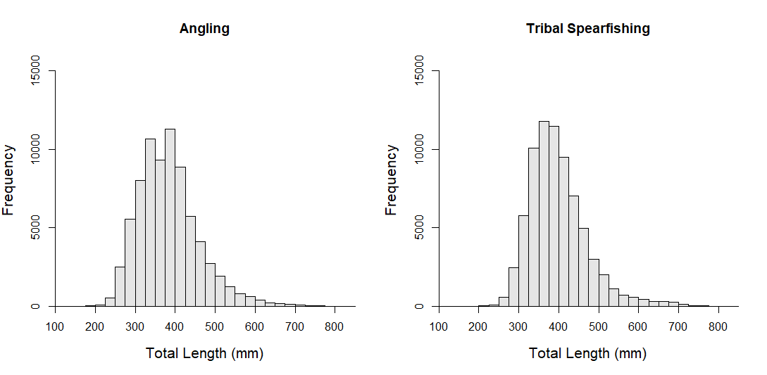

*Figure 1.*

*Corresponding Author: Joseph Mrnak*

*Figure 2.*

*Corresponding Author: Joseph Mrnak*

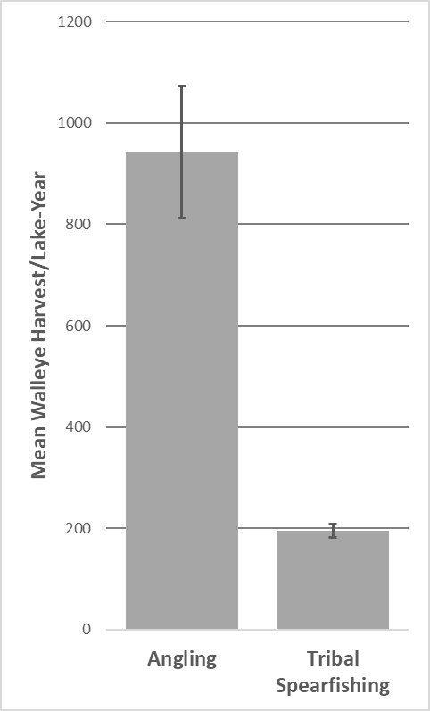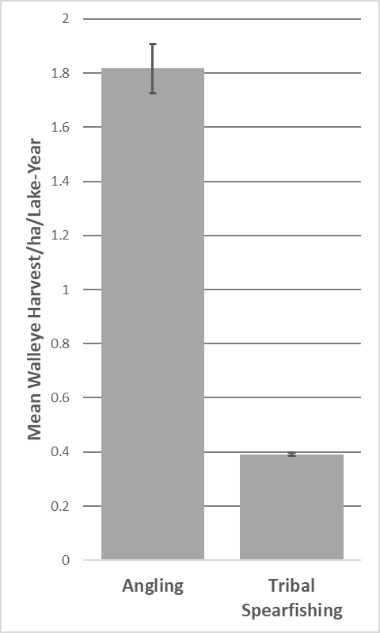

*Figure 3.*

*Corresponding Author: Joseph Mrnak*

*Figure 4.*

*Corresponding Author: Joseph Mrnak*

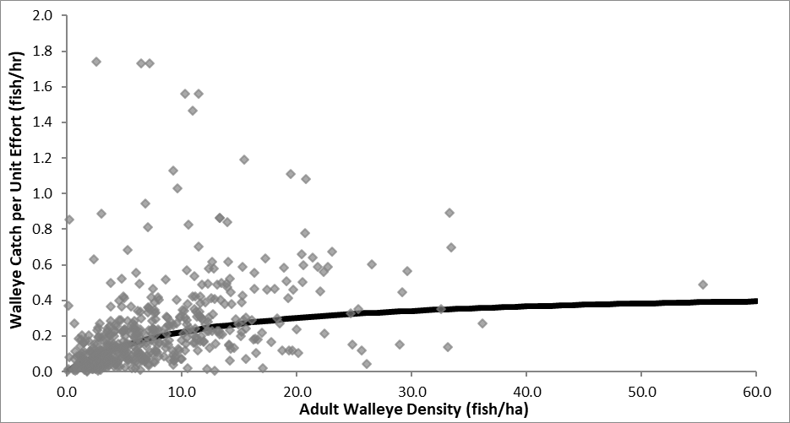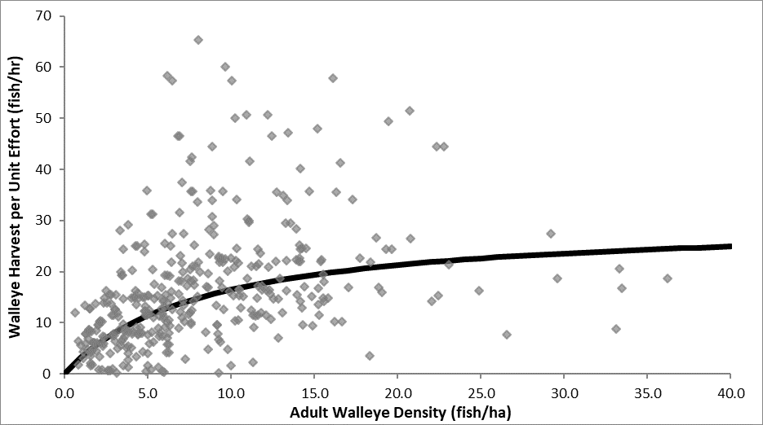

**Angling**

**Tribal Spearfishing**

*Figure 5.*

*Corresponding Author: Joseph Mrnak*