FIVE System

User Guide
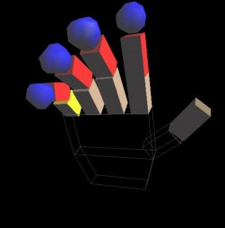

Fully

Interactive
Virtual
Environment

Contents:

Introduction 2

Open GL, an introduction 4

The data glove 5
The virtual hand 6
Representation of hand 6
The palm 6
The fingers 7
Thumb 7
Contact points 8
Hand orientation 8
Gesture Recognition 9
The use of linked-lists 10
Collision Detection 11
Object contact points 11
Cube 11
Sphere 12
Cube 12
Critter 12
Donino 13
Bullet 13
Handling opf contract points 13
The use of classes 14
Hand class 14
The object classes 15
Sphere 15
Cube 15
Falling sphere 15
Key 15
Critter 15
Buller 15
Menu system 16
Environmentat controls 17
Camera movment 17
Environment Creation 17
Gun Mode 17
OpenGL over VRML 18
Future enhancements: 19
Observations: 20
Side effects 20

References: 21

FIVE System

Technical Manual

Fully

Interactive
Virtual
Environment

Introduction:

“Cyberspace. A consensual hallucination experienced daily by billions of legitimate operators, in every nation, by children being taught mathematical concepts…A graphic representation of data abstracted from the banks of every computer in the human system. Unthinkable complexity. Lines of light ranged in the nonspace of the mind, clusters and constellations of data. Like city lights receding…”

- William Gibson, Neuromancer

FIVE (Fully Interactive Virtual Environment), is a graphical interface to computer created environments that permits a user to move and interact with objects in it. The interfacing is through the recognition of users hand gestures through a data glove.

Virtual Reality (VR) applications had a premature birth in the early nineties with the release of W Industries Virtuality game system into the larger computer game arcades (1993). What users saw at that time in a head mounted display did little justice to today’s virtual reality systems. VR was heralded on the Six One news as the next big thing and then little was seen or heard of it in the volume that was anticipated. However outside of the arcades VR systems were developed in a range of specific fields. There is currently huge potential in areas such as telerobotics, (in for example remote surgery), chemical modelling, architecture and the entertainment industry. Molecular modelling systems for walking around and examining chemical bonding for example were an early but well developed system. Remote surgery research resulted in the development of some incredible systems originally intended to take the shake from surgeon’s hands, but later altered to remove the shake from a patient. This means that a heart can be operated on without being stopped as the beating of the heart is eliminated by the software by moving the camera and tools of the surgeon in time with the heart. The surgeon views and works on a stopped heart on screen, which is in fact still beating in the patient’s chest.
The entertainment industry has a large interest in VR. Combined with the increasing power of computer gaming consoles and the growth of the Internet the potential for VR gaming is increasing. Evidence of this was present when looking to purchase a data glove for the FIVE system. Several companies from VR books from the early nineties have since been bought up and assimilated by some of the computing and multimedia giants of today. Keeping this in mind VR will soon pounce as the killer “experience” in gaming and more and more areas will stand to benefit from it.

Consider the analogy of a VR city as the World Wide Web. The user who has just entered into this cyberspace is standing beside a small white pyramid one foot high. It represents his/her entry point into the system. Spread out around the world scape are buildings representing web sites. The servers connected to the Internet would all have physical representations sculpted by the web masters and limited by their hardware specifications. This could be hard coded in the form of a chip in the machine which for example states a domestic personal computer is represented by a white pyramid, engraved with the users name and IP address...

Open GL, an introduction:

The OpenGL graphics system is a software interface to graphics hardware. OpenGL consists of approximately 150 distinct commands that you use to specify the objects and operations needed to produce interactive three-dimensional applications.

OpenGL is designed as a streamlined hardware independent interface to be implemented on many different hardware platforms. OpenGL does not provide high level commands for describing models of three-dimensional objects. With OpenGL you must build your desired model from a set of geometric primitives.

OpenGL manipulates models in three dimensions by applying the current affine transformation matrix (CATM) to the objects co-ordinates. Rotation, scaling and transformation are achieved by manipulating the CATM with the appropriate OpenGL commands, before it is applied to each object. A local co-ordinate system can be achieved by transforming to a specific location and then pushing the CATM onto a stack. The pushing and popping to the stack is implemented with specific OpenGL calls.

The following is an example of the pseudo code to rotate an object in OpenGL:

Push the (CATM)

Translate to objects current position

Rotate the object

Draw Object

Pop the (CATM)

In this manner, only the object within the push and the pop is affected by the manipulation of the CATM. This basic concept of continually pushing and popping onto the CATM stack allows the construction of objects consisting of OpenGL primitives such as cubes and spheres which can be manipulated around their own local co-ordinate system. The construction of the hand in FIVE is a more complex example of what can be achieved with these fundamental OpenGL operations.
The data glove:

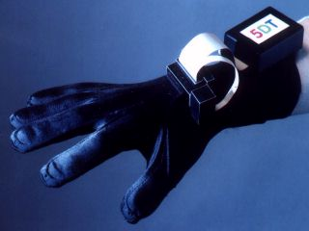
The glove in FIVE is built by 5th Dimension Technologies. Each finger has a loop of fibre optic cable around it. Bending a finger therefore bends the fibre optic loop, which reduces the amount of light passing through the loop and returning to the photo-sensor. The glove interface box positioned on the top of the glove returns 7 values to the COM port of the computer. A finger flexure value of between 0 and 256 (0 =finger straight, 256 = maximum bend of finger), is returned for the fingers and the thumb. A roll and pitch value between 0 and 256 is also returned depending on the pitch and roll of the gloves’ tilt sensor, which is positioned on the top of the glove.

The serial port communications routine was supplied by 5DT with the data glove. The GloveDriver library provides the functions to poll the glove for the current settings of its 5 fingers roll and pitch sensors.

The virtual hand:

Representation of hand:
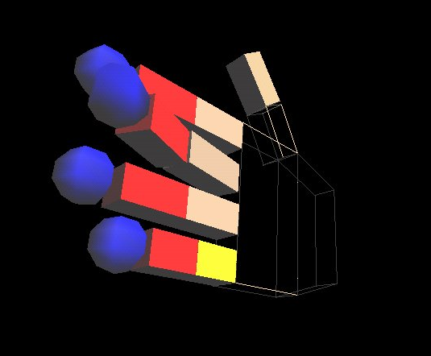
As interaction with FIVE is conducted entirely by means of a data glove worn by the user it was important to have a realistic representation of their hand within the environment. It was also important that the representation behaved in a manner that accurately mirrored their hand movement.

The hand is composed of the following components:

The palm:
The palm is illustrated as being made of two components, it does in fact move as one. Because the user view is from behind the glove, the palm is transparent to prevent it from obscuring the sight of other objects it may be close to. The palm moves on two axes. It tilts up and down on its z-axis, and rolls left and right on it x-axis. The values received from the tilt and roll sensors are applied used to calcuate the appropriate rotation on the relevant axis’s.

The four fingers:
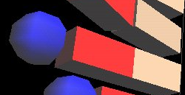
Each of the four fingers is connected to the palm and rotate with the palm. Each finger is comprised of three components, based on the skeletal components, phalanges I II and III of the hand. phalanges I and II are rectangles, and phalange III is a sphere, which is the contact point of the finger. The finger components vary in size, representing their true to life size variation.
Finger, showing phalanges I, II & III

The bend of each finger depends on the finger flexure value received from the glove for that finger. This value does not specify the individual flexure of each phalange but only a value (0-256) for the overall bend of the finger. The bend of each phalange is limited to a maximum of 90 degrees. The finger flexure value is normalised and multiplied by the bend limit of 90 to determine how much the phalange should rotate. All of the phalanges of the finger move together in unison, giving a realistic approximation of real finger flexure.
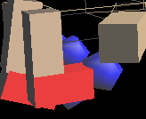
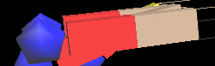
Unbent finger
Finger at maximum flex

The thumb:
The thumb is connected to the palm and therefore rotates with the palm. The thumb is comprised of two components, which bend in relation to the flexure value received from the glove. Its movement is limited to the x-z plane, as the glove does not accurately measure the orientation of the thumb, only its bend.
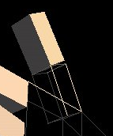
The bend for the thumb is calculated the same way as the finger bend, but with different limiting angles.
The thumb
The eight contact points of the hand:
In the hand are eight contact points, which are used in the collision detection component of FIVE. Phalange III of each finger, represented by a blue sphere is the finger contact point. In the top palm section, there are four invisible spheres, which move with the palm. The diameter of the invisible palm contact spheres are equal to the depth of the palm.

Orientation of the hand:

The complete orientation of the hand, is the combination of the rotation of the palm about its x and z-axis’s, the rotation of the fingers about the z-axis, and the rotation of the thumb about the y-axis. All of the hand components are connected and move in unison about their various axes.
Gesture Recognition:

The use of data gloves is an emerging technology synonymous with Virtual Reality (VR). Most use of these gloves has centred around "point, reach and grab", interaction or signing. Although this addressed the need for natural interfaces, it does not explore the full capabilities of the hand, as an input device. The dexterity and the adaptability of the hand as a tool makes it well suited for a wide range of applications.

In FIVE all interaction within the virtual environment is via the data glove worn by the user. Commands in the form of specially reserved hand gestures, such as a click of the fingers, open a menu where the user selects an option off of it by pointing to highlight the desired command. The user is able to control their navigation, method of interaction, environmental controls and object selection through the combination of a set of gestures and a simple-gesture navigated menu system.

This is implemented by monitoring the current finger flexure values, roll and tilt sensors and checking them against predefined threshold values. In FIVE the glove is polled before each frame is drawn. The values returned are used to determine if a recognised gesture has been made and if so, which gesture. Depending on which gesture has been made the drawn hand is either transformed or rotated in the virtual environment or a specific menu command is executed.

The use of linked-lists:

The use of classes within FIVE greatly simplified the creation of individual objects and the testing parameters and the ability to test them all for certain configurations.

A hierarchy of object classes were implemented, each object having generic properties but also having extensions of individual classes.
Two sets of classes were created in tandem. A linked-list class and an objects class. A linked-list class for holding all of the objects in the world and an object class for holding all of the objects’ properties.

The linked-list class contains functionality for adding and removing objects from it. This is analogous to the creating and destroying of objects in the virtual environment. When an object is created in the world it is put on to the world’s object list. When an object is destroyed in the world it is removed from that list. When the contact points of each object are created they are added to that object’s contact point list.

The object class contains the generic properties of each object, which include its x, y, z position and size, and a virtual display function, which is implemented differently for each sub-class. Within each individual sub-class of object i.e. cube, sphere, falling sphere, critter, domino and key individual characteristics are defined, such as their reaction to being contacted, held and released.

When an object is created for the first time, its generic properties are assigned, its contact points list is created and its contact points are put onto this list. The object is then added to the world’s object list. This class hierarchy means that the creation of a new object within the environment is simply a matter of instantiating the relevant class. This facilitates on the fly creation of objects in the environment

Collision Detection:

Collision detection (CD) within FIVE is one of its major components. OpenGL is purely a graphics library, with no CD. The crux of the CD implemented in FIVE is the fact that every object within the virtual environment has spherical contact points in or around it. These spherical contact points or bounding spheres are placed in or around an object when it is created. The number and placement of these contact points is determined by the properties currently stored in each individual object’s contact point list.

The following is a description of the placement of the contact points of some of FIVES’s primitive objects

Cube:
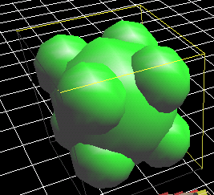
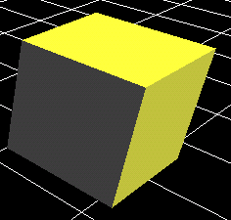
A cube contains 9 contact points.
Contact point view
Solid view

Sphere:
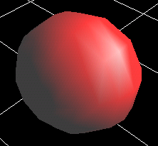
A sphere contains 1 contact point.

Key:
A key contains 4 contact points.
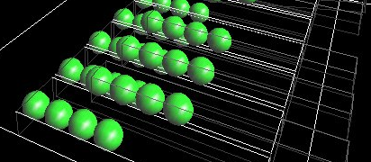
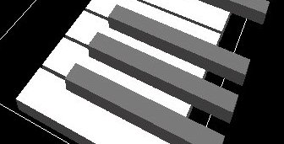

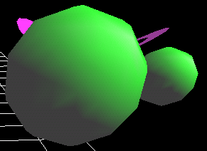
Critter:
A critter contains 2 contact points.
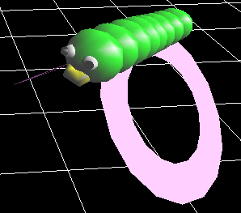
Domino:

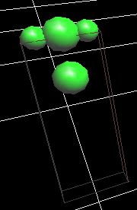
A domino contains 4 contact points.

Bullet:
A bullet has 1 contact point.

Handling of contact points:

When an object is created and its contact points are created the object and the contact points are bound together and move together from then on until the object is destroyed.

In checking for a collision, an object cycles through its own contact points list, checking to see if any contact points on it intrudes on the area occupied by any other object’s contact points. The testing for intrusion is implemented by calculating the distance between the centre of two contact points and checking it against the sum of their respective radii. If the sum of the radii is less then the distance between their centre points then a collision has occurred.

FIVE tests for both primary and secondary collision detection. Primary collision detection is the testing of the eight contact points of the hand for collision with all of the objects in the environment. The primary CD is implemented by the hand cycling through the world’s object list and checking each object’s individual contact point list, against its own contact points. The secondary collision involves each of the objects in the world testing for collisions with all other objects including the hand. This is done by each object scanning through every other object’s contact points lists’ and checking for an intrusion with any of its own contact points.

The use of classes:

Hand class.

This is obviously the most complicated object in the world as it is the link between the user and the rest of the environment. Before it can be displayed it must perform various tasks. These involve polling the glove to read the current orientation and finger flexure, checking to see if the values received correspond to any of the reserved hand gestures and if so acting accordingly. It also checks to see if it has touched another object and if so responds by either grabbing it or by informing that object that it has been selected.

Of the eight sensors present in the hand only the four finger tip ones are drawn, but the four in the palm as well as the four in the fingertips must be tracked at all times. Location of the eight contact points is calculated by allowing for the hands rotation combined with the finger flexure and the length of the phalanges. The contact points centre co-ordinates are then stored in an array. This array is updated every time the glove is polled and the hand redrawn.

The display function of the class hand draws the OpenGL primitives taking into account the various rotations and flexures read from the glove.

When a hand contact point touches an object’s contact point the hand checks the objects parameters to determine its reaction. If an object is anchored then the hand cannot push the object out of the way, as it can with an unanchored object.

Picking up objects is a special instance of touching and object. An object is considered grasped if both a palm contact point and a finger contact point collide with an object at the same time. If such a collision occurs the hand simply tells the object in question that is has been grasped and lets the object act accordingly.

The object classes:

As well containing the properties of the base class, all objects in the world contain their own distinct properties. The only generic function of each if the object classes that changes from sub-class to sub-class is the display function.
The advantage of having a virtual display function in the base class, is that on drawing the object it is not necessary to know which sub-class is being drawn as all relevant information needed to do so is stored local to that sub-class.

Sphere class:

As the sphere object is not anchored it must react when another object or the hand touches it. The sphere's behaviour is that it moves out of the way of the hand when it is touched or attaches itself to the hand if it is grabbed. The sphere class also texture maps a graphic file of .PPM format onto it, and rotates on its y-axis.

Cube class:

The cube object is always anchored and so does not move when touched.

Falling sphere class:
The falling sphere class acts much like a regular sphere class, with the exception that when it is released above the floor it falls under gravity and on contact with the floor it bounces back up with reduced velocity.

Key class:
The key object has its movement limited to that of rotating on its end up and down by 15 degrees

Critter class:
The critter class has some extra functions to that of the FIVE primitive objects. It has random value generators to generate a random flight path through the environment. On collision it check to se if a bullet has hit it and reacts. When hit by any other object it acts like a regular sphere object.

Bullet class:
The bullet object travels in a fixed trajectory out along the z plane emanating from the firing position of the index finger. The bullet object is destroyed on contact with a critter or on travelling out of the environment boundaries,

Domino class:
Once touched by any other object in the world or the hand the domino object rotates from an upright position 90 degrees along its z-axis imitating the falling of its real world representation.

Menu System:

OpenGL does not have any support for handling text. So to have text in our world a 26 letter font was stored as pixel data and a string handling function requested the corresponding string pixel map when passed a phrase. As the menu is a two dimensional overlay on a three dimensional world, the OpenGL drawing mode of the menu location is switched to two dimensions after the environment is rendered when the menu is requested. The gesture recognition of the hand watches for the request menu gesture and then halts the movement of the hand through the world if selected. The hand tilt is then monitored to highlight the various options displayed. The making of a fist either brings up a deeper menu option or executes an environment control. The menu is changed by altering the colour of the button borders to reflect the current menu selection.
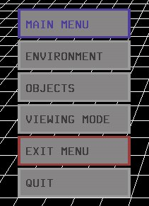
The main menu
Environmental controls

There are several environmental controls a user can alter or access from the menu. These include camera movements, environment creation through the loading and saving of worlds, and the selection of gun mode.

Camera movement:
The camera mode is entered via the menu. The selection of camera mode disables the movement of the glove and moves the users vantage point around the world keeping focused on the hand via an OpenGL camera positioning command.

Environment creation:
A new world can be loaded as the present environment by means of a file reading function that reads in the type, location and size of and object, creates it on the fly and adds it to the world object list. Saving an environment involves reading through the world object list and writing to a file the type, position, and size of each object present.

Gun mode:
The critter object can be “hurt” by bullets. In switching to gun mode the hand’s gestures are monitored for a bullet firing call which results in the creation of a bullet object.
OpenGL over VRML:

It was necessary to make decisions about what languages to use to implement FIVE very early on in its design process. Java 3D, VRML and OpenGL were the contenders because of their graphical handling abilities. We eliminated Java 3D because from what we saw and heard of it, it was still bug riddled and needed another version release to correct several flaws. For FIVE to be expandable a solid foundation was necessary, one which we felt Java 3D was too weak for.

VRML was the eliminated next due to the vast difference we saw in the quality of output between OpenGL and it. OpenGL won outright because of its power and ability it had on its own, and when combined with C++. OpenGL is also easily ported to other operating systems. Compared with OpenGL VRML was simply too slow and blocky in its appearance and the speed and quality of graphics OpenGL offered matched the speed an application such as FIVE warranted. People want instant reaction to their action in a virtual environment just as they do in a real world. As we got more familiar with OpenGL it offered more and more to the possible future of FIVE. OpenGL was also a challenge, which appealed to us, as neither of us had used it or looked at it before the project. Our only major experience of it had been in animated films and special effect sequences, which only strengthened its appeal.
Future enhancements:

In the implementation cycle of FIVE several possible improvements became apparent as it grew. Here we shall discuss a few that we feel will add to its power.

The contact point list of each of the objects on the world object list is traversed by each object when it tests for a collision. If the world linked-list was sorted by object location objects would only have to check for a collision with objects beside it on the linked-list. This would reduce computation, which would be especially important in more complex worlds.

In demonstrating the FIVE system to several people, we determined that a calibration facility would be beneficial because of the varying size of people’s hands and finger flexure. This would allow each user to “teach” FIVE the finger flexure values to call the specific gestures.

The introduction of sound into FIVE introduced another interesting aspect of interaction within a virtual environment. The panning of the sound of moving objects and altering of their volume with the users perceived proximity would increase the users perception of a presence within the environment. This was noticed with the introduction of basic sounds such as that of a bouncing ball. The field of three-dimensional acoustics offers more realistic immersion.

Whilst researching a collision detection (CD) method we came across several methods. The bounded sphere method, we felt was the easier of the possibilities to implement, but we chose it to ensure that we could implement effective and working CD. The following are two examples of more advanced but computationally hungry methods.

One method was the mapping of spheres of varying sizes all over every object so that each object would be made of contact points. This would ensure that no matter where it was touched the object would register a collision. It would also be the next logical progression in FIVE to allow for the creation of more complex objects.

Another method was that of dividing the space in the world up into small sections and testing each section for the presence of objects. Only if two objects occupy the same section of environment space should a collision detection check be carried out between them. This would reduce the collision detection checks but would also need to scan through each “piece” of space to check for object presence.
Observations:

As FIVE’s implementation progressed and its functionality increased, our desire to add to it grew too. Since it is a graphical system and we could see the fruits of our labour in an interactive manner we felt that the extra work equated to more enjoyment of the finished system. Since at the end of the day we got to “play” in this virtual playpen adding to it was rewarding. This enjoyment definitely increased productivity and we were faced with the unusual scenario of a spiralling level of production as we got further and further into FIVE’s implementation. Towards the end of its development we had to draw a line to limit the advancement as time was the critical factor that was against us. The possibilities of FIVE to us seemed unbounded as more and more avenues opened up, in the shape of the artificial intelligence of interactive critters (intelligent agents), more complex collision detection allowing for more complex objects and full immersion in a system with the use of a head mounted display and spatial sound.

The use of classes has also paved the way for simplistic expansion of the current system. It has been created in a modular fashion, which will permit the altering and improving of various functions without disrupting the system as a whole.

Side effects:

In our prolonged visits to the worlds of FIVE we did encounter some interesting side effects. People with some experience of computer games were more able to cope with the manipulation of the objects and learnt how to manipulate more quickly then those who had little computer gaming experience. This could be down to better hand eye co-ordination or just an acceptance and understanding of orientation in a graphical environment controlled by a computer.

One surprising side effect in FIVE after the menu implementation, was the blurring of our perceived control over FIVE and Microsoft Developer. After the menu system within FIVE was implemented we could change environment parameters and exit the program purely by hand gestures. On exiting back into Microsoft Developer Visual C++ we often tried to re-enter FIVE by summoning a menu with the menu call gesture of FIVE as a reflex action. Even though we have both spent far more time sitting in front of Microsoft Developer Visual C++, FIVES menu interaction became a reflex action. This became more apparent after witnessing out speed or interaction against less experienced users.

References:

Virtual Reality – Through the new looking glass.
Ken Pimentel & Kevin Teixeira. McGraw Hill.

Using the Whole Hand in the Human-Computer Interface.

David J. Sturman

The OpenGL Programming Guide 2nd Edition

Mason Woo, Jackie Neider, Tom Davis. Addison Wesley.

Computer Graphics: Principles and Practice
Foley, van Dam et al. Addison Wesley.

The questions and answers posted to various newsgroups as filtered by www.deja.com. We did not post any questions ourselves, but many of the issues that we encountered were topics of much discussion within newsgroups such as comp.graphics.api.opengl.

