QUALITY RACKET RESTRINGING
Scan the QR code to text Chris for tennis racket restringing!
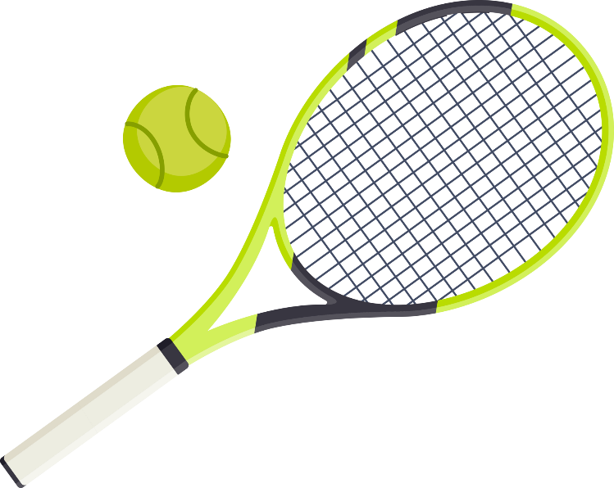
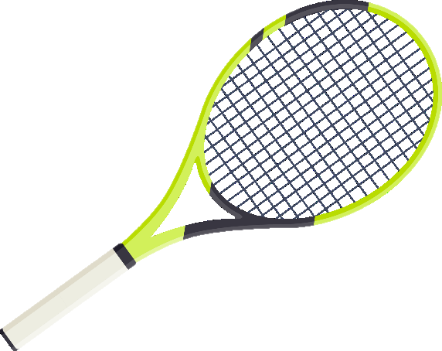
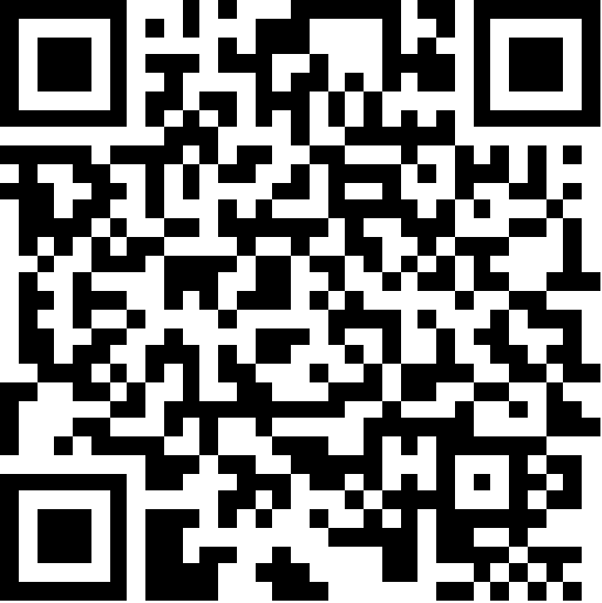
💲 Affordable - $15
🎾 String 4 rackets, Get the 5th Free! 🎾
📍 800N Orem, Utah
📞 (603) 937-8176

