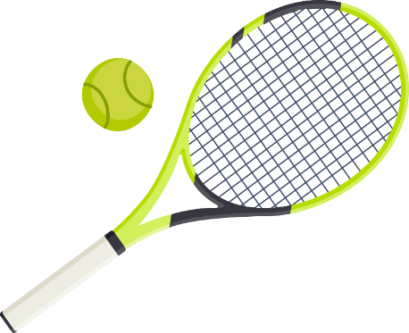
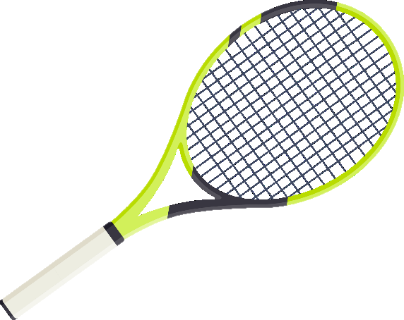
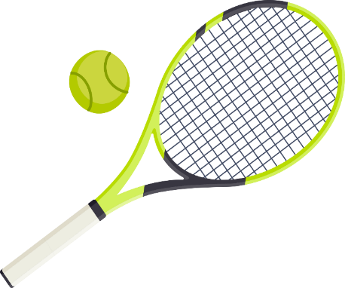
QUALITY RACKET RESTRINGING
Scan the QR code to text Chris for tennis racket restringing!
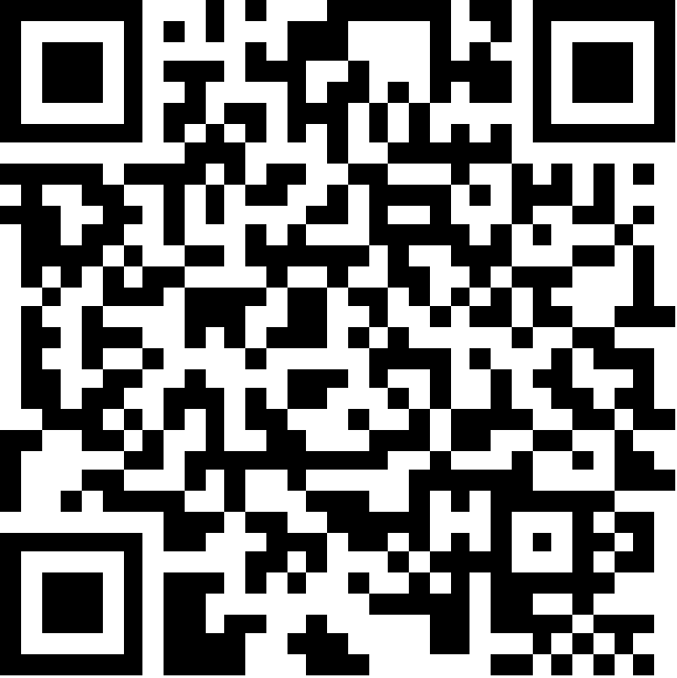
💲 Affordable
🎾 String 4 rackets, Get the 5th free! 🎾
📍 800N Orem, Utah
📞 (603) 937-8176

QUALITY RACKET RESTRINGING
Scan the QR code to text Chris for tennis racket restringing!
💲 Affordable
🎾 String 4 rackets, Get the 5th free! 🎾
📍 800N Orem, Utah
📞 (603) 937-8176

