

55++++++++

Call or Text (603) 937-8176 for racket restringing

Low-priced | Located in Orem | Quick Turnaround
Get 4 rackets restrung at regular price, get the 5th FREE!

1 2 3 4 FREE
CHRIS
TENNIS STRINGING

Call or Text (603) 937-8176 for racket restringing

Low-priced | Located in Orem | Quick Turnaround
1 2 3 4 FREE
Get 4 rackets restrung at regular price, get the 5th FREE!

CHRIS
TENNIS STRINGING

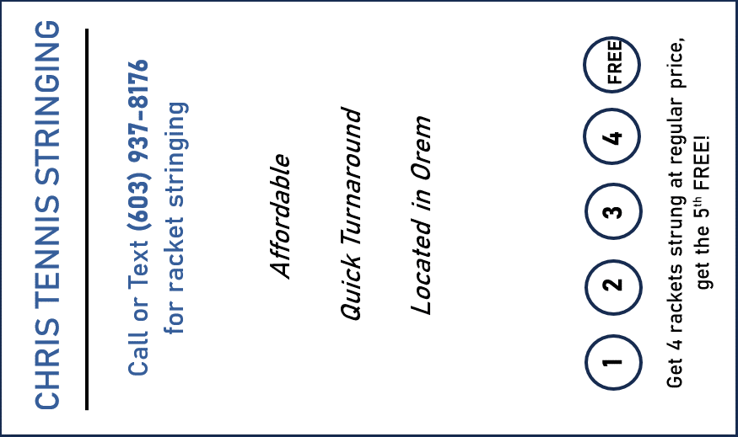

CHRIS
TENNIS STRINGING
CHRIS
TENNIS STRINGING
CHRIS
TENNIS STRINGING
CHRIS
TENNIS STRINGING

Thanks for shopping with us!

Please email us at christophersday@gmail.com if you have any questions or concerns.
CHRIS TENNIS STRINGING
Call or Text (603) 937-8176 for racket stringing

Affordable

Quick Turnaround

Located in Orem
Get 4 rackets strung at regular price,
get the 5th FREE!

1 2 3 4
FREE
CHRIS TENNIS STRINGING
Call or Text (603) 937-8176 for racket stringing

Affordable

Quick Turnaround

Located in Orem
Get 4 rackets strung at regular price,
get the 5th FREE!

1 2 3 4
FREE

Thanks for shopping with us!

Please email us at christophersday@gmail.com if you have any questions or concerns.

Thanks for shopping with us!

Please email us at christophersday@gmail.com if you have any questions or concerns.

Thanks for shopping with us!

Please email us at christophersday@gmail.com if you have any questions or concerns.

Quality Racket Restringing!
Scan the QR code to message us for tennis racket restringing.

💲 Affordable - $15
🎾 String 4 rackets, Get the 5th Free! 🎾
📍 800N Orem, Utah
📞 603-937-8176

